Supplementary Information

Erythrocyte membrane camouflaged celastrol and bilirubin self-assembly for rheumatoid arthritis immunotherapy based on STING inhibition and RONS clearance

Yanguo Su ª, Rui Chen ª, Bingjie Wang ª, Teng Wang ª, Jiaojiao Tao ª, Qijie Diao ª,
Tianze Jiang ª，Xia Zhao ^{a, b,}∗

ª Key Laboratory of Marine Drugs, Ministry of Education, School of Medicine and Pharmacy, Ocean University of China, Qingdao 266003, China
^{b} Laboratory for Marine Drugs and Bioproducts, Qingdao Marine Science and Technology Center, Qingdao 266237, China
Figure S1. Cytotoxicity of Free Cel on RAW264.7 cells. Data are presented as mean ± SD (n = 3). *P < 0.05, **P < 0.01, and ***P < 0.001.
Figure S2. Cytotoxicity of Free BR on RAW264.7 cells. Data are presented as mean ± SD (n = 3). *P < 0.05, **P < 0.01, and ***P < 0.001.

Figure S3. DCFH-DA fluorescence evaluation of ROS scavenging ability with different concentrations of BR. Data are presented as mean ± SD (n = 3). *P < 0.05, **P < 0.01, and ***P < 0.001
Figure S4. DCF fluorescence evaluation of ROS clearance ability of different ratios of Cel-BR. Data are presented as mean ± SD (n = 3). *P < 0.05, **P < 0.01, and ***P < 0.001, ns means no significance.
Figure S5. Particle size and Tyndall effect of Cel-BR nanoparticles prepared at different ratios.
Figure S6. Particle size of RM-Cel-BR (a) and HA-RM-Cel-BR (b).

Figure S7. Stability evaluation of Cel and BR in PBS solution with different assembly ratios.
Figure S8. Stability evaluation of Cel and BR in 10% FBS solution with different assembly ratios.
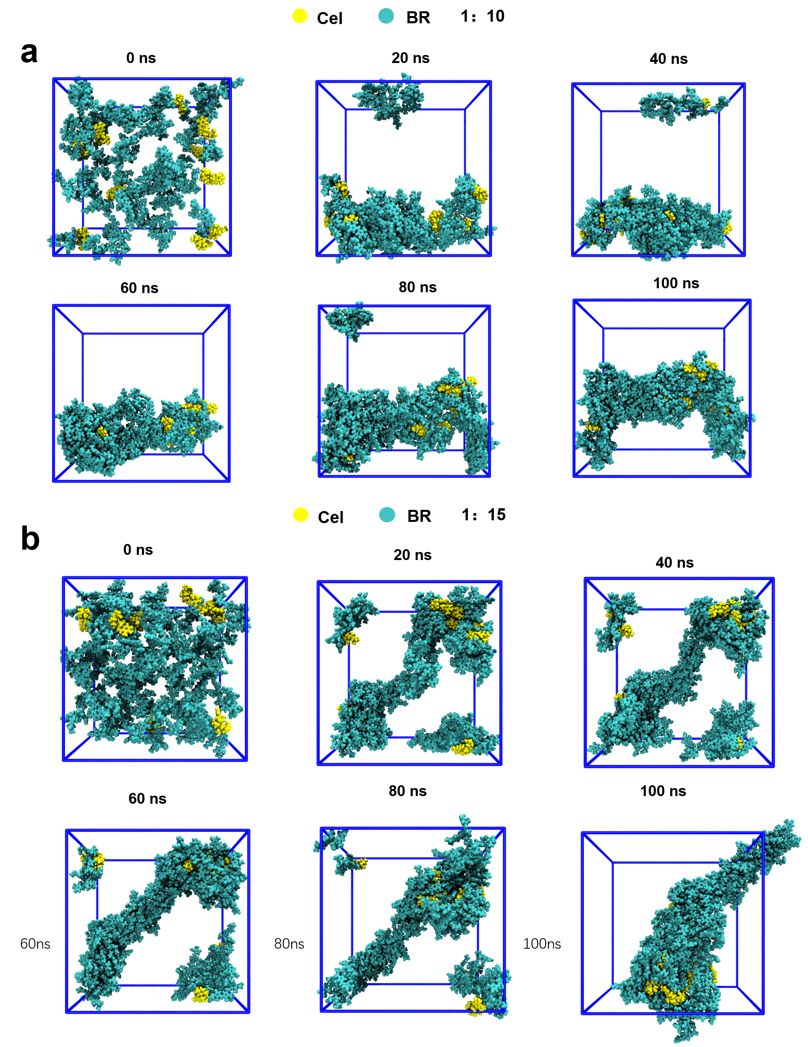
Figure S9. Molecular dynamics simulation of Cel and BR at 1:10 (A) and 1:15 (B) ratios.
Figure S10. Stability of HA-RM-Cel-BR in PBS solution and in 10% FBS solution for 7 days.
Figure S11. XRD pattern of Cel-BR.

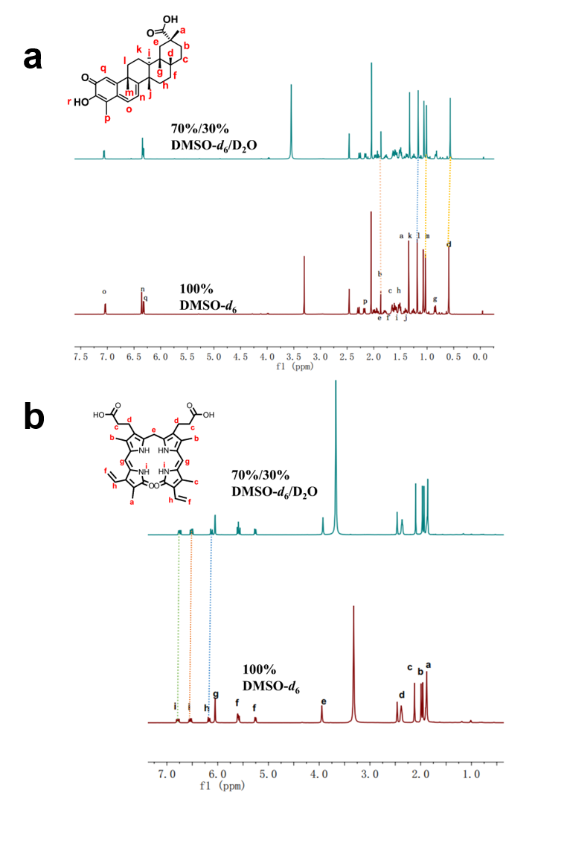
Figure S12.¹H NMR spectra of Cel (a) and BR (b) with different solvents.

Figure S13. Quantitative analysis of endocytosis mechanism of HA-RM-Cel-BR after treatment with different inhibitors (chlorpromazine, colchicine and indomethacin). Data are presented as mean ± SD (n = 3). **P < 0.01, ***P < 0.001.
Figure S14. The expression of different proteins after HA-RM-Cel-BR treatment. Protein quantification of p-IKBα (a), p-p65 (b), Nrf-2 (c), Keap1 (d), HO-1 (e), and STING (f). Data are presented as mean ± SD (n = 3). *P < 0.05, **P < 0.01, and ***P < 0.001.
Figure S15. H&E staining of hearts, spleens, lungs, and kidneys post-treatment in different treatment groups. Scale bar = 200 µm.
Figure S16. H&E staining of livers post-treatment in different treatment groups. Scale bar = 20 µm.

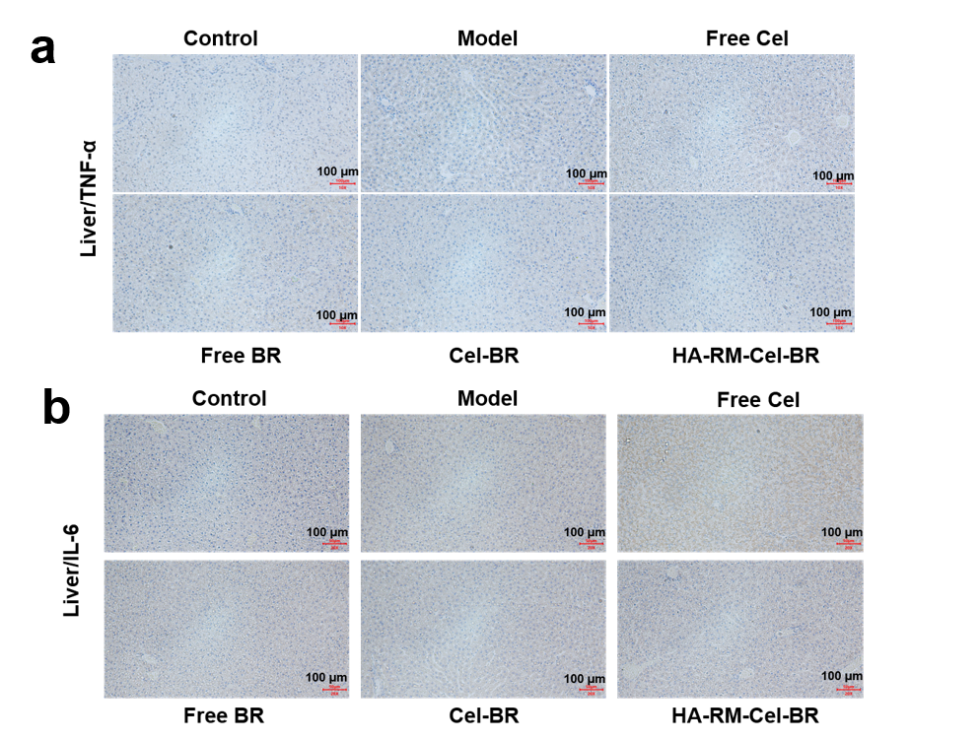
Figure S17. Immunohistochemical analysis of TNF-α (a) and IL-6 (b) liver in different preparation groups. Scale bar = 100 µm.
Figure S18. Blood compatibility evaluation. Hemolysis test (a) and hemolysis rate statistics (b) in different formulation groups. Data are presented as mean ± SD (n = 3). *P < 0.05, **P < 0.01, and ***P < 0.001.

Figure S19. Immunohistochemistry of CD86 and CD206 after treatment with different formulations. Scale bar = 0.02 mm.

TableS1. Table1.Encapsulation efficiency and loading capacity of Cel and BR at 1:10,1:15 and 1:20 ratios.
Molar ratios (Cel:BR) | 1:10 | 1:15 | 1:20
EE% Cel  BR | 88.0 ± 2.28  74.2 ± 0.13 | 88.9 ± 0.94  86.4 ± 0.90 | 97.6 ± 0.85  97.4 ± 2.14
LE% Cel | 10.6 ± 0.25 | 6.50 ± 0.029 | 4.77 ± 0.10
BR | 89.4 ± 0.25 | 93.5 ± 0.029 | 95.2 ± 0.10

∗Corresponding author at: Key Laboratory of Marine Drugs, Ministry of Education, School of Medicine and Pharmacy, Ocean University of China, Qingdao 266003, China. Tel & Fax: 86-532-82031560. E-mail address: zhaoxia@ouc.edu.cn (X. Zhao).

