Supplementary Material
Comprehensive wound healing using ETN@Fe₇S₈ complex by positively regulating multiple programmed phases
Mengxia Chen^{1,2,} †, Ting Liu^{1,3, †}, Xiaonan Wang^{4,5, †}, Lizeng Gao^{4,6}, Yunqing Cheng^{2*}, Jing Jiang^{4*}, Jinhua Zhang^{1*}

¹College of Life Science and Bioengineering, Beijing Jiaotong University, Beijing 100044, China
²School of Life Sciences, Jilin Normal University, Jilin 136000, China
³School of Life Science and Technology, Jinan University, Guangdong 510632, China
⁴CAS Engineering Laboratory for Nanozyme, Key Laboratory of Biomacromolecules, Institute of Biophysics, Chinese Academy of Sciences, Beijing 100101, China
⁵School of Life Sciences, University of Chinese Academy of Sciences, Beijing 101408, China
⁶Nanozyme Laboratory in Zhongyuan, School of Basic Medical Sciences, Zhengzhou University, Zhengzhou 450001, China

†These authors contributed equally to this work.
E-mail addresses: zhangjh@bjtu.edu.cn (JH. Zhang); jiangjing@ibp.ac.cn (J.Jing); chengyunqing1977@163.com (YQ. Cheng)

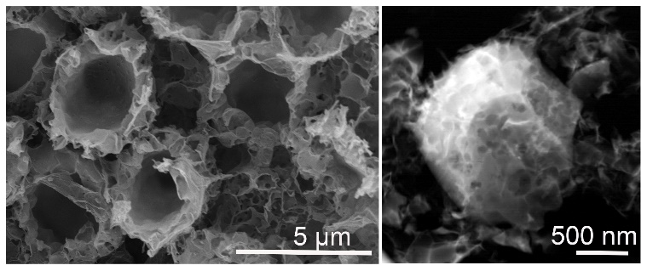
Supplementary Figure 1. The SEM and HAADF image of ETN.
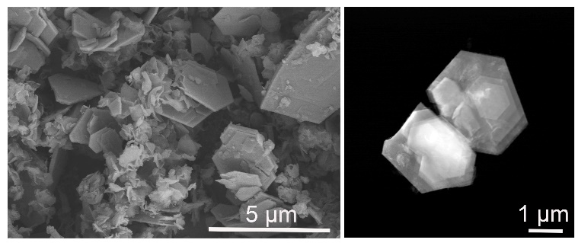
Supplementary Figure 2. The SEM and HAADF image of Fe_{1-x}S.
Supplementary Figure 3. (A) EDS mapping images of ETN. (B) EDS analysis of ETN elements.

Supplementary Figure 4. (A) EDS mapping images of Fe_{1-x}S. (B) EDS analysis of Fe_{1-x}S elements.
Supplementary Figure 5. (A) Photographs of bacterial colonies of MRSA with different concentrations (0, 125, 250, 500 µg/mL). (B) Bacterial viability of MRSA based on (A). ****P < 0.0001.
Supplementary Figure 6. Body weight of mice with different treatments. ns: no significant.
Supplementary Figure 7. (A) IF staining of CK10 for the wounds on days 3 and 7, and (B) quantitative analysis. (C) IF staining of CK14 for the wounds on days 3 and 7, and (D) quantitative analysis. **P<0.01, ****P < 0.001.

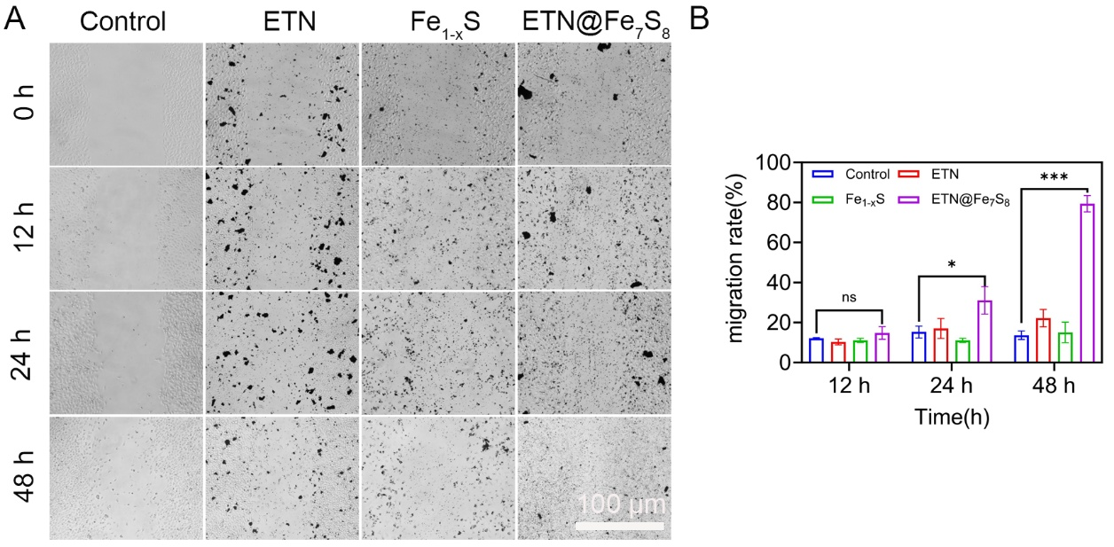
Supplementary Figure 8. (A) IF staining of Ki67 for the wounds on days 3 and 7, and (B) quantitative analysis. **P<0.01, ***P < 0.001.

Supplementary Figure 9. (A) Images of HaCaT migration with different treatments for 0, 12, 24, and 48 hours, and (B) quantitative analysis. ns: no significant，*P<0.05，***P<0.001
Supplementary Figure 10. (A) Optimal concentration of ETN@Fe₇S₈ to Raw264.7. (B) Optimal concentration of Na₂S₄ to Raw264.7. (C) Optimal concentration of FeCl₂ to Raw264.7. *P < 0.05, ***P < 0.001, ****P < 0.001.

Supplementary Figure 11 (A) Images of HUVECs migration with different treatments in the Trans-well migration assay, and (B) quantitative analysis. **P < 0.01
Supplementary Figure 12. (A) Optimal concentration of ETN@Fe₇S₈ to HUVEC. (B) Optimal concentration of Na₂S₄ to HUVEC. (C) Optimal concentration of FeCl₂ to HUVEC. *P < 0.05, **P<0.01, ***P < 0.001, ****P < 0.0001.

Supplementary Tables
Table S1. Details of primary materials and antibodies used in the study.
REAGENT Or RESOURCE | SOURCE | IDENTIFIER
Materials
DMEM | BI | 06-1055-57-1ACS-1
Pen-Strep Solution | BI | 03-031-1B
FBS | Gibco | A31608-02
Ferric chloride (FeCl₃) | Sigma-Aldrich | 7705-08-0
Ferrous chloride (FeCl2) | Sigma-Aldrich | 7758-94-3
Cysteine | Sigma-Aldrich | 3374-22-9
Sodium acetate trihydrate | Sigma-Aldrich | 6131-90-4
Ethylene glycol | Sigma-Aldrich | 107-21-1
NaCl | Sigma-Aldrich | 7647-14-5
SulfoBiotics-SSP4 | DOJINDO | SB10
Cell counting kit-8 | Aladdin Chemistry | C266180
Iron content kit | Solarbio | BC5315
ATP kit | Solarbio | BC0300
Malondialdehyde kit | Nanjing Jiancheng | A003-1-2
GSH and glutathione disulfide (GSSG) assay kit | Beyotime | S0053
NAD/NADH kit | Beyotime | S0175
Propidium iodide (PI) | Beyotime | C1075M
Mouse anticoagulant whole-blood | Bersee | B1057
Agar | Sangon Biotech | A505255
FastKing RT Kit (With gDNase) | TIANGEN | KR116
Fixation & Permeabilization Buffer | Invitrogen | 88-8824-00
IFN-γ ELISA kit | Cloud-Clone | SEA049Mu
TNF-α ELISA kit | Cloud-Clone | SEA133Mu
SYBR Green qPCR Master Mix | MCE | HY-K0501-5
SYTO 9 | Thermo Fisher Scientific | S34854
Antibodies
anti-Mouse CD11b | BD Biosciences | 550282
anti-Mouse F4/80 | Bio Legend | 123101
anti-Mouse Gr1 | BD Biosciences | 550291
Mouse monoclonal anti-Ki67 | BD Biosciences | 550609
anti-Mouse CK10 | Affinity | AF0197
anti-Mouse CK14 | Affinity | AF5370
anti-Mouse CD31 | Affinity | AF6191
Phospho-PI3K Antibody | Affinity | AF3242
PI3K Antibody | Affinity | AF6242
anti-p-p65 | ProteinTech | 82335-1
anti-p65 | ProteinTech | 10745-1
VEGFA | Affinity | AF5131
Mouse monoclonal anti-β-actin | Santa Cruz | sc-47778
Cell lines
Raw264.7 | ATCC | TIB-71
HUVEC | ATCC | PCS-100-013
Bacteria
MRSA | ATCC | F-182
Experimental models: organisms/strains
Balb/c | Hfkbio

Table S2. The primer sequences of pro-inflammatory and anti-inflammatory factors.
Gene | Primer sequence (5’-3’)
IL-6 Forward | TTCTTGGGACTGATGCTGGT
IL-6 Reverse | CTGTGAAGTCTCCTCTCCGG
TNF-α Forward | TGAGGTCAATCTGCCCAAGT
TNF-α Reverse | GGGGTCAGAGTAAAGGGGTC
IL-12 Forward | GTCCTCAGAAGCTAACCATCTCC
IL-12 Reverse | CCAGAGCCTATGACTCCATGTC
IL-10 Forward | CAGGGATCTTAGCTAACGGAAA
IL-10 Reverse | GCTCAGTGAATAAATAGAATGGGAAC
Arg-1 Forward | CAATCCCCAGCTTGTCTACTTCA
Arg-1 Reverse | GCATATCTGCCAAAGACATCGT
YM-1 Forward | GGCAAAGGTCATGGAGATGT
YM-1 Reverse | CTGCAGTCTCCATCACGAAA
β-actin Forward | GGCYGYAYYCCCCYCCAYCG
β-actin Reverse | CCAGTTGGTAACAATGCCATGT

Table S3. Raman data of D band, G band and I_{D}/I_{G} of ETN and ETN@Fe₇S₈.
Samples | D band (cm-1) | G band (cm-1) | I_{D}/I_{G}
ETN | 1722.66 | 1824.91 | 0.94
ETN@Fe₇S₈ | 1204.05 | 1186.87 | 1.01

Table S4. BET-specific surface area, pore volume and pore size of ETN@Fe₇S₈.
Samples | BET specific surface area (m²/g) | Pore volume  (cm³/g) | Pore size (nm)
ETN | 20.72 | 0.05 | 10.28
Fe_{1-x}S | 16.25 | 0.05 | 16.17
ETN@Fe₇S₈ | 10.17 | 0.03 | 11.63

Table S5. Comparison of ETN@Fe₇S₈ with other materials.

 | Nanozybiotics/  others | Antibacterial properties | Microorganism | Antibacterial applications | Other Functions | Refs.
Single-atom nanozybiotics | ETN | PODª | MRSA^{b} | Wound healing | Hemostasis | [1]
Single-atom nanozybiotics | CuL/PHI | POD, OXD^{c} | E. coli^{d}, MRSA | Wound healing | _ | [2]
Single-atom nanozybiotics | Mn/Fe SACs | POD, GOx^{e}, CAT^{f} | S. aureus^{g}, E. coli | Wound healing | _ | [3]
Carbon-based nanozybiotics | ETN@Fe₇S₈ | Fe²⁺, polysulfide release | MRSA | Wound healing | Hemostasis， angiogenesis
Carbon-based nanozybiotics | Cu SASs/NPC | POD, GPx, PTT | MRSA | Wound healing | _ | [4]
Carbon-based nanozybiotics | CeO₂ NPs | OXD | S. aureus, E. coli |  | _ | [5]
Carbon-based nanozybiotics | H-CDs | POD | S. aureus, E. coli, P. aeruginosa^{h}, MRSA | Infection,、wound healing | _ | [6]
Carbon-based nanozybiotics | CS@Fe-N CDs | POD | S. aureus, E. coli | S. aureus, E. coli | _ | [7]
Carbon-based nanozybiotics | Fe-γ-CD | POD | ESBL- E. coli^{i}  , MRSA | Antibacterial agent in  foodstuﬀs | _ | [8]
Metal-based nanozybiotics | Cu ND/CG | POD | MRSA, E. coli | Wound healing | Angiogenesis | [9]
Metal-based nanozybiotics | PtCo@G@H₂A | OXD | H. pylori^{j} | Gastric  diseases | _ | [10]
Metal-based nanozybiotics | Zn-Nx-C | Lactonase | P. aeruginosa^{k} | Antifouling nanocoating | _ | [11]
Metal-based nanozybiotics | V-Fe₂O₃ | POD | MRSA | Wound healing | _ | [12]
Metal-based nanozybiotics | Fe-SAC | POD | MRSA | Wound healing | _ | [13]
MOF-based nanozybiotics | FeCD | FeCD | E. coli, MRSA | Treatment of abscess | _ | [14]
MOF-based nanozybiotics | Ni-MOF | POD, SOD | MRSA, E. coli | Wound healing | _ | [15]
MOF-based nanozybiotics | Fe₃O₄@MOF@Au NPs | POD | S. aureus, E. coli | Wound healing | _ | [16]
MOF-based nanozybiotics | Cu-CNNDs | POD | S. aureus, E. coli | Surface antibacterial  coatings | _ | [17]
MOF-based nanozybiotics | Bi-PCN-222 MOF | POD, OXD | S. aureus | Wound healing | _ | [18]
Others | Ferrous· iron | Ferroptosis | MRSA | Mouse keratitis model | _ | [19]
Others | Polysulfide | Synergistic ferrousiron | MRSA | Infection model | _ | [20]

Reference
1. Wang X, Liu T, Chen M, Liang Q, Jiang J, Chen L, Fan K, Zhang J, Gao L: An Erythrocyte-Templated Iron Single-Atom Nanozyme for Wound Healing. Adv Sci (Weinh) 2024, 11:e2307844.
2. Ou H, Qian Y, Yuan L, Li H, Zhang L, Chen S, Zhou M, Yang G, Wang D, Wang Y: Spatial Position Regulation of Cu Single Atom Site Realizes Efficient Nanozyme Photocatalytic Bactericidal Activity. Adv Mater 2023, 35:e2305077.
3. Zhang M, Xu W, Gao Y, Zhou N, Wang W: Manganese-Iron Dual Single-Atom Catalyst with Enhanced Nanozyme Activity for Wound and Pustule Disinfection. ACS Appl Mater Interfaces 2023, 15:42227-42240.
4. Wang X, Shi Q, Zha Z, Zhu D, Zheng L, Shi L, Wei X, Lian L, Wu K, Cheng L: Copper single-atom catalysts with photothermal performance and enhanced nanozyme activity for bacteria-infected wound therapy. Bioact Mater 2021, 6:4389-4401.
5. Mehta D, Sharma P, Singh S: ATP-triggered, selective superoxide radical generating oxidase-mimetic cerium oxide nanozyme exhibiting efficient antibacterial activity at physiological pH. Colloids Surf B Biointerfaces 2023, 231:113531.
6. Cheng K, Wang H, Sun S, Wu M, Shen H, Chen K, Zhang Z, Li S, Lin H: Specific Chemiluminescence Imaging and Enhanced Photodynamic Therapy of Bacterial Infections by Hemin-Modified Carbon Dots. Small 2023, 19:e2207868.
7. Li L, Wang D, Ren L, Wang T, Tan X, Cui F, Li T, Li J: Chitosan-chelated carbon dots-based nanozyme of extreme stability with super peroxidase activity and antibacterial ability for wound healing. Int J Biol Macromol 2024, 258:129098.
8. Liu X, Zhao Y, Xu Y, Liu C: Synthesis of γ-Cyclodextrin-Reduced Fe(III) Nanoparticles with Peroxidase-like Catalytic Activity for Bacteriostasis of Food. Nano Lett 2023, 23:9995-10003.
9. Cui Y, Zhang W, Shan J, He J, Niu Q, Zhu C, Wang W, Chen XL, Wang X: Copper Nanodots-Based Hybrid Hydrogels with Multiple Enzyme Activities for Acute and Infected Wound Repair. Adv Healthc Mater 2024, 13:e2302566.
10. Deng H, Zhang Y, Cai X, Yin Z, Yang Y, Dong Q, Qiu Y, Chen Z: Dual-Targeted Graphitic Cascade Nanozymes for Recognition and Treatment of Helicobacter pylori. Small 2024, 20:e2306155.
11. Gao M, Xu B, Huang Y, Cao J, Yang L, Liu X, Djumaev A, Wu D, Shoxiddinova M, Cai X, et al: Nano-enabled Quenching of Bacterial Communications for the Prevention of Biofilm Formation. Angew Chem Int Ed Engl 2023, 62:e202305485.
12. Huang H, Geng W, Wu X, Zhang Y, Xie L, Ma T, Cheng C: Spiky Artificial Peroxidases with V-O-Fe Pair Sites for Combating Antibiotic-Resistant Pathogens. Angew Chem Int Ed Engl 2024, 63:e202310811.
13. Liu Q, Liu X, He X, Wang D, Zheng C, Jin L, Shen J: Iron-Single-Atom Nanozyme with NIR Enhanced Catalytic Activities for Facilitating MRSA-Infected Wound Therapy. Adv Sci (Weinh) 2024, 11:e2308684.
14. Xu G, Liu K, Jia B, Dong Z, Zhang C, Liu X, Qu Y, Li W, Zhao M, Zhou H, Li YQ: Electron Lock Manipulates the Catalytic Selectivity of Nanozyme. ACS Nano 2024, 18:3814-3825.
15. Chen Z, Shan J, Niu Q, Chen H, Zhang W, Cao D, Wang X: pH-responsive double-enzyme active metal-organic framework for promoting the healing of infected wounds. J Colloid Interface Sci 2024, 657:250-262.
16. Liu C, Zhao X, Wang Z, Zhao Y, Li R, Chen X, Chen H, Wan M, Wang X: Metal-organic framework-modulated Fe(3)O(4) composite au nanoparticles for antibacterial wound healing via synergistic peroxidase-like nanozymatic catalysis. J Nanobiotechnology 2023, 21:427.
17. Dai X, Liu H, Cai B, Liu Y, Song K, Chen J, Ni SQ, Kong L, Zhan J: A Bioinspired Atomically Thin Nanodot Supported Single-Atom Nanozyme for Antibacterial Textile Coating. Small 2023, 19:e2303901.
18. Wu L, Luo Y, Wang C, Wu S, Zheng Y, Li Z, Cui Z, Liang Y, Zhu S, Shen J, Liu X: Self-Driven Electron Transfer Biomimetic Enzymatic Catalysis of Bismuth-Doped PCN-222 MOF for Rapid Therapy of Bacteria-Infected Wounds. ACS Nano 2023.
19. Wang Z, Li H, Zhou W, Lee J, Liu Z, An Z, Xu D, Mo H, Hu L, Zhou X: Ferrous sulfate-loaded hydrogel cures Staphylococcus aureus infection via facilitating a ferroptosis-like bacterial cell death in a mouse keratitis model. Biomaterials 2022, 290:121842.
20. Shen X, Ma R, Huang Y, Chen L, Xu Z, Li D, Meng X, Fan K, Xi J, Yan X, et al: Nano-decocted ferrous polysulfide coordinates ferroptosis-like death in bacteria for anti-infection therapy. Nano Today 2020, 35:100981.

