Supporting Information

Carbon dot-based treatment for bacterial pneumonia by promoting a PI3K-mediated M1 polarization of macrophages
Xuan Jiang^{1#}, Jun Wang^{1#}, Lin Gan¹, Zengshuai Wu¹, Tong Wu¹, Fengyang Li¹, Xiaowei Xu²*, Liancheng Lei¹*, Na Li¹*
#These authors contributed equally to this work.

¹State Key Laboratory for Diagnosis and Treatment of Severe Zoonotic Infectious Diseases, Key Laboratory for Zoonosis Research of the Ministry of Education Institute of Zoonosis, and College of Veterinary Medicine, Jilin University, Changchun 130062, China.

²Jilin Provincial Key Laboratory of Tooth Development and Bone Remodeling, School and Hospital of Stomatology Jilin University, Changchun 130021, China.

*Correspondence: E-mail
Xiaowei Xu: xiaoweixu@jlu.edu.cn
Liancheng Lei: leiliancheng@163.com
Na Li: vetlina2013@126.com

Supplementary Figures
Fig S1. Physical and chemical properties of CDots.
(A) Emission (red) and UV-vis absorption spectra (black) of ascorbic acid and PEI. Illustrations: photographs of PEI and ascorbic acid solution taken under UV light (right) and sunlight (left). (B) Zeta potential of CDots. (C) EDS pattern of the CDots. (D) N 1s of PEI and C 1s of ascorbic acid XPS spectrum.
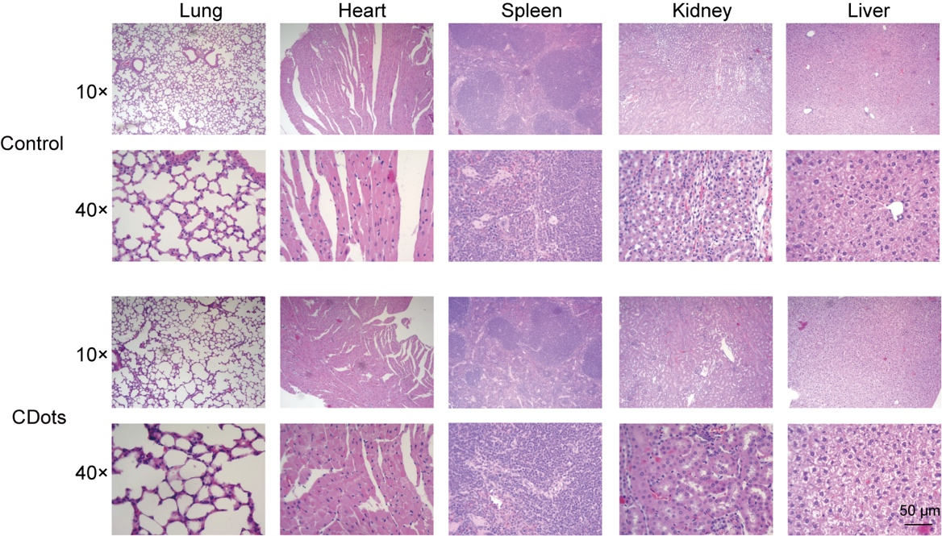
Fig S2 The toxicity effects of CDots on mice were investigated.
Hematoxylin and eosin (H&E) staining of vital organs after administering CDots and control for 48 hours.
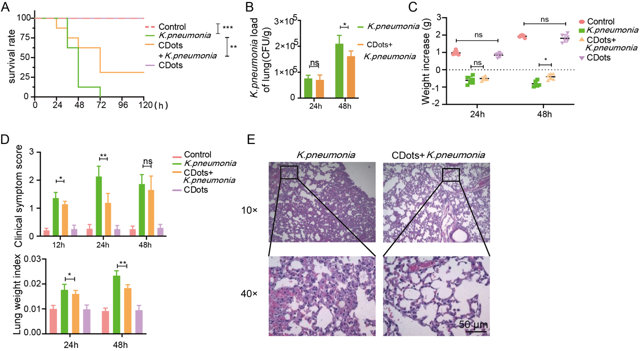
Figure S3. Evaluation of the therapeutic effect of CDots on bacterial pneumonia in mice. (A) Survival rate of the mice in different treatment groups (n=8). (B) Bacterial loads in murine lung homogenate (n=6). (C-D) Clinical index of the mice in different treatment groups, including body weight, clinical signs, and lung index (n=6). (E) H&E staining results of pathological sections of the lungs were recorded at the indicated time points. Statistical significance was analyzed by the two-tailed Student’s t-test. Data are presented as mean ± SD from three independent experiments. *p < 0.05, **p < 0.01, ***p < 0.001. Scale bar = 50 μm.
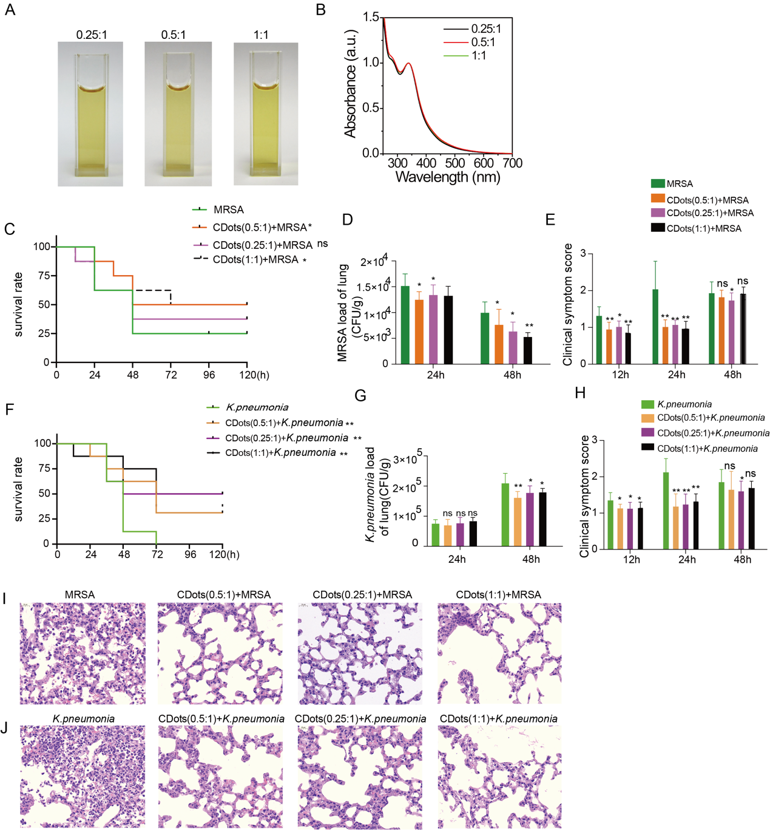
Figure S4 Evaluation of the therapeutic efficacy of CDots with different proportions on bacterial pneumonia in mice.
(A) Photographs of different CDots solution taken under sunlight. (B) UV–vis absorption of different CDots. (C, F) The survival rate of the mice in different treatment groups (n=8). (D, G) Bacterial loads in murine lung homogenate (n=6). (E, H) Clinical symptom score of the mice in different treatment groups. (n=6). (I, J) H&E staining results of lung pathological sections in different groups. Statistical significance was analyzed by the two-tailed Student’s t-test. Data are presented as mean ± SD from three independent experiments. *p < 0.05, **p < 0.01, ***p < 0.001. Scale bar = 20 μm.
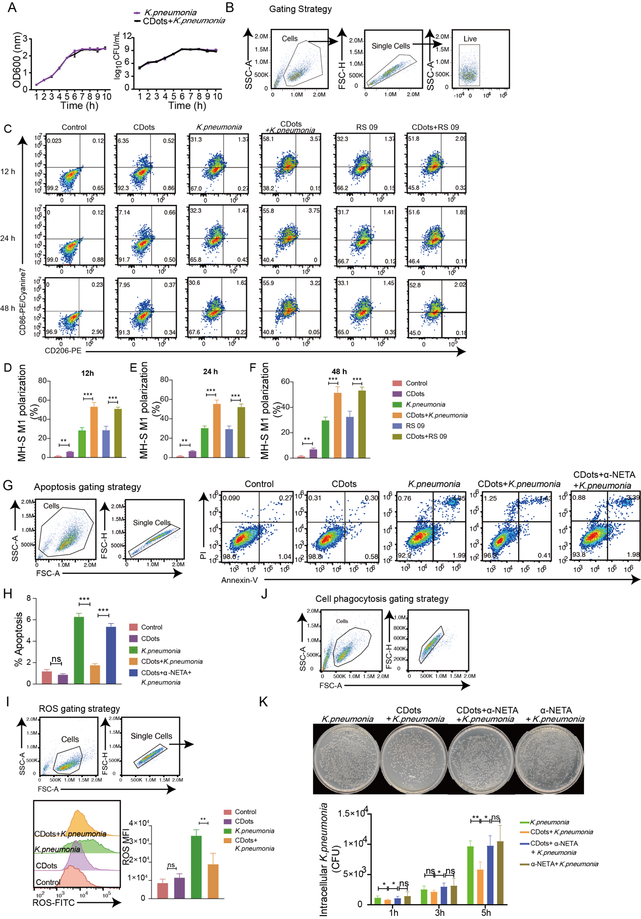
Figure S5. Effects of CDots on macrophage polarization, cell vitality, phagocytosis, and sterilization.
(A) The long curve measurement and colony count were measured for K. Pneumoniae with or without CDots. (B-F) Representative gating strategies for CD206 and CD86 expression in MH-S cells and quantification of CD86⁺ macrophages after indicated treatments. (G-H) Representative flow cytometric plots and quantification of cell apoptosis. (I) The representative gating strategies and flow cytometry analysis of intracellular ROS changes in MH-S cells. (J) The representative gating strategies for phagocytosis of MH-S. (K) Representative images of bacteria after 5 hours’ infection and the quantification of bacterial colonies with indicated treatments. *p < 0.05, **p < 0.01, ***p < 0.001.

Fig S6 The effects of CDots on mouse macrophage RAW264.7 polarization, survival, and phagocytosis.
(A) Flow cytometric analysis and quantification of cell death by 7-AAD staining. (B) Flow cytometric analysis of the phagocytosis of RAW264.7 cells with or without CDots treatments. (C) Representative images of bacteria (MRSA and K. Pneumoniae) after 5 hours’ infection and the quantification of bacterial colonies with indicated treatments. Statistical significance was analyzed by the two-tailed Student’s t-test. Data are presented as mean ± SD from three independent experiments. *p < 0.05, **p < 0.01, ***p < 0.001.
Figure S7. CDots enhance the bacteria-killing ability of macrophages by promoting M1 polarization via inhibiting the PI3K/AKT/mTOR pathway.
(A) Western blot results of PI3K, p-PI3K, AKT, p-AKT, mTOR, and p-mTOR, of MH-S cells after indicated treatment. (B) Flow cytometric analysis of CD206 and CD86 expression in MH-S cells with indicated treatments. (C) Western blot results of p-PI3K, PI3K, p-AKT, AKT, p-mTOR, and mTOR of MH-S cells after indicated treatment. (D) Flow cytometric analysis of CD206 and CD86 expression in MH-S cells after different treatments. (E) Representative images of bacteria after 5 hours’ infection and the colonies of bacteria with different treatments. Statistical significance was analyzed by the two-tailed Student’s t-test. Data are presented as mean ± SD from three independent experiments. *p < 0.05, **p < 0.01, ***p < 0.001, ****p < 0.0001.

Fig S8. The effects on PI3K/AKT/mTOR pathway and bacteria-killing ability of RAW264.7 by PIK3CD-siRNA interference.
(A) Western blot results of PI3K, p-PI3K, AKT, p-AKT, mTOR, p-mTOR of MH-S cells after indicated treatment. (B) The effects of bacteria-killing ability of RAW264.7 by PIK3CD-siRNA interference. Statistical significance was analyzed by the two-tailed Student’s t-test. Data are presented as mean ± SD from three independent experiments. *p < 0.05, **p < 0.01.

