Supporting Information

Cyclic cell-penetrating peptide-engineered ceria nanoparticles for non-invasive alleviation of ultraviolet radiation-induced cataract

a

Figure S1. The MALDI-TOF mass spectrum of DSPE-PEG-linearCPP12. The molecular weight of DSPE-PEG-linearCPP12 is about 4200 g/mol.

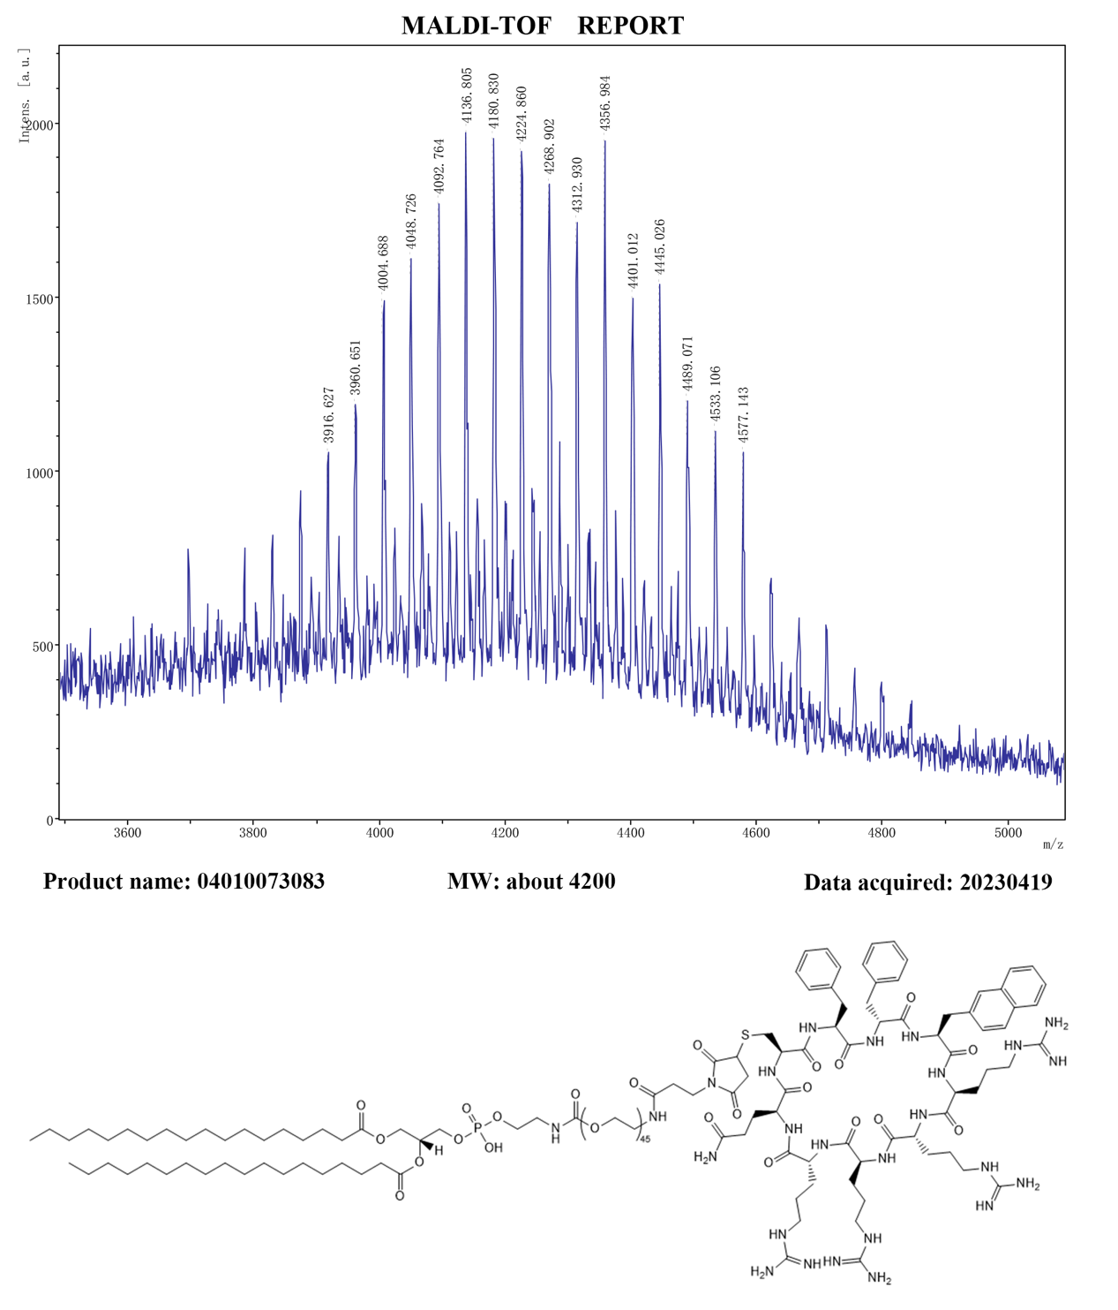
Figure S2. The MALDI-TOF mass spectrum of DSPE-PEG-cyclicCPP12. The molecular weight of DSPE-PEG-cyclicCPP12 is about 4200 g/mol.

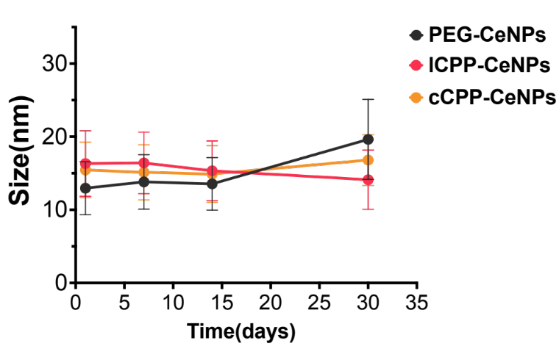
Figure S3. Alterations in the particle size of three sets of nanoparticles dissolved in ultrapure water over 30 days.

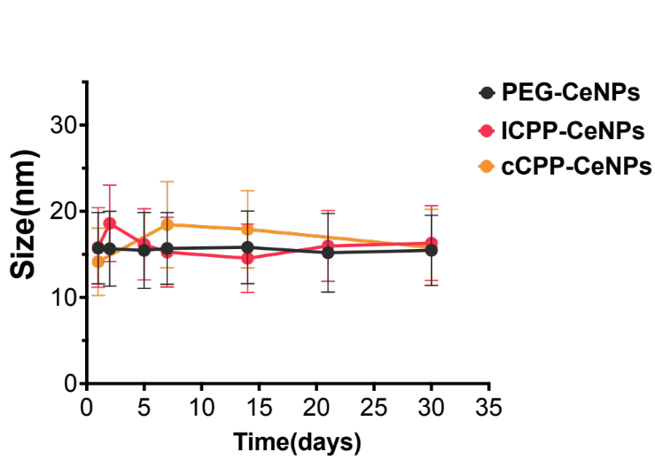
Figure S4. Alterations in the particle size of three sets of nanoparticles dissolved in phosphate-buffered saline (1×PBS) over 30 days.

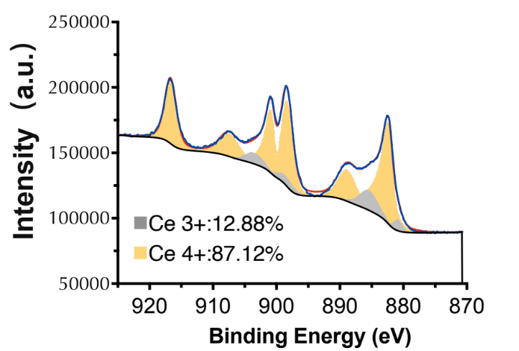
Figure S5. XPS analysis indicates a shift in their surface valence state after H₂O₂ quenching.

Figure S6. EPR studies of PEG-CeNPs. a) H₂O₂, Fe(II) sulfate, and DMPO; b) Fe(II) sulfate, H₂O₂, 0.5 mM PEG-CeNPs and DMPO; c) Fe(II) sulfate, H₂O₂, 1.0 mM PEG-CeNPs and DMPO; d) Fe(II) sulfate, H₂O₂, 5.0 mM PEG-CeNPs and DMPO.

Figure S7. EPR studies of lCPP-CeNPs. a) H₂O₂, Fe(II) sulfate, and DMPO; b) Fe(II) sulfate, H₂O₂, 0.5 mM lCPP-CeNPs and DMPO; c) Fe(II) sulfate, H₂O₂, 1.0 mM lCPP-CeNPs and DMPO; d) Fe(II) sulfate, H₂O₂, 5.0 mM lCPP-CeNPs and DMPO.

Figure S8. (A) Confocal images and (B) statistics of HCECs treated with FITC-labeled PEG-CeNPs, lCPP-CeNPs and cCPP-CeNPs. (C) Schematic diagram of trans-endocytosis experiments. In the histogram, data is presented as the mean ± SD (n = 4). *p < 0.05, **p < 0.01; ns, no significance.

Figure S9. Immunofluorescence imaging of ZO-1 in HCECs (scale bar: 50 µm).

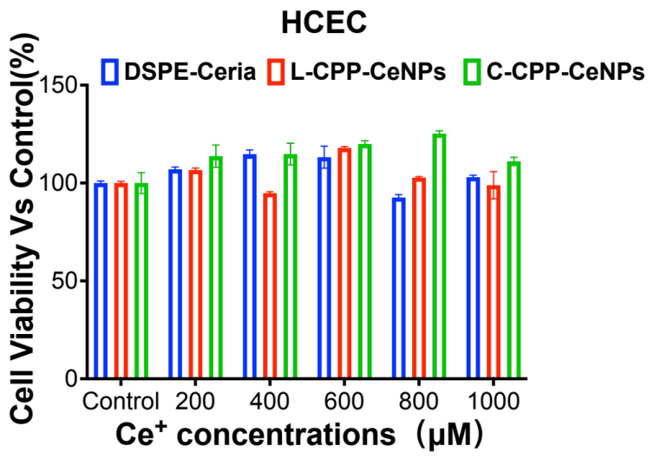
Figure S10. Cell viability of HCEC cells detected by CCK-8 assay after treatment with different concentrations of PEG-CeNPs, lCPP-CeNPs, and cCPP-CeNPs.

Figure S11. Cell viability of HLEB3 cells detected by CCK-8 assay after treatment with different concentrations of PEG-CeNPs, lCPP-CeNPs, and cCPP-CeNPs.

Figure S12. Confocal images of HLEB3 cells treated with cCPP-CeNPs with different time (1 hour, 2 hours, 3 hours, 4 hours). (scale bars: 60 µm).

Figure S13. Confocal images of HLEB3 cells treated with PEG-CeNPs treatment with different time (1 hour, 2 hours, 3 hours, 4 hours). (scale bars: 60 µm).

Figure S14. Confocal images of HLEB3 cells treated with lCPP-CeNPs with different time (1 hour, 2 hours, 3 hours, 4 hours). (scale bars: 60 µm).

Figure S15. Subcellular localization of the FITC-labeled PEG-CeNPs. Golgi apparatus, lysosome, and cell nuclei were stained by the Mito-tracker Red, ER-Tracker Red, Golgi-tracker Red, and Lyso-tracker green, respectively. (scale bars: 40 µm).

Figure S16. Subcellular localization of the FITC-labeled lCPP-CeNPs. Golgi apparatus, lysosome, and cell nuclei were stained by the Mito-tracker Red, ER-Tracker Red, Golgi-tracker Red, and Lyso-tracker green, respectively. (scale bars: 40 µm).

Figure S17. Subcellular localization of the FITC-labeled cCPP-CeNPs. The golgi apparatus, lysosome, and cell nuclei were stained by the Mito-tracker Red, ER-Tracker Red, Golgi-tracker Red, and Lyso-tracker green, respectively. (scale bars: 40 µm).

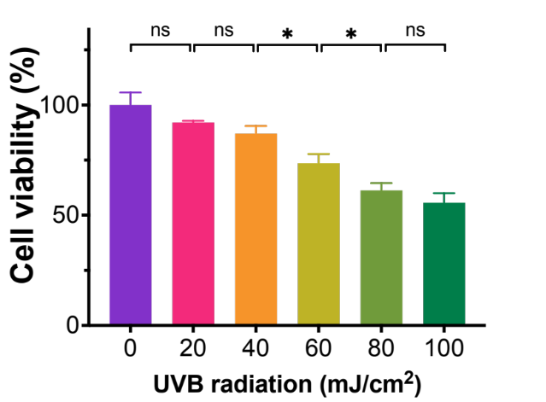
Figure S18. Cell viability of HLEB3 cells detected by CCK-8 assay after treatment with different concentrations of UVB radiation. In this histograms, data is presented as the mean ± SD (n = 3). *p < 0.05; ns, no significance.

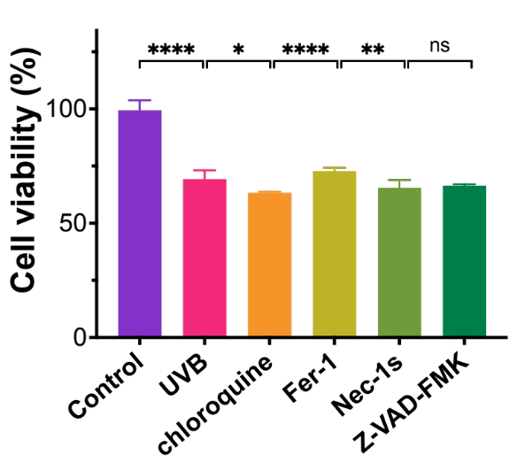
Figure S19. Cell viability detected by CCK-8 assay after treatment with specific autophagy inhibitor chloroquine, ferroptosis inhibitor Fer-1, apoptosis inhibitor Z-VAD-FMK, and necrosis inhibitor Nec-1s in UVB-stimulated HLEB3 cells, control group was treated with PBS. In this histograms, data is presented as the mean ± SD (n = 4). *p < 0.05, **p < 0.01, ****p < 0.0001; ns, no significance.

Figure S20. The repair process of anterior lens subcapsular opacification within 7 days. A) 3.6 Kj/m² total irradiation dose group. B) 5.0 Kj/m² total irradiation dose group. In this histograms, data is presented as the mean ± SD (n = 3). ***p < 0.001.

Figure S21. The formation of anterior subcapsular cataracts in the lenses after 5.0 kJ/m² illumination of UV exposure and the statistics of anterior subcapsular turbid area. In all histograms, data is presented as the mean ± SD (n = 3). ***p < 0.001; ns, no significance.

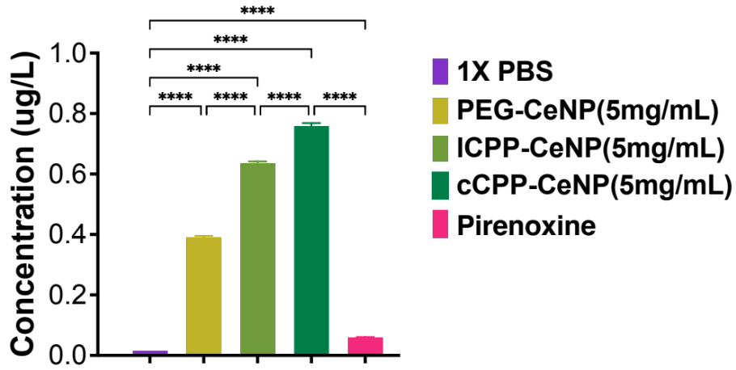
Figure S22. Ce⁺ element in the aqueous humor after administration of 6 kinds of eye drops. Measured by ICP-MS. In this histogram, data is presented as the mean ± SD (n = 3). ****p < 0.0001.

Figure S23. H&E staining of lens with CeNPs treatment after UVB radiation. (scale bars: 100 µm).

Figure S24. Confocal images and statistics of immunofluorescence imaging of ferroptosis-related indicators 4-HNE (red) and FTH (green). (scale bar: 20 µm). In the histograms, data is presented as the mean ± SD (n = 3). **p < 0.01, ***p < 0.001, ****p < 0.0001; ns, no significance.

Figure S25. Lillie staining for Fe²⁺ (A) and Fe³⁺ (B) of lens capsule sections from Control, PBS, PEG-CeNPs, lCPP-CeNPs, and cCPP-CeNPs groups after UVB stimulation. (scale bars: 50 µm).

Figure S26. Corneal fluorescent staining of C57BL/6 mice’s eyes.

Figure S27. Hematoxylin and eosin (H&E)-stained C57BL/6 mice’s cornea. (scale bars: 50 µm).

Figure S28. OCT imaging of morphology in C57BL/6 mice’s posterior eyes.

Figure S29. Hematoxylin and eosin (H&E)-stained images of the major organs of C57BL/6 mice. (scale bars: 200 µm).

