Supporting Information
Inhalable biomimetic polyunsaturated fatty acid-based nanoreactors for peroxynitrite-augmented ferroptosis potentiate radiotherapy in lung cancer
Yiting Chen^{1, †}, Xueli Huang,^{1, †}, Ruining Hu¹, Enhao Lu¹, Kuankuan Luo¹, Xin Yan¹, Zhiwen Zhang¹, Yan Ma^{4, *}, Minghe Zhang^{3, *}, Xianyi Sha^{1, 2, *}
¹ Department of Pharmaceutics, School of Pharmacy, Fudan University, Key Laboratory of Smart Drug Delivery, Ministry of Education, Lane 826, Zhangheng Road, Shanghai, 201203, China
² Quzhou Fudan Institute, 108 Minjiang Avenue, Kecheng District, Quzhou, Zhejiang Province, 324002, China
³ Naval Medical Center, Naval Medical University, Shanghai, 200052, Shanghai, China
⁴ Department of Pharmacy, Shanghai Mental Health Center, Shanghai Jiao Tong University School of Medicine, Shanghai, 201108, China
† Chen Yiting and Xueli Huang contributed equally to this work.
* Correspondence Author
Email address: mayan@smhc.org.cn (Yan Ma), minghezhang@smmu.edu.cn (Minghe Zhang), shaxy@fudan.edu.cn (Xianyi Sha)
Tel/Fax: 86-021-51980072 (Xianyi Sha)
Table S1 Encapsulation efficiency and drug loading of DHA-N@M with different ratios of DHA-SNO to RCM (n = 3).
DHA-SNO : RCM | Encapsulation efficiency (%) | Drug loading content (%)
0.5:1 | 18.56 ± 0.44 | 8.49 ± 0.18
1:1 | 18.22 ± 1.08 | 15.41 ± 0.77
2:1 | 18.39 ± 1.31 | 26.88 ± 1.40
5:1 | 7.05 ± 0.60 | 26.04 ± 1.65
10:1 | 3.60 ± 0.37 | 26.47 ± 2.00

Fig. S1. The synthesis procedures of DHA-SNO, which consisted of five steps including compound 1 to the final product of DHA-SNO.
Compound 1. The 2-acetamido-3-mercapto-3-methylbutanoic acid 1.5g was dissolved in 5 mL pyridine and was maintained at ice-bath for 0.5 h. 5 mL acetic anhydride was mixed with 5 mL pyridine, cooled with an ice-bath, and was slowly dropped into the above solution. After reaction for overnight under protection of nitrogen, the solvent was removed under reduced pressure until an orange solution was remained. The crude product was dissolved in chloroform, washed with 1.0 M HCl, and dried over anhydrous sodium sulfate. Then, the anhydrous sodium sulfate was filtered and the solvent was removed. The resulting solid was washed n-hexane to obtain a pale yellow solid, which was further filed to give the desired product. ¹H NMR (400 MHz, Chloroform-d) δ 6.30 (s, 1H), 5.66 (s, 1H), 2.04 (s, 3H), 1.84 (s, 3H). ESI-MS: m/z = 196.1 [M+Na]⁺, 174.1 [M+H]⁺.
Fig. S2. The MS-ESI spectrum of chemical compound 1.
Fig. S3. The ¹H NMR spectrum of chemical compound 1 in CDCl₃.
DHA-Boc. DHA (350 µL, 1.0 mmol, 1.0 eq), 2-(7-azabenzotriazol-1-yl)-N,N,N',N'-tetramethyluronium hexafluorophosphate (HATU, 450 mg, 12 mmol, 1.2 eq), and N,N-diisopropylethylamine (DIPEA, 258 mg, 2.0 mmol, 2.0 eq) were dissolved in 5.0 mL anhydrous dichloromethane (DCM). After a 0.5 h reaction at ice-bath, N-Boc-ethylenediamine (315 µL, 2.0 mmol, 2.0 eq) was added and reacted for overnight under protection of nitrogen. The mixture was washed with 1.0 M HCl, water (3 times), and brine, then dried over anhydrous sodium sulfate and concentrated. Finally, the residue was purified by column chromatography eluted with DCM/ MeOH (100:1) to afford DHA-Boc. ¹H NMR (600 MHz, Chloroform-d) δ 6.21 (s, 1H), 5.42-5.27 (m, 12H), 4.96 (s, 1H), 3.34 (q, J = 5.4 Hz, 2H), 3.25 (d, J = 5.8 Hz, 2H), 2.87-2.75 (m, 10H), 2.43-2.35 (m, 2H), 2.22 (dd, J = 8.2, 6.9 Hz, 2H), 2.06 (td, J = 7.4, 1.5 Hz, 2H), 1.43 (s, 9H), 0.96 (t, J = 7.5 Hz, 3H). ESI-MS: m/z = 493.43 [M+Na]⁺.
Fig. S4. The ¹H NMR spectrum of DHA-Boc.

Fig. S5. The MS-ESI spectrum of DHA-Boc.

DHA-NH_{2.} To a mixture of DHA-Boc (500 mg) in anhydrous DCM (24 mL), 12 mL trifluoroacetic acid (TFA) was added slowly and stirred at room temperature until the reaction completely as monitored by thin-layer chromatography (TLC) (~1 h). Then, the mixture was diluted with water, neutralized to weakly alkaline by addition of saturated sodium bicarbonate solution and then extracted three times with ethyl acetate (EA). The combined organic fractions were washed with brine, dried over anhydrous sodium sulfate, filed, and concentrated to provide DHA-NH_{2.} ESI-MS: m/z = 371.37 [M+H]⁺.
Fig. S6. The MS-ESI spectrum of DHA-NH₂.

DHA-SH. DHA-NH₂ (160mg, 0.43 mmol, 1.0 eq) and NaHCO₃ (36 mg, 0.43 mmol, 1.0 eq) were combined in 20 mL anhydrous N,N-dimethylformamide (DMF) and stirred vigorously for 1.5 h. Afterwards, compound 1 (81.9 mg, 0.473 mmol, 1.1 eq) was added and reacted for overnight. After removing the undissolved NaHCO₃ by filtration, a double volume of brine was added, and the solution was extracted twice with EA. Then, the combined EA layer was washed with brine (three times), dried over anhydrous sodium sulfate, filtered, and concentrated to give DHA-SH. ESI-MS: m/z = 543.3 [M+H]⁺.
Fig. S7. The MS-ESI spectrum of DHA-SH.

DHA-SNO. To a solution of DHA-SH (0.1 mmol) in MeOH (2.5 mL) was added HCl (1.0 M, 2.5 mL) and H₂SO₄ (0.5 mL) under ice-water bath. NaNO₂ (0.3 mmol) dissolved in water (0.5 mL) was added to the mixture. The ice-water bath was removed after addition, and the reaction was stirred at room temperature for 1 h. Afterwards, the reaction mixture was extracted by DCM (three times). All the organic layer was dried over anhydrous sodium sulfate, filtered, concentrated, and purified by column chromatography eluted with DCM/MeOH (50:1) to obtain a green oily DHA-SNO. ¹H NMR (600 MHz, Chloroform-d) δ 7.36 (d, J = 6.0 Hz, 1H), 6.63 (d, J = 9.1 Hz, 1H), 6.25 (s, 1H), 5.49-5.25 (m, 12H), 5.16 (d, J = 9.1 Hz, 1H), 3.41-3.27 (m, 4H), 2.93-2.72 (m, 10H), 2.39 (q, J = 7.4 Hz, 2H), 2.23 (t, J = 7.5 Hz, 2H), 2.07 (td, J = 7.4, 1.5 Hz, 2H), 2.03 (s, 3H), 2.01 (d, J = 10.6 Hz, 6H), 0.97 (t, J = 7.5 Hz, 3H). ESI-MS: m/z = 573.12 [M+H]⁺, 595.08 [M+Na]⁺, 1085.46 [2M+H]⁺, 1166.64 [2M+Na]⁺.
Fig. S8. The MS-ESI spectrum of DHA-SNO.

Fig. S9. The ¹H NMR spectrum of DHA-SNO.
Fig. S10. The FT-IR of DHA and DHA-SNO. In FT-IR spectrum of DHA, peaks at 3409.49 cm⁻¹ and 1711.50 cm⁻¹ corresponded to the stretching vibrations of terminal -OH and -C=O, respectively. As characteristic peaks of PUFA, the stretching vibrations of cis double bonds at 3013.77 cm⁻¹, 2965.03 cm⁻¹, and 2931.57 cm⁻¹ was attributed to the asymmetric and symmetric stretching vibrations of CH₂ in the fatty acid hydrocarbon chain, a broad peak at 711.95 cm⁻¹ indicated the cis configuration of the PUFA, and the stretching vibration of cis olefin was at 1653.33 cm⁻¹. In the FT-IR spectrum of DHA-SNO, PUFA characteristic peaks consistent with DHA were retained at 3013.18 cm⁻¹, 2958.9 cm⁻¹, 2925.48 cm⁻¹, and 705.9 cm⁻¹. The characteristic peaks of terminal carboxyl in DHA disappeared, replaced by the stretching vibrations of amine N-H at 3304.71 cm⁻¹ and two characteristic absorption peaks of amide groups at 1643.50 cm⁻¹ and 1536.66 cm⁻¹. Nitroso compounds typically existed in dimeric form, hence the appearance of peaks corresponding to the N=O vibration of alkyl cis dimers at 1459.23 cm⁻¹ and 1375.57 cm⁻¹.

Fig. S11. The synthesis procedures of BA-SNO, which consisted of four steps including BA-Boc to the final product of BA-SNO.
BA-Boc. To a solution of BA (350 mg, 1.027 mmol, 1.0 eq) in 20 mL of anhydrous DCM were added HATU (458 mg, 12.33 mmol, 1.2 eq) and DIPEA (537 µL, 3.082 mmol, 3.0 eq) and the mixture was stirred at an ice-bath for 0.5 h, then N-Boc-ethylenediamine (178 µL, 1.13 mmol, 1.1 eq) was added, continuously reacted for overnight in nitrogen atmosphere. The reaction mixture was washed with 1.0 M HCl, water (3 times) and brine, then dried over anhydrous sodium sulfate, filtered, and evaporated under reduced pressure. The crude product was purified by column chromatography eluted with DCM/MeOH (100:1) to give BA-Boc. ¹H NMR (600 MHz, Chloroform-d) δ 6.12 (s, 1H), 4.90 (s, 1H), 3.35 (q, J = 5.4 Hz, 2H), 3.27 (q, J = 5.7 Hz, 2H), 2.20-2.12 (m, 2H), 1.61 (t, J = 7.5 Hz, 2H), 1.44 (s, 9H), 1.25 (d, J = 3.1 Hz, 36H), 0.88 (t, J = 7.0 Hz, 3H). ESI-MS: m/z = 483.14 [M+H]⁺, 505.42 [M+Na]⁺, 965.15 [2M+H]⁺, 987.34 [2M+Na]⁺.

Fig. S12. The MS-ESI spectrum of BA-Boc.
Fig. S13. The ¹H NMR spectrum of BA-Boc.

BA-NH₂. 300 mg BA-Boc was dissolved in 20 mL chloroform followed by addition of 8.5 mL TFA and the reaction solution was stirred until the completion of reaction as monitored by TLC (~1 h). Then the mixture was diluted with water, alkalized with saturated sodium bicarbonate solution, and partitioned three times between EA and brine. After that, the solvent was evaporated to obtain product BA-NH₂. ESI-MS: m/z = 383.48 [M+H]⁺.
Fig. S14. The MS-ESI spectrum of BA-NH₂.

BA-SH. After dissolving BA-NH₂ (35 mg, 0.091 mmol, 1.0 eq) in 4 mL chloroform, 0.18 mL NaOH (1 N) was added in solution followed by vigorously stir for 1.5 h. Then compound 1 (20 mg, 0.115 mmol, 1.25 eq) was added and stirred overnight at room temperature. The chloroform layer was collected, concentrated under reduced pressure and passed through a silica column (DCM/MeOH, 50:1) to give intermediate product BA-SH. ESI-MS: m/z = 556.43 [M+H]⁺, 1111.12 [2M+H]⁺, 1133.15 [2M+Na]⁺.
Fig. S15. The MS-ESI spectrum of BA-SH.

BA-SNO. BA-SH (0.1 mmol) was dissolved in 2.5 mL MeOH, and then 2.5 mL HCl (1 M) and 0.5 mL H₂SO₄ were added below 0℃ with ice bath. After the dropwise addition of NaNO₂ (0.3 mmol) in 0.5 mL water, the ice-bath was removed and the reaction was left to stir for 1 h. Then the reaction solution was extracted three times with DCM followed by dry, filter, and concentrated. Finally, the residue was purified by column chromatography eluted with DCM/MeOH (50:1) to afford the desired product BA-SNO. ¹H NMR (400 MHz, Chloroform-d) δ 7.27 (s, 2H), 6.54 (dd, J = 23.9, 9.6 Hz, 1H), 6.16 (s, 1H), 5.15 (d, J = 9.0 Hz, 1H), 3.37 (d, J = 4.8 Hz, 3H), 2.22-1.98 (m, 9H), 1.85 (s, 2H), 1.59 (d, J = 7.9 Hz, 2H), 1.26 (s, 36H), 0.88 (t, J = 6.7 Hz, 3H). ESI-MS: m/z = 585.17 [M+H]⁺, 1109.66 [2M-NO+H]⁺, 1168.91 [2M+H]⁺, 1190.79 [2M+Na]⁺.
Fig. S16. The MS-ESI spectrum of BA-SNO.
Fig. S17. The ¹H NMR spectrum of BA-SNO.
Fig. S18. The Zeta potential values of RCM and DHA-N@M (n = 3).
Fig. S19. The FT-IR spectrum of RCM and DHA-N@M.
Fig. S20. The protein profile of cell lysate, RCM, DHA-SNO, and DHA-N@M.
Fig. S21. (A) The hydrodynamic diameters, (B) PDI, and (C) drug loading of DHA-N@M in PBS at 4℃ for 5 days (n = 3). The size distributions of DHA-N@M in (D) PBS and (E) 10% FBS at 37℃ for 24 h.
Fig. S22. Expression of VCAM-1 in RAW 264.7 cells (negative control) and LLC cells.
Fig. S23. The synthesis procedures of D-RhB.
D-RhB. Rhodamine B (330.5 mg, 0.69 mmol, 1.5 eq), HATU (315 mg, 0.828 mmol, 1.8 eq) and DIPEA (322 µL, 1.84 mmol, 4.0 eq) was dissolved in anhydrous DCM and stirred for 0.5 h with ice-water bath, then DHA-NH₂ (170 mg, 0.46 mmol, 1.0 eq) was added, continuously reacted overnight under the protection of nitrogen. The reaction mixture was washed with 1 M HCl, water (three times), and brine. Then the DCM layer was dried with anhydrous sodium sulfate, filtered, concentrated, and finally purified to yield D-RhB. ¹H NMR (400 MHz, Chloroform-d) δ 7.90 (dd, J = 5.9, 2.9 Hz, 1H), 7.49-7.41 (m, 2H), 7.09-7.06 (m, 1H), 6.82 (s, 1H), 6.48-6.17 (m, 6H), 5.42-5.24 (m, 12H), 3.32 (p, J = 8.7, 7.9 Hz, 10H), 3.04 (s, 2H), 2.83 (q, J = 6.6, 6.0 Hz, 10H), 2.35 (dt, J = 8.7, 6.6 Hz, 2H), 2.19-2.03 (m, 4H), 1.17 (t, J = 7.0 Hz, 12H), 0.97 (t, J = 7.5 Hz, 3H). ESI-MS: m/z = 795.86 [M+H]⁺.
Fig. S24. The ¹H NMR spectrum of D-RhB.
Fig. S25. The MS-ESI spectrum of D-RhB.
Fig. S26. The relative cargo content of (A) DHA-N@M, (B) D-RhB@M, and (C) DID@M in DMEM with or without 10%FBS for 3 days (n = 4).
Fig. S27. The corresponding quantification of fluorescence intensity inside cells upon D-RhB or D-RhB@M incubation.
Fig. S28. The corresponding quantification of fluorescence intensity inside cells upon DID@Lipo, DID@M, or blocked DID@M incubation.
Fig. S29. The CI values of X-ray (6 Gy) with DHA-N@M at different concentrations against LLC cells.
Fig. S30. Relative viability of MLE-12 cells treated with DHA-N@M at different concentrations.
Fig. S31. FCM analysis and mean fluorescent intensity of the cells determined from the FCM results of NO production in LLC cells after different treatments. * denotes p < 0.05.
Fig. S32. FCM analysis and mean fluorescent intensity of the cells determined from the FCM results of ROS production in LLC cells after different treatments (n = 3). *** denotes p < 0.001.
Fig. S33. FCM analysis and mean fluorescent intensity of the cells determined from the FCM results of ONOO⁻ production in LLC cells after different treatments (n = 3). *** denotes p < 0.001.
Fig. S34. The relative level of GPX-4/β-actin in LLC cells after different treatments. *** denotes p < 0.001.
Fig. S35. The relative BODIPY green/red fluorescence ratio of the cell determined from CLSM images. *** denotes p < 0.001.
Fig. S36. The relative green/red fluorescence ratio of LLC cells after different treatments tested using JC-1 fluorescent probe. *** denotes p < 0.001.

Fig. S37. The mean fluorescence intensity of LLC cells after different treatments immunostaining for γ-H2AX. *** denotes p < 0.001.
Fig. S38. (A) Size distribution and (B) relative DHA-SNO content of DHA-N@M pre-aerosolization and post-aerosolization.
Fig. S39. The deposition profile of DHA-N@M at NGI (n = 6).

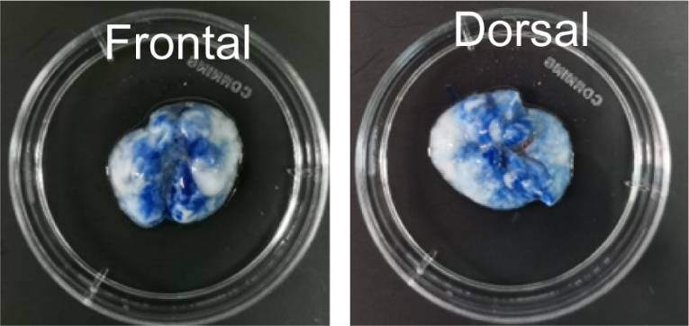
Fig. S40. Frontal and dorsal views of lung after nebulization administration of Evans blue.
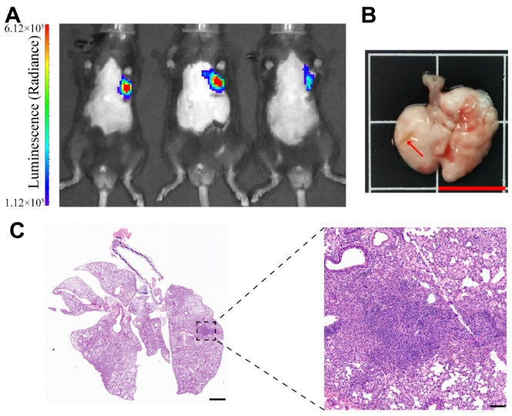
Fig. S41. (A) Bioluminescence images, (B) representative isolated lung (arrow indicates the pulmonary tumor; scale bar = 1 cm), and (C) representative H&E staining and enlarged view of LLC-Luc orthotopic tumors after 5 days of inoculation. Scale bar = 1 mm for left panel and 100 µm for right panel.
Fig. S42. The individual tumor growth curves of LLC-Luc orthoptic lung cancer mice after different treatments monitored by the IVIS system.
Fig. S43. The corresponding fluorescent intensity of immunofluorescence staining with antibody against 3-NT. ** denotes p < 0.01.
Fig. S44. The corresponding fluorescent intensity of immunofluorescence staining with antibody against GPX-4. *** denotes p < 0.001.

Fig. S45. The ratio of BODIPY(Ox)/BODIPY of different views. * and ** denote p <0.05 and p < 0.01, respectively.
Fig. S46. The corresponding fluorescent intensity of immunofluorescence staining with antibody against γ-H2AX. * and *** denote p < 0.05 and p < 0.001, respectively.
Fig. S47. Body weight changes of LLC-Luc orthoptic lung cancer mice after different treatments. Dotted line indicates body weight threshold (20% decrease) for humane endpoint.
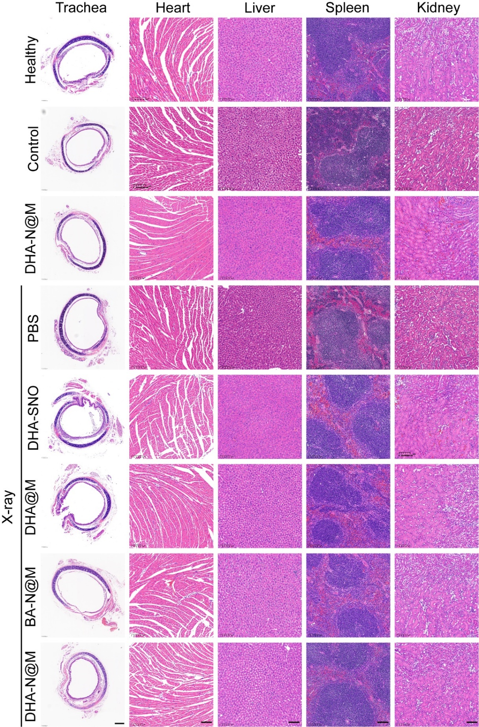
Fig. S48. H&E staining slices of trachea, heart, liver, spleen, lung, kidney of mice from each group at the end of experimentation; Scale bar = 200 μm for trachea images and 100 µm for other images.

