Supporting information

Oral Administration of Probiotic Spores-based Bioybrid System for Efficient Attenuation of Salmonella Typhimurium-Induced Colitis
Mengya Niu^{1,2#}, Luo Zhao^{1,2#}, Shuang Gong^{1,2}, Xinxin Liu^{1,2}, Jiannan Jiao^{1,2}, Fangfang Wang^{1,2}, Lei Wang^{1,2,3*}
¹School of Pharmaceutical Sciences, Zhengzhou University, Zhengzhou 450001, China.
²Henan Key Laboratory of Nanomedicine for Targeting Diagnosis and Treatment, Zhengzhou 450001, China.
³Tumor Immunity and Biomaterials Advanced Medical Center, Zhengzhou University, Luoyang 471009, China

Table S1. Determination of antimicrobial spectrum (MIC, μg/mL)
Bacteria Strains | PME | SC-Au NPs | PME-Au NPs
E. coli ATCC25922 | 1 | >64 | 0.5
S.typhimurium SL1344 | 1 | >64 | 0.5
Bacillus coagulans  S. aureus ATCC25922 | >64  >64 | >64  >64 | >64  >64

Figure S1. HPLC chromatogram of PME.

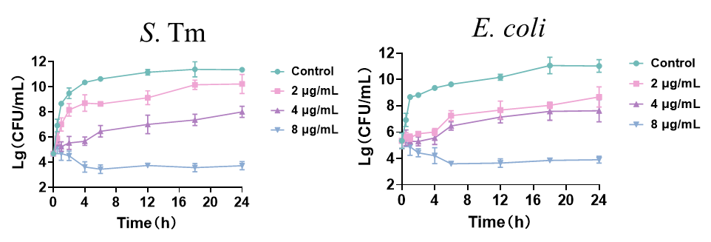
Figure S2. The bactericidal kinetic curve of PME with different concentrations to S. Tm and E. coli.

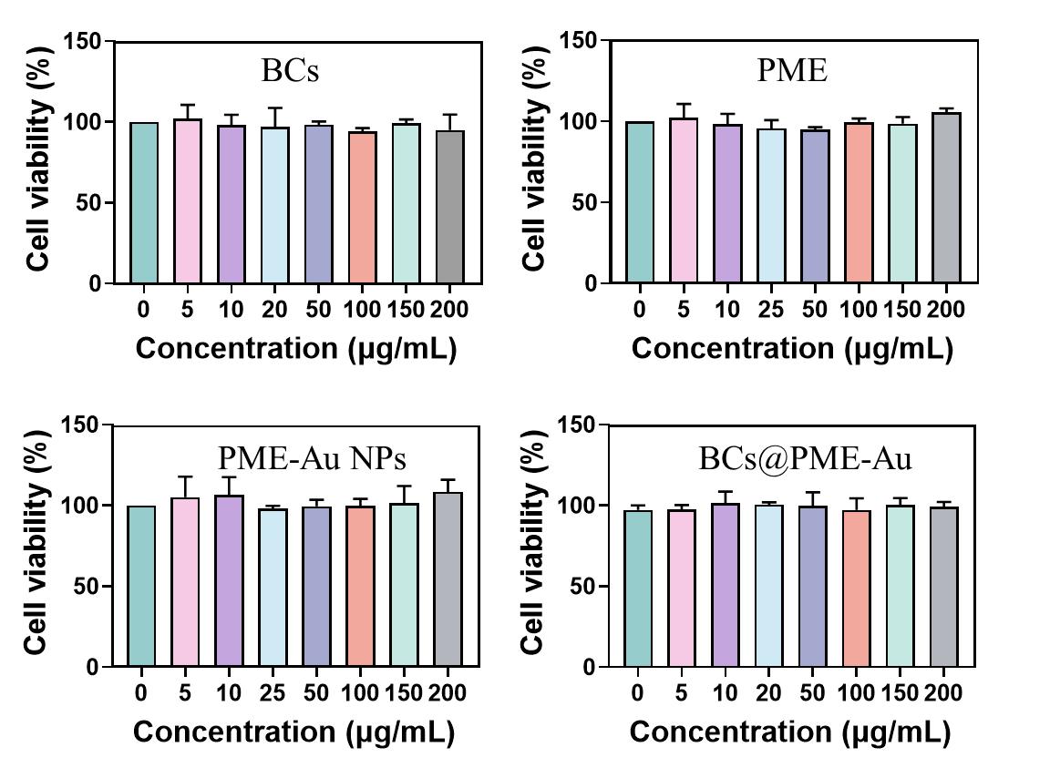
Figure S3. Caco-2 cell-based biocompatibility in BCs, PME, PME-Au NPs and BC_{S}@PME-Au groups.

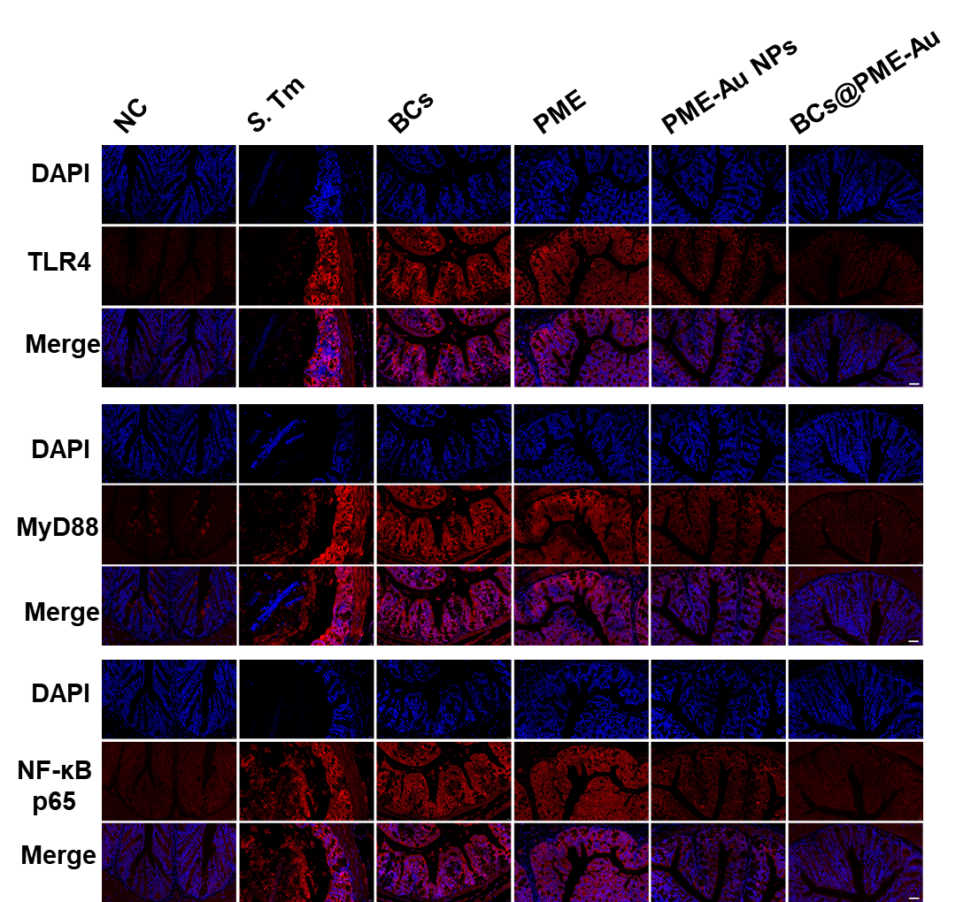
Figure S4. The representative immunofluorescence images of TLR4, MyD88 and NF-κB p65.

