Supporting information
The STING-activating Nanofactory Relieves T Cell Exhaustion in Mn-based Tumor Immunotherapy by Regulating Mitochondrial Dysfunction
Nana Chen, Yushan Yang, Limin Fan, Yanni Cai, Weimin Yin, Zichen Yang, Yuge Zhao, Shiyu Chen, Hui Zhi, Liangyi Xue, Xiaoyou Zhang, Lulu An, Yongyong Li*, Tianbin Ren*
The Institute for Biomedical Engineering & Nano Science, School of Medicine, Tongji University, Shanghai, 200092, China.
Corresponding author:
Tianbin Ren - The Institute for Biomedical Engineering & Nano Science, School of Medicine, Tongji University, Shanghai, 200092, China;
Email: rtb002@tongji.edu.cn

Figure S1. The encapsulation efficiency (EE) and drug loading efficiency (DL) of Mn and SPD in L@Mn@SPD.

Figure S2. The 4T1 cytotoxicity of L@Mn@SPD with different Mn:SPD molar ratios (A) and different Mn concentrations (B). (mean ± SD, *p < 0.05, **p < 0.01, ***p < 0.001)

Figure S3. Live/dead cell staining of 4T1 cells following various treatments showed red for dead cells and green for live cells. Scale bar: 1000 μm.

Figure S4. (A) Quantitative flow cytometry analysis of ROS in 4T1 cells after various treatments. (B) Representative immunofluorescence imaging of ROS in 4T1 cells after various treatments. Scale bar: 50 μM. (mean ± SD, *p < 0.05, **p < 0.01, ***p < 0.001)
Figure S5. The relative cellular viability of BMDC (A) and Jurkat cells (B) treated with PBS, MnCl₂, SPD and L@Mn@SPD, respectively.

Figure S6. (A) Flow cytometric plots of MHC II expression (gated on CD11c⁺ cells) in BMDC after different treatment. (B) Quantitative analysis of MHC II expression (gated on CD11c⁺ cells) in BMDC after different treatment. (mean ± SD, *p < 0.05, **p < 0.01, ***p < 0.001)

Figure S7. O₂ concentration in PBS, MnCl₂, and L@Mn solutions before and after SPD addition. (mean ± SD, *p < 0.05, **p < 0.01, ***p < 0.001)

Figure S8. H₂O₂ levels in 4T1 cells following treatment with different groups. (mean ± SD, *p < 0.05, **p < 0.01, ***p < 0.001)

Figure S9. (A) Flow cytometric plots of CD8⁺ T cell proliferation. (B) Quantitative analysis of CD8⁺ T cell proliferation. (mean ± SD, *p < 0.05, **p < 0.01, ***p < 0.001)

Figure S10. (A) The in vivo fluorescence images of tumor-bearing mice at different time points (B)The accumulation profiles of L@Dir in tumor sites after the intravenous injection of Dir and L@Dir. (mean ± SD, *p < 0.05, **p < 0.01)

Figure S11. Ex vivo images of major organs and tumors from the mice administered with Dir and L@Dir.

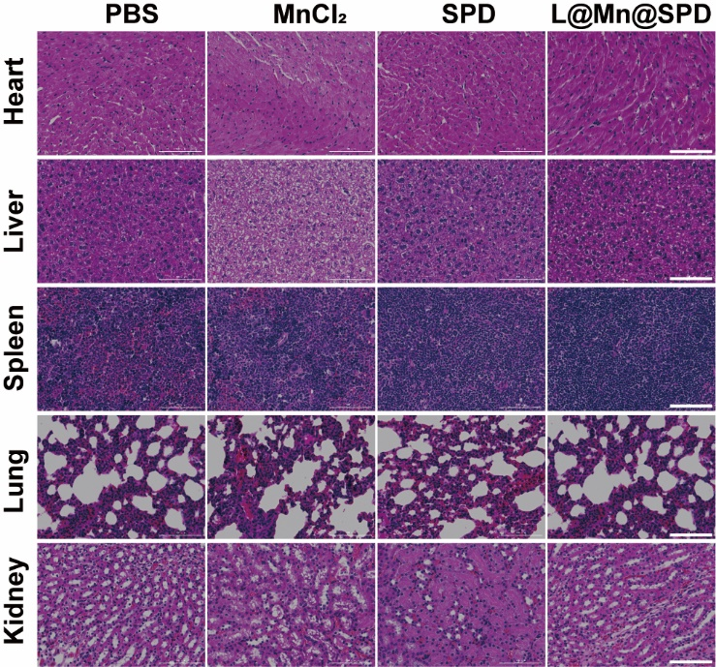
Figure S12. The H&E staining of the major organs (scale bar: 100 μm).

Figure S13. Detection of serum biochemical index (e.g., ALT, AST, CR)
Figure S14. (A) TNF-α and (B) IL-6 in the tumors. (mean ± SD, *p < 0.05, **p < 0.01, ***p < 0.001)

Figure S15. (A) Representative flow cytometry results of Treg (CD3⁺CD4⁺Foxp3⁺) cells and (B) quantitative analysis in tumor tissues.

Figure S16. Representative flow cytometry results of MDSC (CD11b⁺Gr-1⁺) in the spleen.

Figure S17. Heat map of changed genes in mitochondrial gene expression pathway based on GO annotation.

Figure S18. Heat map of the genes of the selected enrichment pathway (show in Figure 8F) based on KEGG analysis

Table S1. Statistical table of transcriptome sequencing analysis results
Sample | Clean reads | Mapping rate | Total gene number
Control 1 | 44,947,372 | 95.29% | 16618
Control 2 | 47,083,066 | 95.31% | 16173
Control 3 | 49,415,748 | 94.80% | 16461
Test 1 | 50,102,020 | 95.19% | 16753
Test 2 | 49,393,064 | 95.46% | 16693
Test 3 | 49,227,204 | 95.13% | 17492

