Supplementary Material
Materials and methods
Materials
Ferrous acetate (Fe(CO₂CH₃)₂), glacial acetic acid, hydrogen peroxide (H₂O₂), 5,5-dimethyl-1-pyrroline N-oxide (DMPO), and glutathione (GSH) were purchased from Aladdin Industrial Corporation (Shanghai, China). Dimethyl sulfoxide (DMSO), sodium hydroxide (NaOH), NaCl, and methanol were obtained from Sinopharm Chemical Regent Co., Ltd (Shanghai, China). 2,3,6,7,10,11-hexahydroxytriphenylene (HTP) was purchased from Shanghai Dibo Biotechnology Co., Ltd. Peptone, yeast extract, and agar were purchased from Thermo Fisher Scientific (Oxoid).

Characterization
The size and zeta potential of FeNZ were measured by Zetasizer Nano ZS90 (Malvern). The morphology was observed by transmission electron microscope (TEM; FEI Tecnai F20) and high-resolution transition electron microscopy (HRTEM; FEI-Talos F200X). Fe 2p spectra were analyzed by X-ray photoelectron spectroscopy (XPS; Thermo Scientific ESCALAB Xi+). The Fe content of FeNZ was determined to be 18.39% using an inductively coupled plasma spectrometer (ICP; Agilent ICPOES 730). A microplate spectrophotometer (PerkinElmer VICTOR NIVO) was used to record the absorption spectra and absorbance.

Glutathione peroxidase (GSH-Px)-like activity
The GSH-Px-like activity of FeNZ was assessed with commercial GSH and GSSG Assay Kit (Beyotime Biotechnology) according to the manufacturer’s instructions. Briefly, FeNZ dispersions (0, 0.5, 1 mg mL⁻¹) were mixed with GSH (10 mM) in a total reaction volume of 1 mL, and reacted at room temperature for 10 min. The supernatants were collected and used for test.

DAPI/PI fluorescence staining of bacteria
To visually demonstrate the antibacterial activity of FeNZ with or without H₂O₂, DAPI and PI staining were chosen to mark bacterial cells. In a total reaction volume of 1 mL, the bacteria were divided into four groups: (I) control; (II) 100 μM H₂O₂; (III) 12.5 μg mL⁻¹ FeNZ; (IV) 12.5 μg mL⁻¹ FeNZ + 100 μM H₂O₂. After treated for 1.5 h at 37℃, the bacteria were washed with PBS for three times and dyed separately with DAPI (2 μg mL⁻¹) and PI (5 μg mL⁻¹) in a dark environment for 30 min at 37 ℃. Then the samples were centrifuged, washed, and resuspended in PBS. The confocal microscope (Nikon) and flow cytometry (BD) were used to observe and detect stained dead bacteria.

Intracellular oxidative stress
The intracellular GSH/GSSG ratio was measured by GSH and GSSG Assay Kit with bacterial precipitates. To determine the level of intracellular ROS and O₂·⁻, bacteria with different treatments were incubated with fluorescent probe 2,7-dichlorofluorescein diacetate (DCFH-DA, 2 μg mL⁻¹) or dihydroethidium (DHE, 2 μg mL⁻¹) at 37 ℃ for 30 min. Samples were detected with flow cytometry.

Determination of intracellular ROS levels
L929 cells were seeded at 2 × 10⁵ cells per well in 6-well plates. After culture for 24 h, 2 mL fresh media with different treated nanoparticles (100 μg mL⁻¹) were added and cultured with cells for 12 h at 37 ℃. Then the L929 cells were incubated with 10 μM 2′,7′-dichlorofluorescin diacetate (DCFH-DA) for 30 min, and then washed gently with PBS for three times. At last, intracellular DCF fluorescence was imaged using a fluorescence spectrophotometer (Olympus IX73 microscope). The untreated cells served as the control.

Determination of GSH content in vivo
Female Balb/c mice (8 weeks, ~ 20 g, n = 5) were purchased from Beijing Vital River Laboratory Animal Technology Company. Wounds (diameter of 1 cm) were established by surgical procedure on the back of the mice after anesthesia. The wounds were inoculated subcutaneously with S. aureus (1 × 10⁶ CFUs) for 12 h. Afterward, the wounds were washed with 50 µL of PBS buffer, and all exudate was collected. Concurrently, the surface matrix and mucosa of the wound were scraped, homogenized together, and then centrifuged at 10000 g for 10 min to obtain the supernatant. The GSH concentration in the supernatant was measured using a GSH Assay Kit (Beyotime Biotechnology).

Promoting oxidation in vivo
Female Balb/c mice (8 week, ~20 g, n = 20) were purchased from Beijing Vital River Laboratory Animal Technology Company. All mice were randomly divided into four groups: (I) control; (II) FeNZ-h (20 μg mL⁻¹); (III) FeNZ (20 μg mL⁻¹); (IV) FeNZ-l (20 μg mL⁻¹), and injected with 100 μL dispersions at different positions on the back at regular intervals according to different groups. The day of the first injection was defined as day 0. The control group was directly injected subcutaneously with 100 μL PBS. All the mice were sacrificed on day 4 and the wound skin tissues were collected for immunohistochemical (DHE), immunofluorescence staining (TNF-α and IL-6) and ELISA analysis. Skin tissues were homogenized in 1 ml of RIPA containing protease inhibitor, and then subjected to centrifugation (5000 g, 10 min) at 4°C. Then, the supernatant was retained, and the TNF-α and IL-6 levels were quantified using commercial enzyme-linked immunosorbent assay (ELISA) kits (Elabscience).

Supplementary Figures
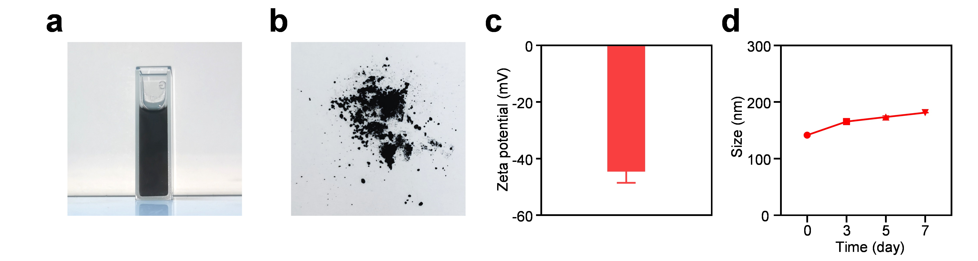
Fig. S1. (a) Dispersion of FeNZ in deionized water. (b) The image shows FeNZ as a black powder. (c) Zeta potential of FeNZ. (e) Hydrodynamic size of FeNZ within 7 days.

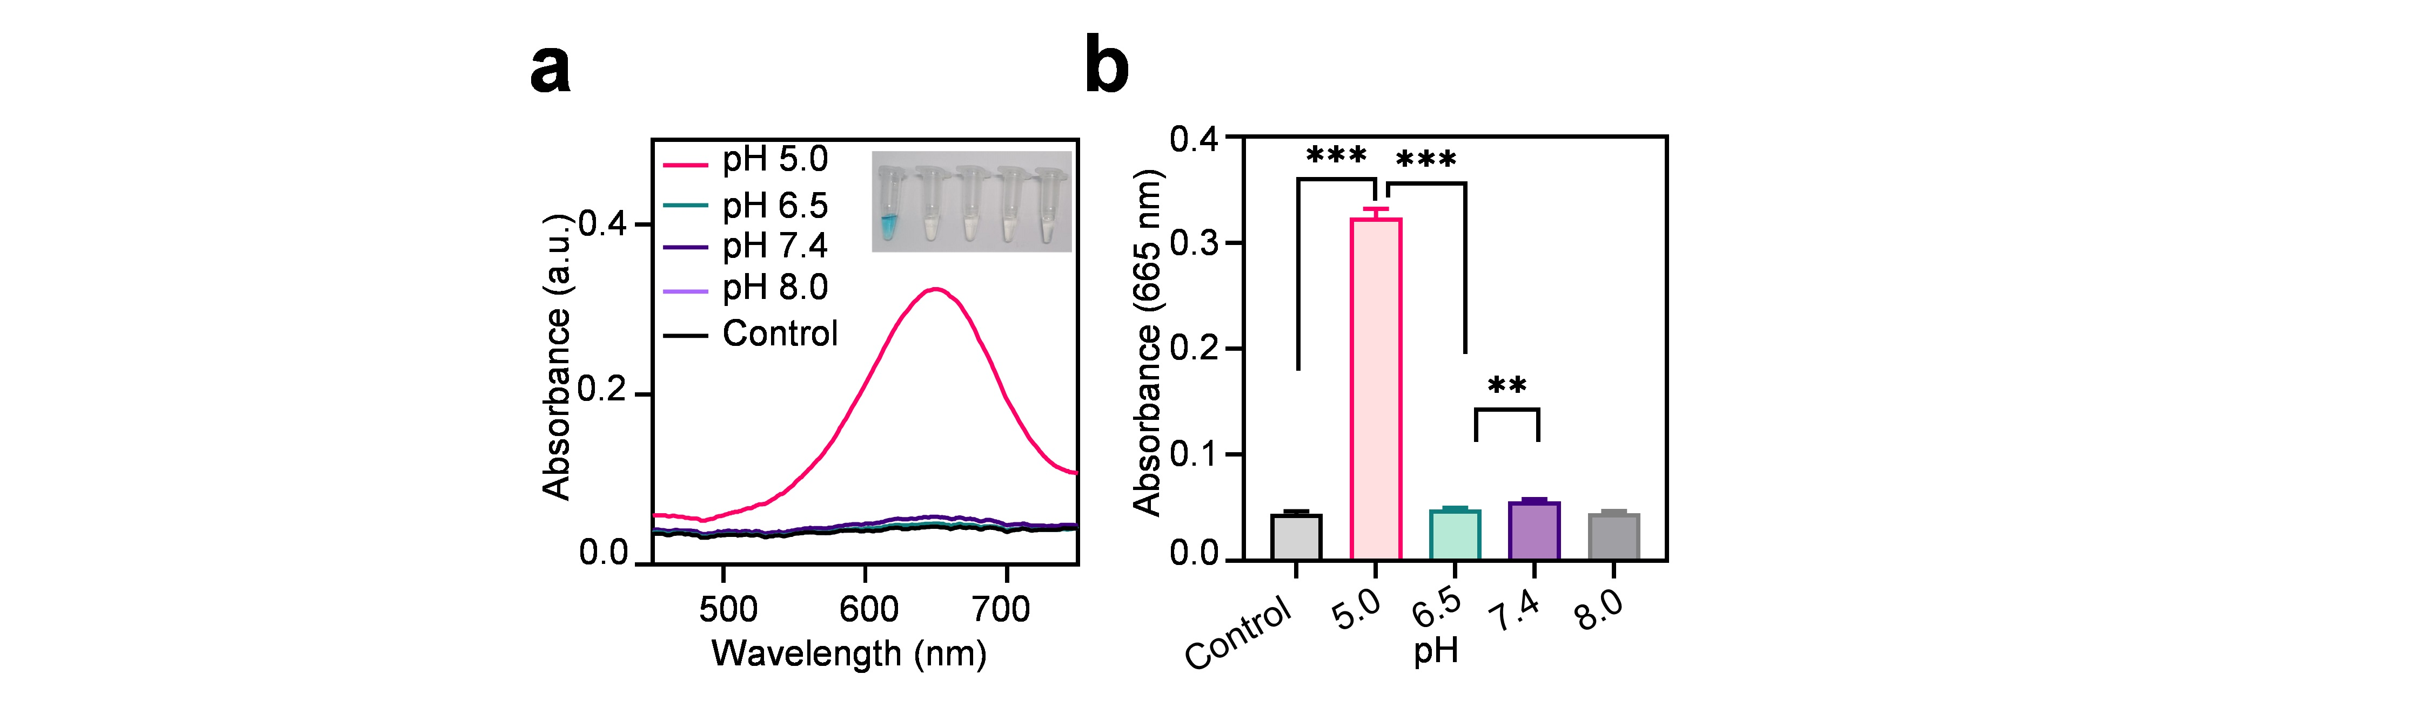
Fig. S2. •OH generated by FeNZ and H₂O₂ under different pH conditions (TMB spectrophotometer assay). Statistical significances were denoted as **p < 0.01, ***p < 0.001.

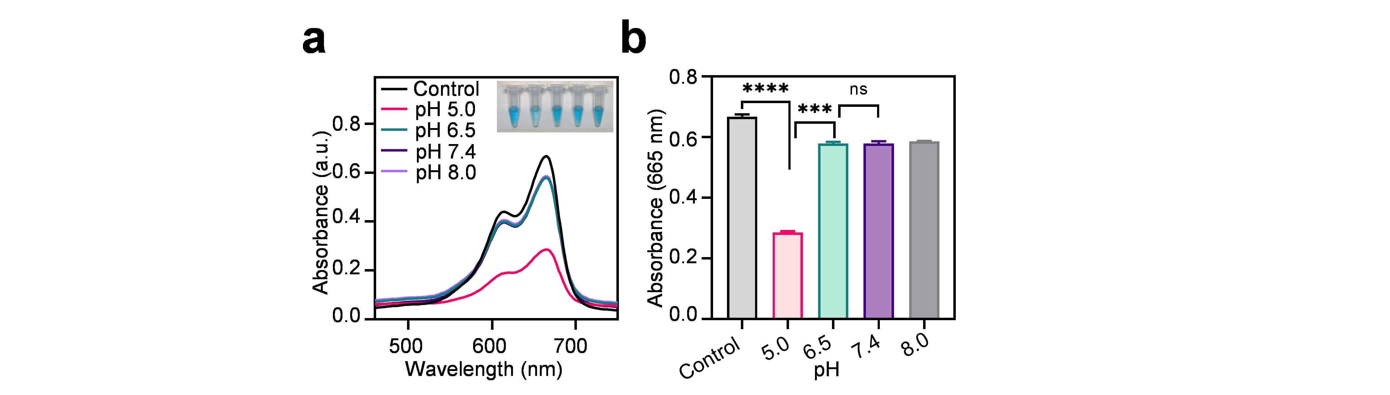
Fig. S3. •OH generated by FeNZ and H₂O₂ under different pH conditions (MB spectrophotometer assay). Statistical significances were denoted as ***p < 0.001, ****p < 0.0001, ns, not signiﬁcant.

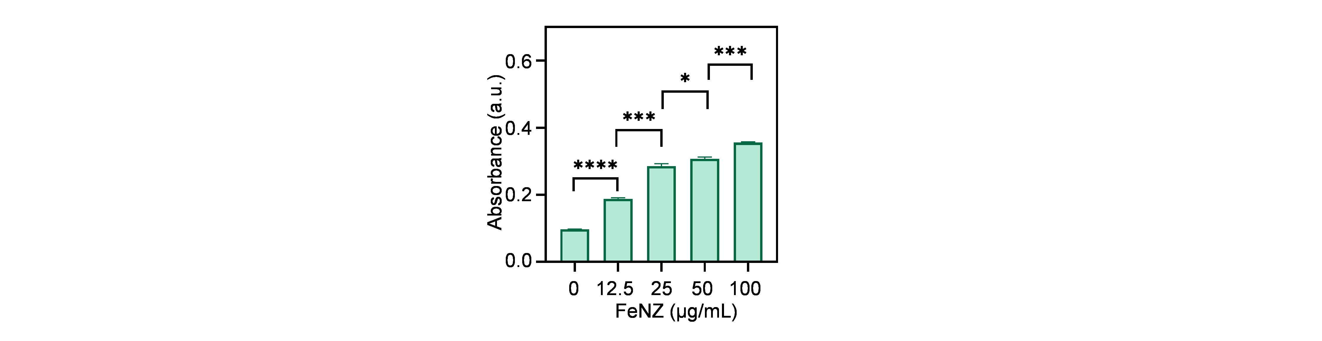
Fig. S4. Concentration-dependent oxidase-mimic activity of FeNZ at pH 5.0. Statistical significances were denoted as *p < 0.05, ***p < 0.001, ****p < 0.0001.

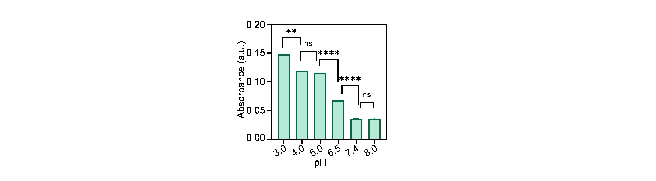
Fig. S5. •OH generated by FeNZ (100 µg mL⁻¹) under different pH conditions. Statistical significances were denoted as **p < 0.01, ****p < 0.0001, ns, not signiﬁcant.

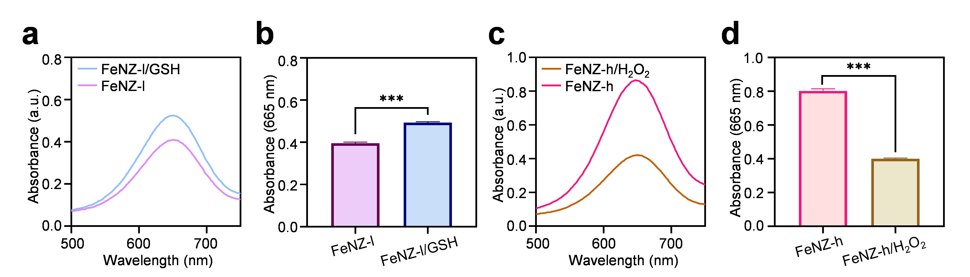
Fig. S6. (a, b) The POD-like catalytic activity of FeNZ-l after treating with GSH (10 mM, 2 h) at pH 5.0. (c, d) The POD-like catalytic activity of FeNZ-h after treating with H₂O₂ (10 mM, 2 h) at pH 5.0. The FeNZ-l treated with GSH is named FeNZ-l/GSH, and the FeNZ-h treated with H₂O₂ is named FeNZ-h/H₂O₂. Statistical significances were denoted as ***p < 0.001.

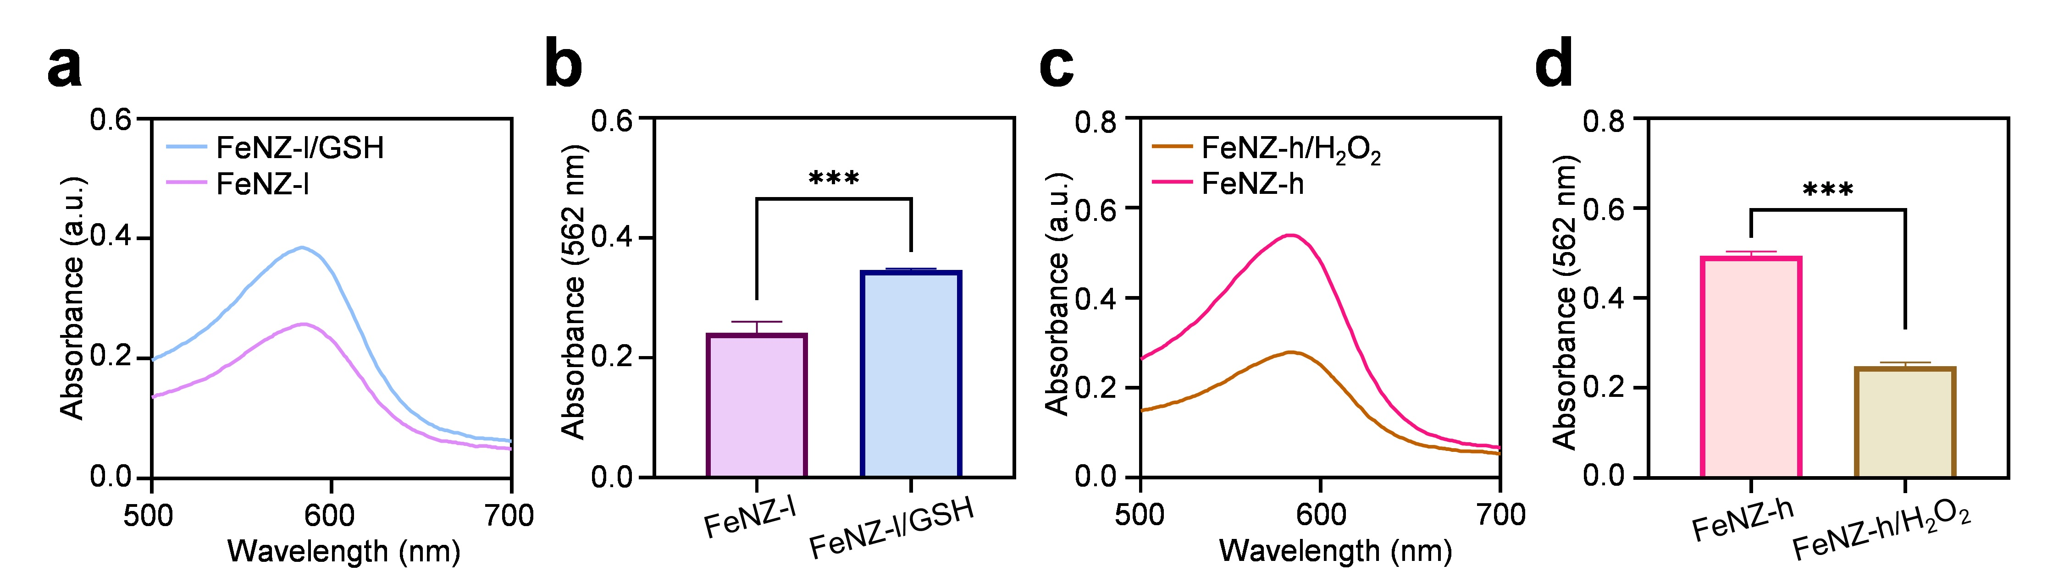
Fig. S7. (a, b) The oxidase activity of FeNZ-l after treating with GSH (10 mM, 2 h) at pH 5.0. (c, d) The oxidase activity of FeNZ-h after treating with H₂O₂ (10 mM, 2 h) at pH 5.0. The FeNZ-l treated with GSH is named FeNZ-l/GSH, and the FeNZ-h treated with H₂O₂ is named FeNZ-h/H₂O₂. Statistical significances were denoted as ***p < 0.001.

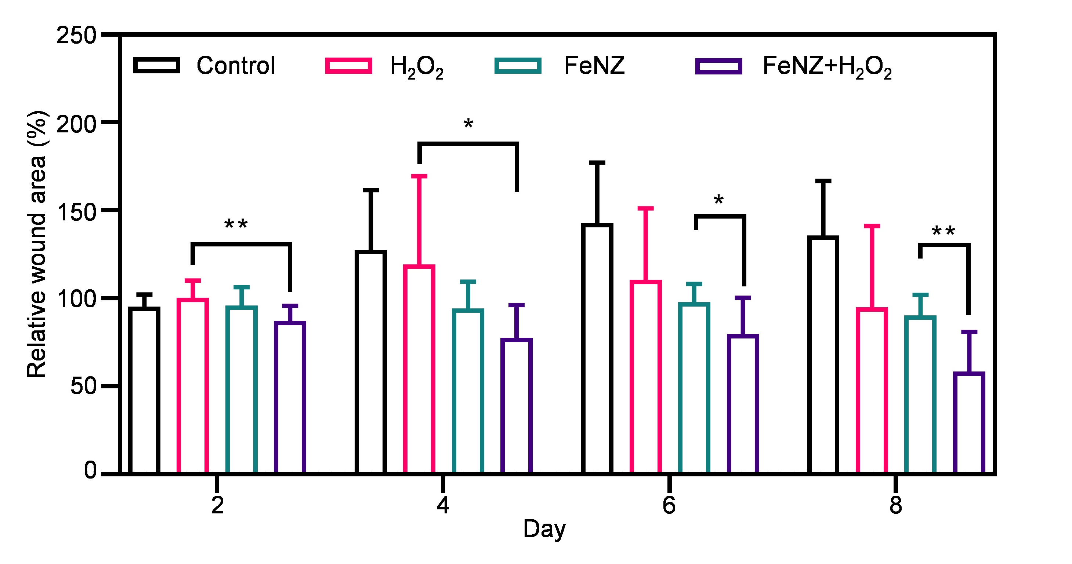
Fig. S8. Relative wound area in early stage. Statistical significances were denoted as *p < 0.05, **p < 0.01.

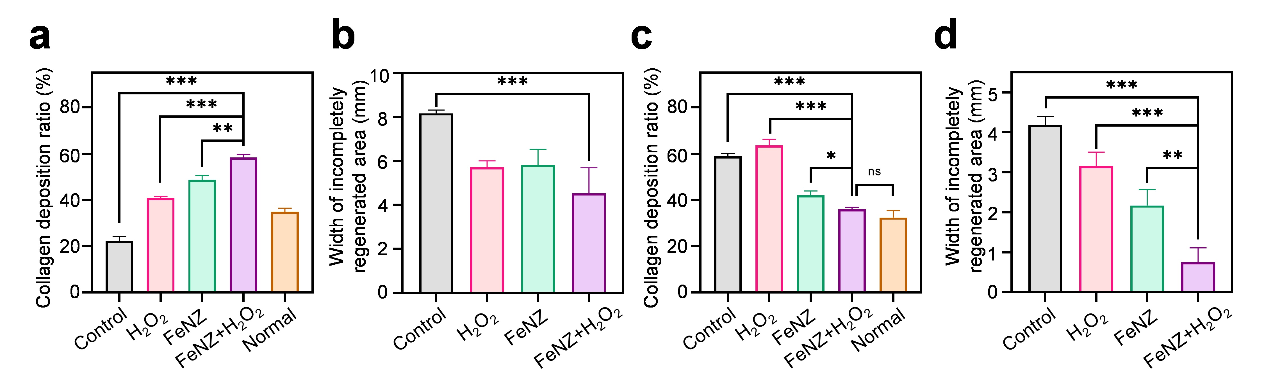
Fig. S9. Quantitative analysis of collagen deposition in the wound area and the width of incompletely regenerated area on (a, b) day 16 and (c, d) day 23. Statistical significances were denoted as **p < 0.01, ***p < 0.001, ns, not signiﬁcant.

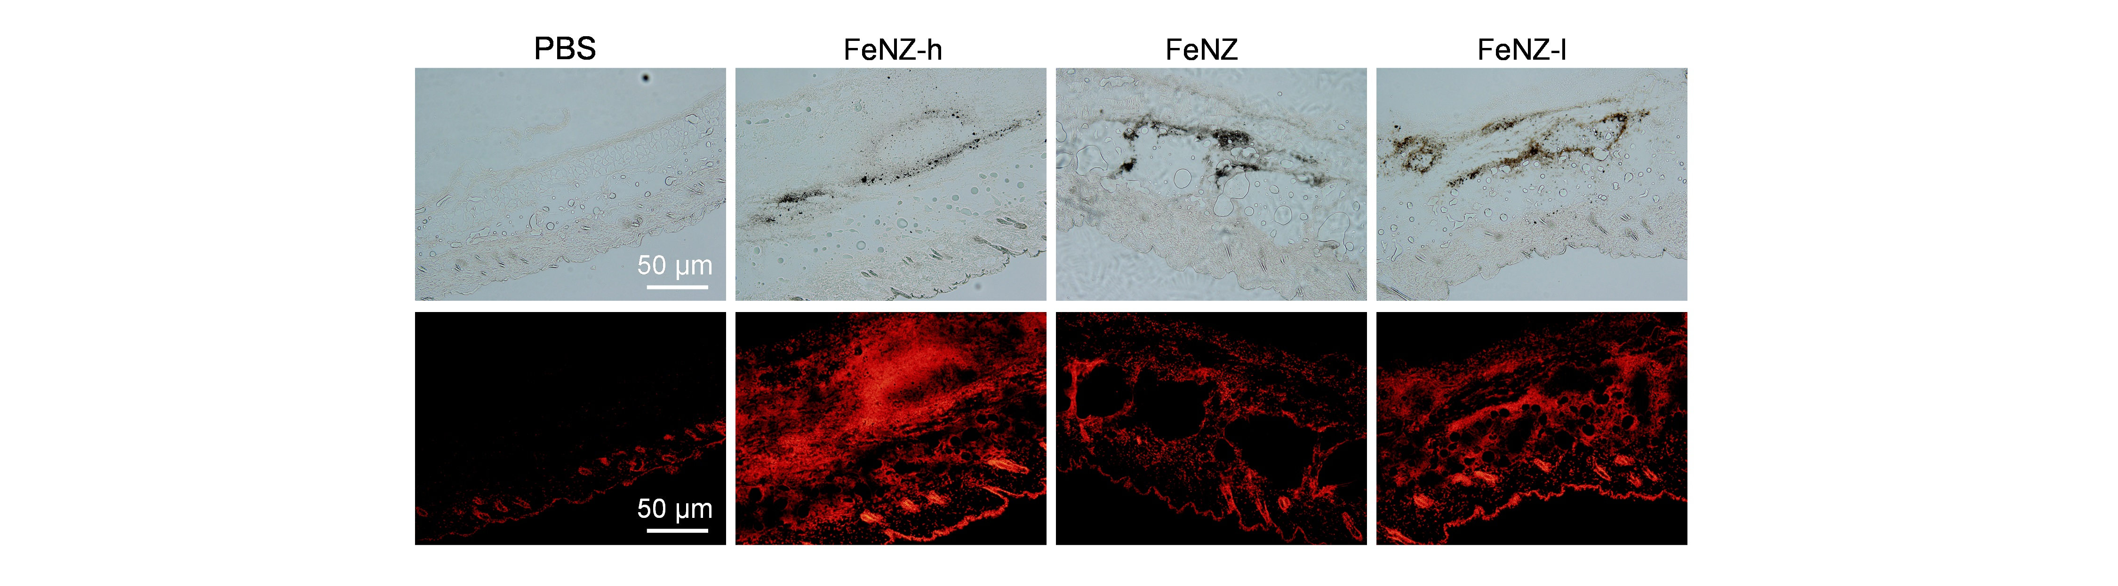
Fig. S10. DHE staining images of skin tissues treated for 24 h.

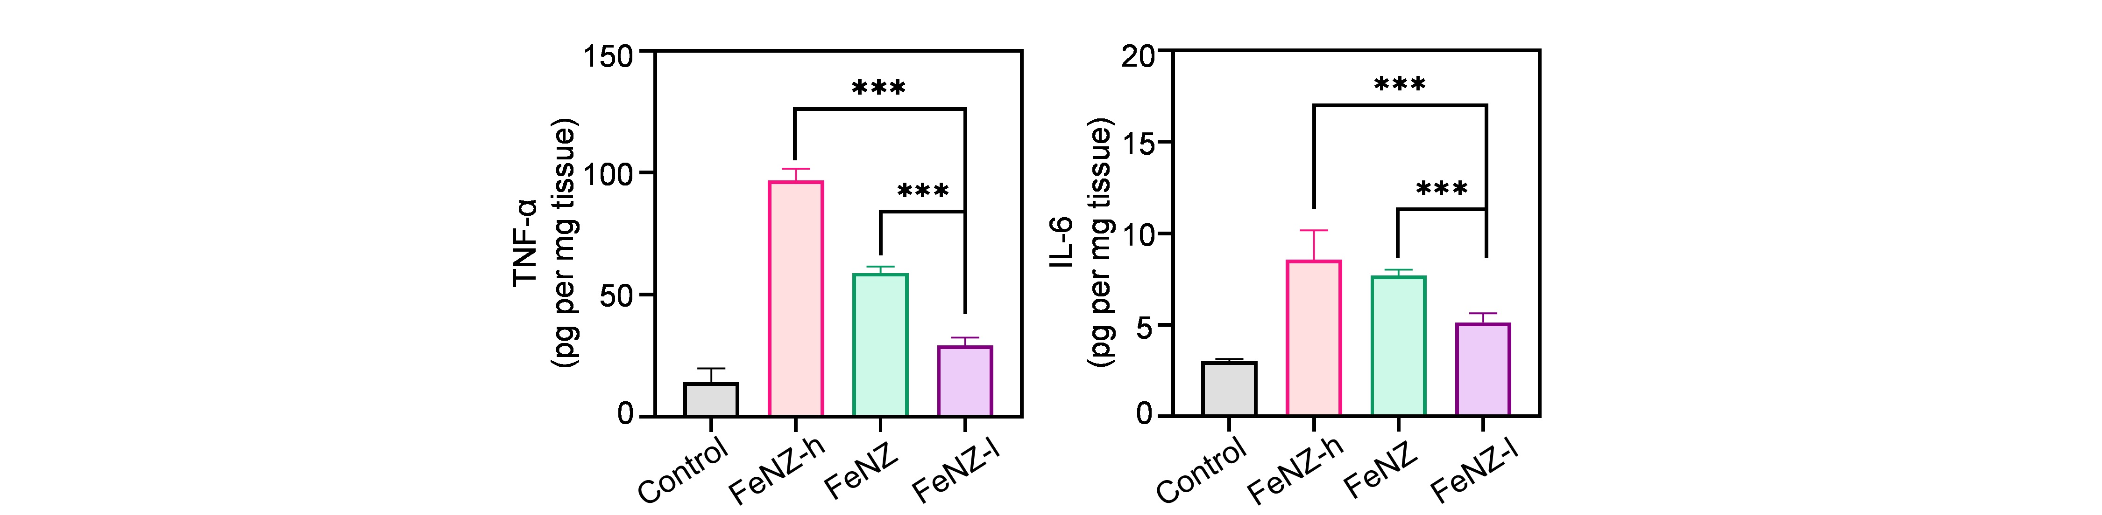
Fig S11. (a) TNF-α and (b) IL-6 levels in the collected skin tissues determined by ELISA analysis.

