Supplementary Information

A self-adhesive hierarchical nanofiber patch for dynamic and multistage management of full-thickness cutaneous wounds

Lihuang Wu¹, Yuqi Wang¹, Xinyue Zhao¹, Tingting Zhao¹, Junhua Li¹, Yi Kuang², Yiyan He^{1*}, Shengxiang Yang^{2*}, Zhongwei Gu¹, and Hongli Mao^{1*}

¹Research Institute for Biomaterials, Tech Institute for Advanced Materials, Bioinspired Biomedical Materials & Devices Center, College of Materials Science and Engineering, Jiangsu Collaborative Innovation Center for Advanced Inorganic Function Composites, Suqian Advanced Materials Industry Technology Innovation Center, Nanjing Tech University, Nanjing 211816, China
²College of Chemical and Materials Engineering, Zhejiang A&F University, Lin’an 311300, China
*Correspondence: h.mao@njtech.edu.cn (Hongli Mao), shengxiangyang2000@163.com (Shengxiang Yang), yiyanhe@njtech.edu.cn (Yiyan He)

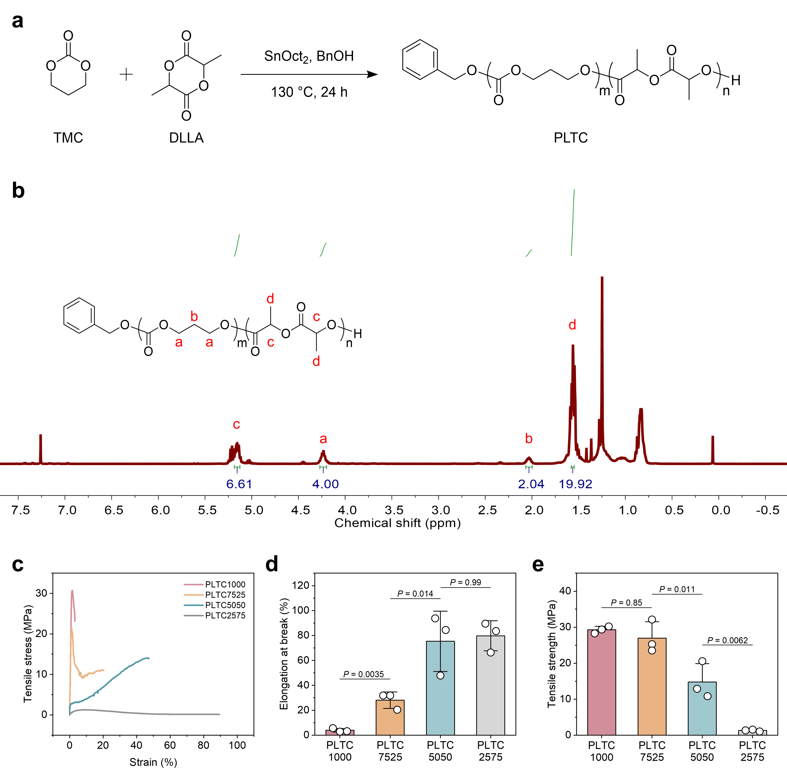
Fig. S1 Synthesis and characterization of poly(lactide-co-trimethylene carbonate) (PLTC). (a) Synthetic route of PLTC. (b) Representative ¹H NMR spectrum of PLTC. (c) Tensile curves, (d) elongation at break, and (e) tensile strength of PLTC at different ratios. Statistical analysis was performed using a one-way ANOVA followed by Tukey post-hoc analysis.

Table S1 Characterization of PLTC.
Polymer | Feed, LA/TMC  (mol/mol) | Product, LA/TMC  (mol/mol) | M_{n}  (kDa) | M_{w}  (kDa) | Đ_{M}  (M_{w}/M_{n})
PLTC1000 | 100/0 | 100/0 | 120 | 227 | 1.89
PLTC7525 | 75/25 | 78/22 | 117 | 216 | 1.86
PLTC5050 | 50/50 | 53/47 | 114 | 213 | 1.87
PLTC2575 | 25/75 | 24/76 | 135 | 256 | 1.90

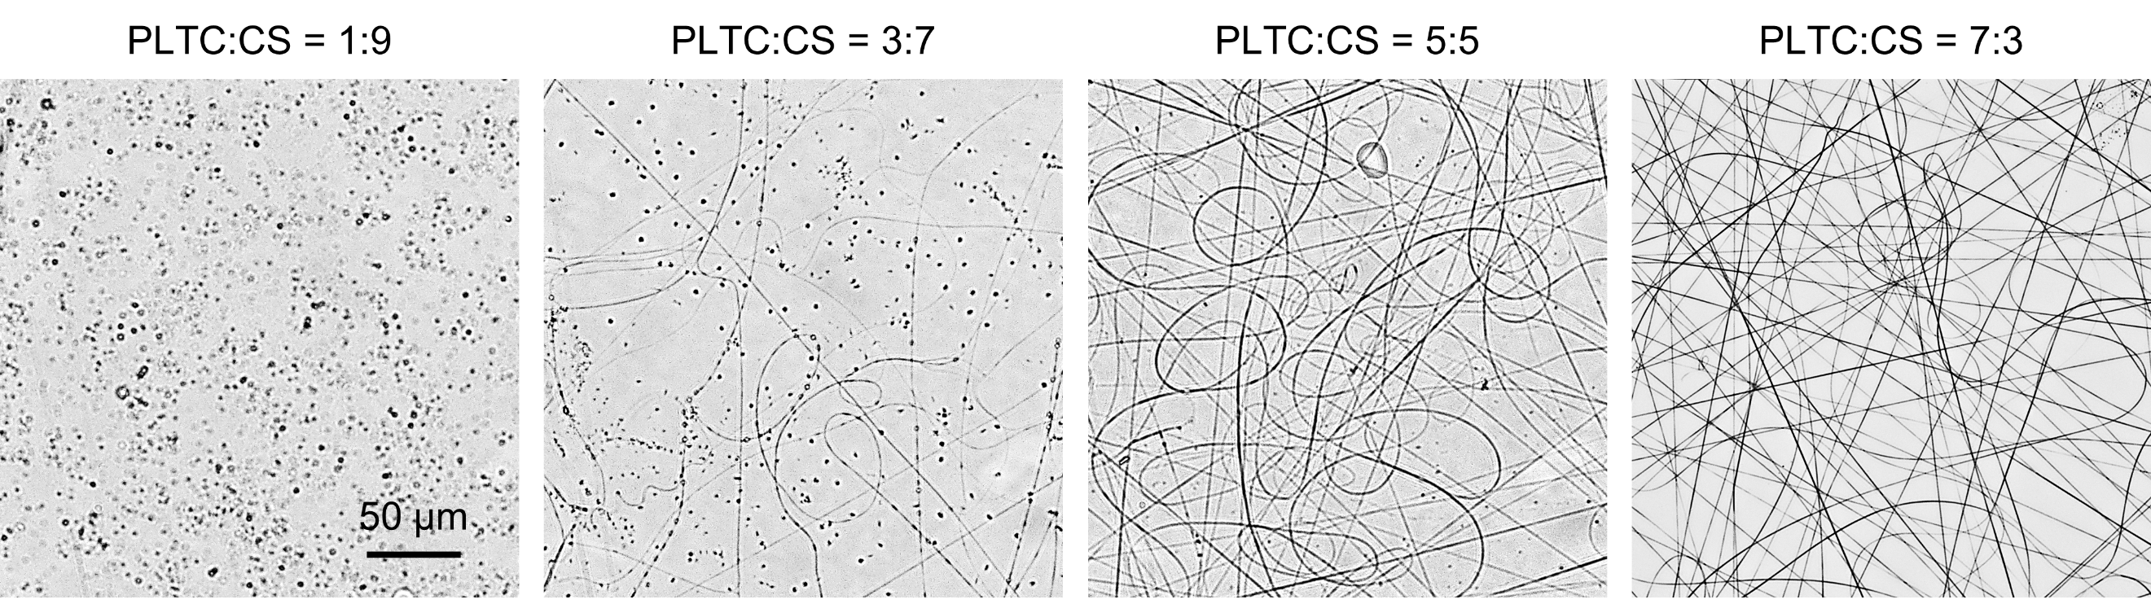
Fig. S2 Electrospun morphologies of PLTC and chitosan (CS) composite materials (PLTC/CS) at different volume ratios (PLTC = 7% w/v and CS = 3.5% w/v).

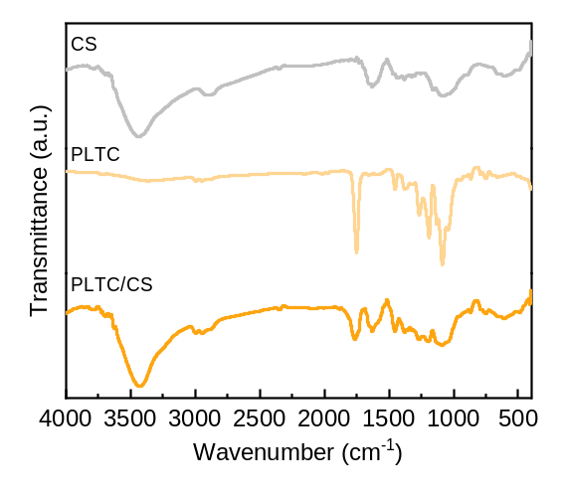
Fig. S3 Fourier transform infrared (FT-IR) spectra of CS, PLTC, and PLTC/CS. Key vibrational bands are indicated as follows: 𝜈_{OH} and 𝜈_{NH} at 3430 cm⁻¹, 𝜈_{C=O} at 1752 cm⁻¹, and 𝛿_{NH} at 1630 cm⁻¹.
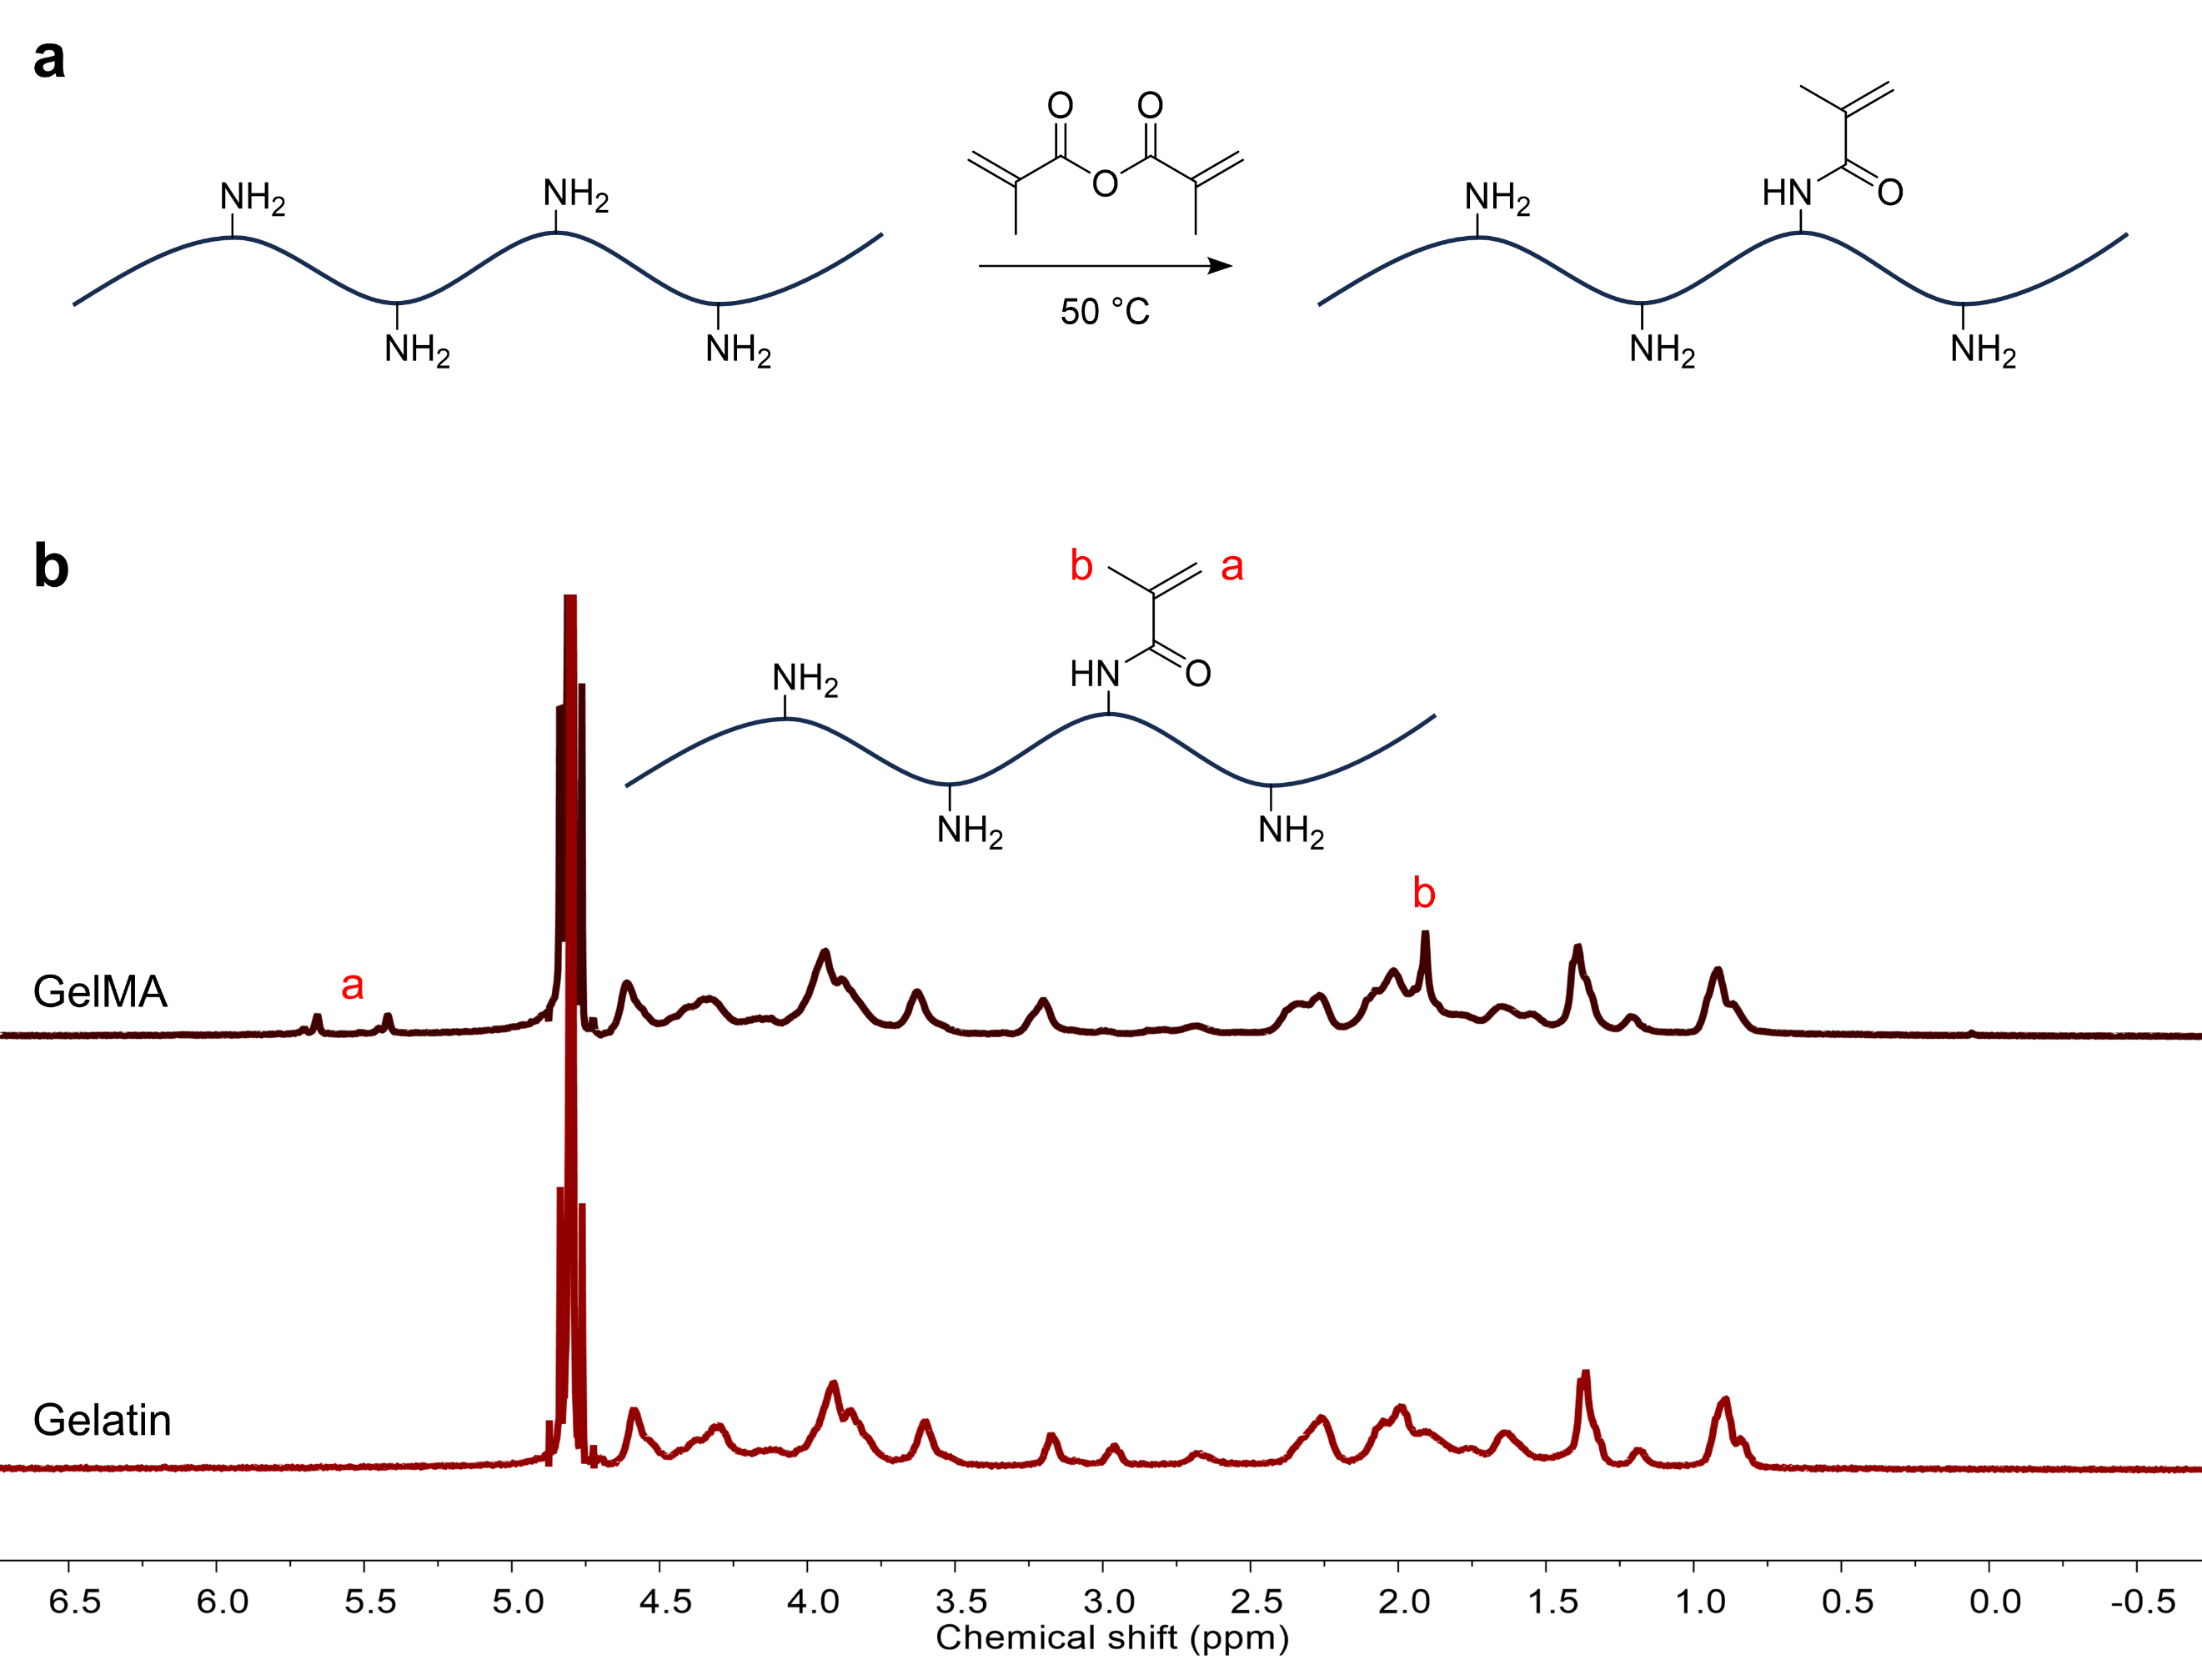
Fig. S4 Synthesis and characterization of methacrylate gelatin (GelMA). (a) The synthetic route of GelMA. (b) ¹H NMR spectra of GelMA and gelatin.

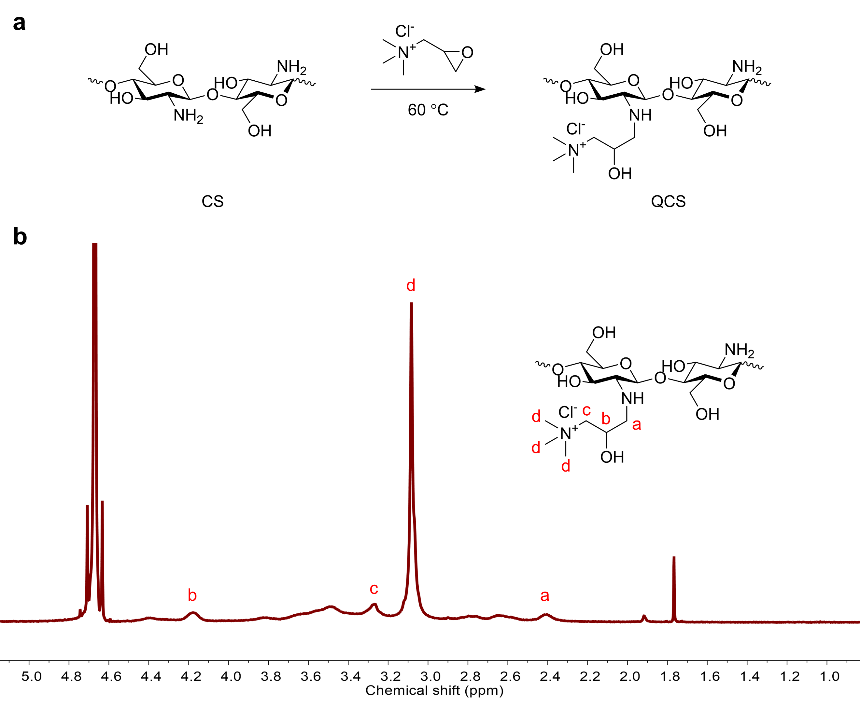
Fig. S5 Synthesis and characterization of quaternized chitosan (QCS). (a) The synthetic route of QCS. (b) ¹H NMR spectrum of QCS.

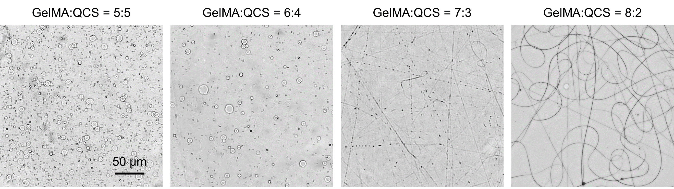
Fig. S6 Electrospun morphologies of GelMA and QCS composite materials (GelMA/QCS) at different volume ratios (GelMA = 15% w/v and QCS = 3% w/v).

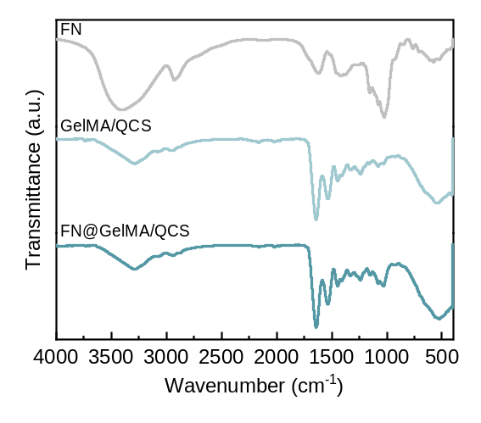
Fig. S7 FT-IR spectra of flavonoid (FN), GelMA/QCS, and FN-loading GelMA/QCS (FN@GelMA/QCS). Key vibrational bands are indicated as follows: 𝜈_{OH} at 3406 cm⁻¹, 𝜈_{NH} at 3286 cm⁻¹, 𝛿_{NH} at 1641 cm⁻¹, 𝜈_{C=C} at 1618 cm⁻¹, and 𝜈_{C-O} at 1025 cm⁻¹.

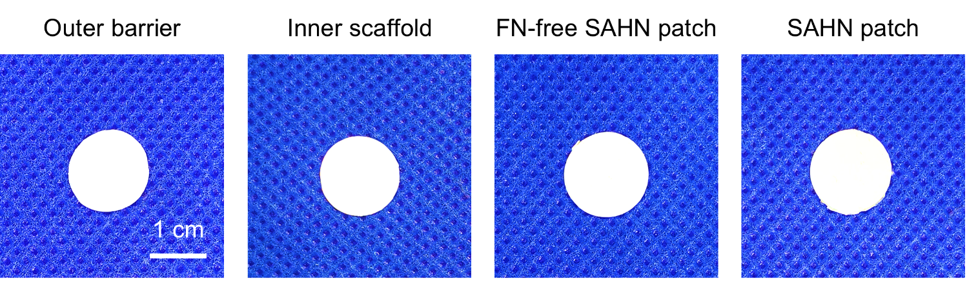
Fig. S8 Macroscopic photographs of the SAHN patch and its individual components.

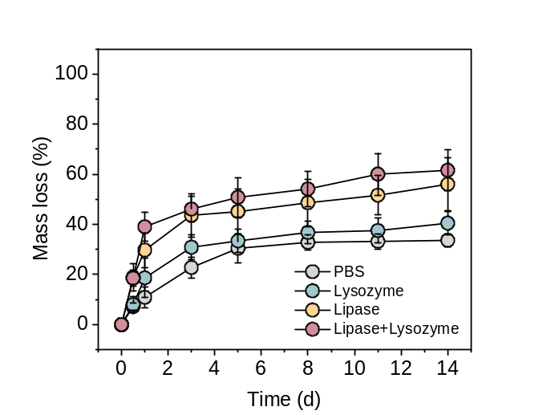
Fig. S9 The degradation of outer barrier (PLTC/CS) in different conditions.

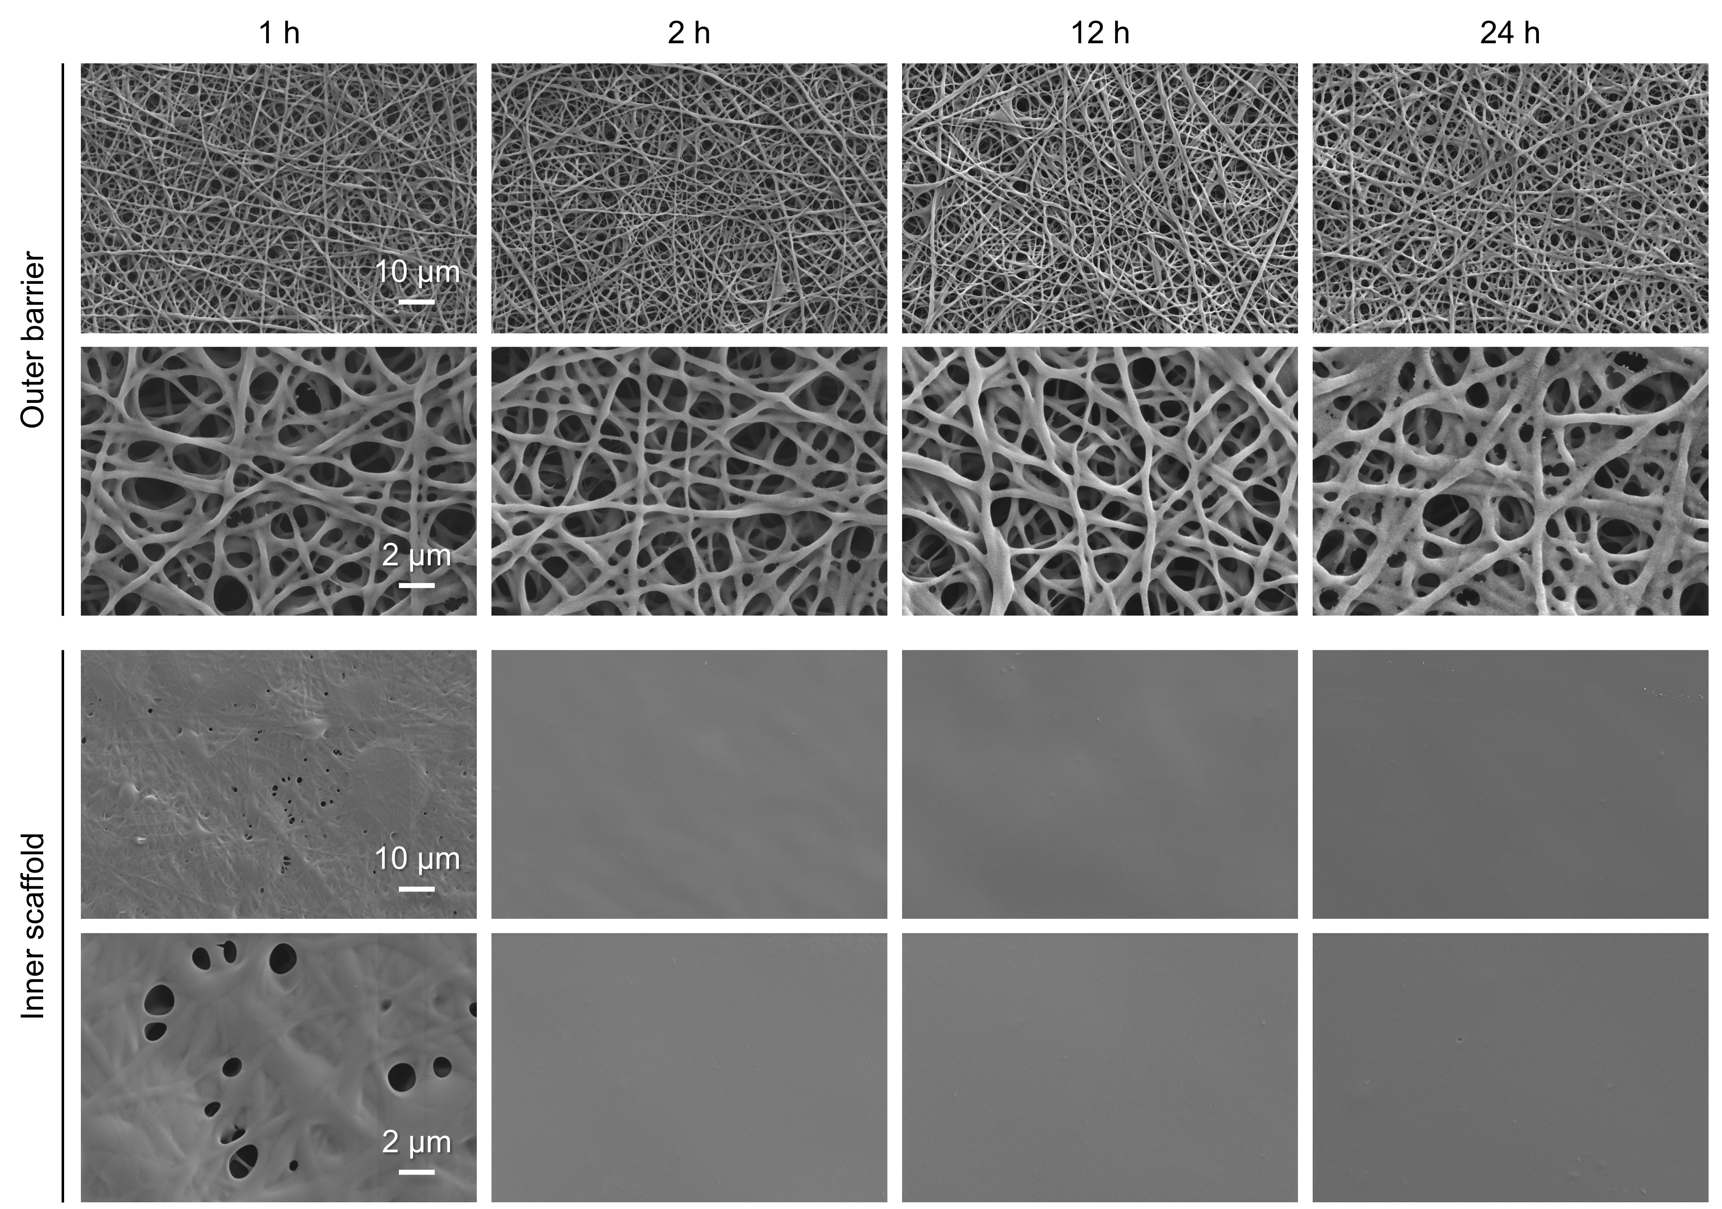
Fig. S10 SEM images of both layers of the SAHN patch under PBS incubation.

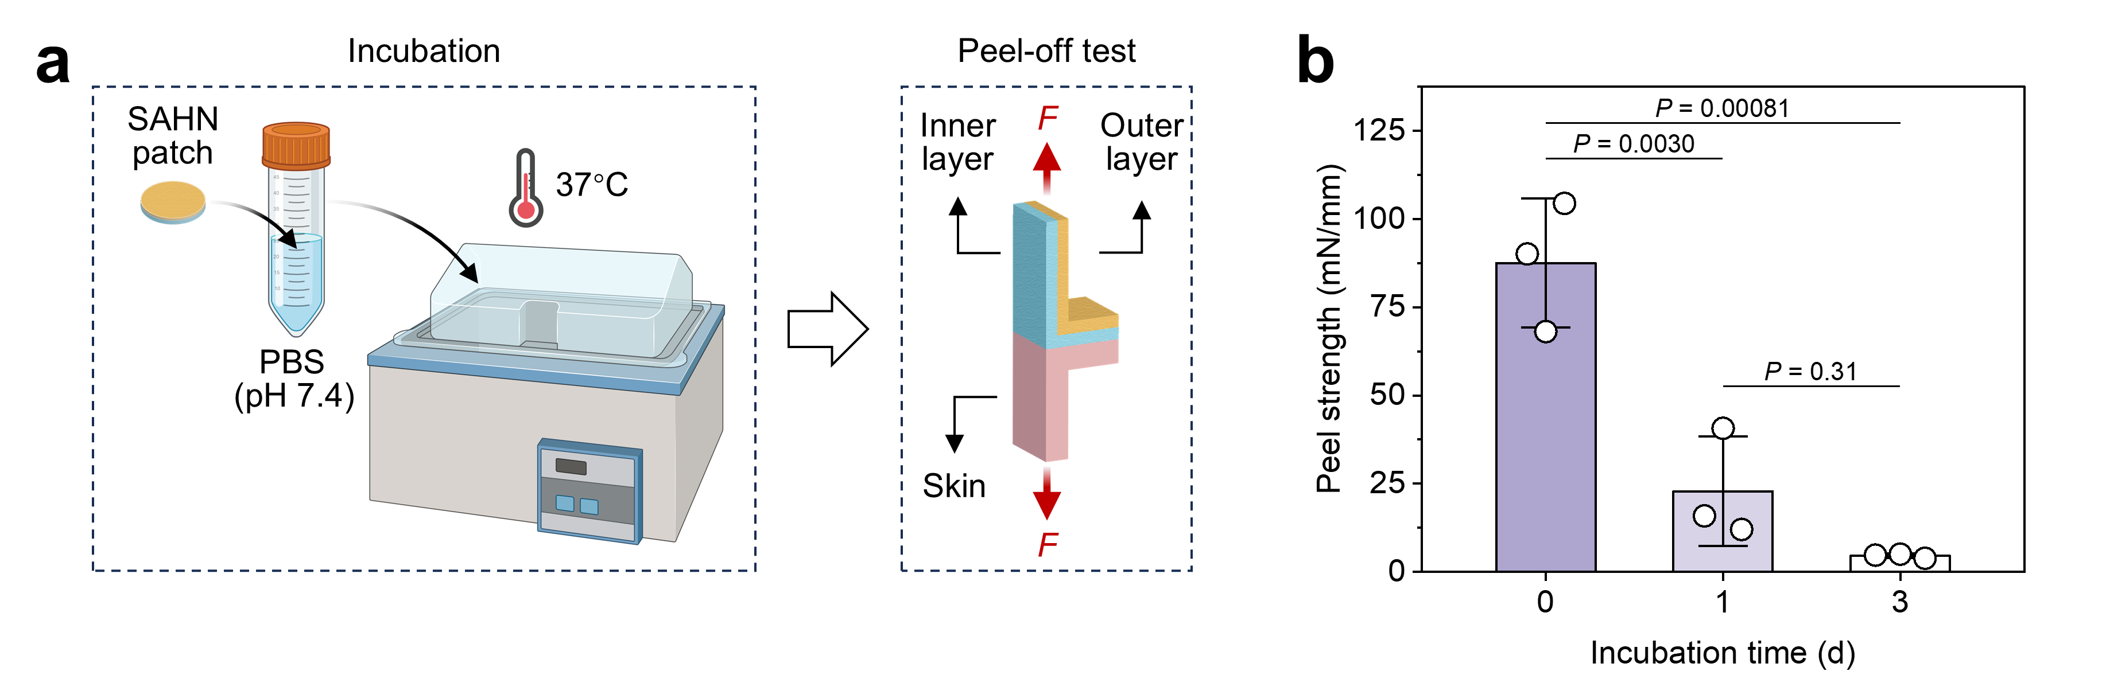
Fig. S11 (a) Schematic illustration of the adhesion-testing protocol for the SAHN patch after hydration and degradation. (b) The variation in peel strength.

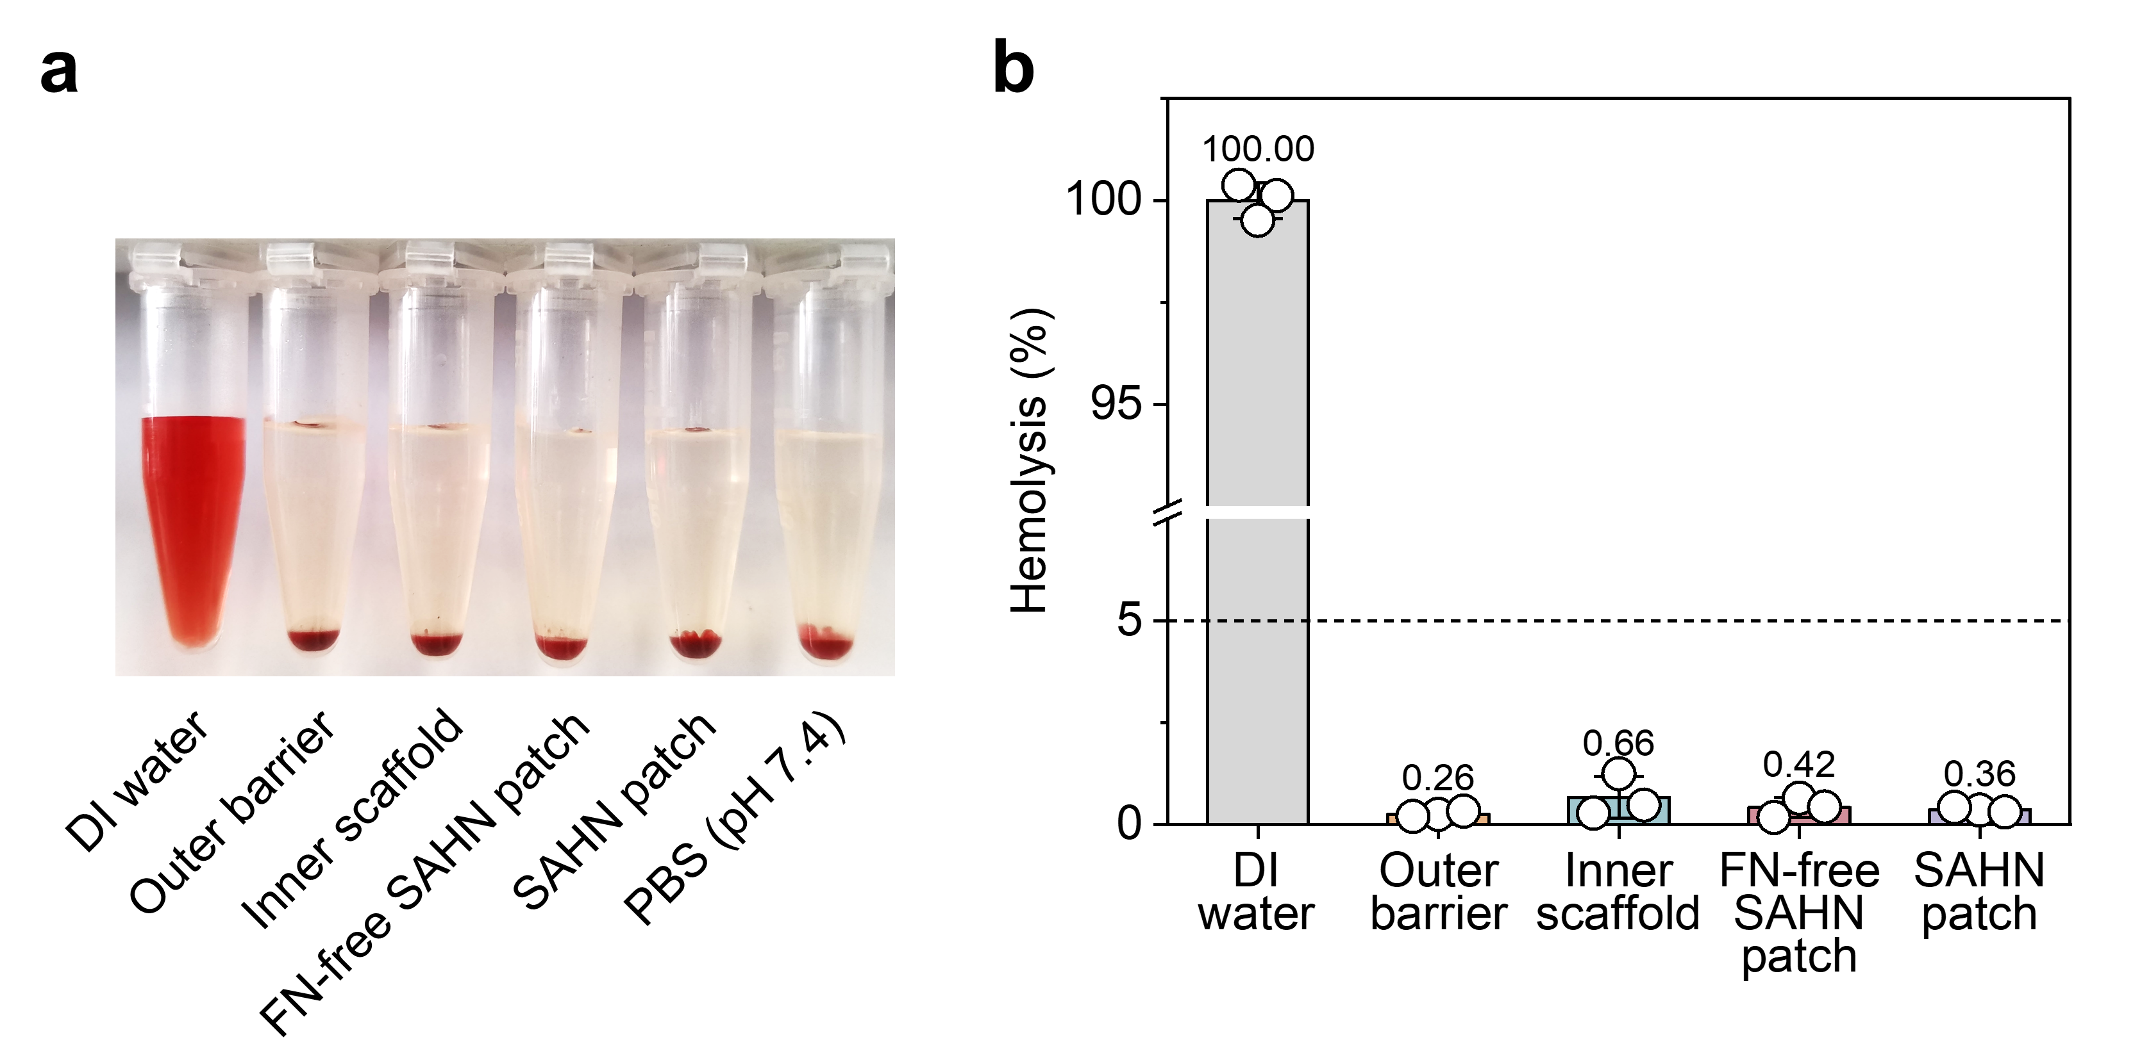
Fig. S12 Hemocompatibility study of the SAHN patch and its individual components. (a) Photographs of hemolysis phenomena after centrifugation of red blood cells co-incubated with different samples. (b) Hemolysis rate.

