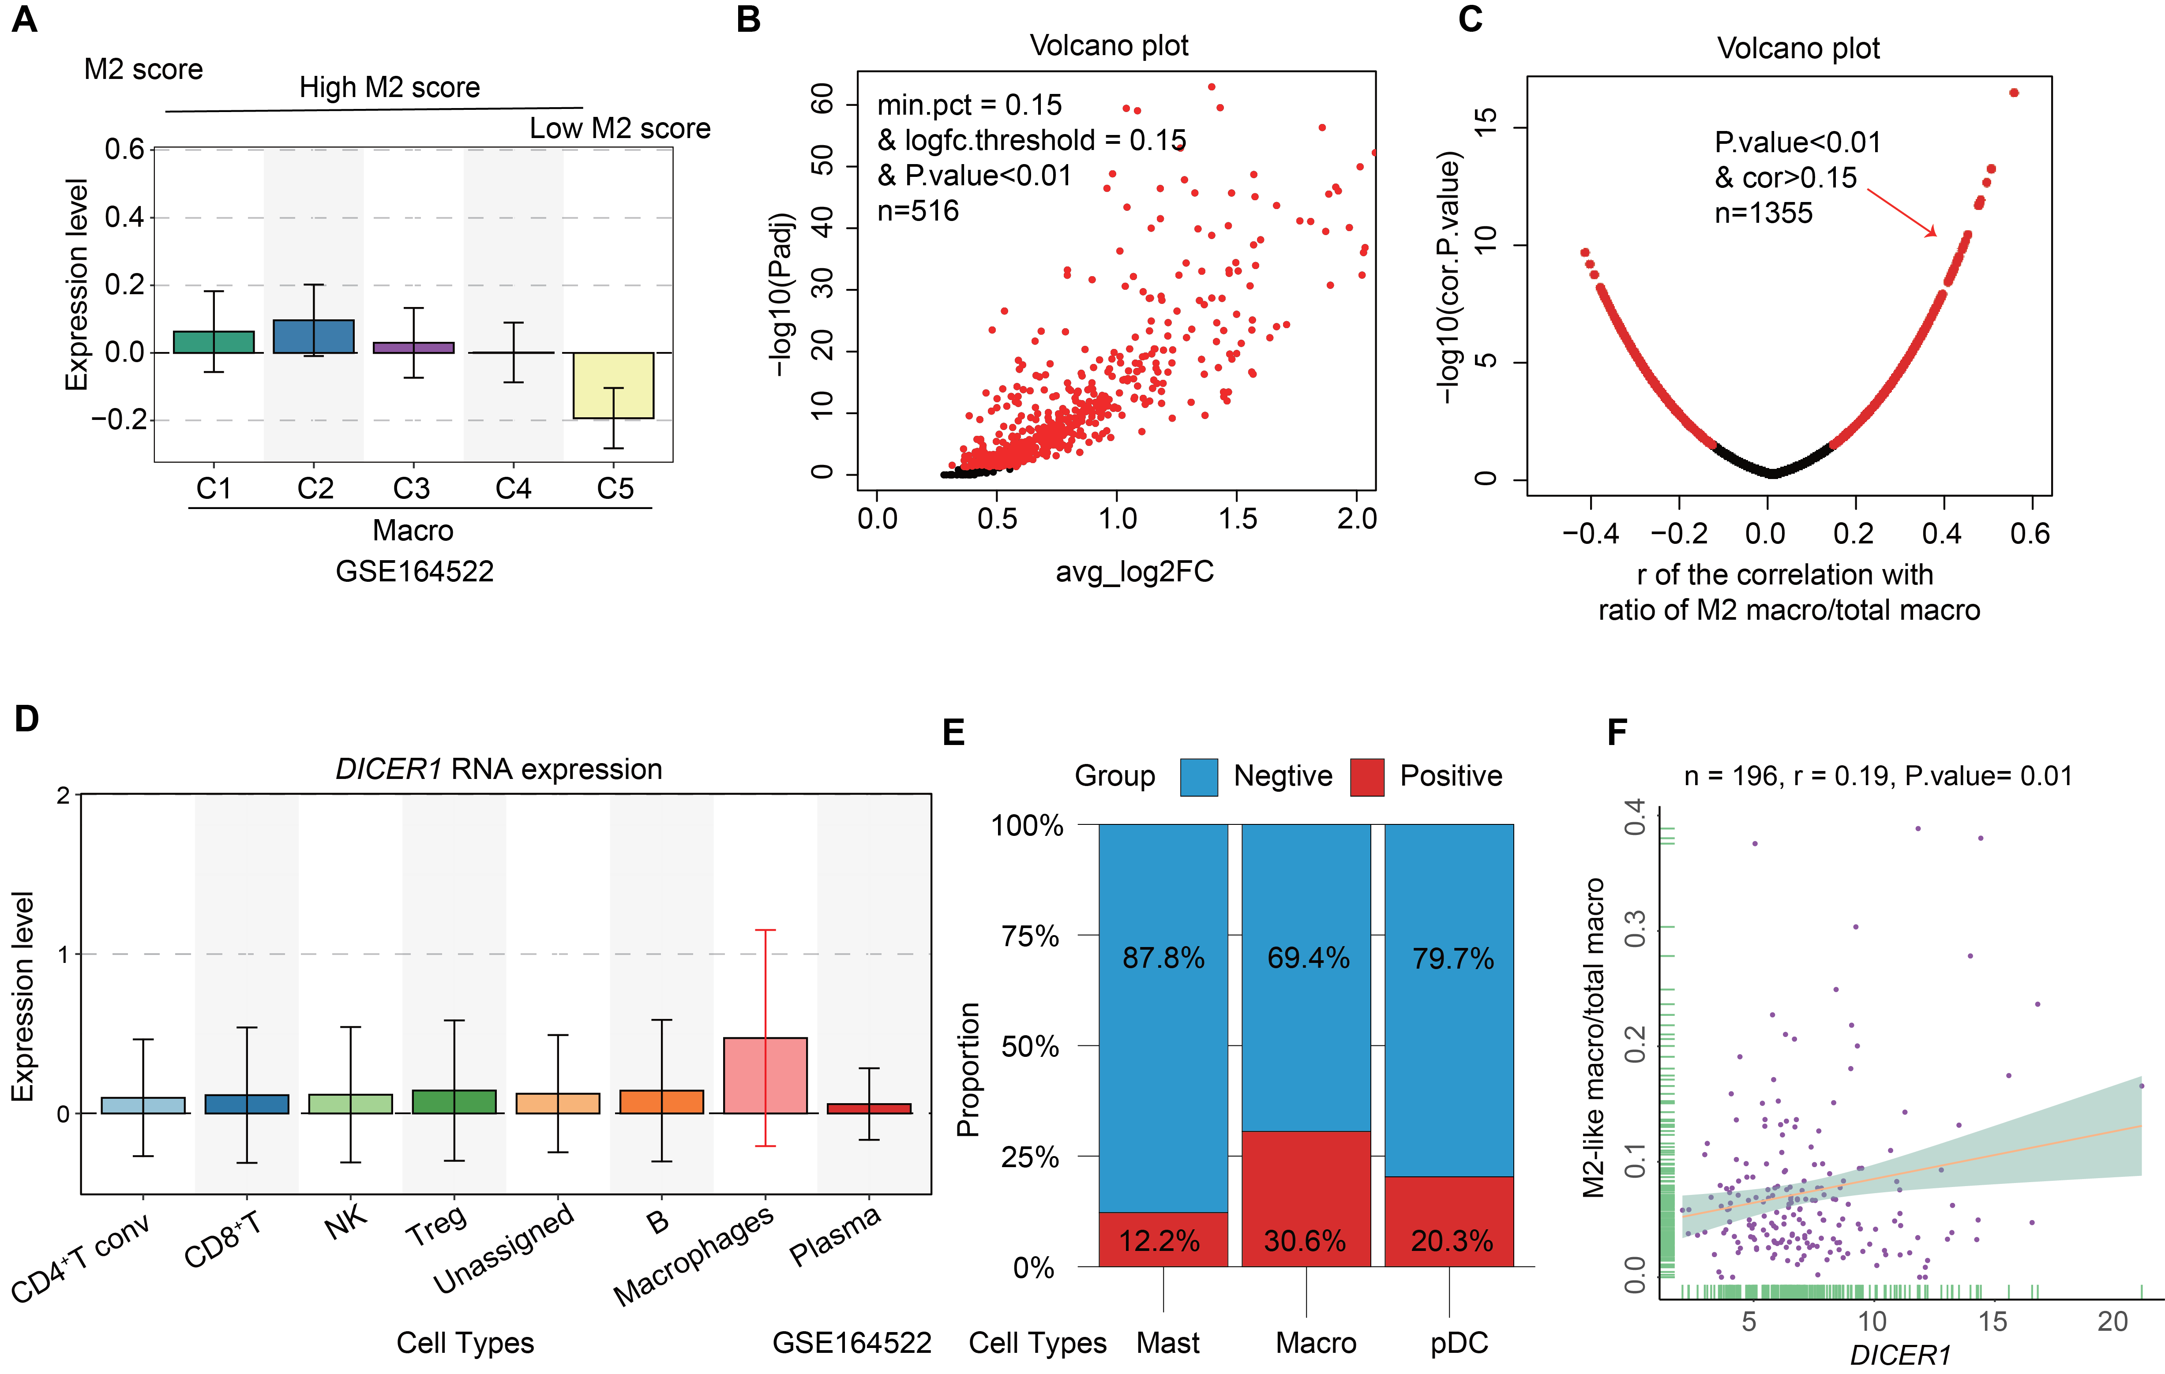
Figure S1. The relationship between DICER1 expression and macrophage M2 polarization. A) M2 score across different macrophage clusters. B) Genes associated with macrophage M2 score in patients with CRLM. C) Genes associated with macrophage M2 polarization levels in patients with pan-cancer. D) DICER1 expression levels among different immune cells in patients with CRLM. E) The proportion of DICER1-positive cells across different subtypes of myeloid cells. F) Correlation between DICER1 expression and macrophage M2 polarization levels in patients with pan-cancer. CD4Tconv: CD4 helper T cells; CLRM: colorectal cancer liver metastases; Treg: regulatory T cells.

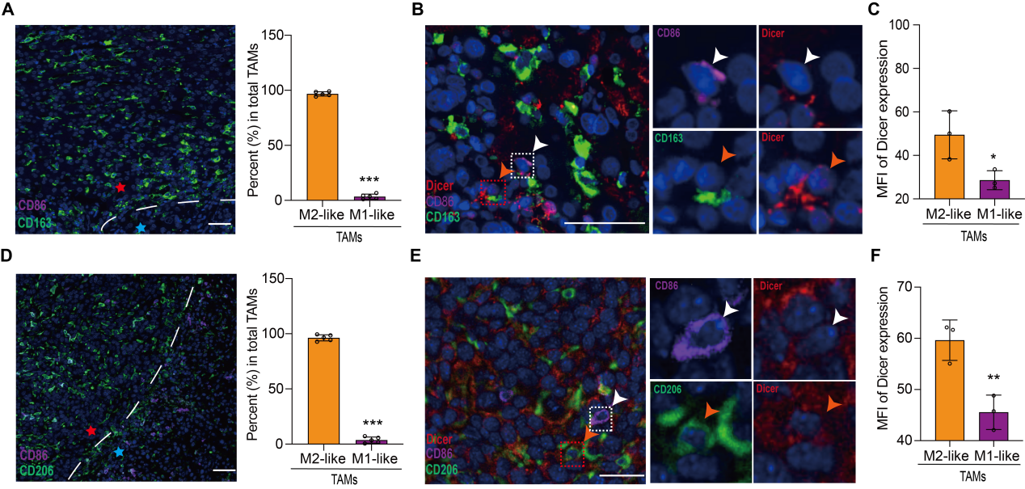
Figure S2. Dicer expression in TAMs within liver metastases. A) Representative immunofluorescence images (left) and quantified analysis (right) of TAMs in liver metastases of patients with CRLM. Scale bar: 50 μm. B-C) Representative immunofluorescence images (B) and quantified analysis (C) of Dicer expression in different phenotypes of TAMs in patients with CRLM. CD86⁺ cells indicate M1-like TAMs and CD163⁺ cells indicate M2-like TAMs. Scale bar: 25 μm. D) Representative immunofluorescence images (left) and quantified analysis (right) of TAMs in liver metastases of CRLM-bearing mice. Scale bar: 50 μm. E-F) Representative immunofluorescence images (E) and quantified analysis (F) of Dicer expression in different types of TAMs in CRLM-bearing mice. CD86⁺ cells indicate M1-like TAMs and CD206⁺ cells indicate M2-like TAMs. Scale bar: 25 μm. Dashed lines indicate the tumor-normal tissue boundaries, ★ indicates the tumor area, and ★ indicates the normal tissue area. Data are presented as the mean ± SD. *P < 0.05, **P < 0.01, ***P < 0.001, as calculated using Student’s t test. TAMs: Tumor-associated macrophages; CRLM: colorectal cancer liver metastasis.

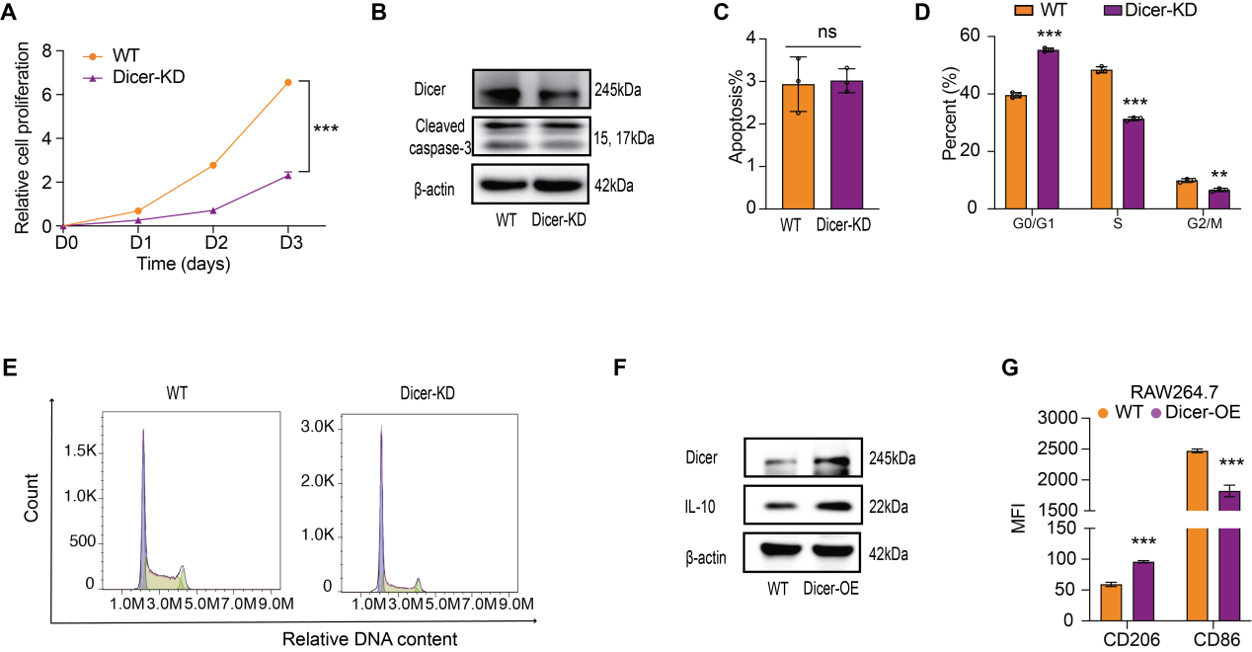
Figure S3. Dicer regulated the proliferation and phenotype of macrophages. A) Proliferation of RAW264.7^{Dicer-KD} cells was assessed using CCK-8 assays. B) Cleaved caspase-3 and Dicer expression in RAW264.7^{Dicer-KD} cells detected using western blotting. C) Apoptosis in RAW264.7^{Dicer-KD} cells detected using FCM. D-E) Cell cycle of RAW264.7^{Dicer-KD} cells detected using FCM. Quantified analysis (D) and representative FCM images (E) are shown. F) Dicer and IL-10 expression in RAW264.7^{Dicer-OE} cells detected using western blotting. G) Macrophage M2 marker CD206 and M1 marker CD86 expression levels were assessed using FCM. MFI values for CD206 and CD86 in macrophages were analyzed. Data are presented as the mean ± SD. *P < 0.05, **P < 0.01, ***P < 0.001, as calculated using Student’s t test, multiple t test with Bonferroni post hoc tests, or one-way ANOVA with Tukey's correction as appropriate. FCM: Flow cytometry; OE: Over-expression.

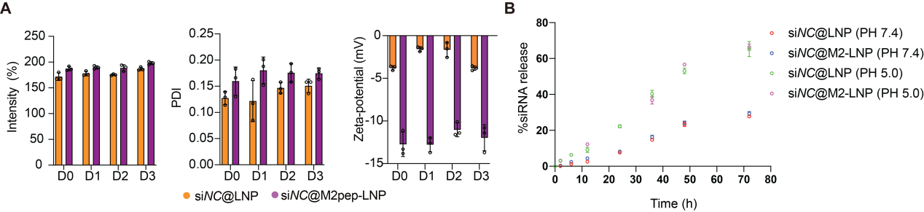
Figure S4. Stability and release profiles of nanoparticles. A) Stability of nanoparticles assessed by dynamic light scattering (DLS). Particle size, polydispersity index (PDI), and zeta potential of nanoparticles were measured over 3 days under storage at 4 °C. B) In vitro siRNA release profiles from nanoparticles. Data are presented as the mean ± SD. *P < 0.05, **P < 0.01, ***P < 0.001, as calculated using one-way ANOVA with Tukey's correction as appropriate.

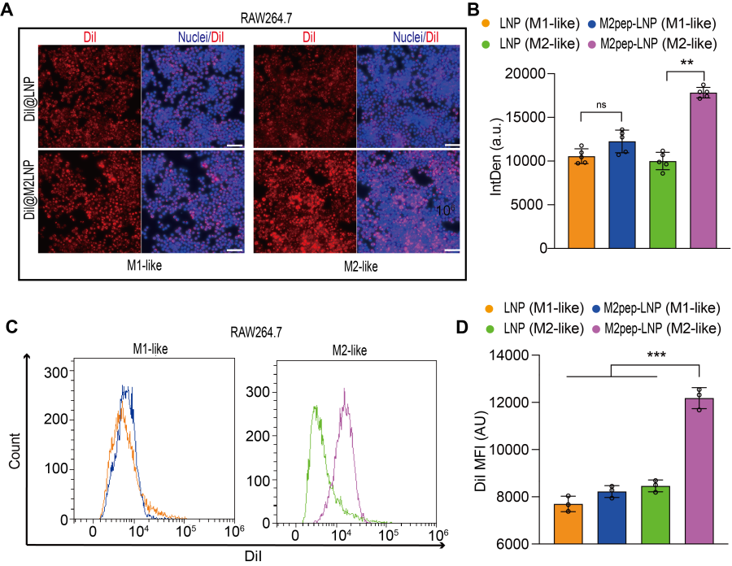
Figure S5. Uptake of nanoparticles by RAW264.7 cells. A-D) Uptake of nanoparticles by RAW264.7 cells in various polarization states, analyzed using fluorescence microscopy (A, B) and FCM (C, D). Representative fluorescence images (A), FCM images (C), and corresponding quantified analyses (B, D) are shown. Scale bar: 50 μm. Data are presented as the mean ± SD. *P < 0.05, **P < 0.01, ***P < 0.001, as calculated using one-way ANOVA with Tukey's correction as appropriate. FCM: Flow cytometry; IntDen: Integrated Density; MFI: Mean fluorescence intensity.

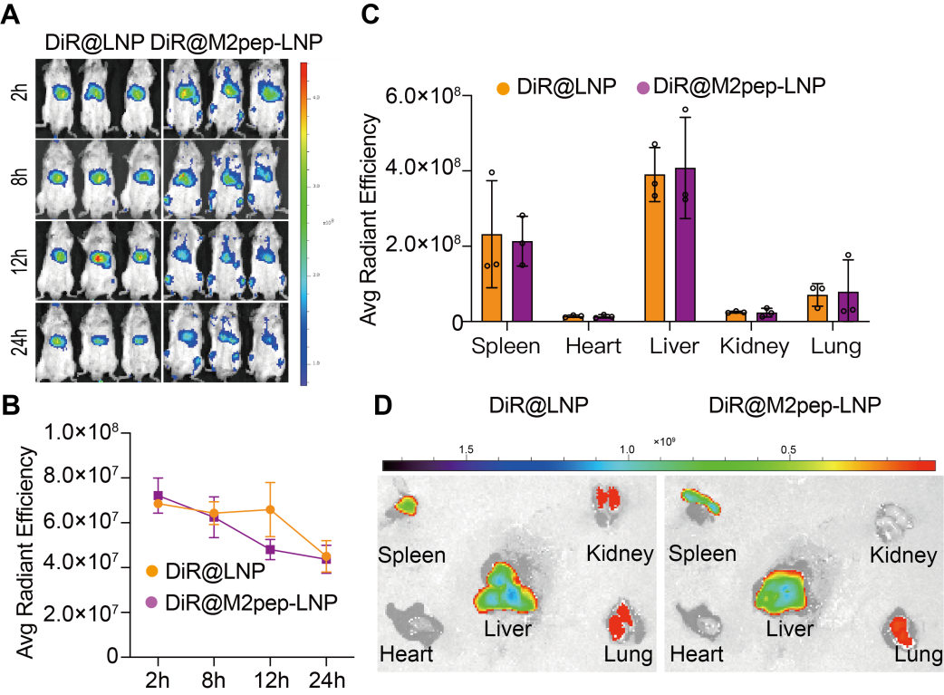
Figure S6. Biodistribution of nanoparticles in normal mice. A-B) Representative images (A) and quantitative results (B) for the biodistribution of nanoparticles at different time points after intravenous injection in mice bearing liver metastasis (n = 3 per group). Average radiant efficiency [(p/s/cm²/sr) /(μW/cm²)] was analyzed. C-D) Biodistribution of nanoparticles in different organs at the 8 h time points (n = 3 per group). Quantitative results (C) and representative images (D) of nanoparticle biodistribution. The average radiant efficiency [(p/s/cm²/sr) /(μW/cm²)] was analyzed. Data are presented as the mean ± SD and analyzed using multiple t tests with Bonferroni post hoc tests.

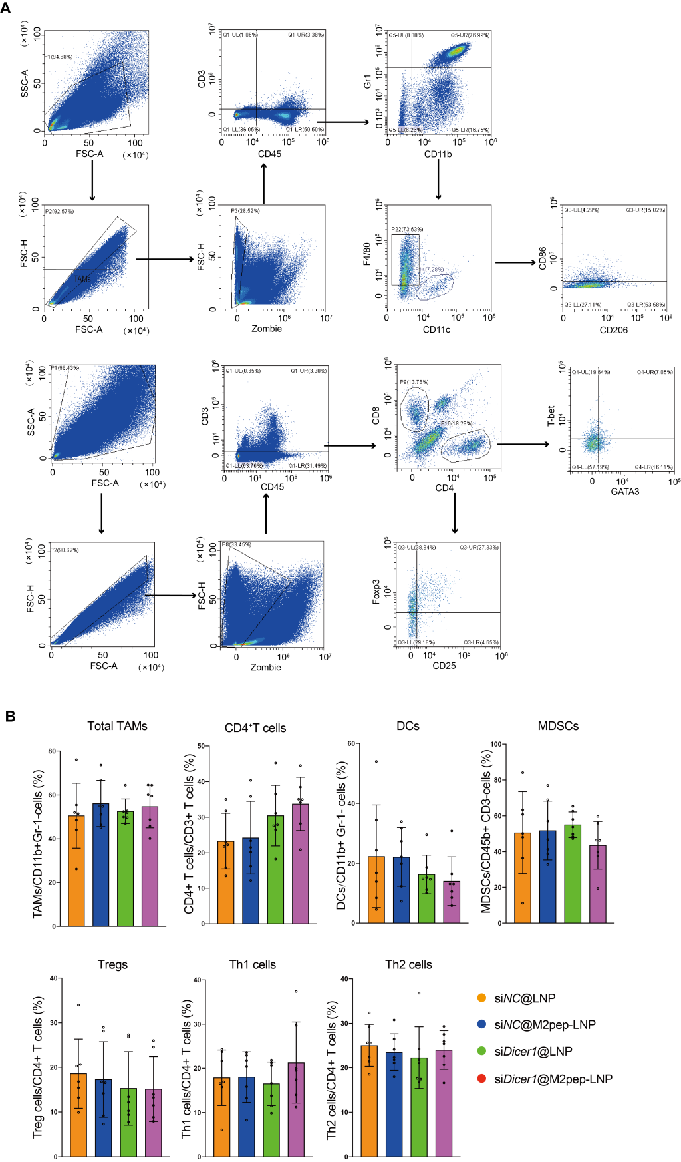
Figure S7. Changes of the immune microenvironment in liver metastases of CRLM model mice that received different treatments. A) Strategies for immune cell profiling. B) Quantified analysis of different immune cells in the liver metastases (n = 7). Data are presented as the mean ± SD and analyzed using one-way ANOVA with Tukey's correction. CRLM: colorectal cancer liver metastasis.
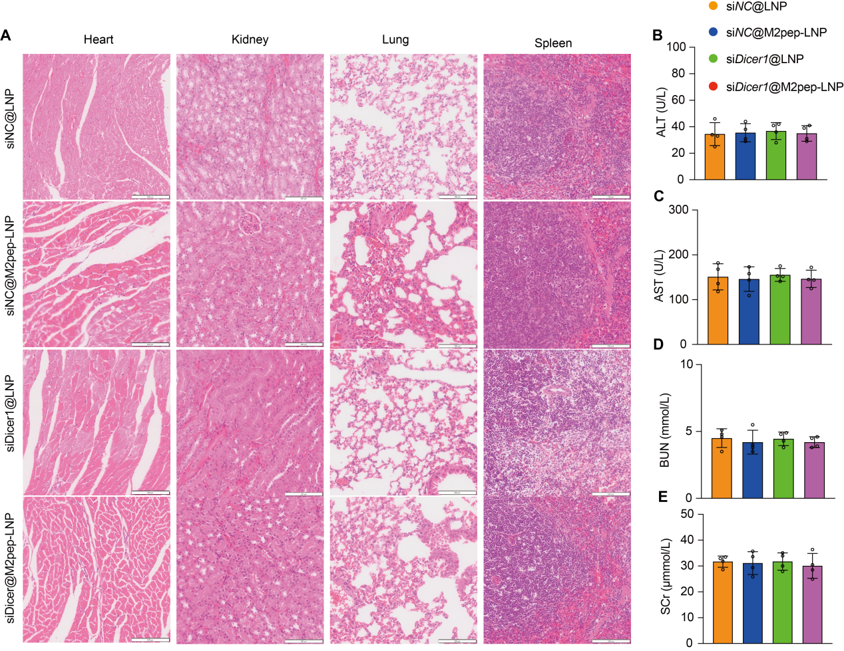
Figure S8. Biosafety assessment. A) HE staining of major organs. Scale bar: 100 μm. B) Liver and kidney function measurement. Data are presented as the mean ± SD and analyzed using one-way ANOVA with Tukey's correction. ALT: alanine transaminase; AST: aspartate transaminase; BUN: blood urea nitrogen; HE: hematoxylin and eosin; SCr: serum creatinine.

