Supplementary Materials for

• Biosynthesized nanoparticles of Tibetan medicine mercuric sulfide preparation to promote endocytosis and realize drug crossing through blood brain barrier

Xiaohui Zhao et al.

*Corresponding author. Email: xhzhao@nwipb.cas.cn

This file includes:

Supplementary Text
Figs. S1 to S21
Table S1

Table S1. The top 20 most abundant corona proteins (PPM) detected from nanoparticles in mice after 24 hours oral administration.
No | ZT | HgS
1 | Lupus La protein homolog | Superoxide dismutase [Cu-Zn]
2 | Keratin, type II cytoskeletal 2 oral | Muscleblind-like protein 1
3 | Muscleblind-like protein 1 | Major urinary protein 2
4 | Hemoglobin subunit beta-1 | Hemoglobin subunit beta-1
5 | Transcriptional repressor CTCFL | Cilia- and flagella-associated protein 44
6 | CREB3 regulatory factor | Transcriptional repressor CTCFL
7 | Serine protease inhibitor A3A | Translation factor Guf1, mitochondrial
8 | Hemoglobin subunit alpha | Keratin, type II cytoskeletal 2 oral
9 | Ubiquitin-60S ribosomal protein L40 | CREB3 regulatory factor
10 | Translation factor Guf1, mitochondrial | Lupus La protein homolog
11 | Oncostatin-M | Hemoglobin subunit alpha
12 | Annexin A2 | Lysozyme C-1
13 | Immunoglobulin heavy constant mu | Alpha-1-antitrypsin 1-3
14 | Superoxide dismutase [Cu-Zn] | Cathepsin Z
15 | Collagen alpha-1(I) chain | Calnexin
16 | Fatty acid-binding protein 5 | Ig kappa chain V-II region 26-10
17 | Protein ATP6V1FNB | Major urinary protein 1
18 | Junction plakoglobin | Histone H4
19 | F-box only protein 50 | Actin, cytoplasmic 2
20 | Cyclin-dependent kinase 9 | Testis-expressed protein 44
Proteins highlighted in the blue are among the top 20 for both nanoparticles from ZT and ꞵ- HgS

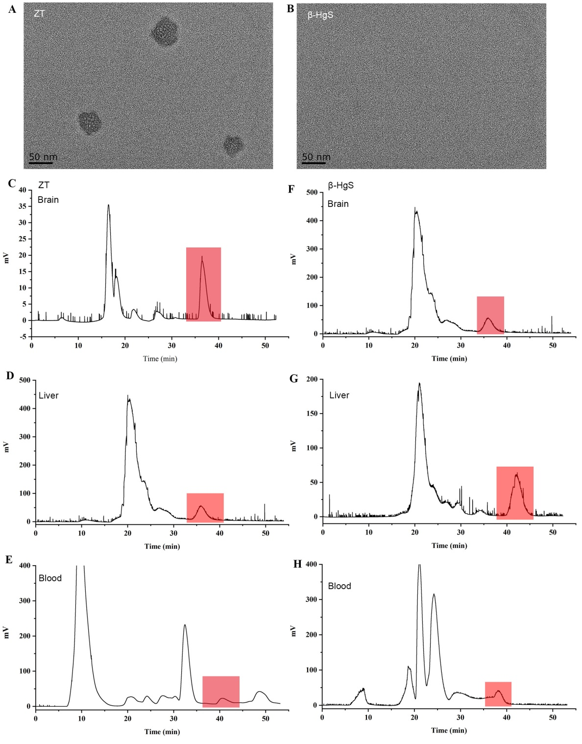
Fig. S1 Detection of nanoparticles in ZT and ꞵ-HgS and HPLC separation of nanoparticles in different tissues of mice. (A) ZT and (B) ꞵ-HgS were dissolved in water respectively, and no NPs were detected by TEM after ultracentrifugation. (C-E) HPLC separation chromatograms of NPs in different mouse tissues. After oral administration of ZT in mice, the NPs in brain, liver and kidney tissues were separated by HPLC. (F-H) After oral administration of β-HgS in mice, the NPs in brain, liver and kidney tissues were separated by HPLC. HPLC separation was performed using a C18 column (5 µm, 300 Å, 4.6 × 250 mm). The mobile phase was composed of methanol and water (10: 90, v/v) at a flow rate of 0.1 mL/min.
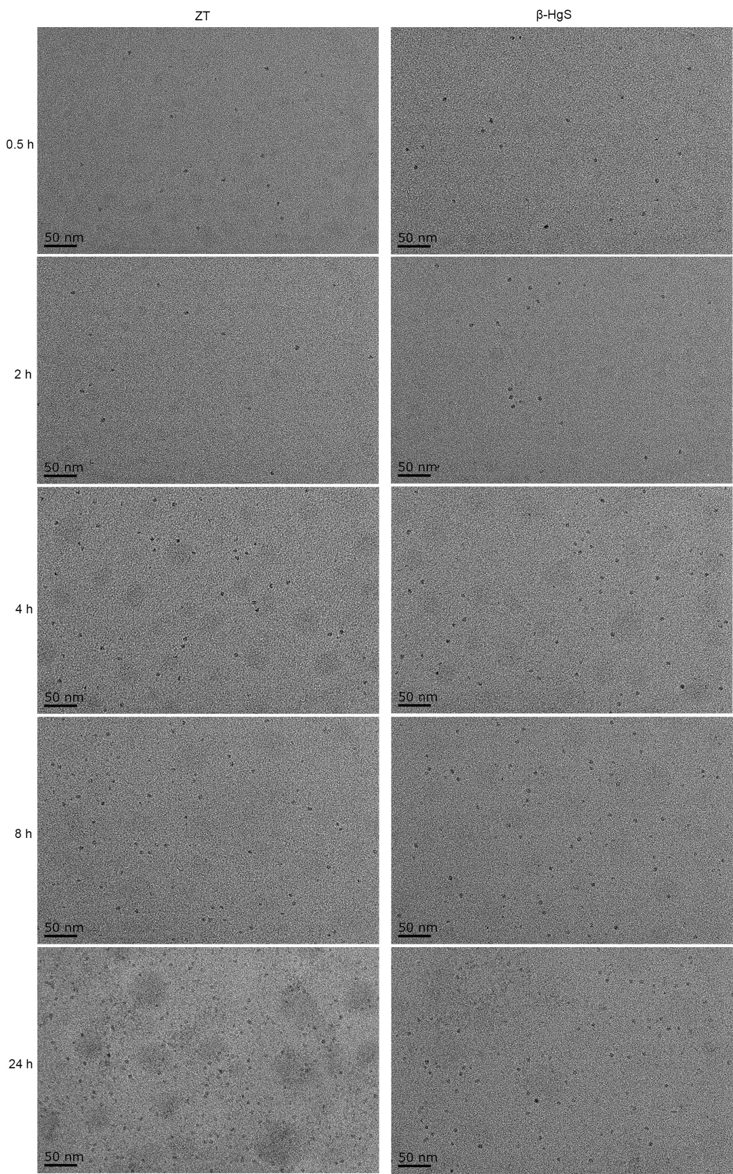

Fig. S2. Synthesis of nanoparticles at different times in mice. The left and right panels in the figure show the TEM detection of nanoparticles in the blood of mice at 0.5 h, 2 h, 4 h, 8 h and 24 h after oral administration of ZT and HgS, respectively.

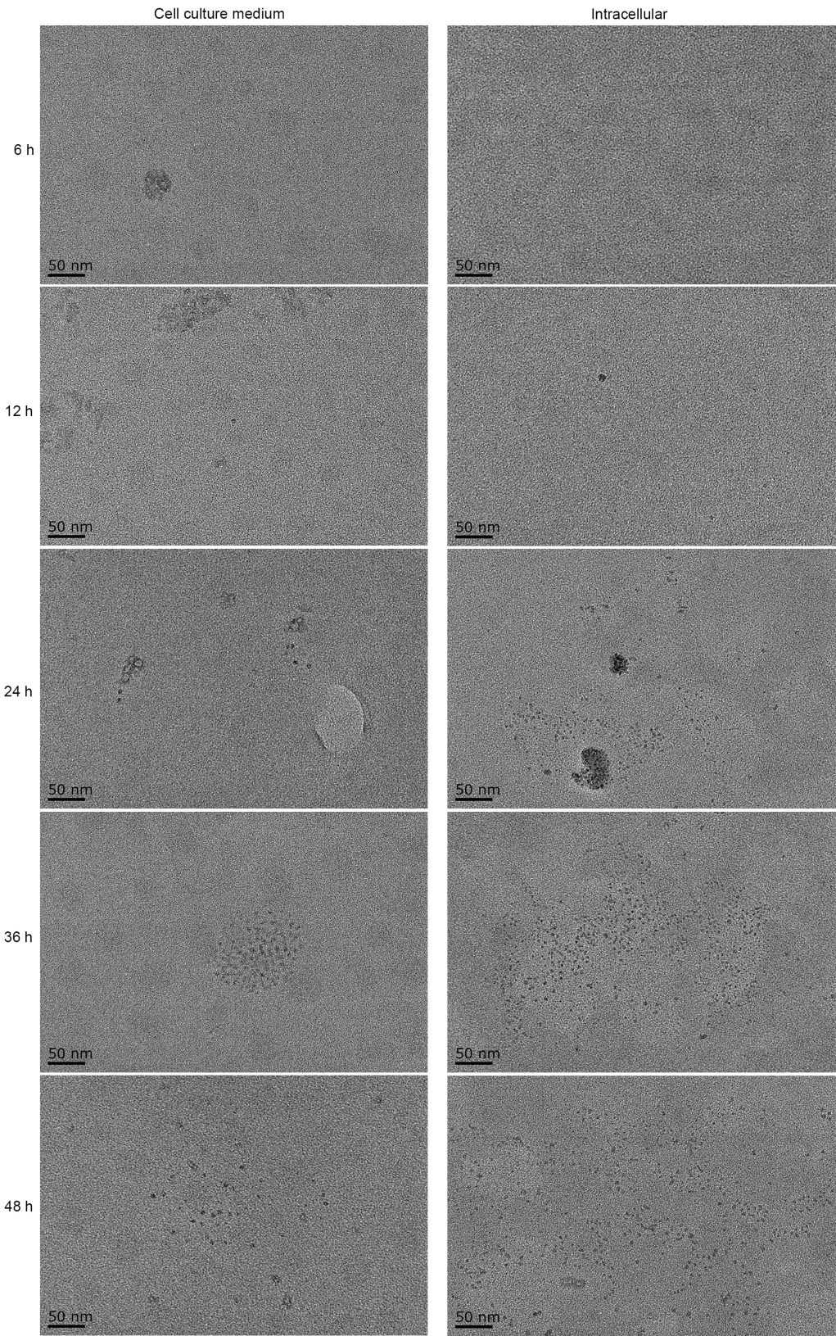

Fig. S3. Cellular synthesis of nanoparticles. The left panels show the TEM detection of nanoparticles in the medium after incubation of cells with ZT for 6 h, 12 h, 24 h, 36 h and 48 h. The right panels show the TEM detection of intracellular nanoparticles after incubation of cells with ZT for different times.

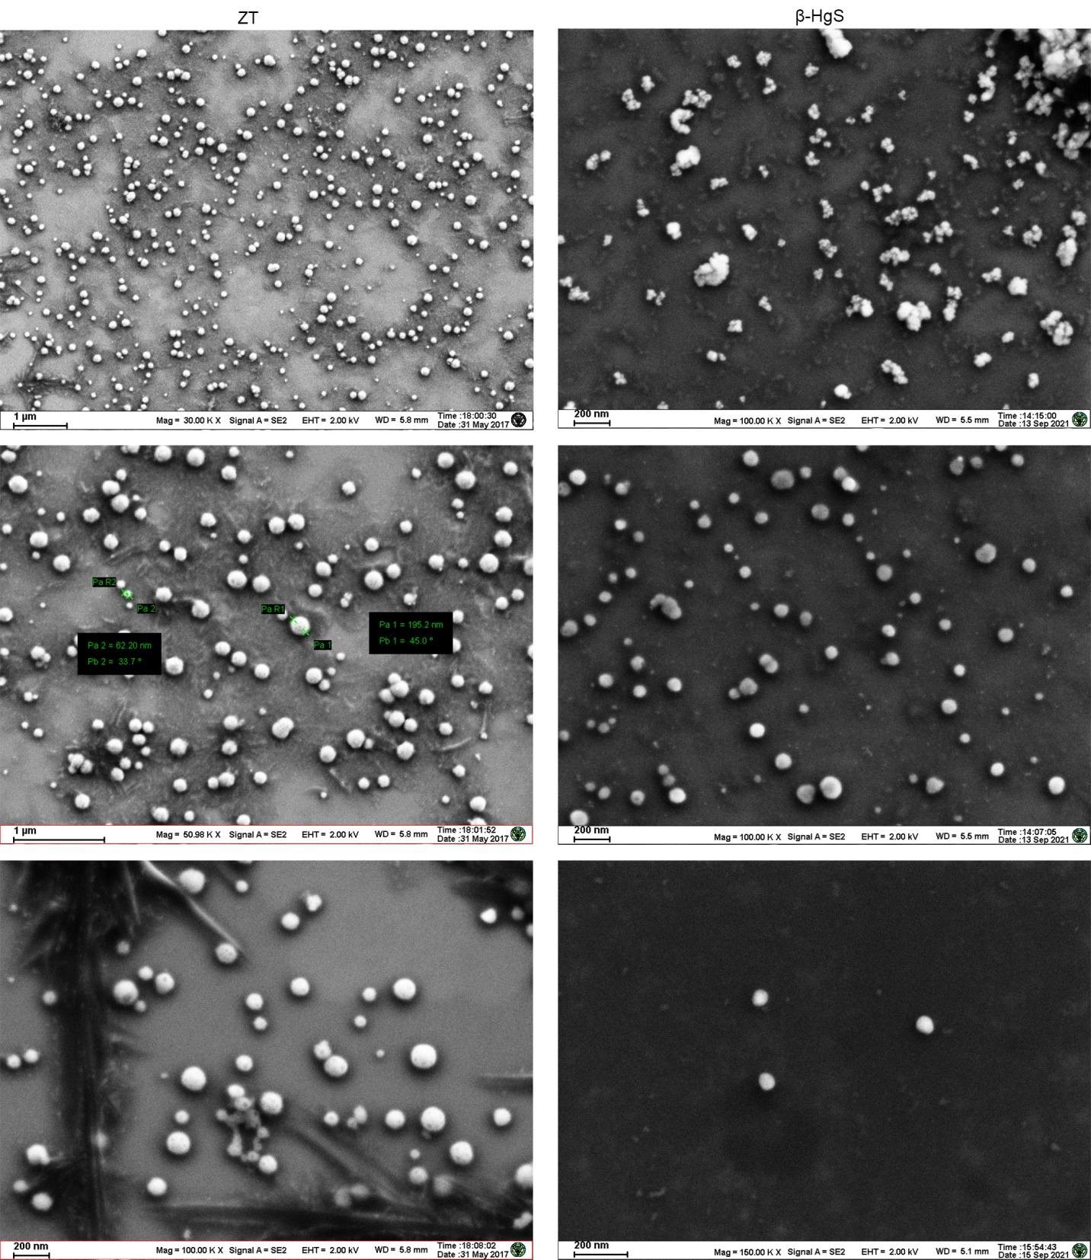
Fig. S4. The overall structure of HgS NPs. After oral administration of ZT or β-HgS to mice for 4 hours, nanoparticles in different tissues of mice were separated and purified by HPLC, and images were obtained using SEM. The shape and size of the nanoparticles formed by ZT and HgS in the organism are basically the same.

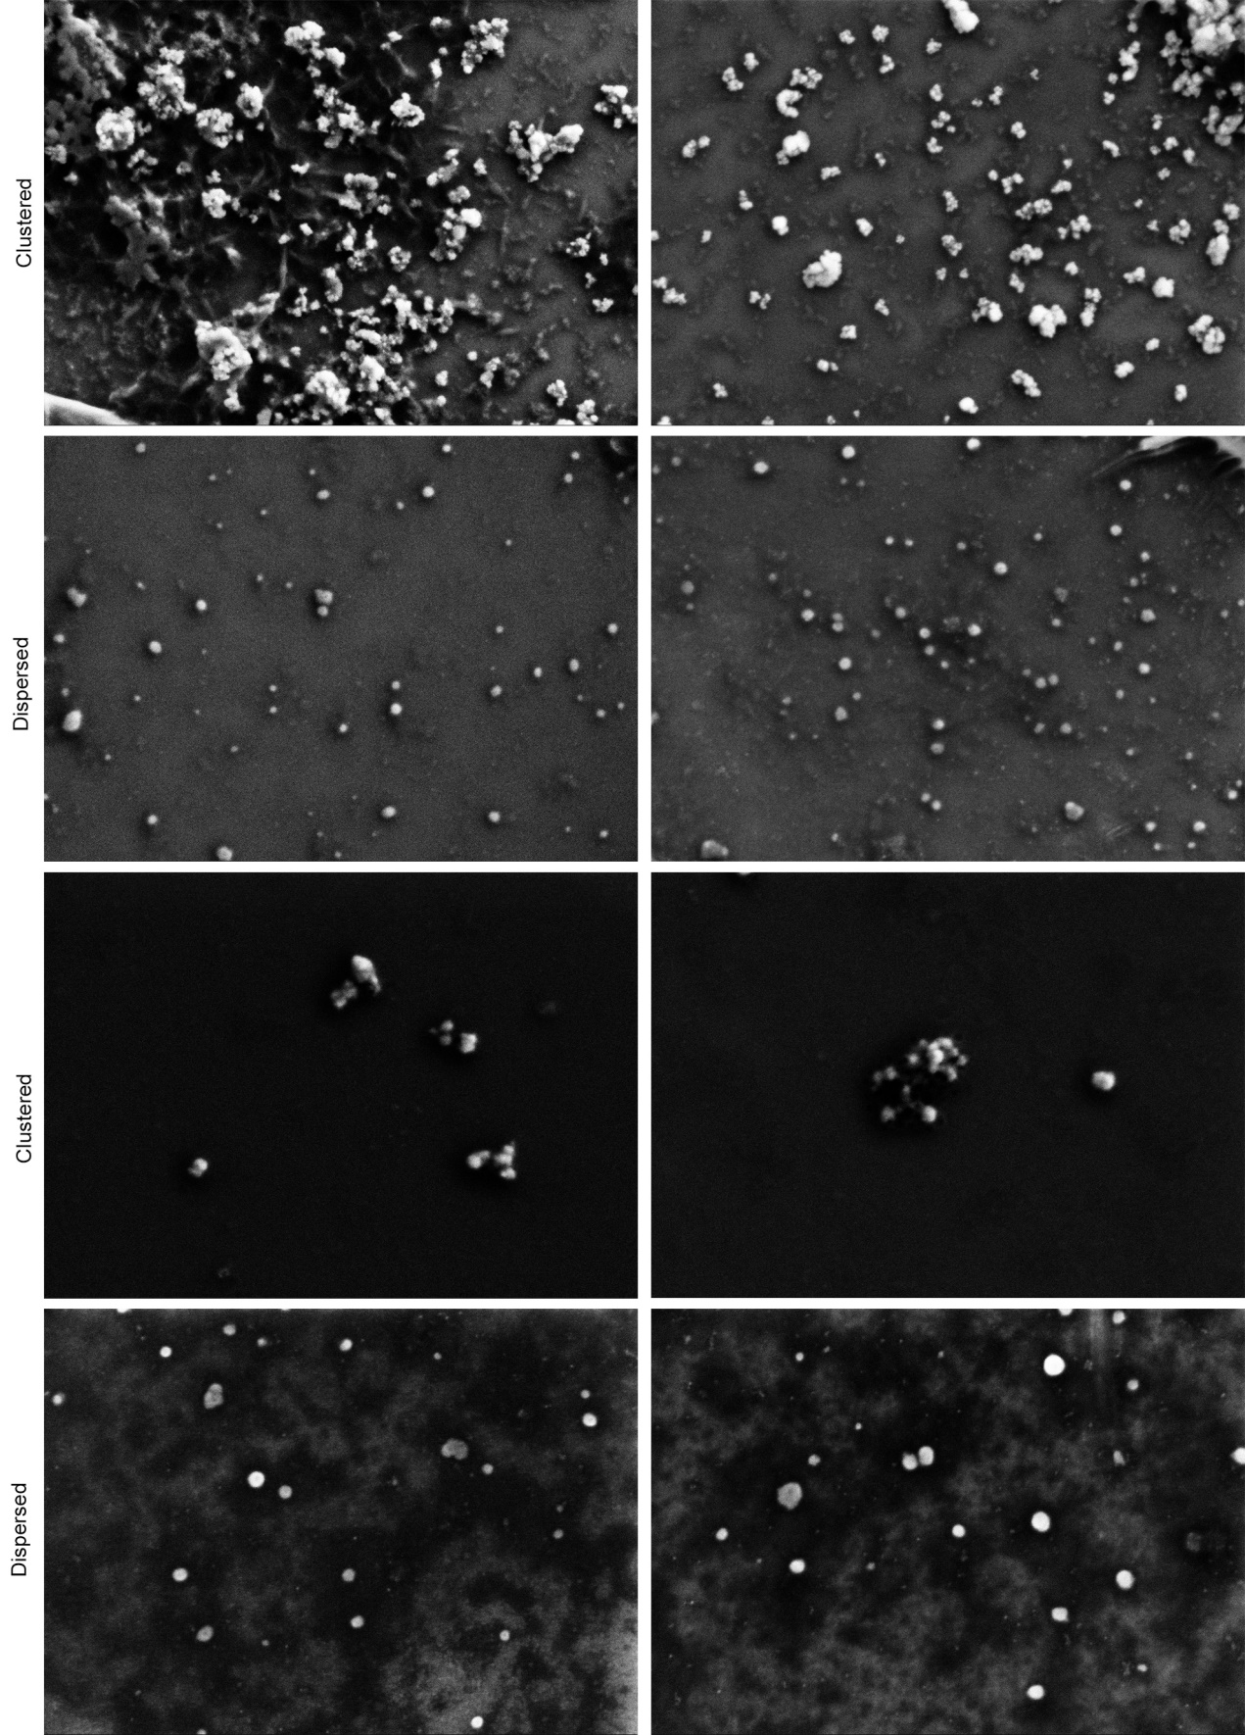
Fig. S5. Dispersed and clustered morphology of HgS NPs. The nanoparticles purified by HPLC gathered into clusters in water when the concentration is high, and disperse into individual spherical particles after dilution.

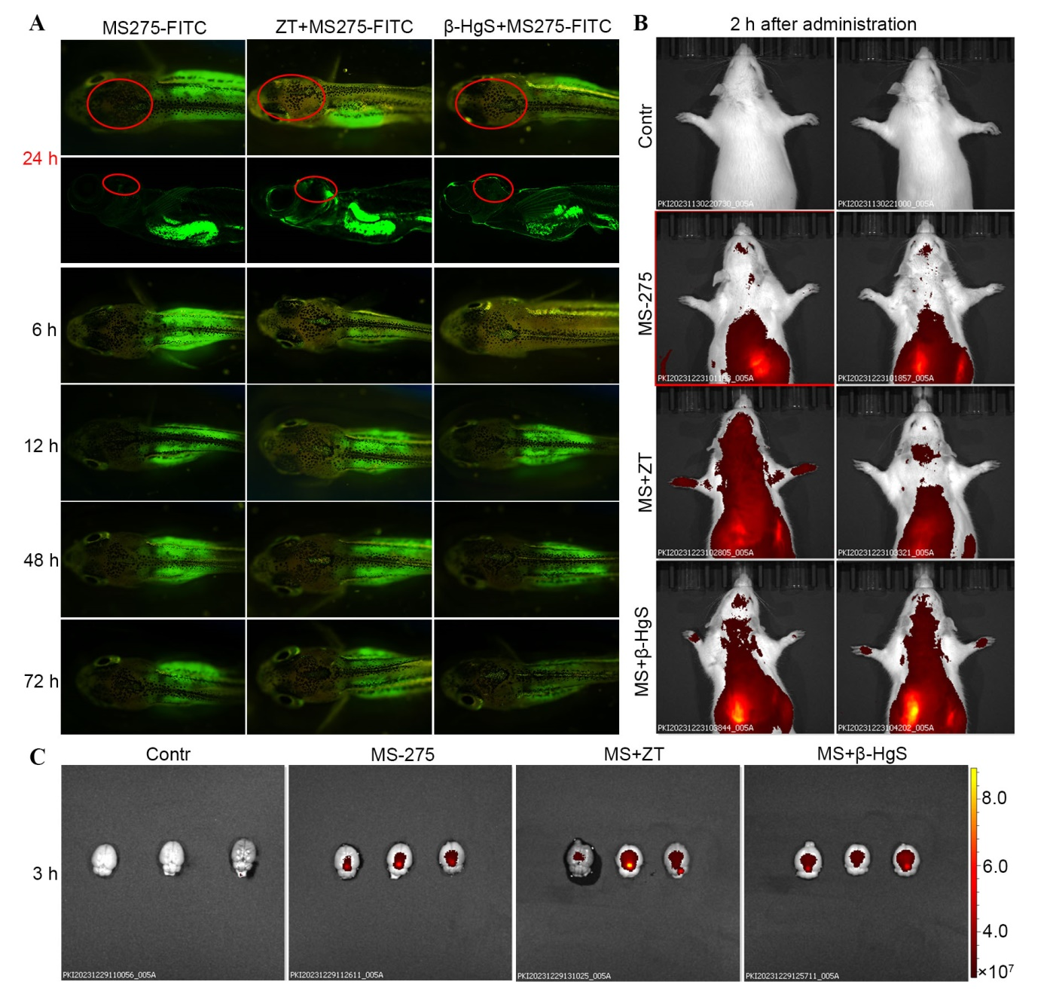
Fig. S6 ZT and β-HgS promote drug entry into zebrafish and rat brain. (A) ZT and β-HgS promote the enrichment of drugs in zebrafish brain at different exposure times. MS-275 connected to FITC. Zebrafish in the combined administration groups were pretreated with ZT (30 μg/mL) and β-HgS (15 μg/mL) for 48 h. Then each group was exposed to water containing 0.25 μg/mL MS-275- FITC. Images were captured using a stereomicroscope and a confocal laser microscope at 6, 12, 24, 48, and 72 h, respectively. (B) Bioluminescence images of rats treated with ZT or β-HgS combined with MS-275 at 2 h show the accumulation of drugs in the brain. Rats in the combined administration groups were given ZT (2.0 mg/kg) or β-HgS (1.0 mg/kg) by gavage 4 h in advance, and then MS-275 (13.0 mg/kg) was injected into the tail vein, and IVIS Spectrum was used to capture images at 2 h. (C) NIR images of rat brains. After 3 h of drug administration, the rats' brains were removed after cardiac perfusion, and images were captured using IVIS Spectrum.

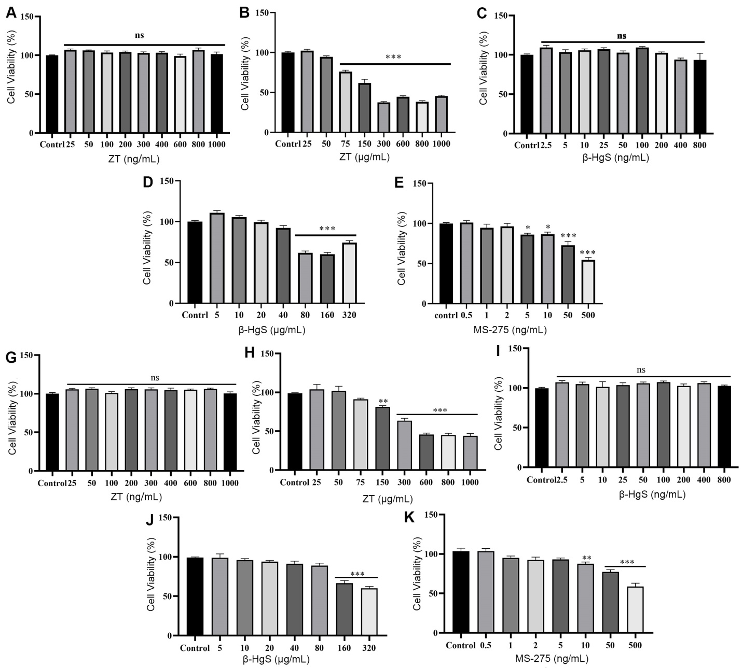
Fig. S7. MTT assay. (A and B) MTT assay of human brain microvascular endothelial cells (HBMEC) viability after ZT treatment. Treatment of cells with ZT concentration less than 50 μg/ mL for 48 h did not lead to any significant proliferative inhibition or abnormal cell morphology cell proliferation inhibition and morphological changes. (C and D) MTT assay of HBMEC viability after β-HgS treatment. Treatment with HgS at a concentration less than 40 μg/mL for 48 hours has no effect on cells. (E) MTT assay of HBMEC viability after MS-275 treatment. MS-275 concentration exceeding 4 ng/mL significantly inhibited HBMEC proliferation. (G and H) MTT assay of HBMEC viability after ZT treatment. Treatment of cells with ZT concentration less than 75 μg/mL for 72 h did not lead to any significant proliferative inhibition or abnormal cell morphology cell proliferation inhibition and morphological changes. (I and J) Treatment with HgS at a concentration less than 80 μg/mL for 72 h has no effect on cells. (K) MS-275 concentration exceeding 5 ng/mL significantly inhibited HBMEC proliferation.

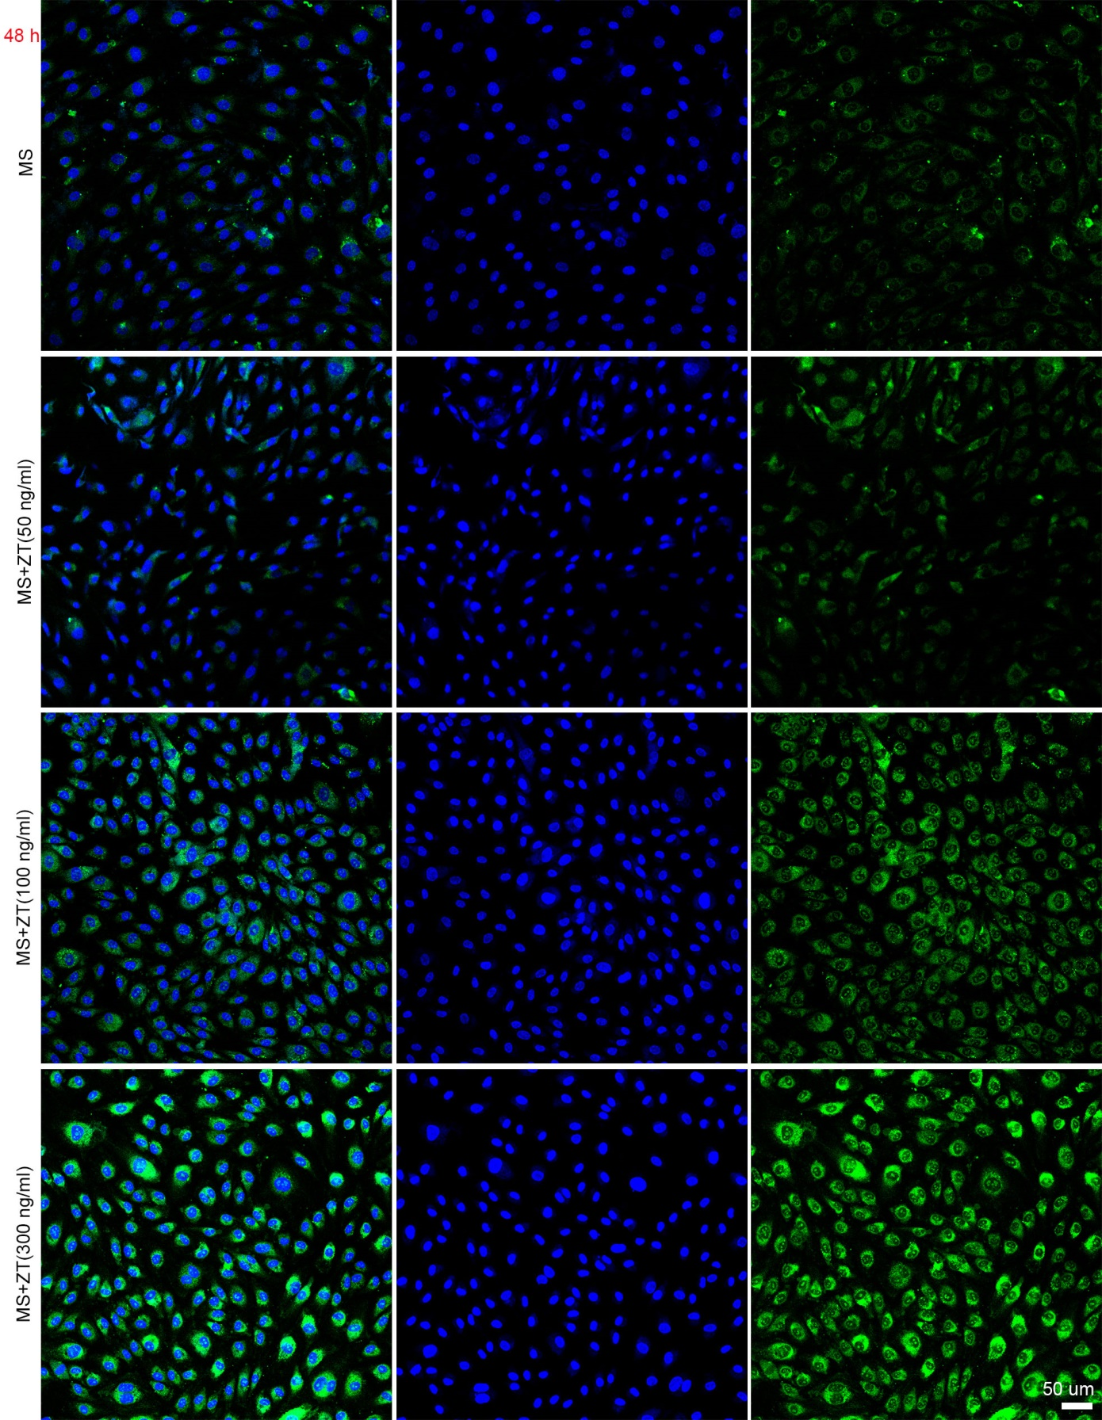
Fig. S8. ZT promotes the entry of MS-275 into HBMEC at 48 h. Confocal laser scanning microscope images of HBMEC cells after incubation with ZT and MS-275 for 48 h. MS-275 was labeled with FITC (green signal). Nuclei were stained with DAPI (blue signal). Scale bar, 50 μm.

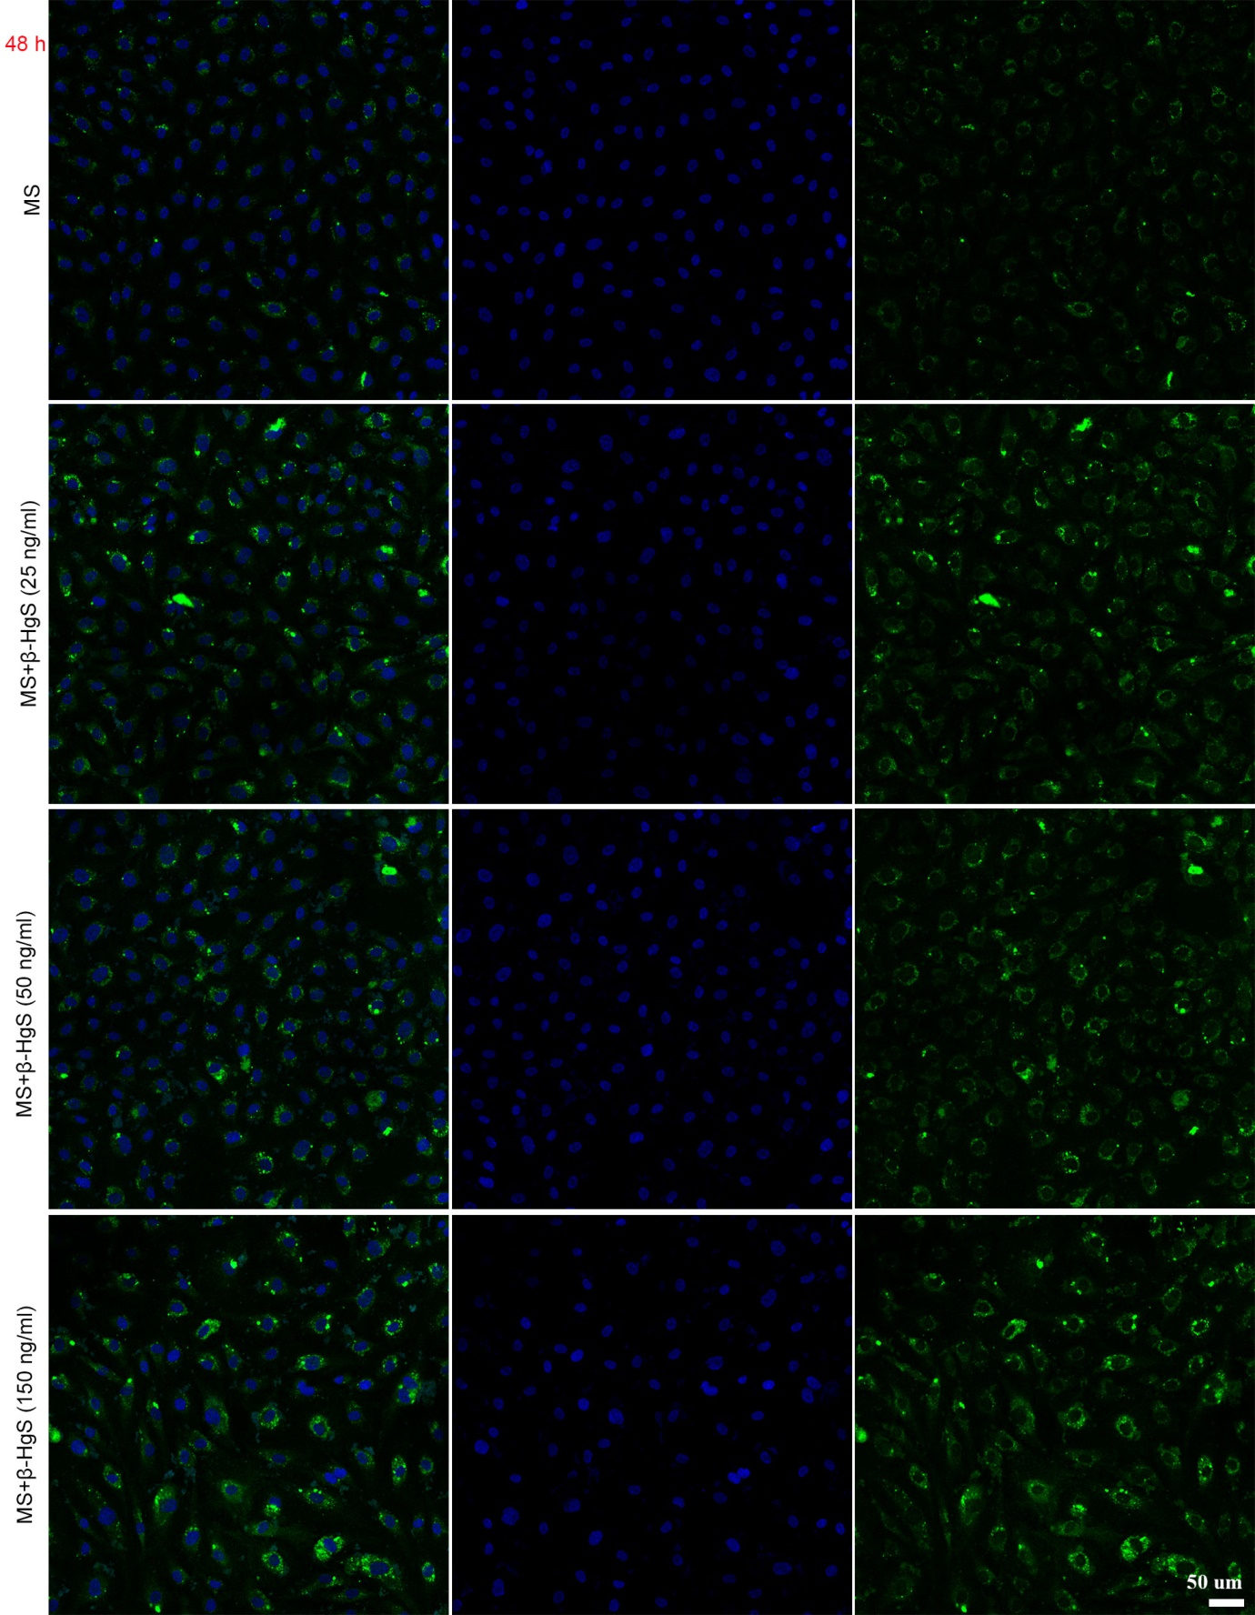
Fig. S9. β-HgS promotes the entry of MS-275 into HBMEC at 48 h. Confocal laser scanning microscope images of HBMEC cells after incubation with β-HgS and MS-275 for 48 h. MS-275 labeled with FITC (green signal). Nuclei were stained with DAPI (blue signal). Scale bar,
50 μm.
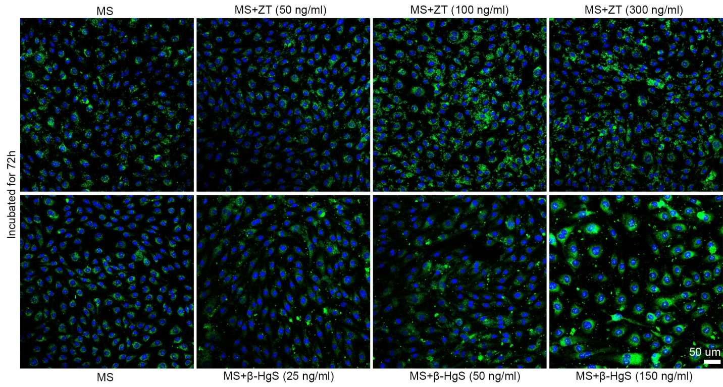
Fig. S10. ZT/β-HgS promote the entry of MS-275 into HBMEC at 72 h. HBMEC cells were incubated with ZT and MS for 72 h. The upper and lower parts of the figure are respectively the fluorescence images of cells treated with different concentrations of ZT and β-HgS combined with MS-275 for 72 h. Scale bar, 50 μm.

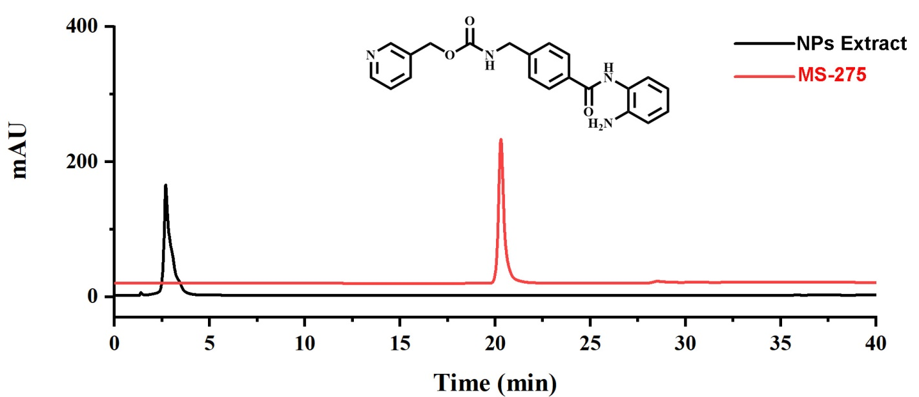
Fig. S11. MS-275 and nanoparticles extract HPLC chromatograms. After administration of ZT (3 mg/kg) or β-HgS (1.5 mg/kg) combined with MS-275 in mice, the tissues were taken and homogenized, and the nanoparticles were separated by centrifugation. The obtained nanoparticles were ultrasonically extracted with methanol, and the extract was detected by HPLC. The red curve is the chromatogram of MS-275 standard. The black curve is the chromatogram of the extract, and MS-275 was not detected.

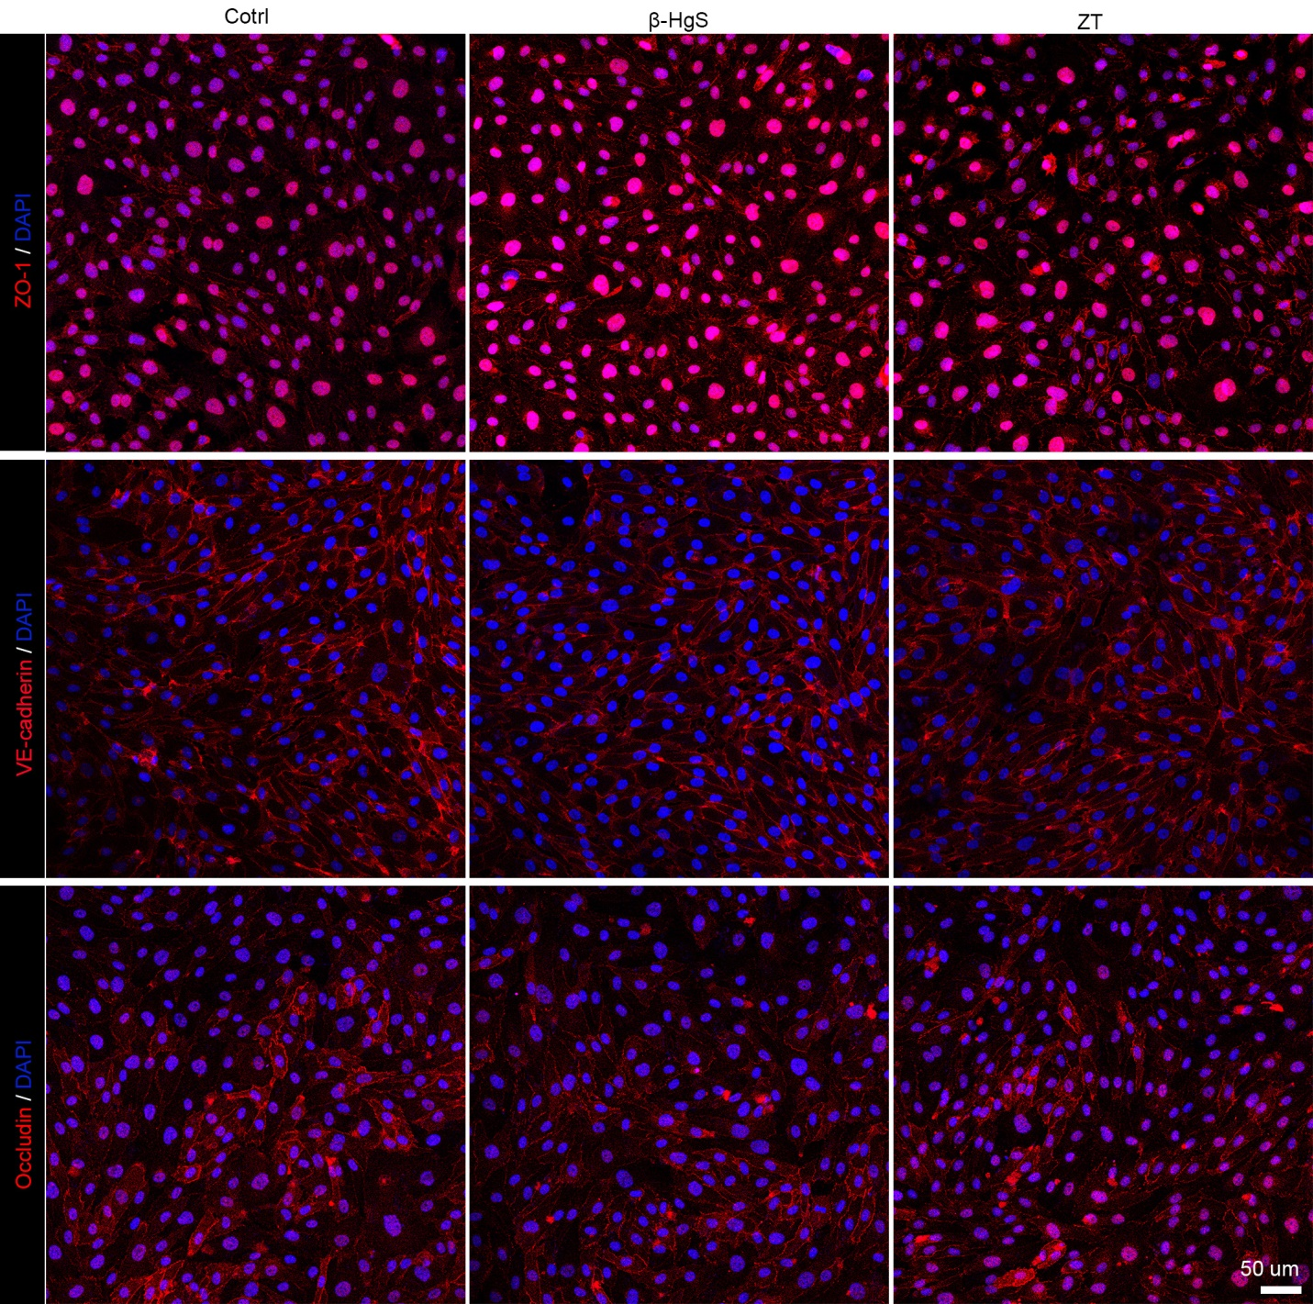
Fig. S12. The effect of ZT and β-HgS on the intercellular junctions of HBMECs. After incubation for 48 h with ZT (300 ng/mL) or HgS (150 ng/mL), there was no effect on the expression of the tight junction proteins ZO-1 and occludin, as well as the adherens junction protein VE-cadherin of HBMECs. Bar: 50 μm.

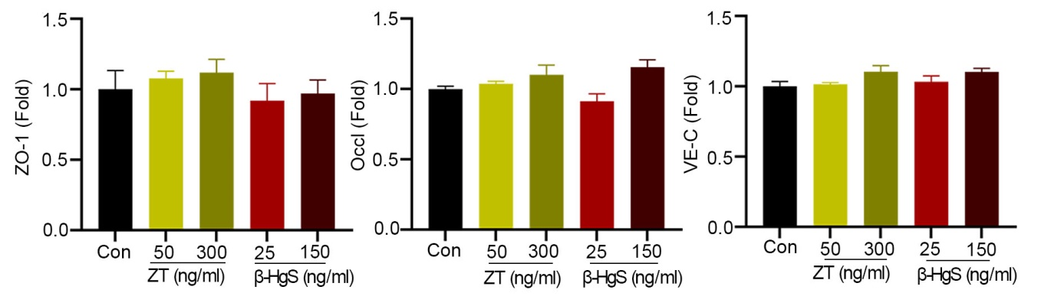
Fig. S13. Western blots confirmed that ZT/β-HgS has no effect on the expressions of connexins in HBMECs. n=3.

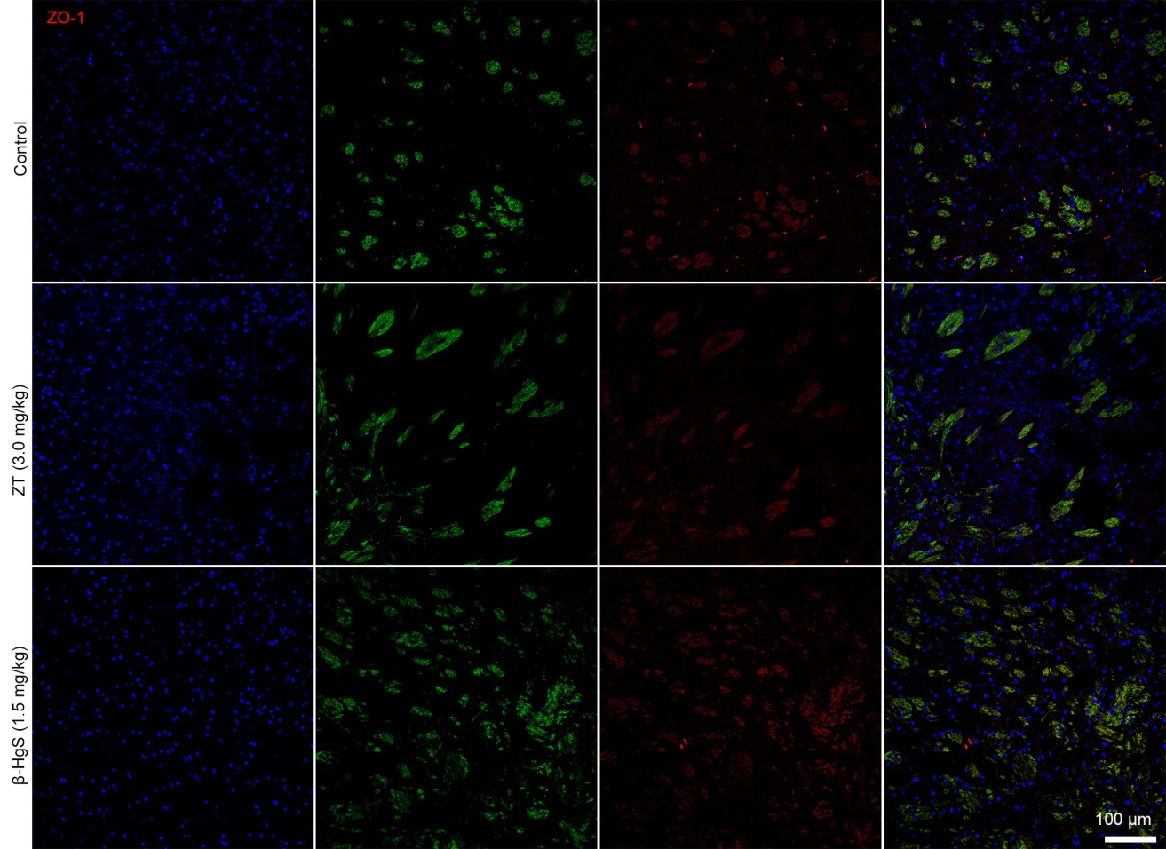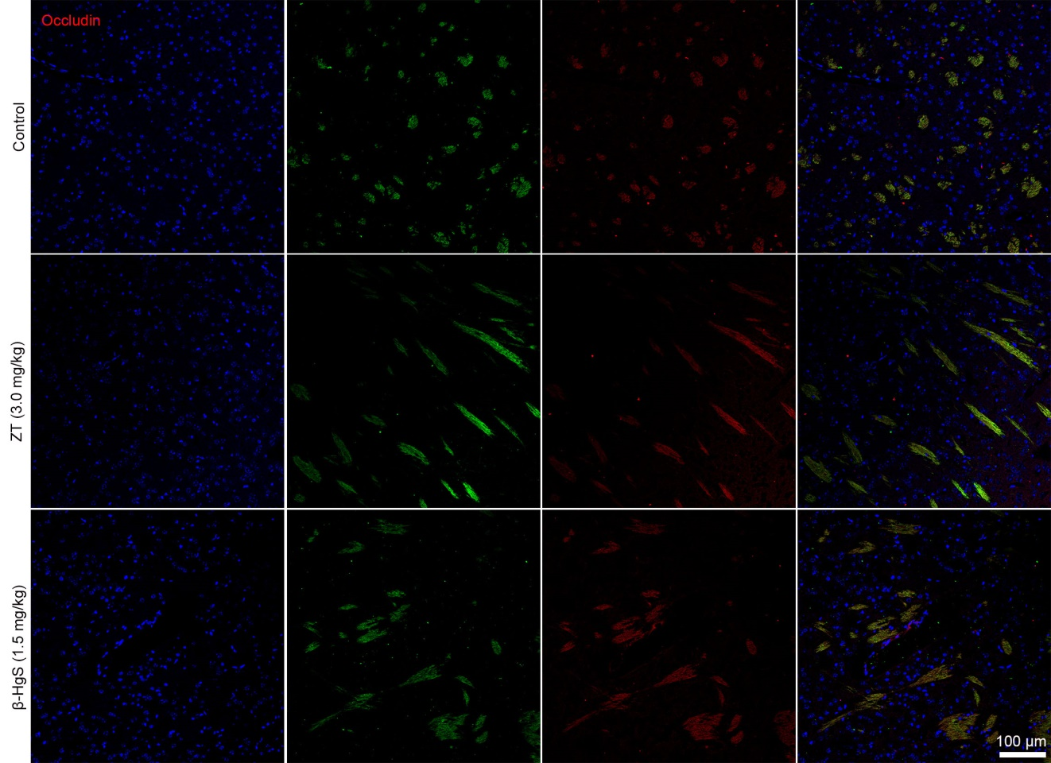
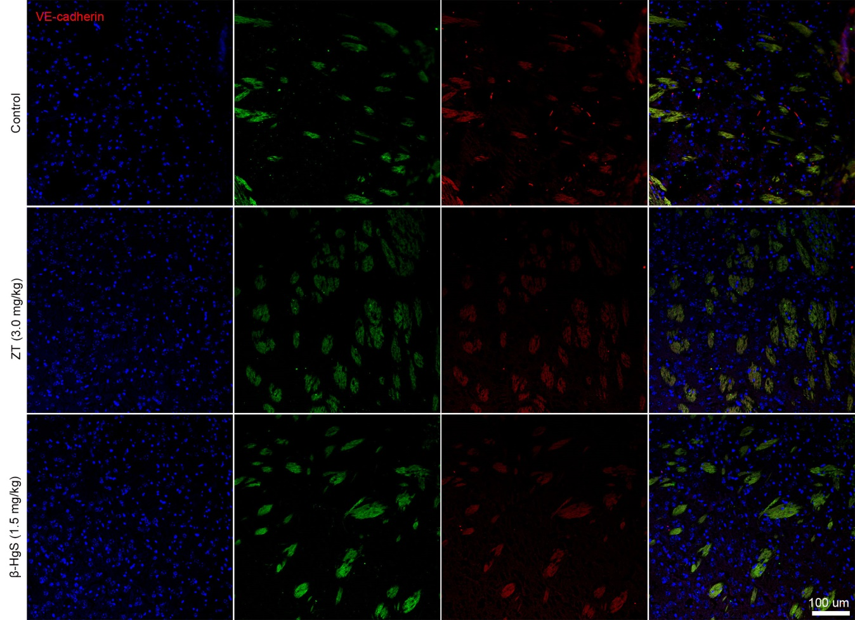
Fig. S14. Effects of ZT/β-HgS on connexins in the BBB of mice. Mice were given ZT (3.0 mg/kg) or β-HgS (1.5 mg/kg) by gavage every other day for two consecutive times. Confocal laser scanning microscopy images showed that the expression levels of tight junction proteins ZO-1, Occludin and adherens junction protein VE-cadherin in brain tissue frozen sections were not affected (n=5).

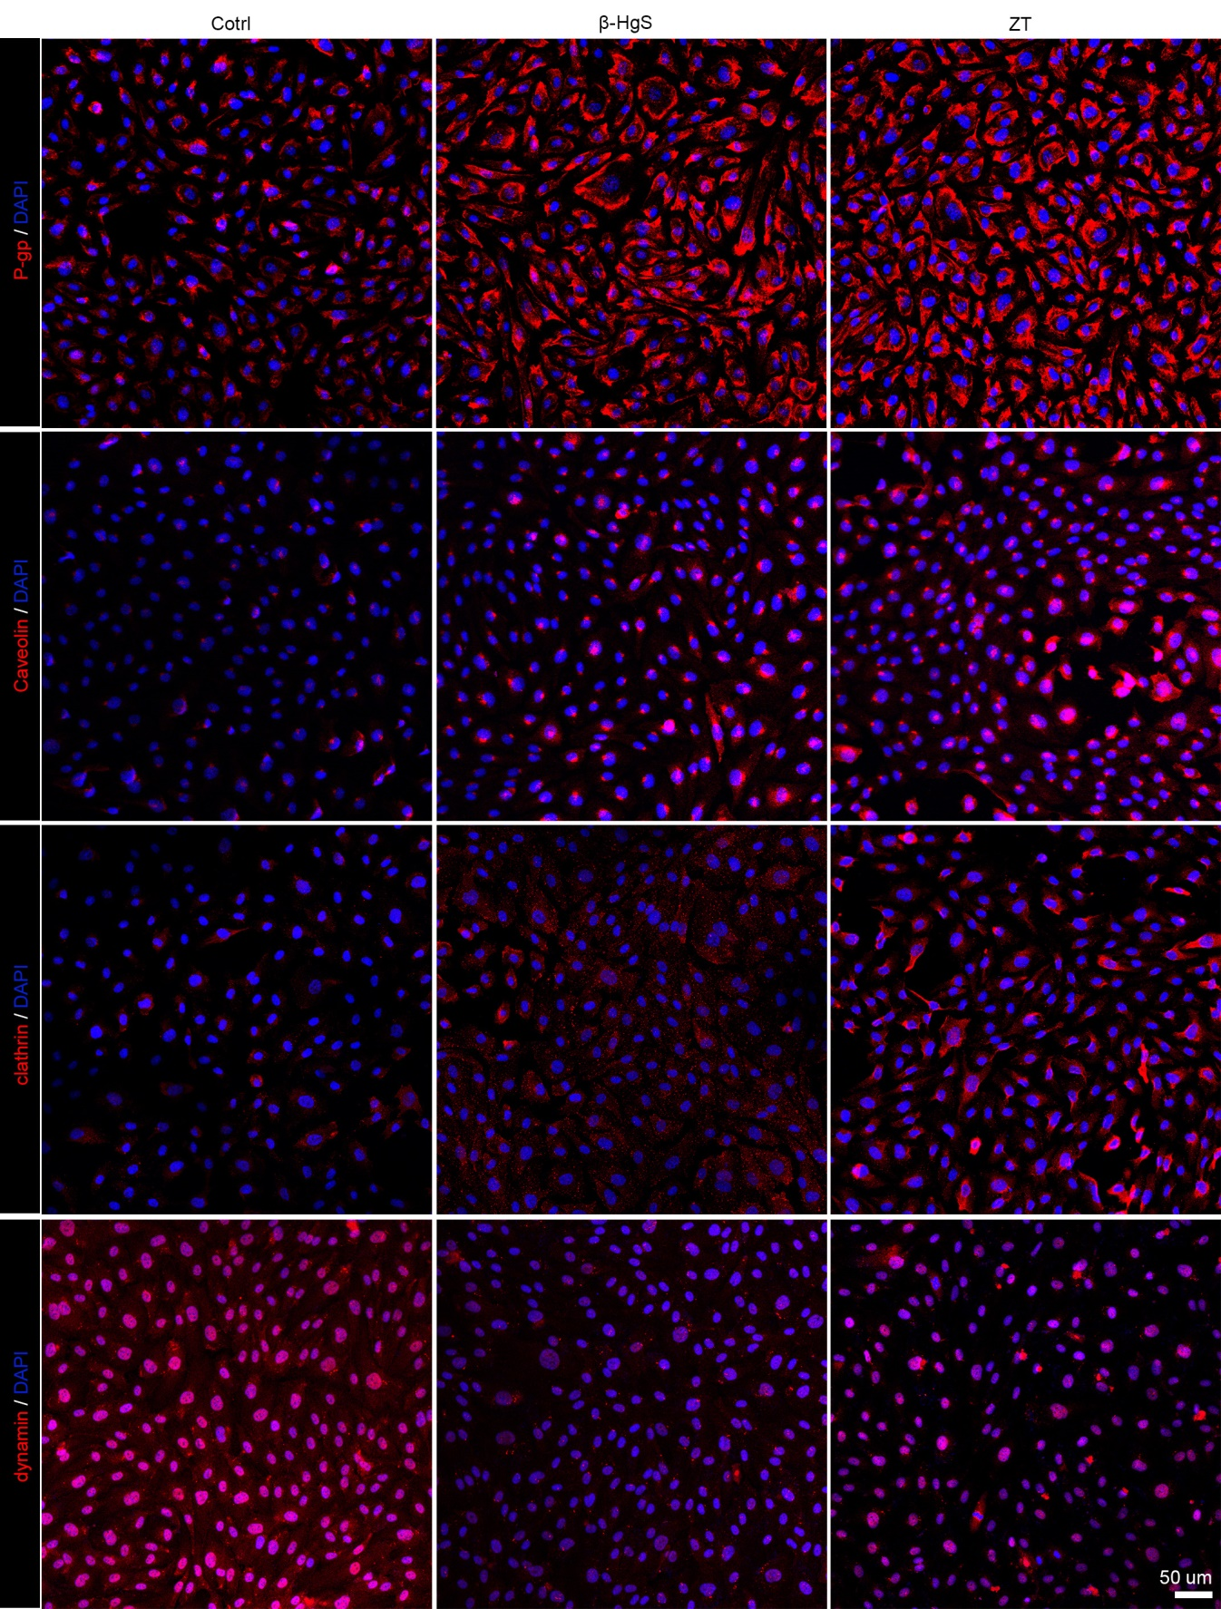
Fig. S15. The effects of ZT and β-HgS on the transporters in HBMECs at 48 h. After incubation with (300 ng/mL) or HgS (150 ng/mL), the expression of endocytosis proteins Caveolin, Clathrin and Dynamin in a cells was significantly increased, while the expression of efflux protein Pg-p was significantly down regulated. Bar: 50 μm.

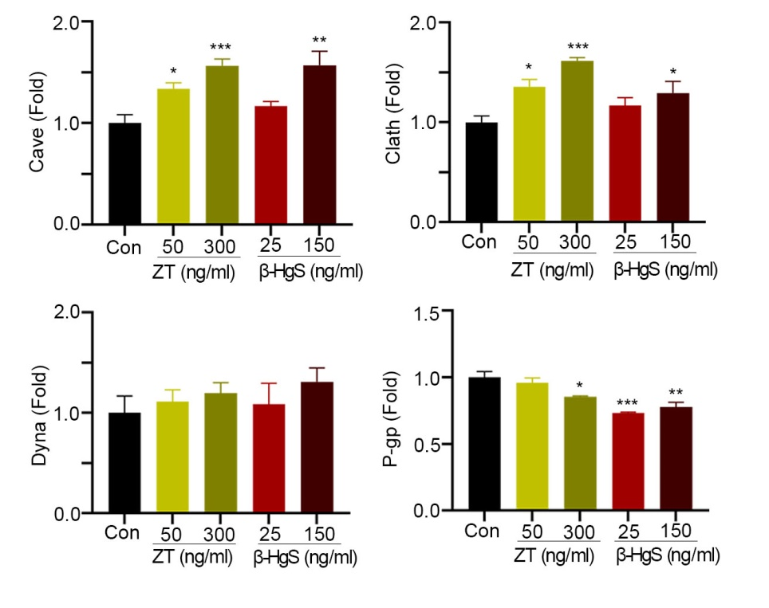
Fig. S16. Western blots confirmed that ZT/β-HgS can regulate the expression of transporters in HBMECs. HBMECs were treated with ZT or HgS at two concentrations (ZT: 50, 300 ng/mL, β-HgS: 25, 150 ng/mL) for 48 h, respectively. The expression of caveolin, clathrin, dynamin and P-gp proteins in the cells were detected by Western blots. n=3. Data were presented as means ± SEM. Experiment performed at least twice. One-way ANOVA was used to analyze the differences between groups. * P<0.05, **P<0.01, ***P<0.001 compared to Control.

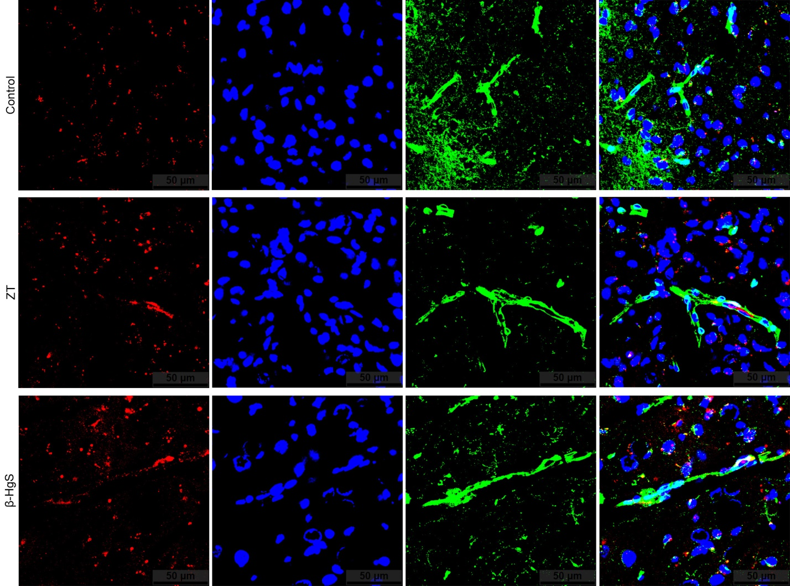
Fig. S17. Effect of ZT/β-HgS on the expression of Dynamin in brain capillaries. 4 h after mice were intragastrically administered ZT/β-HgS, the expression of Dynamin on microvessels in the brain tissue was evaluated by immunohistochemistry.

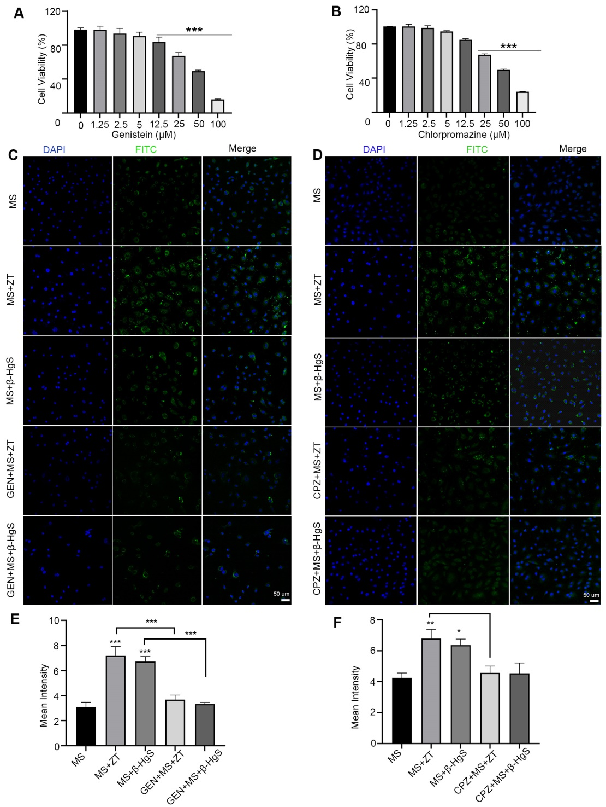
Fig. S18. Inhibitors of caveolin and crathrin can eliminate the effect of ZT/β-HgS to promote drug entry into cells. (A and B) MTT assay for detecting the cytotoxicity of genistein and chlorpromazine hydrochloride. (C and D) The effect of ZT/β-HgS in promoting drug entry into cells was eliminated in the presence of caveolin inhibitor genistein. (E and F) The effect of ZT/β-HgS in promoting drug entry into cells was eliminated in the presence of crathrin inhibitor chlorpromazine hydrochloride. HBMEC cells were seeded onto cell slides in 24-well plates. After the cells adhered and incubated with ZT orβ-HgS for 36 h, MS-275-FITC was added to continue the incubation for 12 h. Two hours before the end of culture, genistein (5 μmol/L) and chlorpromazine hydrochloride (12.5 μmol/L) were added respectively. After the culture, the images were obtained by laser confocal and the fluorescence intensity was calculated. All experiments were repeated at least three times.

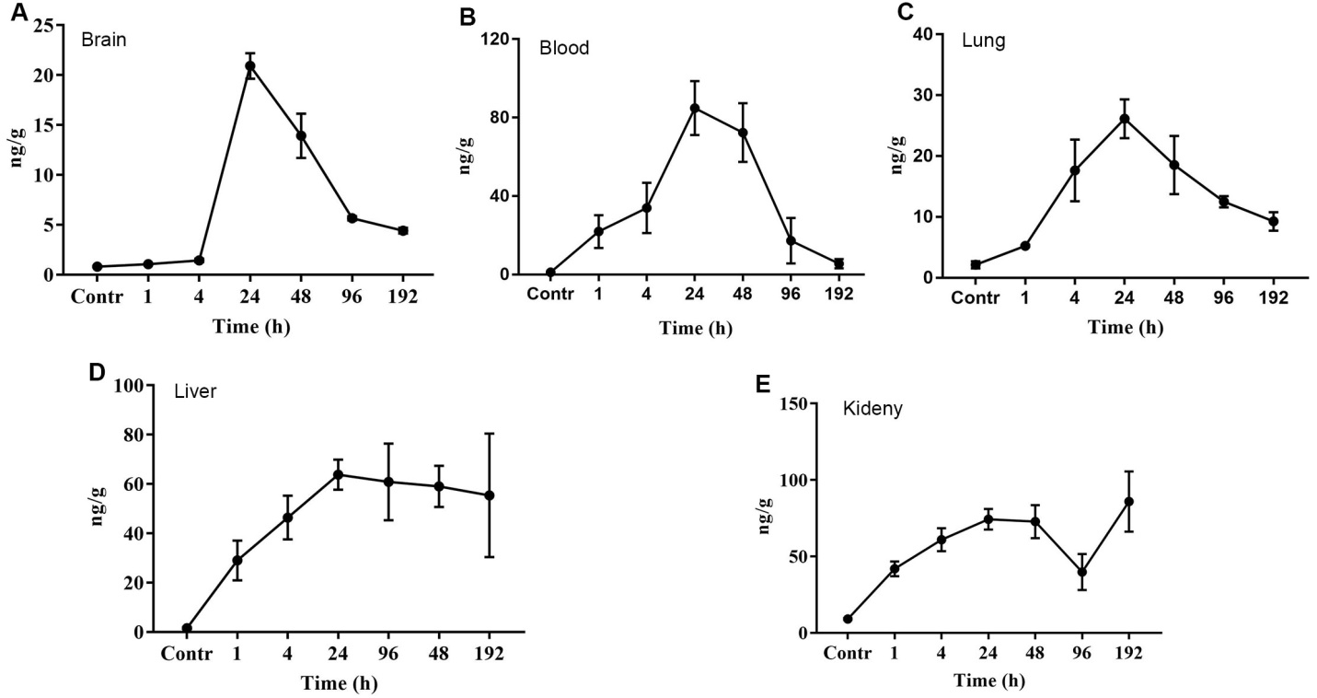
Fig. S19. Dynamic changes of Hg content in different tissues of mice after oral administration of ZT. After oral administration of ZT (3 mg/kg), the changes of Hg content in brain, blood, lung, liver and kidney of mice at different times (1, 4, 24, 48, 96 and 192 h) were detected by atomic fluorescence spectrometer. The Hg content in brain, blood and lung tissues increased with time, reaching the maximum at 24 h, and then decreased, and was basically cleared at 192 h. The changes of Hg content in brain and blood were basically consistent with the time of promoting drug into brain. However, the contents of Hg in liver and kidney as metabolic tissue were still high at 192 h.

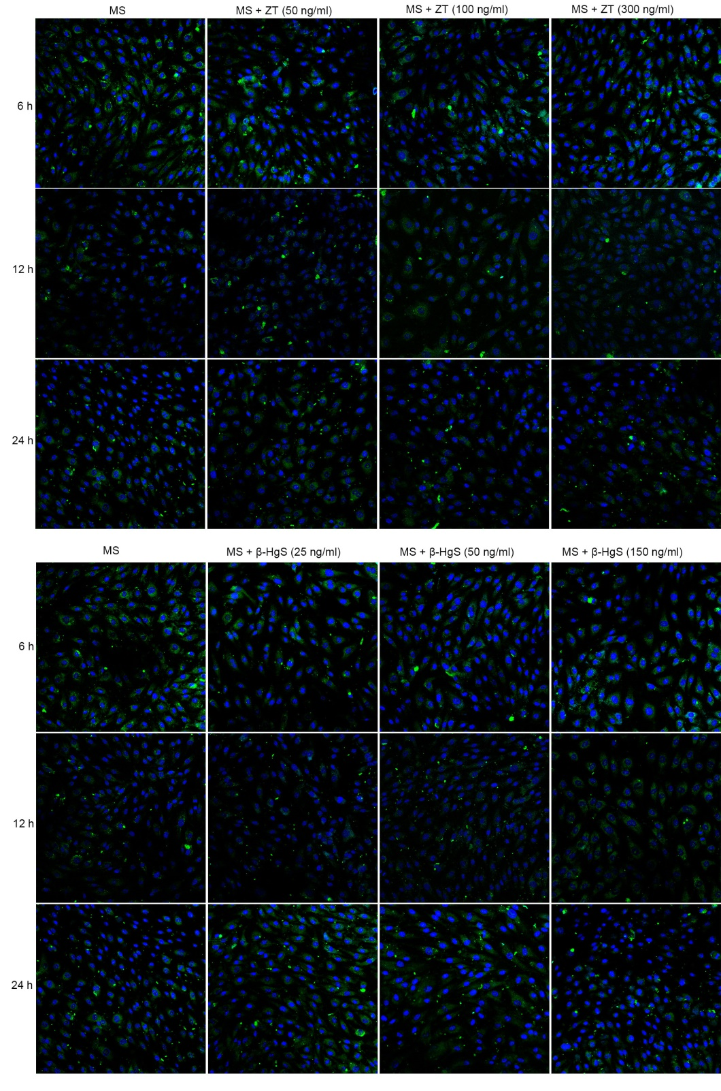
Fig. S20. ZT/β-HgS did not facilitate the entry of MS-275 into HBMEC when the treatment time was less than 24 h. When ZT and β-HgS were incubated with MS-275 (2 ng/mL) for 6, 12 and 24 h, the drug fluorescence signal in cells did not change significantly, indicating that sufficient incubation time is essential for ZT/HgS to promote drug entry into cells. This may be related to the synthesis speed of HgS NPs in cells. In a short period of time, NPs have not been synthesized or the amount synthesized is insufficient to play their role of facilitating the entry of drugs into cells.

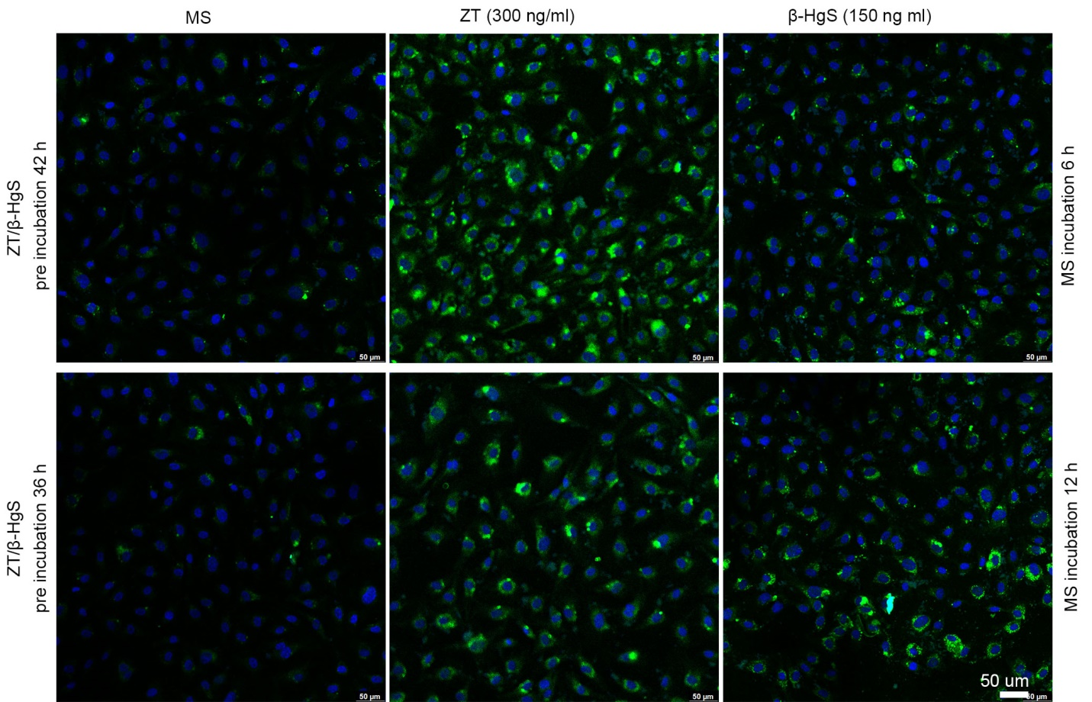
Fig. S21. Pre-incubation with ZT/β-HgS can promote MS-275 entry into cells at 6 h and 12 h.
HBMEC were pre-incubated with ZT/HgS for 36 h and 42 h to ensure the formation of HgS NPs, and then after incubation with MS-275 for 6h and 12 h respectively, the amount of drug entering the cells and the fluorescence intensity increased significantly.

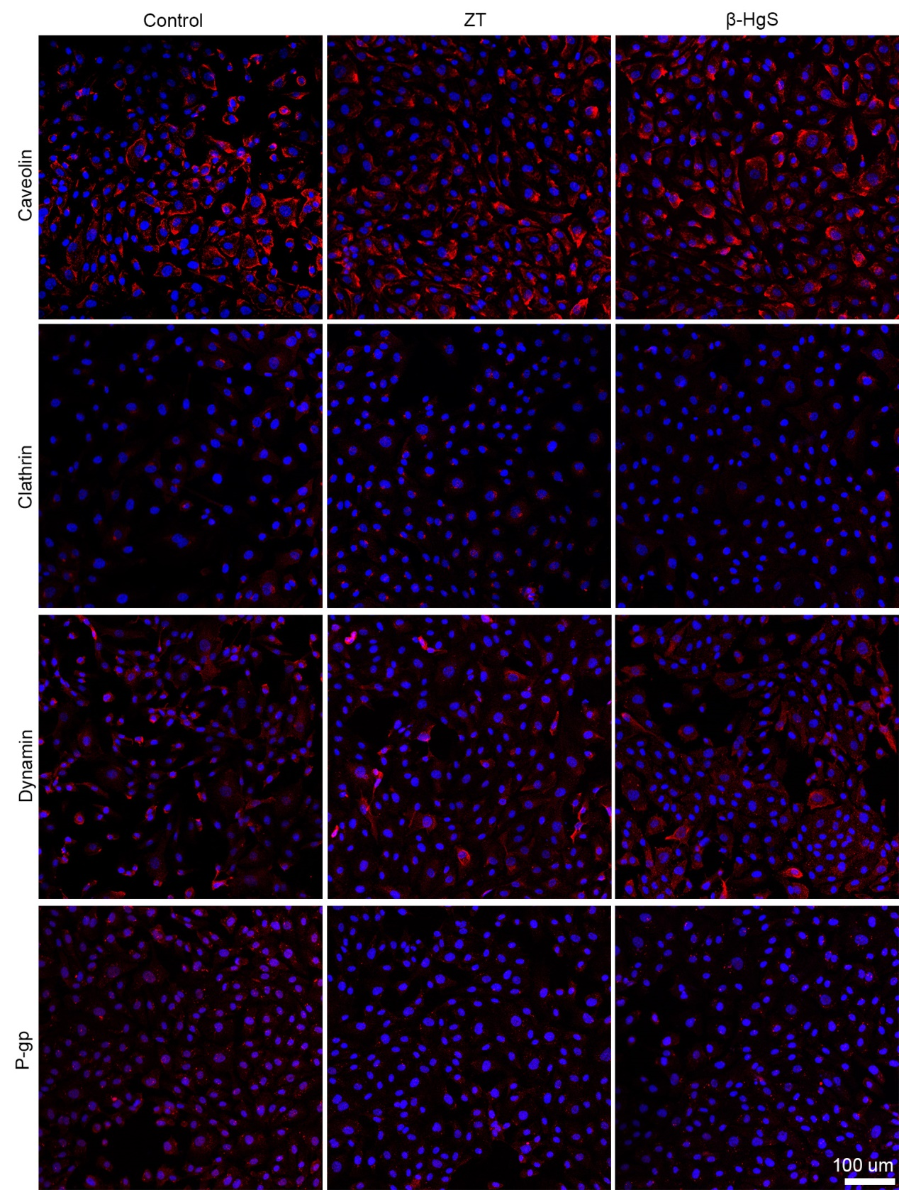
Fig. S22. The effects of ZT and β-HgS on the expression of transporters after treating HBMECs for 24 h. After 24h of incubation with ZT and β-HgS, the expression of Caveolin, Clathrin, Dynamin, and P-gp in cells was evaluated by immunocytochemistry. Except for a significant decrease in the expression of P-gp in cells, the expression of other transport proteins did not change after 24 h of ZT and β-HgS treatment.

