Supporting information
Human Serum Albumin-Based KBiF₄@HSA Nanoclusters for Dual-Energy Computed Tomography and Glutathione-Scavenging Radiotherapy of Breast Cancer
Yuelin Huang^{1,a,c}, Zhenghai Lu^{1,a}, Huanhuan Liu^{a *}, Ningxin Yangª, Yanhong Chenª, Chunting Wang ^{a,c}, Weixi Huangª, Jingjing Hu^{a,b}, Dengbin Wang^{a,b *}, Defan Yao^{a,b,c *}
a Department of Radiology, Xinhua Hospital, Shanghai Jiao Tong University School of Medicine, Shanghai 200092, China
b College of Health Science and Technology, Shanghai Jiao Tong University School of Medicine, Shanghai, 200025, China.
c Shanghai University of Sport, Shanghai 200438, China
*Corresponding authors at: Department of Radiology, Xinhua Hospital, Shanghai Jiao Tong University School of Medicine, Shanghai 200092, China
E-mail addresses: wangdengbin@xinhuamed.com.cn (D. Wang); yaodefan@xinhuamed.com.cn (D. Yao).

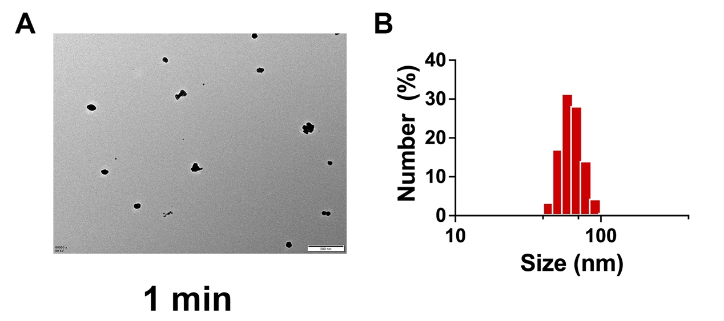
Figure S1. (A) TEM image and (B) DLS of KBiF₄@HSA at a reaction time of 1 minute (scale bar: 200 nm).
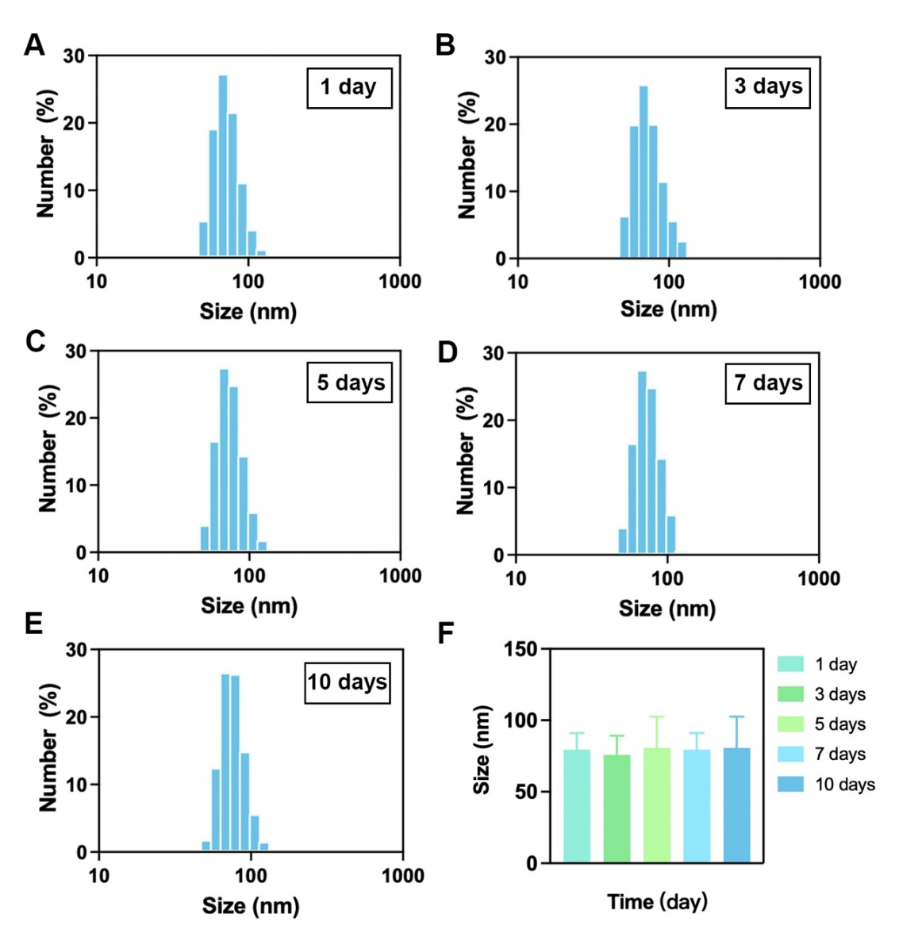
Figure S2. DLS of KBiF₄@HSA at 1, 3, 5, 7, and 10 days after synthesis.
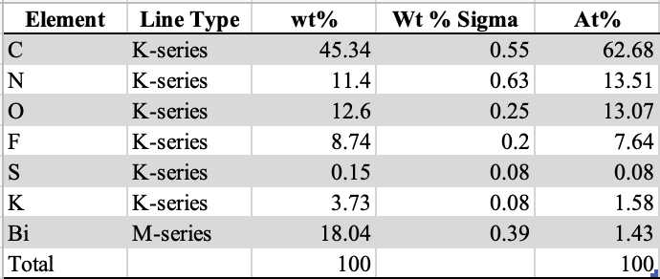
Figure S3. Elemental distribution table of KBiF₄@HSA.

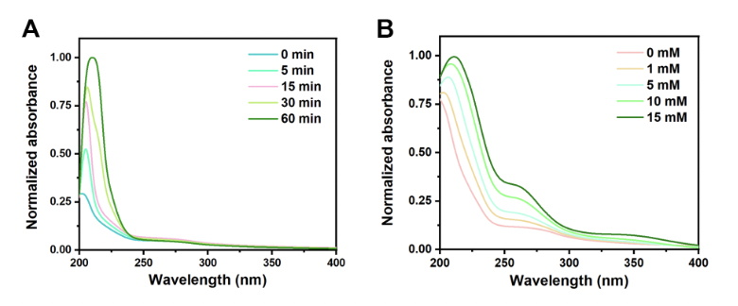
Figure S4. (A) UV-Vis absorption spectra of KBiF₄@HSA at various time intervals following their reaction with GSH. (B) UV-Vis absorption spectra of KBiF₄@HSA after reaction with varying concentrations of GSH.
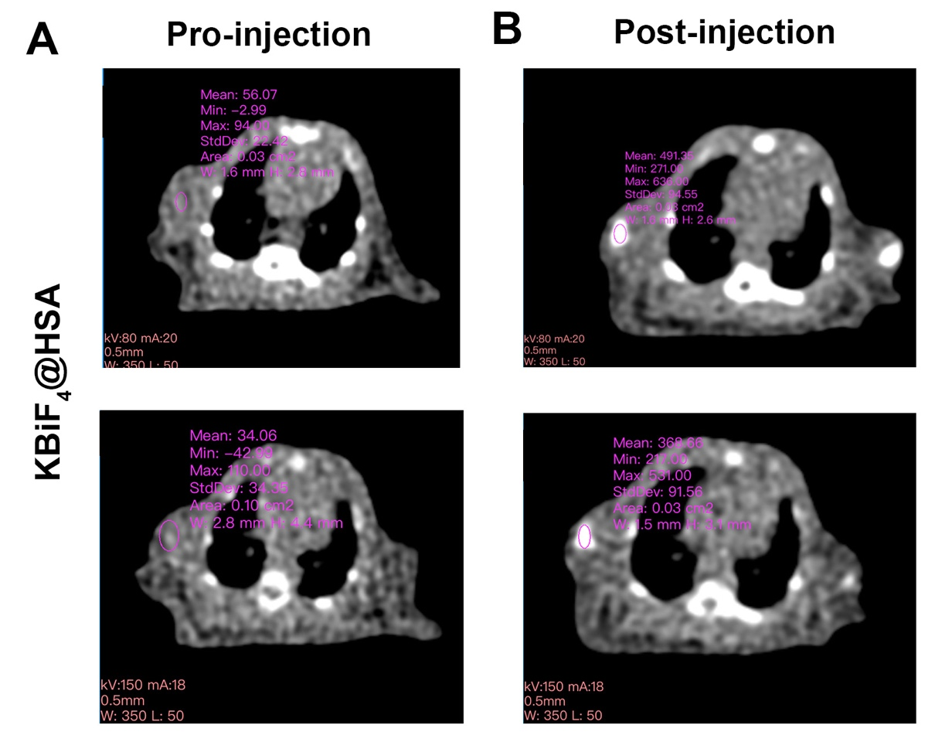
Figure S5. A comparative analysis of CT values for KBiF₄@HSA in tumor tissues before and after injection at 80/150 keV.
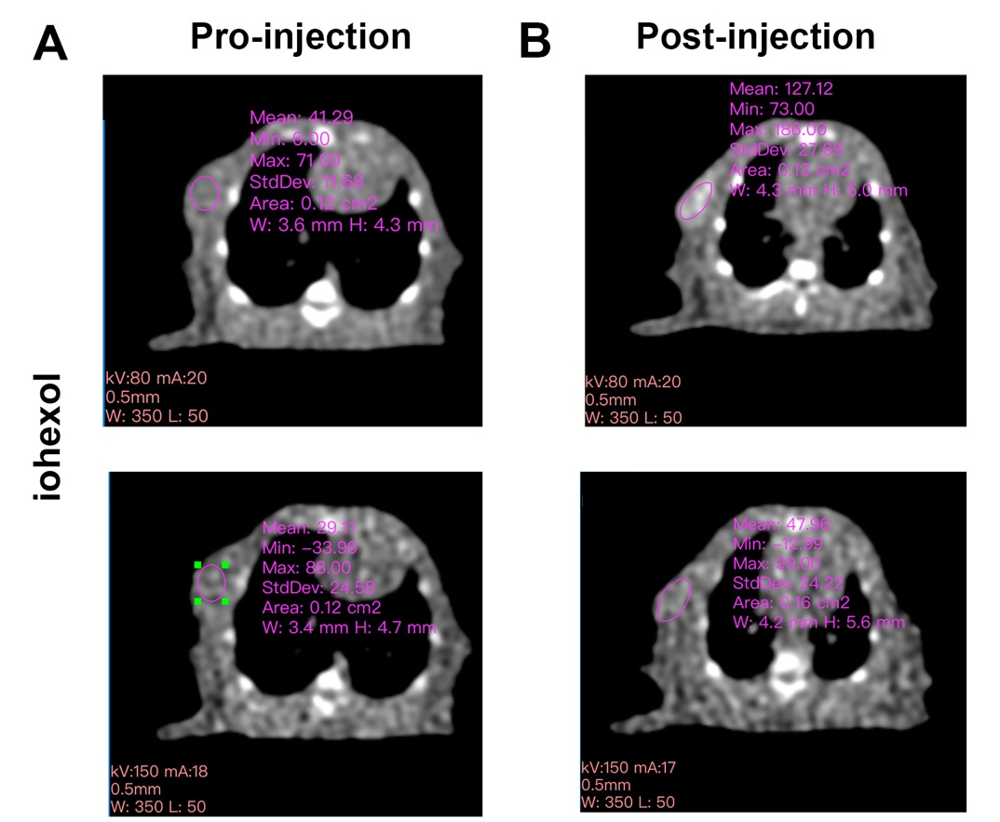
Figure S6. Comparison of CT values of the iohexol before and after injection at 80/150 keV.
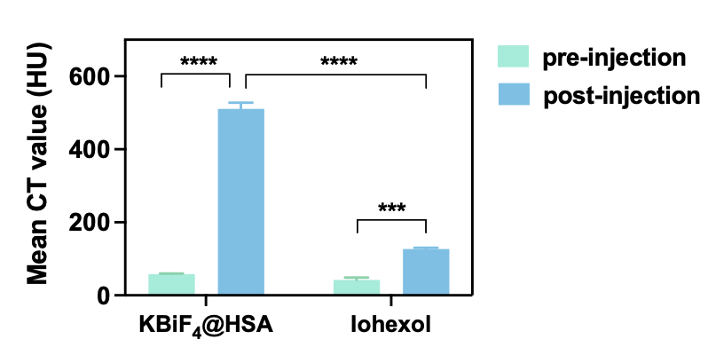
Figure S7. Quantitative analysis of in vivo energy spectrum CT imaging signals in rats at 80 keV. The data are shown as the mean ± standard deviation (SD), as calculated using two-way ANOVA followed by post hoc tests with *p < 0.05, **p < 0.01, ***p < 0.001, and ****p < 0.0001.
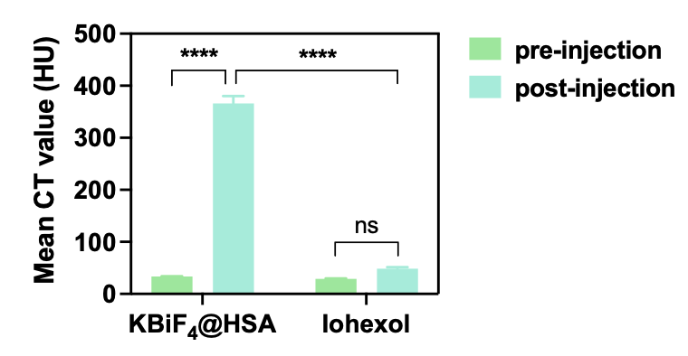
Figure S8. Quantitative analysis of in vivo energy spectrum CT imaging signals in rats at 150 keV. The data are shown as the mean ± SD, as calculated using two-way ANOVA followed by post hoc tests with *p < 0.05, **p < 0.01, ***p < 0.001, and ****p < 0.0001.
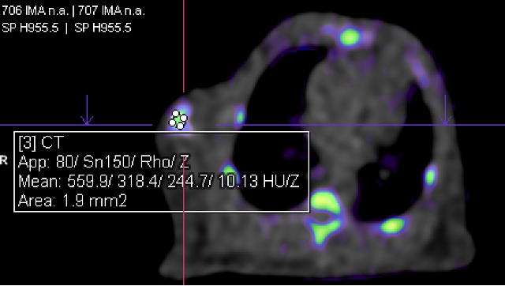
Figure S9. Z_{eff} values of the KBiF₄@HSA post-injection.
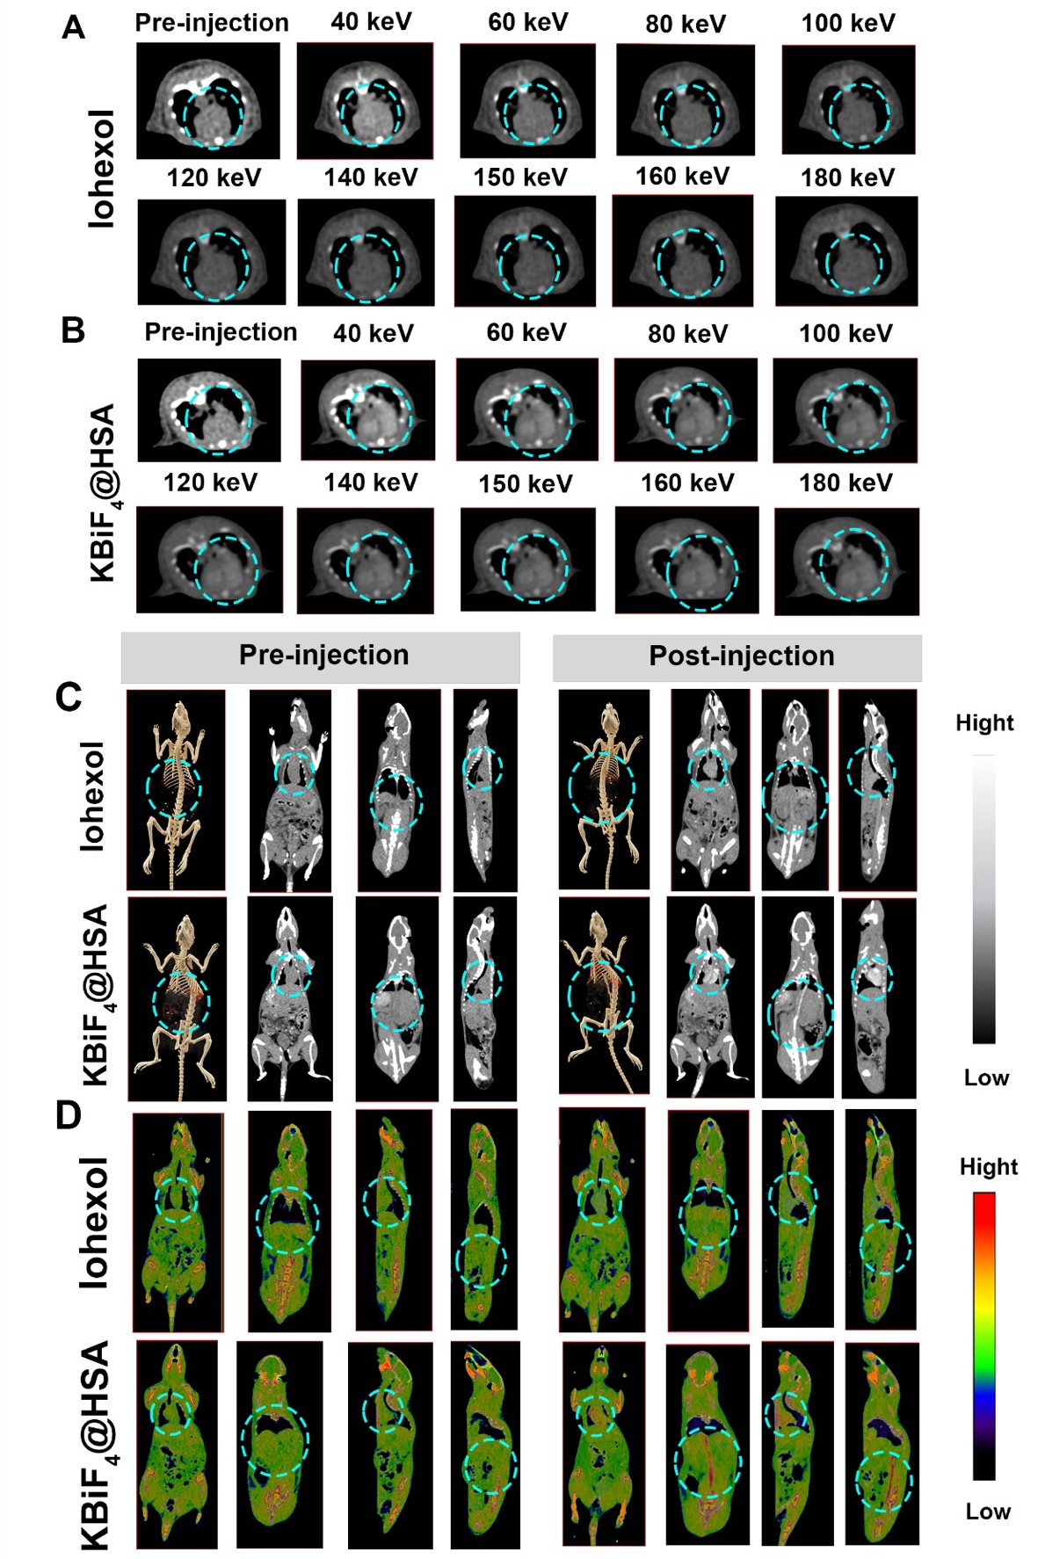
Figure S10. (A) Cardiac imaging at different radiation energies of KBiF₄@HSA. (B) Cardiac imaging at different radiation energies of iohexol. (C) Cardiac imaging at different anatomical positions of KBiF₄@HSA and iohexol. (D) Cardiac imaging and vascular imaging at the Z_{eff} values of KBiF₄@HSA. (The blue circles indicate cardiac/vascular regions.)
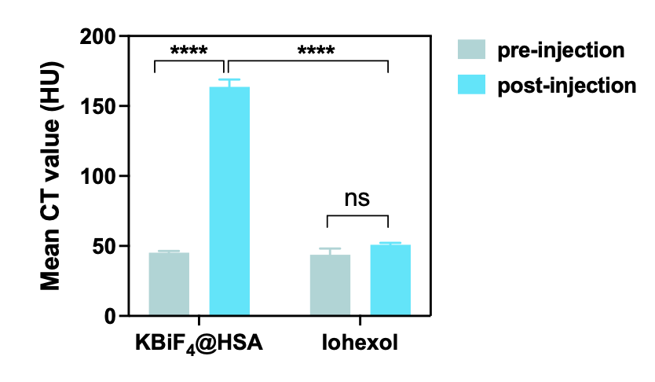
Figure S11. Quantitative analysis of in vivo cardiac imaging signals in rats at 80 keV. The data are shown as the mean ± SD, as calculated using two-way ANOVA followed by post hoc tests with *p < 0.05, **p < 0.01, ***p < 0.001, and ****p < 0.0001.
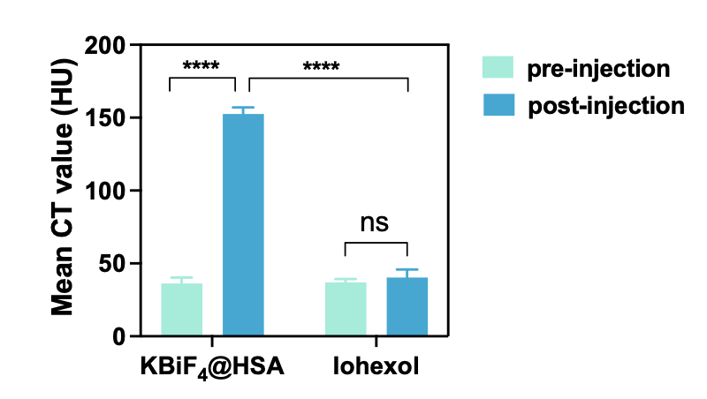
Figure S12. Quantitative analysis of in vivo cardiac imaging signals in rats at 150 keV. The data are shown as the mean ± SD, as calculated using two-way ANOVA followed by post hoc tests with *p < 0.05, **p < 0.01, ***p < 0.001, and ****p < 0.0001.
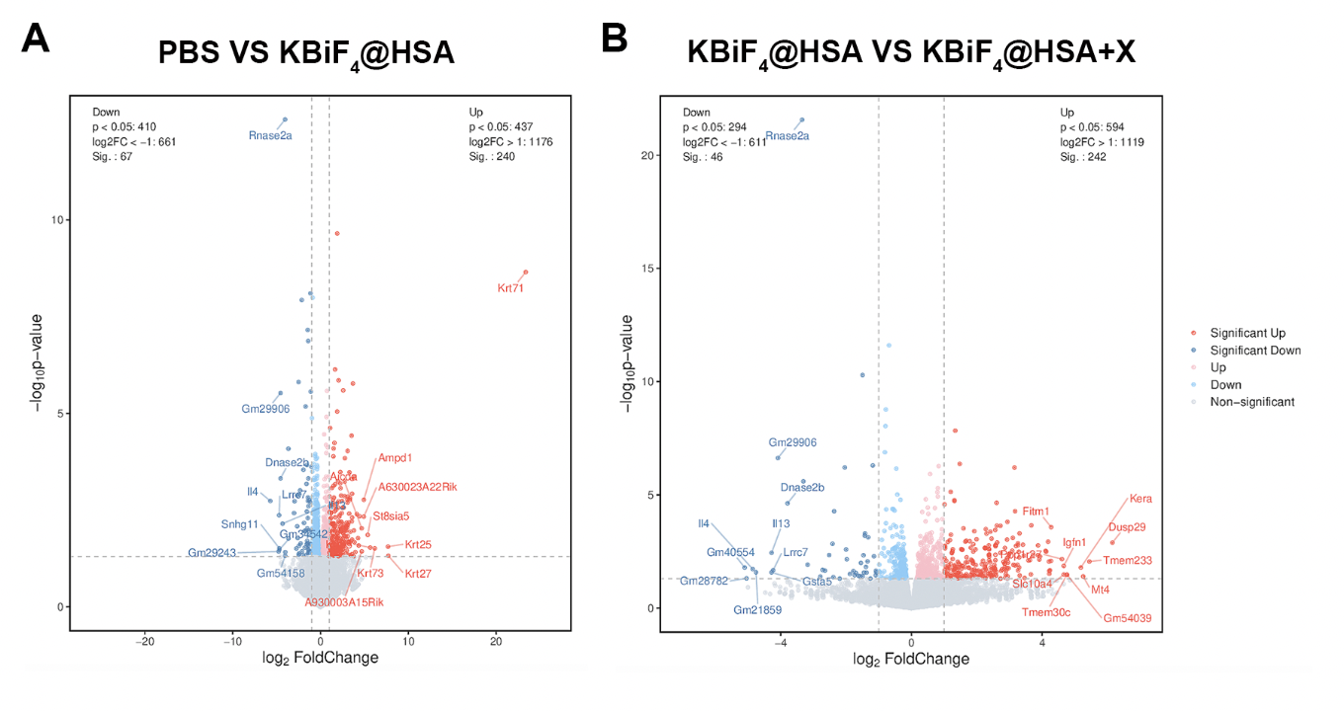
Figure S13. (A) The volcano plot illustrates the genes that are either downregulated or upregulated in the KBiF₄@HSA group compared to the PBS group. (B) The volcano plot shows the differential gene expression in the KBiF₄@HSA group relative to the KBiF₄@HSA+X group.

