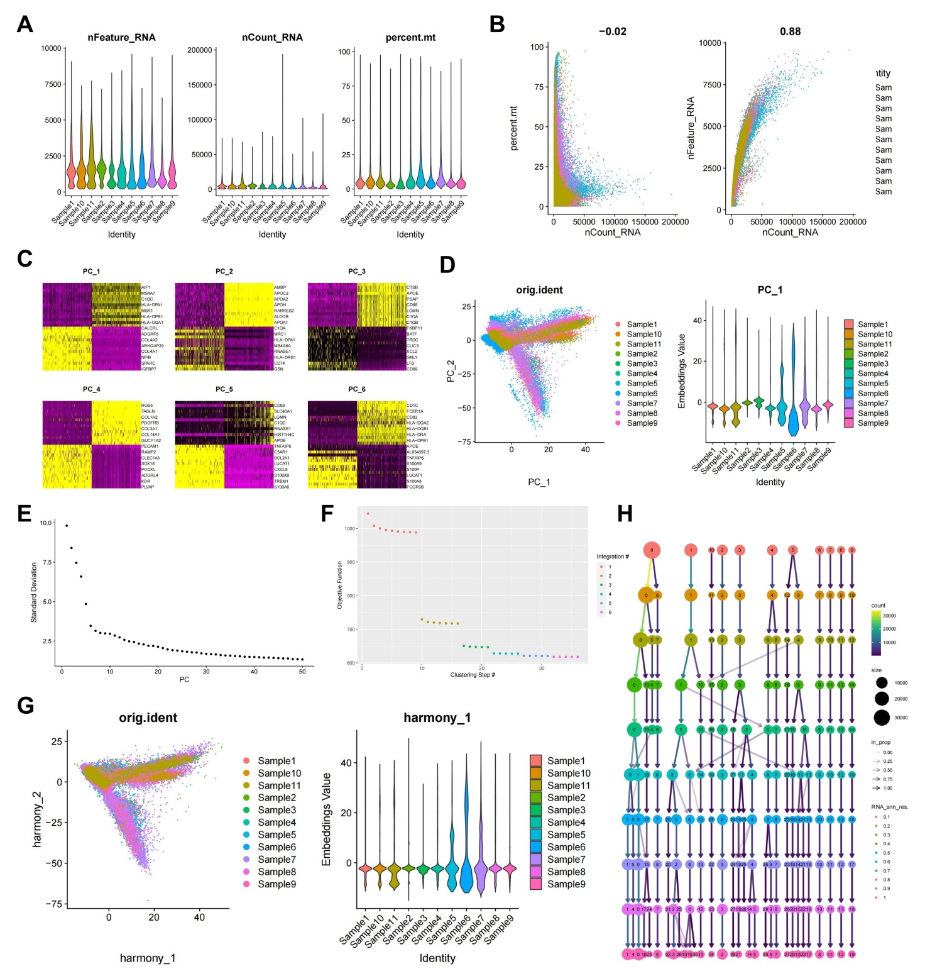
Figure S1. Quality Control, Filtering, and PCA of scRNA-seq Data.
Note: (A) Violin plots showing the distribution of gene counts (nFeature_RNA), mRNA molecule counts (nCount_RNA), and mitochondrial gene percentage (percent.mt) per cell in scRNA-seq data; (B) Scatter plots illustrating the correlations between nCount_RNA and percent.mt, and between nCount_RNA and nFeature_RNA after data filtering; (C) Heatmaps of the top 20 genes correlating with PC_1–PC_6 in PCA, where yellow indicates upregulated expression and purple indicates downregulated expression; (D) Left: Distribution of cells in PC_1 and PC_2 before batch correction, with each point representing a cell, right: Violin plots showing the distribution of cells in PC_1 and PC_2; (E) Harmony batch correction process, with the x-axis representing the number of interaction iterations; (F) Distribution of standard deviations (standard deviation) of PCs, with significant PCs showing larger standard deviations; (G) Left: Cell distribution in PC_1 and PC_2 after Harmony batch correction, with each point representing a cell, right: Violin plots of the distribution after correction; (H) Clustree package displays clustering outcomes at different resolutions.

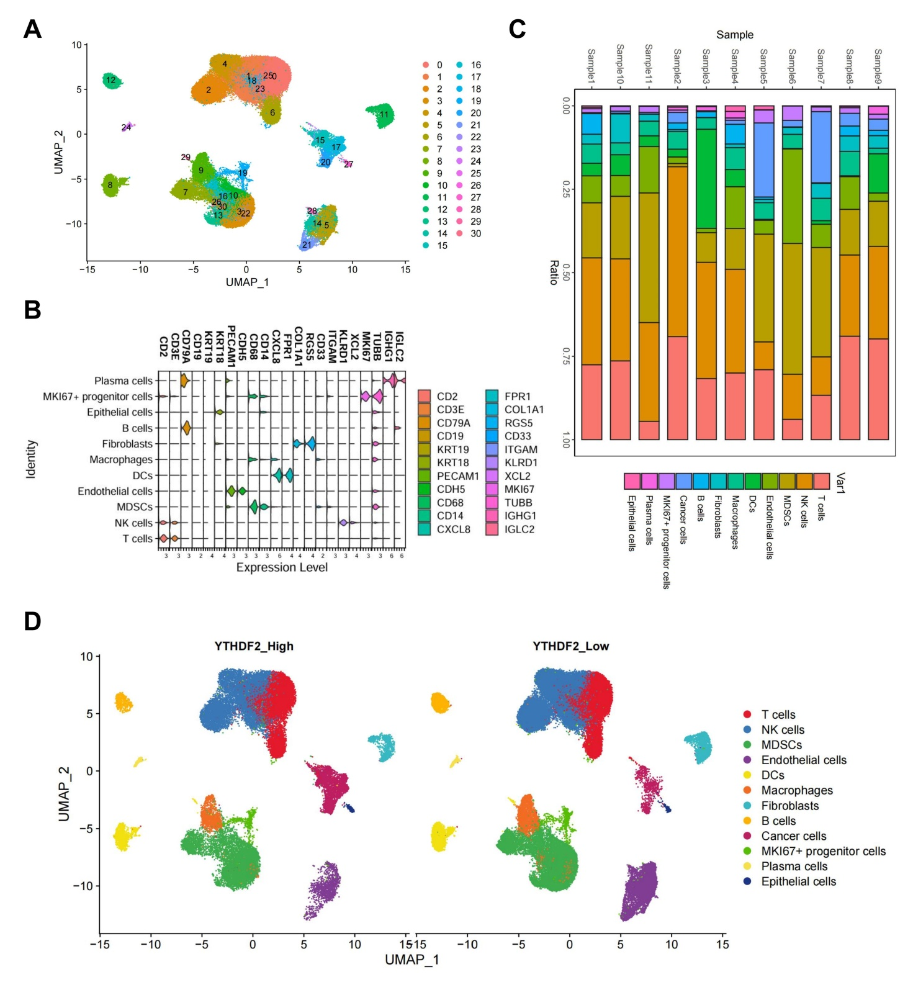
Figure S2. scRNA-seq Cell Clustering.
Note: (A) Visualization of UMAP clustering results, illustrating cell aggregation and distribution where each color represents a distinct cluster; (B) Dot plot showing marker gene expression across 11 cells; (C) Proportions of 12 cell types in 11 samples following annotation of malignant cells; (D) Visualization of cell annotations based on UMAP clustering results after annotating malignant cells.

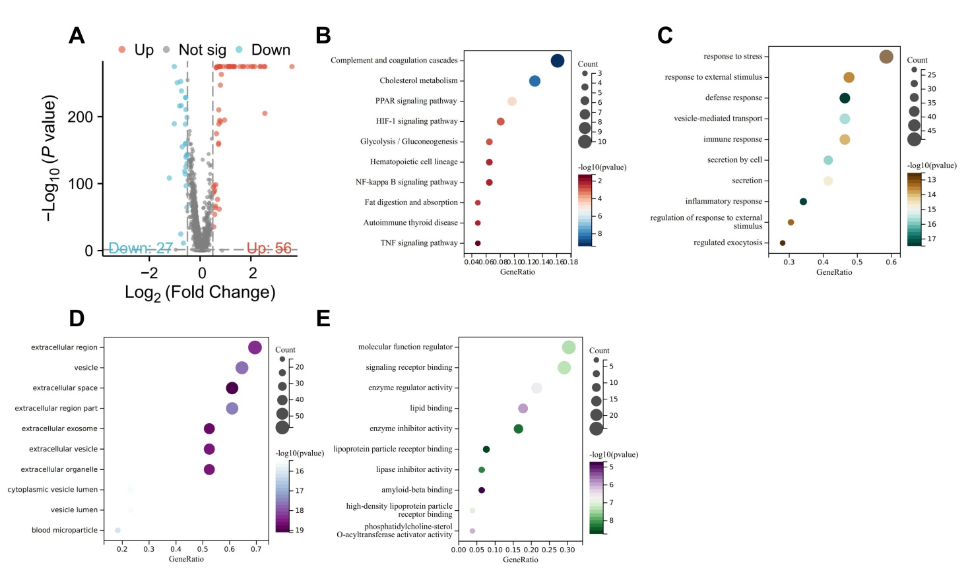
Figure S3. Differential Analysis in MDSC Cells.
Note: (A) Volcano plot showing differential expression between YTHDF2 low and high expression groups in MDSCs. Red indicates significantly upregulated genes, blue represents significantly downregulated genes, and gray denotes genes with no significant difference; (B-E) Functional enrichment analysis of DEGs: (B) KEGG pathways, (C) BP, (D) CC, (E) MF. Sample sizes: YTHDF2_Low: n=7, YTHDF2_High: n=4.

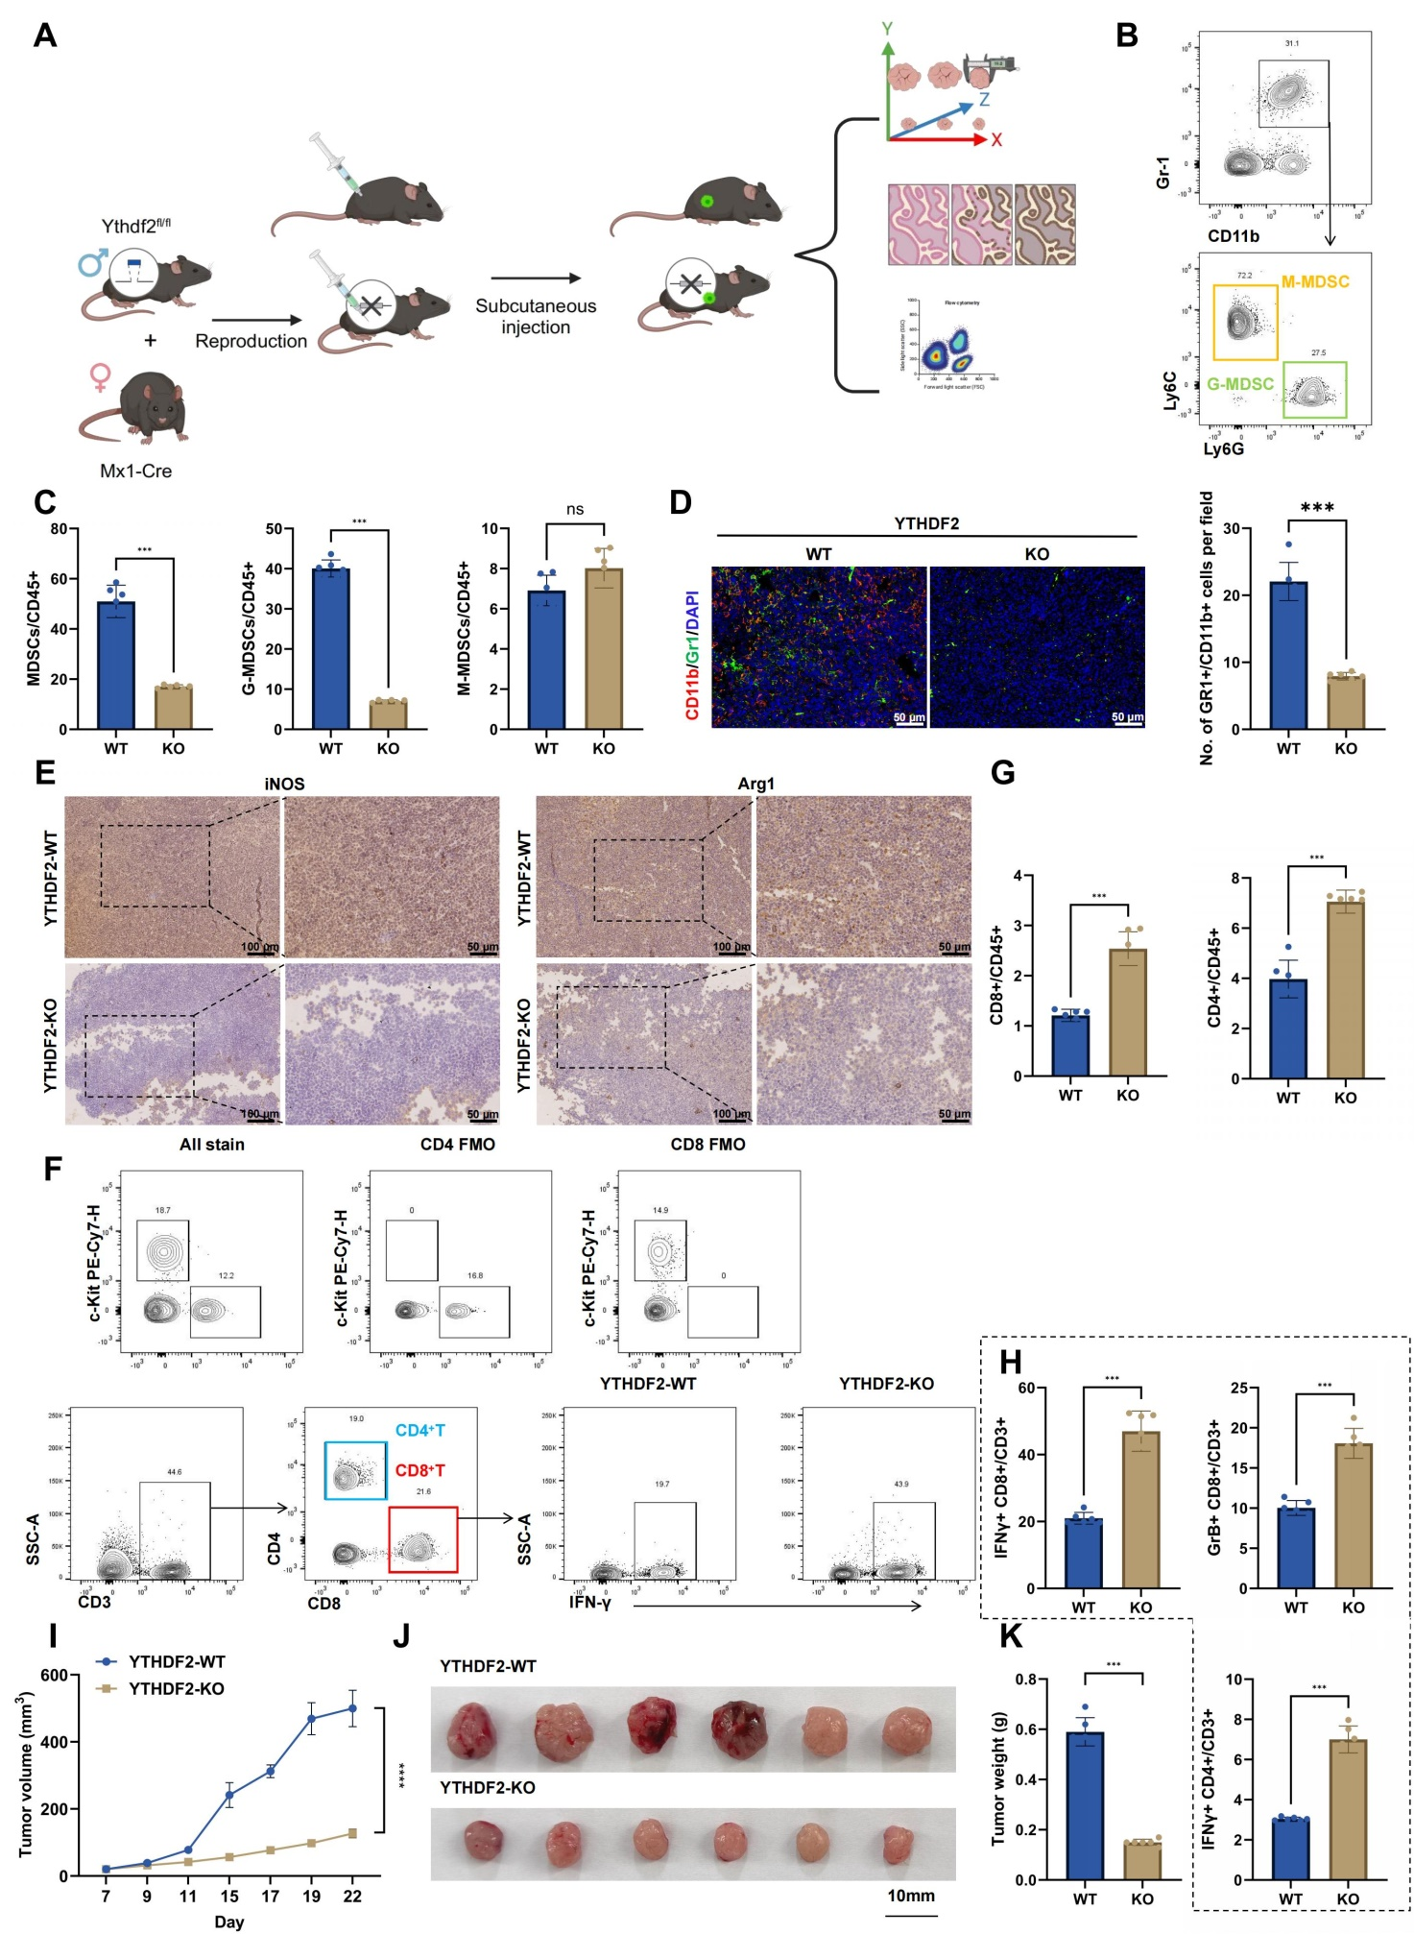
Figure S4. Impact of YTHDF2 Knockout on the TME and Immunosuppressive Status in Tumor-Bearing Mice.
Note: (A) Schematic diagram of the Cre-LoxP system used to construct the conditional YTHDF2 knockout mouse model; (B) Flow cytometry analysis of changes in CD11b⁺Gr-1⁺ MDSCs population within the tumors of tumor-bearing mice; (C) Flow cytometry analysis of the ratio changes between G-MDSCs and M-MDSCs; (D) Immunofluorescence identification of MDSCs cells in subcutaneous tumors; scale bar: 50 μm; (E) Immunohistochemical detection of iNOS and Arg1 expression levels in tumor tissues; scale bar: 100 μm; (F) Gating strategy for flow cytometry; (G) Flow cytometry assessment of CD8⁺T cell and CD4⁺T cell infiltration in tumor tissues; (H) Flow cytometry quantification of IFN-γ⁺CD8⁺ T cells, Granzyme B⁺ CD8⁺ T cells, and IFN-γ⁺CD4⁺ T cells in tumor tissues; (I-K) Monitoring of tumor volume and weight. * indicates statistical significance between groups, **p<0.01, ***p<0.001. Each group comprised six mice.

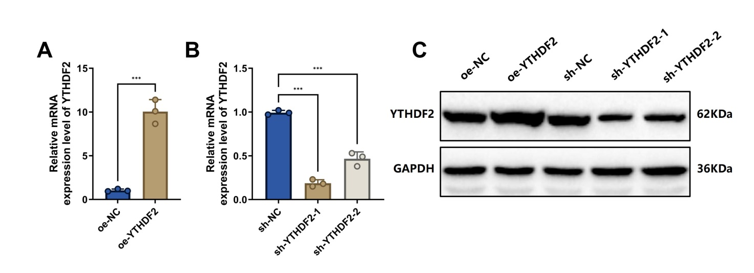
Figure S5. The efficiency of YTHDF2 Knockdown or Overexpression in MDSCs.
Note: (A-B) RT-qPCR analysis of YTHDF2 mRNA expression levels in MDSCs following lentiviral-mediated overexpression or knockdown of YTHDF2; (C) Western blot analysis of YTHDF2 protein expression levels in MDSCs after lentiviral-mediated overexpression or knockdown. Cell experiments were replicated three times. Asterisks indicate significant differences between groups, with *p<0.05 and ***p<0.001.

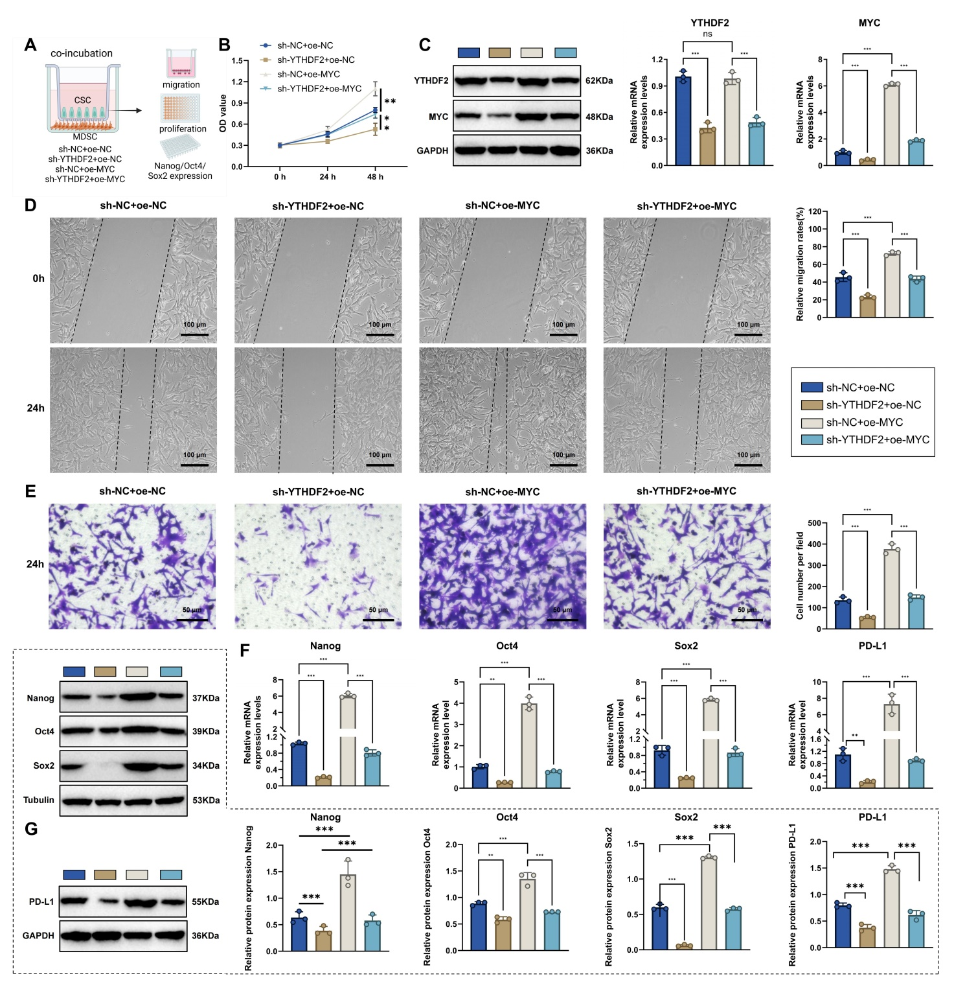
Figure S6. Impact of YTHDF2 Knockout on the Functional Phenotype of MDSCs in CSCs.
Note: (A) Schematic of the experiment where MDSCs and CSCs were co-cultured using Transwell plates; (B) Expression of YTHDF2 and MYC assessed by Western blot and RT-qPCR; (C) Proliferation of various CSC groups measured using the CCK8 assay; (D) Scratch assay evaluating the migration and invasion abilities of CSCs in different groups, bar=100 μm; (E) Transwell migration assay assessing the invasion capabilities of CSC groups, bar=50 μm; (F) Expression levels of stemness genes Nanog, Oct4, and Sox2, as well as PD-L1 in CSC groups, quantified by RT-qPCR; (G) Western blot analysis of stemness genes Nanog, Oct4, and Sox2, and PD-L1 expression in various CSC groups. *p<0.05, **p<0.01, ***p<0.001; experiments were repeated three times.

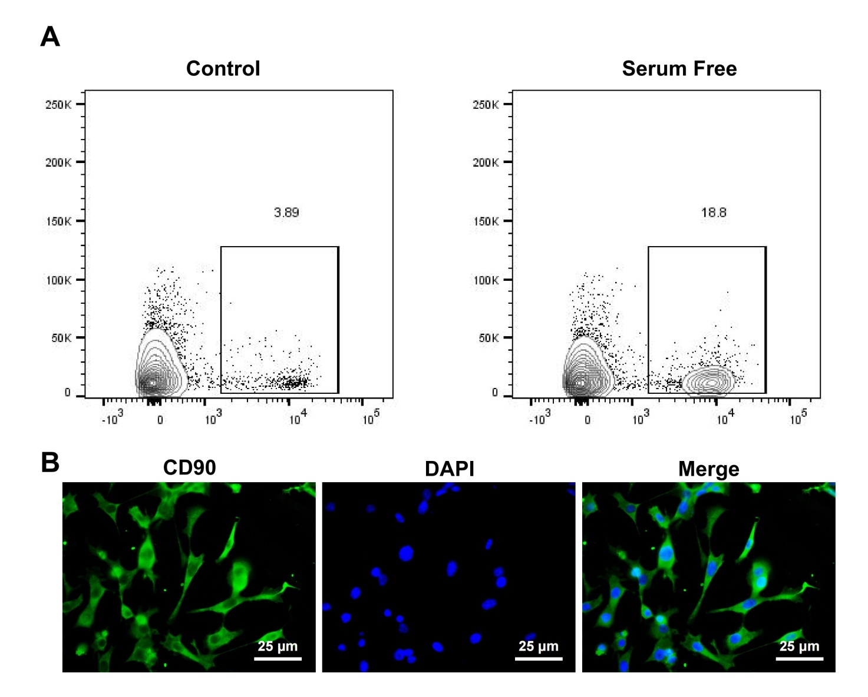
Figure S7. Impact of YTHDF2 Knockout on the Functional Phenotype of MDSCs in CSCs.
Note: (A) Flow cytometry analysis of enriched CSCs in Hepa 1-6 cells; (B) Immunofluorescence staining identifying enriched HCC stem cells, bar=25 μm; (C) The cell experiments were repeated three times.

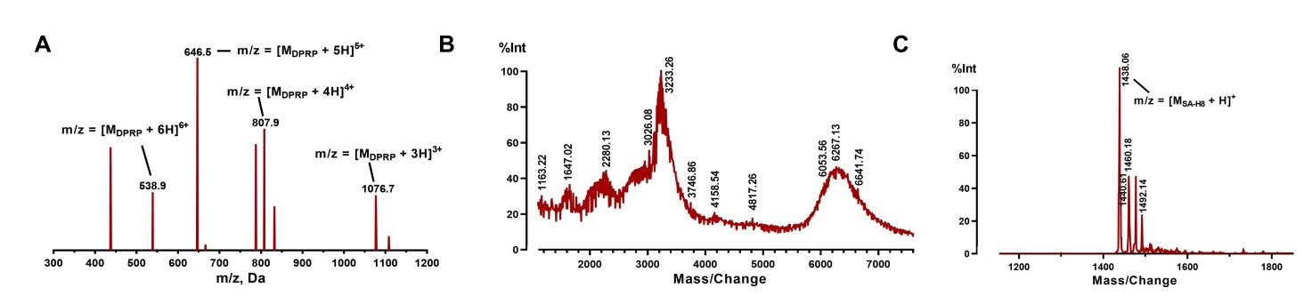
Figure S8. Structural Identification and Coupling Reaction Validation of DSPE-PEG2000-DPRP and SA-H8.
Note: (A) Positive ion electrospray ionization mass spectrum of DPRP; (B) MALDI-TOF mass spectrum of DSPE-PEG2000-DPRP (Ac-CGehGehGehGehGG-benzoic imine-rrrrrrrrGC); (C) Mass spectrometric analysis of the structure of SA-H8.

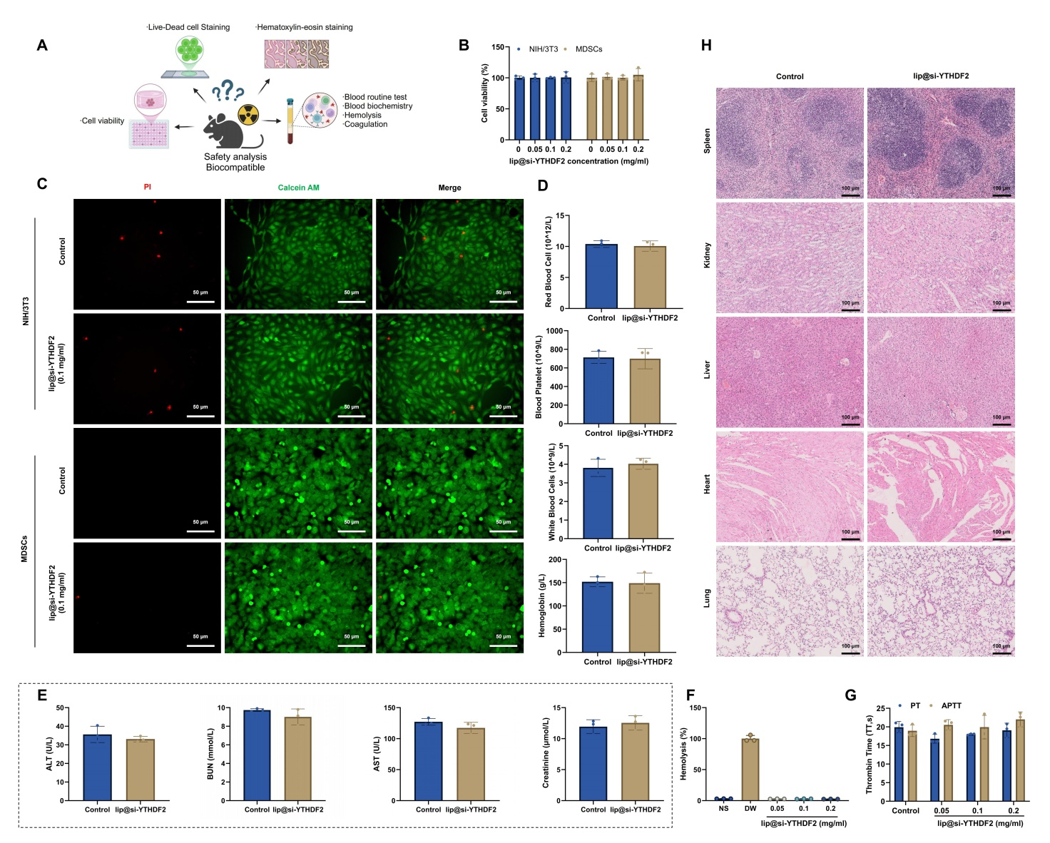
Figure S9. In Vitro and In Vivo Toxicity Assessment of Lip@si-YTHDF2.
Note: (A) Schematic diagram of the toxicity evaluation experiments for lip@si-YTHDF2; (B) Survival rates of MDSCs and NIH/3T3 cells after treatment with different concentrations of lip@si-YTHDF2, as determined by CCK-8 assay; (C) Viability of cells treated with lip@si-YTHDF2 assessed through live/dead cell staining, bar: 50 μm; (D) Hematological analysis showing changes in counts of RBC, WBC, and PLT in mice after treatment with lip@si-YTHDF2; (E) Blood biochemical analysis measuring levels of ALT, AST, BUN, and Cr in mice following lip@si-YTHDF2 treatment; (F) Hemolysis assay evaluating the hemolytic effect of lip@si-YTHDF2 on RBC; (G) Coagulation time assessment (APTT and PT) to examine the impact of lip@si-YTHDF2 on the coagulation system; (H) H&E staining to observe histopathological changes in major organs (liver, kidney, spleen, lungs, heart) of mice treated with lip@si-YTHDF2, bar: 100 μm. Each group included three mice.
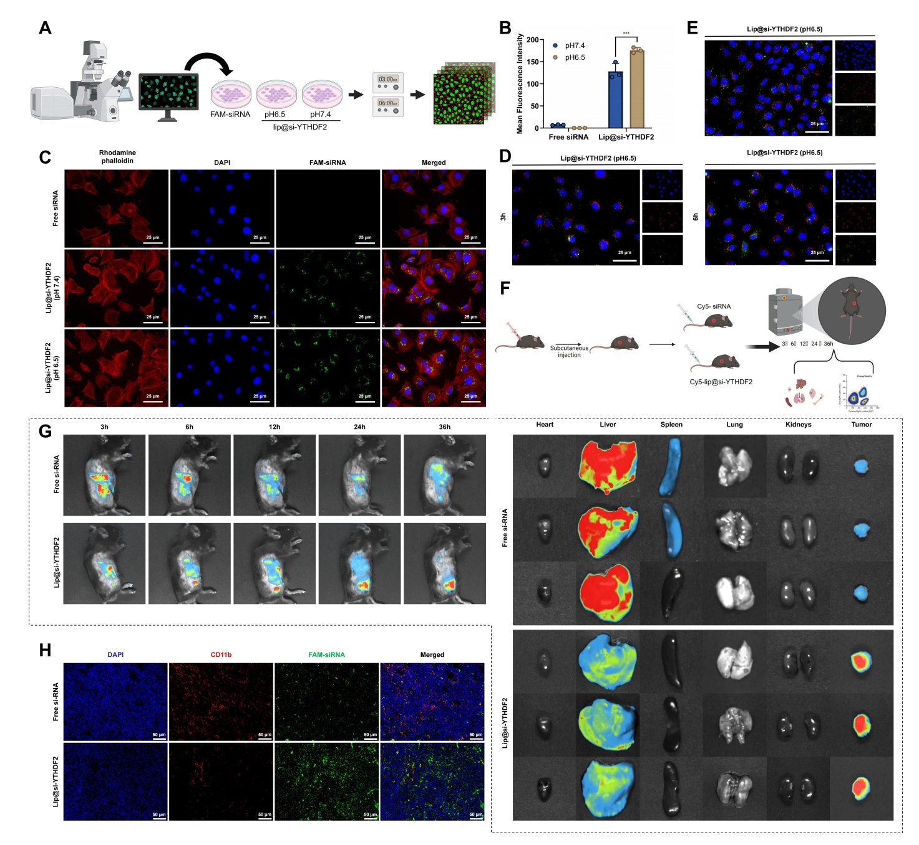
Figure S10. Uptake, Internalization, and Distribution of lip@si-YTHDF2 in MDSCs.
Note: (A) Schematic representation of the uptake and internalization of lip@si-YTHDF2 by MDSCs; (B) Fluorescence microscopy assessing the uptake of free FAM-siRNA and FAM-labeled lip@si-YTHDF2 by MDSCs at pH 6.5 and pH 7.4; (C) CLSM analysis of the uptake and distribution of FAM-labeled lip@si-YTHDF2 in MDSCs under pH 6.5 and pH 7.4 conditions; scale bar: 25 μm; (D) CLSM images showing the intracellular transport and colocalization of FAM-labeled lip@si-YTHDF2 with early endosomes in MDSCs after 3 and 6 hours of incubation at pH 6.5; scale bar: 25 μm; (E) LysoTracker Red staining to monitor changes in the colocalization of FAM-siRNA with late endosomes/lysosomes at pH 6.5; scale bar: 25 μm. FAM-siRNA fluorescence (green), cell nuclei, F-actin, early endosomes, and late endosomes/lysosomes are counterstained with DAPI (blue), Rhodamine-phalloidin (red), CellLight Early Endosomes-RFP BacMam 2.0 (red), and LysoTracker Red (red), respectively; (F) In vivo distribution of Cy5-labeled lip@si-YTHDF2 in subcutaneous tumor-bearing mice monitored using the IVIS imaging system at various time points; (G) Quantitative analysis of fluorescence intensity of lip@si-YTHDF2 in various tissues and organs 12 hours post-injection using the IVIS imaging system; (H) Frozen sections and immunofluorescence staining to observe the accumulation of lip@si-YTHDF2 in tumor tissues and analyze its colocalization with MDSCs; scale bar: 50 μm. *indicates comparison between two groups; ***indicates p<0.001. All cell experiments were performed in triplicate with three mice per group.

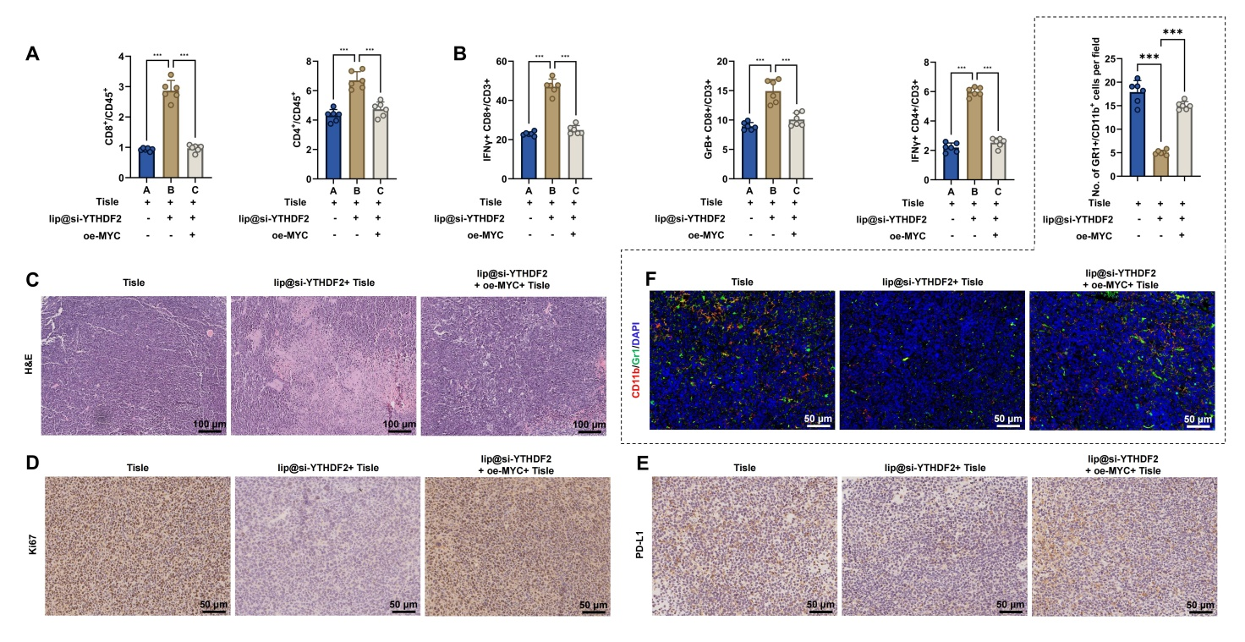
Figure S11. Tumor Growth and Immune Response Assessment Following Treatment with lip@si-YTHDF2 Combined with PD-1 Inhibitors.
Note: (A) Flow cytometry analysis of tumor tissue infiltration by CD8⁺ T cells and CD4⁺ T cells; (B) Flow cytometry assessment of the presence of IFN-γ⁺ CD8⁺ T cells, Granzyme B⁺ CD8⁺ T cells, and IFN-γ⁺ CD4⁺ T cells in tumor tissues; (C) H&E staining to evaluate histopathological changes in tumor tissues; scale bar: 100 μm; (D-E) Immunohistochemistry for detection of Ki-67 and PD-L1 positive cells in tumor tissues; scale bar: 50 μm; (F) Immunofluorescence staining to examine MDSCs infiltration in tumor tissues; scale bar: 100 μm. *Indicates significant differences between groups, *** p<0.001; n=6 mice per group.

