Supporting Information

A Novel Tetrahedral Framework Nucleic Acids-Based Antibiotic Delivery System： Overcoming Biofilm Barriers to Combat Chronic infections

Yue Hu#, Zhou Chen#, Xinggang Mao#, Di Qu, Dongsheng Zhai, Na Li, Shan Zhou, Xiaoyan Xue*, Mingkai Li*
Supplementary Methods and Materials
Table S1. The sequences of LIN, TA and Td (5’-3’).
DNA strands | Sequences
LIN-1 | TAGAGATTGAAGGACGGAATG
LIN-2 | CATTCCGTCCTTCAATCTCTA
TA-L | TTCAATCTCTATCATTCCGTCCTTCAATCTCTATCATTCCGTCCTTCAATCTCTATCATTCCGTCC
TA-S | TAGAGATTGAAGGACGGAATG
Td-S1 | AGGCAGTTGAGACGAACATTCCTAAGTCTGAAATTTATCACCCGCCATAGTAGACGTATCACC
Td-S2 | CTTGCTACACGATTCAGACTTAGGAATGTTCGACATGCGAGGGTCCAATACCGACGATTACAG
Td-S3 | GGTGATAAAACGTGTAGCAAGCTGTAATCGACGGGAAGAGCATGCCCATCCACTACTATGGCG
Td-S4 | CCTCGCATGACTCAACTGCCTGGTGATACGAGGATGGGCATGCTCTTCCCGACGGTATTGGAC

Synthesis of Cy5-labeled polymyxin B
Cy5-labeled polymyxin B with the sequence 6 - methylheptanoic acid - Cys(Cy5) - Dab - Thr - Dab - Dab - Dab - d - Phe - Leu - Dab - Dab - Thr - OH (with a lactam structure: Dab5 - Thr11) was synthesized as follows.
1). Initial Preparation
Weigh 2 g of 2-Cl (Trt)-Cl resin and place it in a 100- mL reactor. Add dichloromethane (DCM) to soak the resin for 30 minutes. Subsequently, wash the resin with N, N - dimethylformamide (DMF) and dry it under vacuum. Repeat this operation four times to ensure that the resin was thoroughly cleaned and dried.
2). Amino Acid Coupling Cycle
In each cycle, weigh a specific amount of amino acid. For example, initially weigh 1.6 mmol of Fmoc-Thr(Tbu)-OH (as the starting amino acid at the C - terminus), and add it to the reactor together with appropriate amounts of DCM and N, N- diisopropylethylamine (DIEA). Place the reactor in a shaker at 30 °C and react for 2 hours. After the reaction, add 2 mL of N, N-Diisopropylethylamine (DIEA), 2 mL of methanol, and 4 mL of DCM (DIEA: methanol: DCM = 1:1:2) and continue the reaction for 20 minutes to block the unreacted groups on the resin. Then, wash the resin with DMF and dry it. Repeat this washing - drying step four times. Next, add an appropriate amount of 20% piperidine solution (the volume ratio of piperidine to DMF was 1:4, and the dosage was 3 - fold the volume of the resin) to the reactor and react for 20 minutes to remove the Fmoc protecting group. After de-protection, wash the resin with DMF four times and dry it by suction. Use a long-neck pipette to take 10-20 resin beads from the reactor and detect with the ninhydrin method. If the resin turned blue, it indicated successful de-protection; if not, repeat the de-protection-washing-detection operation.
After successful de-protection, weigh 3 mmol of the next amino acid (such as Fmoc – Dab (Boc) - OH) and pour it into the reactor. Add an appropriate amount of DMF as the reaction solvent, and then add appropriate amounts of 1 - hydroxybenzotriazole (HOBT) and N, N'-diisopropylcarbodiimide (DIC). Place the reactor in a shaker at 30 °C and react for 1 hour. After the reaction, wash the resin with DMF and dry it by suction. Again, use a long-neck pipette to take 10-20 resin beads and detect by the ninhydrin method. If the resin had a color, it indicated incomplete condensation and further reaction was required; if the resin was colorless, it indicated the reaction was complete. Follow this process and repeat the operation until the coupling of the fifth amino acid Fmoc - Dab(dde) - OH was completed, with the same reaction conditions as above. Subsequently, continue to repeat this cycle until the coupling reaction of the second amino acid Cy's was completed.
3). Capping Reaction
Weigh 2 mmol of 6 - methylheptanoic acid and pour it into the reactor. Add an appropriate amount of DMF as the reaction solvent, and finally add appropriate amounts of 2-(7-azabenzotriazol-1-yl)–N,N,N',N'-tetramethyluronium hexafluorophosphate (HBTU), 1-hydroxybenzotriazole (HOBT), and N,N- diisopropylethylamine (DIEA). Place the reactor in a shaker at 30 °C and react for 30 minutes. After the reaction, wash the resin with DMF and dry it by suction, repeating four times. Then, detect the reaction with the ninhydrin method. After detection, wash the resin with methanol and dry it for three times.
4). Global Deprotection and Cleavage
Prepare the global deprotection cleavage solution accurately according to the ratio of 1 g of peptide resin to 10 ml of cleavage reagent. Place the reactor in a shaker at 30 °C and oscillate for 2 hours. Then, filter the cleavage solution into a lyophilization bottle. Use a rotary evaporator to evaporate the DCM from the cleavage solution, add a small amount of acetonitrile and water to dissolve the remaining substances, and then perform lyophilization. Weigh the lyophilized crude product and calculate its molar quantity after adding protecting groups. Weigh appropriate amounts of HOBT and naked peptide, dissolve them in DMF, add an appropriate amount of DIC, and react overnight. Monitor the reaction process through small-scale cleavage experiments during this period.
5). Lipopeptide Cleavage
(1) Preparation of cleavage reagent: Calculate the amount of cleavage reagent according to the ratio of 1 g of peptide resin to 10 ml ± 2 ml.
(2) Temperature control: Control the temperature of the cleavage reagent at 0 - 10 °C and slowly add it to the peptide resin under continuous stirring. Once the system temperature stabilized, control the temperature at 20 - 25 °C and stir for 2 hours.
(3) Product separation: Filter the cleavage solution, add five volumes of ice-cold diethyl ether, and centrifuge with a high - speed centrifuge. Pour the supernatant into the waste liquid bucket, add ice - cold diethyl ether again, mix thoroughly to ensure uniform dispersion of the precipitated polypeptide, and centrifuge again. Repeat this operation four times. Finally, dry the precipitate under reduced pressure at room temperature to obtain the crude product.

Synthesis of PMB@Lipo
PMB@Lipo were prepared via thin-film hydration followed by extrusion. Briefly, a chloroform solution containing soybean phosphatidylcholine (SPC, 10 mM), cholesterol (4 mM), and DSPE-PEG2K (1.5 mol%) was rotary-evaporated at 40°C under reduced pressure to form a homogeneous lipid film. The film was subsequently hydrated with 5 mL polymyxin B aqueous solution (2 mg/mL in PBS, pH 7.4) under vortex mixing (1,200 rpm, 10 min). The resultant multilamellar vesicles were sonicated (40 kHz, 150 W, 10 min at 25°C) and sequentially extruded through 100-nm polycarbonate membranes using a thermostated extruder. Unencapsulated PMB was removed via centrifugal ultrafiltration (50-kDa MWCO membrane, 4,000 ×g for 30 min at 4°C).

Supplementary Results

Figure S1. The characteristics of FNAs. a) Agarose gel of LIN, TA and Td. LIN: TA1: TA-S (The DNA strand is too short to show up.); TA2: TA-L; TA3: TA-L+3TA-S. Td1: S1; Td 2: S1+S2; Td 3: S1+S2+S3; Td 4: S1+S2+S3+S4. b) AFM images of Td. scale bar: 100 and 10 nm. c) Size of FNAs measured by DLS.

Figure S2. The identification of Cy5-labeled polymyxin B. a) HPLC analysis. b) MS analysis.

Figure S3. The penetration ability of the PMB@Td nanocomplex. a) Representative CLSM images and b) Proﬁle of Cy5 ﬂuorescence intensity from PMB at various depths of the biofilm. Scale bar: 50 μm. Data are presented as mean ± SD (n = 3).

Figure S4. The growth curves of A. baumannii (XJ21021059) treated with 1.5 μg/mL PMB or cy5-labeled PMB. Data are represented as means ± standard deviations, n = 3.

Figure S5. The release curves of PMB from PMB@Td (PMB:Td = 10:1) in the buffer of different pH values.

Figure S6. Evaluation of the antibiofilm effect of PMB@Td in vitro. a) Crystal violet (CV) staining of biofilms treated with free PMB and PMB@Td in different ratios. b) Colony formation on the agar of untreated and treated biofilms.
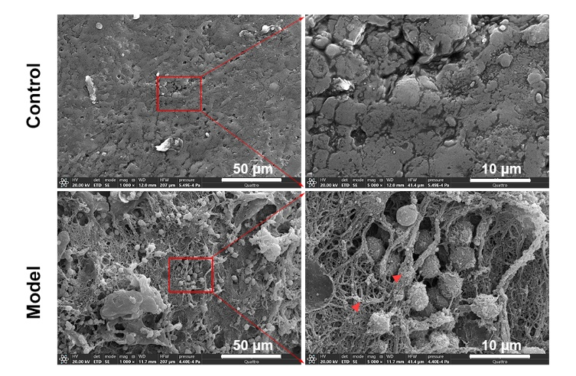

Figure S7. Microscopic images confirming successful establishment of biofilm-related wound infection model by SEM. The red arrow indicates the matrix.
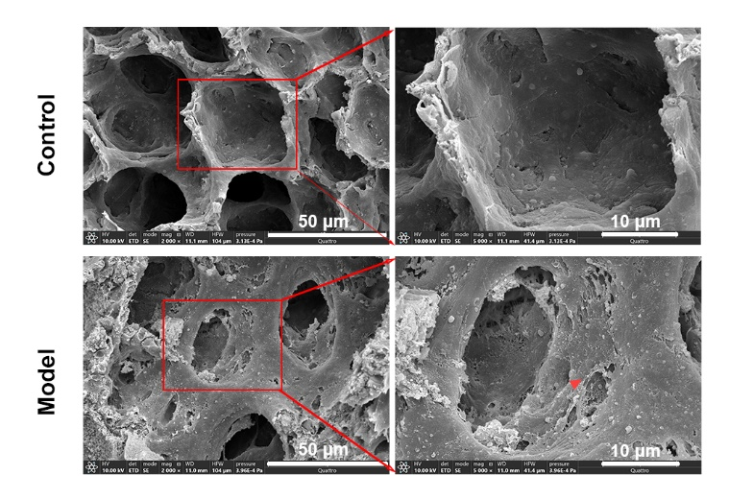

Figure S8. Microscopic images confirming successful establishment of biofilm-related chronic pneumonia model by SEM. The red arrow indicates the matrix.

Figure S9. Dual-label imaging of extracellular polymeric substances (EPS, green) and bacteria (bule) in biofilms after treatment with Cy5-Td (red). Scale bar: 50 μm.

 | Hydrodynamic size (nm) | PDI | Zeta potential (mV)
Mean | 111.76±0.86 | 0.243±0.005 | 7.2±0.85

Table S2. The particle size and zeta potential values of PMB@LipoData are represented as means ± standard deviations, n = 3.

Ions | Diffusion coefficients  (10⁻⁹ m²/s) | Direction of the electric field
K⁺ | 1.957 | inward-pointing
Ac⁻ | 1.089 | inward-pointing
Na⁺ | 1.334 | outward-pointing
Cl⁻ | 2.032 | outward-pointing

Table S3. Diffusion coefficients of ions and direction of the electric field used in the diffusiophoresis experiments.

