Supporting Information for
PIEZO2 is the underlying mediator for precise magnetic stimulation of PVN to improve autism-like behavior in mice

Sha Liu^{1, 2}, Xuan Liu³, Yefan Duan^{1, 2}, Li Huang⁷, Tong Ye⁷, Ning Gu^{5*}, Tao Tan^{7*}, Zhijun Zhang^{4, 6*}, Jianfei Sun^{1, 2*}

Modifications to the Electronic Supplementary Material (ESM):
Fig. S5C
The y-axis label was inconsistent with the main text formatting.
Correction: Changed from “Piezo2/β-tubulin” to “Relative band intensity of Piezo2/β-tubulin”.
Fig. S5E-G
The y-axis format was not aligned with Fig. S5D.
Correction: Unified to the same format as Fig. S5D.
Fig. S6E
The y-axis label conflicted with the main text style.
Correction: Revised from “Piezo2/β-tubulin” to “Relative band intensity of Piezo2/β-tubulin”.

Table S1 Materials used in the experiment
REAGENT or RESOURCE | SOURCE | IDENTIFIER
Deposited data
Raw and analyzed data | This paper | Accession number: S-BSST1454
Antibodies
Anti-oxytocin (Rabbit monoclonal) | Abcam | Cat# ab212193  RRID: AB_2895534
Anti-β-tubulin | Abcam | Cat# ab131205  RRID: AB_11156121
Goat Anti-Rabbit IgG H&L (HRP) | Abcam | Cat# ab205718  RRID: AB_2819160
Goat anti-Mouse IgG (H+L) Secondary Antibody, HRP | ThermoFisher | Cat # A16066  RRID: AB_2534739
Anti-c-Fos antibody [EPR20769] | Abcam | Cat # ab214672  RRID: AB_2939046
Anti-Gαq (Mouse monoclonal) | Santa Cruz | Cat# sc-136181  RRID: AB_2232474
Anti-IP3R1 (Rabbit Polyclonal) | Invitrogen | Cat# PA1901  RRID: AB_2129984
Anti-PLCβ1（Rabbit Polyclonal ） | Invitrogen | Cat# PA596018  RRID: AB_2571827
Anti-PKC alpha (Rabbit monoclonal) | Abcam | Cat# ab32376  RRID:  AB_777294
MAP2 antibody [HM-2] - Neuronal Marker | Abcam | Cat# ab11267  RRID: AB_297885
Tau antibody [EP2456Y] | Abcam | Cat# ab76128  RRID: AB_1524475)
Anti-FAM38B/Piezo2 (Rabbit Polyclonal) | ProSci | Cat# 26-438  RRID: AB_10942964
PIEZO1 Polyclonal Antibody | Invitrogen | Cat# PA5-72974  RRID: AB_2718828
Anti-CD38 (Mouse monoclonal) | Proteintech | Cat# 60006-1-Ig  RRID: AB_716994
Recombinant Anti-PI 3 Kinase p85 alpha antibody [EPR18702] | Abcam | Cat# ab191606  RRID: AB_2891324
Phospho-PI3 Kinase p85 (Tyr458)/p55 (Tyr199) Antibody | Cell Signaling Technology | Cat# 4228  RRID: AB_659940
Akt (pan) (11E7) Rabbit antibody | Cell Signaling Technology | Cat# 4685  RRID: AB_2225340
pan-AKT (phosphor T308) antibody | Abcam | Cat# ab38449  RRID: AB_722678
Bacterial and virus strains
rAAV-hSyn-GCaMp6f | Shenzhen Brain Case (China) | BC-0079
Critical commercial assays
HiScript II OneStep qPCR-PCR-SYBR Green Kit | Vazyme | Cat# Q221-01
OT(Oxytocin) ELISA Kit | Elabscience | Cat#E-EL-0029
FD Rapid Golgi Stain Kit | FD NeuroTechnologies | Cat# PK401
Experimental models: Organisms/strains
Mouse: C57BL6/J | Sino-British SIPPR/BK Lab Animal | N/A
Mouse: Oxytocin-Ires Cre mice | The Jackson Laboratory | RRID: IMSR_JAX:024234
Mouse: Ai9 or Ai9(RCL-tdT) | The Jackson Laboratory | RRID: IMSR_JAX:007909
Oligonucleotides
Real-time PCR primers | Shanghai GENEray | This paper
Genes and Species | Forward Primer（5’ to 3’） | Reverse Primer（5’ to 3’）
Oxytocin-mouse | GTCTGGTCAAATACTTGCAGGT | CGCGCAGCGAGAAAATGTG
GAPDH-mouse | TTGTCTCCTGTGACTTCAA | CTCTTGCTCTCAGTATCCTT
CD38-mouse | ACCACGAAGCACTTTTCTGAC | GGCGTAGTCTTCTCTTGTGATG
PIEZO1-mouse | CCTGTTACGCTTCAATGCTCT | GTGTAGGCATATCTGAAAGGCAA
PIEZO2-mouse | GTGGTATGCAACCCAGTACCC | GGCCATTCTCTATGGGCAGG
TRPV4-mouse | CCATCCTCTTTGACATTGTGTCC | CGCCCGTTGCTTAGGTTCA
Cav3.1-mouse | TGTGGAAATGGTGGTGAAGA | ACTGCGGAGAAGCTGACATT
Cav3.2-mouse | GCTGTTTGGGAGGCTAGAAT | CGAAGGTGACGAAGTAGACG
Gαq -mouse | GTTGATGTGGAGAAGGTGTCTG | GTAGGCAGGTAGGCAGGGT
PLCβ1-mouse | ACCTGAGCGGAGAAGAAAATG | TGTTGTGCGAGGAATTGATGAA
IP3R1-mouse | ATTTGTTCTCTGTATGCGGAGG | AGCTTAAAGAGGCAGTCTCTGA
PKCα(PRKCA)-mouse | GTTTACCCGGCCAACGACT | TCTTTCACCTCATGCACGTTC
Oligonucleotides
Designation | Source | Target Sequence
Piezo2-siRNA-01 | RIBOBIO | GCCTCGTTCAGCCAGCATA
Piezo2-siRNA-02 | RIBOBIO | GTGGTATGCAACCCAGTACCC
Software and algorithms | Software and algorithms | Software and algorithms
Microsoft Excel | Microsoft | RRID:SCR_016137
Any-maze | Stoeling | RRID:SCR_014289
GraphPad Prism version 9.0 | GraphPad | RRID:SCR_002798
Fiji ImageJ | NIH | RRID:SCR_003070
Photoshop CC | Adobe | RRID:SCR_014199
Imaris | OXFORD | RRID:SCR_007370
MATLAB | Mathworks | RRID:SCR_001622
Other
Magnetic field generator | Southeast University | This paper
Superparamagnetic iron oxide (SPIO) nanoparticles | Zhengda Tianqing Pharmaceutical Co., Ltd | NA

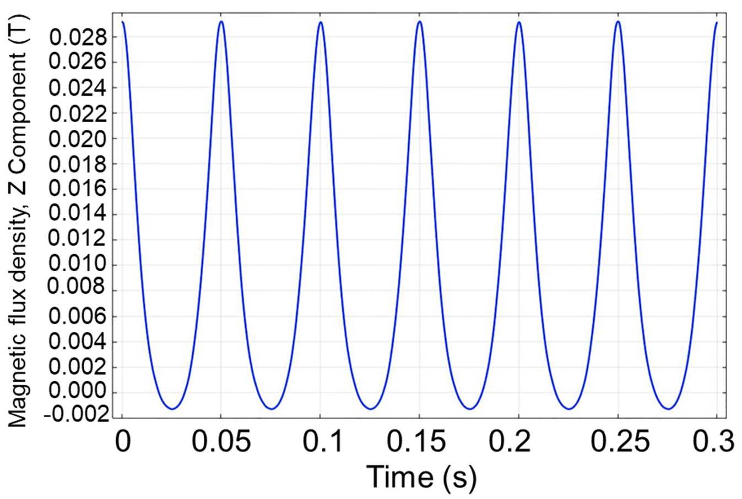
Fig. S1 Time-dependent variation curve of the magnetic field mediated by magnetic nanoparticles.

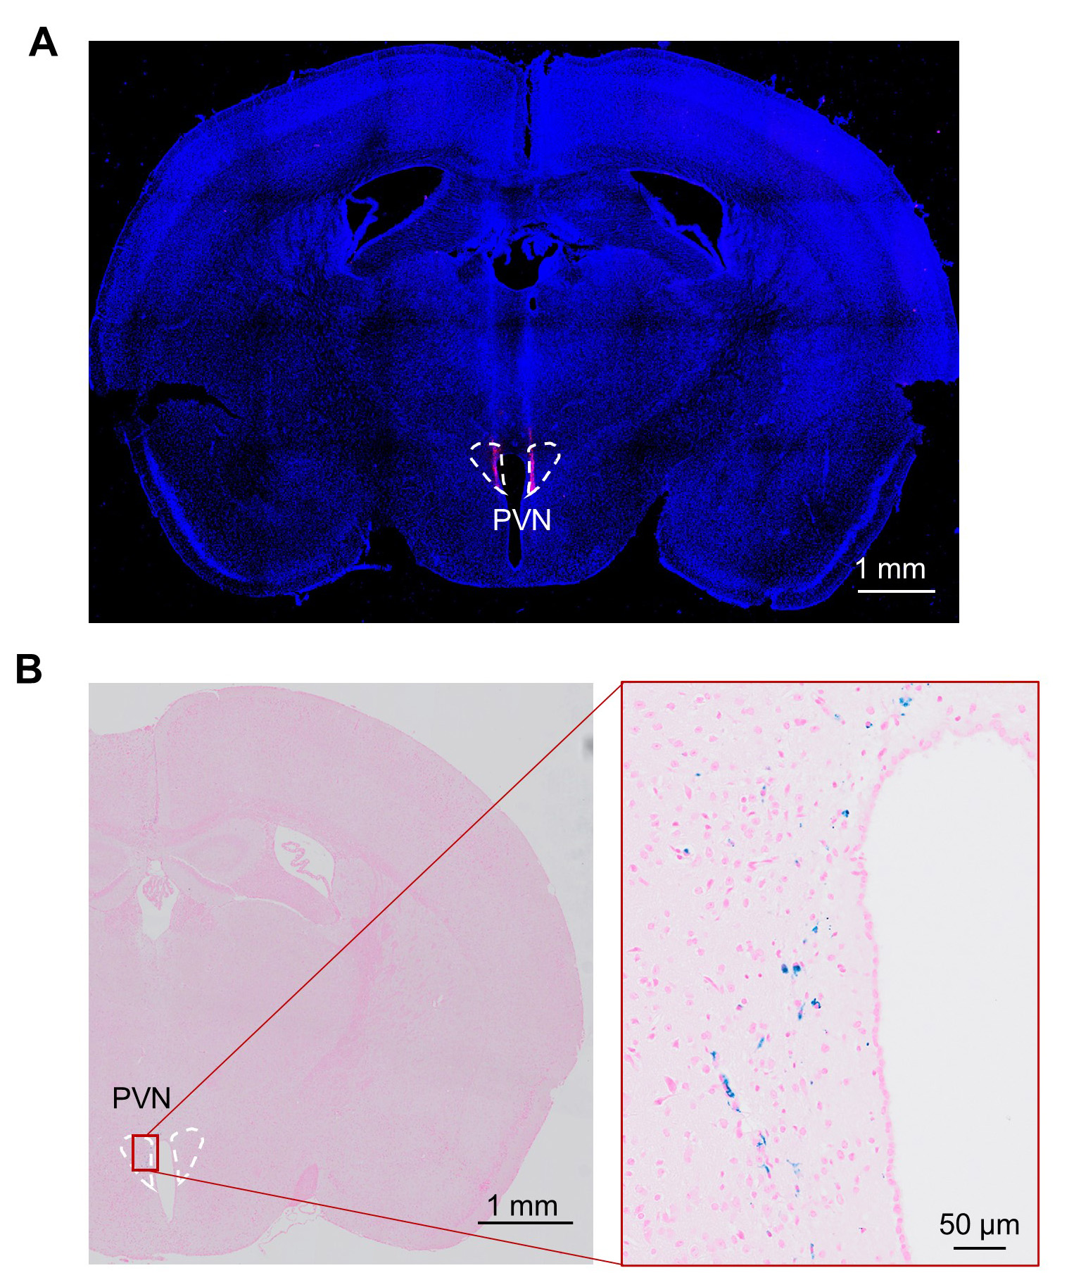
Fig. S2 Targeted delivery of SPIONs to the PVN. A Fluorescence imaging of CTB-labeled brain (coronal section), scale bar: 1 mm. B Prussian blue-stained brain (coronal section), scale bars: 50 μm and 1 mm.

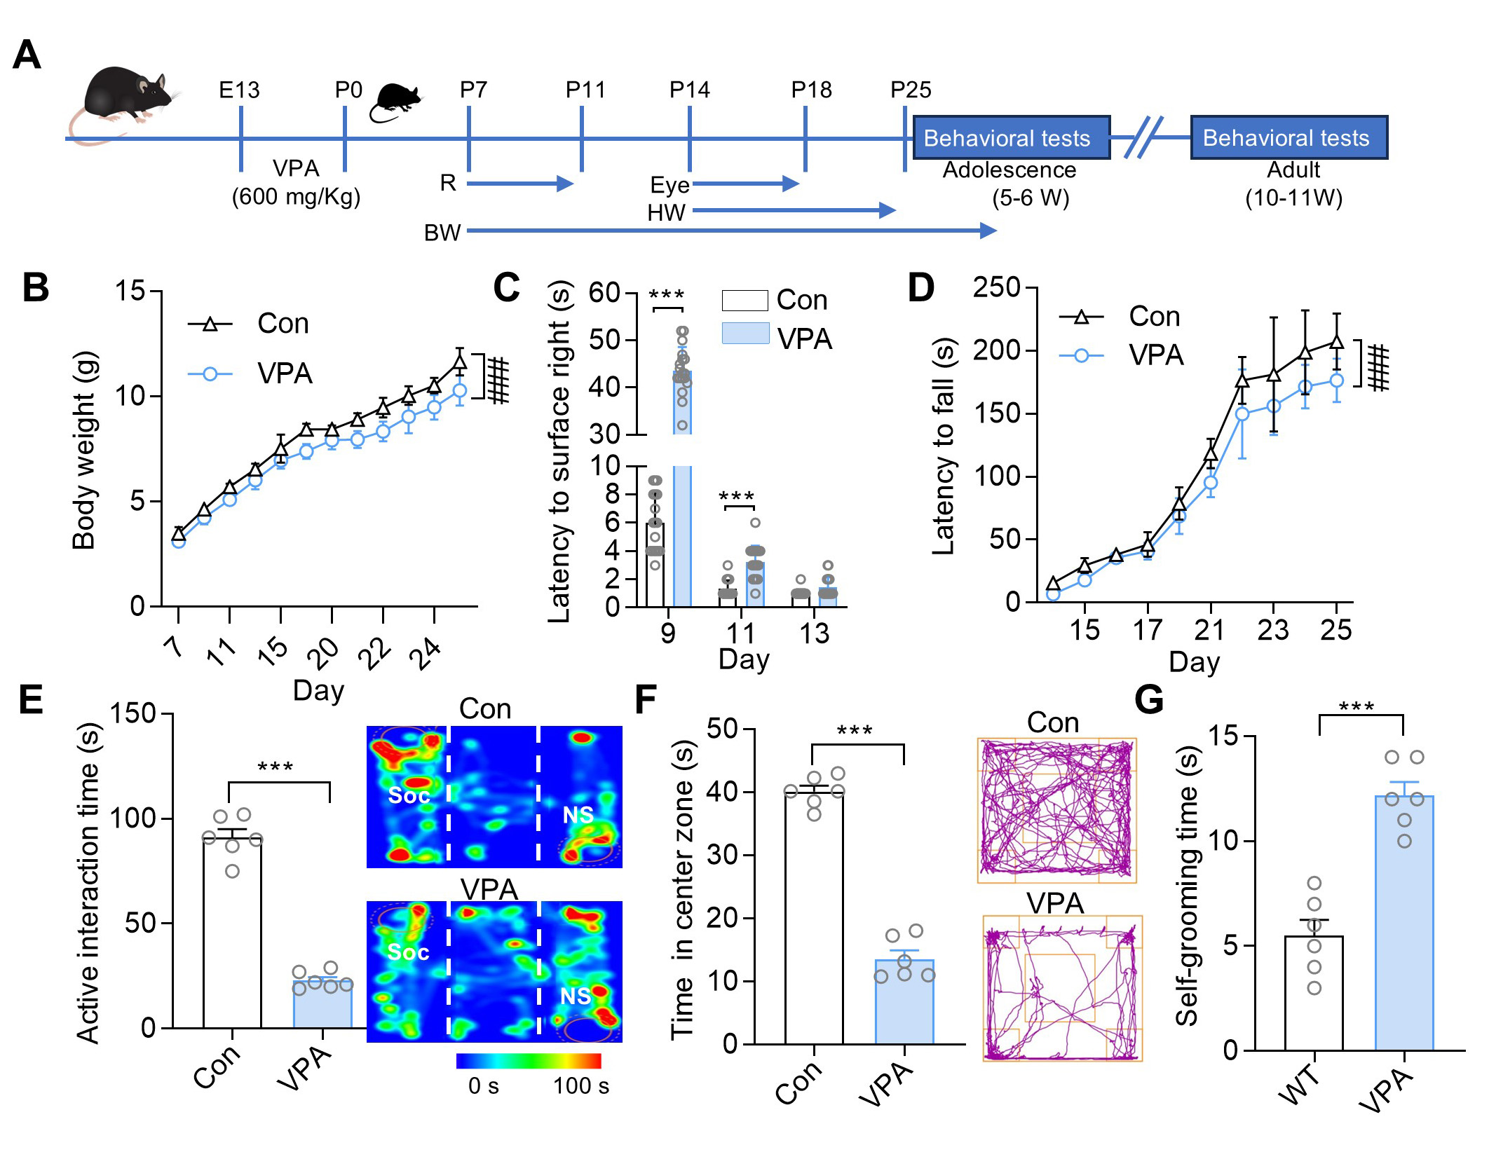
Fig. S3 Construction of VPA-induced ASD model mice. A. Schedule and design of experiment. Body maturation and motor function were assessed from P7–P25 (postnatal days 7 and 25, respectively). The social interaction test was conducted during adolescence (5-6 weeks old) and adulthood (10–11 weeks old). Mice were sacrificed to obtain whole brains. BW: body weight test; R: righting Reaction; Eye: eye opening score; HW: hanging wire test. B. Body weight of mice (n = 6 mice/group). Two-way ANOVA test results: F (11, 120) = 331.5. C. Time of right reflex (n = 6 mice/group). Two-tailed t test. D. Time spent on hanging wire (n = 6 mice/group). Two-way ANOVA test: F (9, 240) = 364.8. E. Time of active interaction in the three-chamber sociability test (n = 6 mice/group). Two-tailed t test. Inset: Representative heat maps illustrating the time mice spent in different locations of the three chambers during the social preference tests. Locations of social (Soc) vs nonsocial (NS) stimuli are labeled with circles. F. Open field test: time spent in the center zone (n = 6 mice/group). Two-tailed t test results: p<0.0001. Inset: Representative traces of open-field test. G. Self-grooming test (n = 6 mice/group). Two-tailed t test. Data are represented as the mean ± SEM. ***p<0.001, ###p<0.001.

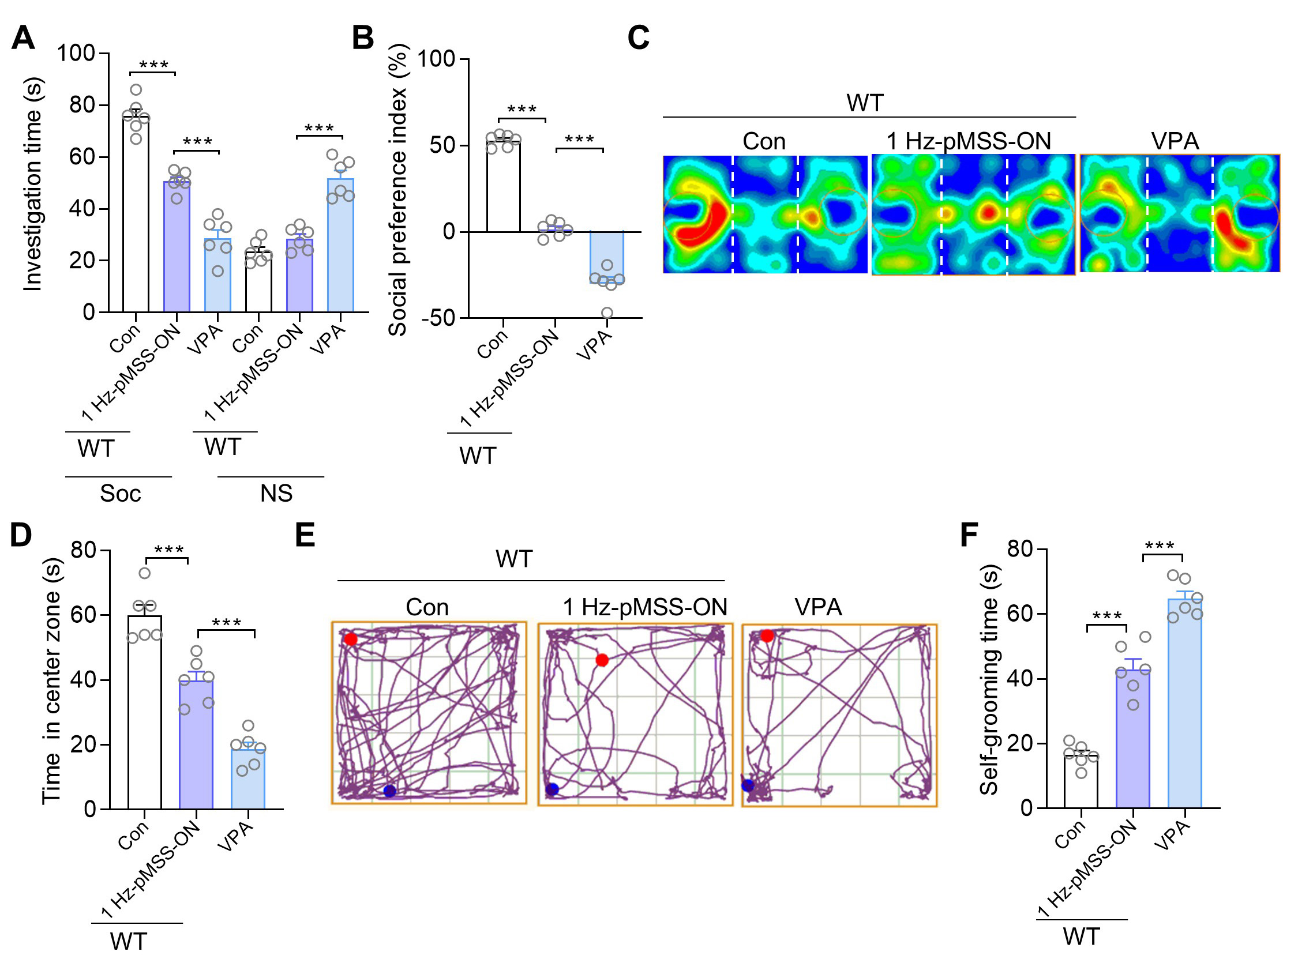
Fig. S4 1 Hz-pMSS induces social impairment in mice by suppressing brain-derived oxytocin release. A Plot of the time investigating social (Soc) vs nonsocial (NS) stimuli in three-chamber sociability tests of mice (n=6 mice/group). Investigation time: two-tailed t tests. B Social preference index in three-chamber sociability tests of mice (n=6 mice/group). Two-tailed t tests. C Representative heat maps of mice illustrating the time spent in different locations of the three chambers from social preference tests. Locations of Soc and NS stimuli are labeled with the circles. D Open field test, time in the center zone (n=6 mice/group). Two-tailed t tests. E Representative trace plot of mice illustrating the time spent in different locations of the open field. F Self-grooming test, time of self-grooming (n=6 mice/group). Two-tailed t tests. Data are represented as the mean ± SEM. ***p<0.001.

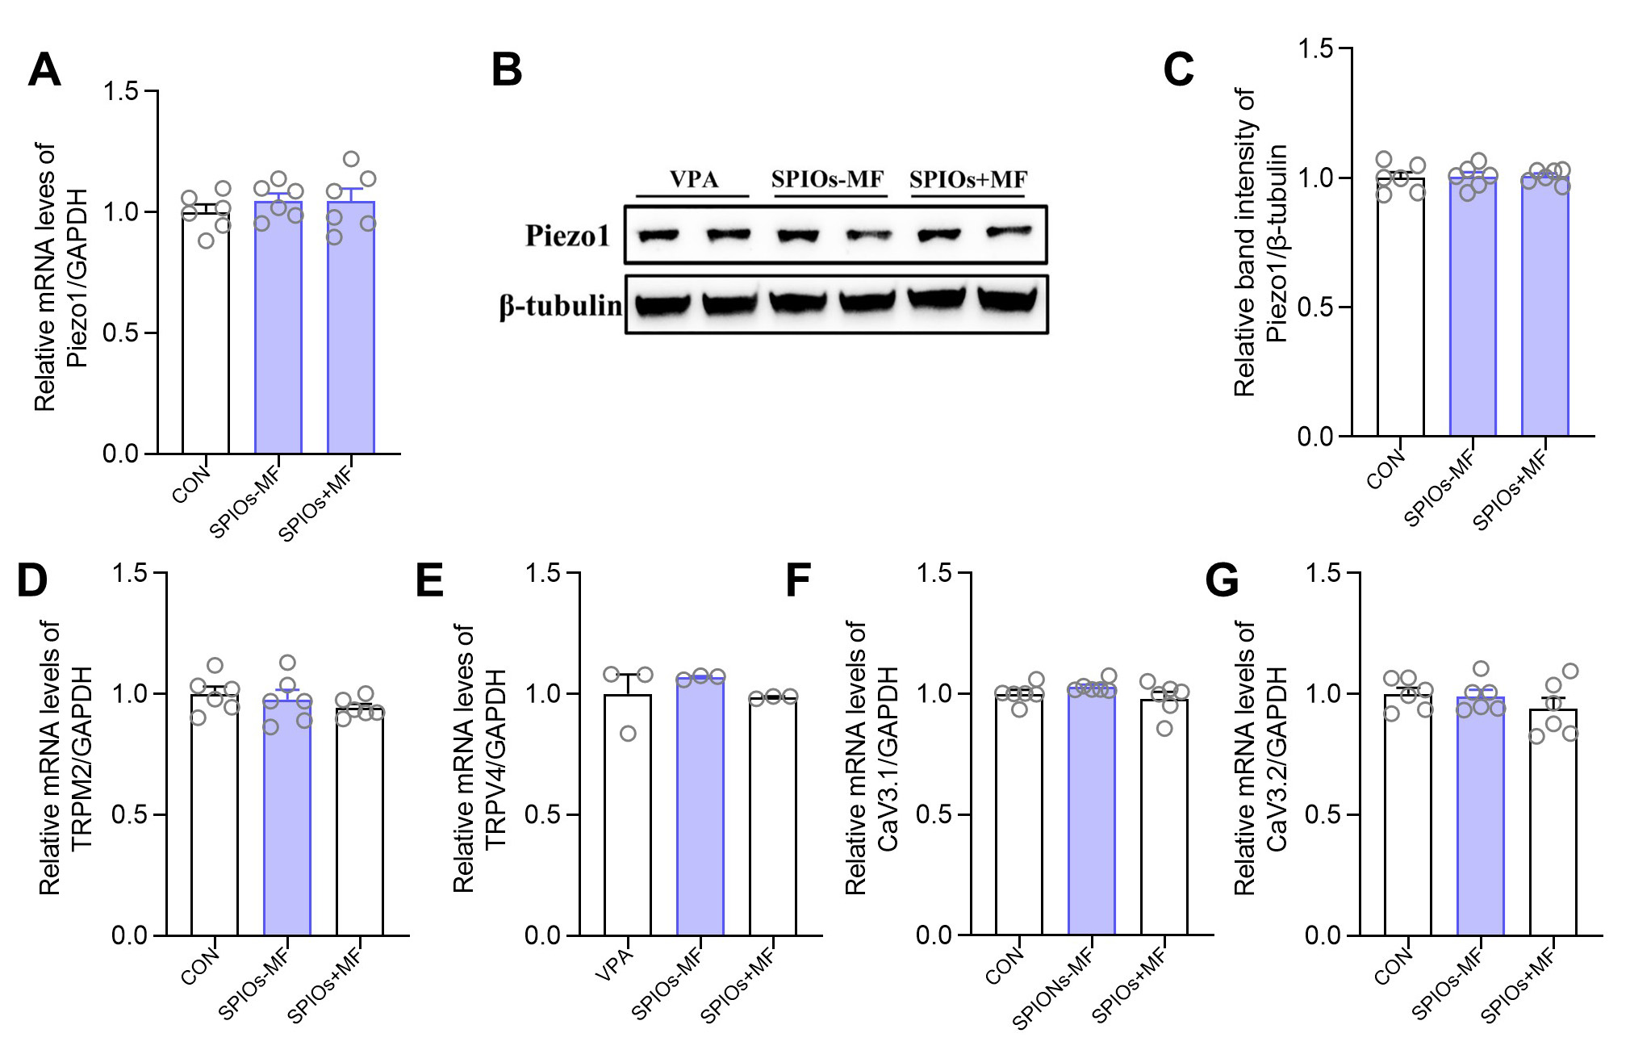
Fig. S5 Screening of ion channels in the hypothalamus affected by 10 Hz-pMSS. A. The qRT-PCR results of Piezo1 in PVN of mice after 7 days of pMSS (n=6 mice/group). B. Representative immunoblots of Piezo1 in PVN. C. Relative expression levels of Piezo1 in PVN of mice after 7 days of pMSS (n=6 mice/group). D. The qRT-PCR results of TRPM2 in PVN of mice after 7 days of pMSS (n=6 mice/group). E. The qRT-PCR results of TRPV4 in PVN of mice after 7 days of pMSS (n=6 mice/group). F. The qRT-PCR results of CaV3.1 in PVN of mice after 7 days of pMSS (n=6 mice/group). G. The qRT-PCR results of CaV3.2 in PVN of mice after 7 days of pMSS (n=6 mice/group).

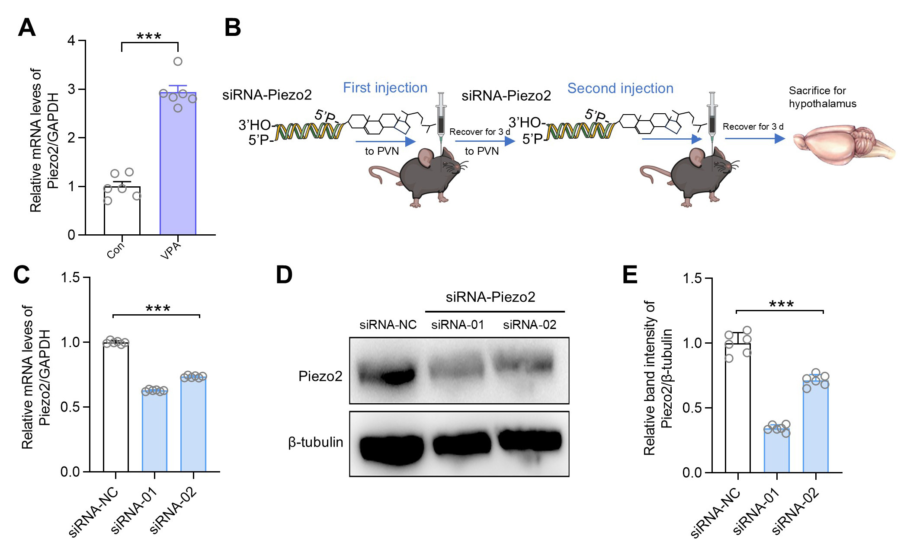
Fig. S6 Construction of a mouse model of conditional knockdown Piezo2 at the PVN. A. The qRT-PCR results of Piezo2 in PVN of mice (n=6 mice/group). Two-tailed t tests,. B. Flowchart of experimental design. C. The qRT-PCR results of Piezo2 in PVN of mice after siRNA-Piezo2 injection (n=6 mice/group). One way ANOVA test: F (2, 15) = 2410. D. Representative immunoblots of Piezo2 in PVN. E. Relative expression levels of Piezo2 in PVN of mice after siRNA-Piezo2 injection (n=6 mice/group). One way ANOVA test: F (2, 15) =206.5. Data are represented as the mean ± SEM. ***p<0.001.

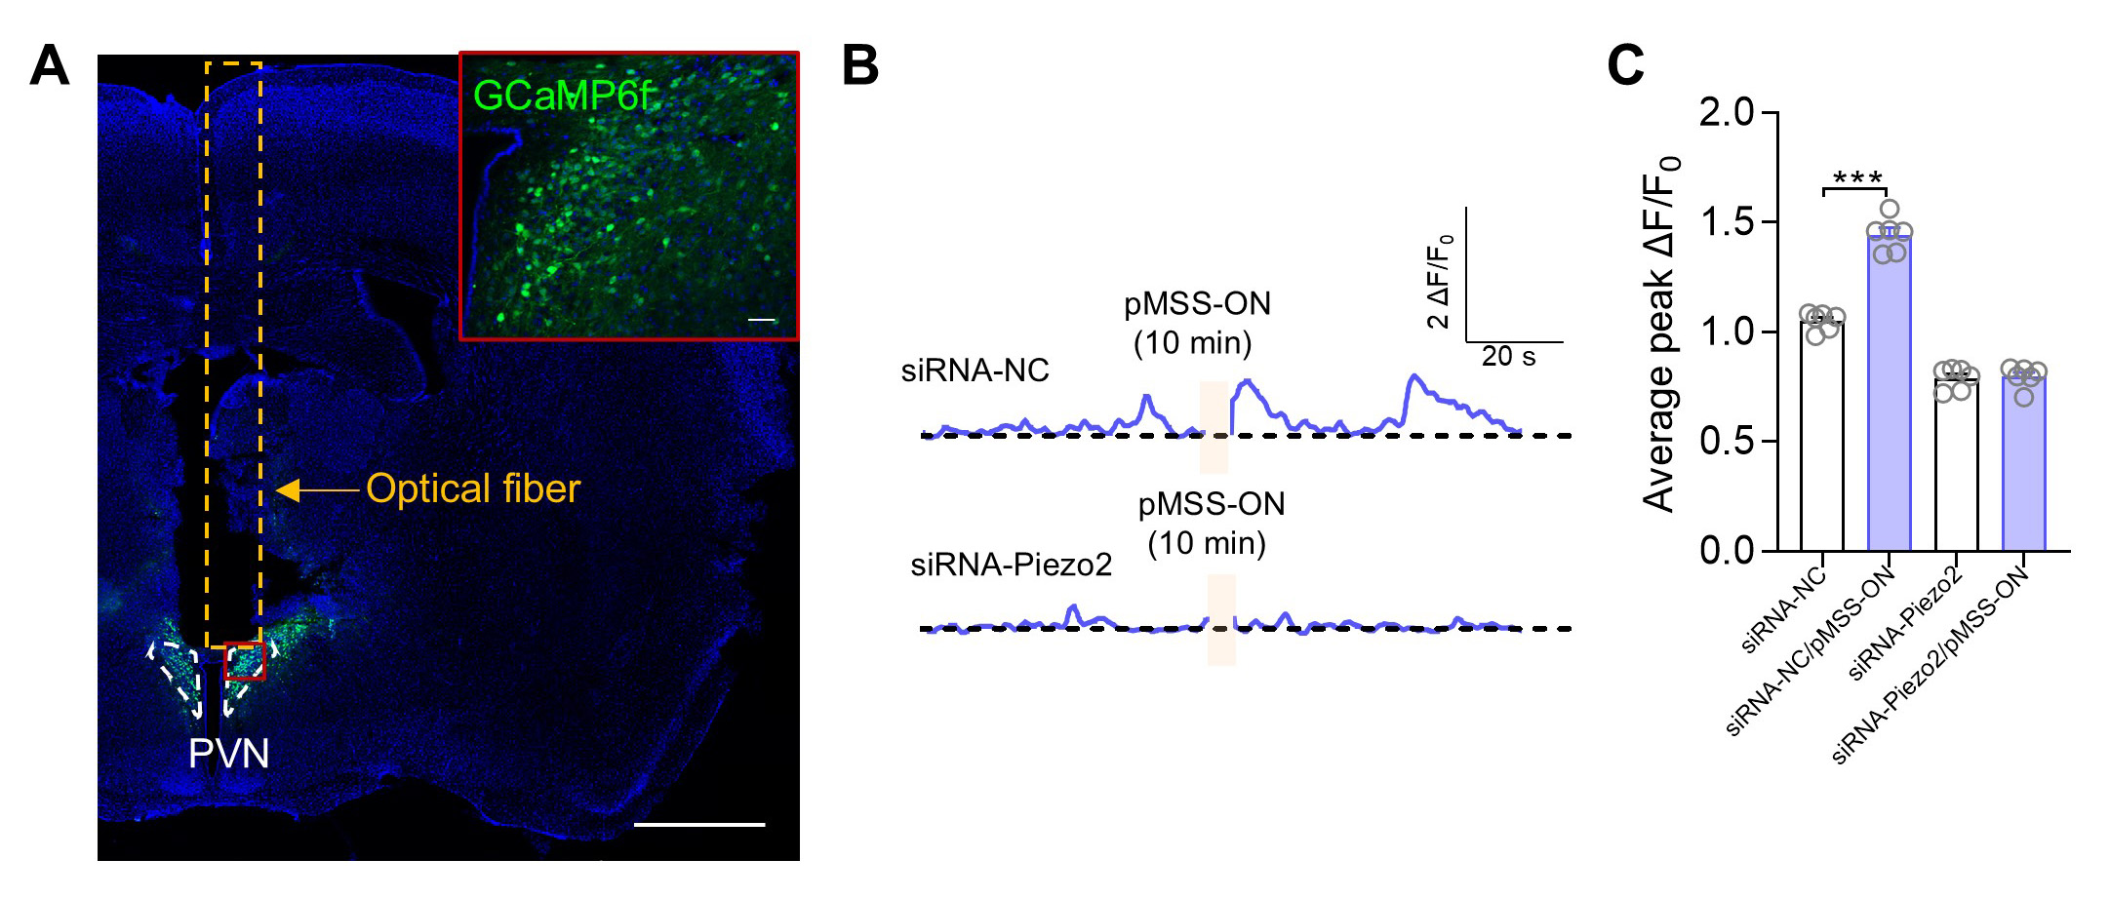
Fig. S7 Piezo2 knockdown in PVN neurons renders 10 Hz-pMSS unable to activate the neurons. A. Representative image of a brain slice injected with GCaMP6f, scale bar: 50 μm,1 mm. B. Fluorescence intensity change (ΔF/F₀) of neurons in the PVN responding to 10 Hz-pMSS. C. Plots of average peak fluorescence intensity change (ΔF/F₀) of neurons in the PVN responding to 10 Hz-pMSS (n=6 mice/group), Two-tailed t tests. Data are represented as the mean ± SEM. ***p<0.001.

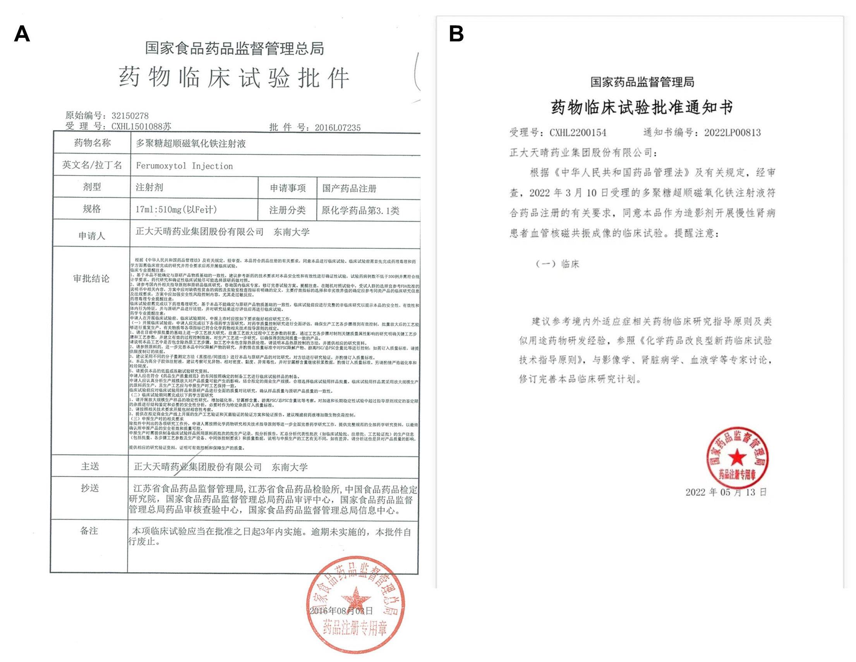
Fig.S8 A. Clinical trial approval for SPIONs as an iron supplement. B. Clinical trial approval for SPIONs as a contrast agent.

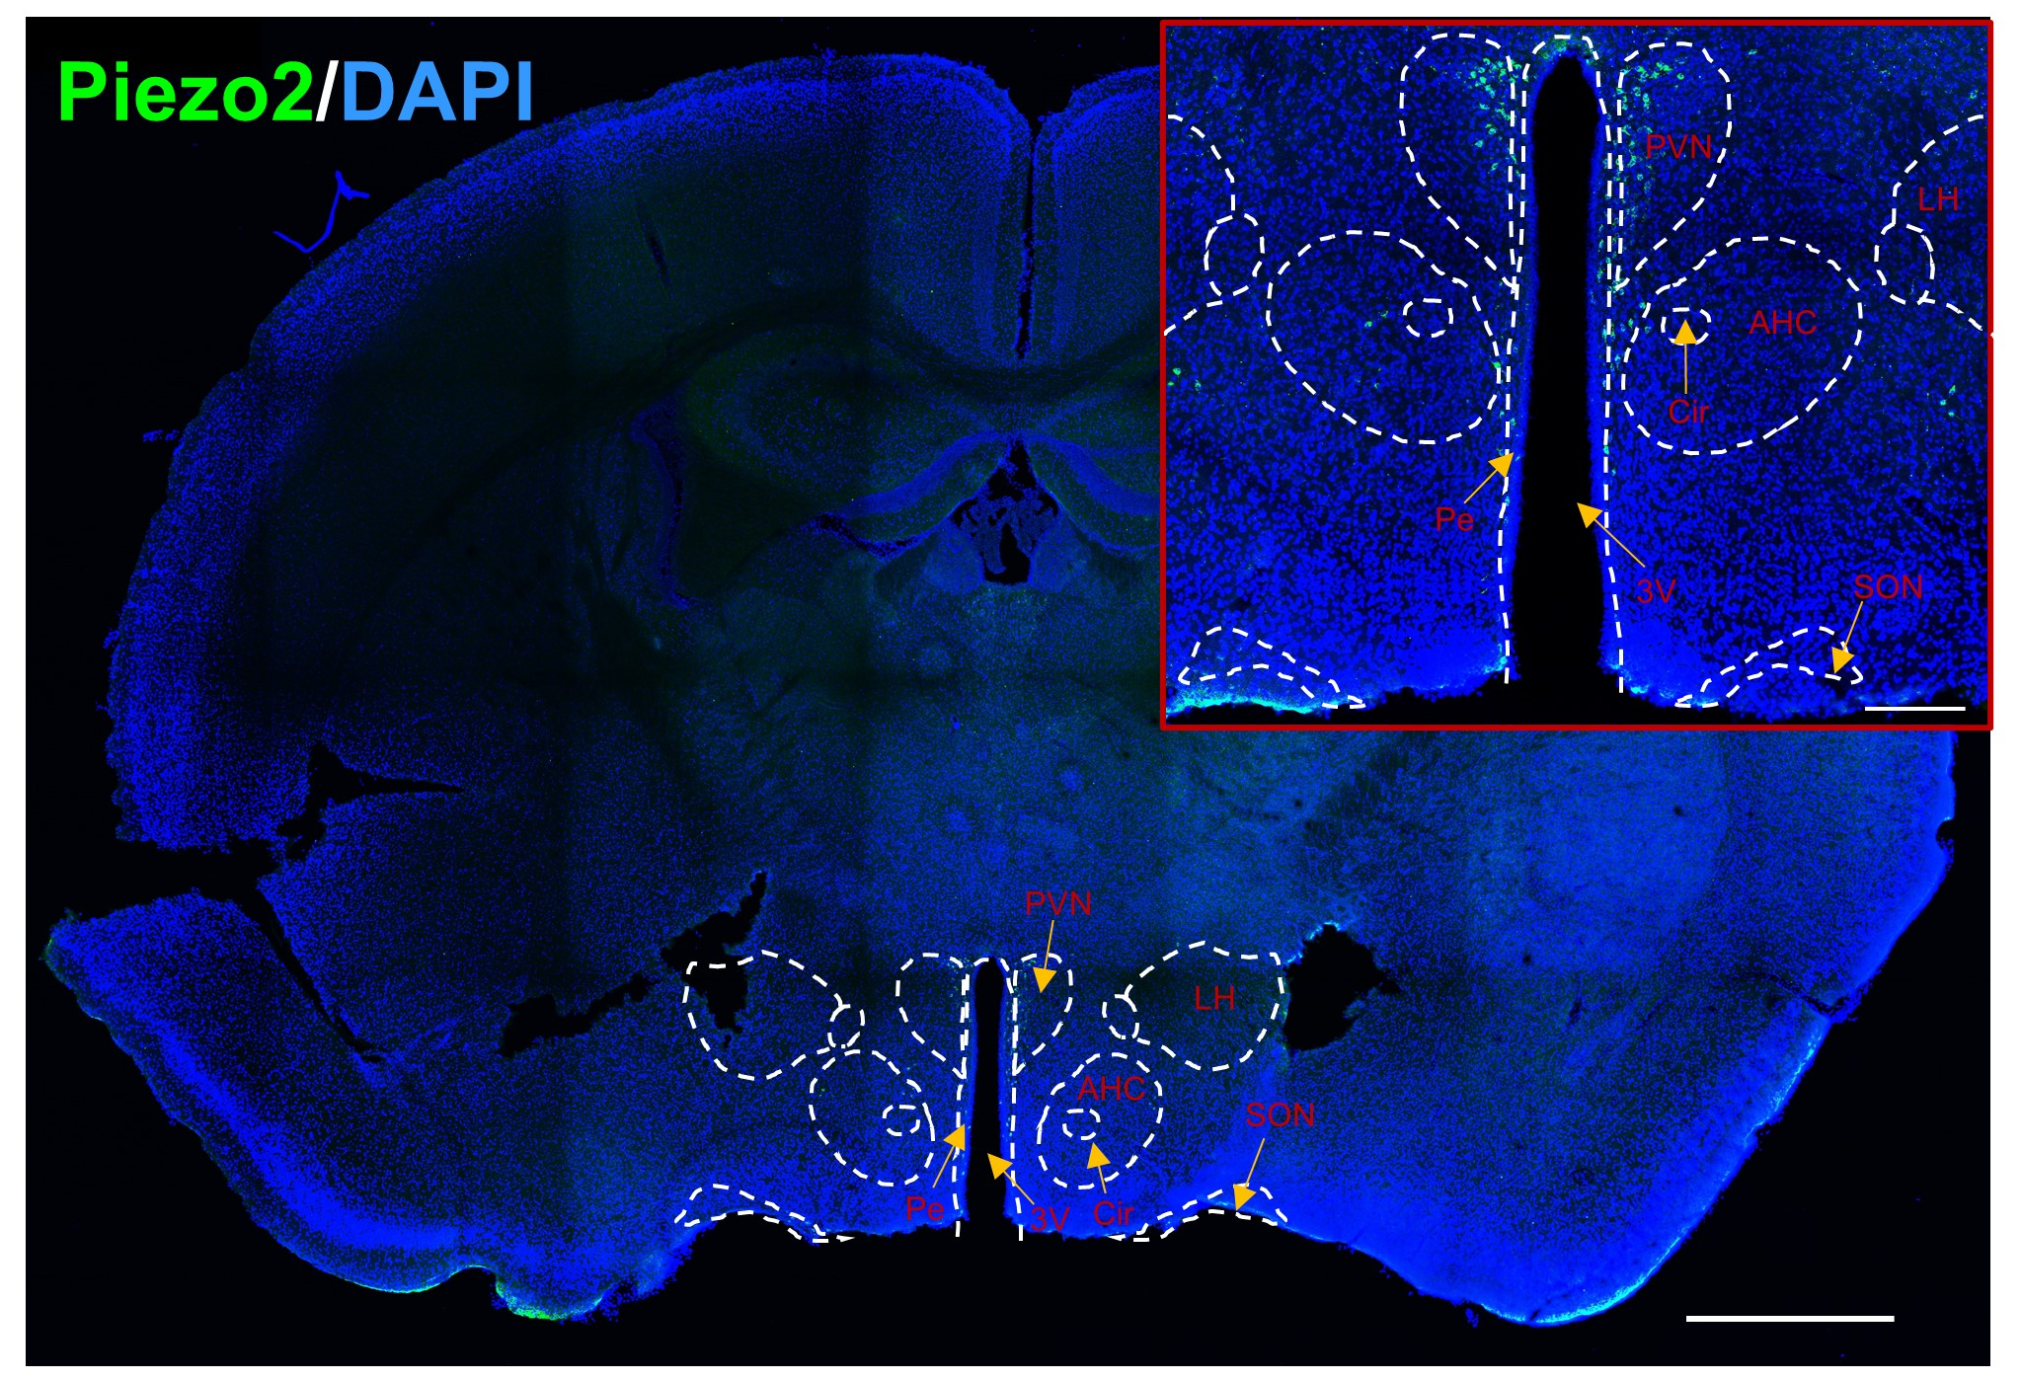
Fig.S9 Representative immunofluorescence image of Piezo2 in mouse brain sections. PVN: Paraventricular nucleus of the hypothalamus. Pe: Periventricular nucleus of the hypothalamus. 3V: Third ventricle. LH: Lateral hypothalamic area. AHC: Anterior hypothalamic central area. Cir: Circular nucleus complex. SON: Supraoptic nucleus. Scale bar：200 µm, 1 mm.

