Suppporting information
Curcumin-based Polymer Prodrug Nanoplatform for High-efficiency Immunotherapy by Synergistically Suppression of Head and neck Cancer Cell Stemness
Zhisen Shen^{a,b 1}, Hao Jiang^{d, 1}, Shuaijun Lu^{c, 1}, Hailong Tian^{e}, Feng Gao^{d,} *, Hongxia Deng^{a,b} *, Canhua Huang^{e,} *
ªDepartment of Otolaryngology-Head and Neck Surgery, Ningbo Medical Center Lihuili Hospital,Ningbo University, Ningbo, 315000, China.
^{b}Ningbo Key Laboratory of Digital Medicine Precision Diagnosis and Treatment of Otorhinolaryngology, Head and Neck Diseases.
^{c}The First Hospital of Ningbo University, Ningbo, 315020, China.
^{d}The Second Affiliated Hospital of Harbin Medical University, Harbin, 150086, China.
^{e}State Key Laboratory of Biotherapy and Cancer Center, Collaborative Innovation Center for Biotherapy, West China Hospital, Sichuan University, Chengdu, 610041, China.
¹These authors contributed equally to this work.
*Corresponding authors.
Email address: hcanhua68@163.com (CH. Huang), xixizb@163.com (HX. Deng). gf9777@126.com (F. Gao).

Materials and methods

Reagents and Materials
IR780, curcumin, aminohexanoic acid, TPGS, and dithiodipropionic acid were obtained from J&K Scientific. Sigma-Aldrich. DSPE-PEG-Biotin was obtained from J&K Scientific. N, N-Dimethylformamide, N-hydroxysuccinimide (NHS), 1-ethyl-3-(3-dimethylaminopropyl) carbodiimide hydrochloride (EDCI), and 4-dimethylaminopyridine (DMAP) were purchased from Aladdin Reagent Co. MTT and crystal violet were acquired from Millipore Sigma. DAPI was sourced from Invitrogen. Ethanol and sodium chloride injection solutions were provided by Sichuan Kelun Pharmaceutical Co., Ltd. AMC-HN-8 and SCC7 cells were supplied from Shanghai QuiCell Biotechnology Co., Ltd. &Technology Co.,Ltd. The following assay kits were supplied by Beyotime Biotechnology: ROS detection kit (catalog number: S0033S), live/dead cell viability kit (catalog number: C2015M), TUNEL apoptosis detection kit (catalog number: C1086), lipid peroxidation MDA assay kit (catalog number: S0131S), and GSH/GSSG detection kit (catalog number: S0053). Annexin V-FITC/PI apoptosis detection kit (40302ES) was obtained from Yeasen. Mouse IL-2 and TNF-α enzyme-linked immunosorbent assay (ELISA) kits (EK202/2-01 and GEM0004, respectively) were acquired from Elabscience. Anti-GPX4 (ab219592), anti-CRT (Ab92516), and anti-HMGB1 (ab79823) antibodies were sourced from Abcam. ZEB1 (E2G6Y), Nanog (1E6C4), C-Myc (E5Q6W), and HSP70 (4872T) antibodies were purchased from Cell Signaling Technology. Anti-SOD1 (SC11407) and anti-β-actin (sc-47778) antibodies were obtained from Santa Cruz Biotechnology.

The preparation of Biotin@P-Cur/T780 NPs
Synthesis of IR780-TPGS (T780): The synthesis of IR780-TPGS (T780) begins with the attachment of carboxyl groups to IR780. IR780, 6-aminohexanoic acid, and TEA (dissolved in anhydrous DMF, molar ratio 1:2:4) were sequentially added to a 50 mL round-bottom flask and stirred at 85°C under nitrogen atmosphere and aluminum foil shielding (500 rpm) for 4 hours. After completion of the reaction, the solvent (anhydrous DMF) was removed by rotary evaporation, yielding the crude product IR780-carboxylic acid (IR780-COOH), which was purified by silica gel column chromatography. The purified IR780-COOH was scraped and weighed to determine its molar mass. Subsequently, purified IR780-OH (1 equivalent molar mass), NHS, EDCI, and DMAP (dissolved in anhydrous DMF, molar ratio 1:2:2:2) were sequentially added to a 50 mL round-bottom flask and stirred at 0°C under nitrogen atmosphere and aluminum foil shielding (500 rpm) for 30 minutes. TPGS was sonicated to dissolve in anhydrous DMF and then added to the reaction mixture, which was stirred at room temperature under nitrogen atmosphere and aluminum foil shielding (500 rpm) for 48 hours. After the reaction, the mixture was dialyzed against DMF and water using a 1000 Da dialysis bag. The final product was obtained as a blue solid after freeze-drying, referred to as T780.
Synthesis of P-Cur: The synthesis of P-Cur was carried out as follows: 3,3'-dithiodipropionic acid (0.238 mmol, 50 mg) was dissolved in 5 mL of DMF and stirred under nitrogen protection for 5 minutes in a round-bottom flask. The carboxyl groups were then activated in an ice bath for 6 hours by adding DMAP (0.954 mmol, 116.3 mg), NHS (0.954 mmol, 109.56 mg), and EDCI (0.954 mmol, 183.5 mg). After activation, curcumin (0.2856 mmol, 105.21 mg) was added at room temperature, and the mixture was stirred for an additional 24 to 48 hours. Upon completion, a small aliquot of the product was dissolved in DMF and analyzed by thin-layer chromatography (TLC) to confirm the formation of the desired product. The reaction mixture was then subjected to dialysis using a 1000 Da dialysis bag in methanol or ethanol, with the dialysis solvent replaced every 2 hours until the methanol became colorless. The dialyzed product was then thoroughly washed with water, frozen at -20°C for 24 hours, transferred to -80°C for further storage, and finally freeze-dried into a powder using a lyophilizer.
Synthesis of Biotin@P-Cur/T780 NPs: The Biotin@P-Cur/T780 NPs were prepared using a combination of thin-film dispersion and ultrasonic dispersion methods. In brief, T820 and P-Cur were dissolved in methanol and subjected to ultrasonic dispersion. The solvent was then removed by rotary evaporation to obtain P-Cur/T780 NPs, with hydrogen bonding and π-π stacking playing a crucial role in the process. The resulting mixture was subsequently dispersed ultrasonically in 5 mL of deionized water and mixed with a DSPE-PEG-Biotin aqueous solution, utilizing electrostatic adsorption for self-assembly. Gentle stirring was carried out at room temperature for 1-2 hours to ensure thorough binding. Following this, the reaction mixture was transferred to a centrifuge tube and centrifuged (typically at 4°C, 3000-12000 rpm for 10-30 minutes) to separate the nanoparticles from the unbound biotin. The supernatant was discarded, and the precipitated nanoparticles were retained.

The characteristics of Biotin@P-Cur/T780 NPs
The Zeta potential, particle size distribution, and morphology of the Biotin@P-Cur/T780 nanoparticles were characterized using a nanoparticle tracking analyzer (NTA, PTM ZetaView) and transmission electron microscopy (TEM, Hitachi HT7800, Sichuan University). The morphology of the Biotin@P-Cur/T780 NPs was further analyzed via TEM (HT7800) at the Electron Microscopy Facility of the West China School of Basic Medical Sciences and Forensic Medicine, Sichuan University. The UV-Vis absorption spectra of the nanoparticles were recorded at room temperature using a UV-Vis spectrophotometer (UV2700, Shimadzu, Japan).

Photothermal Performance In vitro
The temperature changes of 1 mL T780 solution, P-Cur/T780 NPs solution, and Biotin@P-Cur/T780 NPs solution were monitored under 660 nm laser irradiation (1.0 W/cm²), while IR780 was irradiated with an 808 nm laser. The temperature variations were recorded over 5 minutes at 30-second intervals using a digital thermometer and an infrared thermal imaging camera.

Evaluation of GSH-Dependent Nanoparticle Release Effect
In the presence of GSH, disulfide bonds are specifically cleaved, causing the nanoparticles to disintegrate and exert their effects at targeted sites. To assess this effect, the release of T780 from Biotin@P-Cur/T780 NPs was measured using dialysis at 37°C under varying GSH concentrations. Biotin@P-Cur/T780 NPs solution was placed in a dialysis bag with a molecular weight cutoff of 3500 Da and immersed in PBS containing 0.10% DMF (w/w) and different concentrations of GSH (0 mM or 10 mM, 40 mL). The solution was continuously stirred at 300 rpm at 37°C. At various time points, samples (1 mL) were collected and analyzed using a UV-Vis spectrophotometer. Additionally, the remaining solution was replenished with an equal volume (1 mL) of fresh medium.

4.6. Cell culture
Human head and neck cancer cell line AMC-HN-8 and mouse head and neck cancer cell line SCC7 were used as tumor cell models. These cells were cultured in DMEM medium (Thermo Fisher Scientific) supplemented with 10% fetal bovine serum (Biological Industries), 100 U/mL streptomycin (HyClone), and 100 U/mL penicillin-streptomycin. The cells were maintained at 37°C in a humidified incubator with 5% CO₂ [15].

In vitro Cellular Uptake Analysis
The uptake of free IR780, T780, P-Cur/T780 NPs, and Biotin@P-Cur/T780 NPs by cells at different time points was measured using a fluorescence inverted microscope (Nikon, Tokyo, Japan) and a flow cytometer (BD, FACS Celesta).

In vitro Cytotoxicity and Proliferation Assays
The cytotoxicity of Biotin@P-Cur/T780 NPs was assessed using the MTT assay. AMC-HN-8 and SCC7 cells were initially seeded into 96-well plates at a density of 4 × 10³ cells per well and incubated overnight. The cells were then treated with saline (as a control) and varying concentrations of Cur, P-Cur, T780, P-Cur/T780, and Biotin@P-Cur/T780 NPs for 6 hours. After incubation, the supernatant was removed, and the cells were washed with PBS. Cells in the T780, P-Cur/T780, and Biotin@P-Cur/T780 NPs groups were subsequently exposed to a 660 nm laser for 2 minutes (1.0 W/cm² power density) and incubated for an additional 24 hours.
Apoptosis Evaluation: Cells were seeded at a density of 5 × 10⁴ per well in six-well plates and cultured overnight. Afterward, the cells were exposed to different interventions. Both floating and attached cell populations were harvested and incubated in 100 μL of binding buffer containing 5 μL of Annexin V-FITC and 10 μL of propidium iodide (PI) for 30 minutes. Fluorescence data were then collected using flow cytometry.
To evaluate cell proliferation, a colony formation assay was conducted. In this assay, 500 cancer cells were cultured in 24-well plates and treated with the same dose of reagents for 4 hours. The cells were then rinsed with saline and exposed to either a 660 or 808 nm laser for 30 seconds (1.0 W/cm² power density). After one week, the cell colonies were fixed with 4% paraformaldehyde for 40 minutes, stained with 0.2% crystal violet (Beyotime, C0121) at room temperature for 2 hours, and then washed several times with ultrapure water. Finally, the colonies were imaged, and the percentage of colony formation was quantified using ImageJ software.

Assessment of Intracellular ROS Levels and Lipid Peroxidation
The intracellular generation of ROS was visualized using the DCFH-DA assay (Beyotime, S0033S). Cells were seeded into 6-well plates at a density of 3 × 10⁵ cells per well and incubated overnight. After the designated treatments, cells were harvested according to the manufacturer’s protocol and incubated with 10 µM DCFH-DA at 37°C for 20 minutes. Fluorescence intensity was then measured using both fluorescence microscopy and flow cytometry.

For the lipid peroxidation assay, AMC-HN-8 and SCC7 cells were seeded at a density of 2 × 10⁵ cells/mL on sterilized glass coverslips placed in 24-well plates and incubated overnight. Cells were treated according to the experimental protocol. After two washes with PBS, cells were stained with 10 µM C11-BODIPY 581/591 dye (Thermo Fisher Scientific, D3861) in serum-free medium at 37°C for 15 minutes. The cells were then washed twice with PBS and fixed with 4% paraformaldehyde for 2 hours. Fluorescence images were captured using a microscope (Nikon, Tokyo, Japan). A similar procedure was followed for cells in 6-well plates, which were subsequently trypsinized and collected for flow cytometry analysis.

Total GSH Content Measurement

The total GSH levels in AMC-HN-8 and SCC7 cells after various treatments were assessed using a commercial kit (Beyotime Biotechnology, China) following the manufacturer's protocol.

Immunoblotting
Western blot analysis was carried out according to established protocols as previously described [15].

Non-Adherent Head and neck Cancer Sphere Formation Assay
This assay is employed to investigate the biological characteristics of OSCC stem cells and their role in the initiation and progression of head and neck cancer. It also evaluates the impact of various drugs on the function and differentiation of OSCC stem cells. Cells are seeded into six-well plates containing 1% agar at a density of 10³ cells per well and cultured in serum-free medium for 7 days. Subsequently, the cells are treated with Cur, P-Cur, T780, P-Cur/T780, and Biotin@P-Cur/T780 NPs for 6 hours, with PBS serving as the control. After an additional 72 hours of incubation, bright-field images of the tumor spheres are captured using a fluorescent inverted microscope (Nikon, Tokyo, Japan). The mammosphere formation efficiency (MFE) is calculated using ImageJ software.

ATP Release Assay
An ATP detection kit was employed to measure the released ATP. Cells were seeded into 96-well plates at a density of 1 × 10⁴ cells per well. Following the specified intervention, cell supernatants were collected and subjected to further processing. Subsequently, 20 µL of the supernatant was combined with 100 µL of the working solution, and the fluorescence intensity of ATP was measured using a 96-well fluorescent microplate reader.

TNF-α and IL-2 detection assay.
The secretion levels of TNF-α and IL-2 in cell supernatants and mouse serum were measured using ELISA kits provided by Lianke Bio Co., Ltd.

Animal Experiments
C57BL/6 mice and BALB/c nude mice (6 weeks old, weighing 18-20 g) were obtained from Chengdu Yaokang. All in vivo procedures were approved by the Zhejiang Provincial Administration of Traditional Chinese Medicine and the Ethics Committee of Ningbo University [SYXK(Zhejiang)2019-0005]. Primary tumors were induced by subcutaneously injecting 5 × 10⁶ AMC-HN-8 cells into BALB/c nude mice or SCC7 cells into C57BL/6 mice. When the tumors reached approximately 100 mm³, the mice were randomly assigned to one of six groups (n = 5). Each group received an equal volume of saline, Cur, P-Cur, T780/P-Cur, or Biotin@T780/P-Cur nanoparticles via tail vein injection every other day, with each dose equivalent to 2 mg/kg of IR780. Six hours post-injection, mice in the NPs and Biotin@NPs groups were subjected to 660 nm laser irradiation for 5 minutes at a power density of 1.0 W/cm². Body weight and tumor volume were monitored every two days. Tumor dimensions were measured with calipers, and tumor volume was calculated using the formula: Tumor volume (mm³) = (length × width²) / 2. Tumor inhibition rate was determined using the formula: [(average tumor weight of the control group - average tumor weight of the treatment group) / average tumor weight of the control group] × 100%. At the conclusion of the study, mice were humanely euthanized, and tumors and major organs were harvested and weighed to evaluate the efficacy of photothermal ablation in tumor suppression.

Fluorescence Imaging and Biodistribution Analysis
BALB/c mice bearing tumors were subjected to the described protocol. Once tumors naturally reached approximately 100 mm³, mice were intravenously injected with saline, free IR780, T780/P-Cur, or Biotin@T780/P-Cur nanoparticles (with each dose equivalent to 2 mg/kg of IR780). Fluorescence images were acquired at different time points (2, 4, 6, 8, 10, 12, and 24 hours) using a small animal imaging system (Xtreme, Bruker, Germany) to evaluate the biodistribution of the drugs and identify the optimal time for drug uptake.

In Vivo Photothermal Efficiency Assessment
The photothermal efficiency was assessed using an infrared thermal imaging camera (E60: Compact Infrared Thermal Imaging Camera). Thermal images were recorded of tumor-bearing mice 6 hours after drug injection, following 5 minutes of continuous NIR laser irradiation (808 nm or 660 nm). Temperature differentials were measured and plotted to evaluate the effectiveness of photothermal conversion.

Immunological Response Model in Tumor-Bearing Mice
An immune response model was developed using the tumor implantation and drug administration protocols outlined previously. To evaluate the in vivo immune effects, flow cytometry was performed on single-cell suspensions derived from the spleens of C57BL/6 mice. After 2 weeks of treatment, mice were euthanized, and spleens were excised and processed into single-cell suspensions. Before flow cytometric analysis, T cells were labeled with CD3-PECY7, CD4-PE, and CD8-FITC antibodies. DC maturation was evaluated using CD11c-PECY7-PC7, CD80-PE, and CD86-APC antibodies. After fixation and permeabilization, Tregs were stained with anti-CD3-PECY7, anti-CD4-PE, and anti-FOXP3-APC.

Statistical Analysis
All data were analyzed using GraphPad Prism 9 (GraphPad Software, La Jolla, CA, USA). The results are presented as mean ± standard deviation. Statistical significance between groups was assessed using the Tukey-Kramer test. The significance levels were interpreted according to the following p-values: ns (not significant), * p < 0.05, ** p < 0.01, and *** p < 0.001.

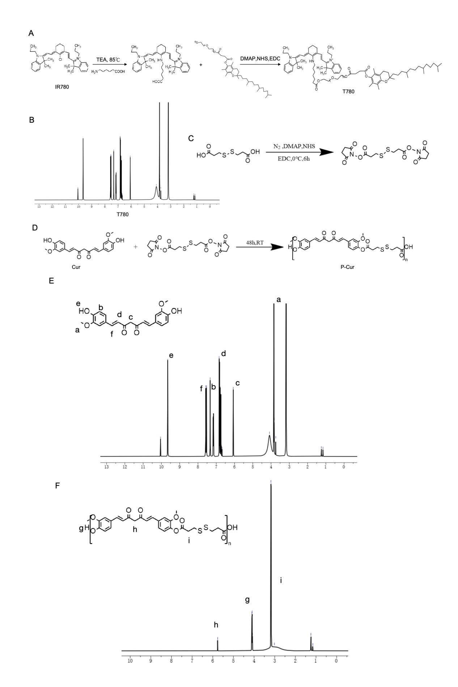
Figure S1. Synthesis and characterization of Biotin@T780/P-cur NPs. A-B Synthesis illustration and ¹H NMR analysis of T780. C-D Synthesis illustration of P-Cur. E-F ¹H NMR analysis of Cur and P-Cur.
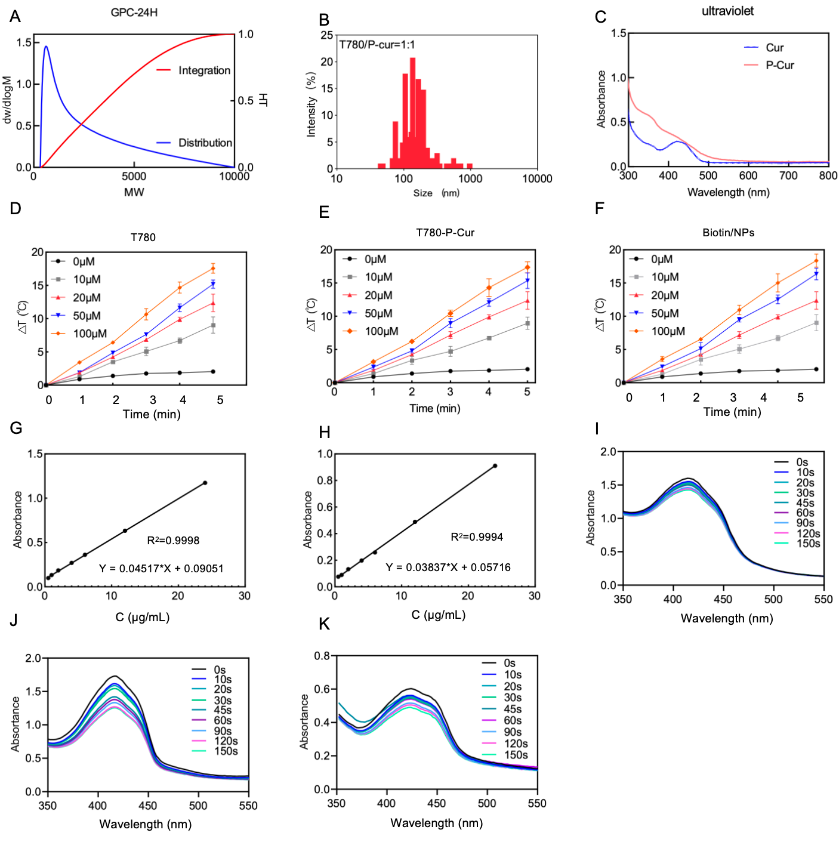
Figure S2. Activity and Function of Biotin@T780/P-cur NPs. A Molecular weight distribution change diagram of the P-cur within 24 h. B Size distribution analysis of T780/P-Cur NPs in a 1:1 molar ratio system. C Schematic diagram of the UV absorption peaks of Cur and P-Cur measured using a UV-Vis spectrophotometer. D-F Temperature increase curves of T780, T780/P-Cur NPs, and Biotin/NPs under near-infrared light irradiation at different concentrations. Figure S3. Mechanism of NPs inducing oxidative stress and sensitizing immune response in vitro. (A, B) ROS levels in AMC-HN-8 following different treatments, measured by fluorescence imaging and flow cytometry. Scale bar: 150 µm. (C, D) Lipid peroxidation levels in SCC7 cells after different treatments, measured by fluorescence imaging and flow cytometry. Scale bar: 150 µm. (E) Lipid peroxidation levels in AMC-HN-8 cells after different treatments, measured by flow cytometry. (F, K, L) Quantification of ATP and pro-inflammatory factors IL-2 and TNF-α in AMC-HN-8 cells following the specified treatments. (G, H) Immunofluorescence staining and flow cytometry analysis of CRT expression on the surface of AMC-HN-8 cells after different treatments. Scale bar: 50 μm. (I-J) AMC-HN-8 cells were subjected to HMGB1 immunofluorescence labeling and flow cytometry analysis after various treatments.
Figure S4. Biosafety of Biotin@T780/P-cur NPs. (A-E) Biochemical parameters in mouse serum and hematoxylin-eosin (H&E) staining of major organs in response to different drugs.

