Near-infrared organic nanoparticles (6BQ NPs) enhance the random flaps survival by modulating the HSP90/HIF-1α axis through mild photothermal therapy

Feng Wu^{a,1}, Jin Zhang^{b,1}, Jiangtian Ye^{a,1}, Jinwu Wangª, Wenhao Zhengª, Hua Chenª, Xiaoyu Dong^{b}, Zu-Sheng Huang^{b,*}, Leyi Cai^{a,*}, Guangheng Xiang^{a,*}

ª Department of Orthopaedics Surgery, The Second Affiliated Hospital and Yuying Children’s Hospital of Wenzhou Medical University, Wenzhou, 325000, Zhejiang Province, China.
^{b} School of Pharmaceutical Sciences, Wenzhou Medical University, Wenzhou, 325000, Zhejiang Province, China.

¹ These authors contributed equally: Feng Wu, Jin Zhang and Jiangtian Ye
* Zu-Sheng Huang, Leyi Cai and Guangheng Xiang contributed equally to this work and should be considered co-corresponding authors.

E-mail:
Zu-Sheng Huang huangzusheng@wmu.edu.cn
Leyi Cai caileyi@wmu.edu.cn
Guangheng Xiang xiangguangheng@wmu.edu.cn

Address: Department of Orthopaedics Surgery, The Second Affiliated Hospital and Yuying Children’s Hospital of Wenzhou Medical University. NO.109, XueYuan West Road , Luheng District, Wenzhou, Zhejiang Province, 325000, P.R. China.

Synthesis of 6BQ.
Compound 3 (3,3'-((5,6-Dinitrobenzo[c][1,2,5]thiadiazole-4,7-diyl)bis(thiophene-5,2-diyl))bis(10-hexyl-10H-phenothiazine)).
Compound 1 (1.03 g, 2.52 mmol) and compound 2 (600 mg, 1.09 mmol) were dissolved in toluene (10.0 mL) in a 50 mL two-neck flask. Potassium carbonate (2 M, 2.18 mL) and catalyst Pd(PPh₃)₄ (62.9 mg, 0.0545 mmol) were added to the mixture. Under argon atmosphere, the reaction mixture was heated to 110 ℃ and stirred for 12 h. The reaction mixture cooled to room temperature, washed with 30.0 mL of deionized water, extracted three times with DCM and dried with MgSO₄. The solvent was evaporated under reduced pressure to obtain the crude product which was separated and purified by silica gel column chromatography (petroleum ether/dichloromethane = 2/1). The compound 3 was dried to yield a dark purple solid (0.595 g), yield: 57.3%. ¹H NMR (400 MHz, DMSO-d₆, ppm) δ 7.61 (d, J = 4.0 Hz, 2H), 7.56–7.50 (m, 4H), 7.46 (d, J = 3.9 Hz, 2H), 7.23–7.18 (m, 2H), 7.16–7.14 (m, 2H), 7.06–7.02 (m, 4H), 6.95 (t, J = 7.4 Hz, 2H), 3.88 (t, J = 6.8 Hz, 4H), 1.72–1.64 (m, 4H), 1.42–1.35 (m, 4H), 1.26–1.23 (m, 8H), 0.83–0.80 (m, 6H).¹³C NMR (100 MHz, DMSO-d₆, ppm) δ 153.41, 152.28, 149.01, 145.64, 144.52, 140.87, 133.02, 128.01, 127.38, 125.77, 124.97, 124.40, 123.27, 121.06, 116.61, 47.11, 31.31, 26.64, 26.28, 22.56, 14.34. HRMS (ESI) Calcd for C₅₀H₄₄N₆O₄S₅⁺[M]⁺: 952.2028, found: 952.2074.
6BQ (3,3'-(6,7-diphenyl[1,2,5]thiadiazolo[3,4-g]quinoxalin-4,9-diylbis(thiophene-5,2-diyl))bis(10-hexyl-10H-phenothiazine)).
Compound 3 (150 mg, 158 mmol) was dissolved in DCM (10.0 mL), followed by addition of absolute ethanol (2.00 mL) and 10.0 mg of Pd/C catalyst. The reaction mixture was stirred and reacted at room temperature under the hydrogen atmosphere for 4 h until the color of the reaction solution turned yellow. After the reaction was completed, excess Pd/C was filtered off using diatomaceous earth, and the filtrate was concentrated by rotary evaporation under reduced pressure without further purification. The above reduced product (150 mg) and benzil (662 mg, 0.315 mmol) were dissolved in chloroform (10.00 mL) and glacial acetic acid (10.00 mL), and the reaction solution was refluxed at 70℃ overnight. After completion and cooling to room temperature, the reaction solution was filtered with a Buchner funnel, washed with petroleum ether, and the crude product was separated and purified by silica gel column chromatography (petroleum ether/dichloromethane = 2/1). The product was obtained as a grass green solid (0.078 g), yield: 46.3%. ¹H NMR (400 MHz, Pyridine-d₅, ppm) δ 9.26 (d, J = 4.1 Hz, 2H), 8.06–8.05 (m, 4H), 7.81–7.80 (m, 2H), 7.76–7.74 (m, 2H), 7.63 (d, J = 4.1 Hz, 2H), 7.57 (s, 2H), 7.54–7.48 (m, 4H), 7.35–7.26 (m, 4H), 7.08–7.01 (m, 6H), 3.86 (t, J = 7.1 Hz, 4H), 1.80–1.73 (m, 4H), 1.41–1.33 (m, 4H), 1.21–1.18 (m, 8H), 0.82 (t, J = 6.8 Hz, 6H).¹³C NMR (125 MHz, Pyridine-d₅, ppm) δ 152.51, 151.56, 148.74, 148.42, 148.23, 144.93, 144.75, 138.24, 134.40, 132.84, 132.80, 130.95, 129.70, 129.64, 129.17, 128.17, 127.50, 127.38, 125.25, 124.77, 124.36, 123.90, 120.47, 115.98, 115.82, 47.14, 31.12, 29.45, 26.22, 22.30, 13.60.HRMS (ESI) Calcd for C₆₄H₅₄N₆S₅⁺[M]⁺: 1066.3013, found: 1066.3071.

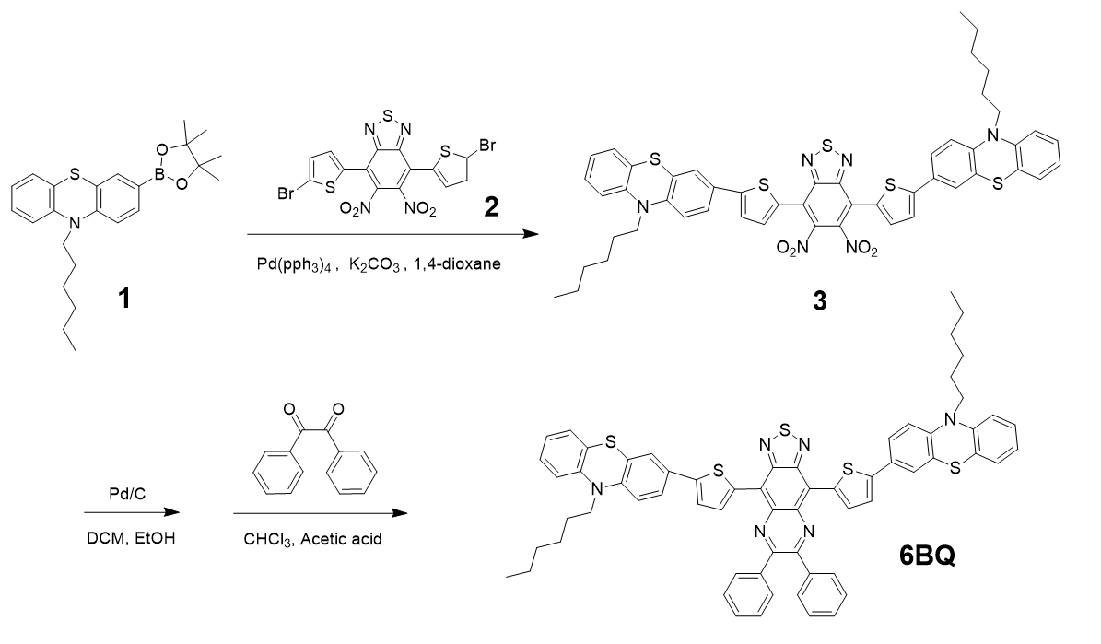
Scheme S1. Synthetic route of 6BQ.

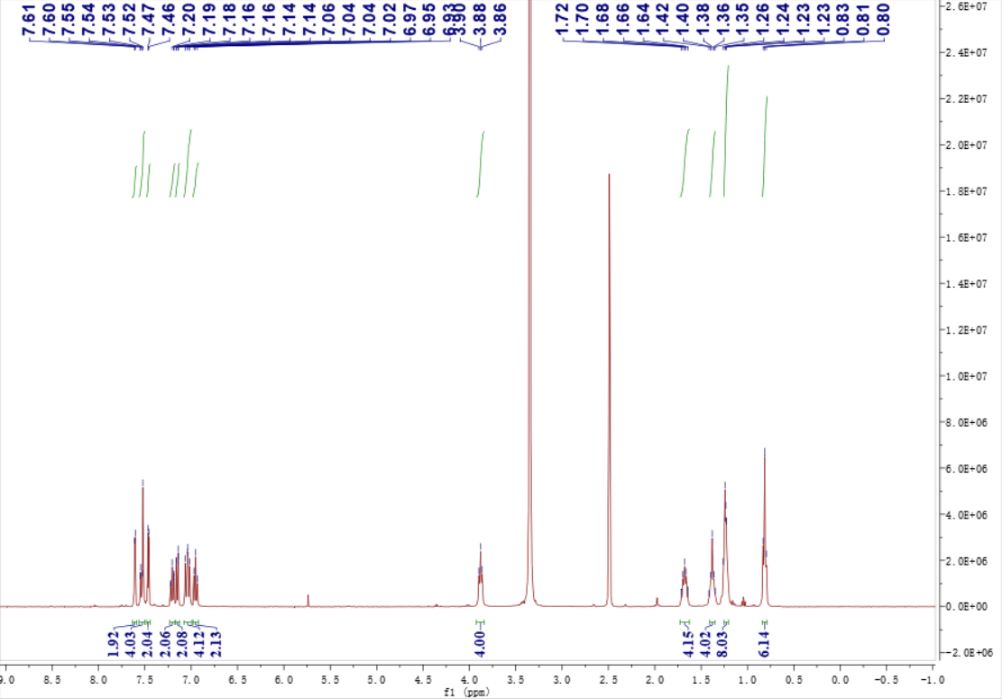
Figure S1. ¹H NMR of compound 3 (400 MHz, DMSO-d₆).

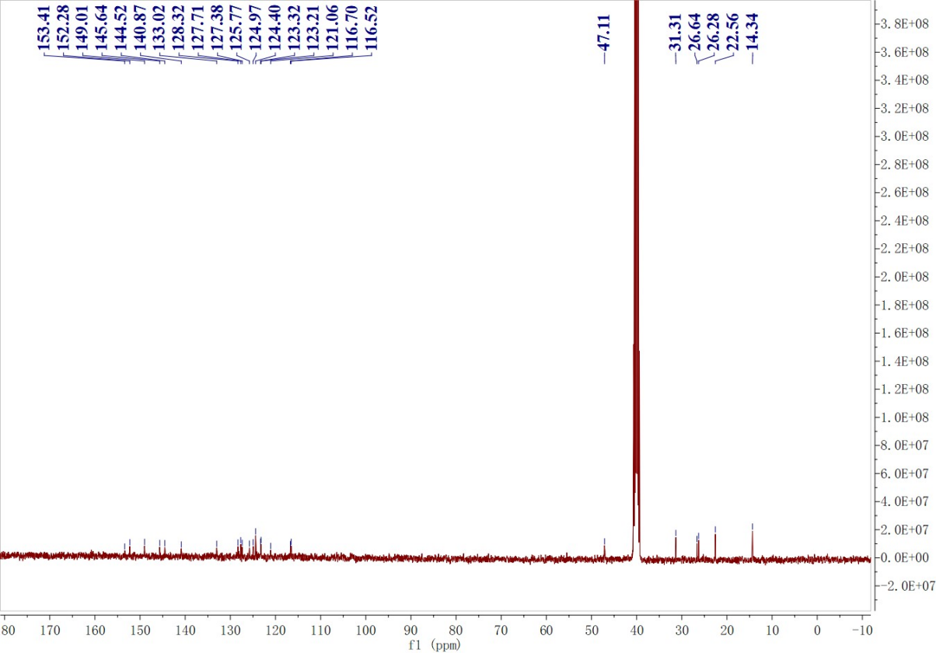
Figure S2. ¹³C NMR of compound 3 (100 MHz, DMSO-d₆).

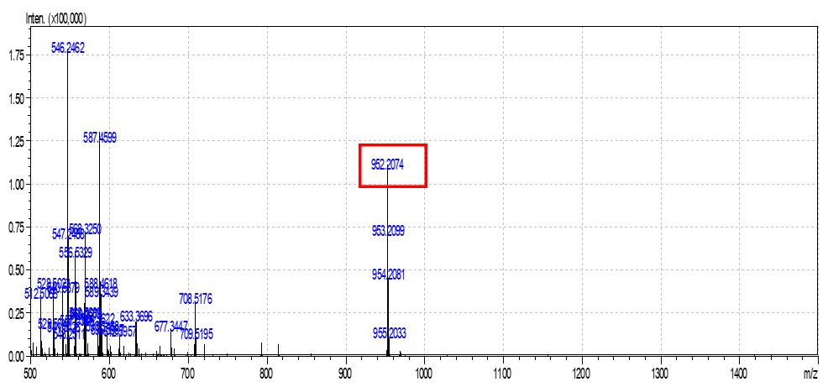Figure S3. HRMS of compound 3.

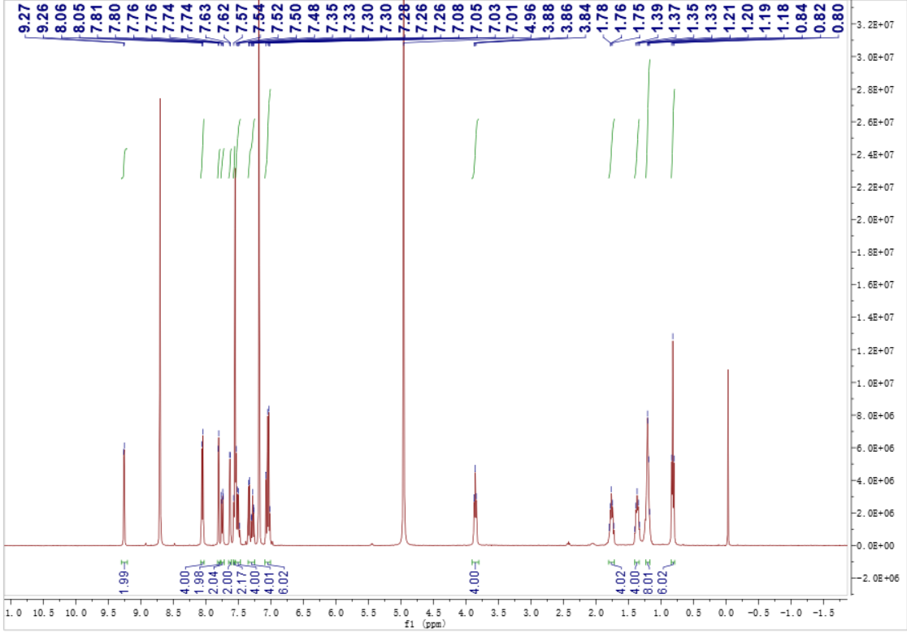
Figure S4. ¹H NMR of 6BQ (400 MHz, THF-d₈).

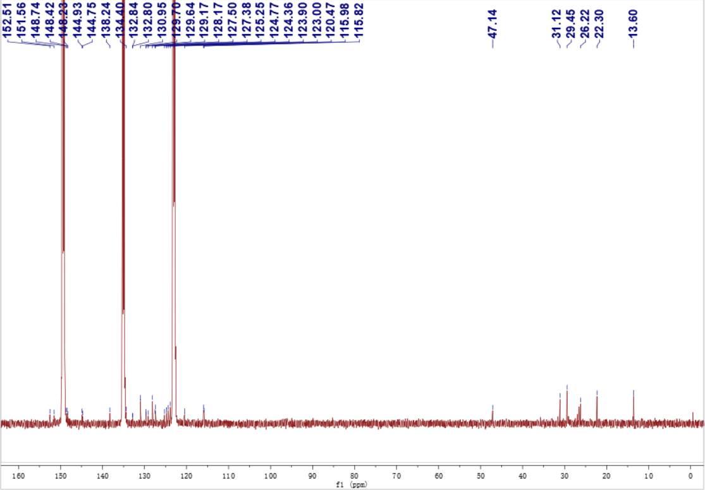
Figure S5. ¹³C NMR of 6BQ (125 MHz, Pyridine-d₅).

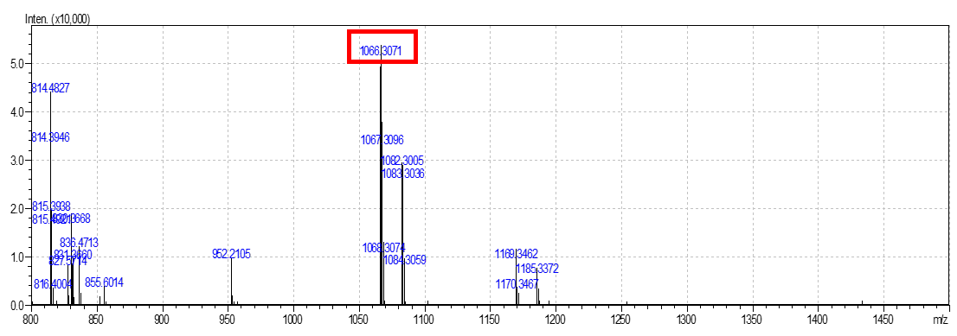
Figure S6. HRMS of 6BQ.

Figure S7. Absorption spectra of 6BQ (10 μM) in THF.
Figure S8. (A)Photothermal images of 6BQ NPs solution irradiated by laser (808 nm, 0.5 W/cm²) at different concentrations. (B) Photothermal images of 6BQ NPs (25 μM) solution irradiated by laser (808 nm) at different laser power densities. (C) Photothermal images of 6BQ NPs (25 μM) solution irradiated by laser (808 nm, 0.5 W/cm²) for 15 minutes.

Figure S9. A₀ and A are the peak absorbance of 6BQ NPs before and after 808 nm laser irradiation (0.5 W/cm²).

Table S1. Primers sequences of Human for RT-qPCR
Primer | Sequence (5′-3′)
HSP90 | F 5′-CAGGTGACAATCTCCAATAGA-CTTGTGTCT-3′
HSP90 | R 5′-GACCTAGCTTGATCATGCGATAG-ATGCGGT-3′
HIF-1α | F 5′-ATCCATGTGACCATGAGGAAAT-3′
HIF-1α | R 5′- CTCGGCTAGTTAGGGTACACTT-3′
VEGF | F 5′- TATGCGGATCAAACCTCACCA-3′
VEGF | R 5′- CACAGGGATTTTTCTTGTCTTGCT-3′
GAPDH | F 5′- GATTTGGTCGTATTGGGCG-3′
GAPDH | R 5′-CTGGAAGATGGTGATGG-3′

Table S2. Primers sequences of Rats for RT-qPCR
Primer | Sequence (5′-3′)
HSP90 | F 5′-GGTTAGTCACGTTTCGTGCG-3′
HSP90 | R 5′-ATCCAGAGCGTCTGAGGAGT-3′
HIF-1α | F 5′-GACAATAGCTTCGCAGAATGC-3′
HIF-1α | R 5′-TCGTAACTGGTCAGCTGTGG-3′
VEGF | F 5′-AATGATGAAGCCCTGGAGTG-3′
VEGF | R 5′-AATGCTTTCTCCGCTCTGAA-3′
GAPDH | F 5′-GAGATTACTGCCCTGGCTCC-3′
GAPDH | R 5′-AAACGCAGCTCAGTAACAGTC-3′

