Supporting Information
Macrophage-Mimetic Liposomes Co-delivering Ceria and Ac2-26 Peptide for Penumbra Protection in Ischemic Stroke
Lingyun Bai ^{1†}, Na Li ^{2†}, Huiqin Li ^{3†}, Yuxuan Dai ³, Yi Bai ¹, Feiyu Ma ¹, Dujuan Sha ⁴, Shengnan Xia ³, Yun Xu ^{3,5*}, Xiang Cao ^{1,3,5*}

¹ Department of Neurology, Nanjing Drum Tower Hospital, Drum Tower Hospital Life and Health Research Institute, Nanjing Normal University, Nanjing, 210008, China
² Department of Blood Transfusion Medicine, Jinling Hospital, Affiliated Hospital of Medical School, Nanjing University, Nanjing, 210002, China
³ Department of Neurology, Nanjing Drum Tower Hospital, Affiliated Hospital of Medical School, Nanjing University, Nanjing, 210008, China
⁴ Department of General Practice, Nanjing Drum Tower Hospital, Affiliated Hospital of Medical School, Nanjing University, Nanjing, 210008, China
⁵ Nanjing Neurology Clinical Medical Center, Nanjing, 210008, China

† Lingyun Bai, Na Li and Huiqin Li contributed equally to this work.

*Correspondence:
Yun Xu
xuyun20042001@aliyun.com
Xiang Cao
caoxiang@njglyy.com

Fig. S1 Characterization of CeO₂. (A) Size distribution of CeO₂ nanoparticles measured by DLS. (B) Zeta potential of CeO₂ nanoparticles measured by DLS. (C) Elemental mapping of CeO₂ nanoparticles. Scale bar = 50 nm. (D) EDX spectrum of CeO₂ nanoparticles.

Fig. S2 (A) TEM image of CeO₂-Ac2-26@MM-LPs. Scale bar = 50 nm. (B) Magnified TEM images of CeO₂ nanoparticles encapsulated within CeO₂-Ac2-26@MM-LPs. Scale bar = 10 nm. (C) EDX spectrum of CeO₂-Ac2-26@MM-LPs.

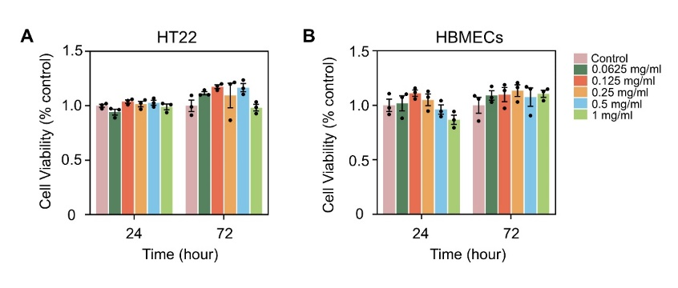
Fig. S3 (A) Viability of HT22 cells co-cultured with MM-LPs at different concentrations, measured by CCK-8 assay (n = 3). (B) Viability of HBMECs co-cultured with MM-LPs at different concentrations, measured by CCK-8 assay (n = 3).

Fig. S4 Hemolysis assay of CeO₂-Ac2-26@MM-LPs (n = 6). “ns” means no significance (P > 0.05), ***P<0.001 versus the pure water group.

Fig. S5 H&E staining of major organs (heart, liver, spleen, lungs, and kidneys) from different treatment groups. Scale bar = 50 μm.

Fig. S6 In vivo biocompatibility of CeO₂-Ac2-26@MM-LPs measured by (A) hematology and (B) blood chemistry tests (n = 5).

Fig. S7 Representative fluorescence images of major organs including heart, liver, spleen, lung and kidney from tMCAO mice at different timepoints post i.v. injection of DiR-labeled LPs and MM-LPs.

Fig. S8 (A-B) The Nrf2 inhibitor ML385 abolished the ROS-scavenging capacity of CeO₂-Ac2-26@MM-LPs in OGD/R-treated HT22 cells (n = 3). **P<0.01, ***P<0.001versus the control group; ##P<0.01 versus the OGD/R group; &P<0.05 versus the OGD/R + CeO₂-Ac2-26@MM-LPs group.

Fig. S9 (A-B) ML385 (Nrf2 inhibitor) blocked CeO₂-Ac2-26@MM-LPs-mediated reduction of apoptosis in OGD/R-injured HT22 cells (n = 3). *P<0.05, ***P<0.001 versus the control group; ###P<0.001 versus the OGD/R group; &&&P<0.001 versus the OGD/R + CeO₂-Ac2-26@MM-LPs group.

Fig. S10 TEER measurements revealed that CeO₂-Ac2-26@MM-LPs and the NF-κB inhibitor PDTC produced comparable effects in reducing endothelial permeability (n = 3). **P<0.01, ***P<0.001 versus the control group; ##P<0.01, ###P<0.001 versus the OGD/R group.

