Supporting information
Targeted inhibition of cGAS/STING signaling induced by aberrant R-LOOP in Nucleus pulposus to alleviate cellular senescence and intervertebral disc degeneration

Supplementary figures and legends
Figure S1. A: UMAP visualizing all the cell subclusters after unsupervised clustering. Each point indicates a single cell, colored according to different cell subclusters. B: Relative proportion of all the cell clusters within IVD tissue between control (mild IVDD) group and IVDD (severe IVDD) group as indicated. IVD: Intervertebral disc; IVDD: Intervertebral disc degeneration. C: Representative molecular signatures for each cell cluster. The area of the bubbles indicates the proportion of cells expressing the gene, and the color intensity reflects the expression intensity.

Figure S2 IVDD is accompanied by aberrant genomic DNA damage and the activation of cGAS/STING axis A: GSEA from human NP tissues (GSE2451747). B and C: Representative images and quantitative results of Immunohistochemistry of cGAS and STING in NP tissues with different degrees of degeneration (n=3). Scale bar=20 μm. D: Schematic workflow to explore the effects of inhibiting STING on NPC senescence. E: Representative images of S-β-Gal staining in H₂O₂-treated primary rat NPCs with or without inhibiting STING via H-151 (1μM). Scale bar=100 μm. F: Quantitative results of S-β-Gal staining (n=3). G: qRT-PCR detecting the mRNA expression of IL-1β, IL-6, and TNFα in H2O2-treated primary rat NPCs with or without inhibiting STING via H-151 (1μM) (n=3). *p < 0.05, **p < 0.01, ***p < 0.001, ****p < 0.0001.
Figure S3. KEGG analysis of NPCs based on the blue-yellow module.
Figure S4. KEGG analysis of NPCs based on the module.

Figure S5. scRNA sequencing of rat IVD tissue. Differentially expressed genes in each NPC cluster.
Figure S7 Relative mRNA expression of proinflammatory genes in rat primary NPCs from different groups. **p < 0.05, **p < 0.01, ***p < 0.001, ****p < 0.0001.
Figure S8 A and B: Representative images and quantitative results of IF staining for ACAN and MMP3 in H2O2-treated primary rat NPCs with or without overexpression of RNase H1 (n=3). Scale bar = 20 μm. **p < 0.05, **p < 0.01, ***p < 0.001, ****p < 0.0001. ACAN: Aggrecan; MMP3: Matrix metalloproteinase-3.

Figure S9 A: Volcano plot of the differentially expressed genes of human degenerated and non-degenerated IVD (GSE167931). B: Volcano plot of the differentially expressed genes of NP cells at passage 2 (P2) generation and passage (P8) generation via serial passage (GSE245147).
Figure S10 that ERCC5 operates upstream of cGAS/STING pathway. A: Representitative results of the RT-qPCR indicating the senescence-related gene expression of Cdkn1a, Cdkn2a, Il1b, Il6, and Mmp3 in Ercc5-overexpressed rat NPCs treated with or without H151 (a selective STING inhibitor, 1μM). B: Representitative images of the expression of senescence indicator, GLB1, in Ercc5-overexpressed rat NPCs treated with or without H151 (a selective STING inhibitor, 1μM). Scale bar=20 μM. **p < 0.05, **p < 0.01, ***p < 0.001, ****p < 0.0001.

Figure S11 A: Evaluation of the targeting ability of PEG-PAMAM to NPCs with or without CTP labeled by FITC. B: The measurement of representative im-ages of A. **p < 0.05, **p < 0.01, ***p < 0.001, ****p < 0.0001.
Figure S12 Comparison of the delivery system's efficiency, cytotoxicity, and therapeutic efficacy between CTP-PEG-PAMAM against Lip3000. A:Cytotoxicity assay of CTP-PEG-PAMAM with varying concentrations (0, 1, 2, 5, 10, 20, 40, and 50 μg /mL) to rat NPCs. B: Live/dead assay and fluorescence imaging of rat NPCs after treatment with siRNA only for 24 h. Scale bar=100/20 μm. C: Representitative results of the RT-qPCR indicating the expression of Ercc5 in rat NPCs treated with si-Ercc5 delivered by Lip3000, PEG-PAMAM, and CTP-PEG-PAMAM, respectively. D and E: Representitative results of the RT-qPCR indicating the expression of degeneration-related genes (Acan and Mmp3) and senescence-related genes (Cdkn1a, Cdkn2a, Il1b, and Il6) in in rat NPCs treated with si-Ercc5 delivered by Lip3000 and CTP-PEG-PAMAM, respectively. **p < 0.05, **p < 0.01, ***p < 0.001, ****p < 0.0001.
Figure S13. Evaluation the targeting ability to NPCs of CTP-PEG-PAMAM nano-delivery system in vitro and in vivo. A: Representative images of IF staining for the CTP-PEG-PAMAM-FITC signal intensity in rat nucleus pulposus cells (NPCs) and annulus fibrosus cells (AFCs) in vitro, respectively. NPCs were marked by COL2A1 (red), AFCs were marker by COL1A1 (red). CTP-PEG-PAMAM were labeled by FITC. Nuclei were counterstained with DAPI (blue). Scale bar=20 μm. B: Quantation resunts of IF staining for the FITC signal intensity in rat nucleus pulposus cells (NPCs) and annulus fibrosus cells (AFCs), respectively. C: Representative images of IF staining for PBS, PEG-PAMAM-FITC, and CTP-PEG-PAMAM-FITC in rat nucleus pulposus tissue in vivo, respectively. NPCs were marked by COL2A1 (red), PEG-PAMAM and CTP-PEG-PAMAM were labeled by FAM. Nuclei were counterstained with DAPI (blue). Scale bar=20 μm. D: Quantation resunts of IF staining for PBS, PEG-PAMAM-FITC, and CTP-PEG-PAMAM-FITC in rat nucleus pulposus tissue in vivo, respectively.

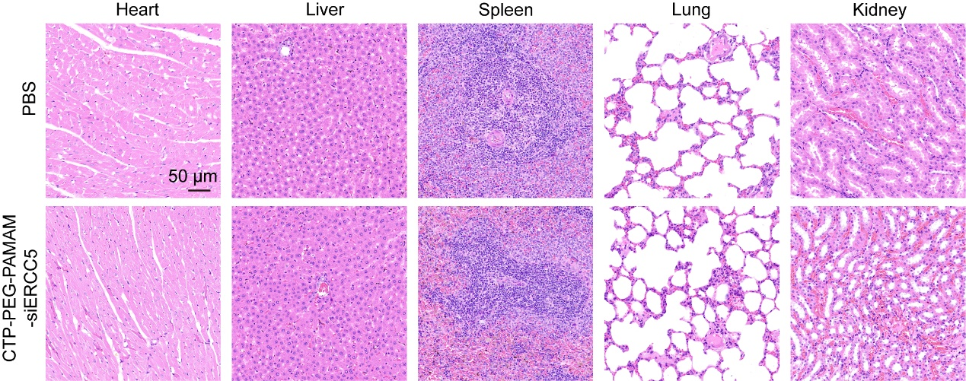
Figure S14. H&E staining of the major organs’ sections (heart, liver, spleen, lung and kidney) obtained from mice in PBS group and IVDD+ CTP-PEG-PAMAM-si-Ercc5 group.

Table S1. Classical surface markers for rat NPC subclusters.
NPC subclusters | Markers
NPC1 | Grem1, Smoc2, Tuba1c
NPC2 | Pcsk2, Meltf, Krt16
NPC3 | Itgbl1, Angptl7, Clec11a
NPC4 | Igfbp5,Apoe, Col2a1
NPC5 | Col14a1, Mmp2, Tnc
NPC6 | Vcan, Col10a1, Ibsp
NPC7 | Fosb, Fos, Junb

Table S2. Primer sequences for Rat tissue and cells
Gene name | Gene ID | Reference sequence | Primer Sequence (5'-3')
Acan | 58968 | NM_022190 | 5' ATG AGT GGC AGT GGA GAT TC 3'  5' AGA CCC TAA CCC CTC TTC TTC 3'
Mmp3 | 171045 | NM_133523.3 | 5' GTTTCTTTACTTCTTCAGCGGAT3'  5' GCTCTTCAATATGTGGGTCACT3'
Cdkn1a | 114851 | NM_080782 | 5' CTG AGT AGG ACT TCG GGG TCT 3'  5' GTC AAG GCT CTG GAC GGT A 3'
Cdkn2a | 25163 | NM_031550.2 | 5' CGTACCCCGATACAGGTGA 3'
Cdkn2a | 25163 | NM_031550.2 | 5' TCGAATCTGCACCATAGGAG 3'
Ercc5 | 301382 | NM_001426998.1 | 5'GAACACAGAGTGCCTCCTACAAG 3'  5'CATTCGTCGGGTGAGTCCT 3'
Ercc6 | 306274 | NM_001107296.1 | 5'GTGTTCCTGAGAGCCCACAAGT3'
Ercc6 | 306274 | NM_001107296.1 | 5'GCTGCCTGGATGCTATGGTAG3'
Il-1β | 24494 | NM_031512.2 | 5'GCTAGTGTGTGATGTTCCCATTA 3'  5'CTTATGTTCTGTCCATTGAGGTG 3'
IL-6 | 24498 | NM_012589 | 5' AAT CTG CTC TGG TCT TCT GGA 3'  5' ATT GCT CTG AAT GAC TCT GGC 3'
TNFα | 24835 | NM_012675.3 | 5'CCCCAATCTGTGTCCTTCTAACT3'  5'CGTGTGTTTCTGAGCATCGTA 3'
β-Actin | 81822 | NM_031144 | 5' CCT CTA TGC CAA CAC AGT 3'
β-Actin | 81822 | NM_031144 | 5' AGC CAC CAA TCC ACA CAG 3'

TableS3 Histological grading system of intervertebral disc
Case number | Gender | Age  (years) | Pfirrmann  score | Diagnosis
1 | Female | 32 | II | Lumbar fracture
2 | Male | 26 | II | Idiopathic scolios
3 | Female | 35 | II | Idiopathic scolios
4 | Male | 19 | II | Tethered cord syndrome
5 | Female | 25 | II | Idiopathic scolios
6 | Female | 60 | III | Lumbar spinal stenosis
7 | Male | 47 | III | Lumbar disc herniation
8 | Male | 43 | III | Lumbar spinal stenosis
9 | Male | 51 | III | Lumbar disc herniation
10 | Female | 53 | III | Lumbar disc herniation
11 | Female | 49 | IV | Lumbar disc herniation
12 | Female | 59 | IV | Lumbar spinal stenosis
13 | Male | 59 | V | Lumbar spinal stenosis
14 | Female | 62 | V | Lumbar disc herniation
15 | Female | 63 | IV | Lumbar spinal stenosis

TableS4 Histological grading system of intervertebral disc
Category | Score
Morphology of the NP | Score 0: round shape and the NP constitutes >75% of the disc area;  Score 1: round shape and the NP constitutes 50–75% of the disc area;  Score 2: round shape and the NP constitutes 25–50% of the disc area;  Score 3: round shape and the NP constitutes <25% of the disc area.
Cellularity of the NP | Score 0: stellar-shaped cells with a proteoglycan matrix located at the periphery, evenly distributed;  Score 1: partially stellar and partially round cells, more stellar than round;  Score 2: mostly large, round cells, separated by dense areas of proteoglycan matrix;  Score 3: large, round cells, separated by dense areas of proteoglycan matrix.
Morphology of the AF | Score 0: well-organized collagen lamellae with no ruptures;  Score 1: inward bulging, ruptured, or serpentine fibers constitute <25% of the af;  Score 2: inward bulging, ruptured, or serpentine fibers constitute 25−50% of the af;  Score 3: inward bulging, ruptured, or serpentine fibers constitute >50% of the af.
Cellularity of the AF | Score 0: fibroblasts comprise >90% of the cells;  Score 1: fibroblasts comprise >75–90% of the cells;  Score 2: intermediate;  Score 3: chondrocytes comprise >75% of the cells.
Border between the NP and AF | Score 0: normal, without any interruption;  Score 1: minimal interruption;  Score 2: moderate interruption;  Score 3: severe interruption.
NP: Nucleus pulposus; AF: Annulus fibrosus

