Supplementary Information

Mesenchymal stem cell-derived extracellular vesicles attenuate periductal fibrosis by inhibiting Th17 differentiation in human liver multilineage organoids and Mdr2^{-/-} mice

Materials and methods
  - Immunostaining of organoids
Organoids were completely harvested using Cell Recovery Solution (Corning, USA).
Immunohistochemical (IHC) staining: organoids were washed once with 1 × PBS, dehydrated in 70% ethanol (SangoBiotech, China), and stained in 0.5% eosin (Sango Biotech, China; dissolved in 96% ethanol) for 30 min. After rehydration in 100% ethanol, the organoids were embedded in paraffin. The subsequent procedures were the same as the normal IHC steps. The data were analyzed using ImageJ (https://imagej.net/Download)
Immunofluorescent (IF) staining: after fixation with 4% (w/v) paraformaldehyde (Absin, China) at 4 °C, the organoids were washed in 0.1% (v/v) Tween-PBS (Sango Biotech, China) and blocked with TritonX-100-BSA solution. Primary antibodies were used to incubate the organoids in 24-well plates at 4 °C overnight. After one wash, the organoids were incubated with corresponding secondary antibodies, before being transferred onto slides with coverslips and observed under a laser scanning confocal fluorescence microscope (LSCFM, Leica STELLARIS 5, Germany). The detailed procedures were described previously[1, 2]. Immunostaining of mouse liver sections were performed following the usual staining procedures. The complete list of antibodies used for immunostaining can be found in Table S3.

  - Function characterization of organoids
Rhodamine 123 (Rho123) staining: The culture media were removed from organoids cultured in Matrigel. The organoids were washed with 1× PBS once. 50 μg/ml Rodamin123 (Solarbio, Beijing, China) regent was then added and cultured with the organoids at 37℃ for 5~10 min in dark. the control group was treated with Verapamil (10mM) (MedChemExpress, USA) for three hours before staining. After the staining, the organoids were washed with PBS three times and observed under a fluorescence microscope (Sigma- Aldrich, Darmstadt, Germany).
Indocyanine green (ICG) uptake/excretion experiment: The culture media were removed, and the organoids were washed with PBS once. 1mg/ml polymethine dye (ICG) (Sigma-Aldrich, Darmstadt, Germany) was added to the well and incubated with the organoids at 37℃ for 30 min. After the incubation, the ICG solution was removed, and the organoids were washed 3 times. 1× PBS was added to the well and the uptake of ICG was observed with a microscope (Leica, Germany). Then PBS was replaced with culture medium to observe the excretion of ICG, and images were captured every 1~2 hours by a microscope (Leica, Germany).
Periodic acid-schiff (PAS) and alkaline phosphatase (ALP) staining: The organoids were harvested completely as described before [2, 3], fixed using 4% polyformaldehyde (PFA) and washed with 1× PBS 3~5 times. Then staining procedure was performed following the instructions of Perodic Acid-Schiff stain kit (Solarbio, Beijing, China) and Alkaline Phosphatase Stain Kit (Yeasen Biotechnology, Shanghai, China). All images were captured with a microscope (Leica, Germany).

  - Analysis of organoids by transmission electron microscopy (TEM) and scanning electron microscopy (SEM)
The organoids were harvested using a cell recovery solution (Corning, USA), as described previously [2]. Organoids were fixed overnight with 2.5% (vol/vol) glutaraldehyde in PBS, followed by further analysis on a cryo-electron microscopy platform at Zhejiang University School of Medicine. TEM and SEM images were acquired and further processed with Adobe Photoshops CS6 (version 13.0; Adobe Systems Software, USA) and Adobe Illustrator 2024 (version 28.0; Adobe Systems Software, USA).

  - Immunohistochemical (IHC) staining of liver tissues
Paraffin sections were heated in an oven at 70°C for 1 hour, then immersed in xylene I for 20 minutes, xylene II for 10 minutes, 100% ethanol for 4 minutes, 100% ethanol for 4 minutes, 90% (vol/vol) ethanol for 4 minutes, 80% (vol/vol) ethanol for 5 minutes and 70% (vol/vol) ethanol for 4 minutes. The slides were rinsed with pure water and then placed in 3% H₂O₂ (diluted in methanol) for 10 minutes. After antigen repair, the slides were blocked with 5% (wt/vol) BSA-PBS for 0.5 to 1 hour.
Primary antibodies were added directly to the slides and incubated overnight at 4°C in a humid chamber. After rewarming at 37°C for 1 hour, the slides were rinsed three times with 1× PBS . After DAB staining, the slides were counterstained with hematoxylin. After dehydration: in 70% (vol/vol) ethanol, 80% (vol/vol) ethanol, 90% (vol/vol) ethanol, 100% ethanol, and xylene, the slides were covered with resin and placed with coverslips. The slides were dried and ready for scanning and analysis. Antibodies were shown in Table S3.

  - Immunofluorescence staining (IF) of liver frozen sections
Briefly, fresh mouse liver tissues were trimmed and embedded in optimal cutting temperature compound (OCT) (Sakura, USA). After cryo-sectioning at 6 μm thickness, the sections were fixed in 4% paraformaldehyde, blocked with 3% (wt/vol) BSA in 1× PBS for 30 minutes, and incubated with primary antibody at 4°C overnight. Subsequently, secondary antibody was applied and incubated at room temperature for 1 hour, followed by DAPI counterstaining (10–20 minutes, room temperature). Finally, the sections were mounted and imaged using a laser scanning confocal microscope (LSCFM, Leica STELLARIS 5, Germany). DiR signaling were detected within the 720–800 nm emission range.

  - Isolation of intrahepatic immunocytes
Infiltrating lymphocytes were freshly isolated from PSC or normal human liver tissue, or from FVB mouse livers, for phenotyping. Briefly, resected liver tissue was cut to 5 mm³ cubes and digested with Liver Dissociation Kit (Miltenyi Biotech, Germany). Mechanical and enzymic digestion was applied and the homogenized tissue was filtered through a 70-μm mesh. Lymphocytes were separated in 40% (vol/vol) PercollTM (Cytiva, Shanghai, China) by centrifugation at 600 × g for 15 minutes. The phenotype of freshly isolated liver-infiltrating lymphocytes was identified on the day of preparation without further expansion.

  - Flow cytometry analysis
Freshly isolated infiltrating lymphocytes from human/mice liver or differentiated Th17 were subjected to flow cytometry analysis. Before intracellular staining, cells were stimulated with 100 ng/mL of PMA and 1 µg/mL of ionomycin for 5 h and incubated with 4 µg/mL brefeldin A for more than 3 h, depending on the experiments. Lymphocytes were fixed and permeabilized with Intracellular Fixation & Permeabilization Buffer Set (Thermo Fisher Scientific, USA), according to the manufacturer’s protocol. Antibodies used in this experiment are listed in Table S3. All data were collected using a 13-color CytoFlex flow cytometer and analyzed using Flowjo10 software (BD Biosciences, USA).

  - Th17 cell differentiation and EV/miRNA treatment
PBMCs were isolated from the peripheral blood of human donors following general procedures. Then CD4⁺ naïve T cells were isolated using MojoSort™ Human CD4 Naïve T Cell Isolation Kit (Biolegend, California, USA) according to the manufacturer’s instructions. The cells were cultured in a 48-well plate with 300 μl/well differentiation medium: Iscove's Modified Dulbecco’s Medium (IMDM) (Sigma-Aldrich, Germany) supplemented with GlutaMAX (Corning, USA), anti-CD3/CD28 (0.5-1μg/ml) (Biolegend, USA), 1% (vol/vol) penicillin and streptomycin (Corning, USA), hIL-23 (100ng/ml), hIL-21 (50ng/ml), hIL-6 (20ng/ml), hIL-1β (50ng/ml), hIL-2 (50ng/ml), hIL-6 (20μg/ml), anti-INFγ (2.5μg/ml) and anti-IL-4 (500ng/ml)(Biolegend, USA). Differentiation medium was refreshed every 3 days. And EVs (10 ng/ml) or miR-7977 mimic (50nM) (RiboBio, Guangzhou, China) were applied during medium changes (every 3 days). Optimal differentiation was reached after two weeks in culture and purity was confirmed by flow cytometry.

  - Determination of cytokines in the culture supernatant
The supernatant from the culture was collected, frozen, and stored at -80℃ until use. Supernatants were thawed on ice before measuring the concentration of cytokines. Levels of IL-17A, IL-6, and IL-8 were measured using a bead-based LEGENDplex™ Human Proinflammatory Chemokine Detection Kit (BioLegend, USA). Data were collected using a Cytoflex LX flow cytometer (Beckman Coulter, USA) and analyzed using Legendplex V 8.0 software (BioLegend, USA). Levels of CCL20, CCL2, and IL-22 were measured using specific ELISA kits (BioLegend, USA). All assays were performed according to the manufacturer’s instructions.

  - Detection of liver transaminases levels of the mouse serum
Each serum biochemical parameters, such as ALT, AST, and ALP, were measured in a 10-μl volume of mouse serum in a Dry Biochemical Analyzer (Fuji, Japan).

  - Quantitative reverse transcription polymerase chain reaction (qRT-PCR) analysis
RNAs of cells, liver tissue and EVs were extracted with a RNeasy Isolation Kit (QIGEN), the TRIzol (Invitrogen, CA, USA) extraction method, and an Exosome RNA Purification Kit (EZBioscience, USA), respectively. RNA quality was assessed on an Agilent 2100 Bioanalyzer (Agilent Technologies, Palo Alto, CA, USA). Equal amounts of RNA were subjected to reverse transcription using HiScript III Reverse Transcriptase (Vazyme, China), followed by qRT-PCR quantification with ChamQTM SYBR qPCR Master Mix (Vazyme, China). The expression levels were normalized using the house keeping gene Gapdh or Actb. The complete list of quantitative PCR primers can be found in Table S4.

  - Western-blot analysis
Approximately 2–10 μg of protein was separated on 4–15% Mini-PROTEAN® TGX™ Gels (Bio-Rad Laboratories, CA, USA) by SDS-PAGE in a Mini-PROTEAN® Tetra Vertical Electrophoresis Cell (Bio-Rad Laboratories, CA, USA) and then transferred to polyvinylidene difluoride membranes (Merck KGaA, Darmstadt, Germany). After incubation in blocking buffer (Beyotime Biotech., Shanghai, China) at room temperature for 1 h, the membranes were incubated with primary antibodies overnight at 4°C, then washed three times in Tris-buffered saline with 0.1% Tween (TBST 1×; Sangon Biotech, Shanghai, China) and incubated with secondary antibodies. After washing in 1× TBST, the membranes were incubated with the Pierce™ ECL Western Blotting Substrate (Thermo Fisher Scientific, USA) for 5 min and detected with the ChemiScope Western Blot Imaging System (Clinx Science Instruments Co., Shanghai, China). Primary and secondary antibodies used in this research are shown in Table S3.

  - RNA sequencing and transcriptomic analysis
Total RNA was extracted from mouse livers according to the manufacturer’s protocol. RNA quality was assessed on an Agilent 2100 Bioanalyzer (Agilent Technologies, Palo Alto, CA, USA) and checked using RNase free agarose gel electrophoresis. After total RNA was extracted, eukaryotic mRNA was enriched by Oligo (dT) beads, while prokaryotic mRNA was enriched by removing rRNA with a Ribo-ZeroTM Magnetic Kit (Epicentre, Madison, WI, USA). Then the enriched mRNA was fragmented into in fragmentation buffer and transcribed into cDNA with random primers. Second-strand cDNA was synthesized using DNA polymerase I, RNase H, dNTP and PCR buffer. Then the cDNA fragments were purified with a QiaQuick PCR extraction kit (Qiagen, Venlo, The Netherlands), end repaired, added with poly(A), and ligated to Illumina sequencing adapters. The ligation products were size selected by agarose gel electrophoresis, amplified by PCR, and sequenced using Illumina HiSeq2500 by Gene Denovo Biotechnology Co. (Guangzhou, China). The following bioinformatics analysis was performed with the help of Omicsmart web analysis platform.

  - CUT&Tag assay
CUT&Tag library construction: CUT&Tag assay was performed using HyperactiveTM In-Situ ChIP Library Prep Kit for Illumina (cat.no.TD901-TD902, Vazyme Biotech, China) according to manufacturer's instructions [4]. Briefly, concanavalin A-coated magnetic beads (ConA beads) were prepared and added to resuspended cells and incubated at room temperature to bind the cells. Non-ionic detergent Digitonin was used to permeate the cell membrane. Then, the IκBζ antibody (Cell Singal Transduction), the secondary antibody and the Hyperactive pA-Tn5 Transposase were incubated sequentially with the cells bound with ConA beads. Therefore, the Hyperactive pA-Tn5 Transposase can precisely cut off the DNA fragments that were bound with the target protein. In addition, the cut DNA fragments could be ligated with P5 and P7 adaptors using Tn5 transposase, and the resulting libraries were amplified by PCR with P5 and P7 primers. The purified PCR products were evaluated using the Agilent 2100 Bioanalyzer (Agilent Technologies, Santa Clara, CA, USA). Finally, these libraries were sequenced on the Illumina NovaSeq6000 platform and 150 bp paired-end reads were generated for the following analysis.
CUT&Tag analysis：The raw sequence data were firstly quality trimmed by fatsp [5] software to obtain the clean reads. Then the clean reads were aligned to the human genome GRCh38.p14 using Bowtie2 [6] and subsequently analyzed by the SEACR software based the ‘stringent’ parameter to detect genomic regions enriched for multiple overlapping DNA fragments (peaks) that we considered to be the putative binding sites. Visualization of peak distribution along the genomic regions of target genes was performed with IGV. Peaks were then annotated using chipseeker [7] software. Significant Motif of peaks were analyzed by MEME and DREME software [8] and aligned to the motif database. Th17 cells differentiated from naïve CD4⁺ T cells were regarded as Ctrl, and the group treated with miR-7977 mimic was denoted as Th17^{miR}. Different peaks between Th17^{miR} and Ctrl groups were analyzed using Manorm [9] software. Firstly, the algorithm established a regression model of M-value and A-value of common peaks between the two samples to eliminate the influence of sequencing deviation. The M-value was calculated as log₂(case common peak abundance/control common peak abundance), and the A-value as log₂(case common peak abundance × control common peak abundance). Then p-value was calculated by the bayesian model. Finally, the significantly different peaks were identified with the threshold of p-value < 0.05 and |M-value| > 1。

Supplementary Tables
Table S1. miRNAs in Exo^{MSC} detected by miRNA microarrays.
ProbeID | gTotalProbeSignal (raw) | Normalized | Active_sequence | Mirbase accession No
hsa-miR-7975 | 160.394 | 7.325476 | TGGTGCCGTGACT | MIMAT0031178
hsa-miR-7977 | 137.8552 | 7.10701 | TGGTGCGTTGGCTG | MIMAT0031180
hsa-miR-5100 | 17.33085 | 4.115271 | AGAGGCACCGCTGG | MIMAT0022259
hsa-miR-6089 | 17.08556 | 4.094706 | CCGCCCCGCCC | MIMAT0023714
hsa-miR-1273g-3p | 10.5754 | 3.40264 | CTCAGGCTGGAGTGC | MIMAT0022742
hsa-miR-1260a | 9.42448 | 3.236413 | TGGTGGCAGAGGTGG | MIMAT0005911
hsa-miR-4665-3p | 6.51081 | 2.702837 | GGCGGGGGCTAC | MIMAT0019740
hsa-miR-1234-3p | 6.39379 | 2.676671 | GTGGGGTGGGT | MIMAT0005589
hsa-miR-940 | 6.19823 | 2.631856 | GGGGAGCGGGGG | MIMAT0004983
hsa-miR-6819-3p | 6.14479 | 2.619364 | CTGGGGTGGGGAC | MIMAT0027539
hsa-miR-4286 | 5.56441 | 2.476229 | GGTACCAGGAGTGGG | MIMAT0016916
hsa-miR-4433a-5p | 5.47032 | 2.451625 | ACAGGAGTGGGGG | MIMAT0020956
hsa-miR-4313 | 5.17616 | 2.371882 | GGGTTTGGGGCCA | MIMAT0016865
hsa-miR-6737-3p | 4.97449 | 2.314549 | CTGGGTAGGGGTGA | MIMAT0027376
hsa-miR-1228-3p | 4.65108 | 2.217566 | GGGGGGCGAGG | MIMAT0005583
hsa-miR-3162-3p | 4.49864 | 2.169489 | TGGGGAGTGGAGGG | MIMAT0019213
hsa-miR-1238-3p | 4.30039 | 2.104468 | GGGGCAGACAGAC | MIMAT0005593
hsa-miR-6069 | 4.22243 | 2.078074 | GGGGGCAGCAGG | MIMAT0023694
hsa-miR-6766-3p | 4.19904 | 2.07006 | TGAGGGTGGGGGAA | MIMAT0027433
hsa-miR-6515-3p | 4.19626 | 2.069104 | CTGGGGGGTAGATGA | MIMAT0025487
hsa-miR-191-3p | 4.1556 | 2.055057 | GGGGACGAAATCCAAG | MIMAT0001618
hsa-miR-6797-3p | 4.14677 | 2.051988 | GTGGGGAGGGAAGG | MIMAT0027495
hsa-miR-1304-3p | 4.05247 | 2.018802 | GGGGTTCGAGGCT | MIMAT0022720
hsa-miR-4459 | 3.97967 | 1.992649 | CTCCACCTCCTCCG | MIMAT0018981
hsa-miR-4749-3p | 3.8762 | 1.954643 | CTGTGGGGGCAGG | MIMAT0019886
hsa-miR-6508-5p | 3.8129 | 1.930889 | GGTGGGTCATGCATT | MIMAT0025472
hsa-miR-6763-3p | 3.63441 | 1.861721 | CTGGGGGCAGAGG | MIMAT0027427
hsa-miR-6800-3p | 3.59391 | 1.845554 | GGGGCGATGCCAG | MIMAT0027501
hsa-miR-1260b | 3.58667 | 1.842645 | ATGGTGGCAGTGGTG | MIMAT0015041
hsa-miR-4649-3p | 3.40098 | 1.765951 | TGGGGAGAGGCAGG | MIMAT0019712
hsa-miR-4725-5p | 3.33624 | 1.738223 | GGTGGGAAGGCTGC | MIMAT0019843
hsa-miR-6889-3p | 3.31886 | 1.730688 | CTGGGAAGTAGGGGC | MIMAT0027679
hsa-miR-6777-3p | 3.22429 | 1.688982 | CTGGGGGCCAGG | MIMAT0027455
hsa-miR-425-3p | 3.22002 | 1.68707 | GGGCGGACACGAC | MIMAT0001343
hsa-miR-1281 | 3.21225 | 1.683584 | GGGAGAGGAGGAGG | MIMAT0005939
hsa-miR-3180-5p | 3.12157 | 1.642272 | CGACGTGGGGCG | MIMAT0015057
hsa-miR-6880-3p | 2.91041 | 1.541222 | CTGGGGGAGGAGAG | MIMAT0027661
hsa-miR-1237-3p | 2.88131 | 1.526725 | CTGGGGGACGG | MIMAT0005592
hsa-miR-6813-3p | 2.83833 | 1.505042 | CTGGGGAGAGGGG | MIMAT0027527
hsa-miR-6795-3p | 2.72226 | 1.444805 | CTGGGGGAAGAAACG | MIMAT0027491
hsa-miR-766-3p | 2.716986 | 1.442007 | GCTGAGGCTGTGGGGCT | MIMAT0003888
hsa-miR-6824-3p | 2.58767 | 1.371654 | CTGGGGTGGCAAGA | MIMAT0027549
hsa-miR-1246 | 2.38653 | 1.254914 | CCTGCTCCAAAAATCC | MIMAT0005898
hsa-miR-6870-3p | 1.88614 | 0.915437 | CTGAAAGGAGATGGGG | MIMAT0027641
hsa-miR-6848-3p | 1.84972 | 0.887307 | CTGGGGGCCAAGA | MIMAT0027597
hsa-miR-6851-3p | 1.847205 | 0.885344 | CTGGAGGGGTACAAAG | MIMAT0027603
hsa-miR-4323 | 1.81545 | 0.860327 | TCTGAGGCTGTGGGG | MIMAT0016875
hsa-miR-2116-3p | 1.61359 | 0.690274 | GGGAGTTCTTGGCATG | MIMAT0011161
hsa-miR-1908-3p | 1.60617 | 0.683625 | CGGGGCGGAGC | MIMAT0026916
hsa-miR-550a-5p | 1.567005 | 0.64801 | GGGCTCTTACTCCCT | MIMAT0004800
hsa-miR-23c | 1.56647 | 0.647517 | GGGTAATCACTGGCAA | MIMAT0018000
hsa-let-7f-1-3p | 1.543511 | 0.626216 | GGGAAGGCAATAGATTGTAT | MIMAT0004486
hsa-miR-1825 | 1.51966 | 0.603749 | GGAGAGGAGGGCAC | MIMAT0006765
hsa-miR-4769-3p | 1.51385 | 0.598222 | GTAGGGGAGGGAGG | MIMAT0019923
hsa-miR-6087 | 1.47799 | 0.563637 | GCTCGCCCCCCC | MIMAT0023712
hsa-miR-8069 | 1.47517 | 0.560881 | ACGCCGACCGCC | MIMAT0030996
hsa-miR-3614-5p | 1.41433 | 0.500119 | GGGCAGCCTTCAGA | MIMAT0017992
hsa-miR-4787-3p | 1.41175 | 0.497485 | GCGCGGGGCAG | MIMAT0019957
hsa-miR-4698 | 1.3859 | 0.470823 | TGGGGTCTTCCTCTAC | MIMAT0019793
hsa-miR-4515 | 1.38178 | 0.466528 | GGGCTGCCGGGA | MIMAT0019052
hsa-miR-6812-3p | 1.37826 | 0.462848 | CTGGGGTCAGGGG | MIMAT0027525
hsa-miR-98-3p | 1.31302 | 0.392889 | GGGAAAGTAGTAAGTTGTA | MIMAT0022842
hsa-miR-6760-3p | 1.29041 | 0.36783 | CTGGGGAGAAGGGG | MIMAT0027421
hsa-miR-4274 | 1.28917 | 0.366443 | CAGGGGGAGGGAC | MIMAT0016906
hsa-miR-149-5p | 1.28162 | 0.357969 | GGGAGTGAAGACACGGAG | MIMAT0000450
hsa-miR-1539 | 1.26679 | 0.341177 | GGGCATCTGGGACG | MIMAT0007401
hsa-miR-4750-3p | 1.26097 | 0.334534 | CTGCGGGAGGGG | MIMAT0022979
hsa-miR-6507-3p | 1.25212 | 0.324373 | GGGAAAAATAGGAAGGAC | MIMAT0025471
hsa-miR-7974 | 1.24021 | 0.310584 | GGGCTCAGGAGAGC | MIMAT0031177
hsa-miR-7641 | 1.10988 | 0.150404 | GCTTAGCTTCCGAGATC | MIMAT0029782
hsa-miR-33b-3p | 0.78961 | -0.34079 | GGGCTGCACTGCCG | MIMAT0004811
hsa-miR-636 | 0.741569 | -0.43135 | TGCGGGCGGGACG | MIMAT0003306
hsa-miR-933 | 0.664447 | -0.58977 | GGGAGAGGTCTCCCT | MIMAT0004976
hsa-let-7b-3p | 0.644189 | -0.63444 | GGGAAGGCAGTAGGTT | MIMAT0004482
hsa-miR-563 | 0.609161 | -0.7151 | GGGAAACGTATGTCAAC | MIMAT0003227
(Note: concentration relative to quality control)

Table S2. Differentiation Medium (DM) for Cholangiocyte-Organoids differentiation into Hepatocyte-Organoids.
Medium name | Product code | Company
HepatiCult™ Organoid Basal Medium (Human) | 100-0387 | StemCell
HepatiCult™ Organoid Differentiation Supplement (Human) | 100-0388 | StemCell
Dexamethasone (DHAP) | 1950/2/2 | ApexBio Technology
Penicillin/streptomycin | 15240-062 | Gibco

Table S3. Antibodies used in WB, flow cytometry and immunostaining analysis.
Primary antibody
Western-Blot
Recombinant Anti-TSG101 antibody [EPR7130(B)] | ab125011 | Abcam
Recombinant Anti-CD63 antibody [EPR5702] - Late Endosome Marker | ab134045 | Abcam
Recombinant Anti-Hsp70 antibody [EPR16892] | ab181606 | Abcam
Beta Tubulin Polyclonal antibody | 10094-1-AP | Proteintech
GAPDH Monoclonal antibody | 60004-1-Ig | Proteintech
IKBζ antibody | 9244S | CST
Phospho-eIF2α (Ser51) (D9G8) XP® Rabbit mAb | 3398T | CST
eIF2α (D7D3) XP® Rabbit mAb | 5324T | CST
Cleaved caspse-3 | 9664S | CST
Caspase-3 | 66470-2-Ig | Proteintech
Cleaved caspse-9 | 9509T | CST
Caspase-9 | 10380-1-Ap | Proteintech
Flow Cytometry
Brilliant Violet 421™ anti-mouse IL-17A Antibody | 506925 | Biolegend
Brilliant Violet 421™ anti-human IL-17A Antibody | 512322 | Biolegend
PE anti-human CD4 Antibody | 300508 | Biolegend
BV605 Rat Anti-Mouse CD4 | 563151 | BD
FITC anti-mouse CD45 Antibody | 103108 | Biolegend
PE anti-mouse CD4 Antibody | 100407 | Biolegend
Immunostaining (IF and IHC)
IL-17a Polyclonal antibody | 26163-1-AP | Proteintech
DAPI Staining Solution | Ab228549 | Abcam
Recombinant Anti-HNF-4-alpha antibody [EPR3648] | ab92378 | Abcam
Recombinant Anti-Albumin antibody [EPR20195] | ab207327 | Abcam
CoraLite® Plus 488-conjugated Albumin Monoclonal antibody | CL488-66051 | Proteintech
Cytokeratin 18 Polyclonal antibody | 10830-1-AP | Proteintech
Recombinant Anti-Cytokeratin 18 antibody [EPR1626] | ab133263 | Abcam
Recombinant Anti-Desmin antibody [Y66] - Cytoskeleton Marker | ab32362 | Abcam
Anti-alpha smooth muscle Actin antibody [1A4] | ab7817 | Abcam
Anti -Collagen I Rabbit pAb | GB11022-3 | Servicebio
Anti -Collagen III Rabbit pAb | GB111629 | Servicebio
Anti-GFAP antibody [GF5] | ab10062 | Abcam
Recombinant Anti-GFAP antibody [EPR1034Y] - Rat IgG2a (Chimeric) | ab279291 | Abcam
Anti-Cytokeratin 19 antibody [A53-B] | ab194399 | Abcam
Recombinant Anti-Cytokeratin 19 antibody [EP1580Y] - Cytoskeleton Marker | ab52625 | Abcam
CoraLite®555-conjugated Cytokeratin 19 Polyclonal antibody | CL555-14965 | Proteintech
CFTR Polyclonal antibody | 20738-1-AP | Proteintech
Anti-Cytokeratin 7 antibody [EPR17078] - Cytoskeleton Marker | ab181598 | Abcam
CD45 (D3F8Q) Rabbit mAb | 70257 | CST
Secondary antibodies
Goat Anti-Rabbit IgG H&L (Alexa Fluor® 488) preadsorbed | Ab150081 | Abcam
Goat Anti-Rabbit IgG H&L (Alexa Fluor® 647) preadsorbed | ab150083 | Abcam
Goat anti-Mouse IgG (H+L) Cross-Adsorbed Secondary Antibody, Alexa Fluor™ 488 | A11001 | Thermo
Goat Anti-Rat IgG H&L (Alexa Fluor® 488) | ab150157 | Abcam
Donkey anti-Rat IgG (H+L) Highly Cross-Adsorbed Secondary Antibody, Alexa Fluor 594 | A21209 | Thermo
Goat Anti-Mouse IgG H&L (Alexa Fluor® 647) | ab150115 | Abcam
Goat anti-Rabbit IgG (HRP) | ab6721 | Abcam
Rabbit Anti-Mouse IgG H&L (HRP) | ab6728 | Abcam

Table S4. The primer sequences used in RT-qPCR.
Gene name | NCBI (Gene ID) | Forward | Reverse
mCol1a1 | 12842 | ACGTGGAAACCCGAGGTATG | TTGGGTCCCTCGACTCCTAC
mCol3a1 | 12825 | ACGTAAGCACTGGTGGACAG | GGAGGGCCATAGCTGAACTG
mActa2 | 11475 | TTCGCTGTCTACCTTCCAGC | GAGGCGCTGATCCACAAAAC
mTgfβ1 | 21803 | AGGGCTACCATGCCAACTTC | CCACGTAGTAGACGATGGC
mTgfβ2 | 21808 | GCAGATCCTGAGCAAGCTG | GTAGGGTCTGTAGAAAGTGG
mMmp2 | 17390 | CAAGTTCCCCGGCGATGTC | TTCTGGTCAAGGTCACCTGTC
mStat3 | 20848 | CAATACCATTGACCTGCCGAT | GAGCGACTCAAACTGCCCT
mNfkbiz | 80859 | GCTCCGACTCCTCCGATTTC | GAGTTCTTCACGCGAACACC
mDesmin | 13346 | GTGGATGCAGCCACTCTAGC | TTAGCCGCGATGGTCTCATAC
mIl-17a | 16171 | TTTAACTCCCTTGGCGCAAAA | CTTTCCCTCCGCATTGACAC
mβ-actin | 11461 | CCACCGATCCACACAGAGTA | GGCTCCTAGCACCATGAAGA
hCOL3A1 | 1281 | GGAGCTGGCTACTTCTCGC | GGGAACATCCTCCTTCAACAG
hCOL1A1 | 1277 | GAGGGCCAAGACGAAGACATC | CAGATCACGTCATCGCACAAC
hTGFβ1 | 7040 | GGCCAGATCCTGTCCAAGC | GTGGGTTTCCACCATTAGCAC
hTGFβ2 | 7042 | CAGCACACTCGATATGGACCA | CCTCGGGCTCAGGATAGTCT
hMMP3 | 4314 | AGTCTTCCAATCCTACTGTTGCT | TCCCCGTCACCTCCAATCC
hACTA2 | 59 | AAAAGACAGCTACGTGGGTGA | GCCATGTTCTATCGGGTACTTC
hIL-17A | 3605 | TCCCACGAAATCCAGGATGC | GGATGTTCAGGTTGACCATCAC
hGAPDH | 2597 | CTGGGCTACACTGAGCACC | AAGTGGTCGTTGAGGGCAATG
hNFKBIZ | 64332 | ACACCCACAAACCAACTCTGG | GGCAAAACTGTGATTCTGGACC

Supplemental figures and figure legends
Figure S1. Distribution and retention of DiR-stained EV^{MSC} in Mdr2^{-/-} mice.
(a) Representative in vivo imaging system (IVIS) images on days 1, 4, and 7 following treatments. Mdr2^{+/+} and Mdr2^{-/-} mice were injected with PBS; Mdr2^{+/+}-Blank and Mdr2^{-/-}Blank mice were injected with DiR-stained PBS; Mdr2^{+/+}-EV and Mdr2^{-/-}-EV mice were injected with DiR-stained EV^{MSC}. (b) Representative IVIS images show signal distribution across organs (heart, lung, spleen, kidney, intestine, and liver) from day 1 to day 7. The strongest signals were detected in the liver, with additional signals in the lung and spleen. (c) Quantification of EV^{MSC} distribution. DiR-labeled EV^{MSC} was quantified using the region of interest (ROI) analysis in IVIS, analyzed with Prism. Mdr2^{+/+}-EV vs. Mdr2^{-/-}-EV, n (day1 and day4) = 5; n (day7) = 4, data presented as mean ± SEM. Statistical significance was determined by ordinary one-way ANOVA and Tukey’s test. (d) Representative laser scanning confocal microscope (LSCM) images showing DiR-labeled EV^{MSC} within liver tissue of Mdr2^{+/+}-EV and Mdr2^{-/-}-EV mice.

Figure S2. RNA-seq analysis of Mdr2^{-/-} mouse liver after EV^{MSC} treatment.
(a) Heatmap of significant differentiated expressed genes (DEGs) between the livers of male Mdr2^{-/-} and Mdr2^{-/-}-EV mice, indicating a general downregulation of genes by EV^{MSC} treatment (n=3). (b) GO enrichment analysis of DEGs between Mdr2^{-/-} and Mdr2^{-/-}-EV mice. The numbers of up-regulated and down-regulated genes were categorized by biological process, cellular component, and molecular function. (c) Trend analysis of DEGs across three groups of mice (n=3). Profile 6, 1, and 5 showed significant differences (P < 0.05). (d) The expression of genes in profile 5 was upregulated in Mdr2^{-/-} mice and down-regulated following EV^{MSC} treatment.

Figure S3. Th17 cell differentiation pathway network analysis.
(a) GSEA network analysis: network diagram of Th17 cell differentiation and other pathways involved in the Th17 cell differentiation pathway, including Th1 and Th2 cell differentiation, inflammatory bowel disease, T cell receptor signaling pathway, cytokine-cytokine receptor interaction, IL-17 signaling pathway, etc.

Figure S4. Functional features of Cholangiocyte organoids (Chorgs) and Hepatocyte organoids (Heporgs).
(a) Representative image of Cholangiocyte organoids (Chorgs): expressed CK19 and functional protein transmembrane conductance regulator (CFTR), capable of transported Rho123 (red) and secreted ALP (brown). The membrane transport function was inhibited by verapamil. (b) Chorgs (P1, day3) differentiated into Heporgs (generation 0, P0) after 5~7 days in differentiation medium, expressing hepatocyte-specific markers HNF4α (red) and Alb (green). (c) Representative light microscopy images of Heporgs on days 1, 5 and 7 after a single passage. (d) ICG (green) uptake and excretion by Heporgs: representative images captured at 1, 2.5 and 4 hours by light microscopy. (e) Periodic acid-Schiff (PAS) staining of Heporgs.

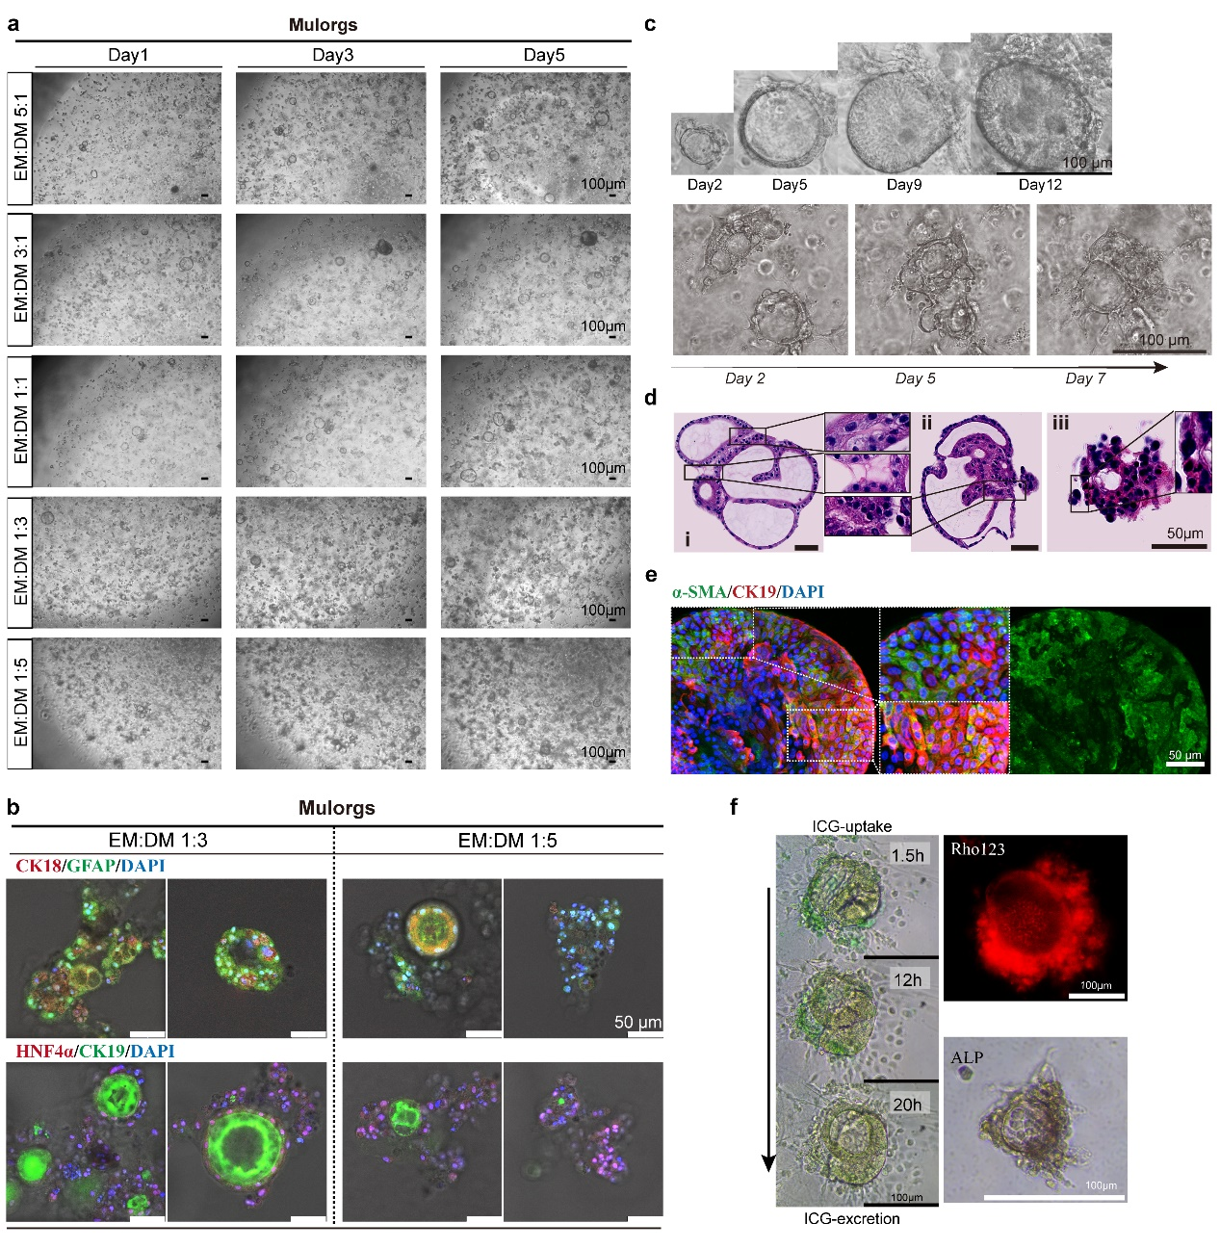
Figure S5. Development and characterization of multilineage organoids (Mulorgs).
(a) Mulorgs cultured in different ratios (vol/vol) of expansion medium (EM) to differentiation medium (DM) from day 1 to day 12, as observed by light microscopy. (b) IF staining of CK18 (top row, red) and hepatocyte nuclear factor 4α (HNF4α, bottom row, red) for hepatocyte, glial fibrillary acidic protein (GFAP, top row, green) for HSCs, and CK19 (bottom row, green) for cholangiocytes in Mulorgs cultured in EM: DM ratios of 1:3 or 1:5. The nuclei stained with DAPI (blue). (c) Representative light microscopy images of Mulorgs. (d) Hematoxylin-eosin (HE) staining of Mulorgs. Multiple organoids fused to form Mulorgs, with HSCs wrapping around the sphere and fibrous filaments involved in fusion. (e) IF 3D images of Mulorgs showing the distribution of α-SMA (green) and CK19 (red). IF images were photographed by LSCM. (f) Representative light microscopy images showing ICG (green) uptake and excretion by Mulorgs captured at 1.5, 12, and 20 hours; Rho123 staining (red) and ALP staining (brown) demonstrate the function of membrane transport and ALP secretion.

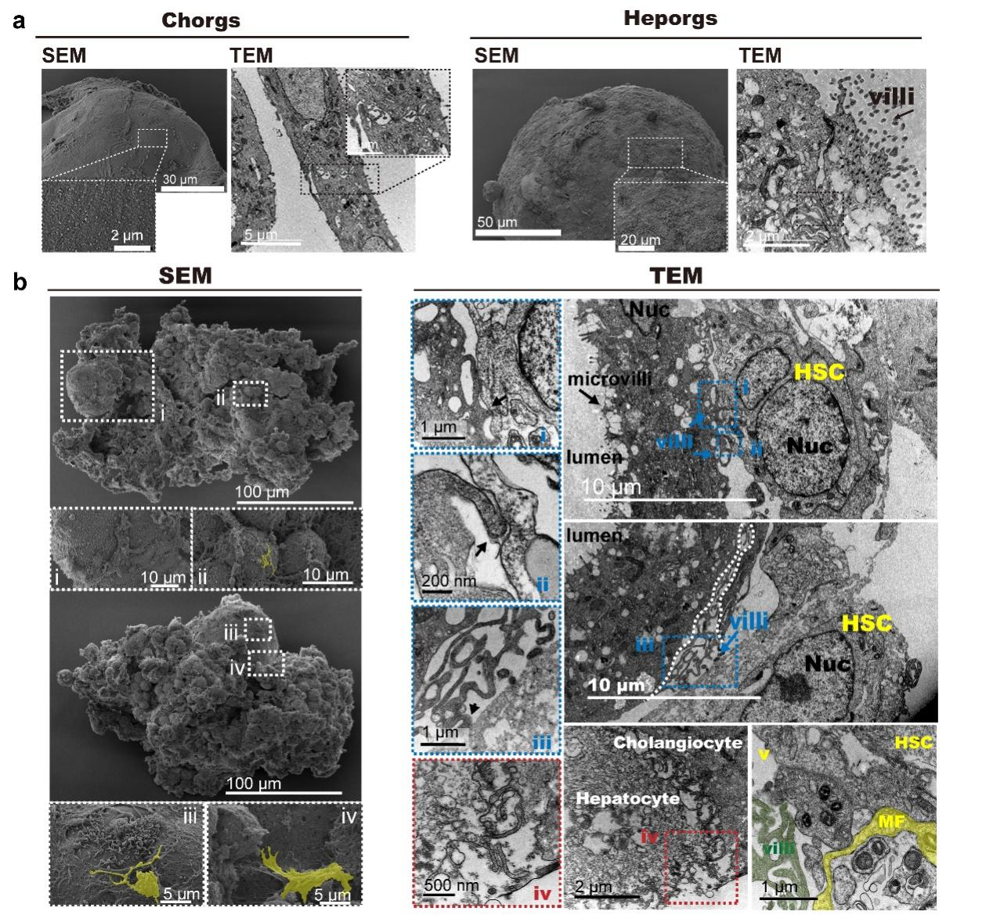
Figure S6. Structural characteristics of Chorgs, Heporgs and Mulorgs
(a) Chorgs display smooth spherical structures with tight connections (TC) and irregular “finger-like” structures (FLS) as analyzed under scanning electron microscope (SEM) and transmission electron microscope (TEM). Heporgs exhibit villi on their outer surface (black arrow). (b) SEM images of Mulorgs (left column, i-iv) provide detailed magnified views. TEM images of Mulorgs (right column, i-v) provide fine structure views, highlighting collagen fibers in yellow.

Figure S7. Transcription-related pathways regulation by EV^{MSC} in Mdr2^{-/-} mice.
(a) Top 20 GO enrichment terms of DEGs from profile 5 (see Figure S2). (b) Gene Set Enrichment Analysis (GSEA) of DEGs: Typical downregulated transcriptional regulation pathways identified by GSEA in DEGs between Mdr2^{-/-} and Mdr2^{-/-}–EV mice.

Figure S8. Gating strategy for identification of differentiated human Th17 cells.
(a) Cell population of lymphocytes. (b) Exclusion of cell adhesions. (c) Viable cells were selected by Fixable Viability Dye eFluor™ 780. (d) CD4 positive cells and IL-17A positive T cells were gated.

Figure S9. Hsa-miRNA-7977 targets NFKBIZ in human Th17 and Mdr2^{-/-} mouse liver-derived CD4⁺T cells.
(a) PKH-67-labeled EV^{MSC} (green) were engulfed by Th17 cells during differentiation (Scale bar = 20 μm). (b) CD4⁺ T cells isolated from the liver of Mdr2^{-/-} mice were treated with EV^{MSC}, miR-7977 mimic, miR-7977 inhibitor, or respective negative controls, and the expression of Nfkbiz was detected (n=4, Min to Max). (c) liver derived CD4⁺ T cells from Mdr2^{-/-} mice were treated with EV^{MSC} or miR-7977 mimic, and Il-17a expression was analyzed (n=4, Min to Max). Significance of differences between groups was determined using one-way ANOVA and Tukey’s test.

Figure S10. KEGG analysis of RNA-seq data from Th17 cells and Th17^{miR} cells
(a) KEGG analysis of RNA-seq data of Th17 and Th17^{miR} cells (n=3). (b) Top 20 unregulated pathways from KEGG enrichment, showing bile secretion pathway was unregulated by miR-7977 treatment. (c) Top 20 downregulated pathways from KEGG enrichment, including downregulation of the IL-17 signaling pathway with miR-7977 treatment.
Figure S11. Gene Set Enrichment (GSEA) analysis of RNA-seq data from Th17 cells and Th17^{miR} cells.
(a-b) Enriched pathways related to extracellular matrix structural constituents. (c) Heatmap of DEGs associated with extracellular matrix structural constituent (GO:0030020). (d) Downregulated of pathways related to binding of functional proteins (e.g. fibronectin, collagen, and myosin) following miR-7977 treatment.

Figure S12. Liver characteristics of EV^{low} /EV^{high} treated Mdr2^{-/-}mice.
(a) Immunohistochemical (IHC) staining of Desmin in liver tissues across different treatment groups (n=5). (b) Totally thirty views at 5× were randomly selected and analyzed using ImageJ-Pro Plus, significance was determined by ordinary one-way ANOVA and Tukey test, and results show no significant differences.

Figure S13. Intestinal and splenic characteristics of Mdr2^{-/-} mice treated with EV^{low} and EV^{high}.
(a) GSEA analysis of DEGs between livers from Mdr2^{-/-} and Mdr2^{-/-}-EV mice (n=3). The innate immune response in mucous pathway, organ or tissue specific immune response pathway, and mucosal immune response pathway were upregulated by EV^{MSC} treatment. (b) Typical HE-staining results from the lower end of the stomach to the rectum (divided into three intestinal segments) in 12-week-old mice (Mdr2^{-/-}, Mdr2^{-/-}-EV^{low} and Mdr2^{-/-}-EV^{high}). (c) HE-staining of the spleens in 12-week-old mice (Mdr2^{-/-}, Mdr2^{-/-}-EV^{low} and Mdr2^{-/-}-EV^{high}). (d) Spleen weight analysis (n=3, mean ± SD). Significance was determined by ordinary one-way ANOVA and Tukey’s test.

Figure S14. Characteristics of Th17-related microenvironment in vitro.
(a) Co-culture of healthy donor-established FibHOs with Th17 or Th17^{miR}. (b) Healthy donor-established FibHOs cultured without Th17 cells served as blank control (Healthy Ctrl-Blank). (c) Increased expression of NFKBIZ in Mulorgs in response to elevated IL-17A levels (n=6, Min to Max). (d) NFKBIZ expression in FibHOs derived from healthy donor and PSC patients, with or without EV^{MSC} treatment. Patients-1 n=4, Patient-2 n=5, Patient-3 n=3; Healthy Ctrl: n=3, experiments were repeated four times. Data analyzed with one-way ANOVA and Tukey’s test.

References
1. Chen W, Lin F, Feng X, Yao Q, Yu Y, Gao F, Zhou J, Pan Q, Wu J, Yang J, et al: MSC-derived exosomes attenuate hepatic fibrosis in primary sclerosing cholangitis through inhibition of Th17 differentiation. Asian Journal of Pharmaceutical Sciences 2024:100889.
2. Chen W, Yao Q, Wang R, Fen B, Chen J, Xu Y, Yu J, Li L, Cao H: Highly Efficient Methods to Culture Mouse Cholangiocytes and Small Intestine Organoids. Front Microbiol 2022, 13:907901.
3. Chen W, Zhu J, Lin F, Xu Y, Feng B, Feng X, Sheng X, Shi X, Pan Q, Yang J, et al: Human placenta mesenchymal stem cell-derived exosomes delay H(2)O(2)-induced aging in mouse cholangioids. Stem Cell Res Ther 2021, 12:201.
4. Kaya-Okur HS, Wu SJ, Codomo CA, Pledger ES, Bryson TD, Henikoff JG, Ahmad K, Henikoff S: CUT&Tag for efficient epigenomic profiling of small samples and single cells. Nat Commun 2019, 10:1930.
5. Chen S, Zhou Y, Chen Y, Gu J: fastp: an ultra-fast all-in-one FASTQ preprocessor. Bioinformatics 2018, 34:i884-i890.
6. Langmead B, Salzberg SL: Fast gapped-read alignment with Bowtie 2. Nat Methods 2012, 9:357-359.
7. Yu G, Wang LG, He QY: ChIPseeker: an R/Bioconductor package for ChIP peak annotation, comparison and visualization. Bioinformatics 2015, 31:2382-2383.
8. Bailey TL, Boden M, Buske FA, Frith M, Grant CE, Clementi L, Ren J, Li WW, Noble WS: MEME SUITE: tools for motif discovery and searching. Nucleic Acids Res 2009, 37:W202-208.
9. Shao Z, Zhang Y, Yuan GC, Orkin SH, Waxman DJ: MAnorm: a robust model for quantitative comparison of ChIP-Seq data sets. Genome Biol 2012, 13:R16.

