Supporting Information
Nanoengineered Hydrogels Disrupt Tumor Antioxidant Defense via Photothermal-Chemodynamic Synergy and Oxidative Stress Boosts
Leiguang Ye¹, Yang Qiao^{2#}, Peisan Wang^{2#}, Wei Li³, Xianwen Wang²*, Yiqun Zhang⁴*, Zhennan Yuan³*
- Department of Medical Oncology, Harbin Medical University Cancer Hospital, Harbing 150081, P. R. China.
- School of Biomedical Engineering, Anhui Medical University, Hefei 230032, P. R. China.
- Department of Surgical Oncology, Harbin Medical University Cancer Hospital, Harbing 150081, P. R. China.
- Department of Orthopedics, The First Affiliated Hospital of Anhui Medical University, Hefei 230022, P. R. China.

*Corresponding Authors:
YiqunZhang0614@163.com (Y. Zhang); yuanzhennan123@hrbmu.edu.cn (Z. Yuan); xianwenwang@ahmu.edu.cn (X. Wang).

# These authors contributed equally.

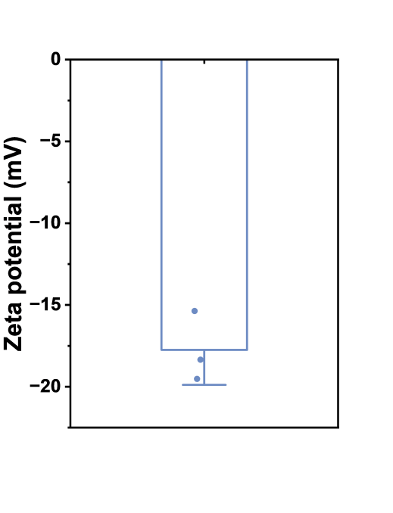
Figure S1. Zeta potential of Ru-PC measured via DLS

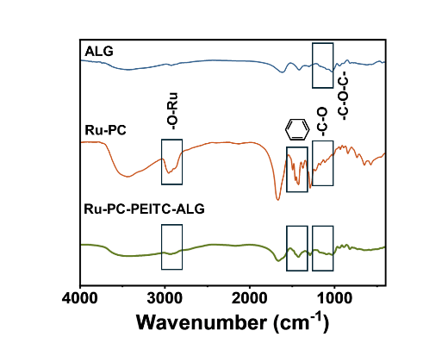
Figure S2. FT-IR transmittance curves of ALG, RU-PC and Ru-PC-PEITC-ALG.

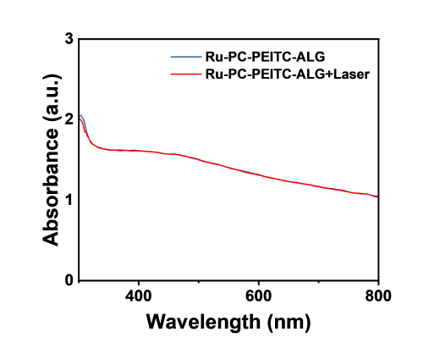
Figure S3. Changes in the UV absorbance profile of Ru-PC-PEITC-ALG before and after NIR irradiation.

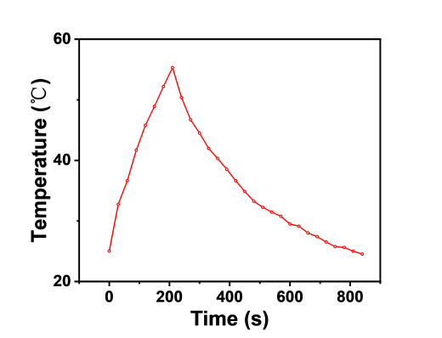
Figure S4. Temperature change curve of Ru-PC-PEITC-ALG under a single photoperiod.

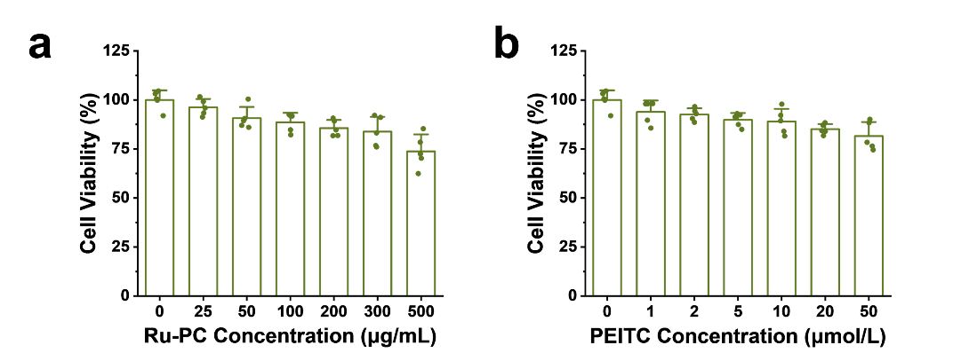
Figure S5. Effects of different concentrations of RU-PC (a) and PEITC (b) on the viability of HUVECs.

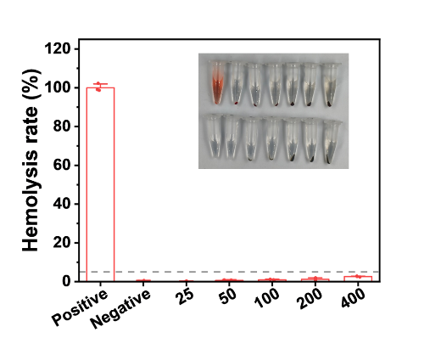
Figure S6. Toxic effects of different concentrations of Ru-PC on erythrocytes.

