Supplementary Materials

Injectable responsive hydrogel with synergistic antibacterial and anti-inflammatory properties for enhanced periodontitis treatment

Xinjie Li^{1#}, Zhidong Zhang^{1#}, Xin Yang^{1,2#}, Mengyu Yu¹, Yanjiao Tang¹, Jinxian Wei¹, Zhige Li¹*, Jun Hai³*, Baoping Zhang^{1,4}*

¹ School (Hospital) of Stomatology, Lanzhou University, Lanzhou, 730000, China
² Department of Stomatology, Affiliated Hospital of Gansu University of Chinese Medicine, Lanzhou, 730000, China
³ CAS Key Laboratory of Chemistry of Northwestern Plant Resources and Key Laboratory of Natural Medicine of Gansu Province, Lanzhou Institute of Chemical Physics, Chinese Academy of Sciences, Lanzhou, 730000, China
⁴ Gansu Province Key Lab of Maxillofacial Reconstruction and Intelligent Manufacturing, Lanzhou, 730000, China

#Xinjie Li, Zhidong Zhang and Xin Yang contributed equally to this paper.

* Correspondence:
Zhige Li, lizhig0206@163.com
Jun Hai, haijun@licp.cas.cn
Baoping Zhang, zhangbp@lzu.edu.cn

1. Experimental Section
1.1 Materials
Zinc nitrate hexahydrate, 2-methylimidazole, chitosan, and β-sodium glycerophosphate were purchased from Aladdin Scientific Corp. (Shanghai, China); minocycline hydrochloride was obtained from Sigma-Aldrich (Missouri, USA); the CCK-8 Cell Proliferation and Cytotoxicity Assay Kit was sourced from APEx BIO (Texas, USA); DMEM medium, trypsin, penicillin-streptomycin solution, fetal bovine serum (FBS), and phosphate-buffered saline (PBS) were acquired from Biological Industries (Kibbutz Beit Haemek, Israel); the LIVE/DEAD™ BacLight™ Bacterial Viability Kit was procured from Thermo Fisher Scientific Inc. (Massachusetts, USA); the Calcein/PI Cell Viability and Cytotoxicity Assay Kit and Reactive Oxygen Species Assay Kit were supplied by Beyotime Biotechnology (Shanghai, China); nutrient agar and LB agar were purchased from Beijing Solarbio Science & Technology Co.,Ltd. (Beijing, China); TNF-α ELISA Kit, RNA Extraction Kit, Reverse Transcription Kit, and Real-Time PCR Kit were obtained from Mei5 Biotechnology Co., Ltd (Beijing, China); Masson’s Trichrome Staining Kit, Hematoxylin and Eosin (H&E) Staining Kit, Immunohistochemistry (IHC) Staining Kit, Anti-NLRP3, Anti-Caspase-1, Anti-IL-1β, and Anti-TNF-α antibodies were provided by Servicebio Technology Co., Ltd (Wuhan, China).
1.2 Synthesis of MH@ZIF-8/CS/β-GP
Synthesis of MH@ZIF-8: Three aliquots of 200 mg zinc nitrate hexahydrate were precisely weighed and dissolved in 5 mL deionized water, respectively. Minocycline hydrochloride (MH) at doses of 2.5 mg, 5 mg, and 10 mg was separately dissolved into the zinc nitrate hexahydrate solutions, followed by pH adjustment to 8. Subsequently, 1000 mg of 2- methylimidazole powder was dissolved in 5 mL deionized water. The fully dissolved 2-methylimidazole solution was added dropwise to the vigorously stirred MH containing zinc nitrate hexahydrate solutions. After complete addition, the mixture was stirred for 60 minutes. The resulting suspension was transferred to 15 mL centrifuge tubes and centrifuged at 8000 rpm for 5 minutes. The precipitate was alternately washed three times with anhydrous ethanol and deionized water, followed by vacuum drying at room temperature for 24 hours. The final products, designated as ZIF-8@MH-0.25, ZIF-8@MH-0.5, and ZIF-8@MH-1, corresponded to MH concentrations of 0.25 mg/mL, 0.5 mg/mL, and 1 mg/mL, respectively.
Synthesis of MH@ZIF-8/CS/β-GP: A 2.5 g aliquot of chitosan (CS) powder was precisely weighed, sterilized via autoclaving for 10 minutes, and fully dissolved in 100 mL of 0.1 M glacial acetic acid solution. Separately, 3 g of β-glycerophosphate (β-GP) was dissolved in 10 mL deionized water and filtered through a 0.22 μm membrane into a sterile vial. Both solutions were stored overnight at 4°C for subsequent use. Next, 0.8 mg of ZIF-8@MH-1 was ultrasonically dispersed in 1 mL of β-GP solution. The ZIF-8@MH-1-containing β-GP solution was then added dropwise to the CS solution at a 1:4 volume ratio under continuous ice-bath conditions with magnetic stirring at 800 rpm. After complete addition, stirring was maintained for 15 minutes, and the pH was adjusted to 7.4 to obtain the CS/β-GP/ZIF-8@MH hydrogel solution.
1.3 Characterisation of MH@ZIF-8 and MH@ZIF-8/CS/β-GP
The microscopic morphology of the synthesized materials was analysed using scanning electron microscopy (SEM, Apreo S, USA). For SEM imaging, 1 mg of ZIF-8 or MH@ZIF-8 was resuspended in 100 μL anhydrous ethanol and sonicated for 5 minutes to ensure uniform dispersion. The suspension was deposited onto a silicon wafer via 200 μL pipette capillary action. After ethanol evaporation, samples were gold-sputtered for 60 s and examined under SEM, with simultaneous elemental composition analysis via energy-dispersive spectroscopy (EDS, Apreo S, USA). For hydrogel morphology assessment, 2 mL aliquots of CS/β-GP and MH@ZIF-8/CS/β-GP sols were dispensed into 6-well plates, frozen overnight at -20°C, and freeze-dried for 24 h. The freeze-dried samples were gold-coated and imaged under SEM.
X-ray diffraction (XRD, Rigaku, Japan) was employed to investigate material crystallinity. Data were collected using Cu-Kα radiation with a 2θ scanning range of 5–60°, step size of 0.02°, and operating parameters of 40 kV/100 mA. Fourier-transform infrared spectroscopy (FTIR, Thermo Fisher, USA) was performed at room temperature over a wavenumber range of 500–4000 cm⁻¹ to identify functional groups.
The sol-gel transition behaviour was evaluated via vial inversion assay. Briefly, 1–2 mL of hydrogel solution was dispensed into the base of a 5 mL vial, which was then incubated upright in a 37°C water bath. The vial was inverted every 30 s to monitor phase transition. Successful gelation was defined as the absence of fluid flow upon inversion.
Rheological characterisation was performed using a Malvern Kinexus Pro+ rheometer (Malvern Panalytical, UK) fitted with a Peltier temperature-controlled lower plate. Prior to testing, the MH@ZIF-8/CS/β-GP composite was carefully deposited into the measurement geometry and maintained under controlled hydration conditions until reaching full equilibration. Temperature-dependent viscoelastic behaviour was assessed through thermal sweeps spanning 27°C to 37°C at a controlled ramp rate of 2°C/min. Oscillatory frequency sweeps were subsequently conducted within the predetermined linear viscoelastic region using 0.1% strain amplitude, with angular frequencies ranging from 6.283 rad/s (1 Hz). The shear rheological behavior was investigated over a shear rate range of 0.1–100 s⁻¹, while the thixotropic recovery properties were evaluated through step tests alternating between high (100%) and low (0.1%) strains. Additionally, the temperature-dependent viscosity was characterized within the 24°C to 40°C range at a fixed frequency of 1 Hz. Both storage modulus (G') and loss modulus (G'') were quantitatively tracked throughout thermal cycling experiments.
The adhesion strengths of CS/β-GP and MH@ZIF-8/CS/β-GP hydrogels were investigated by tensile-stress and lap shear experiments using a universal testing machine under a 500 N load cell with stretch rate of 1cm min⁻¹. Fresh porcine skin was cut into a 10 mm × 10 mm section, then cemented on the surface of a ‘T’ shaped sheet. 1 mL of the CS/β-GP and MH@ZIF-8/CS/β-GP hydrogels were added and spread over the surface of tissues; the two strips were brought in contact and allowed to cure for 5 min at 37 °C.
To evaluate the degradation of the MH@ZIF-8/CS/β-GP hydrogel, the dried hydrogel specimens were accurately weighed (W₀) and soaked in phosphate-buffered saline (PBS) at physiologically relevant pH values (7.4 and 6.0) under controlled temperature (37°C ± 0.5°C) for 9 days. The remaining hydrogel was freeze-dried after discharging the PBS at the prescribed time to obtain the residual mass (W_{t}).
The degradation rate was calculated as:
 | $$Degradation Rate (\%)=\frac{{W_{0}−W}_{t}}{W_{0}}×100\%$$ | (1.1)
1.4 Drug loading and release profiling
The drug loading efficiency (DLE) was determined as follows: given the pH-responsive degradation of ZIF-8 under acidic conditions, 0.1 M HCl was used as a solvent. A standard curve for minocycline hydrochloride was established using a microplate reader (λ = 350 nm). Aliquots of 10 mg MH-0.25@ZIF-8, MH-0.5@ZIF-8, and MH-1@ZIF-8 were dissolved in 1 mL 0.1 M HCl, ultrasonicated to ensure complete dissolution, and their absorbance at 350 nm was measured to calculate DLE via the standard curve.
The DLE was calculated using the formula:：
 | $$Drug Loading Efficiency (\%)=\frac{W_{MH}}{W_{0}}×100\%$$ | (1.2)
Where $W_{MH}$ is the mass of MH loaded into ZIF-8, and $W_{0}$ is the total mass of MH@ZIF-8.
For drug release kinetics, equal masses of MH@ZIF-8 were suspended in 5 mL PBS (pH 7.4) and incubated at 37°C. Aliquots (600 μL) were collected at 2 h, 4 h, 6 h, 12 h, 24 h, 48 h, and 72 h, transferred to a 96-well plate (200 μL/well), and analysed at 350 nm to quantify MH release using the standard curve. To evaluate the pH-responsive release profile of the MH@ZIF-8/CS/β-GP hydrogel, specimens were incubated in PBS at physiologically relevant pH values (7.4 and 6.0) under controlled temperature (37°C ± 0.5°C) for 72 h, with release quantification performed as follow.
The cumulative drug release rate was calculated as:
 | $$Drug Release Rate (\%)=\frac{m_{t}}{m_{0}}×100\%$$ | (1.3)
Where $m_{t}$ is the cumulative mass of MH released at each time point, and $m_{0}$ is the total loaded MH mass.
1.5 Antibacterial rate
We performed plate colony counting on bacteria from different treatment groups and subsequently calculated the antibacterial rate.
 | $$Antibacterial Rate (\%)=\frac{{N_{C}−N}_{T}}{N_{C}}×100\%$$ | (1.4)
Where $N_{C}$ is the mean colony count of control group, and $N_{T}$ is the mean colony count of treatment group.
1.6 Establishment of RAW264.7 inflammatory model
RAW264.7 murine monocyte-macrophage leukaemia cells (Procell Life Science & Technology Co., Ltd, Wuhan, China) were cultured per protocol. Second-passage cells were used for experiments. RAW264.7 cells were divided into four groups: control, LPS, ZIF-8, and MH@ZIF-8. Cells (1 × 10⁶ cells/well) were seeded into 6-well plates. The control group was cultured in DMEM with 10% fetal bovine serum (FBS) for 48 h. The LPS, ZIF-8, and MH@ZIF-8 groups were pretreated with 1 μg/mL LPS for 24 h, followed by 23-hour incubation with DMEM (10% FBS), ZIF-8 extract, or MH@ZIF-8 extract, respectively. Cells were then stimulated with 1 mg/mL ATP for 3 h.

1.7 Animal experiments

1.7.1 Antibacterial effects evaluation. At weeks 2 and 4 post-treatment, sterile filter paper strips were gently inserted into periodontal pockets for 30 sec to collect gingival crevicular fluid samples, which were immediately transferred into 5 mL of brain heart infusion (BHI) broth and incubated at 37°C for 24 h. 100 μL of bacterial suspension was aliquoted into 96-well plates, and the optical density was measured at 600 nm using a microplate reader. Additionally, 1 mL of bacterial suspension was transferred to 24-well plates for quantitative analysis of biofilm formation via crystal violet staining.

1.7.1 Micro-CT analysis. Maxillary bones were fixed in 4% paraformaldehyde for 24 h and scanned using a SkyScan-1176 micro-CT system (Bruker). Three-dimensional reconstructions were generated with CTvox 3.3 software. The cementoenamel junction to alveolar bone crest (CEJ-ABC) distance was measured to quantify bone loss.

1.7.2 Histological analysis. Maxillary bones, surrounding soft tissues, and major organs (heart, liver, spleen, lungs, kidneys) were fixed in 4% paraformaldehyde, decalcified in 10% EDTA for 1 month, dehydrated, and paraffin-embedded. Sections (4 μm) were stained with hematoxylin and eosin (H&E) or Masson’s trichrome (Beyotime Biotechnology) following manufacturer protocols.

1.7.3 Immunohistochemical analysis. Paraffin-embedded periodontal tissue sections underwent dewaxing and rehydration, followed by antigen retrieval in citrate-based antigen retrieval solution (95°C incubation for 20 min). Endogenous peroxidase activity was blocked with 3% H₂O₂, and nonspecific binding sites were blocked with 5% bovine serum albumin (BSA). Primary antibodies against NLRP3, Caspase-1, IL-1β, and TNF-α (1:200 dilution) were applied and incubated at 4°C overnight. Subsequently, HRP-labelled secondary antibodies (1:500 dilution) were added for 1 h at room temperature. Colour development was performed using DAB substrate, followed by hematoxylin counterstaining. Sections were dehydrated, cleared, and mounted for microscopic observation.
1.7 Primer sequences for inflammation-related genes

Table S1 Primer sequences for inflammation-related genes
Gene | Primer (5’→3’)
NLRP3 | F: ATCAACAGGCGAGACCTCTG
NLRP3 | R: GTCCTCCTGGCATACCATAGA
Caspase-1 | F: AATACAACCACTCGTACACGTC
Caspase-1 | R: AGCTCCAACCCTCGGAGAAA
IL-1β | F: GAAATGCCACCTTTTGACAGTG
IL-1β | R: TGGATGCTCTCATCAGGACAG
GAPDH | F: TGACCACAGTCCATGCCATC
GAPDH | R: GACGGACACATTGGGGGTAG

2. Result Section

2.1 Dose optimisation of MH for nanocarrier loading
The proliferation of human gingival fibroblasts (Shanghai Zishi Biotechnology Co., Ltd., Cat# JNO-H0654) in media containing different concentrations of minocycline hydrochloride was evaluated using CCK-8 assay to identify optimal concentrations for ZIF-8 nanoparticle loading. As shown in Fig. S1, minocycline hydrochloride at concentrations of 0.25 mg/mL, 0.5 mg/mL, and 1 mg/mL exerted pro-proliferative effects, with cell viability reaching 118.59 ± 5.21%, 121.80 ± 1.97%, and 125.69 ± 6.04%, respectively. These concentrations demonstrated favourable cellular bioactivity and were therefore selected for subsequent experiments.
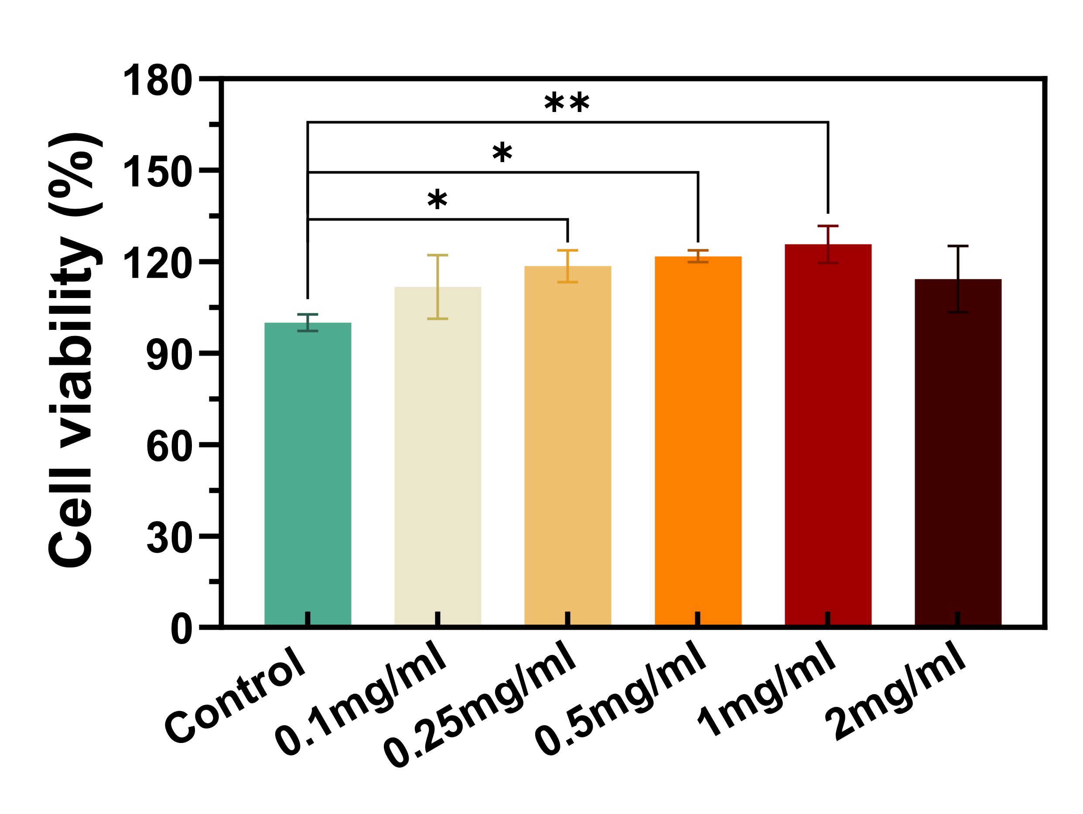
Fig. S1. Cell viability of human gingival fibroblasts (HGFs) in response to minocycline hydrochloride at varied concentrations.

2.2 Macroscopic characterisation of ZIF-8 samples
The ZIF-8 samples demonstrated a homogeneous powdered morphology following vacuum desiccation under ambient temperature conditions (Fig. S2).
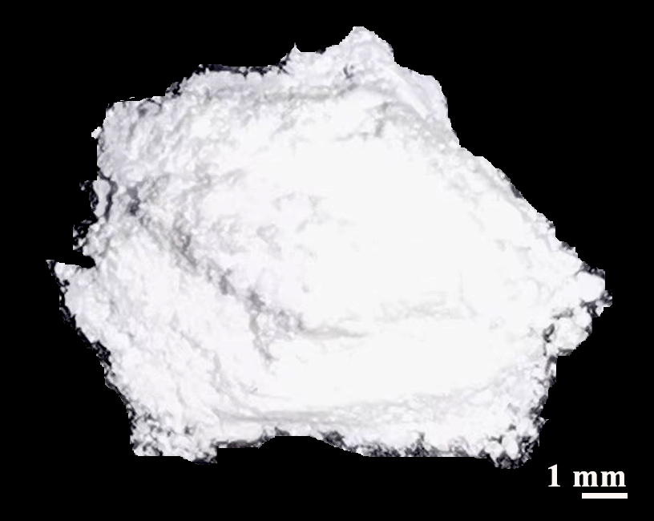
Fig. S2. Macroscopic characterisation of ZIF-8 samples post vacuum desiccation under ambient conditions.

2.3 SEM images of ZIF-8, MH-0.25@ZIF-8, and MH-0.5@ZIF-8
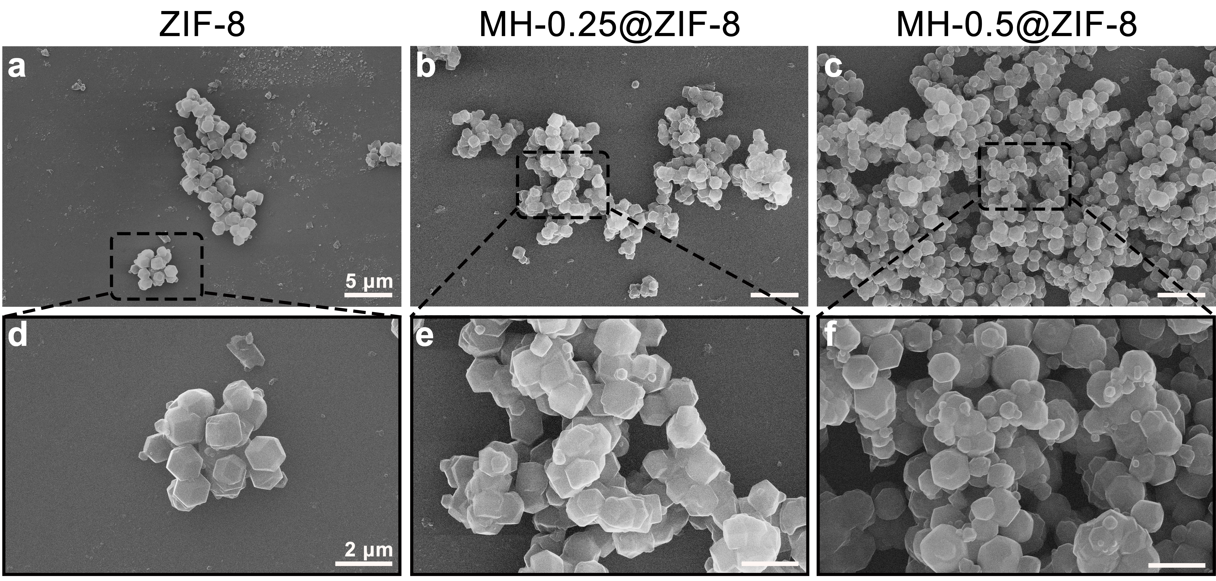
Fig. S3. SEM images of ZIF-8 and Drug-Loaded ZIF-8. (a-c) Microstructural features at ×5,000 magnification: (a) Pristine ZIF-8, (b) MH-0.25@ZIF-8 composite, (c) MH-0.5@ZIF-8 composite. (d-f) Microstructural features at ×15,000 magnification: (d) Pristine ZIF-8, (e) MH-0.25@ZIF-8 composite, (f) MH-0.5@ZIF-8 composite.

2.4 Elemental composition analysis of MH@ZIF-8
EDS analysis demonstrated significantly elevated chlorine (Cl) and nitrogen (N) levels in MH@ZIF-8 compared to pristine ZIF-8 (Fig. S4), attributable to the encapsulation of minocycline hydrochloride. The observed Cl signal originated from the hydrochloric, while the enhanced N content corresponded to the tetracycline backbone structure, thereby confirming successful drug encapsulation within the zeolitic framework.
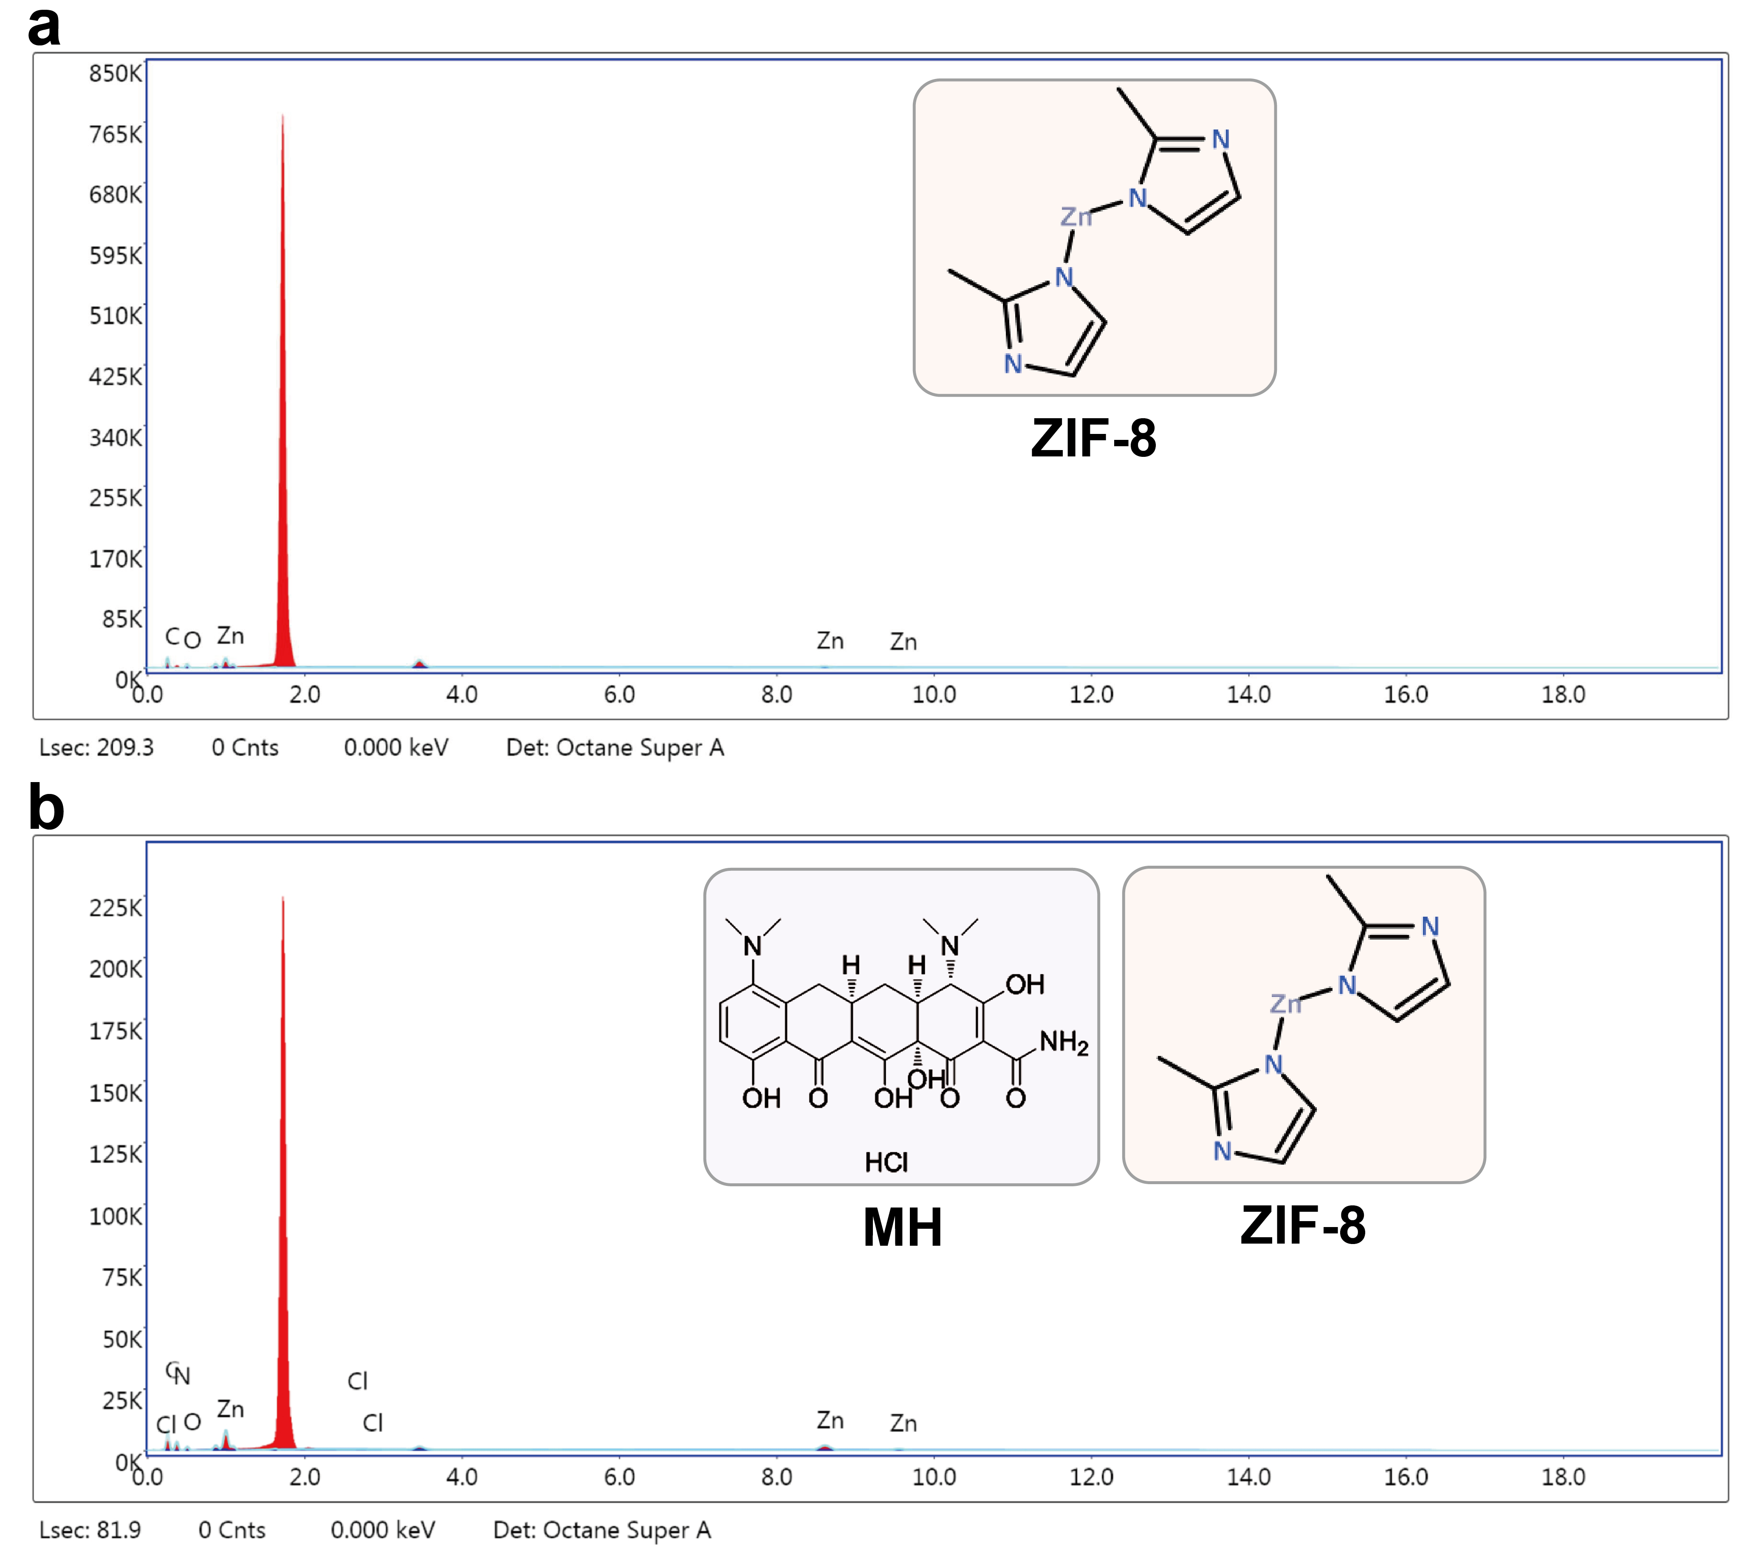
Fig. S4. EDS analysis of elemental composition. (a) ZIF-8 and (b) MH@ZIF-8.

2.5 Antibacterial growth curve of MH@ZIF-8 in vitro
Culture media containing ZIF-8 and MH@ZIF-8 (at MIC concentrations of 0.08 mg/ml for S. aureus, 0.08 mg/ml for E. coli, 0.16 mg/ml for Pg, and 0.08 mg/ml for Aa) were co-cultured with four bacterial strains. OD₆₀₀ values were monitored over a 12-hour period, with the corresponding growth curves shown in Fig. S5. MH-1@ZIF-8 demonstrated superior antibacterial activity compared to other groups. Against S.aureus and Pg, the optimal antimicrobial efficacy occurred at the 10-hour mark. For E.coli and Aa, peak activity was observed at 7 h and 6 h, respectively.
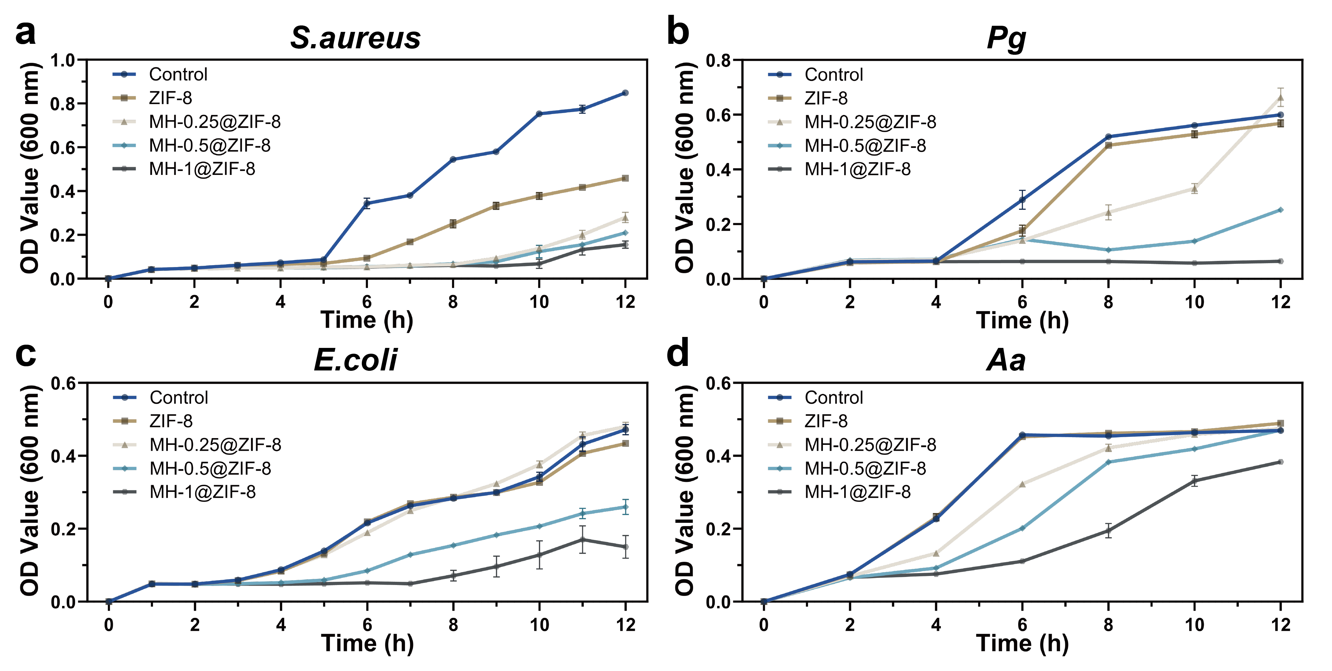
Fig. S5. Growth curves of bacterial strains co-cultured with ZIF-8 and MH@ZIF-8. (a) Staphylococcus aureus (S. aureus), (b) Porphyromonas gingivalis (Pg), (c) Escherichia coli (E.coli), (d) Aggregatibacter actinomycetemcomitans (Aa).

2.6 Antibacterial performance of MH@ZIF-8
Bacterial viability was assessed using the LIVE/DEAD® BacLight™ staining kit. ImageJ software (version 8.0, NIH, USA) quantified colour ratios in live/dead staining regions, with results shown in Fig, S6a, MH-1@ZIF-8 induced >70% bacterial death in S.aureus, E.coli, Pg, and Aa, consistent with plate counting results, confirming its potent antibacterial activity. Biofilm quantification involved dissolving 0.1% crystal violet with 33% glacial acetic acid, followed by OD₅₉₀ measurement ( Fig. S6b). MH-1@ZIF-8 exhibited significantly enhanced biofilm disruption compared to controls (P < 0.0001), demonstrating superior antibiofilm efficacy.
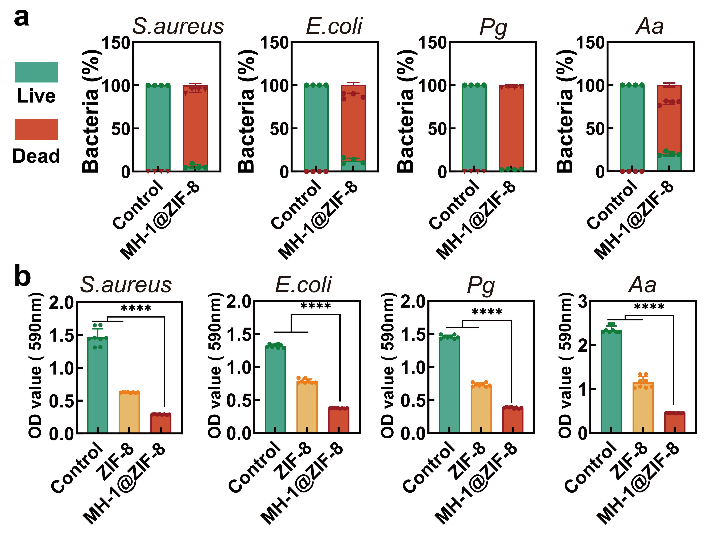
Fig. S6. Antibacterial performance of MH@ZIF-8. (a) Quantitative live/dead bacterial staining analysis of S.aureus, E. coli, Pg, and Aa after co-culture with MH-1@ZIF-8. (b) Biofilm quantification analysis of ZIF-8 and MH-1@ZIF-8.

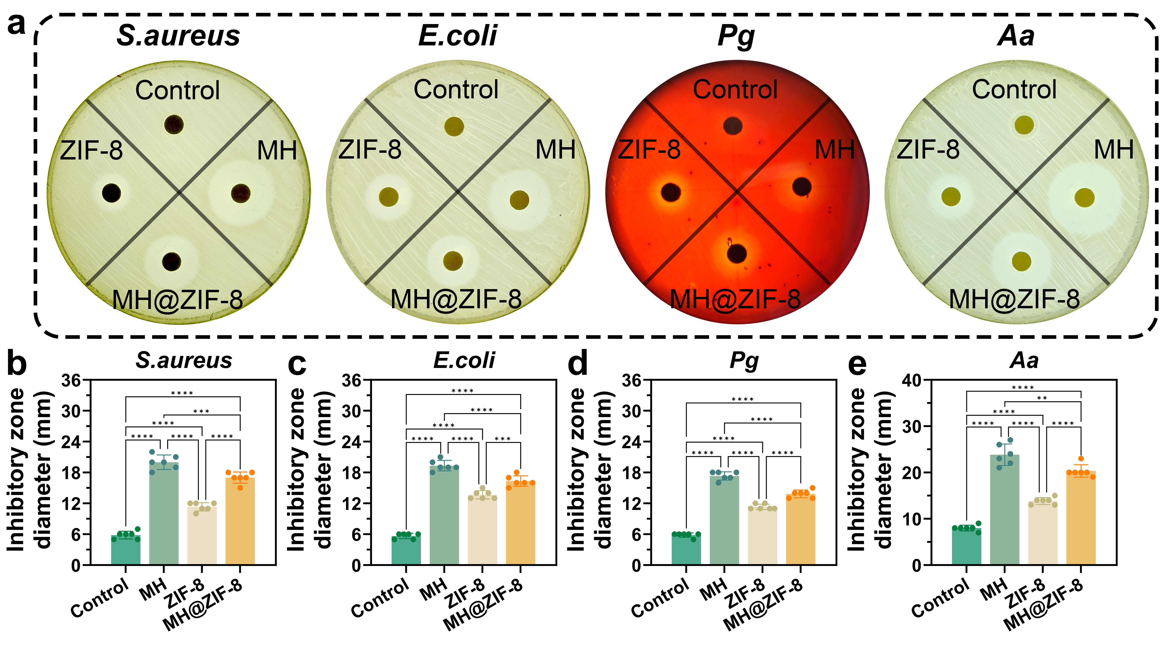
Fig. S7. Zone of inhibition experiments of MH@ZIF-8. (a) Zone of inhibition of S.aureus, E. coli, Pg, and Aa. (b-e) Quantification analysis of Zone of inhibition.

2.7 Porosity of CS/β-GP and MH@ZIF-8/CS/β-GP
Both CS/β-GP and MH@ZIF-8/CS/β-GP hydrogels retained the characteristic porous architecture of hydrogels after lyophilization, as evidenced by scanning electron microscopy (Fig. S8).
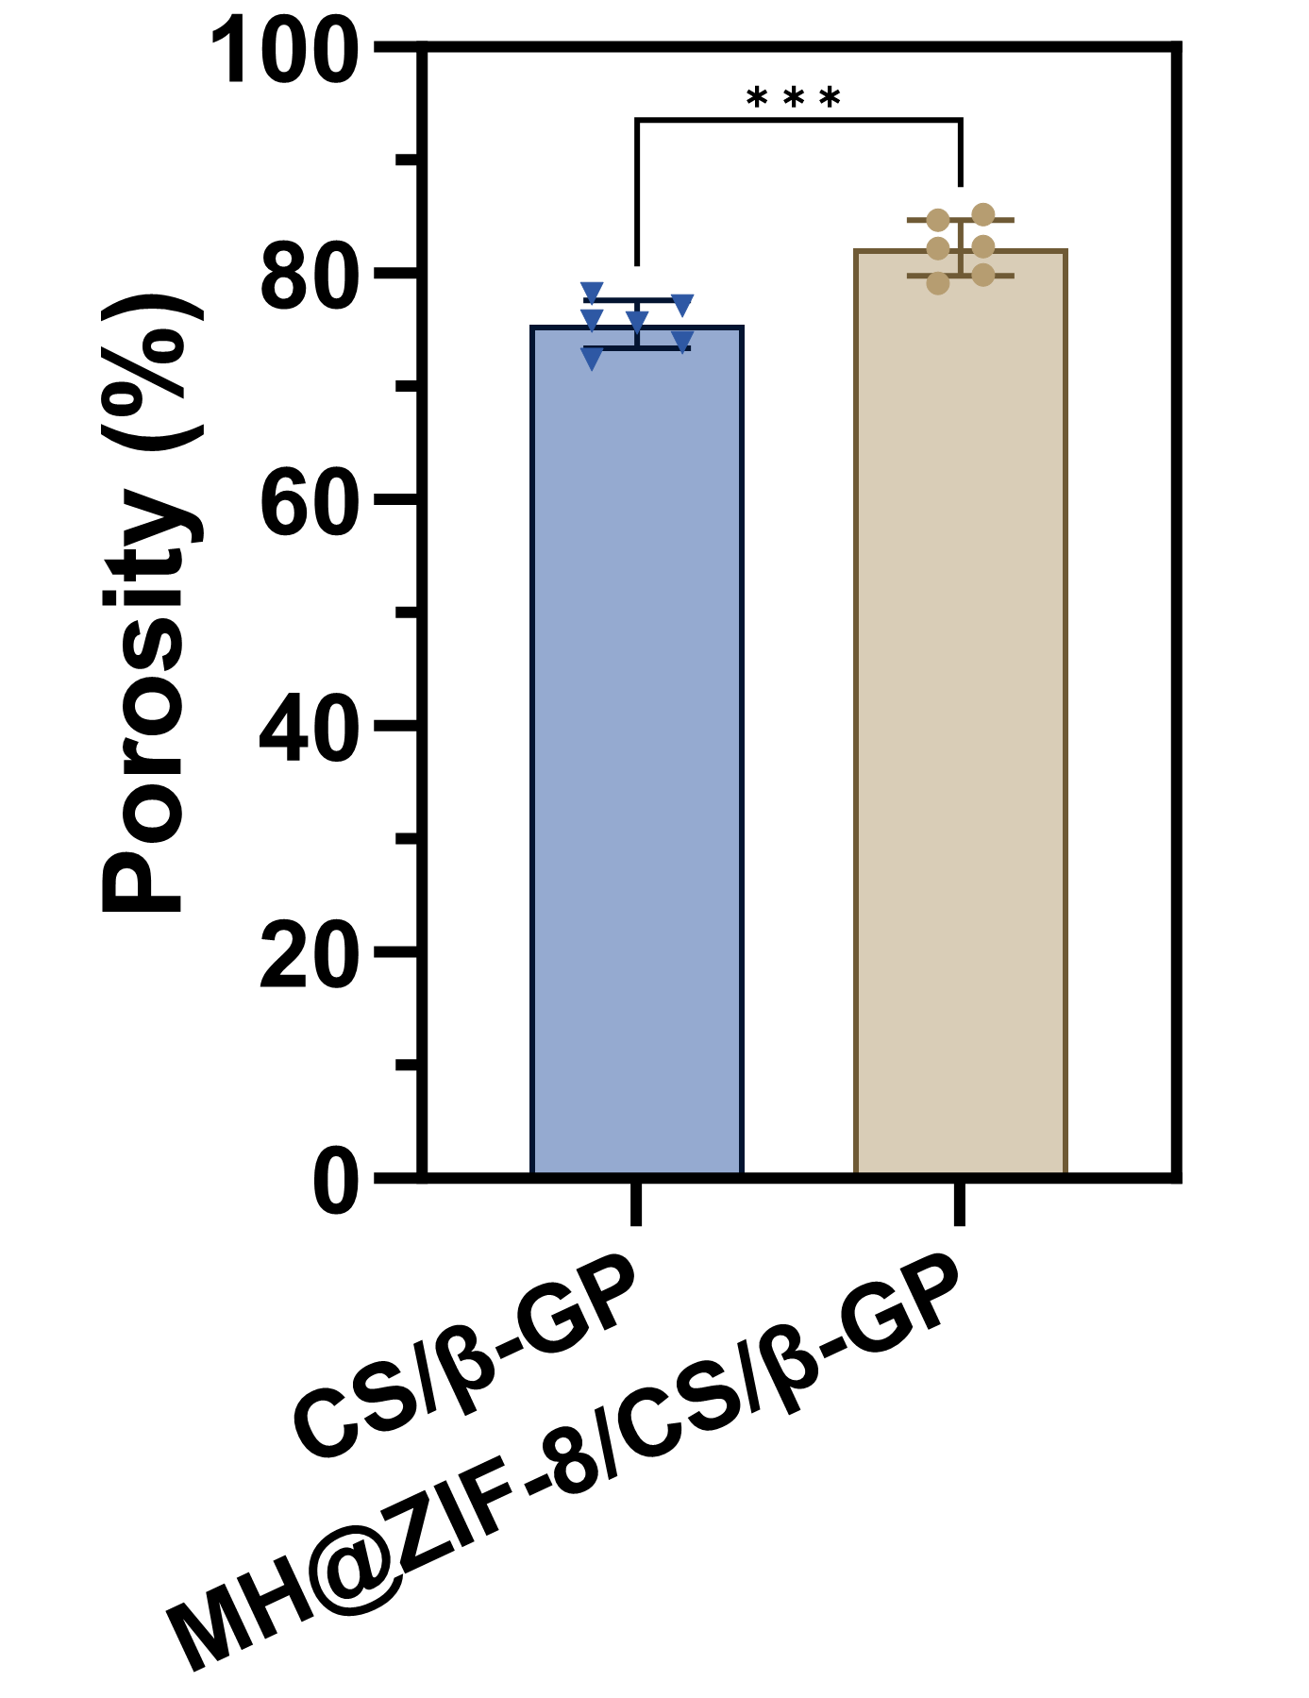
Fig. S8. Porosity comparison between CS/β-GP and MH@ZIF-8/CS/β-GP hydrogels.
2.8 Kinetic models of drug release
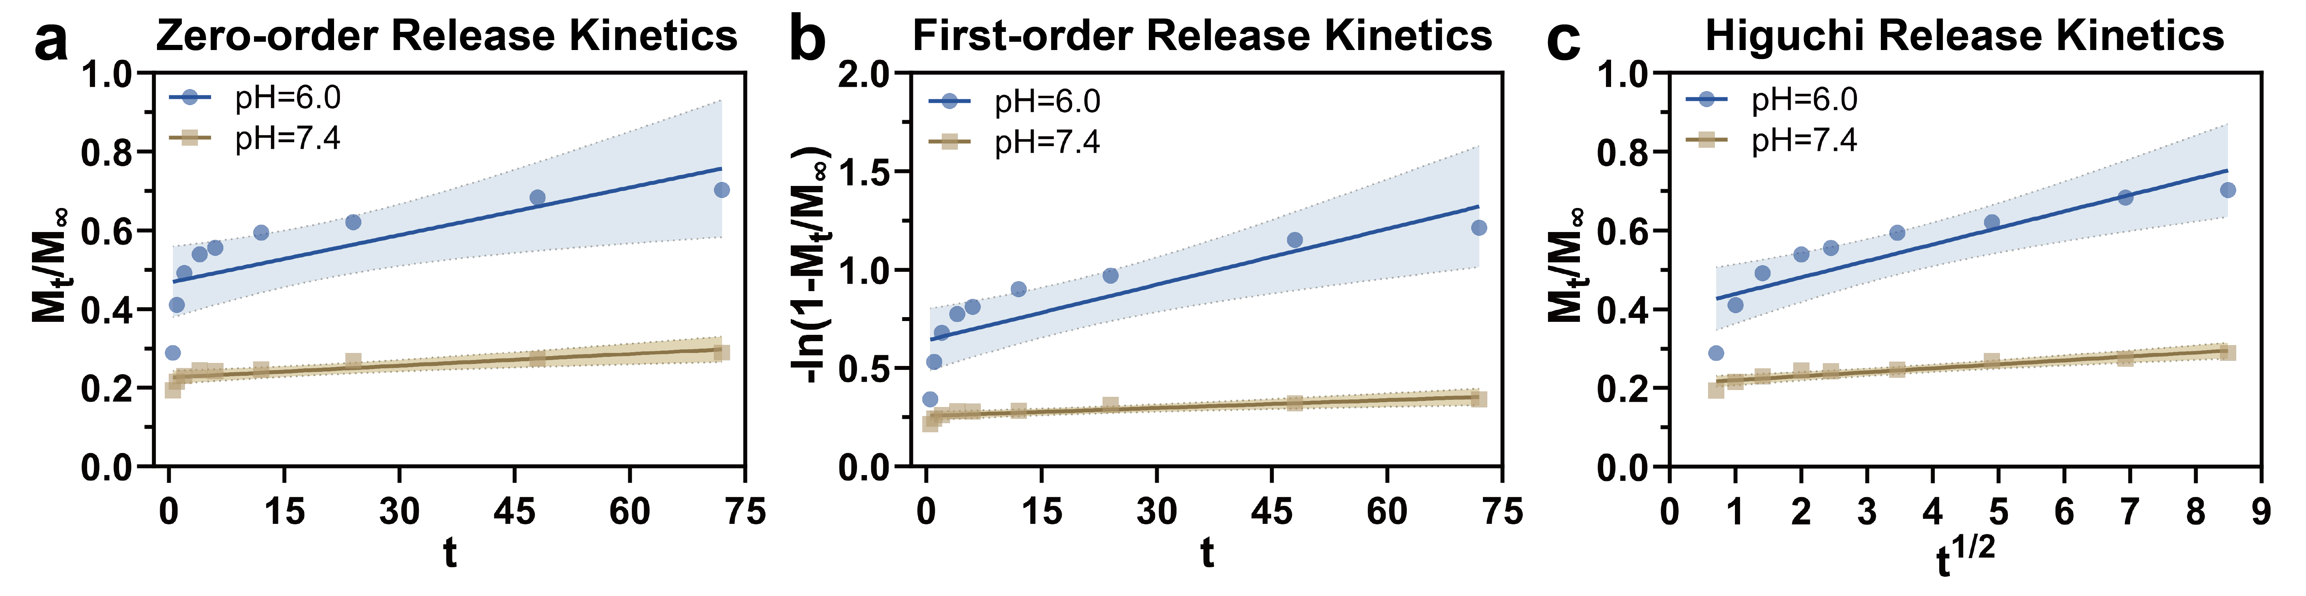
Fig. S9. Kinetic models of drug release. (a) Zero-order model. (b) First-order model. (c) Higuchi model.
Table S2. Parameters of kinetic models of drug release
Kinetic model | pH = 6.0 |  | pH = 7.4
Kinetic model | K | R² | K | R²
Zero-order | 0.004 | 0.591 | 0.001 | 0.716
First-order | 0.009 | 0.718 | 0.001 | 0.730
Higuchi | 0.042 | 0.761 | 0.010 | 0.856

2.9 In vivo degradation of CS/β-GP/ZIF-8@MH

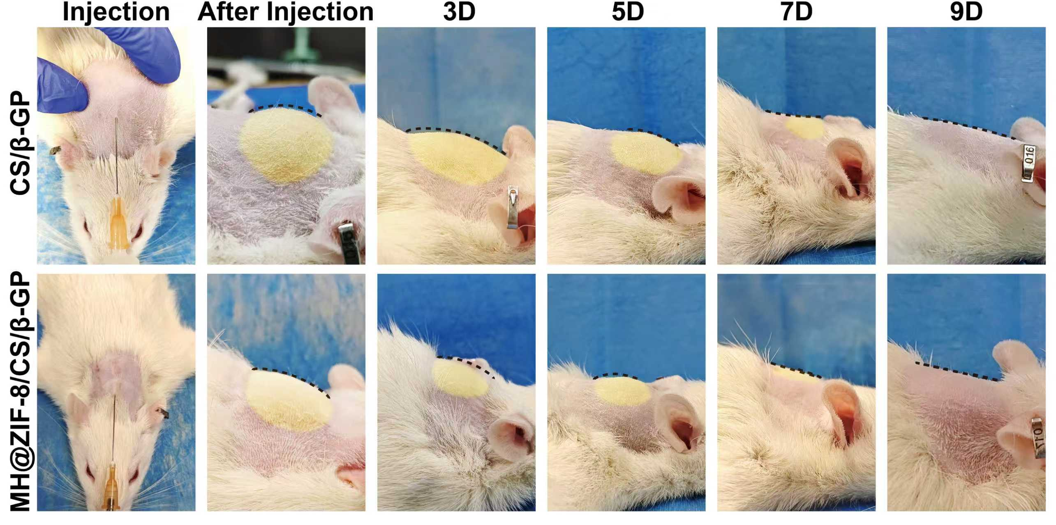
Fig. S10. Lateral views of the cranial region in SD rats at 3D, 5D, 7D, and 9D post-injection with CS/β-GP and CS/β-GP/ZIF-8@MH

2.10 Rheological analysis of MH@ZIF-8/CS/β-GP
The sol-gel transition behaviour of CS/β-GP and MH@ZIF-8/CS/β-GP hydrogels in a 37°C water bath environment was observed and recorded every 30 s (Fig. S11).
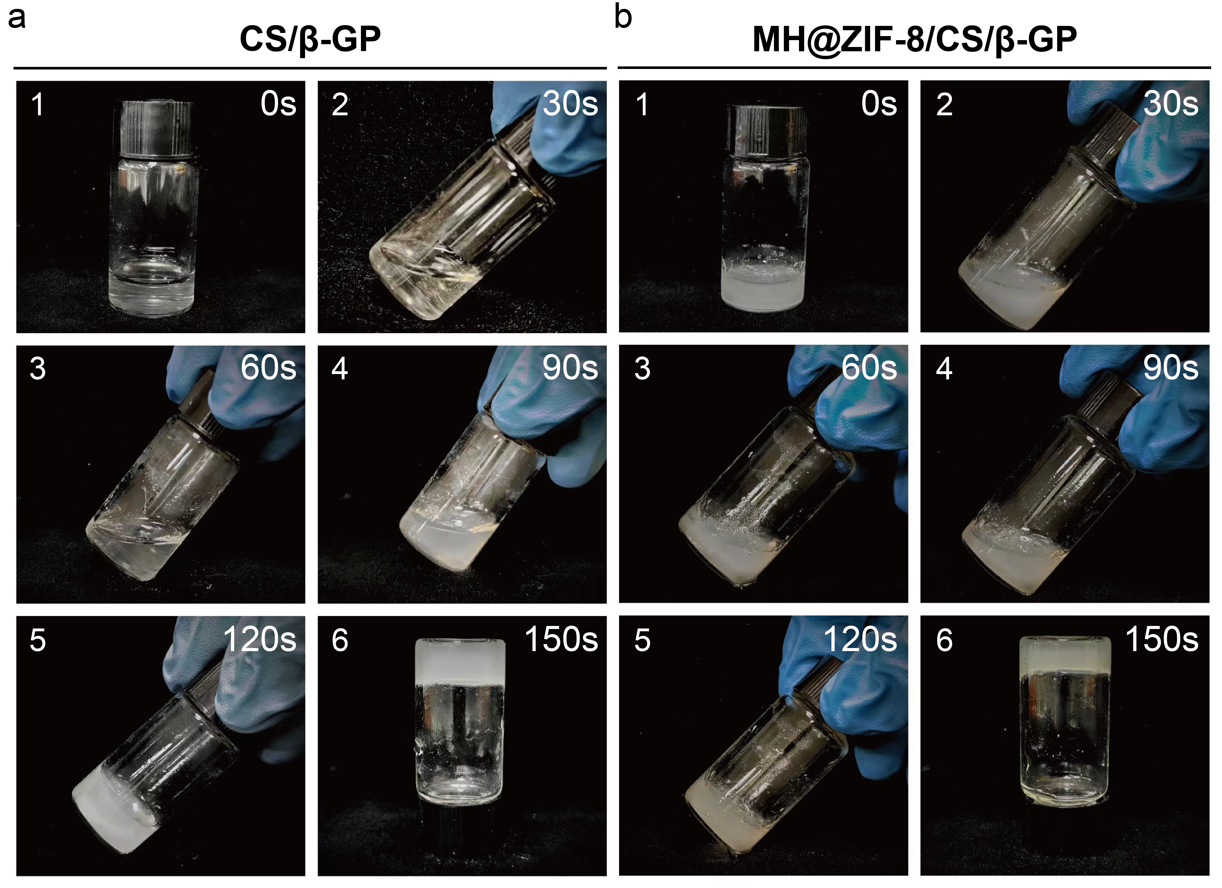
Fig. S11. Thermoresponsive gelation behaviour of CS/β-GP and MH@ZIF-8/CS/β-GP hydrogels. (a) Sol-gel transition kinetics of CS/β-GP. (b) Sol-gel transition kinetics of MH@ZIF-8/CS/β-GP.
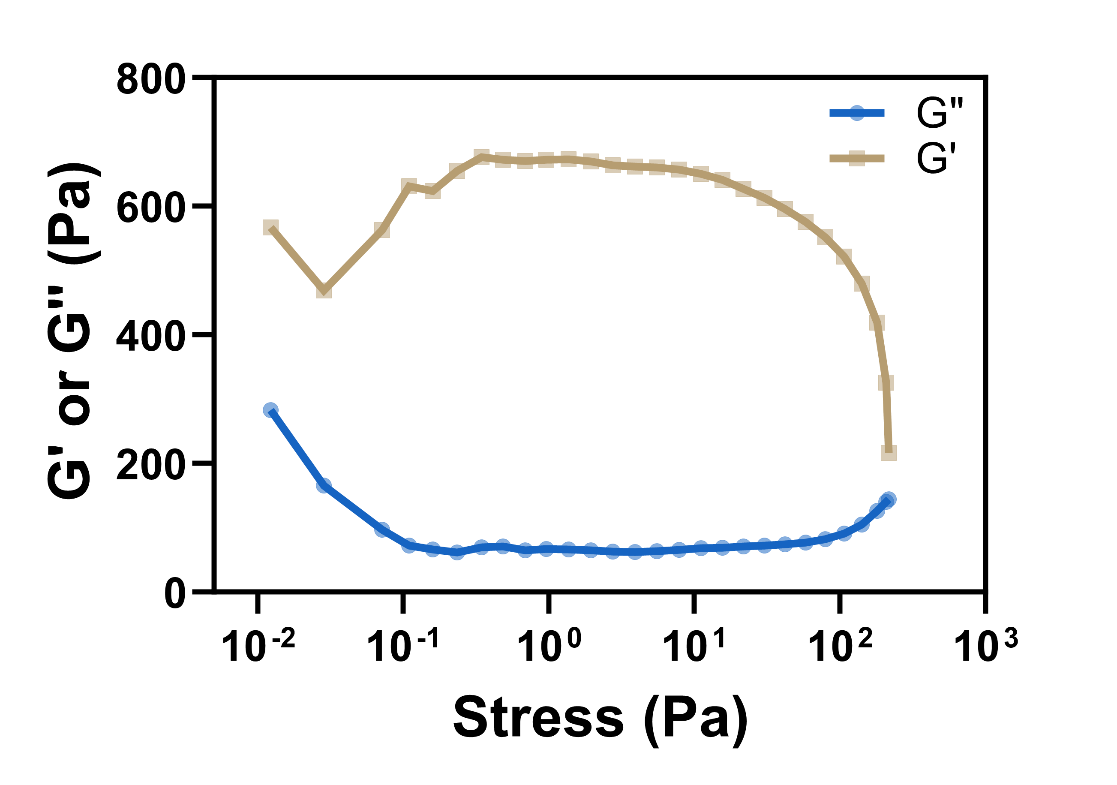
Fig. S12. Oscillatory strain test of MH@ZIF-8/CS/β-GP hydrogel

2.11 Adhesion of MH@ZIF-8/CS/β-GP hydrogel
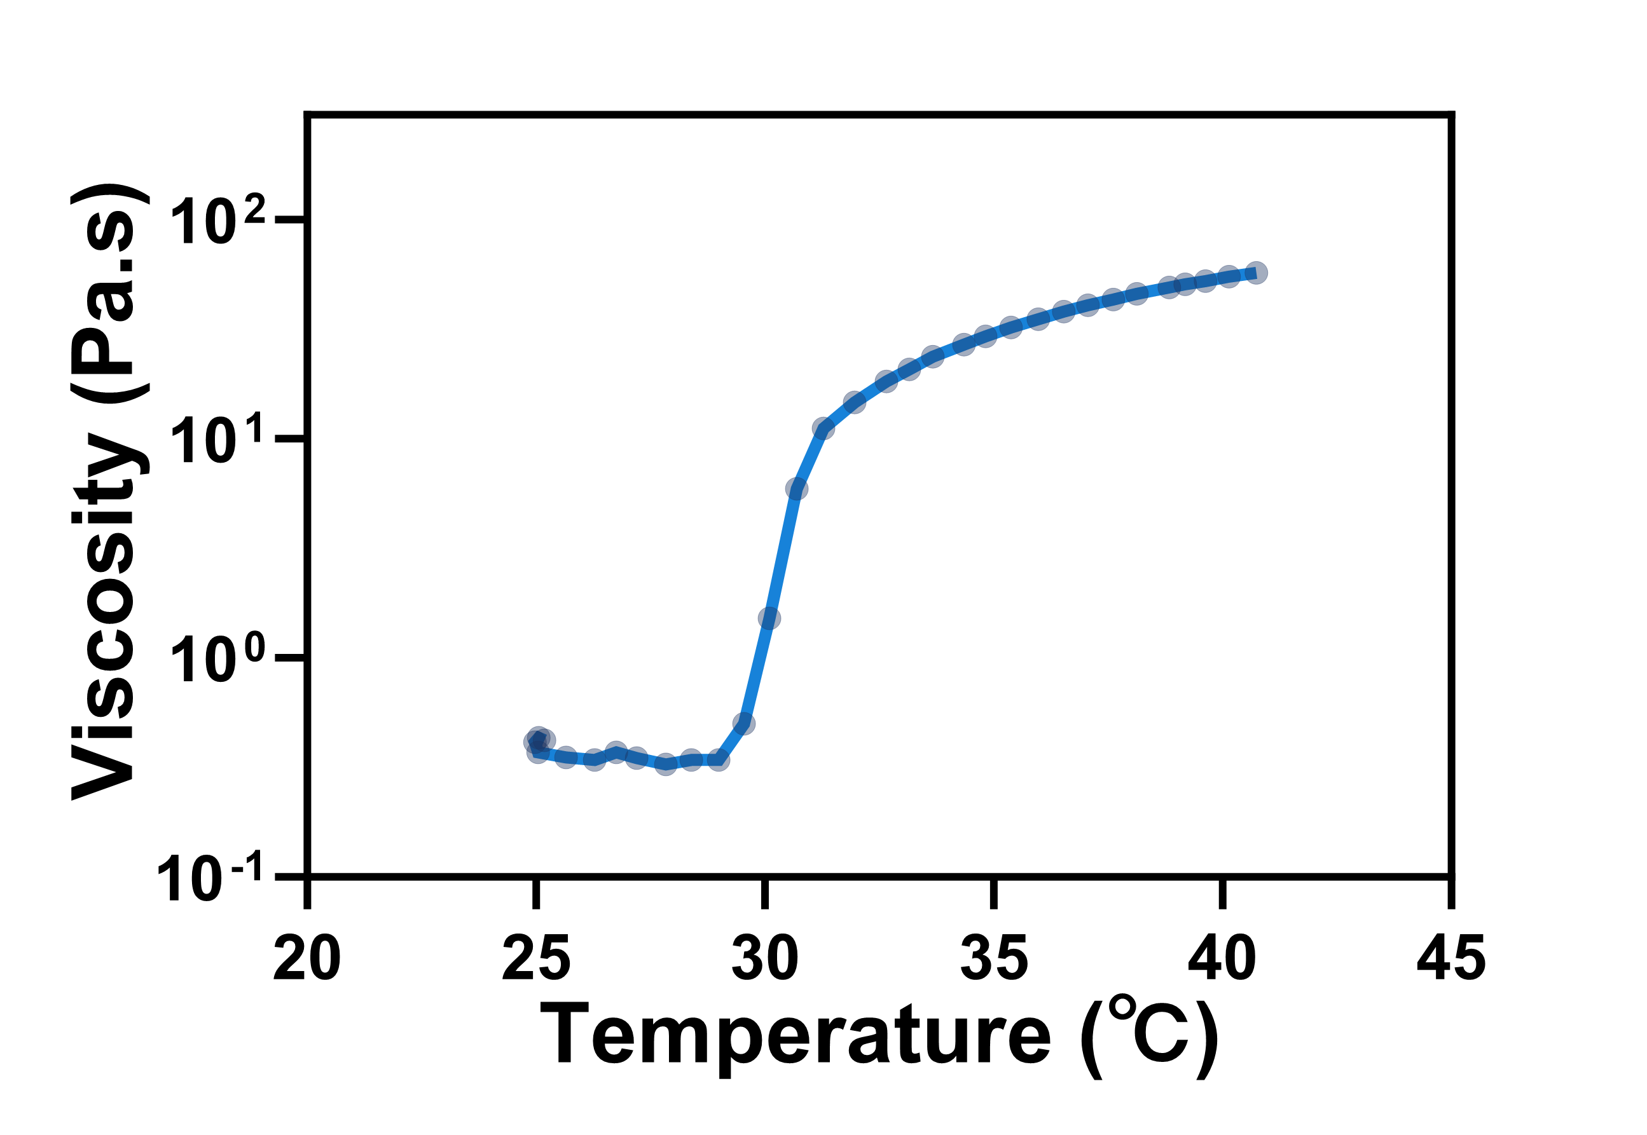
Fig. S13. Temperature-viscosity test of MH@ZIF-8/CS/β-GP hydrogel

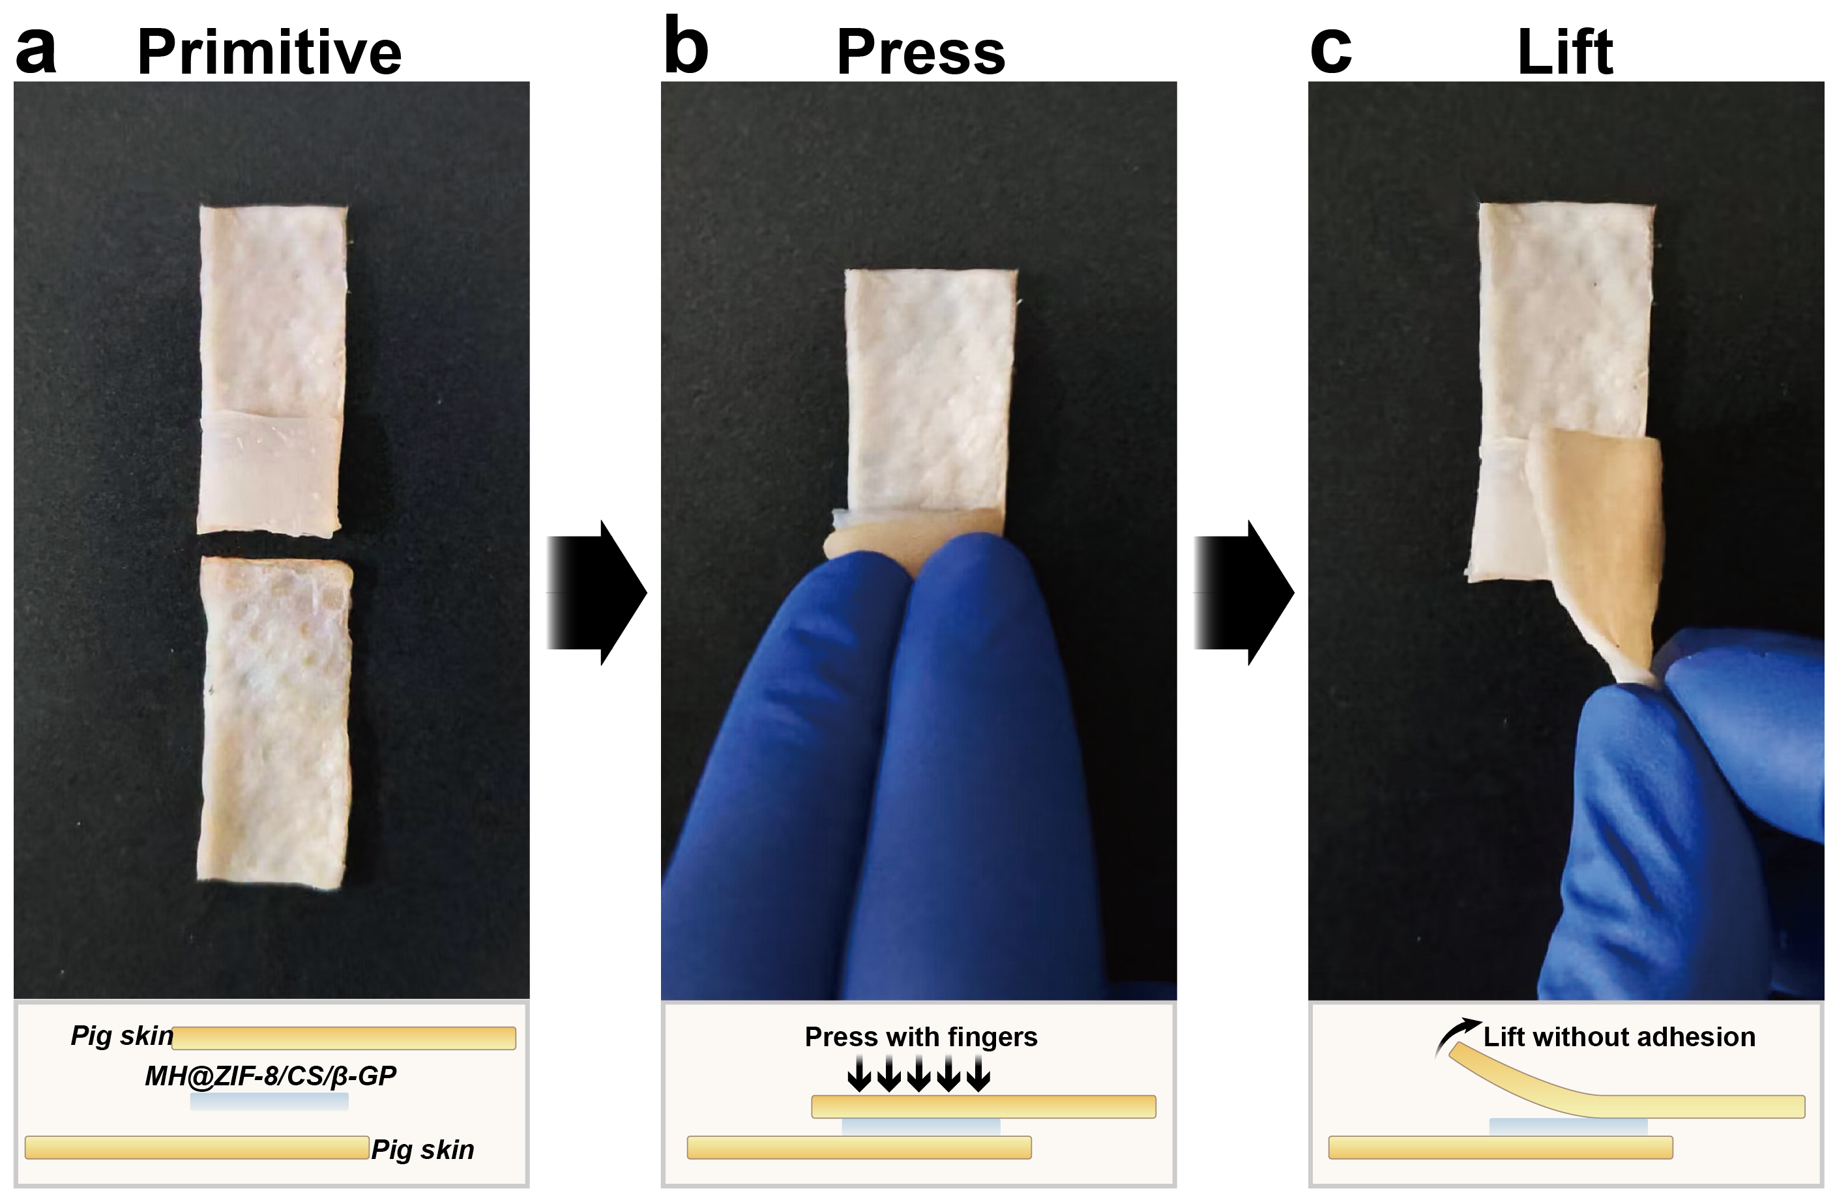
Fig. S14. Surface adhesion test of MH@ZIF-8/CS/β-GP hydrogel. (a) Two porcine skin samples and the hydrogel material were prepared; (b) Finger pressure was applied to press the skin layers into contact with the hydrogel; (c) The upper skin layer could be lifted.

2.12 Establishment of chronic periodontitis model in SD rats
Anaesthetized SD rats were secured in supine position on a dissection table. A dental explorer was used to separate the interproximal spaces around the maxillary second molars. A 3-0 cotton ligature was tied around the cervical region of the molars, followed by securing with 0.25mm-diameter ligature wire over the cotton to prevent coronal displacement. The wire was tightened palatally using needle holders and trimmed to 2mm. Starting 1 week post-ligation, Porphyromonas gingivalis (0.5 McFarland standard) was inoculated into the periodontal sulcus every 48 h for 2 weeks. Successful model establishment was confirmed by ligature removal, bleeding on probing (BOP+), and probing depth (PD) >1mm (Fig. S15).
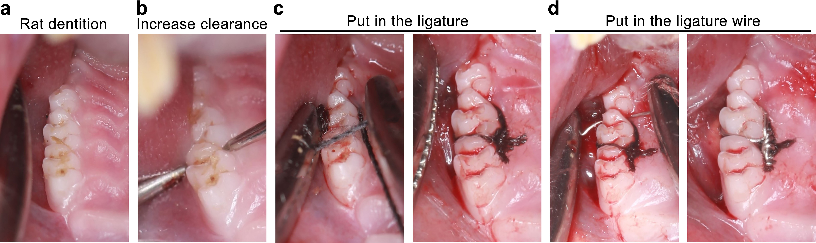
Fig. S15. Intraoperative photographs of chronic periodontitis model establishment in SD rats. (a) Preoperative view of the left maxilla. (b) Separation of mesiodistal spaces in the maxillary second molar. (c) 3-0 cotton ligature placement around the molar cervix. (d) 0.25mm-diameter ligature wire securing the cotton ligature at the cervical region.

Table S3. Clinical presentation of periodontitis model rats before and after treatment
Clinical presentation |  | Control | Periodontitis | PBS | CS/β-GP | MH@ZIF-8/CS/β-GP
Food impaction | Yes | 0 | 100% | 75.0% | 50.0% | 37.5%
Food impaction | No | 100% | 0 | 25.0% | 50.0% | 62.5%
Gingival bleeding | Yes | 0 | 96.9% | 87.5% | 62.5% | 25.0%
Gingival bleeding | No | 100% | 3.1% | 12.5% | 37.5% | 75.0%
Probing depth (mm) |  | 0.21±0.03 | 1.14±0.16 | 0.89±0.18 | 0.65±0.11 | 0.32±0.05

2.13 In vivo biocompatibility analysis of MH@ZIF-8/CS/β-GP
Tissue sections of heart, liver, spleen, lung, and kidney were harvested from all experimental SD rat groups for HE staining. Compared with the Control group (Fig. S16), no significant pathological alterations were observed in vital organs of PBS, CS/β-GP, and MH@ZIF-8/CS/β-GP groups, confirming the non-toxic nature of MH@ZIF-8/CS/β-GP in vivo.
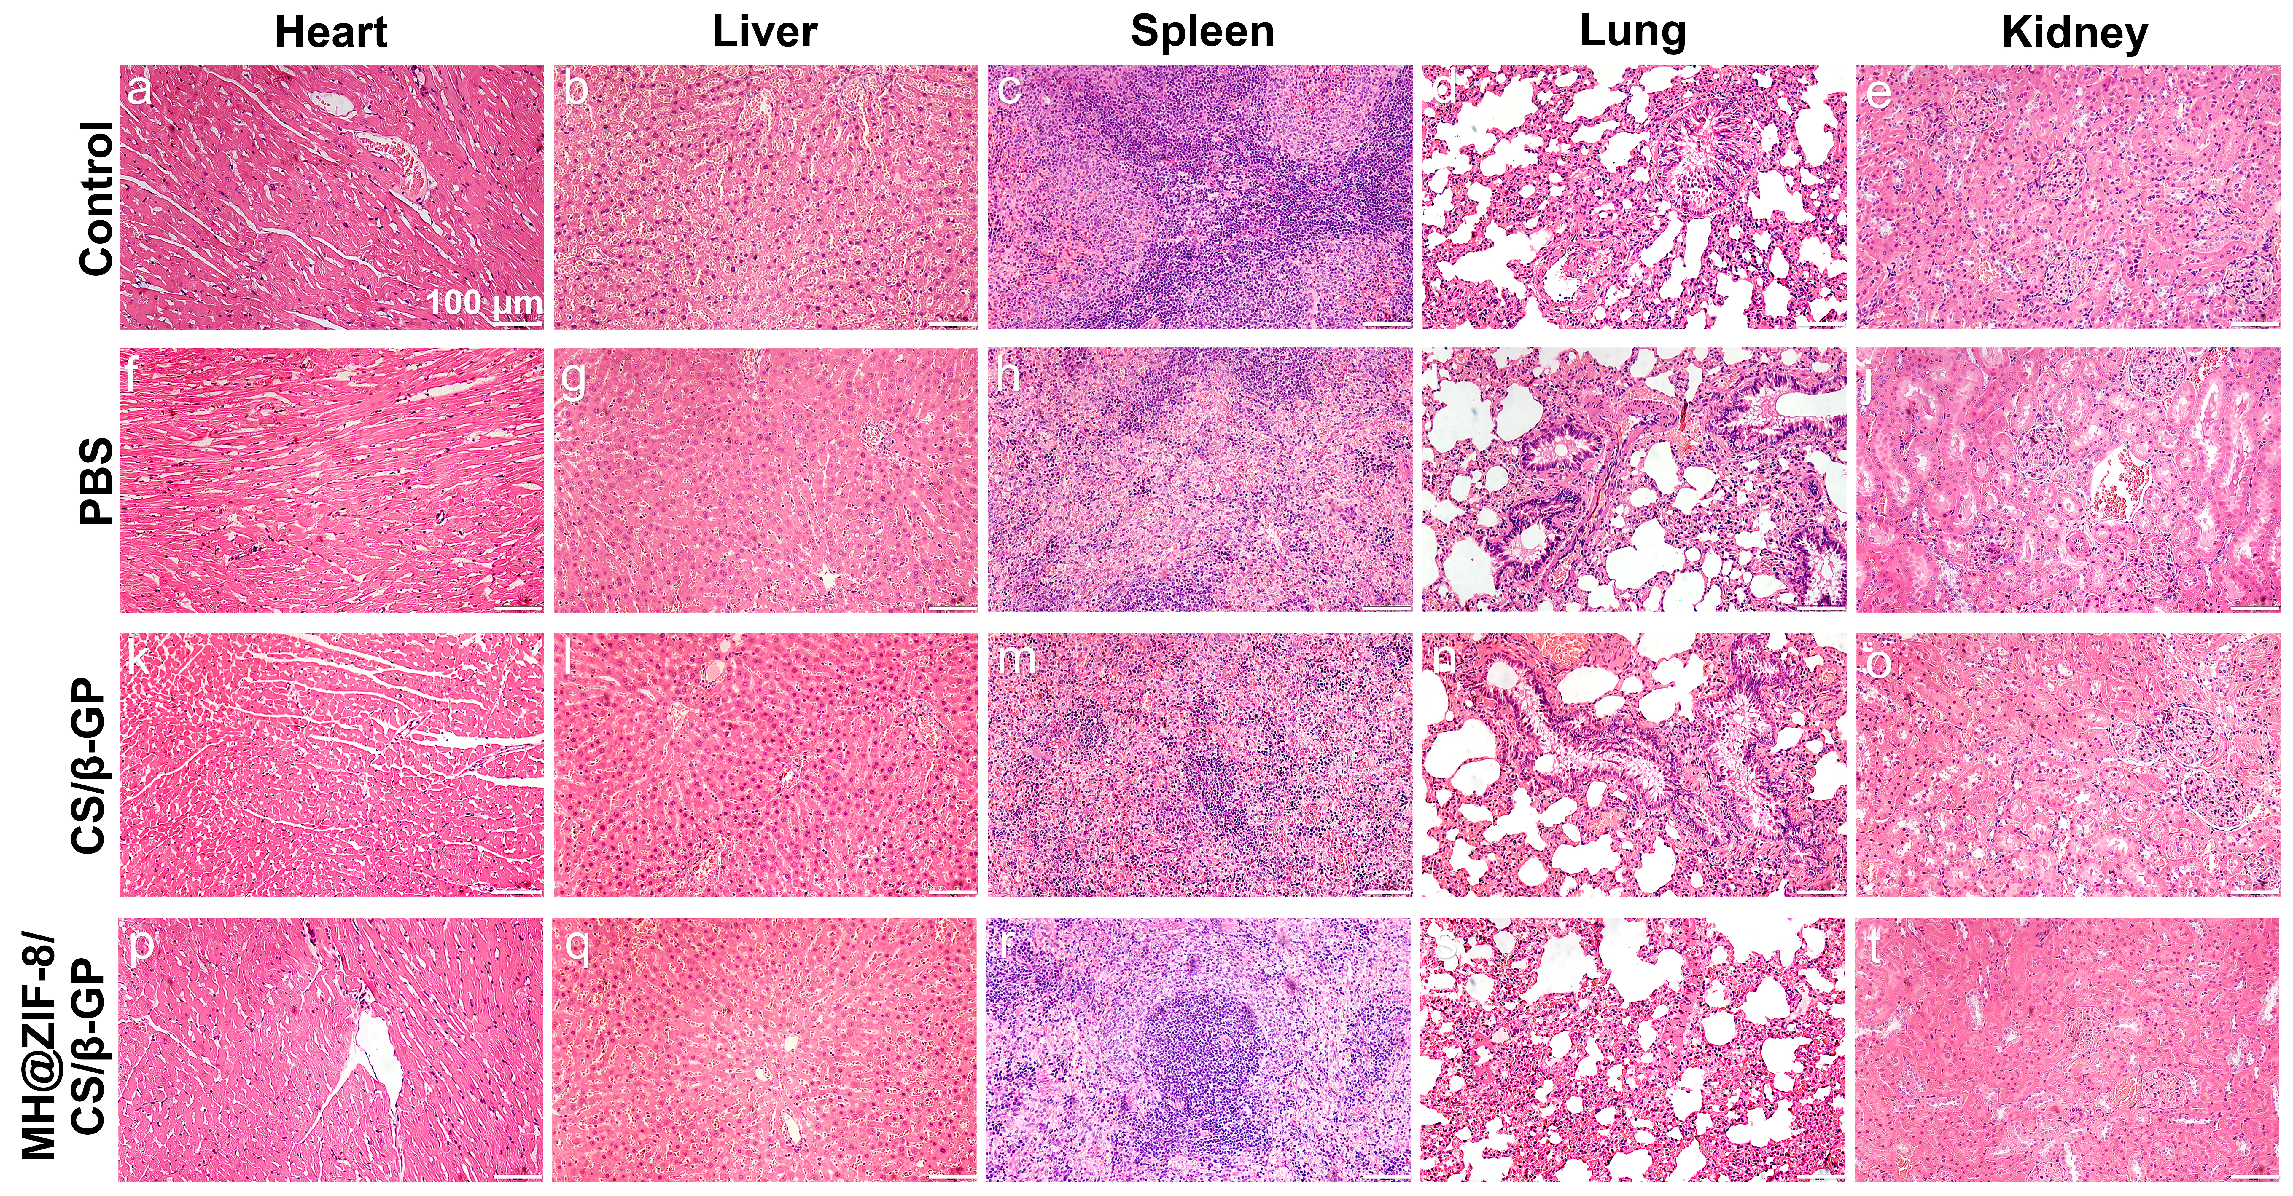
Fig. S16. HE staining of vital organs in SD rats from Control, PBS, CS/β-GP, and MH@ZIF-8/CS/β-GP groups. (a, f, k, p) Heart; (b, g, l, q) Liver; (c, h, m, r) Spleen; (d, i, n, s) Lung; (e, j, o, t) Kidney.

