Drug Loaded Cerium Oxide Nanozymes Prevent Radiation-Induced Cataracts via Suppressing the cGAS-STING Pathway
Qifang Chen ^{a,†}, Peilin Gu ^{a,†}, Hongwei Li ^{b,†}, Xuemei Liu ª, Ting Liu ^{a,}*, Qin Ouyang ^{b,}*, Dong Liu ^{c,}*, Chongyi Li ^{a,}*

ªDepartment of Ophthalmology, Daping Hospital, Army Medical University, Chongqing 400042, China.
^{b}Department of Pharmaceutical Chemistry, Army Medical University, Chongqing 400038, China.
^{c}State Key Laboratory of Ophthalmology, Zhongshan Ophthalmic Center, Sun Yat-sen University, Guangzhou 510060, China.

*Correspondence: liuting0727@tmmu.edu.cn (T. Liu); ouyangq@tmmu.edu.cn (Q. Ouyang); liud99@mail.sysu.edu.cn (D. Liu); lichongyi@tmmu.edu.cn (C. Li);

†Q. Chen, P. Gu and H. Li contributed equally to this work.

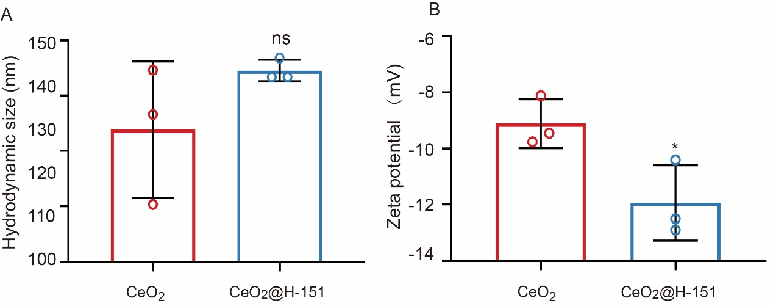
Fig. S1. Characterization of the prepared CeO₂@H-151 nanozymes. (A) DLS of CeO₂ and CeO₂@H-151 nanozymes (n = 3). (B) Zeta potentials of CeO₂ and CeO₂@H-151 nanozymes (n = 3). *P<0.05, ***P<0.001.
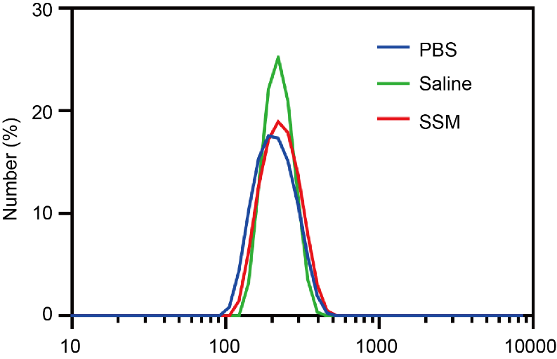
Fig. S2. Size of CeO₂@H-151 in phosphate-buffered saline (PBS), saline (0.9% sodium chloride (NaCl)), and serum-supplemented medium (SSM) from DLS.
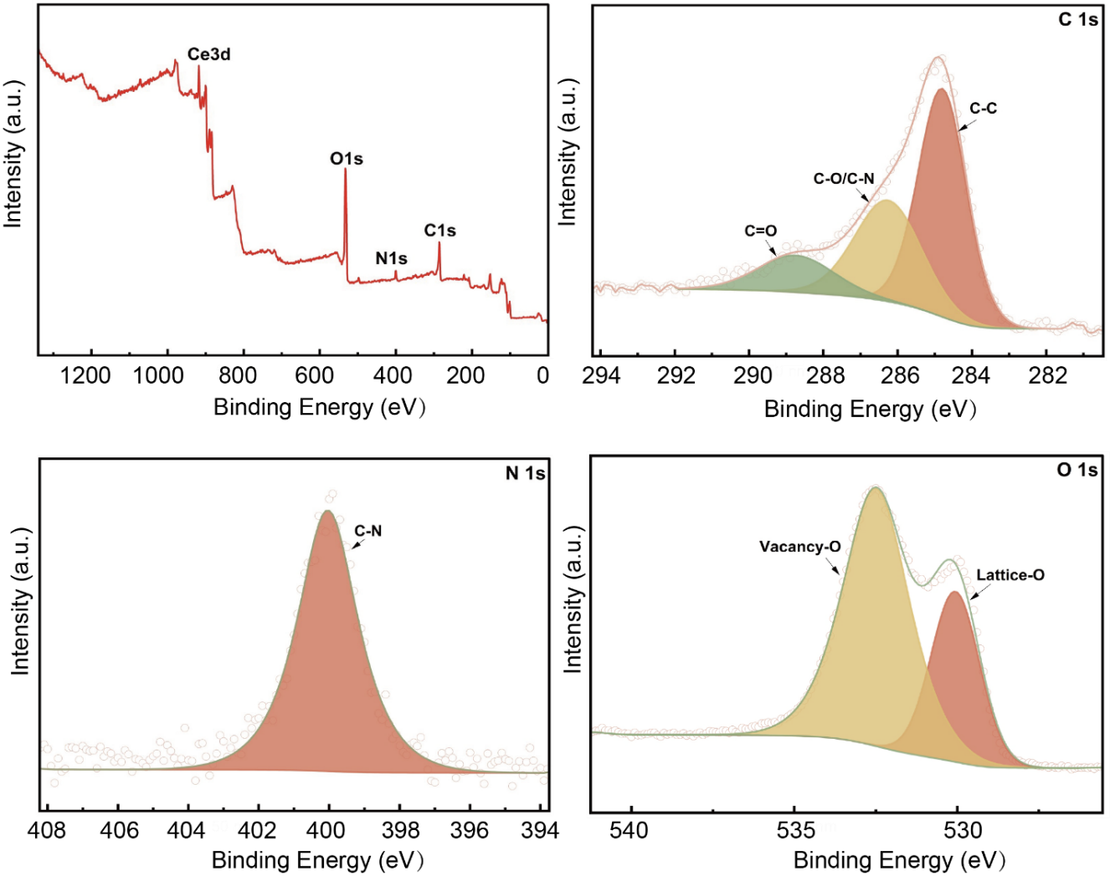
Fig. S3. XPS analysis of CeO₂@H-151 nanozymes.
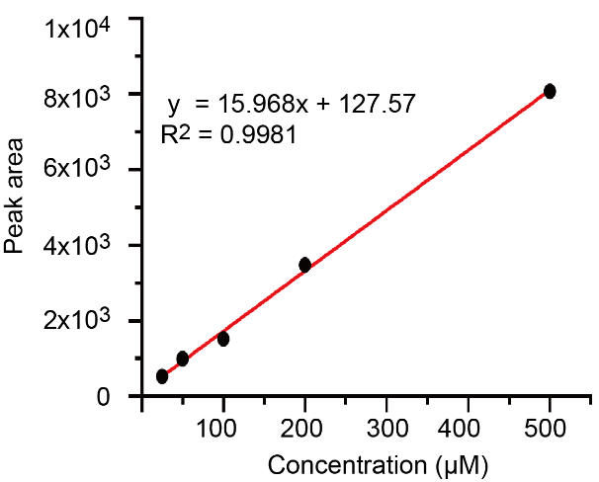
Fig. S4. The calibration curve of H-151 by HPLC.

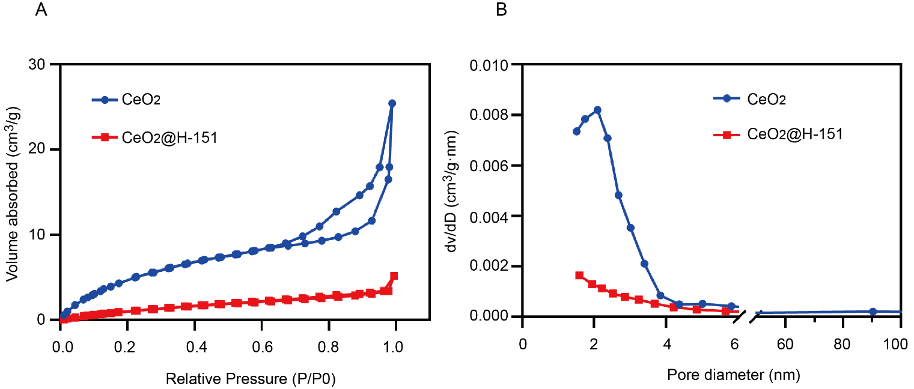
Fig. S5. BET analysis of CeO₂ and CeO₂/H-151. (A) N₂ adsorption isotherms of CeO₂ and CeO₂/H-151. (B) Pore size distributions of CeO₂ and CeO₂/H-151.

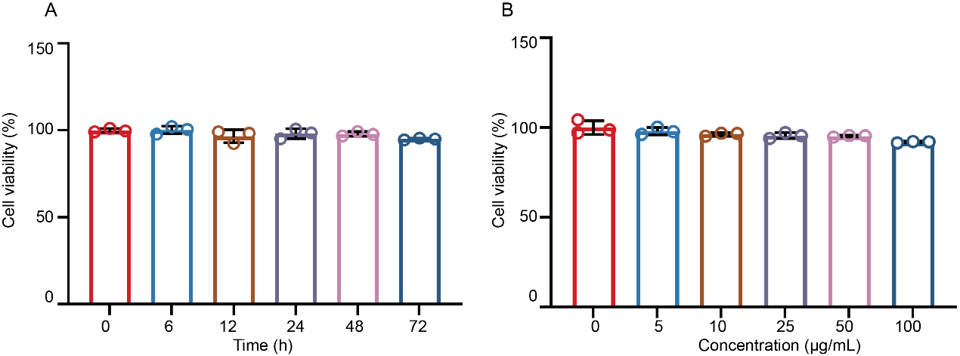
Fig. S6. Cytotoxicity assessment of CeO₂@H-151 nanozymes. (A) Cell viability of HLECB3 cells treated with CeO₂@H-151 nanozymes at 100 μg/mL for different durations. (B) Cell viability of HLECB3 cells treated with different concentrations of CeO₂@H-151 nanozymes for 72 h.

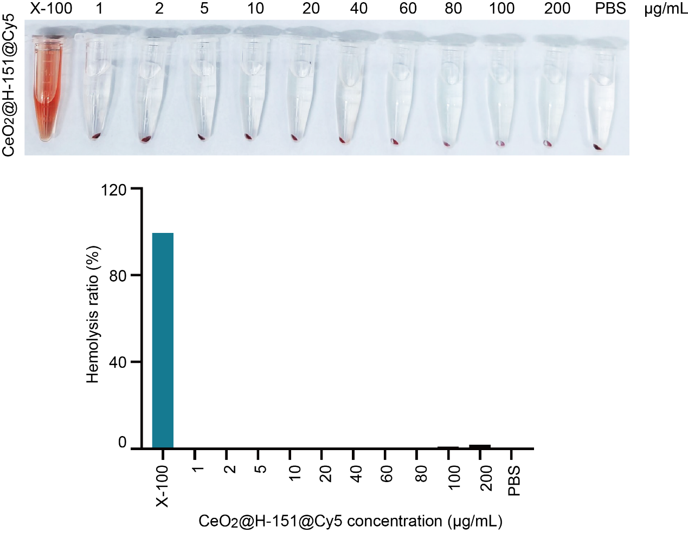
Fig. S7. The photos of hemolysis assay treated with CeO₂@H-151@Cy5 at different concentrations and hemolysis ratios of CeO₂@H-151@Cy5.

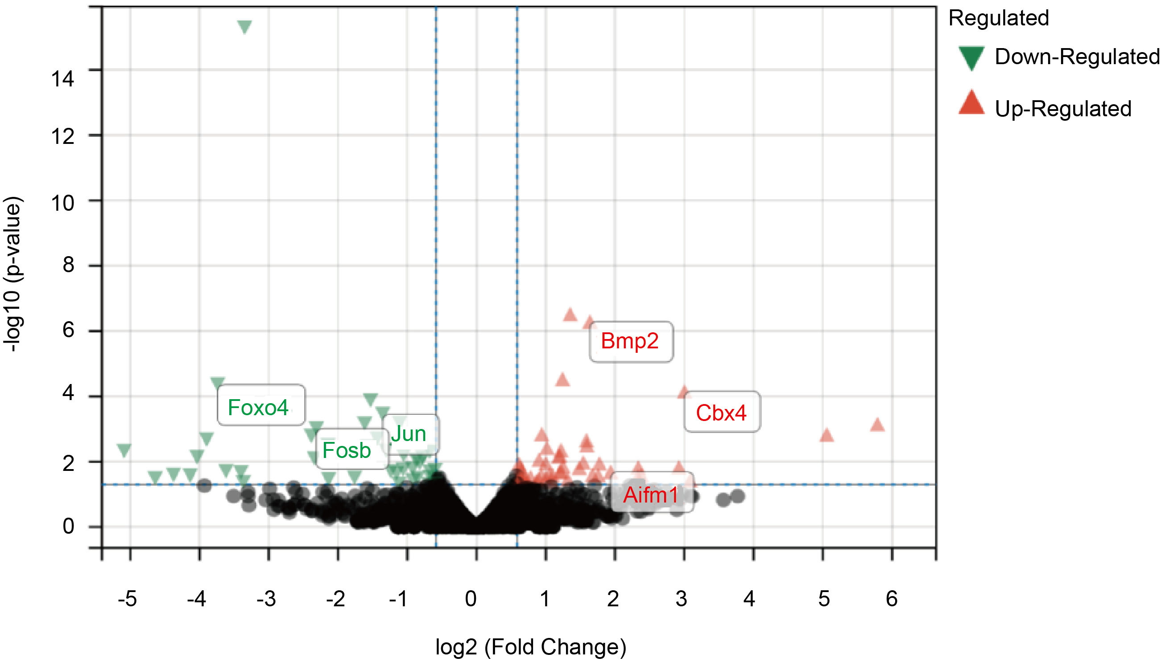
Fig. S8. Volcano plot of gene expression in IR exposure with or without CeO₂@H-151 treatment.

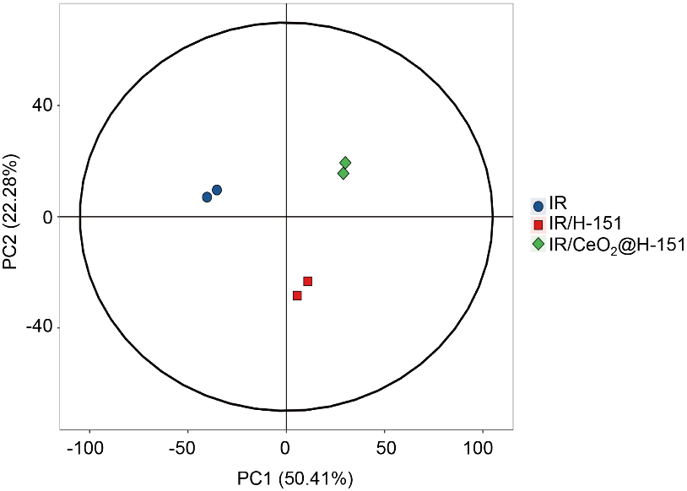
Fig. S9. PCA analysis after IR induction with H-151 and CeO₂@H-151 nanozymes treatments.
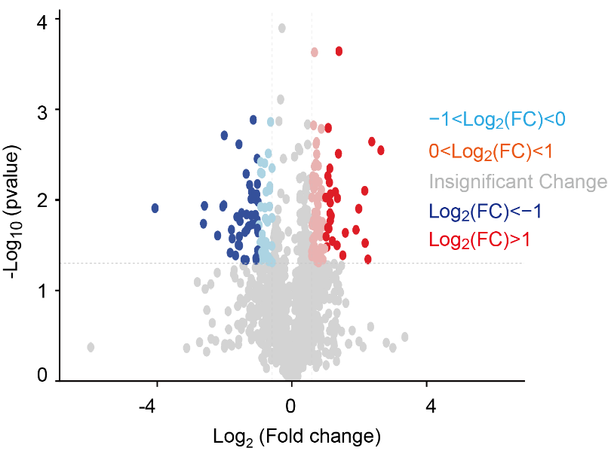
Fig. S10. Volcano plot of protein modifications abundance in H-151 and CeO₂@H-151 groups.
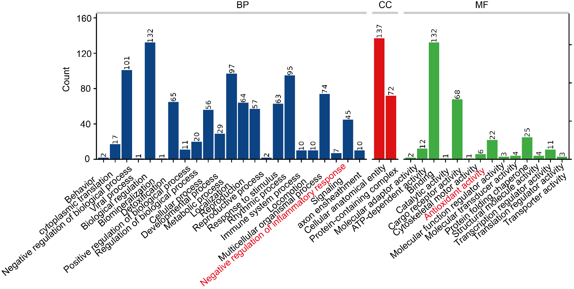
Fig. S11. The GO analysis after IR/H-151 and IR/ CeO₂@H-151 treatment.

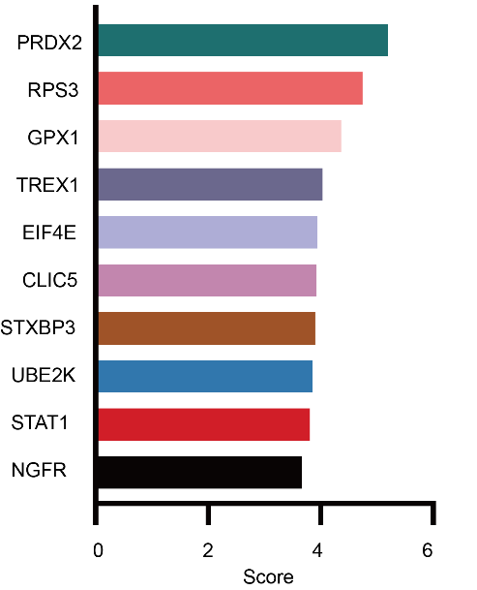

Fig. S12. Average molecular docking score of 10 differential proteins by Sybyl and AutoDock Vina.

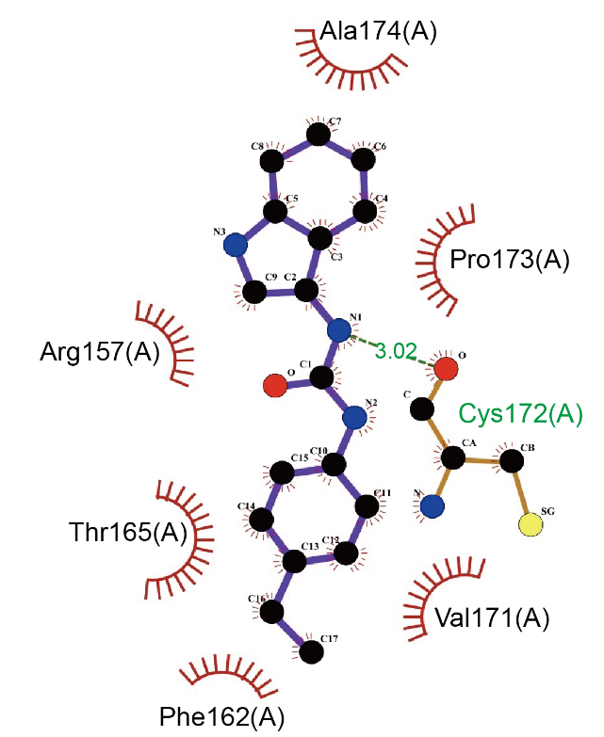
Fig. S13. The 2D visualization of the interaction between PRDX2 and H-151.

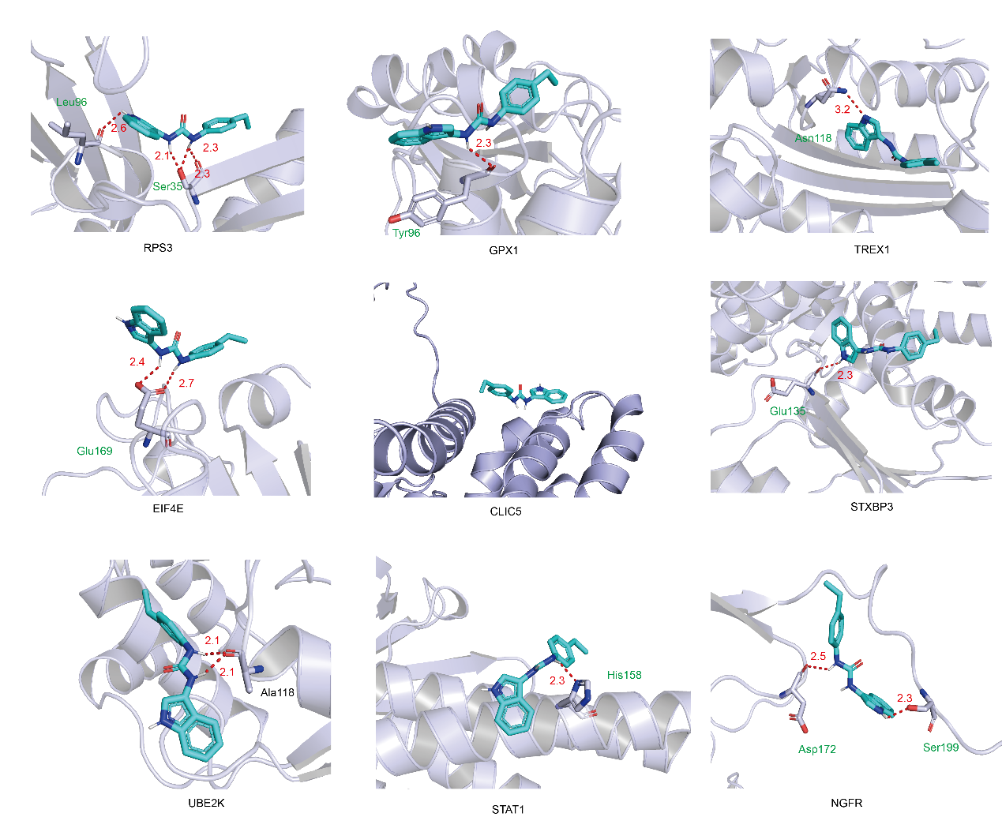
Fig. S14. Two- and three-dimensional mapping of the binding sites between H-151 and the other nine target protein. H-151 is displayed in green, while the TREX1 target protein is shown in blue.
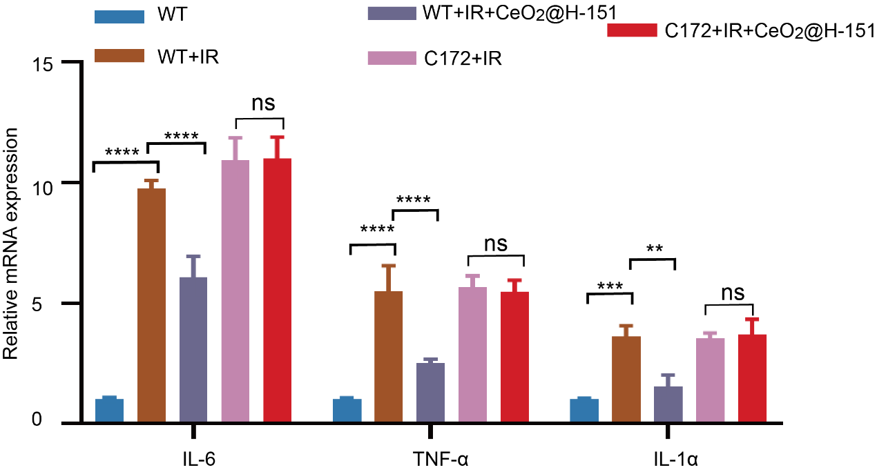
Fig. S15. RT-qPCR analysis of IL-1α, IL-6 and TNFα with treatments as indicated (n=3). **P < 0.01, ***P < 0.001, ****P < 0.0001, and n.s., no significance.

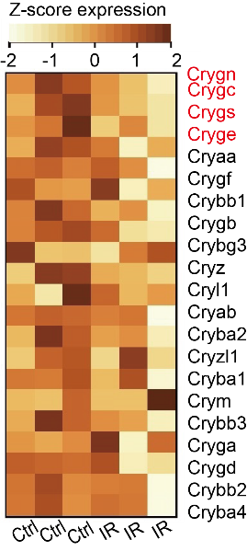
Fig. S16. Heatmap of RNA-seq data of the control and IR-induced LECs.
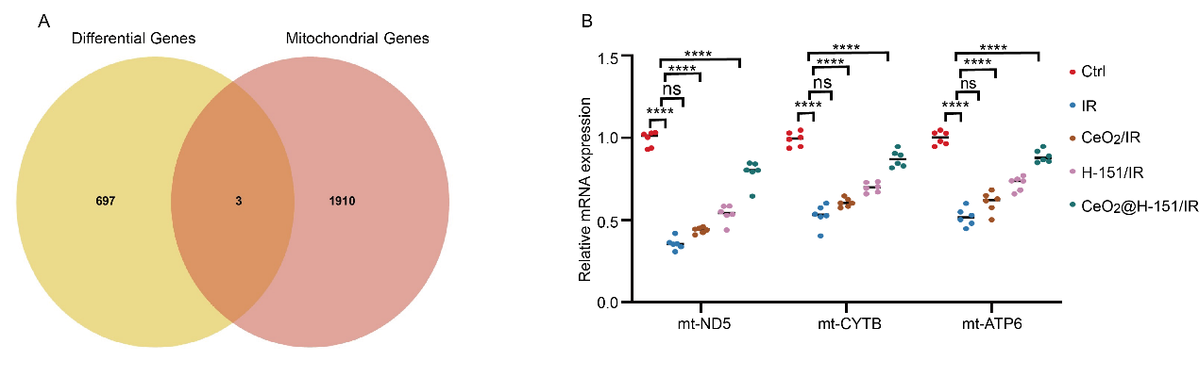
Fig. S17. The regulation of mitochondrial function genes by CeO₂@H-151. (A) Venn diagram showing shared three genes under differential genes of IR-induced LECs and mitochondrial genes. (B) RT-qPCR analysis of mt-ND5, mt-CYTB, mt-ATP6 mRNA expression of mice lens of different groups in consecutive days (n=3). ****P < 0.0001, and n.s., no significance.
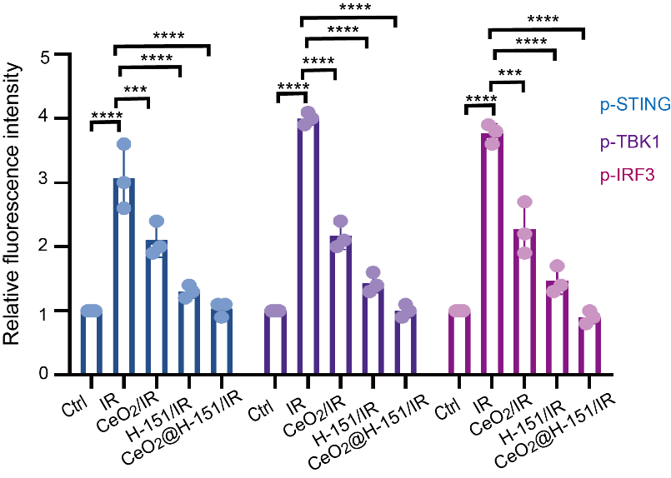
Fig. S18. Quantitative analysis of IF staining in p-STING, p-TBK1 and p-IRF3 proteins with treatments as indicated (n=3). ***P < 0.001, ****P < 0.0001.
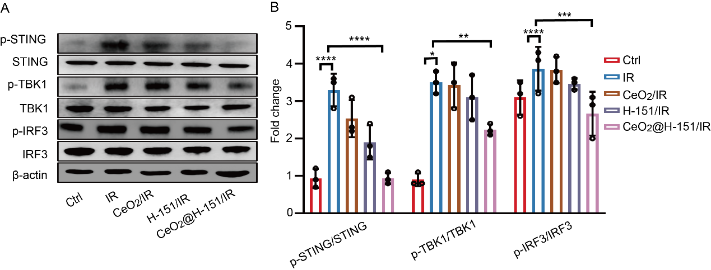
Fig. S19. Inhibition of STING pathway and TBK1-IRF3 downstream pathways by CeO₂@H-151. (A-B) WB and quantitative analysis of p-STING, p-TBK1 and p-IRF3 proteins in the mice lens with treatments as indicated (n=3). *P < 0.05, **P < 0.01, ***P < 0.001, ****P < 0.0001, and n.s., no significance.
Table S1. Molecular docking score of 10 differential proteins by Sybyl and AutoDock Vina.
