Supplementary Material
A Two-Stage Transdermal Drug Delivery System Comprising Sono-Phase-Change Transfersomes for Non-Invasive Deep Dermal Delivery
Yi Zhang^{1,2#}, Xiong He^{1,2#}, Xiang Mao^{1,2#}, Yukun Yang^{1,2}, Faqi Li^{1,2}, Xiaofeng Han³, Hao Lu³, Liang Tang^{1,2}, Yujun Yang⁴, Yan Wang^{1, 2}, Yuling Du^{1,2}, Wei Xu^{3*}, Zhenyu Wang^{1,2*}
¹College of Biomedical Engineering, Chongqing Medical University, Chongqing 400016, China; ²State Key Laboratory of Ultrasound in Medicine and Engineering, Chongqing Medical University, Chongqing 400016, China; ³Department of Dermatology, the First Affiliated Hospital of Chongqing University of Chinese Medicine, Chongqing 400011, China; ⁴Key Laboratory of Laboratory Medical Diagnostics, Ministry of Education, Department of Laboratory Medicine, Chongqing Medical Laboratory Microfluidics and SPRi Engineering Research Center, Chongqing Medical University, Chongqing 400016, China.
#These authors contributed equally to this work
Corresponding authors: xuwei@cqctcm.edu.cn; wangzhenyu@cqmu.edu.cn

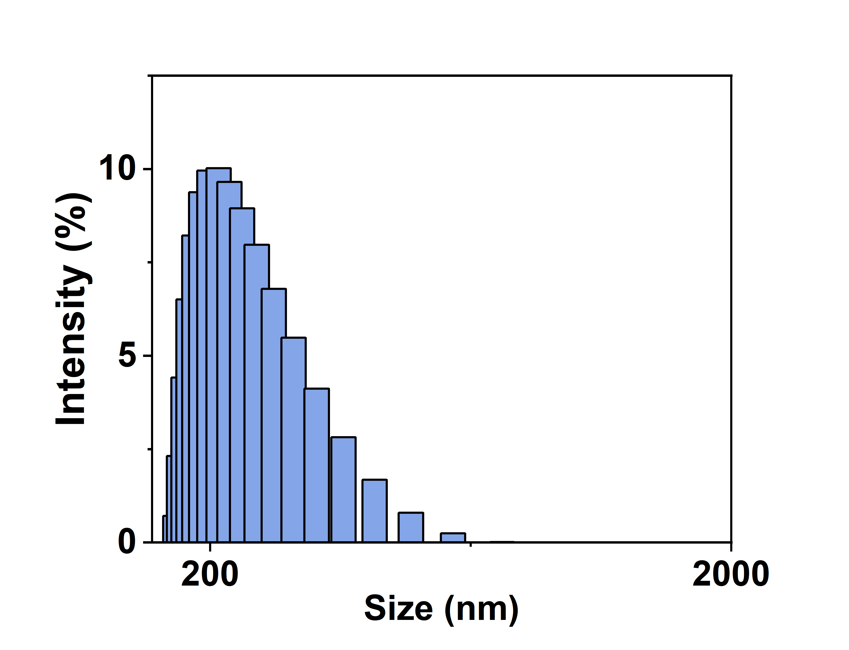
Figure S1. Particle size distribution of 5-FU@SPCTs.

Figure S2. The standard curve of 5-FU obtained from the absorbance at 266 nm with different concentrations of 5-FU.
Figure S3. Microscopic images of diluted 5-FU@SPCTs solution by ultrasound irradiation over time.

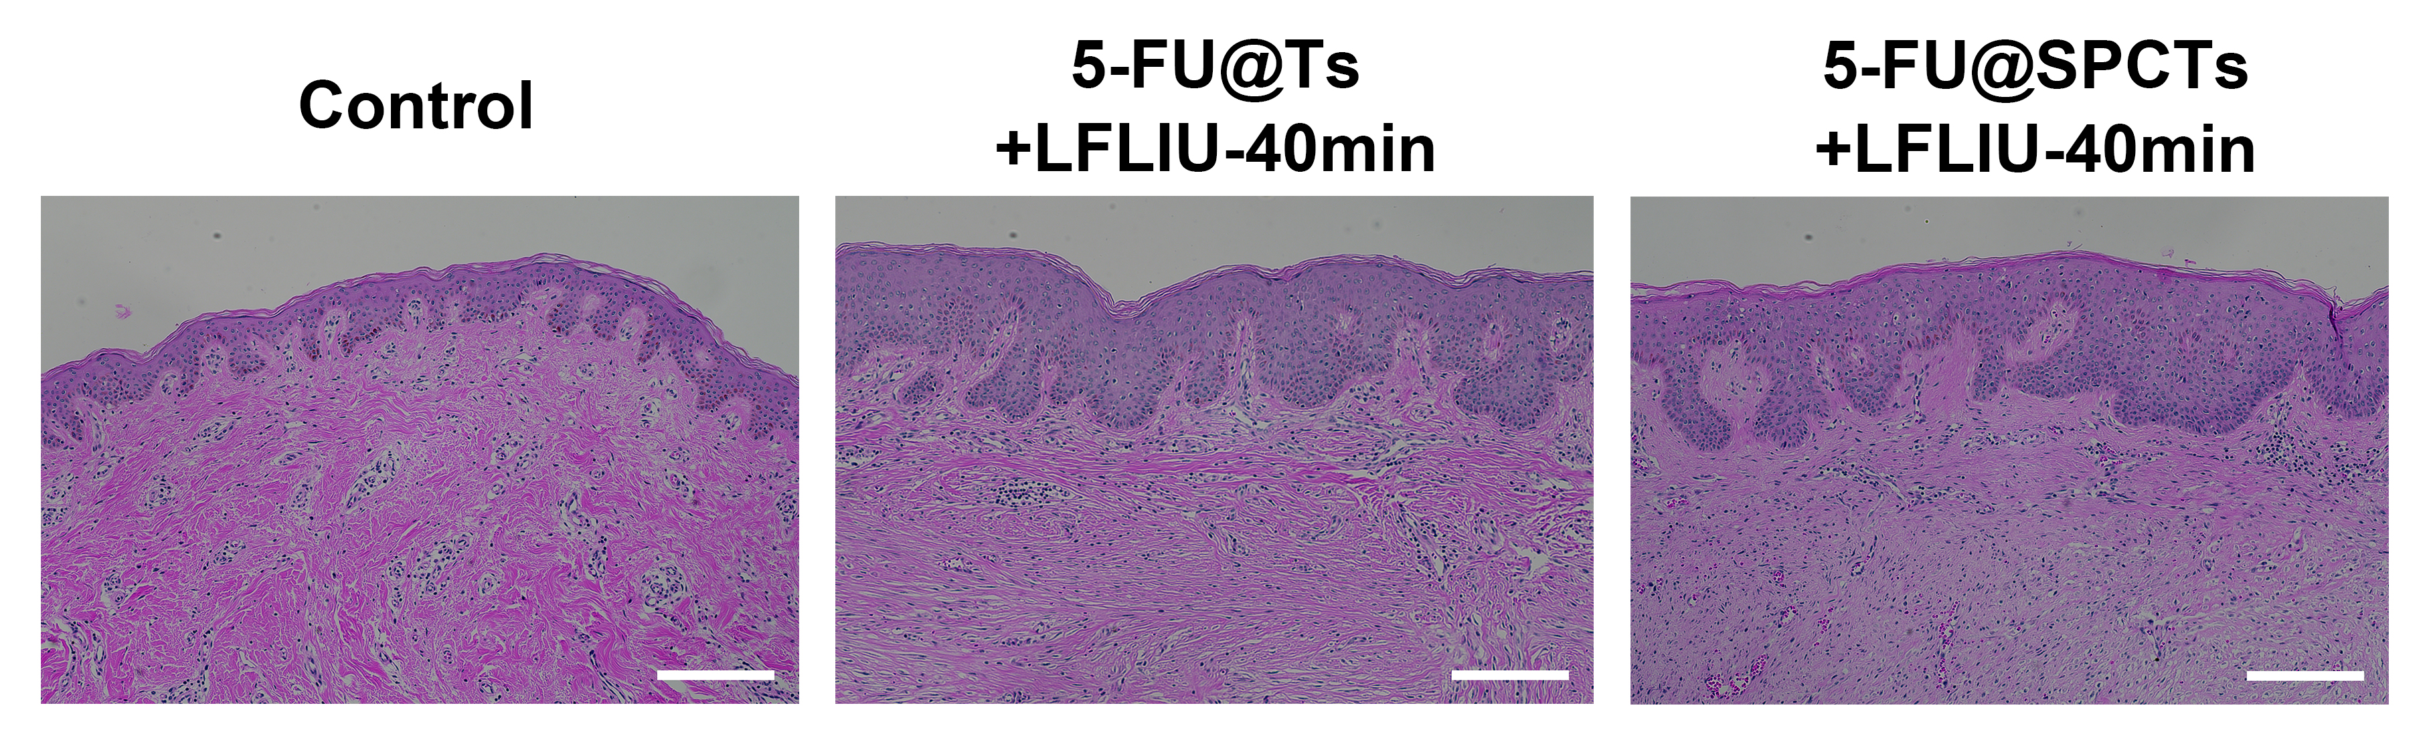

Figure S4. H&E staining of the three groups: untreated keloids (Control), 5-FU@Ts combined with ultrasound irradiation for 40 min (5-FU@Ts+LFLIU-40min), and 5-FU@SPCTs combined with ultrasound irradiation for 40 min (5-FU@SPCTs+LFLIU-40min). Scale bar = 100 μm.

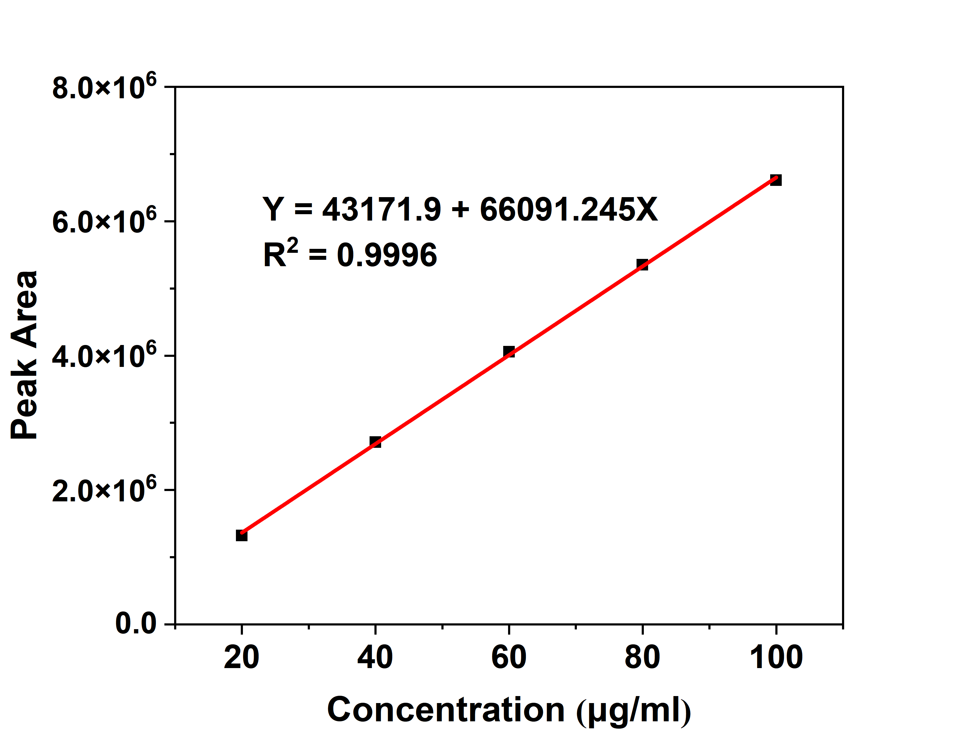
Figure S5. The HPLC standard curve of 5-FU.
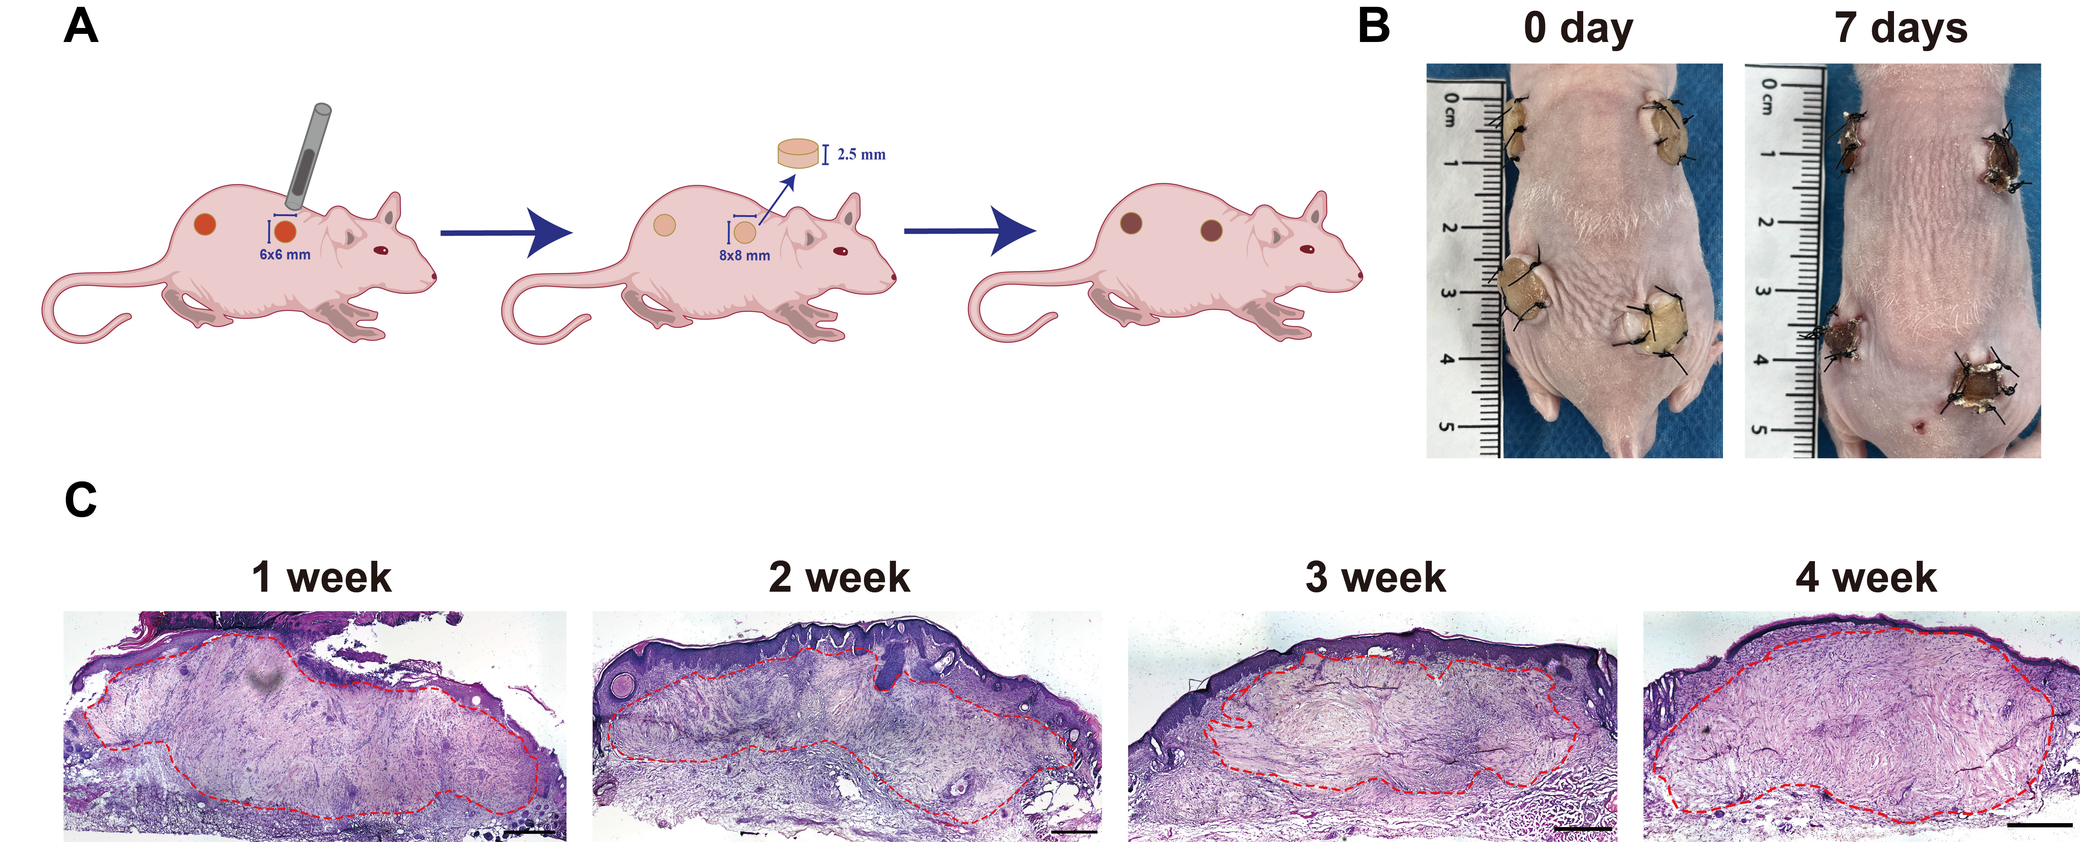
Figure S6. (A) Schematic representation of keloids transplanted in a nude mouse. (B) Images of the model at 0 and 7 days after transplantation. (C) H&E staining of keloid at different growth stages after transplantation. Scale bar = 500 μm.

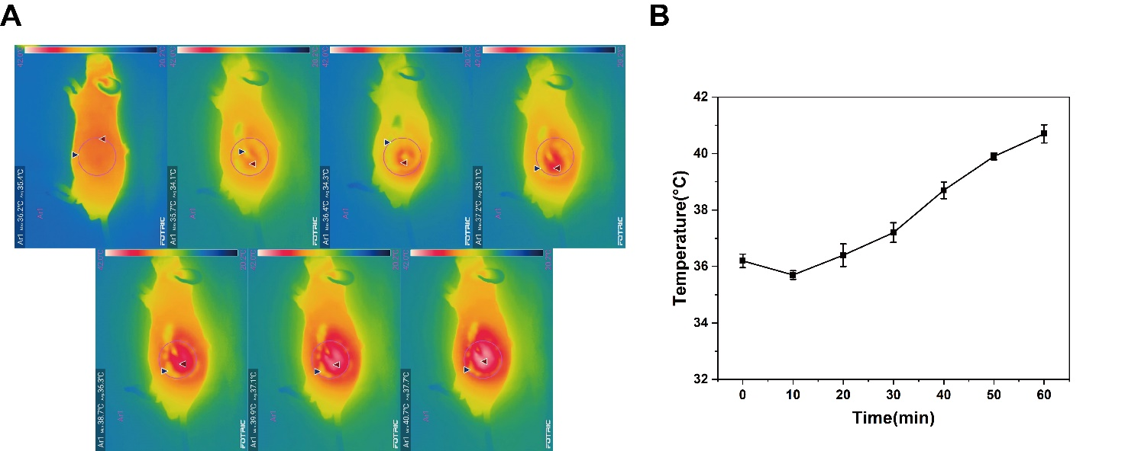
Figure S7. (A) Images of temperature changes within 60 min of applying ultrasound to nude mice. (B) Temperature change curve in nude mice during 60 min of ultrasound.

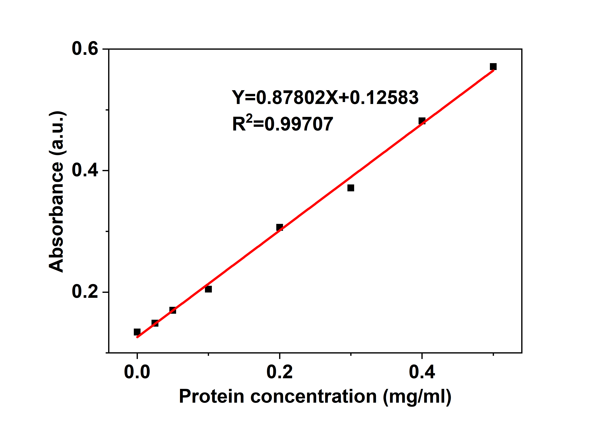
Figure S8. The standard curve of BCA protein.

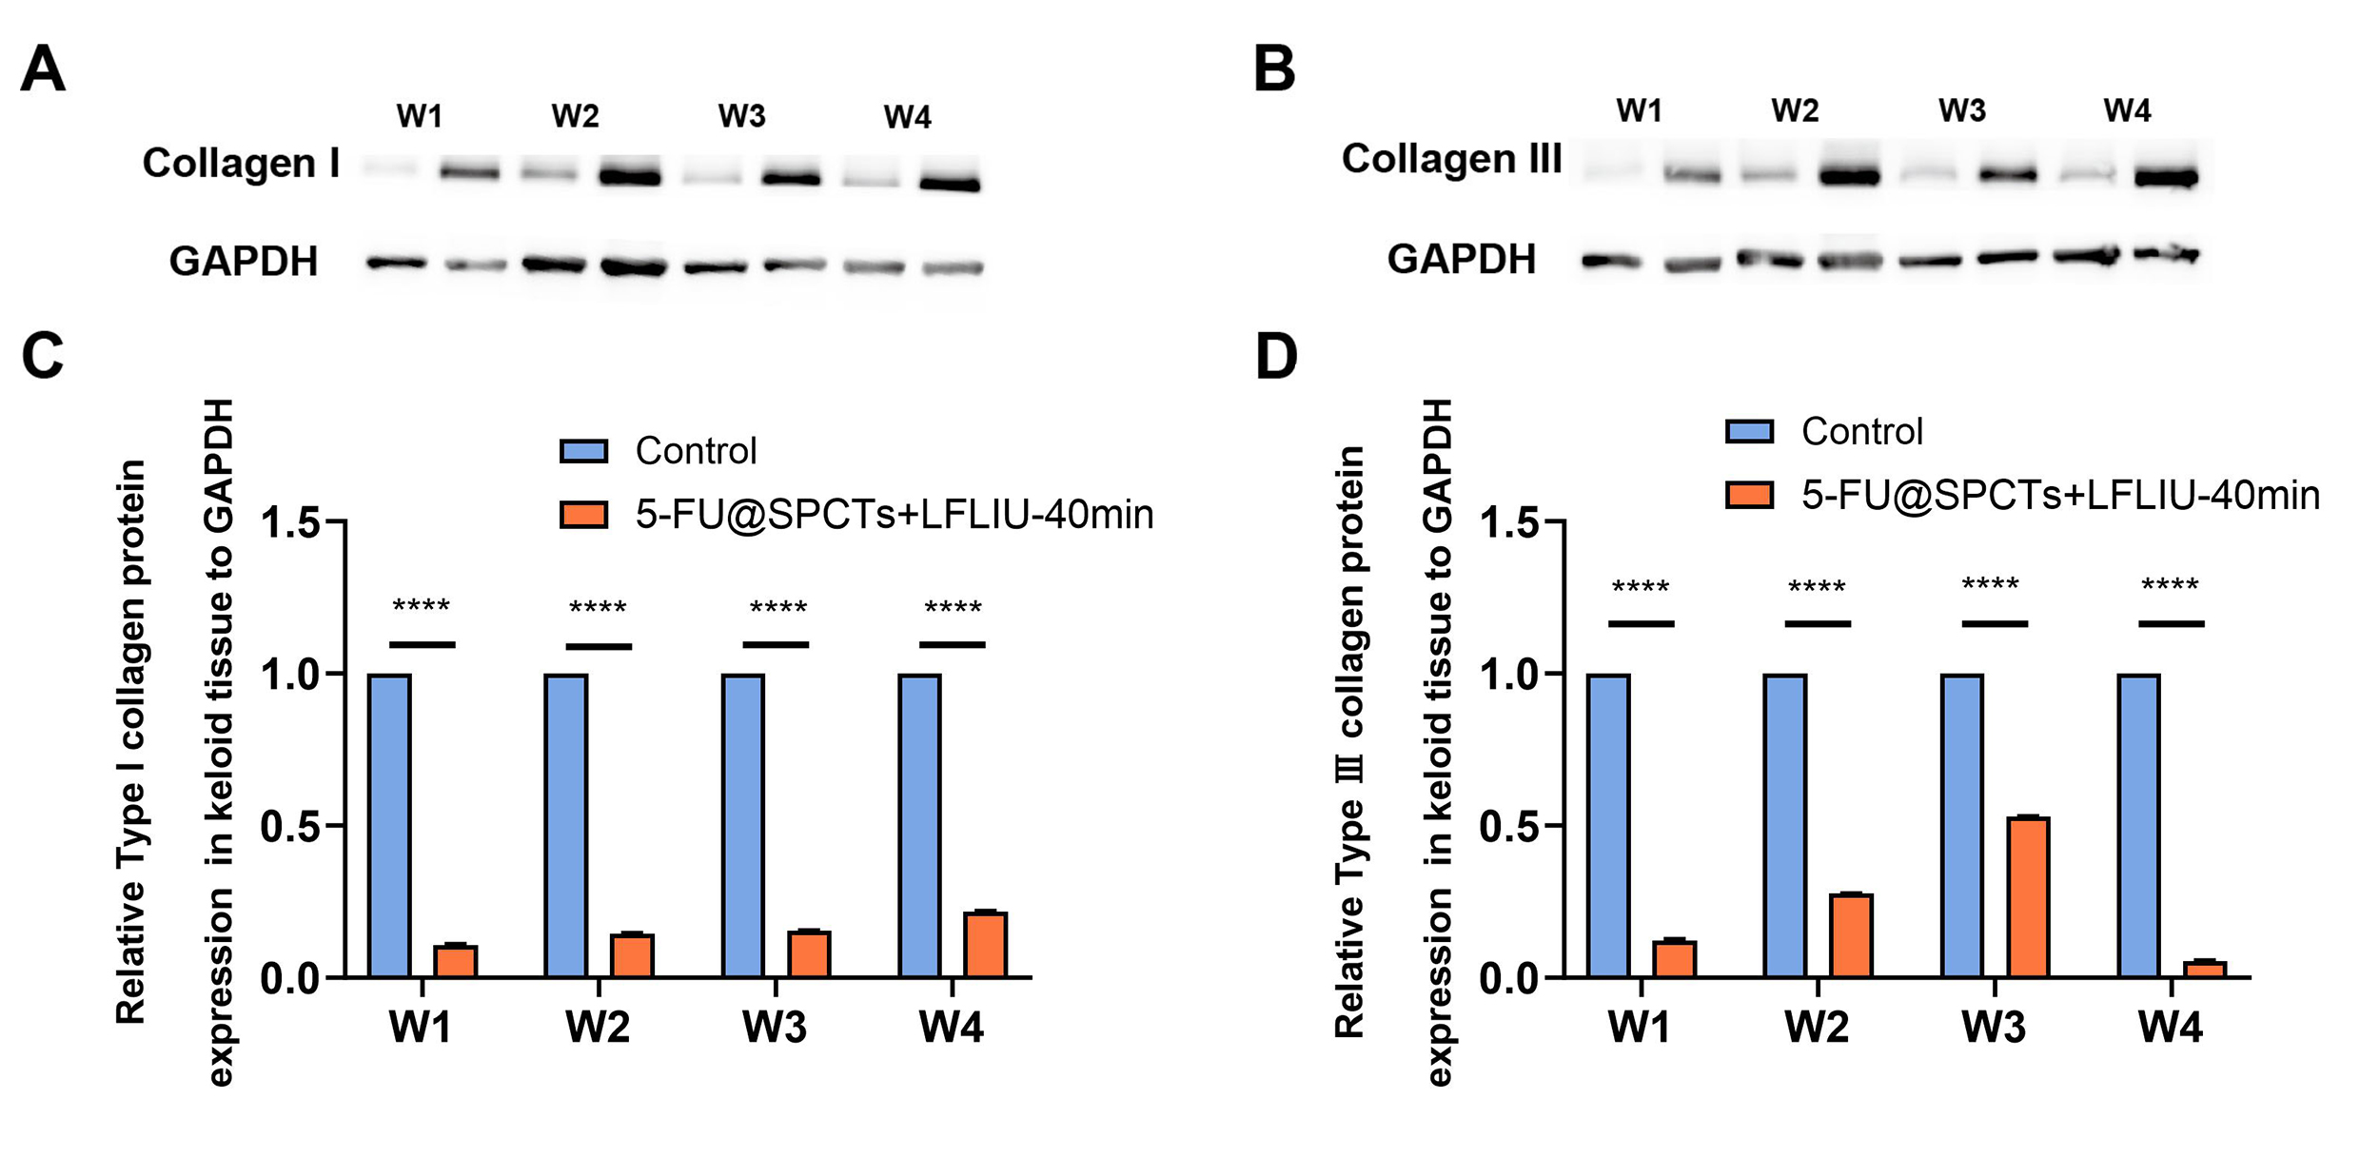

Figure S9. Protein expression of (A) collagen Ⅰ and (B) collagen Ⅲ was detected by western blot analysis within four weeks.The left one is 5-FU@SPCTs combined with ultrasound irradiation for 40 min (5-FU@SPCTs+LFLIU-40min) group, and the right one is Control group. Gray values analysis of protein expression corresponding to (C) collagen Ⅰ and (D) collagen Ⅲ, respectively. (W1: 1 week; W2: 2 weeks; W3: 3 weeks; W4: 4 weeks)

Table S1. Degree of deformability of 5-FU@Liposomes and 5-FU@SPCTs
Type | Particle size(nm)  (before) | Particle size(nm)  (after) | Extruded vol.  (mL) | Degree of deformability
5-FU@Liposomes | 371±11.02 | 240.57±3.73 | 4.8±0.1 | 6.04
5-FU@SPCTs | 432.33±3.01 | 431.37±6.52 | 4.8±0.1 | 19.41

