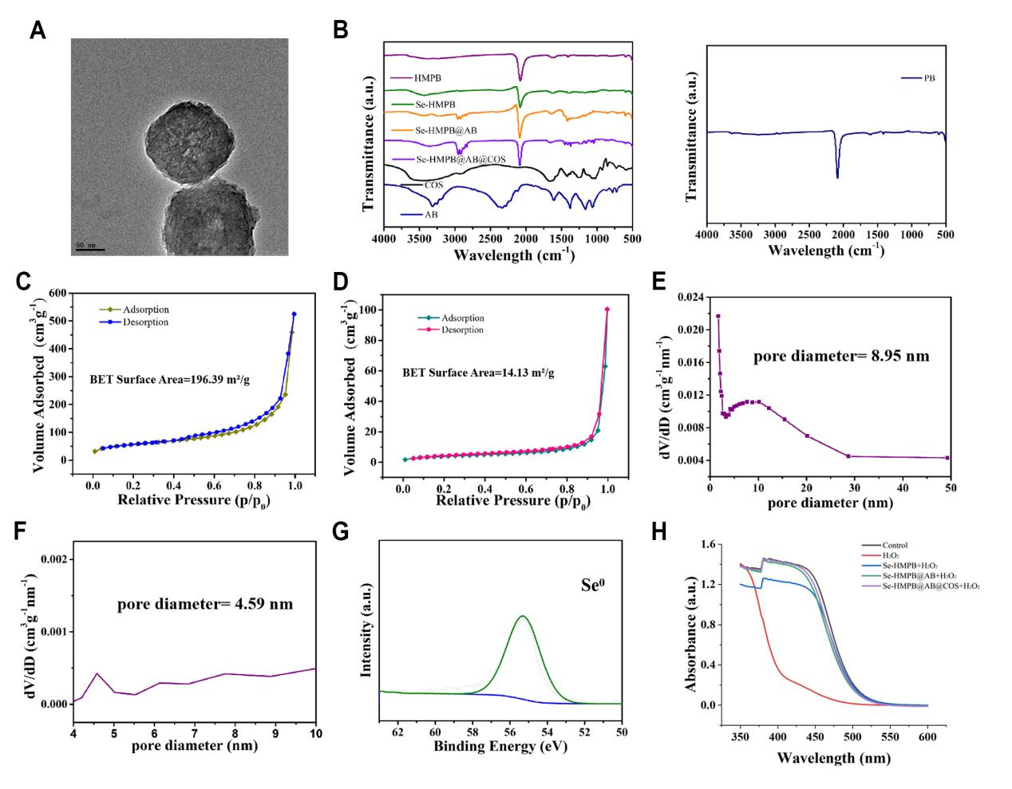

Figure S1. Characterization and Safety of Hydrogen-Releasing Nanozymes. (A) TEM images of Se-HMPB@AB. (B) the Fourier transform infrared (FTIR) spectrum of PB, HMPB, Se-HMPB, Se-HMPB@AB, Se-HMPB@AB@COS (C, D) Brunauer–Emmett–Teller (BET) surface area of HMPB and Se-HMPB. (E, F) the pore size distribution of HMPB and Se-HMPB. (G) X-ray photoelectron spectroscopy (XPS) analysis of Se0. (H) Monitoring GSH consumption via DTNB assay.

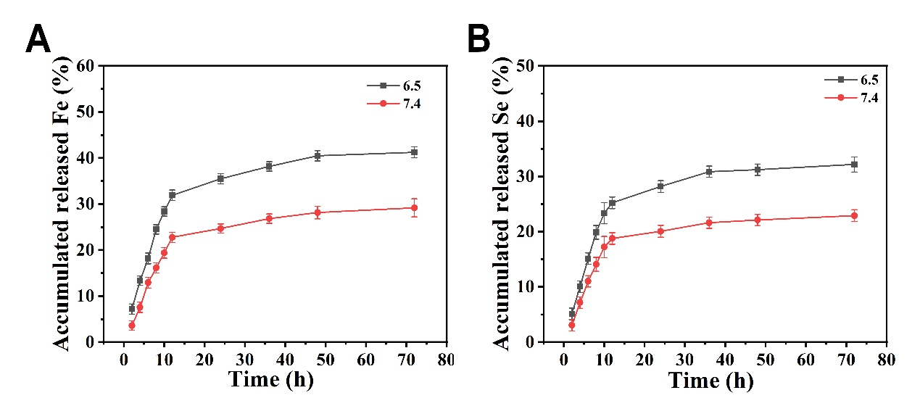

Figure S2. Ion-responsive release under different pH conditions.

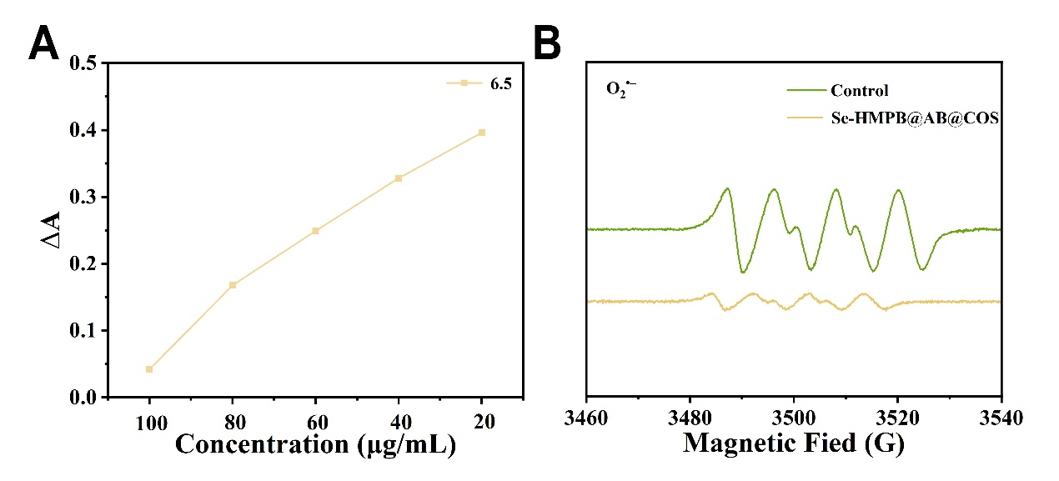

Figure S3. (A) Detection of the SOD activity of Se-HMPB@AB@COS at varying concentrations. (B) ESR was employed to assess the impact of Se-HMPB@AB@COS nanozyme on O₂^{•−}.

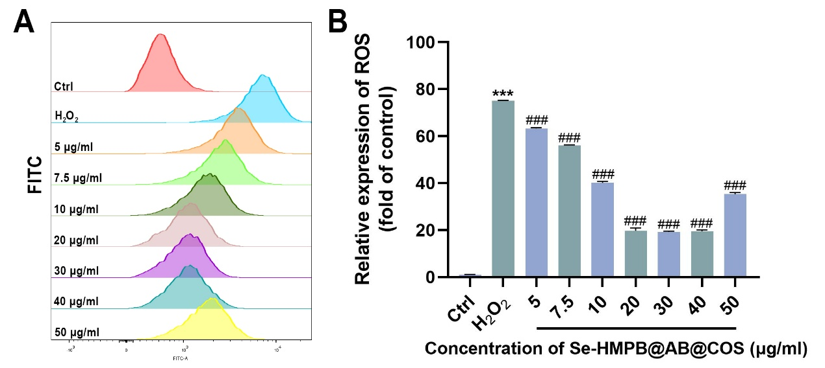

Figure S4. Flow cytometry was utilized to assess the effect of Se-HMPB@AB@COS on ROS at various concentrations (A), along with performing quantitative analysis (B). n = 3 independent biological replicates per group. All quantified data are shown as mean ± SEM; ***, ### p < 0.0001 by one-way ANOVA followed by the Tukey-Kramer test.

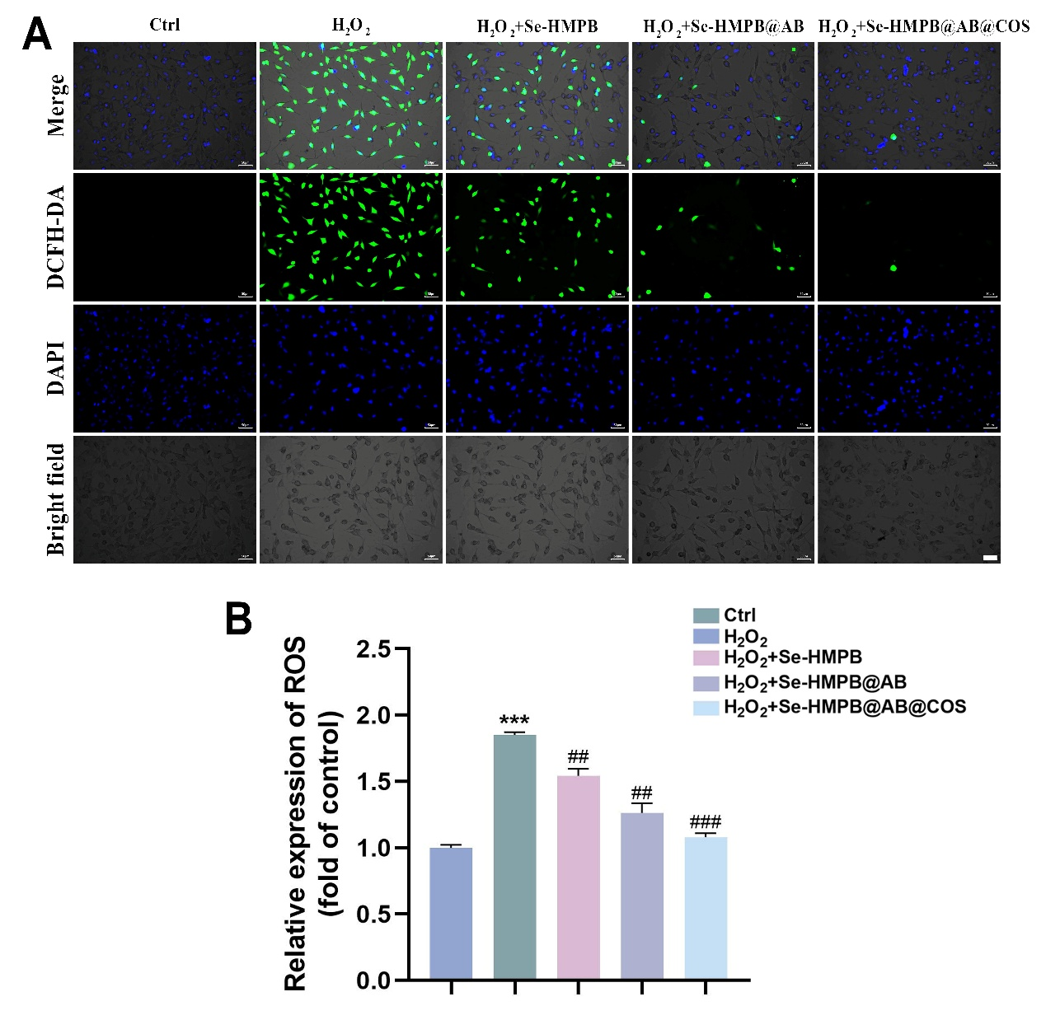

Figure S5. (A) Representative images of intracellular reactive oxygen species detection (including images of DCFH-DA probe, DAPI, bright field, and merged images). Bar= 50 μm. (B) Quantitative analysis of cellular ROS subsequent to treatment with various nanozymes. n = 3 independent biological replicates per group. All quantified data are shown as mean ± SEM; ## p < 0.001, ***, ### p < 0.0001 by one-way ANOVA followed by the Tukey-Kramer test.

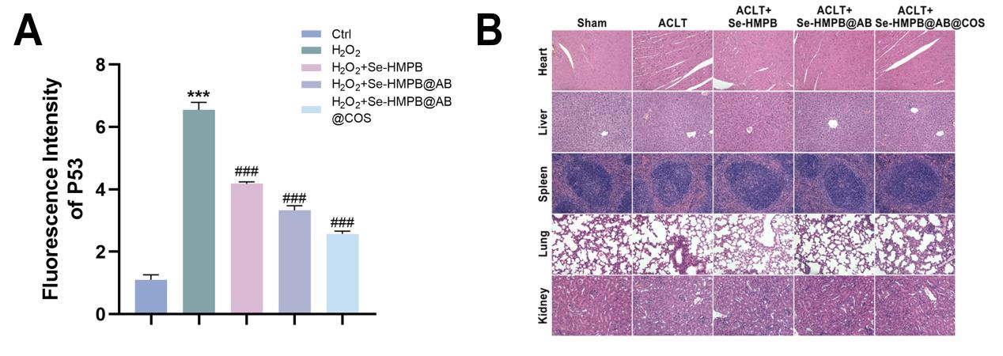

Figure S6. (A) Quantitative Analysis of P53 Fluorescence Intensity. (B) Hematoxylin and eosin (H&E) stained sections of the five visceral organs of mice following various treatments. n = 3 independent biological replicates per group. All quantified data are shown as mean ± SEM; ***, ### p < 0.0001 by one-way ANOVA followed by the Tukey-Kramer test.

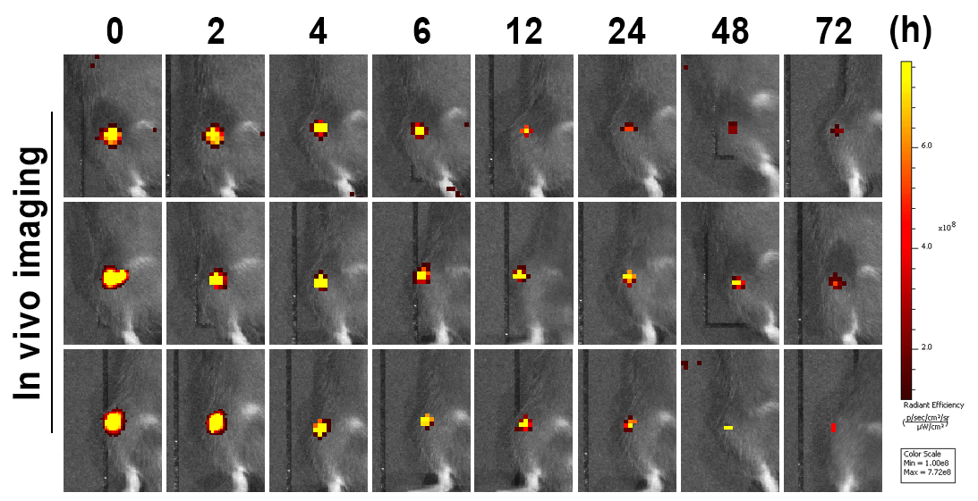

Figure S7. Representative fluorescent images of in-vivo imaging of nanozymes in the knee joint.

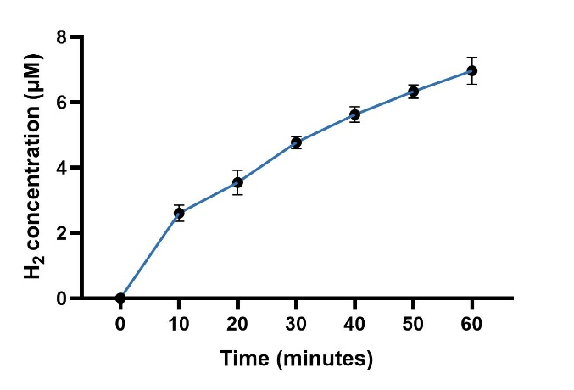
Figure S8. In-vivo hydrogen release.

