Supplementary Information

Amorphous layered double hydroxide-based nano-enzyme eye drops against dry eye disease by inhibiting mitochondrial damage and pyroptosis
Dandan Chu, Tingting Hu, Haohao Cui, Liu Yang, Zhanrong Li*, Chaoliang Tan*, Jingguo Li*

These authors contributed equally: Dandan Chu and Tingting Hu.

D. Chu, Dr. T. Hu, H. Cui, L. Yang, Prof. Z. Li, and Prof. J. Li
Henan Eye Hospital, Henan Provincial People's Hospital, People's Hospital of Zhengzhou University, Zhengzhou, 450003, PR China
E-mail: lizhanrong@zzu.edu.cn (Z. Li), lijingguo@zzu.edu.cn (J. Li)
Prof. C. Tan
Department of Electrical Engineering & Department of Biomedical Engineering, City University of Hong Kong, Hong Kong SAR 999077, China
E-mail: chaoltan@cityu.edu.hk
Prof. C. Tan
Hong Kong Branch of National Precious Metals Material Engineering Research Center (NPMM), City University of Hong Kong, Kowloon, Hong Kong SAR 999077, P. R. China

Experimental Sections
Chemicals
Aluminum nitrate hexahydrate (Al(NO₃)₃·9H₂O, >99.0%), copper nitrate trihydrate (Cu(NO₃)₂·3H₂O, >99.0%), zinc nitrate hexahydrate (Zn(NO₃)₂·6H₂O, >99.0%), sodium hydroxide (NaOH, >98.0%), and polyethylene glycol-2000 (PEG-2000) were acquired from Macklin (Shanghai, China). 3,3’,5,5’-Tetramethylbenzidine (TMB), methylene blue (MB), 5,5-dimethyl-1-pyrroline N-oxide (DMPO), dihydroethidium (DHE), H₂O₂ (30%), xanthine, and xanthine oxidase were obtained from Aladdin Reagent (Shanghai, China). Phosphate-buffered saline (PBS), hydroxyl radical Assay Kit and superoxide dismutase (SOD) Assay Kit were bought from Sigma-Aldrich and Fisher (USA). 0.05% Cyclosporine A (CsA) was purchased from Shenyang Xingqi Pharmaceutical Co., Ltd. Cell counting Kit-8 (CCK-8) was purchased from Shanghai Life-iLab Biotech (Shanghai, China). 2′,7′-dichlorofluorescein diacetate (DCFH-DA, CAS number 2044-85-1), Fluoroshield™ with DAPI (F6057), and dihydroethidium (DHE, D7008), and Benzalkonium chloride (CAS number 63449-41-2) were purchased from Sigma-Aldrich (St Louis, MO, USA). Sodium chloride (NaCl) was purchased from Tianjin Hengxing Chemical Preparation Co., Ltd. MitoTracker™ Green FM (M7514), MitoSOX™ Red mitochondrial superoxide tracker (M36008), and TRIzolTM (15596026CN) were purchased from Invitrogen (Thermo Fisher, CA, USA). DAPI solutions were purchased from Solarbio Science & Technology Co., Ltd. (Beijing, China). A mitochondrial membrane potential assay kit with JC-1 (C2006) was purchased from Beyotime Biotechnology (Shanghai, China). Primary antibodies against SOD1 (bs-10216R), GPX1 (bs-3882R), NLRP3 (bs-6655R), Caspase-1 (bs-0169R), IL-1β (bs-0812R), and 8-OHdG (bs-1278R) were purchased from Bioss. ASC (sc-514414) antibody was purchased from Santa Cruz Biotechnology. Primary antibodies against GSDMD (AF4012), NF-κB P65 (AF5006), P-NF-κB P65 (AF2006), IL-18 (DF6252), TNF-α (AF7014), and IL-6 (DF6087) were purchased from Affinity. N-GSDMD (Cat#55651) antibody was purchased from Signalway Antibody Co. Ltd. Primary antibodies against β-actin (20536-1-AP-1) and β-Tubulin (80713-1-RR) were purchased from Proteintech (Wuhan, China). Secondary antibodies included FITC-conjugated goat anti-rabbit IgG H&L (A0562) and Cy3-conjugated goat anti-mouse IgG (H+L) (A0521) were sourced from Beyotime. Additionally, HRP-conjugated goat anti-rabbit-IgG (abs20040) and HRP-conjugated goat anti-mouse-IgG (abs20039) were obtained from Absin.
Characterization
The structural features of ZnCuAl-LDH and a-ZnCuAl-LDH nanoparticles were examined through high-resolution transmission electron microscopy (HRTEM, JEOL Ltd., Japan). Crystalline phase identification was conducted using an X-ray diffractometer (XRD-6000, Shimadzu) with Cu Kα radiation. Thickness measurements were obtained via atomic force microscopy (AFM, Bruker MultiMode 8) employing tapping mode operation. Elemental characterization was performed through X-ray photoelectron spectroscopy (Escalab 250Xi, Thermo Scientific) using Al Kα excitation. Electron spin resonance (ESR) spectra were investigated by electron paramagnetic resonance spectroscopy (EMX1598, Bruker). Hydrodynamic sizes and surface charge characteristics were assessed through dynamic light scattering measurements (Zetasizer UV, Malvern).
Preparation of ZnCuAl-LDH nanoparticles
To synthesize ZnCuAl-LDH nanoparticles, a precursor solution (Solution A) was prepared by dissolving stoichiometric quantities of Zn(NO₃)₂·6H₂O (0.5 mmol), Cu(NO₃)₂·3H₂O (1.5 mmol) and Al(NO₃)₃·9H₂O (0.5 mmol) in 10 mL of deionized water under ultrasonic homogenization. Separately, an alkaline solution (Solution B) containing 8 mmol of NaOH dissolved in 10 mL of deionized water was formulated. Solution B was then gradually introduced into Solution A under controlled conditions until a pH of 9.5 was attained. The reaction system was maintained under constant agitation for 20 min at ambient temperature within a nitrogen-purged environment. The resulting precipitate was isolated and subjected to triple washing cycles with deionized water to yield purified ZnCuAl-LDH nanoparticles.
Preparation of a-ZnCuAl-LDH nanoparticles
To obtain a-ZnCuAl-LDH nanoparticles, 30 mg of ZnCuAl-LDH was uniformly dispersed in 30 mL of PBS (pH 4.0) and subjected to sustained agitation at ambient conditions for 4 h. The resulting product was isolated and washed with deionized water for further characterization.
Synthesis of QCS-PBA
The QCS-PBA conjugate was prepared through a sequential synthesis approach. Initially, chitosan underwent reaction with glycidyltrimethylammonium chloride at a threefold molar excess under thermal conditions (60°C, 24 h) to generate quaternized chitosan (QCS). The product was purified through extensive dialysis (3.5 kDa cutoff membrane) over a 72-hour period. In the subsequent stage, QCS was functionalized with 4-carboxyphenylboronic acid (PBA) via EDC/NHS coupling chemistry, employing a molar ratio of 1:0.6:0.6:0.6 (QCS/PBA/NHS/EDC). The reaction proceeded at room temperature for 12 h, followed by a subsequent three-day dialysis purification (3.5 kDa membrane) to isolate the final QCS-PBA polymer.
Preparation of modified LDH and a-LDH nanoparticles
To achieve surface modification, PEG-2000 (10 mg) and QCS-PBA (2 mg) were supplemented into 10 mL suspensions of ZnCuAl-LDH or a-ZnCuAl-LDH (10 mg) under continuous agitation at ambient temperature for 12 h. Post-reaction, the functionalized nanoparticles were isolated via brief centrifugation (5 min, 5000 rpm) and underwent multiple purification cycles with deionized water to remove unbound components.
Hydroxyl radical (·OH) scavenging performance evaluation
To evaluate ·OH scavenging capabilities, ·OH was initially generated through Fenton chemistry by combining FeCl₂ (0.05 mM) and H₂O₂ (10 mM) in H₂O (2 mL) for 10 min. The ·OH scavenging performance of ZnAl-LDH, CeO₂, Zn_{4-x}Cu_{x}Al₁-LDH, or a-Zn_{4-x}Cu_{x}Al₁-LDH was investigated using dual analytical approaches: (1) chromogenic assays with MB and TMB, and (2) ESR spectroscopy. For the colorimetric assays, test materials (100 μg mL⁻¹) were incubated with ·OH solution for 30 min, respectively, followed by addition of MB (15 μg mL⁻¹) or TMB probes (190 μg mL⁻¹). After 10 min of reaction, absorbance spectra were recorded using a UV-visible spectrophotometer to quantify residual radicals. Complementary ESR analysis involved mixing samples (equivalent concentration) with ·OH solution for 30 min, respectively, after which DMPO (5.65 mg mL⁻¹) was introduced as a spin-trapping agent. Radical adduct signals were measured after 10 min using ESR spectroscopy to comparatively assess scavenging efficiencies across the tested materials.
Superoxide radical (·O₂–) scavenging performance evaluation
To assess ·O₂– scavenging performance, ·O₂– was generated by dissolving KO₂ (1 mg) in DMSO (1 mL). The ·O₂– scavenging capacities of ZnAl-LDH, CeO₂, Zn_{4-x}Cu_{x}Al₁-LDH, and a-Zn_{4-x}Cu_{x}Al₁-LDH were investigated through dual analytical methodologies: DHE fluorescence assay and ESR spectroscopy. For fluorescence-based evaluation, test materials (100 μg mL⁻¹) were incubated with ·O₂– solution (0.05 mg mL⁻¹) in H₂O (2 mL) for 30 min, respectively. Subsequently, DHE probe (5 μL, 10 μM) or DHR 123 (100 μL, 50 μM) was introduced, and fluorescence intensity was quantified after 10 min using a spectrofluorometer for DHE or DHR 123 oxidation products. Complementary ESR analysis involved incubating samples with ·O₂– solution (0.05 mg mL⁻¹) for 30 min, followed by addition of DMPO (5.65 mg mL⁻¹) as a spin-trapping agent. After 10 min, spectral signatures were acquired via ESR to comparatively analyze ·O₂– scavenging efficiencies across materials.
Cell lines and cell culture
The human corneal epithelial cell line HCE-2 and the conjunctival epithelial cell line CCL-20.2 were purchased from American Type Culture Collection (Manassas, VA, USA). Cells were cultured in Dulbecco's modified Eagle's medium/nutrient mixture F12 (DMEM/F12) supplemented with 10% fetal bovine serum (FBS), 100 U mL⁻¹ penicillin, and 100 µg mL⁻¹ streptomycin in a 5% CO₂ humidified atmosphere at 37°C.
Evaluation of cytocompatibility
HCE-2 cells (8 × 10³) and CCL-20.2 cells (10 × 10³) per well were grown in 96-well plates and cultivated overnight. Afterward, the cells were treated with LDH and a-LDH at a final concentration ranging from 1.95 to 250 μg mL⁻¹ for 24 h. Then, the supernatant was removed, and 100 μL fresh medium containing 10% CCK-8 solution was added into each well and incubated at 37°C for 4 h. The optical density (OD values) at 450 nm was measured to calculate the cell viability using an Enzyme Labeler (PerkinElmer EnVision, England).
Determination of anti-apoptotic properties
The hypertonic model (HOM) was established by supplementing DMEM/F12 medium with 90 mM NaCl to elevate its osmotic pressure to 500 mOsM, thereby inducing oxidative damage and cell apoptosis. The anti-apoptotic capacities of LDH and a-LDH were detected in the hypertonic model. Briefly, HCE-2 cells were seeded in 96-well plates at a density of 8 × 10³ cells per well and incubated at 37°C overnight. Then, the cells were pretreated with serum-free DMEM/F12 medium containing various concentrations of LDH and a-LDH (1, 2, 4, 8, 10 μg mL⁻¹) for 6 h. Subsequently, the cells were incubated with hypertonic medium (500 mOsM) for an additional 24 h. Then the supernatant was removed and 100 μL of fresh serum-free medium containing 10% CCK-8 solution was added to each well for an additional 4 h. The optical density (OD values) was measured at 450 nm using an Enzyme Labeler (PerkinElmer EnVision, England). Cells cultured with medium alone served as control.
Determination of antioxidative activities
Hypertonic model (HOM) was used to generate excess ROS. Briefly, HCE-2 cells were pretreated with serum-free DMEM/F12 medium containing LDH and a-LDH (2 μg mL⁻¹) for 6 h. Then, the cells were incubated in a hypertonic medium (500 mOsM) for 24 h. Subsequently, cells were stained with DCFH-DA for 30 min at 37°C and rinsed with PBS. The ROS fluorescence images were photographed by inverted fluorescence microscopy (OlympusCKX41SF, Japan).
The ability of LDH and a-LDH to scavenge mitochondria-specific ROS was also determined. HCE-2 cells were seeded onto confocal culture dishes and incubated overnight. Then, the cells were pre-treated with serum-free DMEM/F12 medium containing LDH and a-LDH (2 μg mL⁻¹) for 6 h and incubated with hypertonic medium for 24 h. The cells were washed with PBS and stained with DAPI solution (10 μg mL⁻¹), MitoTracker™ Green FM (200 nM), and MitoSOX™ Red (2 µM) for 20 minutes. The cells were observed and photographed by confocal laser scanning microscopy (CLSM, NikonC1Si, Japan).
The immunofluorescence analysis of 8-OHdG, SOD1, and GPX1 were evaluated. HCE-2 cells were seeded onto coverslips within a six-well plate at a density of 5 × 10³ cells per well and treated with LDH and a-LDH (2 μg mL⁻¹) as mentioned above. Following fixation with 4% paraformaldehyde (Biosharp, China) for 10 min, the cells were washed and permeabilized with 0.5% Triton X-100 for 20 min and then blocked with goat serum (Elabscience, China) for 30 min at room temperature. Subsequently, the HCE-2 cells were incubated with diluted primary antibodies overnight at 4°C. The next day, cells were incubated with FITC-labeled goat anti-rabbit IgG H&L against 8-OHdG, SOD1, and GPX1 conjugated secondary antibody for 1 h at room temperature, and the nuclei were counterstained using DAPI. Images were acquired by fluorescence microscopy (Nikon ECLIPSE 80i, Japan), and fluorescence intensity was quantified using ImageJ.
Evaluation of anti-inflammatory efficacy
Immunofluorescence was conducted to determine whether LDH and a-LDH inhibit NLRP3 inflammasome activation by alleviating oxidative stress. HCE-2 cells were seeded onto coverslips within six-well plate at a density of 5 × 10³ cells per well and treated with LDH and a-LDH (2 μg mL⁻¹) as mentioned above. Following fixation with 4% paraformaldehyde for 10 min, the cells were washed and permeabilized with 0.5% Triton X-100 for 20 min and then blocked with goat serum for 30 min at room temperature. Subsequently, the HCE-2 cells were incubated with diluted primary antibodies overnight at 4°C. The next day, cells were incubated with FITC-labeled goat anti-rabbit IgG H&L or Cy3-labeled goat anti-mouse IgG (H+L) conjugated secondary antibody for 1 h at room temperature, and the nuclei were counterstained using DAPI. Images were acquired by fluorescence microscopy (Nikon ECLIPSE 80i, Japan), and fluorescence intensity was quantified using ImageJ.
RNA-seq analysis
Gene expression levels in HCE-2 cells were examined following incubation with HOM medium with or without a-LDH pretreatment using RNA sequencing (RNA-seq). The control (CON), HOM, and a-LDH groups were treated as previously described. The total RNA of HCE-2 cells from each group was extracted using TRIzol Reagent and stored at -80°C for subsequent RNA-seq analysis (LC-Bio Technology CO., Ltd., Hangzhou, China). Differentially expressed genes (DEGs) were identified by comparing the transcriptomes of HCE-2 cells. Venn diagram and volcano map of the DEGs were constructed using a web-based tool provided by LC-Bio Technology Co., Ltd. Additionally, Gene Ontology (GO) and Kyoto Encyclopedia of Genes and Genomes (KEGG) pathway enrichment analyses were performed utilizing the OmicStudio platform (https://www.omicstudio.cn/tool).
Mitochondrial membrane potential detection
Considering that HOM might pose harm to mitochondria, the mitochondrial membrane potential of HCE-2 cells was evaluated using JC-1 assay. As described above, the cells were treated with 2 μg mL⁻¹ LDH and a-LDH for 6 h. Following treatment, 1 mL of JC-1 staining solution (1X) was added to each well and incubated for 20 minutes. Subsequently, the supernatant was removed, and the cells were washed twice with JC-1 staining buffer (1X). The intensities of red and green fluorescence were examined using CLSM.
Mitochondrial and N-GSDMD colocalization detection
TOM20 is a protein located on the outer membrane of mitochondria. Double staining of TOM20 with N-GSDMD was used to detect whether N-GSDMD co-localized with mitochondria. N-GSDMD was stained using rabbit anti-N-GSDMD and FITC-labeled goat anti-rabbit IgG, and TOM20 was stained using mouse anti-TOM20 and Cy3-labeled goat anti-mouse IgG. Following the final wash with PBS, the nuclei were stained with DAPI, and then images were captured by fluorescence microscopy (Nikon ECLIPSE 80i, Japan).
Western blot analysis
Western blot techniques were conducted to assess the effect of a-LDH in HOM-treated HCE-2 cells on the NLRP3/Caspase-1/GSDMD signaling pathway protein expression. The HCE-2 cells were pretreated with a-LDH (2 μg mL⁻¹) for 6 h. Then, hypertonic medium (500 mOsM) incubated the cells for another 24 h. Following cell processing, proteins were collected, and the protein concentrations were measured using the BCA assay. Equal amounts of protein samples were separated by 12.5% SDS-PAGE and then electro-transferred to polyvinylidene difluoride (PVDF) membranes. The membranes were blocked with 5% nonfat milk for 1 h and incubated with specific primary antibodies against the following: SOD1, GPX1, NLRP3, ASC, Caspase-1, GSDMD, N-GSDMD, IL-1β, IL-18, IL-6, TNF-α, NF-κB P65, P-NF-κB P65, β-actin, and β-tubulin overnight at 4°C. Membranes were incubated with HRP-conjugated anti-rabbit or anti-mouse secondary antibodies for 1 h at room temperature. The chemiluminescence signals were analyzed using Image Lab and quantified using Image J.
DED mouse model establishment
Adult C57BL/6 female mice (6-8 weeks, 20-25 g) were acquired from Henan Xinuogu Biotechnology Co., Ltd. [Production license: SYXK (Yu) 2023-0007]. All experimental procedures adhered to the guidelines of the Chinese Animal Administration and the guidelines of the Association for Research in Vision and Ophthalmology Statement for the Use of Animals in Ophthalmic and Vision Research. All mice were maintained under a 12 h light/dark cycle at room temperature with ample food and water.
The benzalkonium chloride (BAC, Sigma) was adopted to establish the mice model of DED. Briefly, 5 μL of 0.2% BAC eye drops (w/v) was administered to the right eye of each mouse twice per day for 14 days. Then, the mice were randomly divided into three groups (n = 6) and treated with topical eye drop solutions of 5 μL saline (control), Needs (100 μg/mL), and 0.05% CsA to the right eyes of the DED mice twice per day (8 AM and PM) for 6 days.
In vivo therapeutic effect evaluation
Tear secretion was assessed using cotton threads (Liaoning Meizilin Pharmaceutical Co., Ltd.) in accordance with the manufacturer’s instructions. The threads were positioned on the lower eyelid palpebral conjunctiva, approximately one-third of the distance from the lateral canthus for 20s, and the wetted length of the cotton thread was recorded. Corneal epithelial damage was assessed via corneal fluorescein staining. Sodium fluorescein was instilled into the conjunctival sac and manually blinked thrice to ensure uniform corneal coverage. Corneal staining was subsequently examined under a slit-lamp microscope equipped with a cobalt blue filter. The cornea was divided into five quadrants, each of which was independently assessed according to the previous scoring criteria.
Histopathological analysis
After treatment, the mice were sacrificed by overdose anesthesia, and the eyes and adnexa were taken and fixed in FAS eyeball fixative (Servicebio, China). The tissues were embedded in paraffin and sectioned into slices with a thickness of 5 μm for hematoxylin and eosin (H&E) staining and periodic acid-Schiff (PAS) staining. Apoptotic cells in corneal tissue were marked using a TUNEL staining kit. The presence of ROS in corneal tissues was detected via Dihydroethidium (DHE) staining. Furthermore, the expression levels of 8-OHdG, IL-1β, and IL-18 in corneal tissues were analyzed using immunofluorescence techniques. The stained sections were subsequently imaged using a digital light microscope (3D HISTECH P250 FLASH, Hungary).
Safety evaluation
On day 7 after Needs treatment, the mice were euthanized under anesthesia, and vital organs such as the eyes (including cornea, conjunctiva, iris, lens, and retina), heart, liver, spleen, lung, and kidney were quickly collected and made into H&E stained specimens for further study of in vivo biosafety.
Statistical analysis
Statistical analyses in this study were conducted using GraphPad Prism Software Version 9.5 (GraphPad Software Inc., La Jolla, CA). Data were presented as the mean ± standard deviation (SD). Each experiment was conducted at least three times. Statistical significance among groups were determined by one-way analysis of variance (ANOVA). p < 0.05 was considered significant.

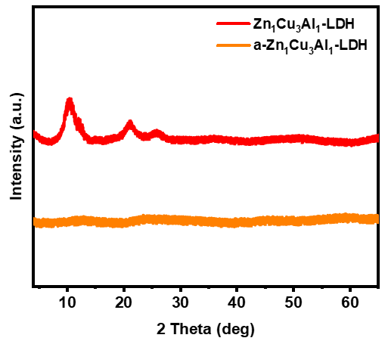
Fig. S1. XRD patterns of LDH and a-LDH nanoparticles.

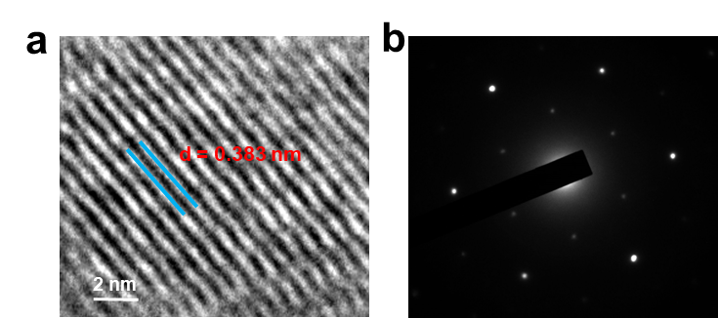
Fig. S2. (a) HRTEM image and (b) SAED pattern of LDH nanoparticles.

Table S1. Elemental content of ZnCuAl-LDH and a-ZnCuAl-LDH detected by ICP-AES.
Samples | Zn/ppm | Cu/ppm | Al/ppm | Molar ratio
ZnCuAl-LDH | 1.15 | 2.26 | 0.27 | 0.018:0.035:0.01
a-ZnCuAl-LDH | 0.59 | 0.96 | 0.11 | 0.009:0.015:0.004

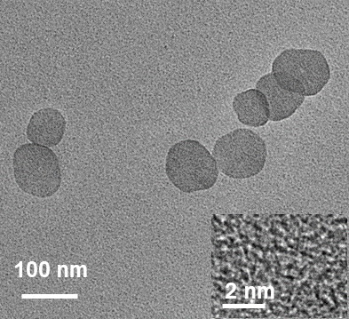
Fig. S3. HRTEM images of a-LDH nanoparticles.

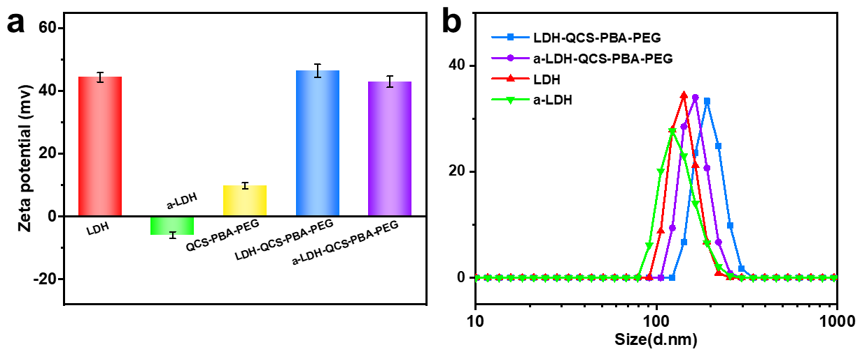
Fig. S4. (a) Zeta potentials of LDH, a-LDH, QCS-PBA-PEG, modified LDH, and modified a-LDH. (b) Size distribution of LDH, a-LDH, modified LDH, and modified a-LDH.

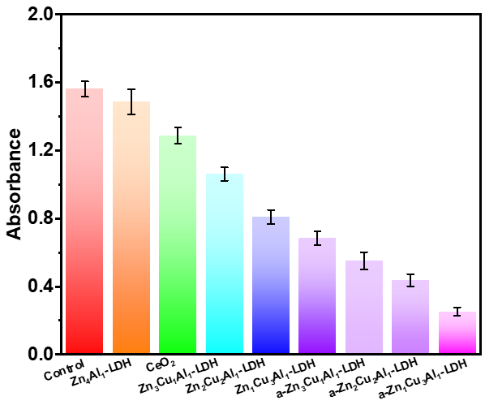
Fig. S5. Absorbance of TMB at 650 nm in the presence of ZnAl-LDH, CeO₂, Zn_{4-x}Cu_{x}Al₁-LDH, and a-Zn_{4-x}Cu_{x}Al₁-LDH.
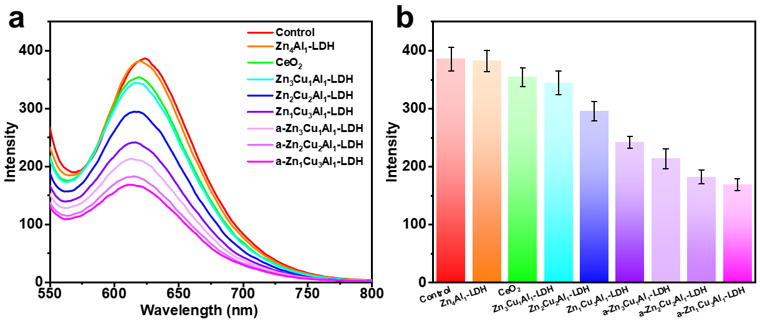
Fig. S6. (a) Fluorescence spectra of DHE for evaluating ·O₂⁻ scavenging in the presence of ZnAl-LDH, CeO₂, Zn_{4-x}Cu_{x}Al₁-LDH, and a-Zn_{4-x}Cu_{x}Al₁-LDH. (b) The corresponding fluorescence intensity at 620 nm.

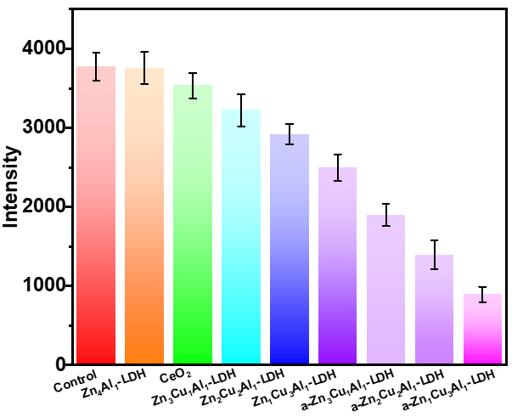
Fig. S7. Fluorescence intensity of DHR123 at 525 nm in the presence of ZnAl-LDH, CeO₂, Zn_{4-x}Cu_{x}Al₁-LDH, and a-Zn_{4-x}Cu_{x}Al₁-LDH.

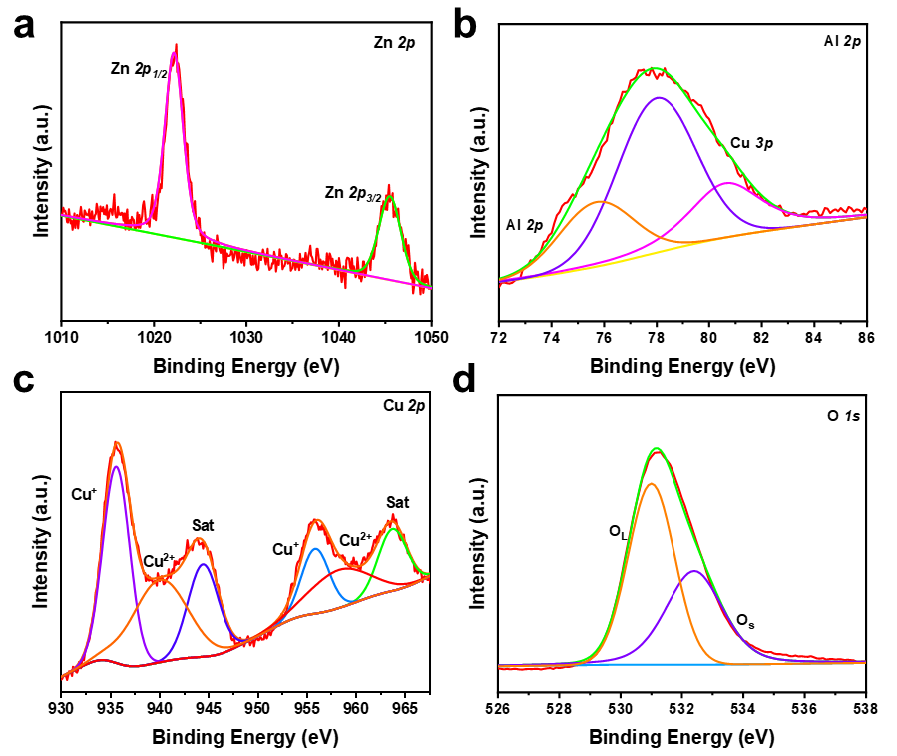
Fig. S8. XPS (a) Zn 2p, (b) Al 2p, (c) Cu 2p, and (d) O 1s spectra of a-LDH nanoparticles after exposing to ROS.

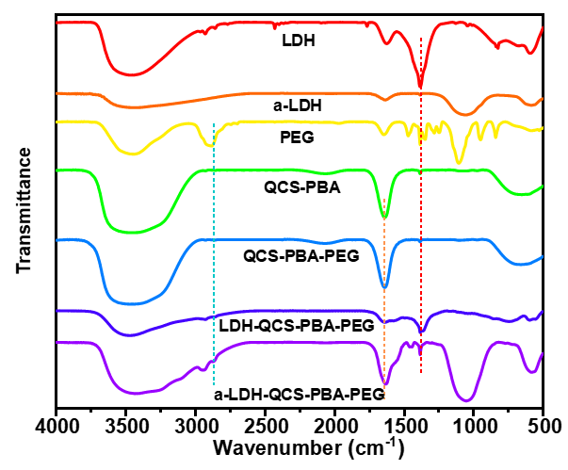
Fig. S9. FT-IR spectra of LDH, a-LDH, PEG, QCS-PBA, QCS-PBA-PEG, modified LDH, and modified a-LDH.

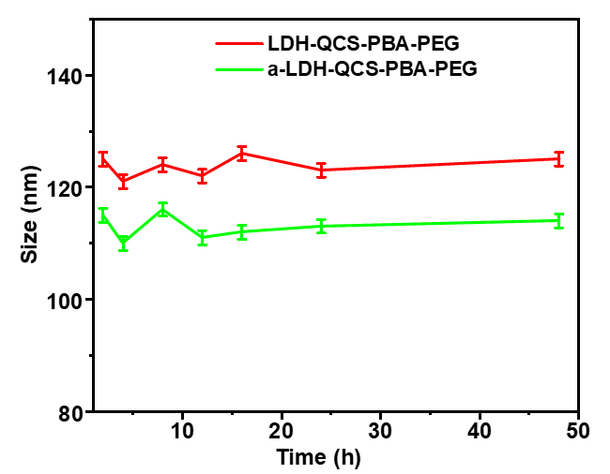
Fig. S10. Stability tests of modified LDH and modified a-LDH.

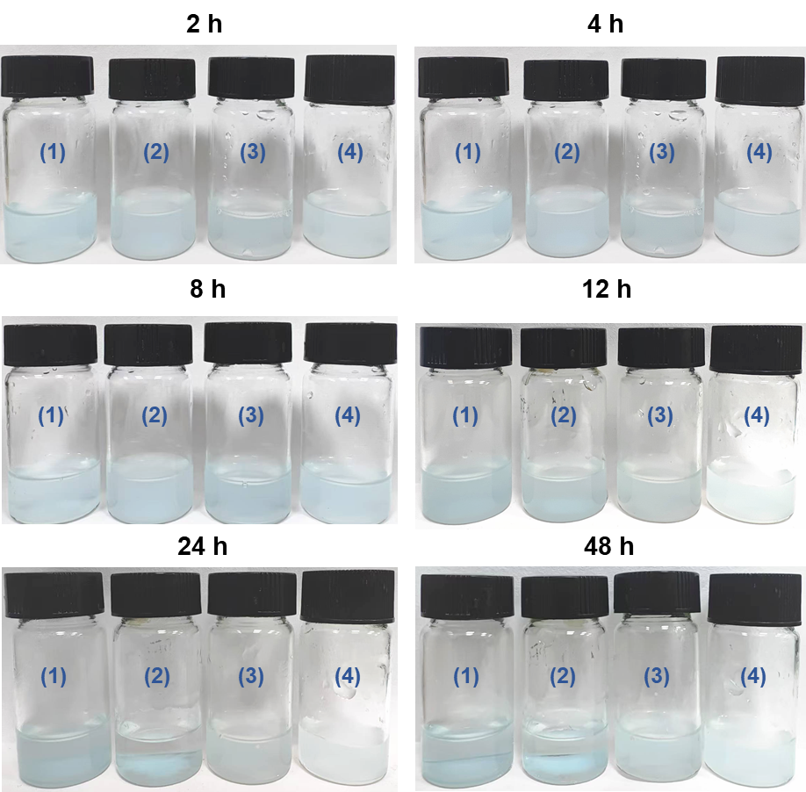
Fig. S11. The photos of the material in aqueous solution at different time points: (1) LDH, (2) a-LDH, (3) modified LDH, and (4) modified a-LDH.

Fig. S12. Assessment of (a) HCE-2 and (b) CCL-20.2 cytocompatibility with various concentrations of LDH and a-LDH.

Fig. S13. Cell viability of HCE-2 cells exposed to the hypertonic model (HOM, 500 mOsM) and pre-treated with various concentrations of LDH and a-LDH. Data are presented as mean values ± SD. (n=3). *p < 0.05, **p < 0.01, and ***p < 0.001.

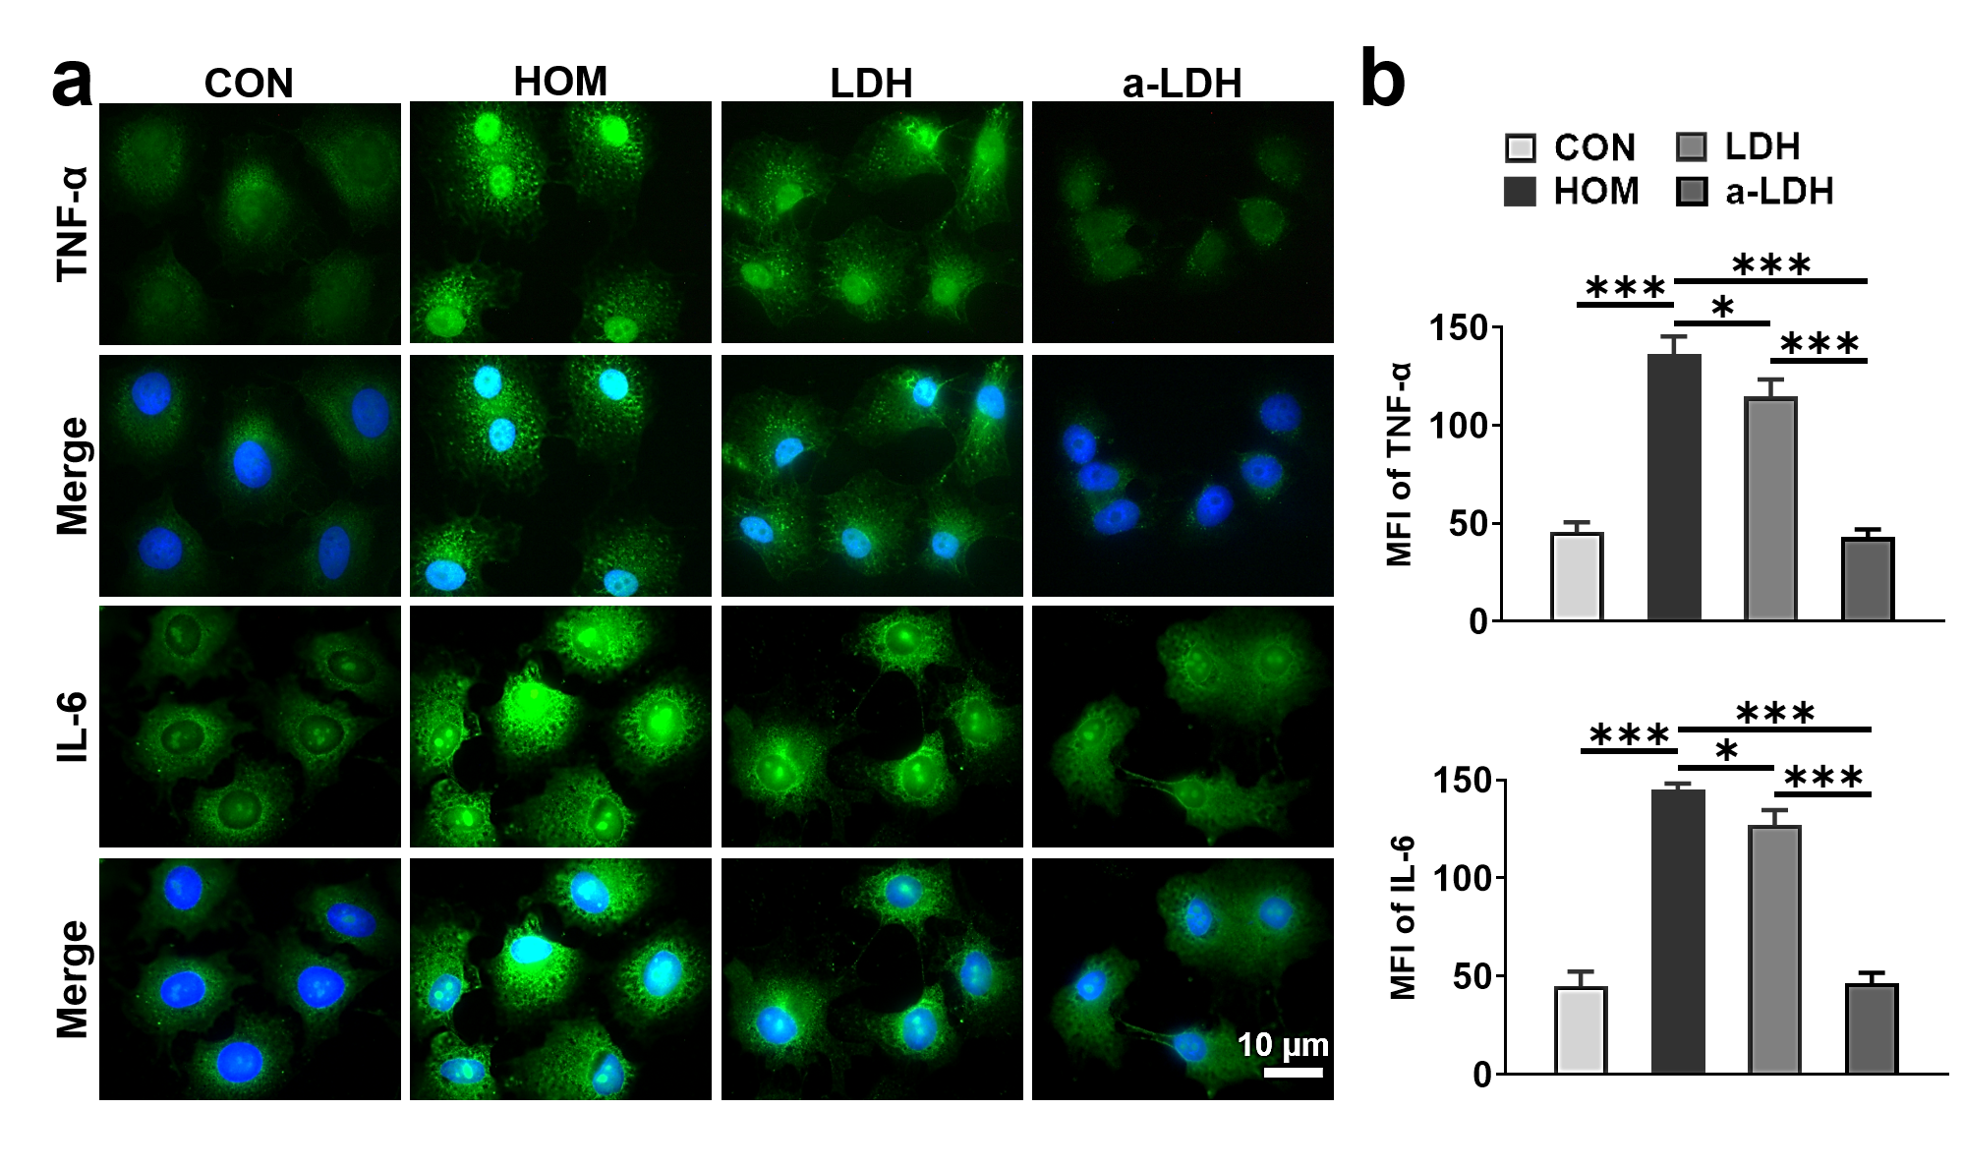
Fig. S14. Immunofluorescence staining of (a) TNF-α and IL-6, and (b) corresponding quantitative analysis of mean fluorescence intensity (MFI). Data are presented as mean values ± SD. (n=3). *p < 0.05, **p < 0.01, and ***p < 0.001.

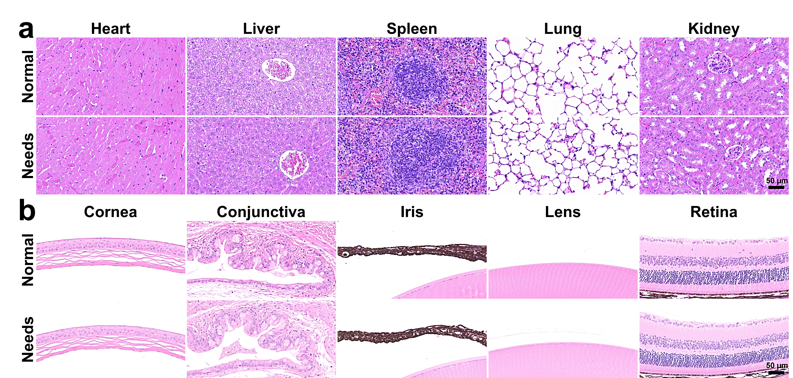
Fig. S15. In vivo biosafety evaluation. H&E staining of histological sections of (a) major organs (heart, liver, spleen, lung, and kidney) and (b) ocular tissues (cornea, conjunctiva, iris, lens, and retina) following twice-daily instillation of Needs for 7 days.

