Supplementary Material for
Itaconate-Functionalized Tetrahedral Framework Nucleic Acids Break the Dry Eye Vicious Cycle Through Dual Antioxidant and Anti-Inflammatory Actions
Kai Jiang¹ †, Zhenyi Lin^{2†}, Mingrui Cheng^{1†}, Yanmin Chen², Yiru Jiang³, Changhua Xu^{2*}, Lijuan Zhu^{4*}, Bo Gong^{5*}, Chuan Zhang^{6*}, Jiaxu Hong^{1,7,8,9*}
- Department of Ophthalmology, Eye & ENT Hospital, State Key Laboratory of Brain Function and Disorders, Fudan University, Shanghai 200031, China
- College of Food Science & Technology, Shanghai Ocean University, Shanghai 201306, China.
- State Key Laboratory of Brain Function and Disorder, Department of Radiology, Huashan Hospital, Fudan University, Shanghai, China
- Institute of Molecular Medicine, Renji Hospital, School of Medicine, Shanghai Jiao Tong University, 160 Pujian Road, Shanghai 200217, China.
- Department of Human Disease Genes Key Laboratory of Sichuan Province, Sichuan Provincial People’s Hospital, University of Electronic Science and Technology of China, 32 The First Ring Road West 2, Chengdu, Sichuan 610072, China.
- School of Chemistry and Chemical Engineering, Frontiers Science Center for Transformative Molecules, Shanghai Key Laboratory for Molecular Engineering of Chiral Drugs, Shanghai Jiao Tong University, 800 Dongchuan Road, Shanghai 200240, China.
- NHC Key laboratory of Myopia and Related Eye Diseases Shanghai, 200031, China
- Shanghai Key Laboratory of Rare Disease Gene Editing and Cell Therapy; Shanghai Engineering Research Center of Synthetic Immunology, Shanghai, 200032, China
- Department of Ophthalmology, Children's Hospital of Fudan University, National Pediatric Medical Center of China, Shanghai, China.
† These authors contributed equally.
*Corresponding authors: Changhua Xu (chxu@shou.edu.cn); Lijuan Zhu (lijuanzhu@sjtu.edu.cn); Bo Gong (gongbo@med.uestc.edu.cn); Chuan Zhang (chuanzhang@sjtu.edu.cn); Jiaxu Hong (jiaxu.hong@fdeent.org)

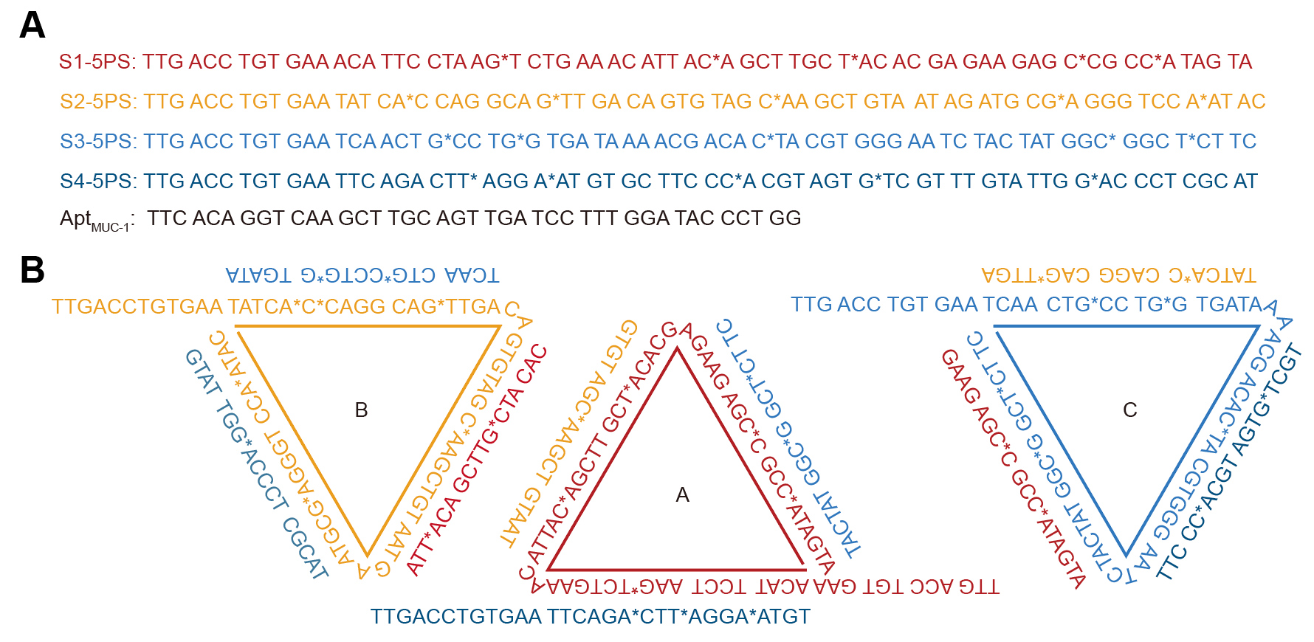
Fig. S1. Pre-designed single strand DNA sequence with PS modifications. A) DNA sequences used in the present study, * represents the site with phosphorothioate modifications. B) Schematic representation of the DNA tetrahedron with complementary double-stranded sequences.

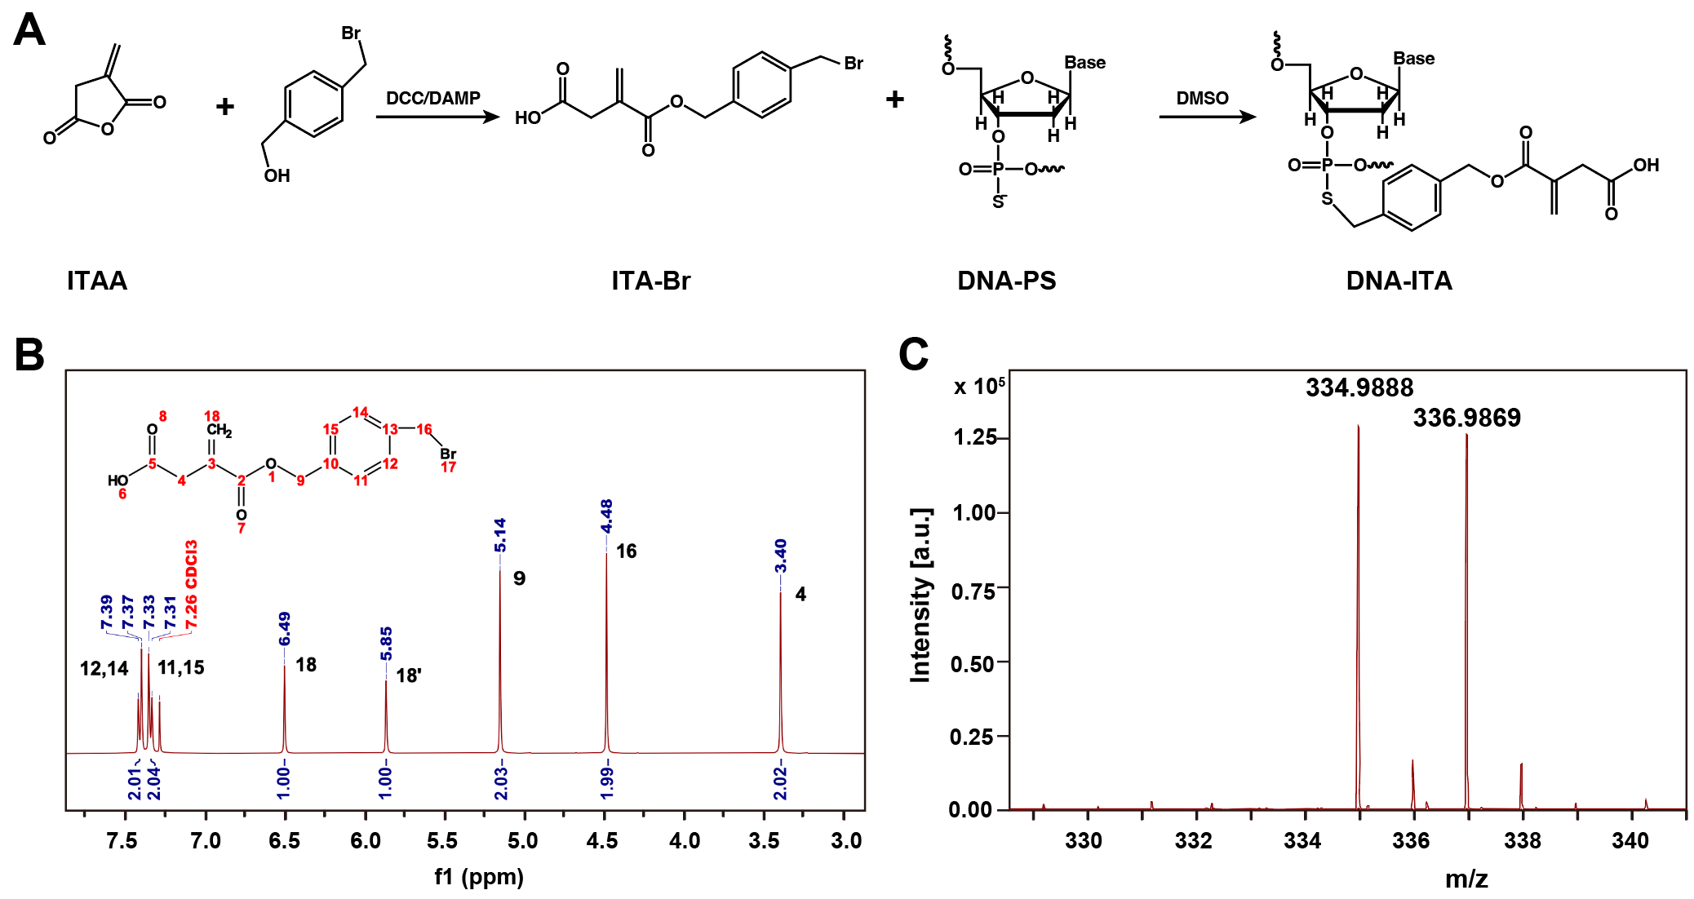
Fig. S2. Characterizations of compound ITA-Br. A) The synthetic route of ITA-DNA conjugates. B) The ¹H-NMR spectra of ITA-Br. C) The MS spectra of ITA-Br.

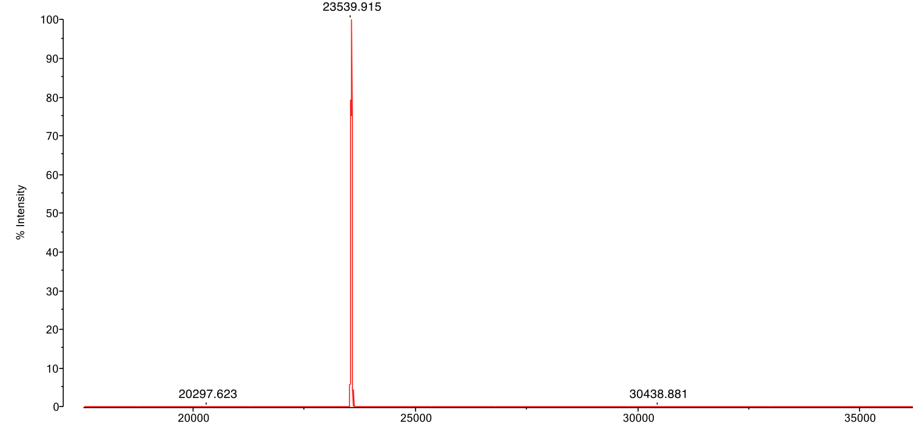
Fig. S3. Representative MALDI-TOF MS spectra of ITA-DNA conjugate.

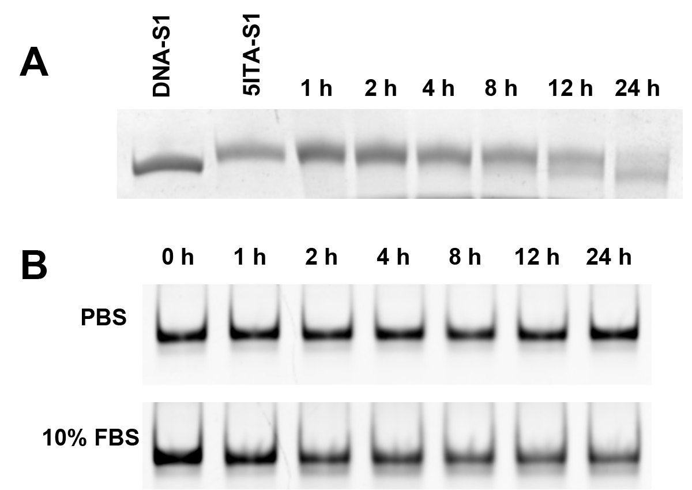
Fig. S4. The ITA release behavior and the stability assay of tFNA-IM. A) The ITA release behavior by analysis of denaturing PAGE. B) The stability of tFNA-IM in PBS and 10% FBS at 37 ℃.
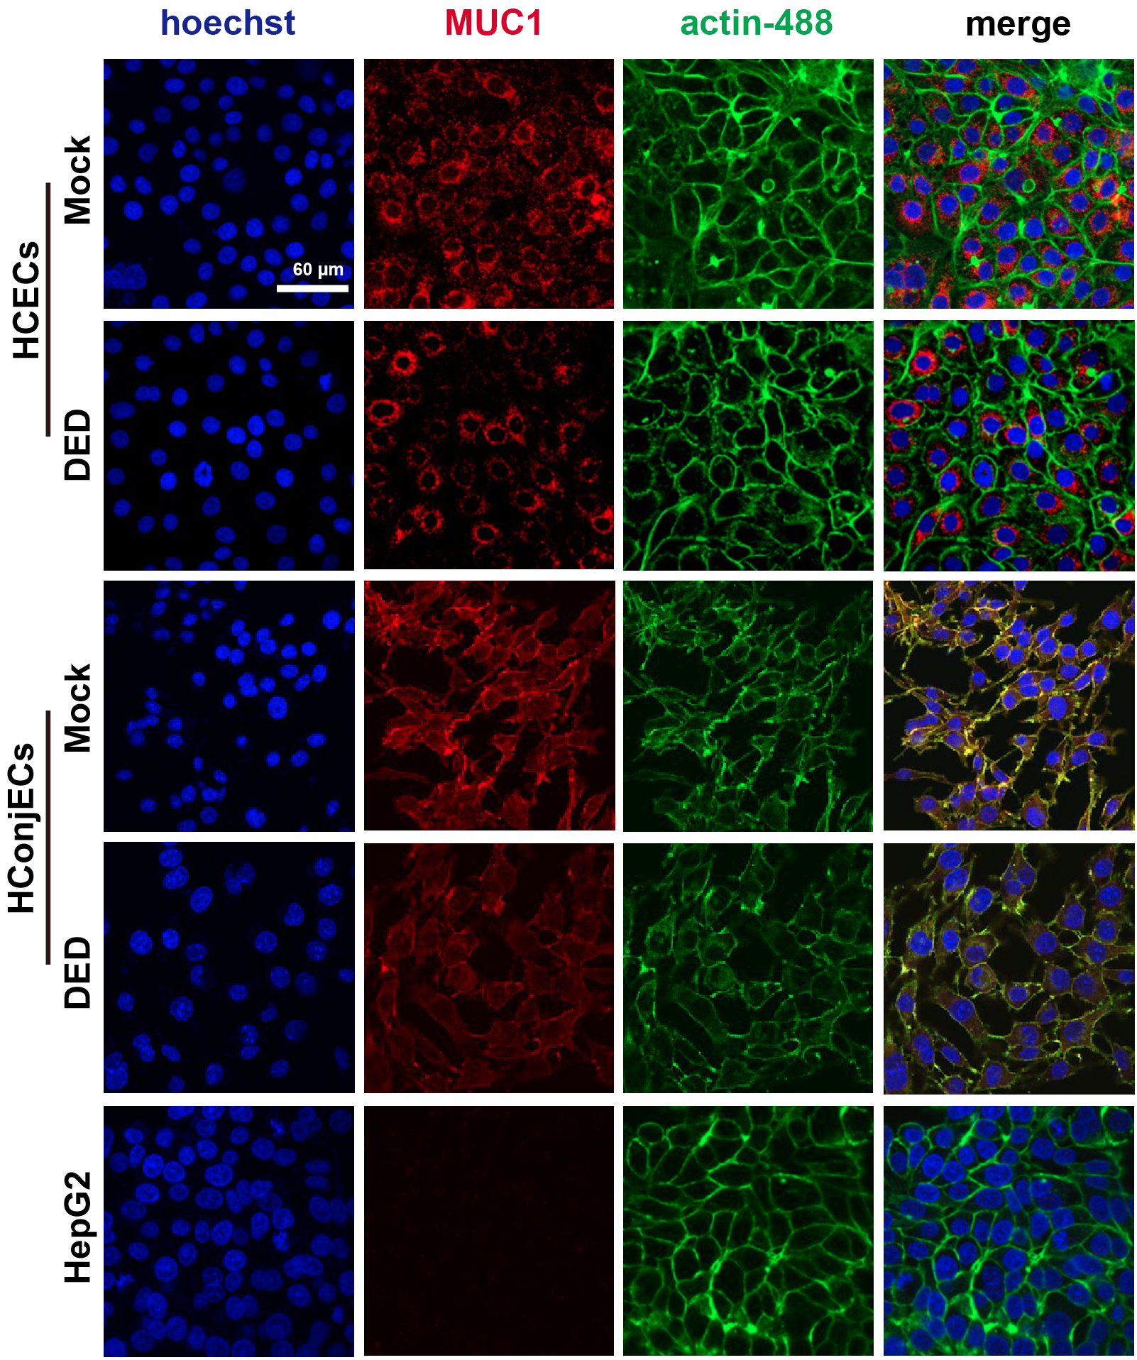
Fig. S5. IF staining of MUC1 protein expression in HCECs and HConjECs under normotonic and hypertonic conditions, with HepG2 cells as a negative control.

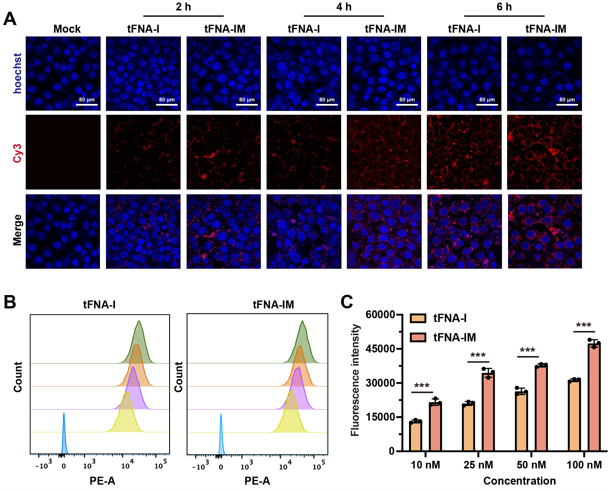
Fig. S6. CLSM and Flow cytometric analysis of cellular uptake of tFNA-I and tFNA-IM. A) CLSM images of time-dependent cellular uptake of HCECs treated with Cy3 labeled tFNA-I and tFNA-IM. B) Representative flow cytometry histograms showing the uptake of Cy3 labeled tFNA-I and tFNA-IM by HCECs at different concentrations. C) Quantitative analysis of fluorescence intensity, indicating the degree of cellular uptake. Data are presented as mean ± SD (n = 3 biological replicates).

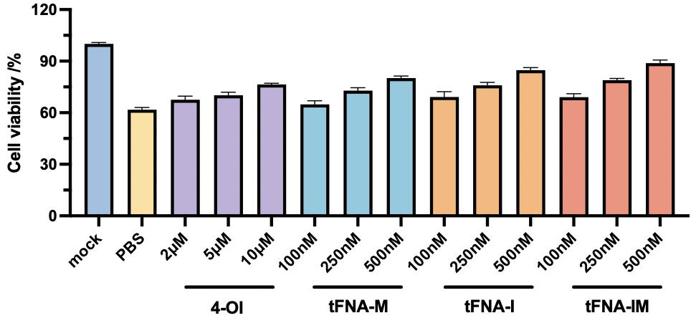
Fig. S7. Cell viablity valuation of tFNA-IM in dose-dependent manner.

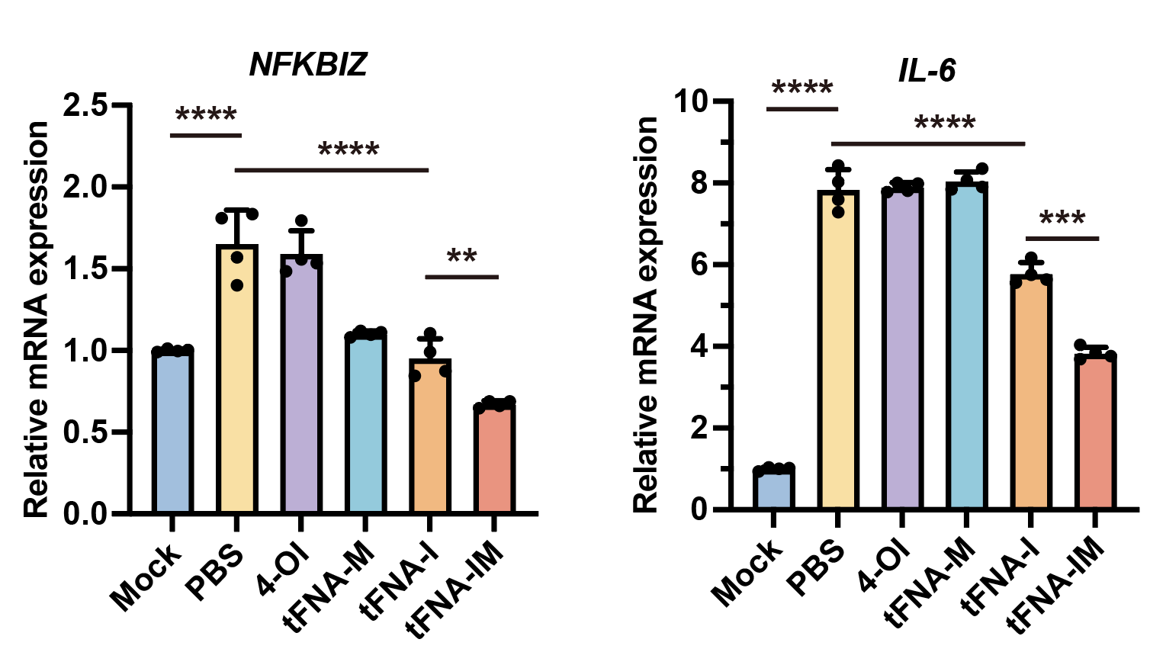
Fig. S8. The gene expression of NFKBIZ, IL-6 in THP-1 using RT-qPCR.

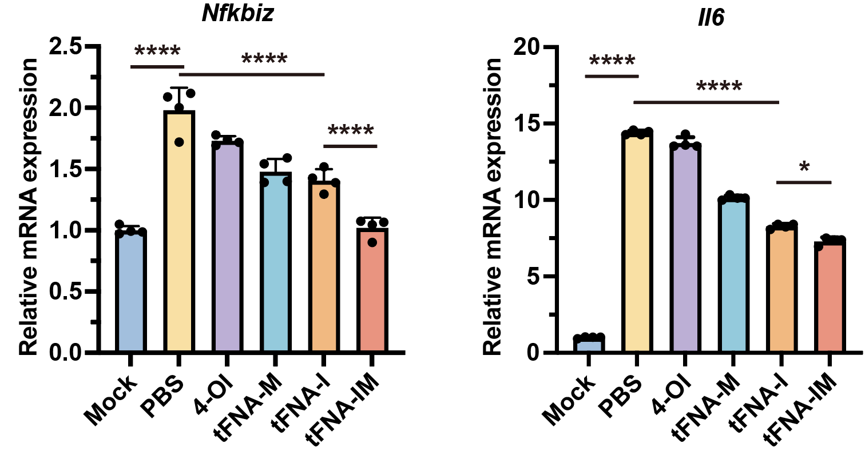
Fig. S9. The gene expression of Nfkibz, Il6 in MCECs using RT-qPCR.

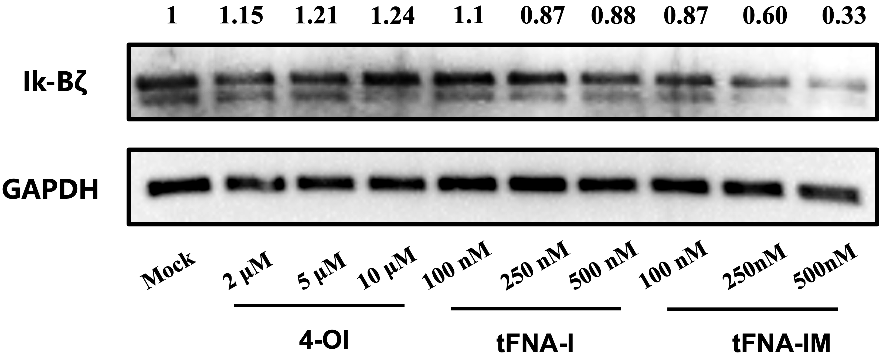
Fig. S10. Western-blot analysis of Iκ-Bζ expression at differnernt concentration of tFNA-IM.

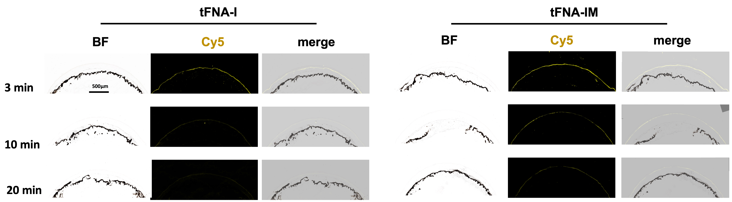
Fig. S11. Fluorescence images of frozen eye sections after topical administration of Cy5-labeled tFNA-I and tFNA-IM.

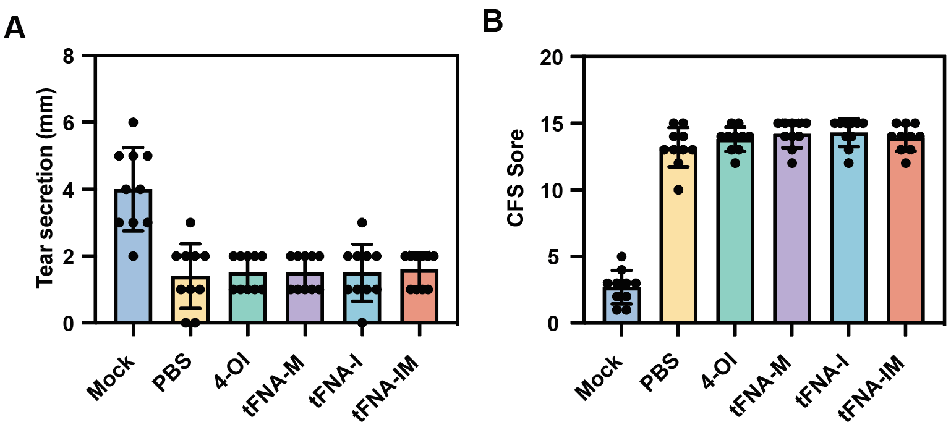
Fig. S12. Quantitative analysis of Tear secretion (A) and corneal fluorescein staining scores (B) after the DED model establishment.
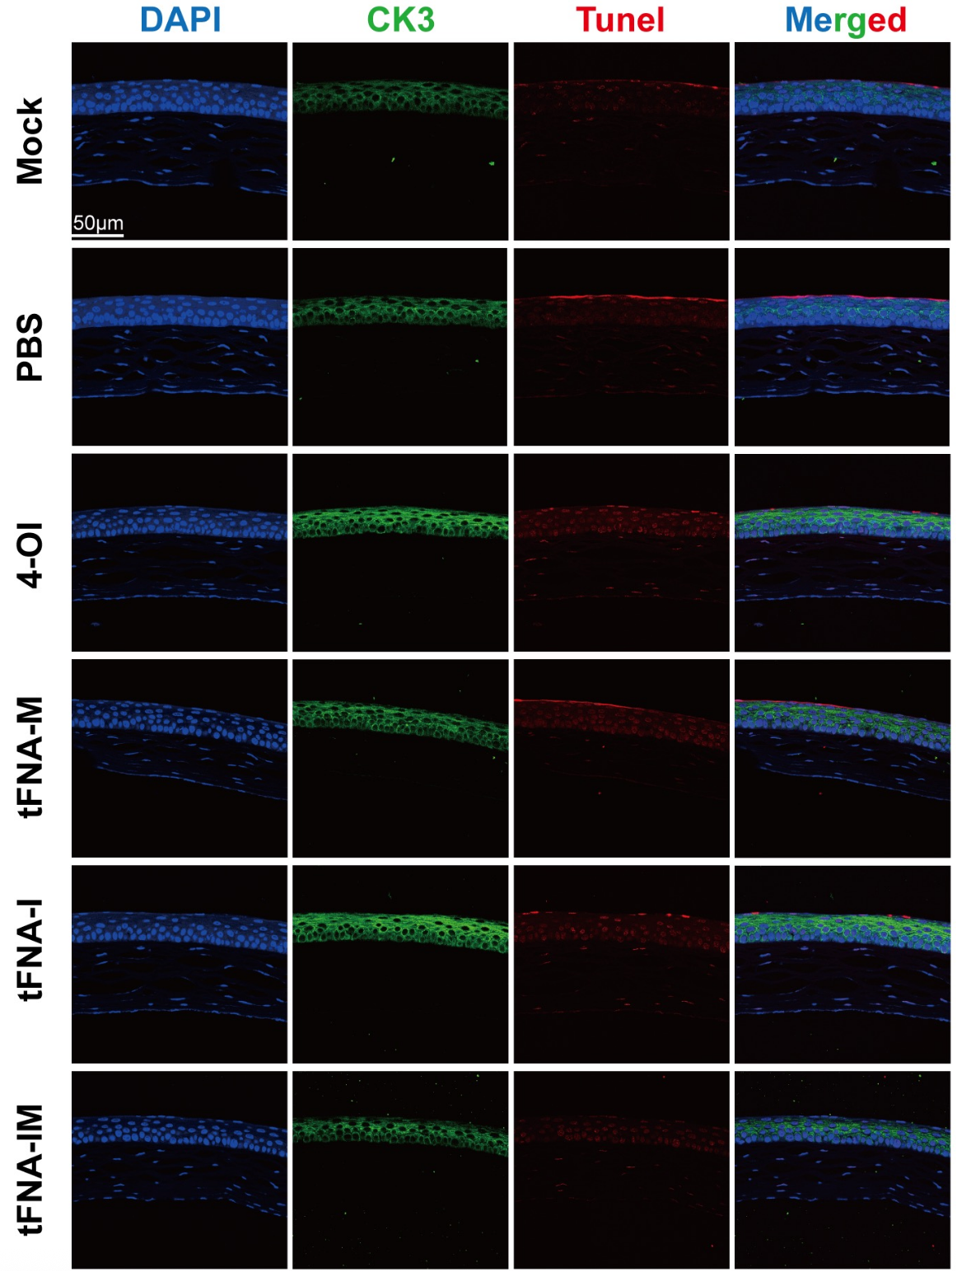
Fig. S13. TUNEL and CK3 staining of corneal cross‐sections of Mock and all treated groups. Nucleus (blue), TUNEL (red), and CK3 (green) in CLSM images, scale bar: 50 µm.

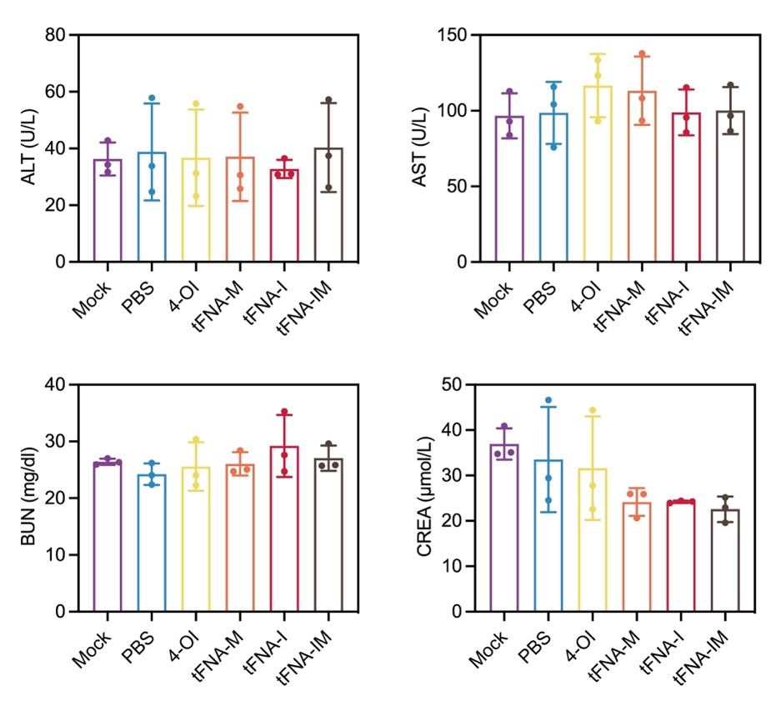
Fig. S14. Biochemical analysis of liver and kidney functions in DED mice after the treatment

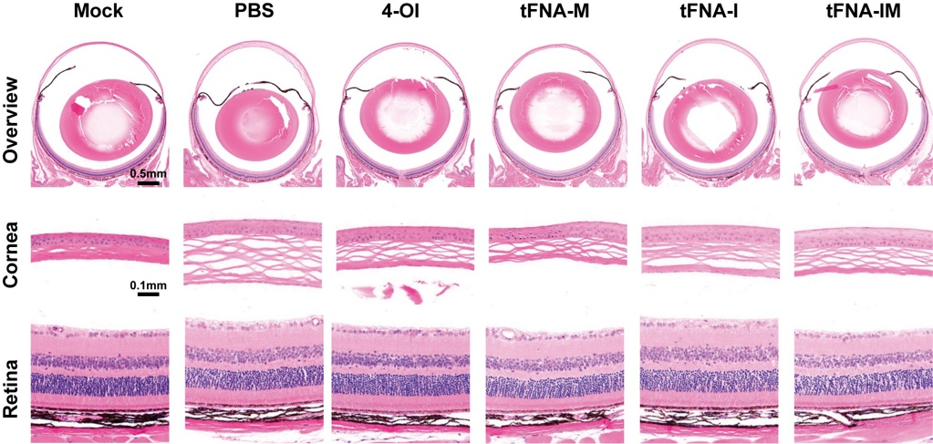
Fig. S15. In vivo biosafety of DED mice treated with different formulations (PBS, 4-OI, tFNA-M, tFNA-I, tFNA-IM). Histopathological analysis of corneal and retina using H&E staining after 14 days’ treatment.

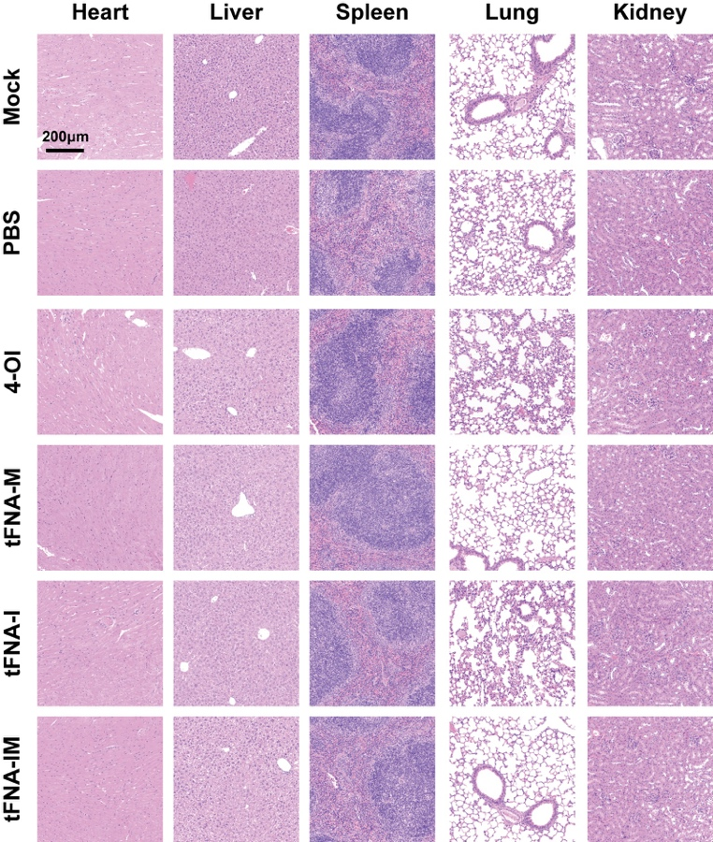
Fig. S16. Histopathological analysis of major organs by hematoxylin and eosin (H&E) staining. Tissue sections of the heart, liver, spleen, lung, and kidney were stained with H&E to evaluate histological changes. Scale bar: 200 µm.

Table S1. The primers used in the present study.
Target | Sequence
Actin (human) | Forward | GTGGCCGAGGACTTTGATTG
Actin (human) | Reverse | CCTGTAACAACGCATCTCATATT
NFKBIZ (human) | Forward | ACACCCACAAACCAACTCTGG
NFKBIZ (human) | Reverse | GGCAAAACTGTGATTCTGGACC
IL-6 (human) | Forward | CCTGAACCTTCCAAAGATGGC
IL-6 (human) | Reverse | TTCACCAGGCAAGTCTCCTCA
TNF-α (human) | Forward | GGACACCATGAGCACTGAAAGC
TNF-α (human) | Reverse | TGCCACGA TCAGGAAGGAGAAG
IL-1β (human) | Forward | ATGATGGCTTATTACAGTGGCAA
IL-1β (human) | Reverse | GTCGGAGATTCGTAGCTGGA
Nrf-2 (human) | Forward | CAGCGACGGAAAGAGTATGA
Nrf-2 (human) | Reverse | TGGGCAACCTGGGAGTAG
HO-1 (human) | Forward | CCAGGCAGAGAATGCTGAGTTC
HO-1 (human) | Reverse | AAGACTGGGCTCTCCTTGTTGC
Actin (mouse) | Forward | CATCCGTAAAGACCTCTATGCCAAC
Actin (mouse) | Reverse | ATGGAGCCACCGATCCACA
Nfkbiz (mouse) | Forward | TGCTACACATCCGAAGCAACA
Nfkbiz (mouse) | Reverse | CACTGCACTCTTCAGGTCTGT
Il-6 (mouse) | Forward | TCTATACCACTTCACAAGTCGGA
Il-6 (mouse) | Reverse | GAATTGCCATTGCACAACTCTTT
TNF-α (mouse) | Forward | CAGGCGGTGCCTATGTCTC
TNF-α (mouse) | Reverse | CGATCACCCCGAAGTTCAGTAG
Nrf2 (mouse) | Forward | TCTTGGAGTAAGTCGAGAAGTGT
Nrf2 (mouse) | Reverse | GTTGAAACTGAGCGAAAAAGGC

