Supporting Information for:

Image-Guided Therapy of Colorectal Cancer Using a Zirconium Coordinated Nanosensitizer
Shuyang Yang ^{1,1}, Xiaodan Jiao ^{2,1}, Xuan Lou ¹, Yan Du ², Kangkang Zhao ³, Lili Shan ², Hao Hong ^{2,4*}, Min Feng ^{1*}
¹ Department of General Surgery, Nanjing Drum Tower Hospital, Affiliated Hospital of Medical School, Nanjing University, Nanjing, 210008, Jiangsu, China.
² State Key Laboratory of Pharmaceutical Biotechnology Chemistry and Biomedicine Innovation Center (ChemBIC) Medical School of Nanjing University Nanjing 210093, China.
³ Department of Urology, Nanjing Drum Tower Hospital, Affiliated Hospital of Medical School, Nanjing University, Nanjing, 210008, Jiangsu, China.
⁴ Wuxi Xishan NJU Institute of Applied Biotechnology, Wuxi, 214000, Jiangsu, China.

* Corresponding Authors at: Department of General Surgery, Nanjing Drum Tower Hospital, Affiliated Hospital of Medical School, Nanjing University, Nanjing, 210008, Jiangsu, People’s Republic of China.
State Key Laboratory of Pharmaceutical Biotechnology Chemistry and Biomedicine Innovation Center (ChemBIC) Medical School of Nanjing University Nanjing 210093, China.7
E-mail addresses: haohong@nju.edu.cn (H. Hong), fengmindoctor@163.com (M. Feng)

¹ These authors contributed equally to this work.

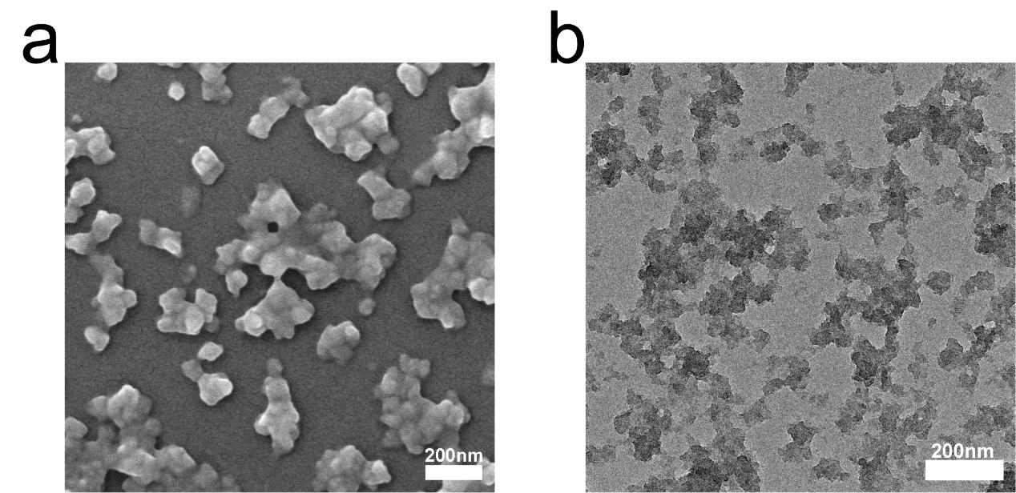
Fig. S1 a) Scanning electron microscopy (SEM) image of HP and b) Transmission electron microscopy (TEM) image of HP (scale bar: 200 nm).

Fig. S2 The hydrodynamic size distribution of HZ and HP was determined by DLS.

Fig. S3 Zeta potential measurements of the three nanosensitizers.

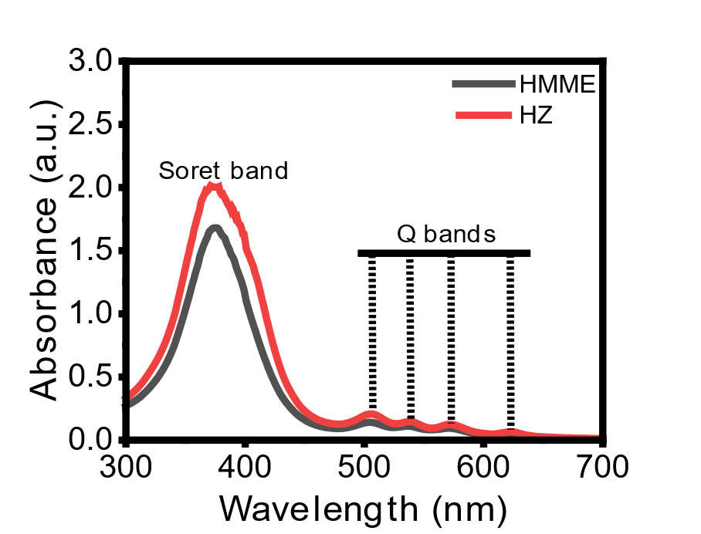
Fig. S4 The UV–vis absorption spectra of HMME and HZ.
Fig. S5 FT-IR spectra of HP-LNC.

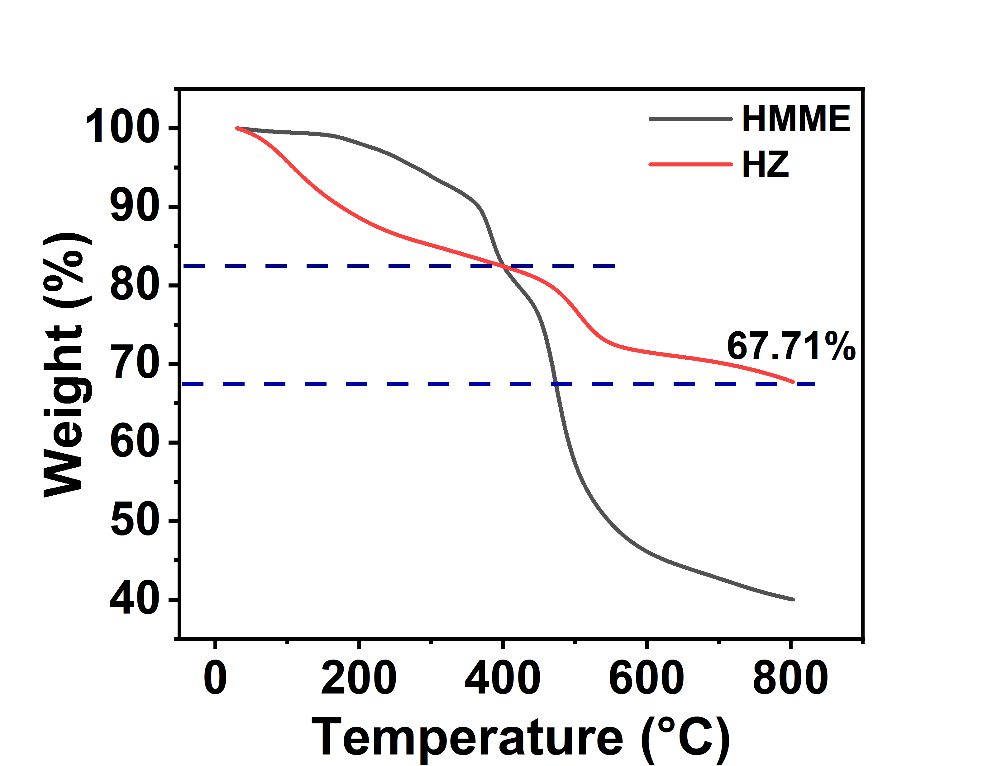
Fig. S6 Thermogravimetric analysis (TGA) of HMME and HZ.
Fig. S7 The XPS spectrum exhibits characteristic peaks of the Zr element in HZ.

Fig. S8 a) DPBF detection under ultrasound (US) exposure for different treatment durations (HP: 20 μg/mL). b) UV-Vis spectra of HP, DPBF, and their mixture (HP+DPBF). c) UV-Vis spectra of DPBF at different time points without ultrasound treatment. d) UV-Vis spectra of DPBF at different time points after ultrasound treatment. (US: 1 MHz, 50% duty cycle, 1 W/cm²)

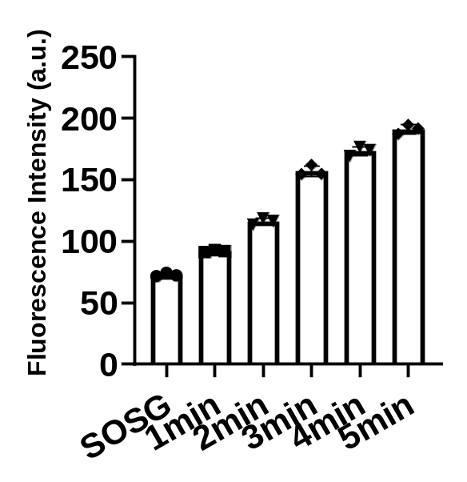
Fig. S9 Measurement of SOSG fluorescence intensity at different ultrasound treatment durations to assess singlet oxygen (¹O₂) generation by HP-LNC (Ex: 504 nm, Em: 525 nm). (US: 1 MHz, 50% duty cycle, 1 W/cm²)

Fig. S10 Quantitative analysis of HMME fluorescence in the materials was performed using flow cytometry to evaluate the intracellular levels of HP and HP-LNC at different time points.
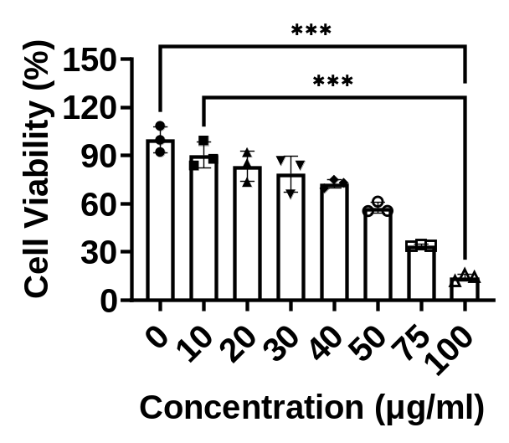
Fig. S11 Cell viability of T84 cells after 24-hour treatment with different concentrations of HMME without ultrasound exposure, assessed by the CCK-8 assay.

Fig. S12 a) SDS-PAGE analysis of GCC (123 kDa) protein levels in different treatment groups, with β-tubulin (55 kDa) used as a loading control. b) Quantification of GCC protein expression in various treatment groups.

Fig. S13 Quantification of a) pro-caspase3 and b) HMGB1 protein expression in various treatment groups.

Fig. S14 Measurement of intracellular ATP levels after different treatments (US: 1 MHz, 1 W/cm², 50% duty cycle, 2 min).

Fig. S15 a) SDS-PAGE analysis of CRT (47 kDa) protein levels in different treatment groups, with GAPDH (36 kDa) used as a loading control. b) Quantification of CRT protein expression in various treatment groups.

Fig. S16 a) Confocal fluorescence images showing the release of HMGB1 from the nucleus following different treatments. b) Translocation of CRT protein from the cytoplasm to the cell membrane after various treatments. (US: 1 MHz, 1 W/cm², 50% duty cycle, 2 min). Scale bar: 20 μm.

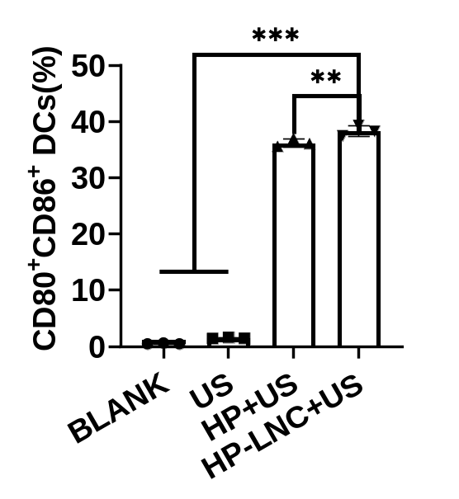
Fig. S17 Quantitative analysis of the proportions of CD80 and CD86 positive cells in different treatment groups.

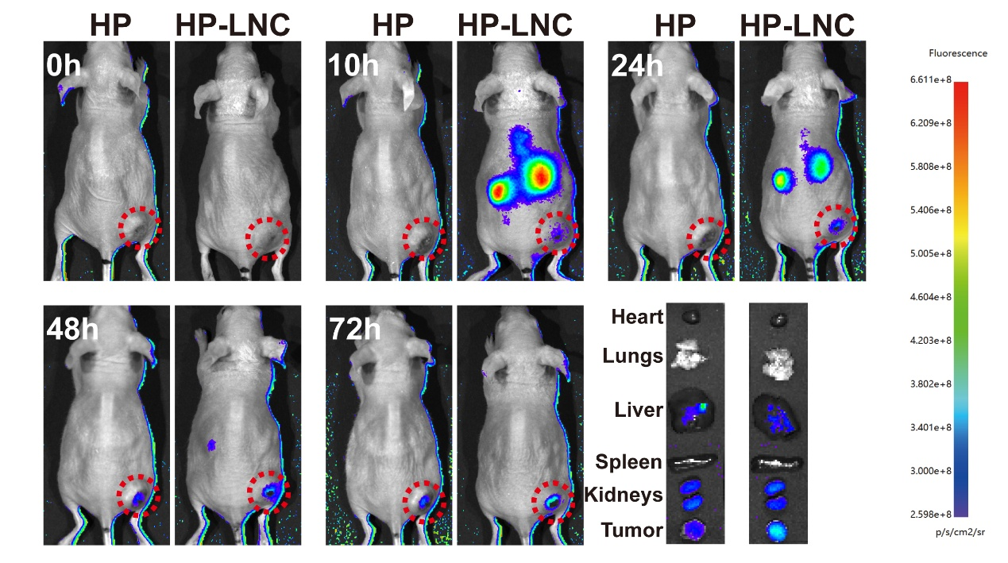
Fig. S18 Fluorescence signal changes in the tumor and major organs of nude mice were observed at different time points and after dissection at 72 h following intravenous injection of two different sonosensitizers. The tumor site is marked with a red circle. Excitation and emission wavelengths were 745 nm and 820 nm, respectively.
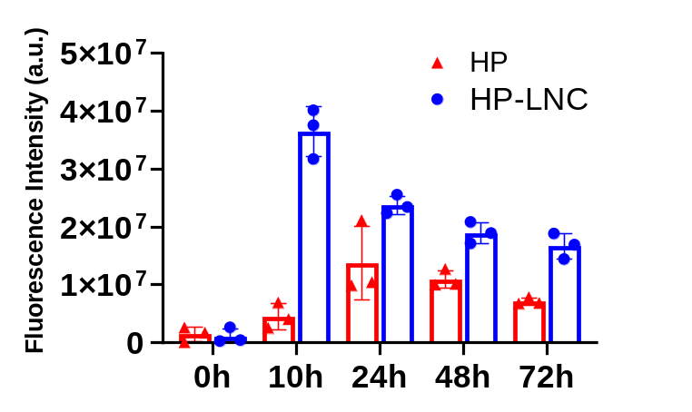
Fig. S19 Quantitative analysis of fluorescence intensity in subcutaneous tumors at different time points after intravenous injection of HP or HP-LNC (n = 3). Excitation and emission wavelengths were 745 nm and 820 nm, respectively.

Fig. S20 a) Ex vivo fluorescence images of major organs (heart, liver, spleen, lungs, and kidneys) collected at 5, 7, and 13 days post-injection. b) Quantitative analysis of fluorescence intensities in these organs corresponding to panel a. Excitation and emission wavelengths were 745 nm and 820 nm, respectively.

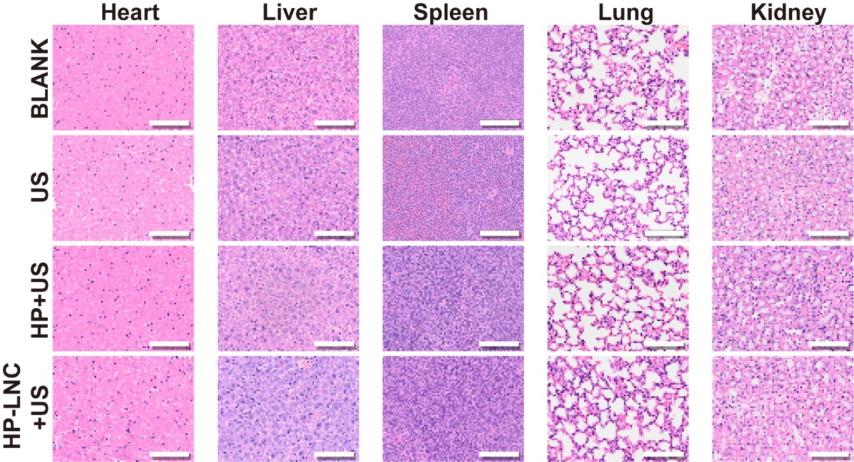
Fig. S21 After treatment, the mice were euthanized, and their five organs (heart, liver, spleen, lungs, and kidneys) were stained with hematoxylin and eosin (HE) for safety evaluation (scale bar = 100
μm).

Fig. S22 Expression levels of key immune-stimulatory cytokines in tumor-bearing mice following different treatments. (a, b) ELISA analysis of IL-12P70 (a) and GM-CSF (b) in serum samples from the Blank, US, HP + US, and HP-LNC + US groups. Data are presented as mean ± SD (n = 3 per group).

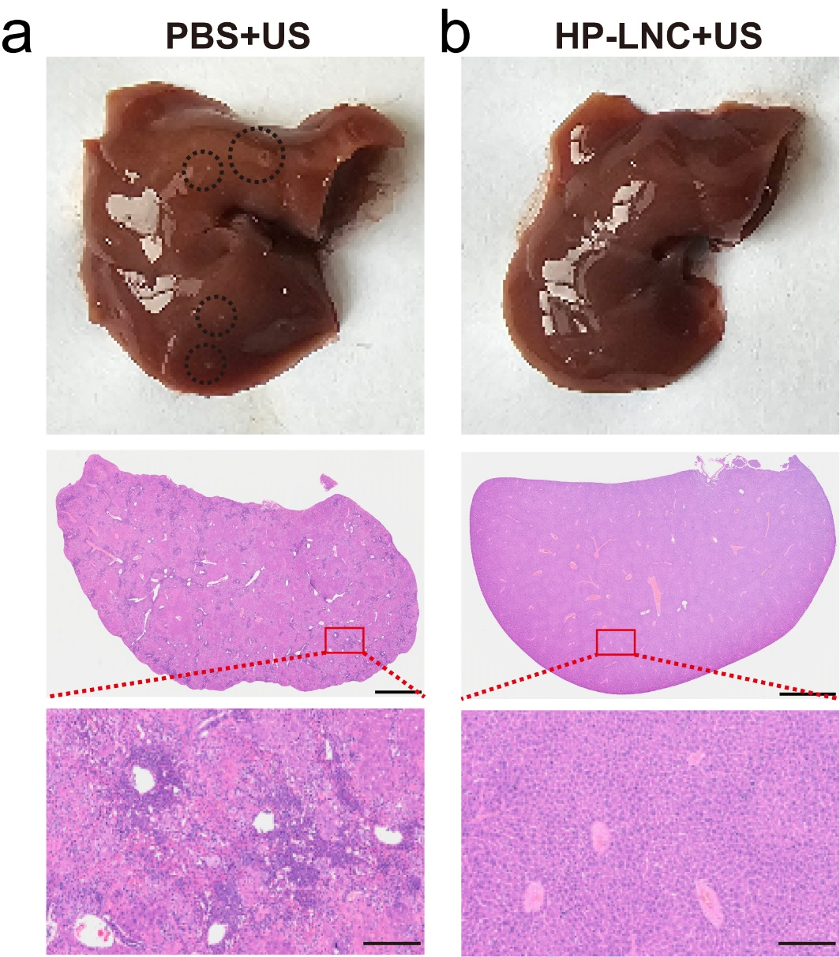
Fig. S23 Representative images of liver metastases in a colorectal cancer liver metastasis model after different treatments. (a, b) Gross liver morphology, HE-stained sections, and magnified views of metastatic nodules from the PBS + US group (a) and the HP-LNC + US group (b). (scale bar from top to bottom: 2 mm, 200 μm)

