Supporting Information
Tungsten disulfide atomic crystals with RONS scavenging and liver targeting capabilities for acetaminophen-induced acute liver injury therapy
Ziwen Xiao ^{a,#}, Yu Liu ^{a,#}, Zhenchao Tao ^{b,#}, Yu Zhang ª, Qian Chen ª, Zhaohua Miao ª, Zhengbao Zha ª, Yan Ma ^{c*}, Hua Wang ^{d*}, Deyan Gong ^{a*}
ª School of Food and Biological Engineering, Hefei University of Technology, Hefei 230009, China
^{b} Department of Radiation Oncology, Anhui Provincial Cancer Hospital, Hefei 230031, China
^{c} School of Biomedical Engineering, Anhui Medical University, Hefei, 230022 China
^{d} Department of Oncology, The First Affiliated Hospital of Anhui Medical University, Hefei 230032, China
#These authors contributed equally
*Corresponding authors: may@ahmu.edu.cn (Yan Ma); wanghua@ahmu.edu.cn (Hua Wang); gongdy@hfut.edu.cn (Deyan Gong)

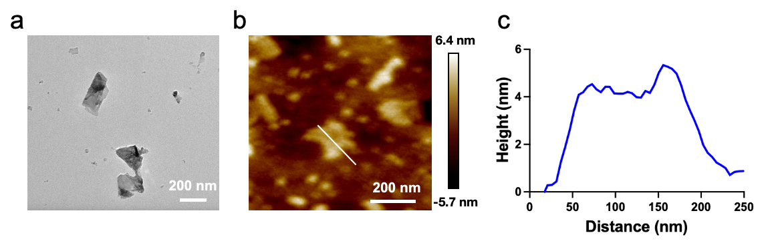
Figure S1. (a) TEM image of WS₂ NSs. (b) AFM image and (c) the corresponding thickness profiles of WS₂ NSs.
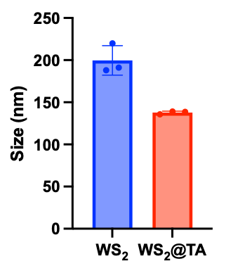
Figure S2. Hydrated particle size of WS₂ NSs and WS₂@TA NSs.
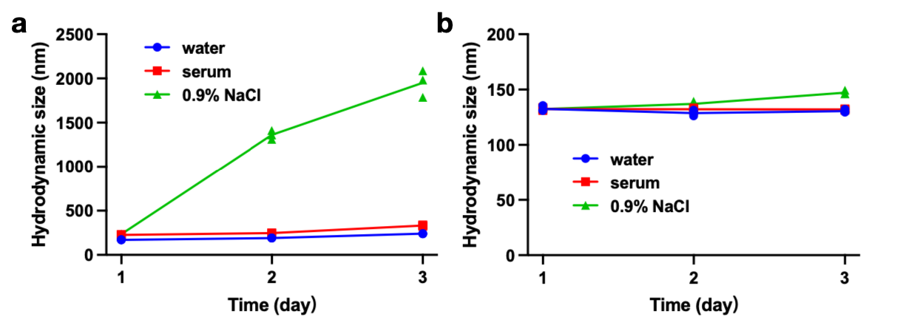
Figure S3. (a) The variation of hydration particle size of WS₂ NSs in different media. (b)The variation of hydration particle size of WS₂@TA NSs in different media.
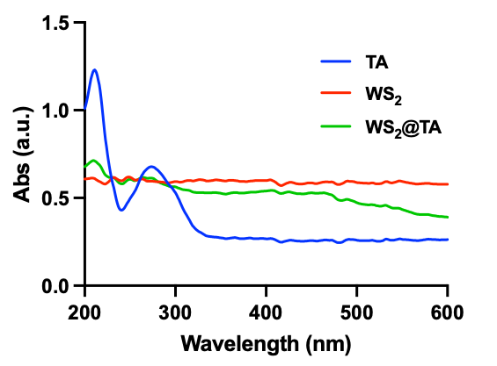
Figure S4. UV−vis spectra of WS₂@TA NSs, WS₂ NSs, and TA.
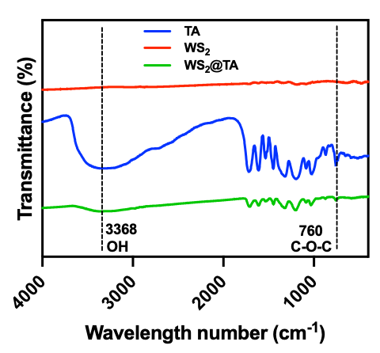
Figure S5. Fourier transform infrared (FTIR) spectra of WS₂@TA NSs, WS₂ NSs, and TA.
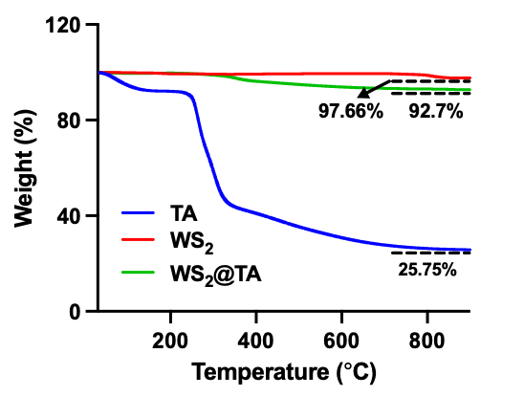
Figure S6. Thermogravimetric (TG) analysis of WS₂@TA NSs, WS₂ NSs, and TA.
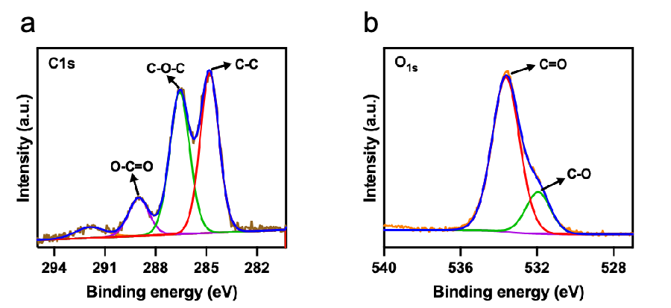
Figure S7. (a) Core XPS spectra of C element. (b) Core XPS spectra of O element.
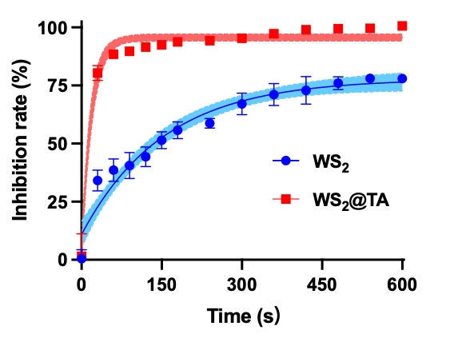
Figure S8. The clearance kinetics curve of DPPH.
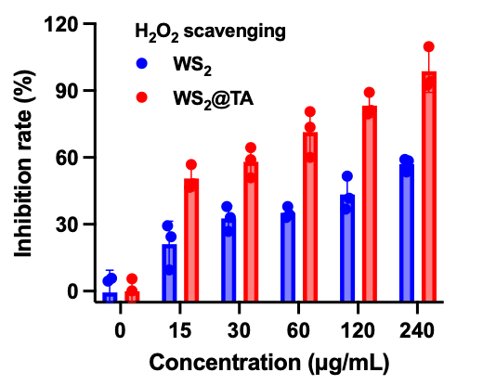
Figure S9. H₂O₂ scavenging efficiencies.

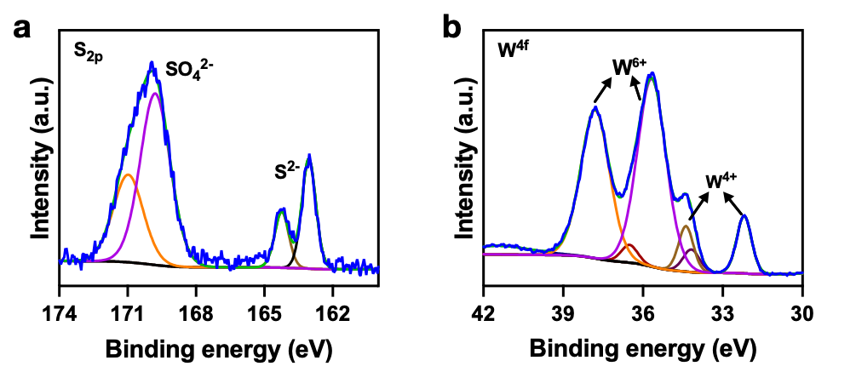
Figure S10. (a) Core XPS spectra of S element and (b) W element in WS₂@TA after H₂O₂ treatment.
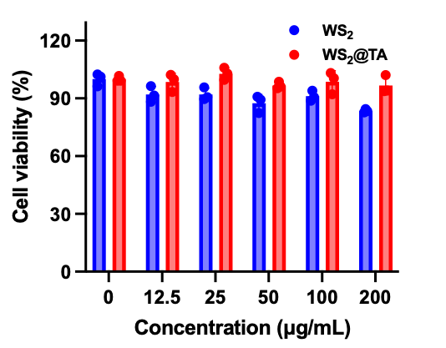
Figure S11. Cell viability of Raw 264.7 cells treated with WS₂ NSs or WS₂@TA NSs of different concentrations (n = 3).
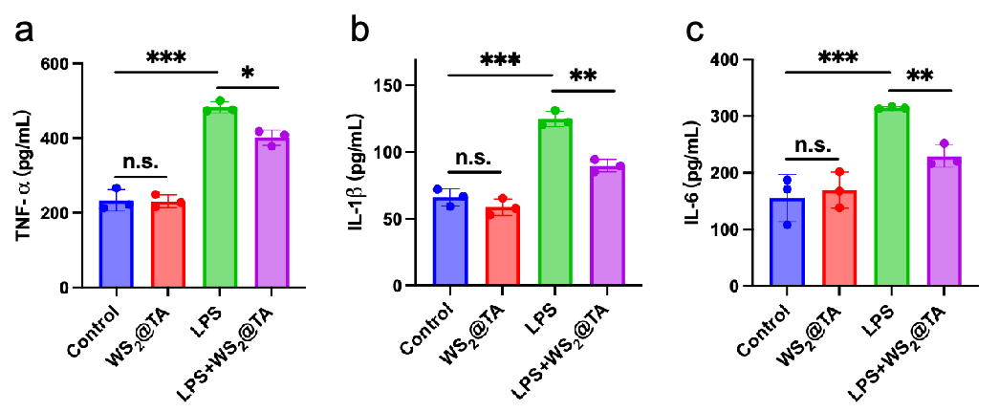

Figure S12. (a-c) Downregulation of LPS-induced proinflammatory cytokine (TNF-α, IL-1β, and IL-6) levels.
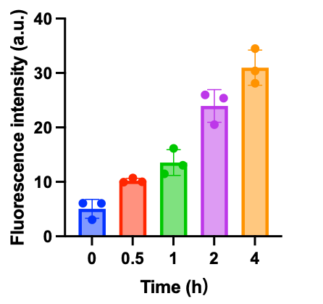
Figure S13. Quantitative analysis of the fluorescence intensity of intracellular Cy5.5-labeled WS₂@TA NSs (n = 3).
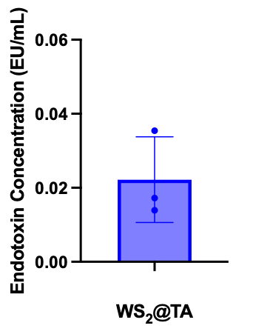
Figure S14. Endotoxin activity in 0.5mg/mL WS₂@TA solution.
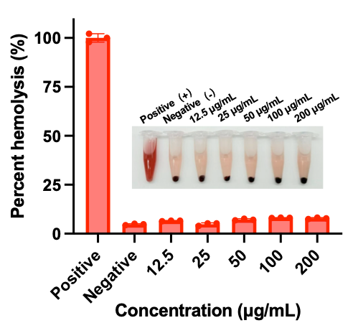
Figure S15. Hemolysis test of WS₂@TA NSs.
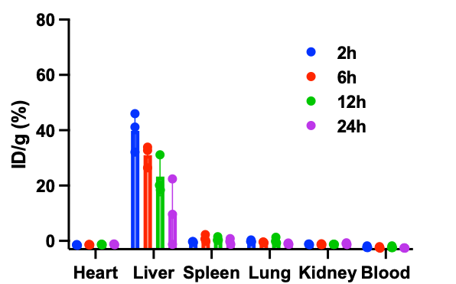
Figure S16. Distribution of W element in organs of AILI mice after intravenous injection of WS₂ NSs (n=3).

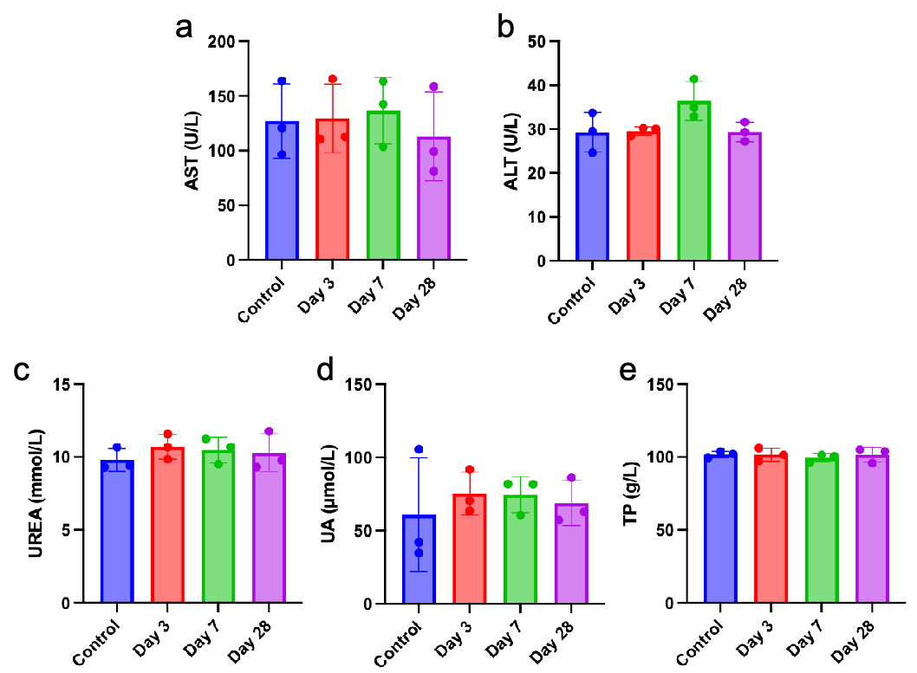
Figure S17. Blood biochemistry index tests. (a) Serum levels of ALT, (b) AST, (c) UREA, (d) UA and (e) TP.

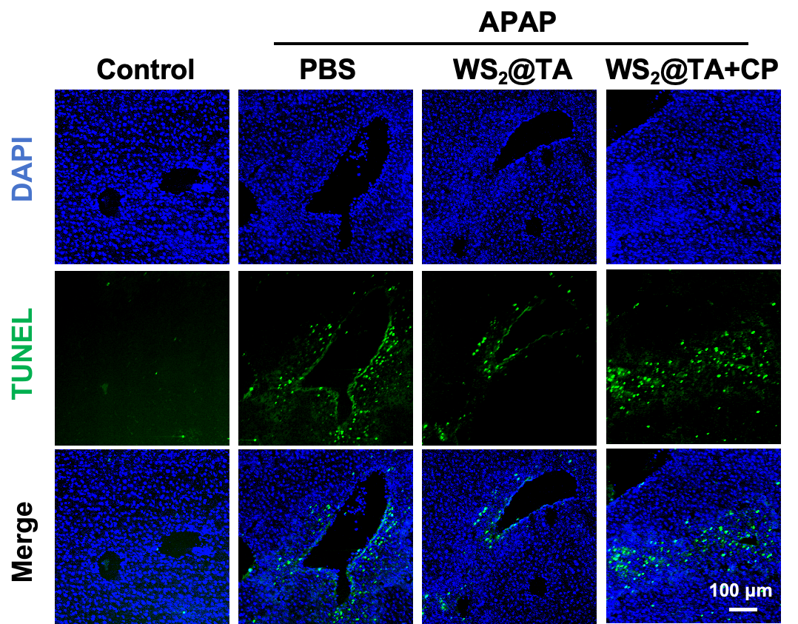
Figure S18. Representative images of TUNEL fluorescence imaging of liver tissue sections.

