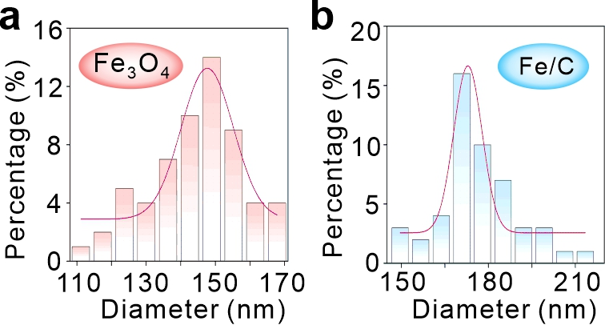
Figure S1. Hydrodynamic size distribution profiles of Fe₃O₄ and Fe/C.

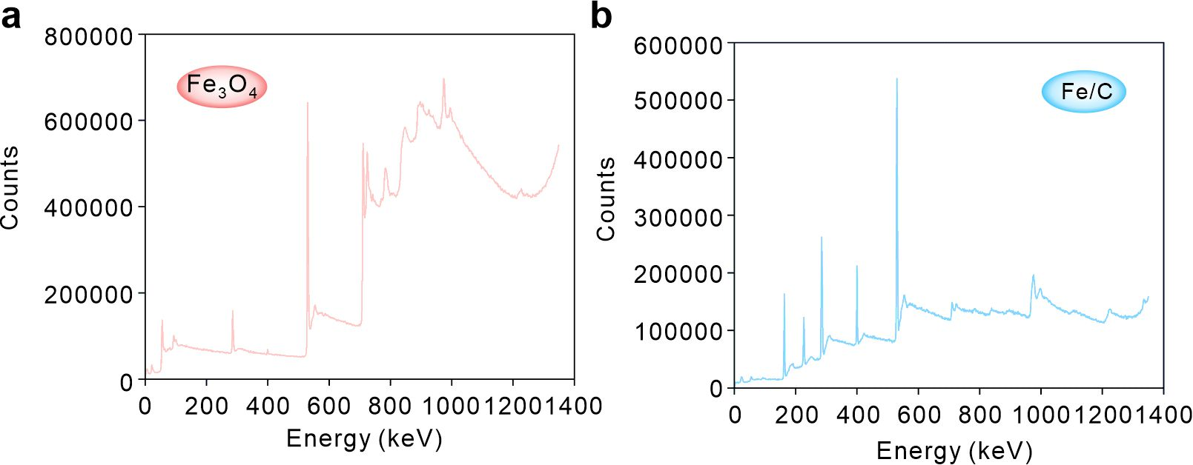
Figure S2. (a, b) XPS survey spectra of Fe₃O₄ (a) and Fe/C (b).

Figure S3. TEM image of Fe/C, black arrows indicate the CS layer on Fe₃O₄ nanoparticles.

Figure S4. Thermogravimetric analysis of Fe₃O₄ and Fe/C.
Figure S5. XRD patterns (2D)
Figure S6. (a, b) UV-vis spectra of varying DOX (a) and the standard curve (b) calculated from (a). (c, d) UV-vis spectra of varying pravastatin (c) and the standard curve (d) calculated from (c).

Figure S7. The colloidal stability of Fe/CDP in PBS (pH 7.4) containing 10% fetal bovine serum at 4°C (a) and in DMEM medium (b) (n = 3).

Figure S8. UV-vis spectra of oxTMB with or without Fe₃O₄ and H₂O₂.

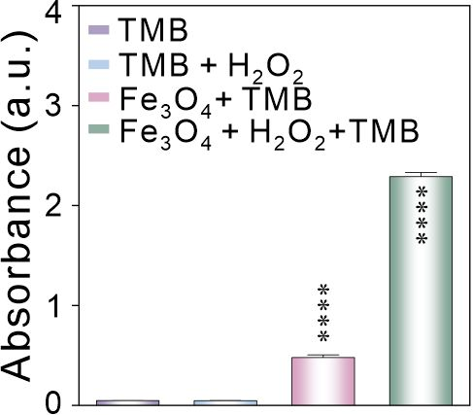
Figure S9. The absorbance intensity of oxTMB at 655 nm incubated with Fe₃O₄ with or without H₂O₂.

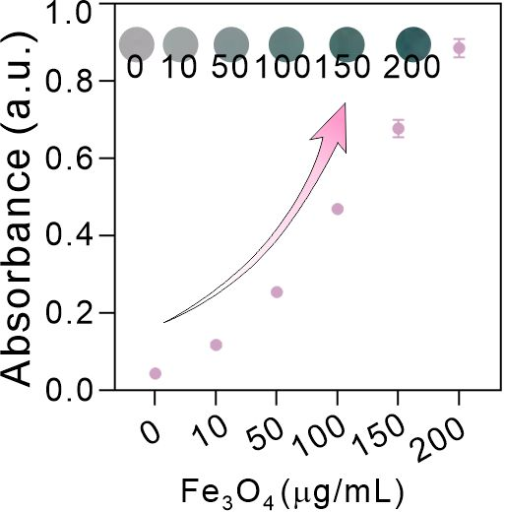
Figure S10. The oxTMB intensity at 655 nm wavelength incubated with varying concentrations of Fe₃O₄.

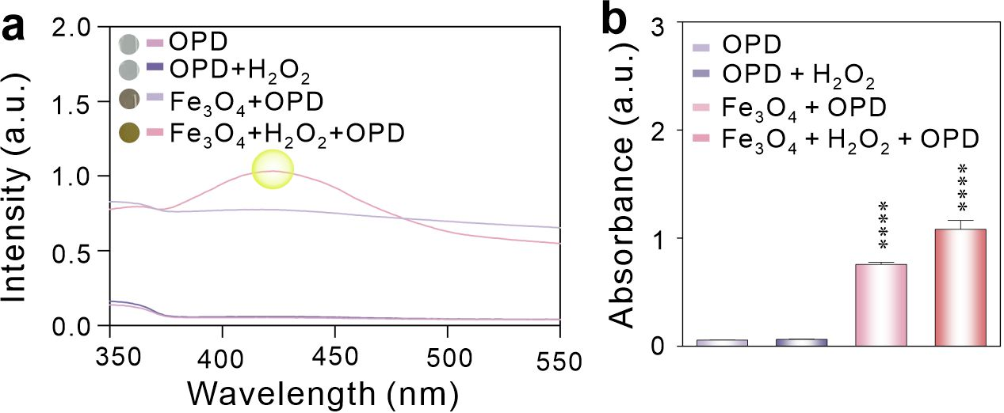
Figure S11. (a, b) The UV-vis spectra of ODP incubated with Fe₃O₄ with or without H₂O₂ and the statistical analysis (b).

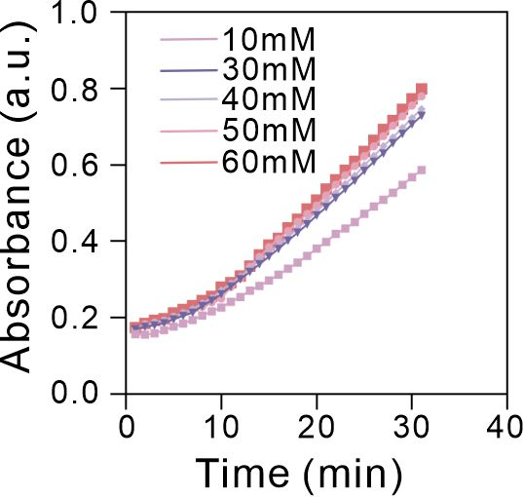
Figure S12. The record intensity of oxTMB in the course of 30-min incubated with Fe₃O₄ using the H₂O₂ as substrate.

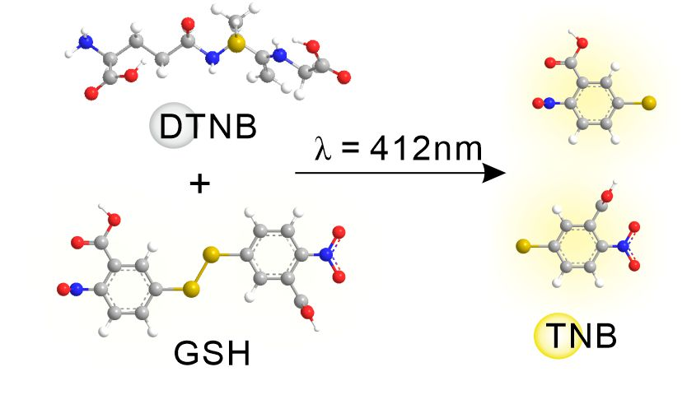
Figure S13. Schematic illustration of the GSHox-like activity using DTNB as substrate.

Figure S14. UV-Visible absorption spectra of DTNB after different reaction times with Fe₃O₄ and GSH (2D).

Figure S15. UV-Visible absorption spectra of DTNB after different reaction times with Fe/C and GSH (2D).

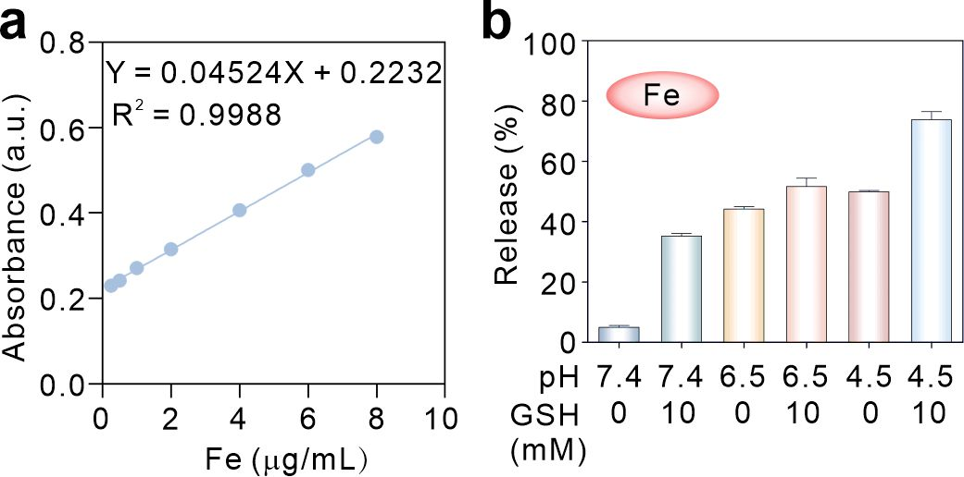
Figure S16. (a) The standard curve of Fe element determined by AAS. (b) The release profile of Fe ions under various conditions.

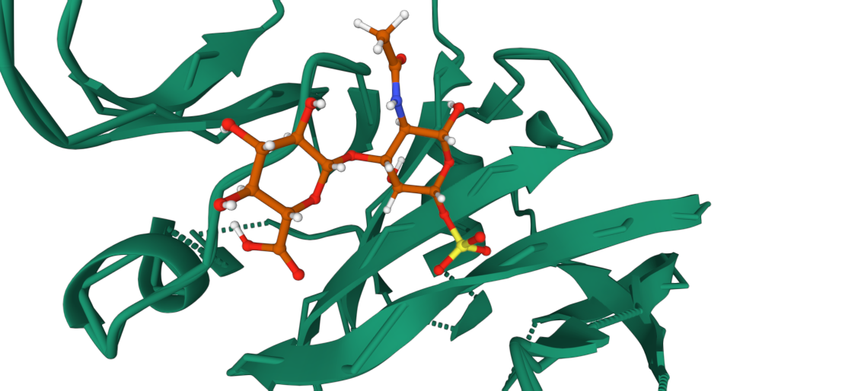
Figure S17. Sulfated chondroitin and the CD44 binding site.

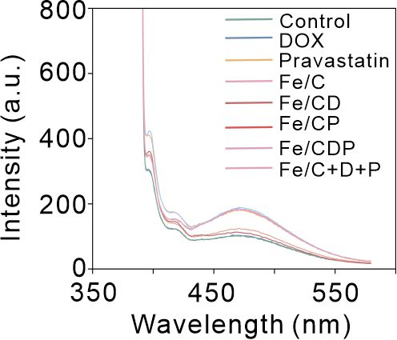
Figure S18. The fluorescence spectra of 4T1 cells stained with 1-pyrenedecanoic acid.

Figure S19. (a)Western blot analysis of HMGCR, E-cad, and CD59 expression. (b) Western blot analysis of GPX4 and FSP1 expression. (c)Western blot analysis of EGFR, P-gp, ALDH1, and γ-H₂AX expression. (d-l) Quantification of western blot band intensities for HMGCR (d), E-cad (e), CD59 (f), GPX4 (g), FSP1 (h), EGFR (i), P-gp (j), ALDH1 (k), and γ-H₂AX (l).

Figure S20. Total GSH content within the cell.

Figure S21. Imaging intracellular Fe²⁺ using the FerroOrange fluorescent probe. Scale bar: 50 μm.

Figure S22. Imaging of intracellular ACSL4 using immunofluorescence staining assay. Scale bar: 50 μm.

Figure S23. (a-b) Flow cytometric analysis of CD44⁺CD24⁻ subpopulations. (c) Quantitative analysis of and CD44⁺CD24⁻ cell percentages. (d, e) Representative histogram (d) and frequency analysis (e) of CD133⁺ cell populations.
Figure S24. The uptake efficiency of DOX by tumor spheres with different treatments.

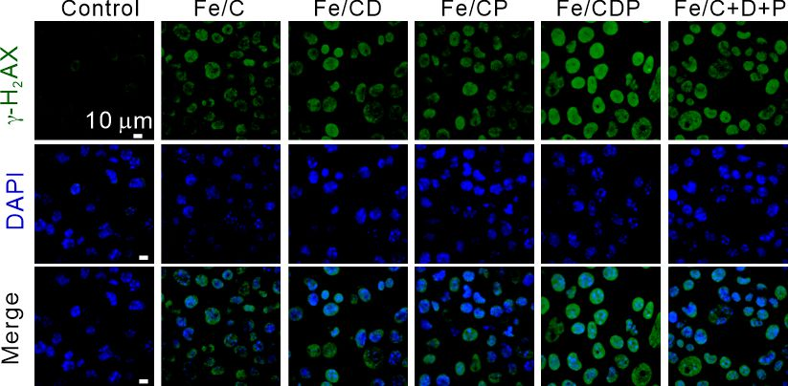
Figure S25. The immunofluorescence imaging of γ-H₂AX. The nucleus are stained with DAPI.

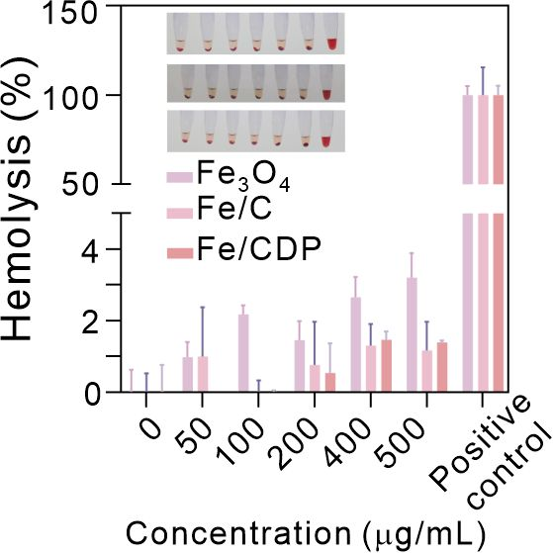
Figure S26. The hemolysis percentage of red blood cells incubated with varying concentrations of Fe₃O₄, Fe/C, and Fe/CDP. The 5% Triton X-100 was utilized as positive control.

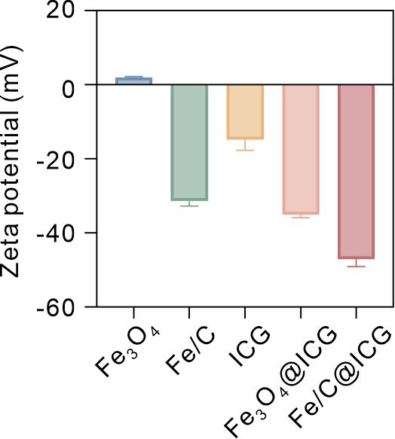
Figure S27. Zeta potentials of Fe₃O₄ and Fe/C before and after ICG modification.

Figure S28. The long-term fluorescence stability of Fe/C@ICG

Figure S29. Describe the histogram and statistics of the Fe/CDP targeting.

Figure S30. (a-d) Screening strategies for CD133⁺ (a), CD 11b⁺ (b), CD 3 (c), and CD 45 (d) in tumors.

Figure S31. Tumor growth AUC curve.

Figure S32. Organ weight analysis (2D).

Figure S33. Serum biochemical parameters of GOT (a), CRE (b), AKP/ALP (c), GPT (d), BUN (e), and cTnT (f).

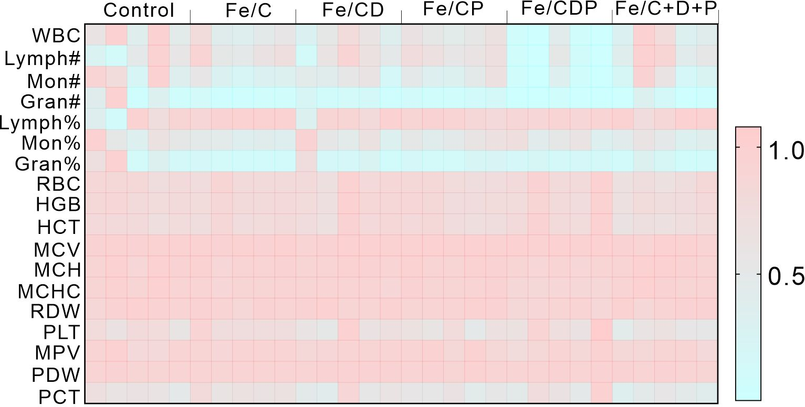
Figure S34. Heat map of hematological parameters of serum from mice received treatments on day 14.

Table S1. Serum biochemical parameters of mice following 14 days of treatment (mean ± SD).
.
 | Control | Fe/C | Fe/CD | Fe/CP | Fe/CDP | Fe/C + D + P
WBC | 0.684+0.288 | 0.521+0.155 | 0.513+0.188 | 0.556+0.079 | 0.118+0.174 | 0.563+0.312
Lymph# | 0.487+0.317 | 0.653+0.170 | 0.562+0.290 | 0.654+0.075 | 0.143+0.214 | 0.651+0.284
Mon# | 0.660+0.349 | 0.340+0.131 | 0.442+0.162 | 0.462+0.133 | 0.097+0.140 | 0.430+0.335
Gran# | 0.372+0.385 | 0.071+0.040 | 0.128+0.072 | 0.103+0.038 | 0.019+0.026 | 0.116+0.125
Lymph% | 0.613+0.371 | 0.948+0.033 | 0.783+0.267 | 0.888+0.054 | 0.898+0.024 | 0.913+0.103
Mon% | 0.602+0.245 | 0.412+0.046 | 0.579+0.241 | 0.525+0.096 | 0.520+0.144 | 0.447+0.104
Gran% | 0.458+0.376 | 0.128+0.030 | 0.283+0.255 | 0.179+0.047 | 0.170+0.018 | 0.161+0.097
RBC | 0.810+0.053 | 0.811+0.061 | 0.830+0.097 | 0.789+0.0521 | 0.872+0.098 | 0.729+0.069
HGB | 0.825+0.038 | 0.811+0.034 | 0.839+0.114 | 0.804+0.055 | 0.841+0.087 | 0.748+0.057
HCT | 0.779+0.045 | 0.785+0.048 | 0.808+0.108 | 0.772+0.052 | 0.863+0.099 | 0.699+0.058
MCV | 0.957+0.017 | 0.963+0.018 | 0.968+0.023 | 0.973+0.012 | 0.985+0.014 | 0.954+0.026
MCH | 0.944+0.049 | 0.928+0.037 | 0.936+0.025 | 0.943+0.025 | 0.896+0.026 | 0.951+0.039
MCHC | 0.933+0.038 | 0.911+0.019 | 0.914+0.015 | 0.918+0.023 | 0.860+0.018 | 0.943+0.035
RDW | 0.938+0.046 | 0.920+0.041 | 0.948+0.041 | 0.934+0.020 | 0.880+0.037 | 0.932+0.040
PLT | 0.711+0.100 | 0.765+0.085 | 0.687+0.185 | 0.632+0.106 | 0.797+0.200 | 0.556+0.076
MPV | 0.899+0.766 | 0.907+0.018 | 0.899+0.039 | 0.904+0.059 | 0.877+0.076 | 0.863+0.0387
PDW | 0.924+0.0162 | 0.923+0.006 | 0.943+0.012 | 0.937+0.024 | 0.935+0.016 | 0.926+0.017
PCT | 0.605+0.066 | 0.661+0.074 | 0.591+0.177 | 0.540+0.065 | 0.672+0.214 | 0.458+0.076

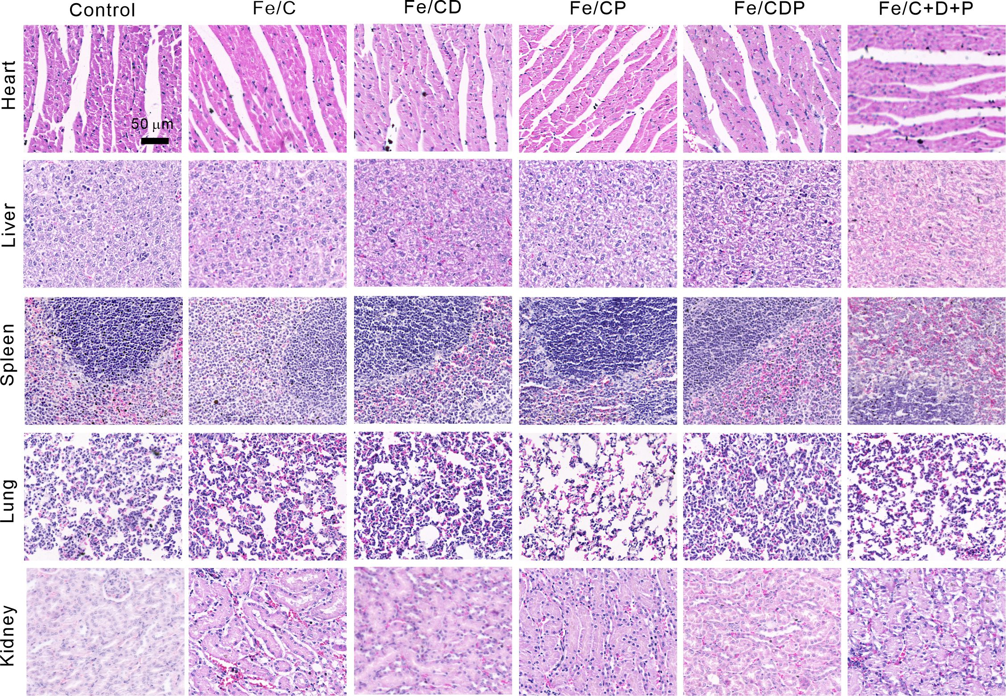
Figure S35. Representative images of H&E staining of major organs. Scale bar: 50 μm.

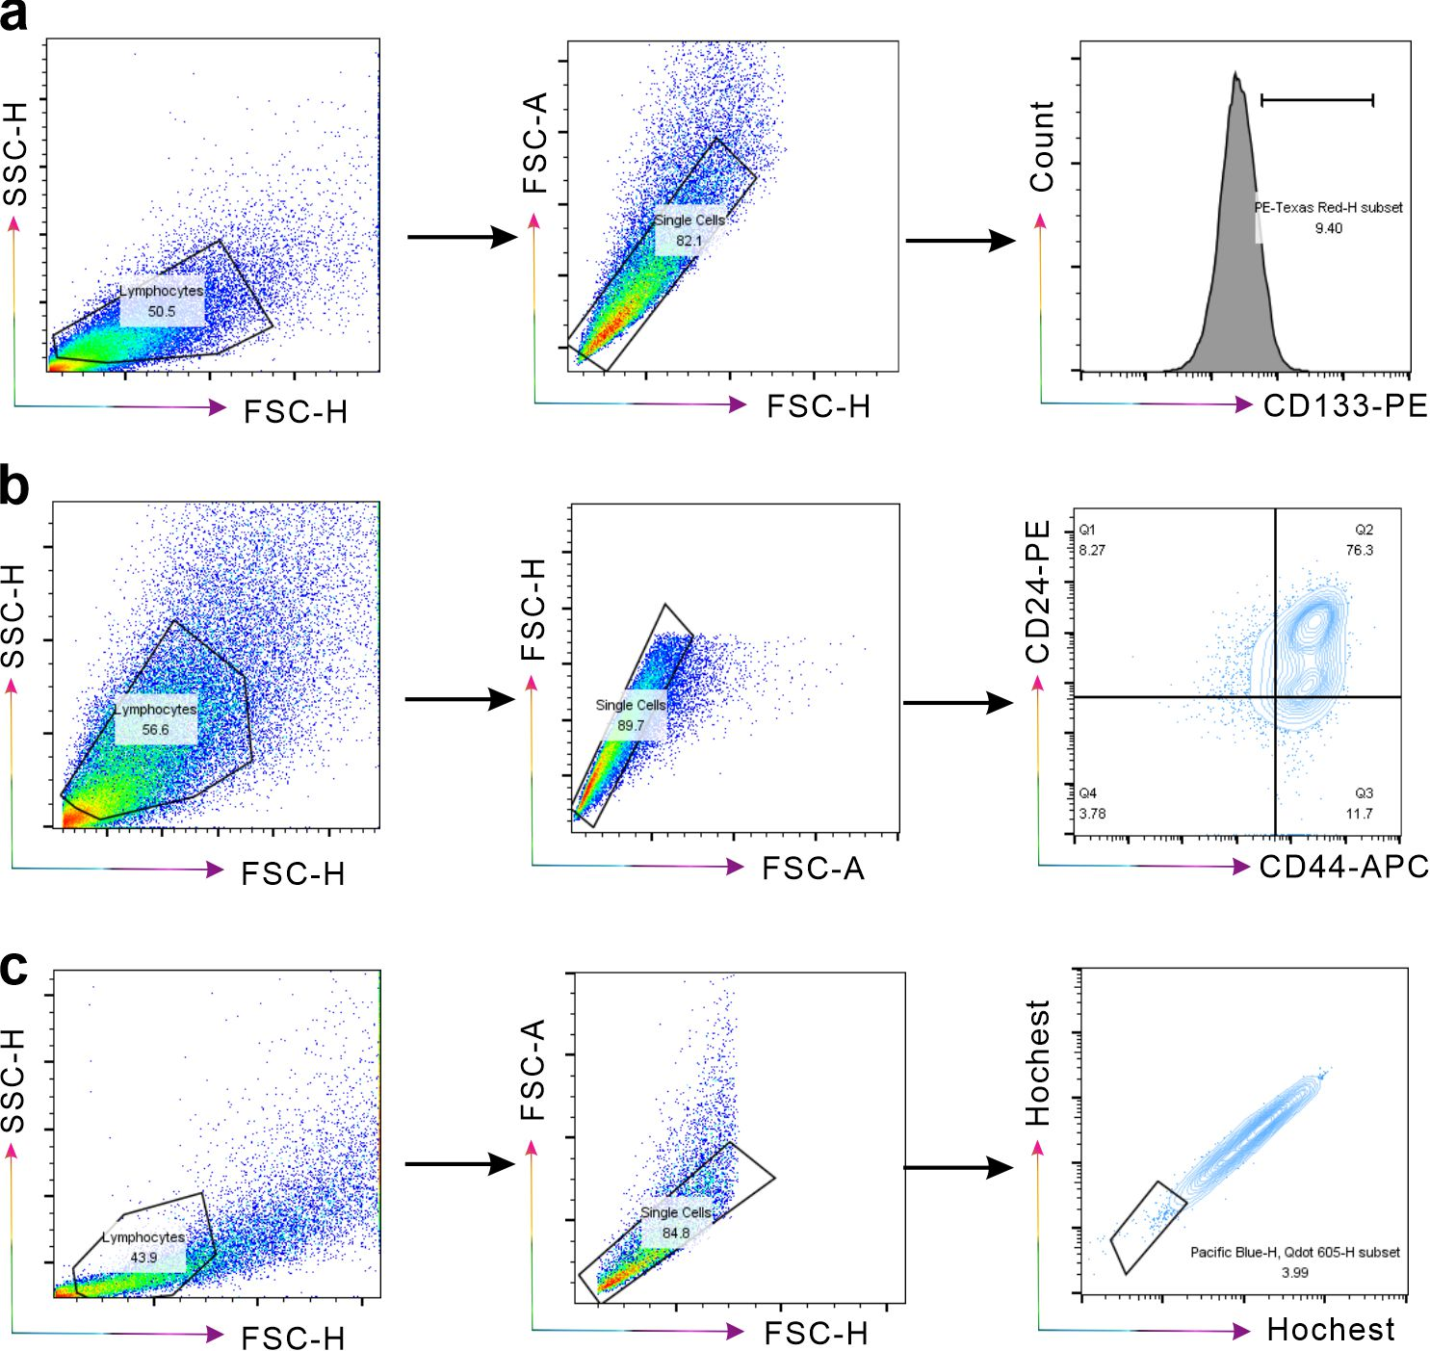
Figure S36. (a-c) The gating strategy for CD133⁺ (a), CD44⁺CD24⁻ (b), and side populations (c) in tumors.

Figure S37. Fe/CPD bio-targeting schematic diagram.

