Supporting Information

Single-atom Ca Nanozyme Induces Glioma Death Through Ca2+-Overload-Enhanced Catalytic Tumor Nanotherapy, Ferroptosis and Synergistic Remodeling of the Immune Microenvironment

Zhizhong Jin^{a,1}, Xinqiao Li^{b,1}, Xiaoyu Hou^{c,1}, Jinpeng Huª, Yue Zhuoª, Jianghua Shiª, Tao Xu^{d***}, Qi Zhao^{e,f,1**}, Zhitao Jing^{a,*}

ªDepartment of Neurosurgery, The First Hospital of China Medical University, Nanjing Street 155, Heping District, Shenyang 110001, P. R. China
^{b}Department of Neurosurgery, Liaoning Cancer Hospital and Institute, Cancer Hospital of China Medical University, Shenyang 110042, P. R. China
^{c}Department of Rheumatology and Immunology, The First Hospital of China Medical University, Shenyang 110001, P. R. China
^{d}Center for Bio-intelligent Manufacturing and Living Matter Bioprinting, Research Institute of Tsinghua University in Shenzhen, Tsinghua University, Shenzhen, 518057, People's
Republic of China
^{e}Center of Super-Diamond and Advanced Films (COSDAF), Department of Chemistry, City University of Hong Kong, 83 Tat Chee Avenue, Kowloon, Hong Kong SAR, P. R. China
^{f}Department of Chemistry and the Institute for Sustainability and Energy, Northwestern University, 2145 Sheridan Road, Evanston, IL 60208-3113, USA

Supplementary Figure 1.
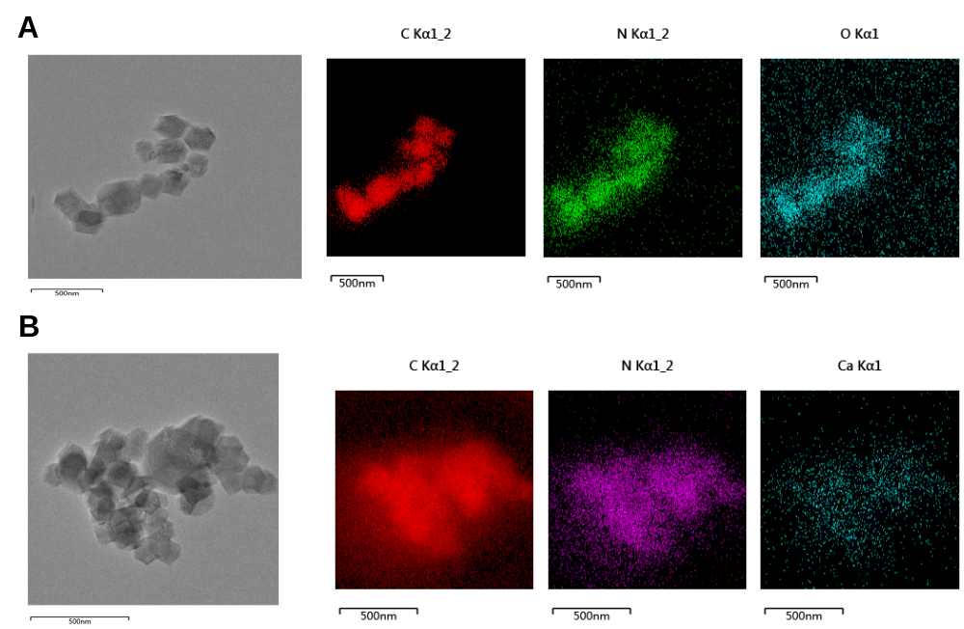
Supplementary Figure 1.
- The TEM image of ZIF-8 and the images of elemental mapping of C, N, and O.
- The TEM image of Ca/ZIF-8 and the images of elemental mapping of C, N, and Ca.

Supplementary Figure 2.
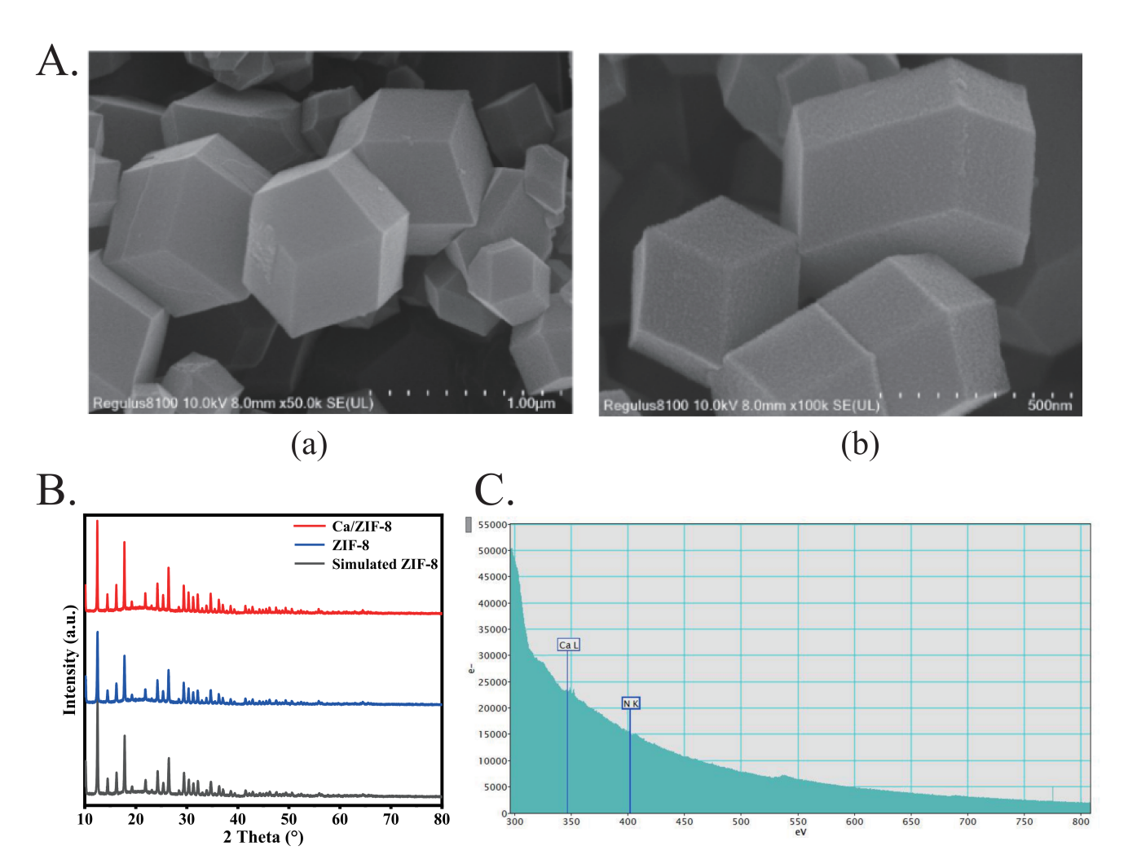
Supplementary Figure 2.
- SEM image of (a) ZIF-8 and (b) Ca/ZIF-8.
- Simulated XRD patterns of ZIF-8 and experimental XRD patterns of ZIF-8 and Ca-ZIF 8.
- Ca-CN electron energy loss spectroscopy (EELs）

Supplementary Figure 3.
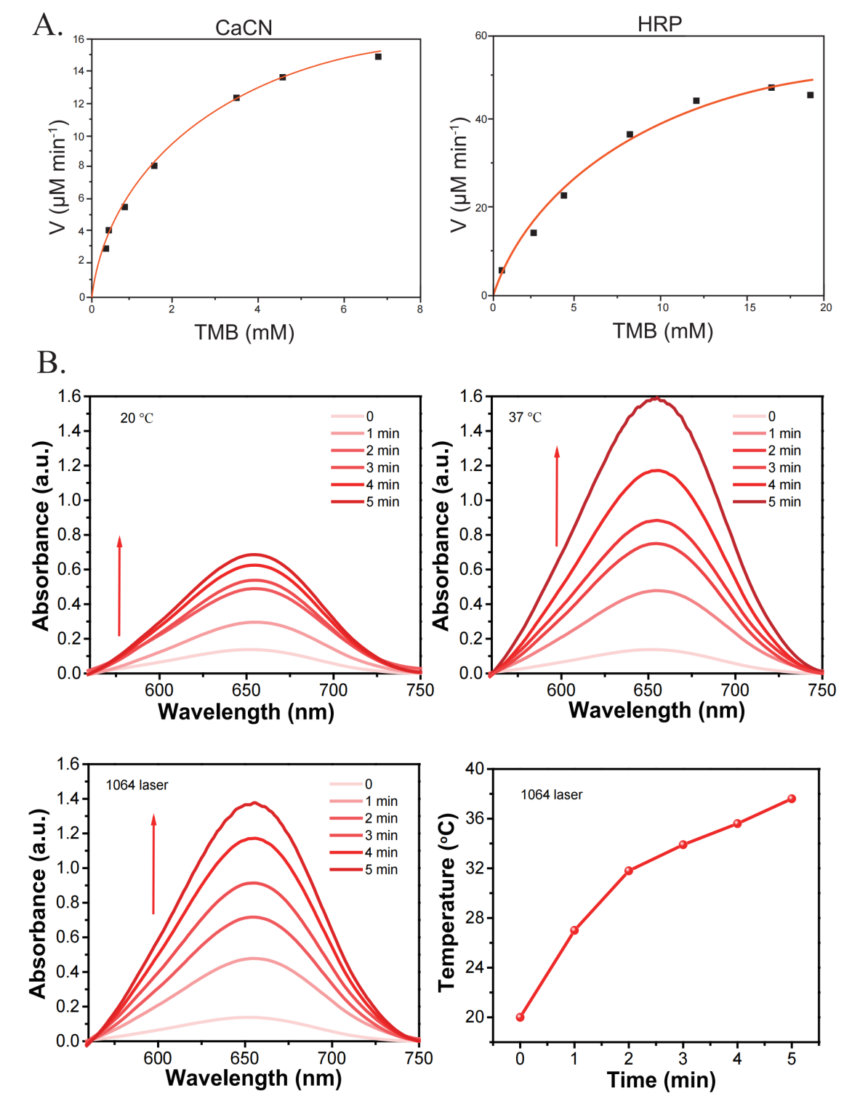
Supplementary Figure 3.
- Comparison of the peroxidase-like activity between CaCN and HRP.
- Photothermal analysis of Ca/CN-SAzyme.

Supplementary Figure 4.
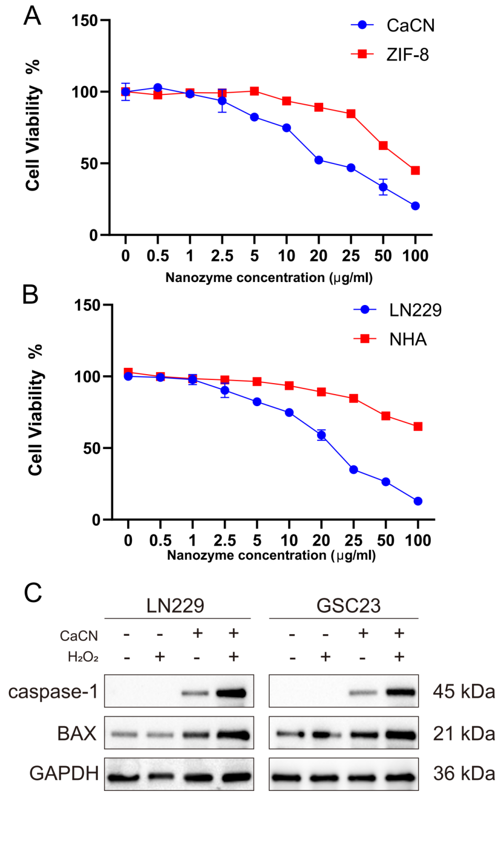
Supplementary Figure 4.
- The cytotoxicity between ZIF-8 after calcination and CaCN in LN229 cell line.
- Viability curves of LN229 and NHA cells treated with different concentrations of TF-CaCN.
- WB results show that in LN229 and GSC23 cell lines, H2O2 influences the catalytic efficiency of CaCN, thereby promoting cell apoptosis.

Supplementary Figure 5.
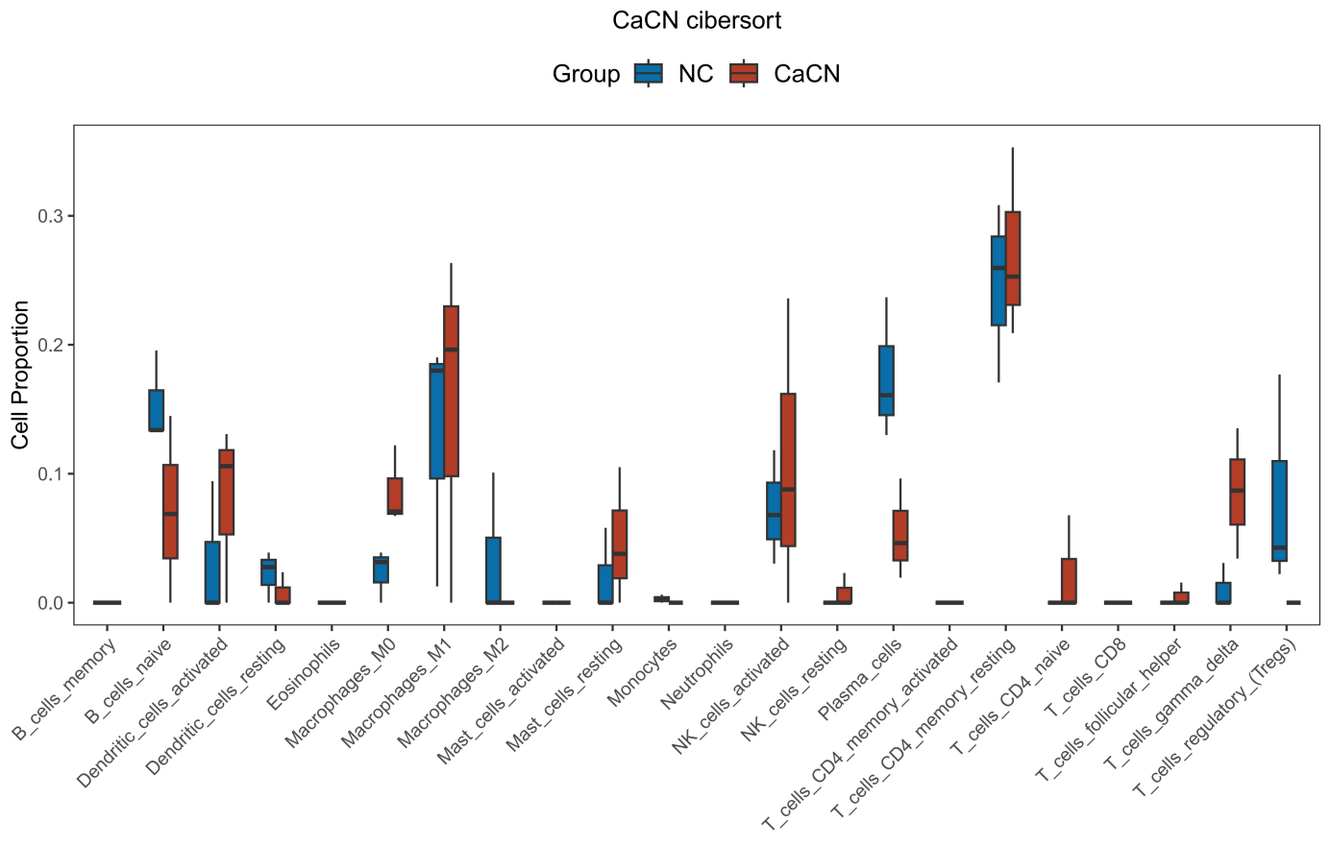
Supplementary Figure 5. Immune infiltration in CaCN-treated glioma cells versus controls was calculated using the cibersort algorithm.

Supplementary Figure 6.
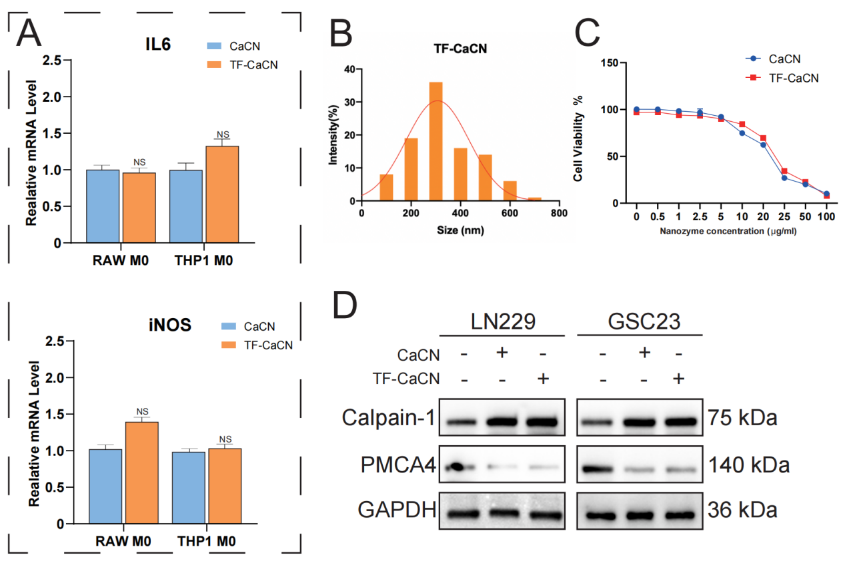
Supplementary Figure 6.
- PCR results demonstrate the effects of CaCN and TF-CaCN on M1 markers (IL-6 and iNOS) in RAW and THP-1 cell lines.
- Dynamic light scattering (DLS) analysis for measuring the particle size of TF-CaCN.
- The cytotoxicity between CaCN and TF-CaCN in LN229 cell line.
- WB results compare the effects of CaCN and TF-CaCN on calcium ion channels in LN229 and GSC23 cell lines.

Supplementary Figure 7.
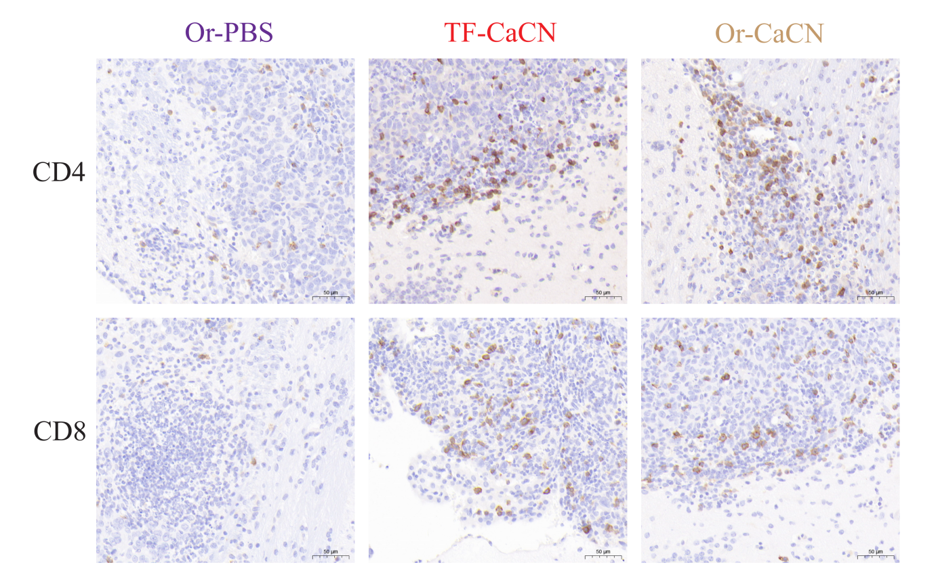
Supplementary Figure 7. Immunohistochemistry was used to detect the expression of peritumoral immune-related indicators (CD4, CD8) in mice after injection of TF-CaCN and CaCN.

Supplementary Figure 8.
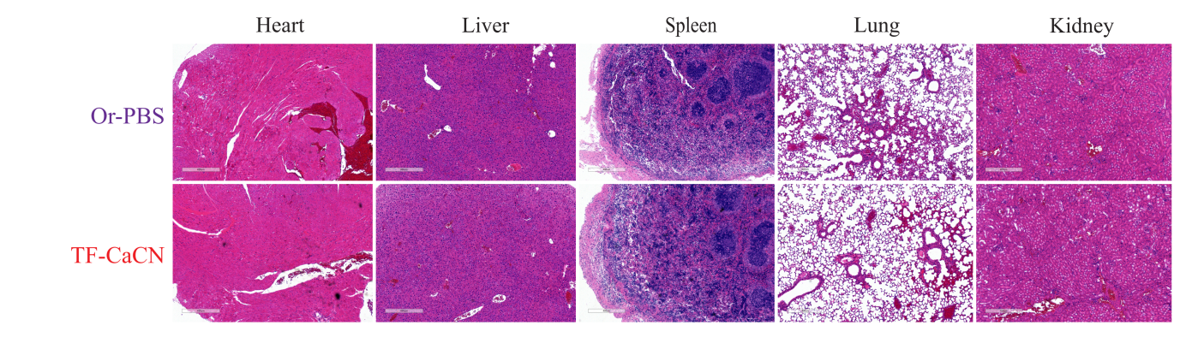
Supplementary Figure 8. Histological examination of major organs (heart, liver, spleen, lung and kidney)from G261 tumor-bearing mice in various treatment groups.

GEO | https://www.ncbi.nlm.nih.gov/geo/
TCGA | https://portal.gdc.cancer.gov/
CGGA | http://www.cgga.org.cn/
GSEA | https://www.gsea-msigdb.org/gsea/msigdb/index.jsp
Table S1. The database website.

Primer | Forward (5’-3’) | Reverse (5’-3’)
Caspase1 | AAATCTCACTGCTTCGGACA | GGCTGCTCAAATGAAAATCGAAC
GPX4 | CGCCTTTGCCGCCTACTGA | CTGGCTCCTGCTTCCCGAAC
Il6 | AACAAATTCGGTACATCCTCGAC | ATTTTCACCAGGCAAGTCTCC
iNOS | TCCCACCTGACCTTGTGCTT | CAGGGCGTACCACTTTAGCTC
PMCA4 | ATTAACACATTCCAGACGGGAG | CTATGGAACGCTTTGACCACT
TNF-α | TCGAACCCCGAGTGACAAGCC | GTTCTTATACTCGGGCCACAC
GAPDH | ACGACCACTTTGTCAAGCTC | CTGTTGCTGTAGCCAAATTCGTT
ACSL4 | ACTTAAGCTAAATGTGCTCACC | ATTCTCTTTGCCATAGCGTTT
Table S2. PCR Primers sequences.

Refrence:
[1] M. E. Ritchie, B. Phipson, D. Wu, Y. Hu, C. W. Law, W. Shi, G. K. Smyth, Nucleic Acids Res. 2015, 43, e47.
[2] T. Wu, E. Hu, S. Xu, M. Chen, P. Guo, Z. Dai, T. Feng, L. Zhou, W. Tang, L. Zhan, X. Fu, S. Liu, X. Bo, G. Yu, Innov. Camb. Mass 2021, 2, 100141.
[3] Y. Jiang, J. Zhou, J. Zhao, D. Hou, H. Zhang, L. Li, D. Zou, J. Hu, Y. Zhang, Z. Jing, EBioMedicine 2020, 52, 102651.
[4] J. Zhao, Y. Jiang, H. Zhang, J. Zhou, L. Chen, H. Li, J. Xu, G. Zhang, Z. Jing, J. Exp. Clin. Cancer Res. CR 2021, 40, 134.

