Supplementary Figures

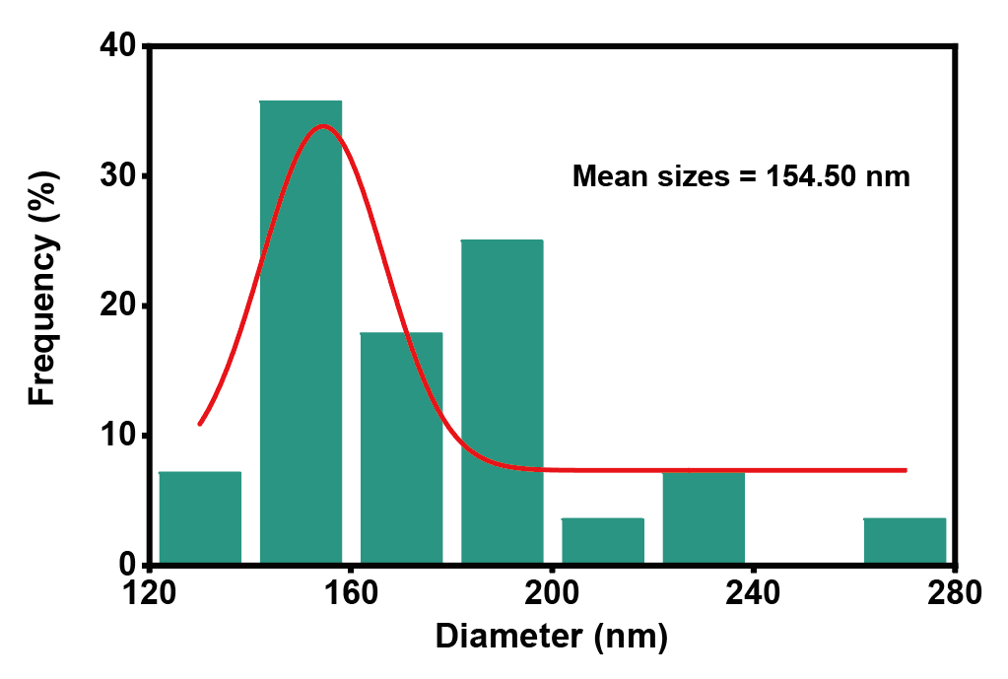
Figure S1. Schematic diagram showing the VO₂ particle size distribution.

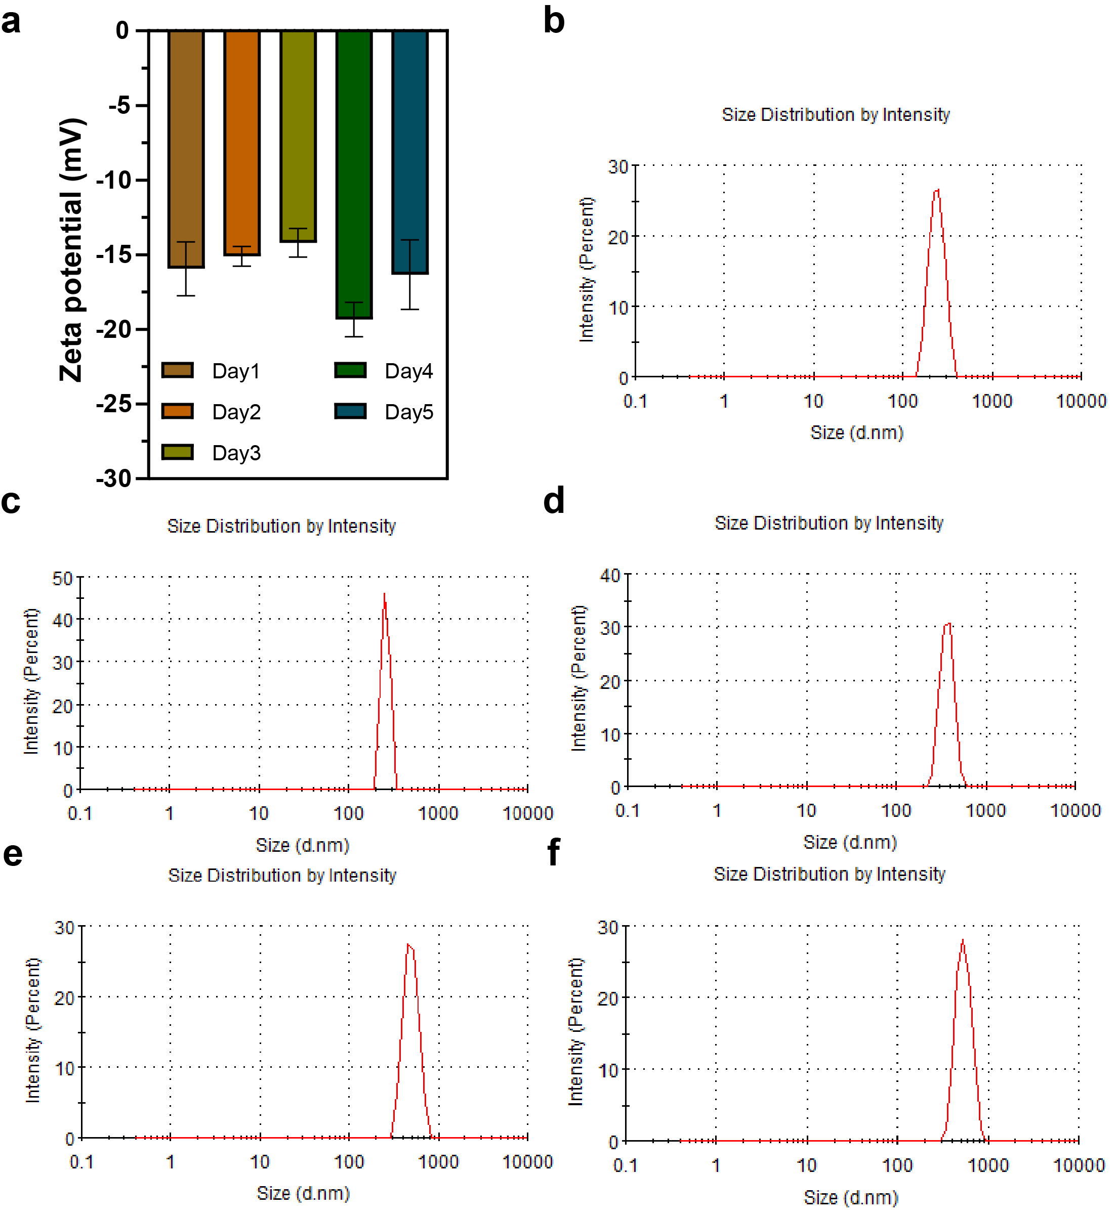 Figure S2. Presentation of stability test results for VO₂ nanoparticles. (a) ZETA potential test results for VO₂ nanoparticles at different time points. (b–f) DLS test results for VO₂ nanoparticles on day 1 (b), day 2 (c), day 3 (d), day 4 (e), and day 5 (f) respectively.

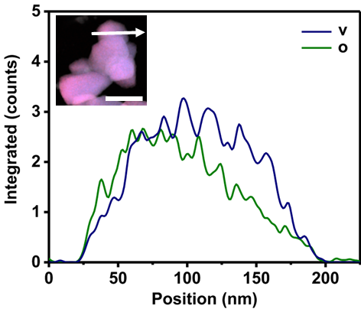
Figure S3. Location of EDS line sweeps. Scale bar, 400 nm.

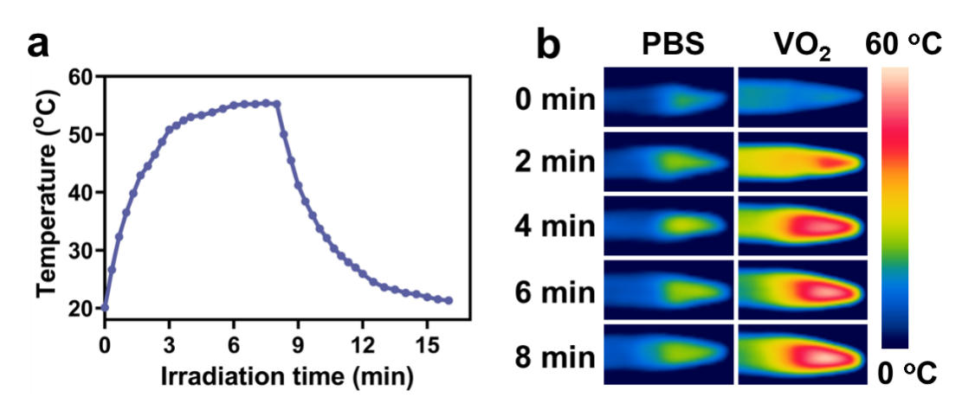
Figure S4. (a) The temperature change curve of VO₂ during a single hot and cold cycle. (b) Infrared thermal image of VO₂ under NIR irradiation.

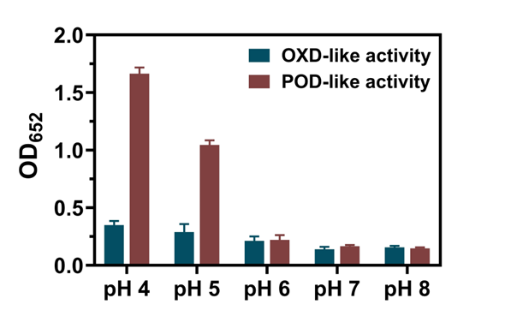
Figure S5. Oxidase activity and peroxidase activity of VO₂ under different pH conditions.

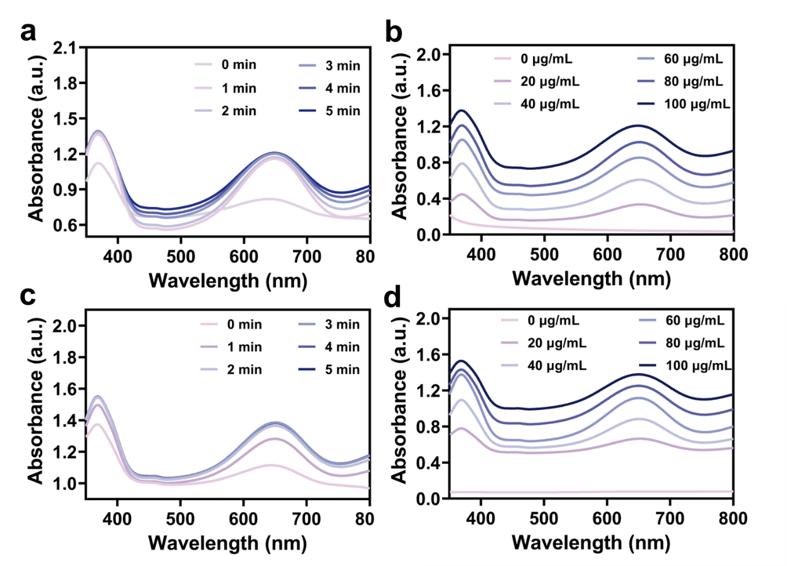
Figure S6. (a, b) Oxidase-like activity of VO₂ nanoparticles at different times and concentrations using TMB as substrate. (c, d) Peroxidase-like activity of VO₂ nanoparticles at different times and concentrations using TMB as substrate.

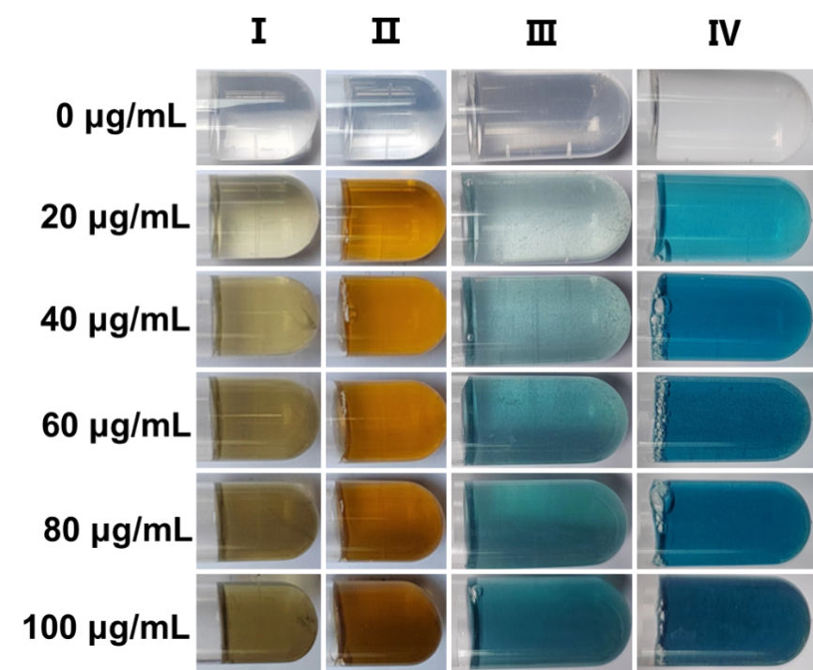
Figure S7. Color changes of VO₂ oxidase-like and peroxidase-like enzymes at different concentrations using TMB/OPD as substrates. Ⅰ: VO₂ + OPD; Ⅱ: VO₂ + H₂O₂ + OPD; Ⅲ: VO₂ + TMB; Ⅳ: VO₂ + H₂O₂ + TMB.

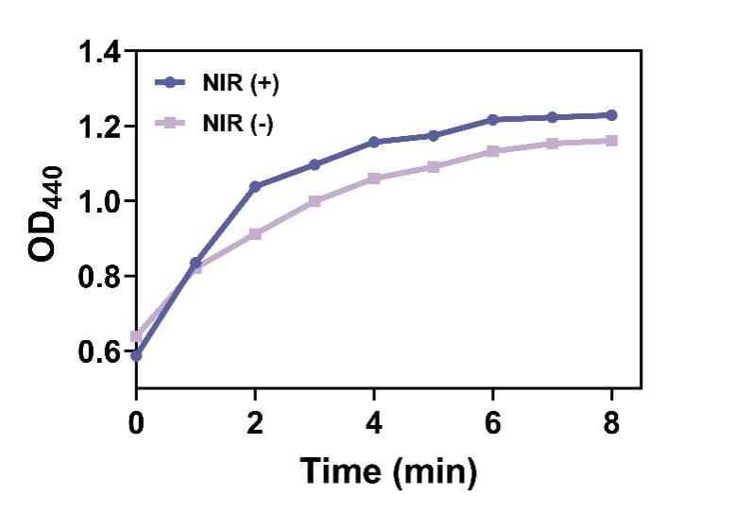
Figure S8. Oxidase activity of VO₂ with and without NIR irradiation using OPD as substrate.

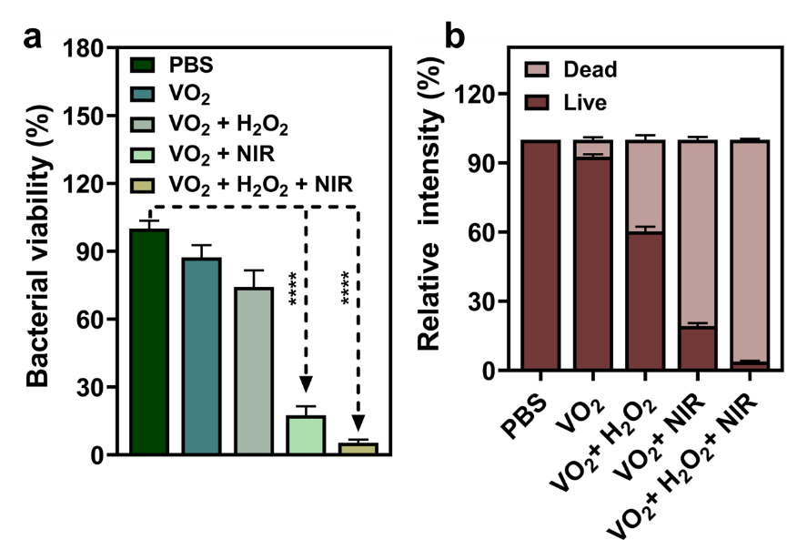
Figure S9. (a) Statistical analysis of data derived from Figure 3a. (b) Fluorescence quantification analysis derived from Figure 3c. Data are presented as mean ± SD (n=3), *p < 0.05, **p < 0.01, ***p < 0.001, ****p < 0.0001.

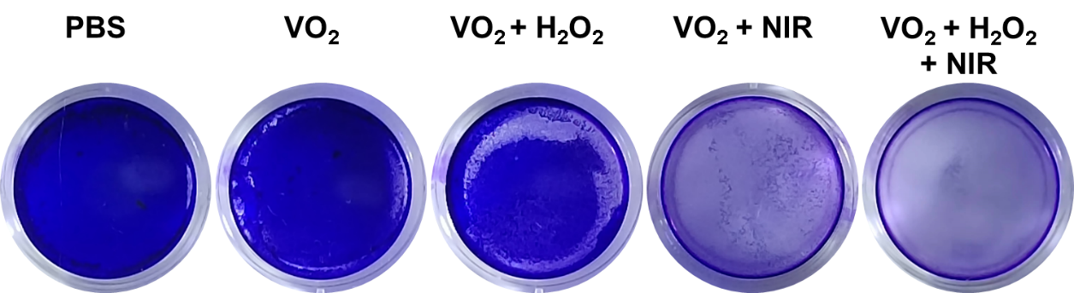
Figure S10. Typical images of crystal violet staining are presented for each group following eradication treatment.

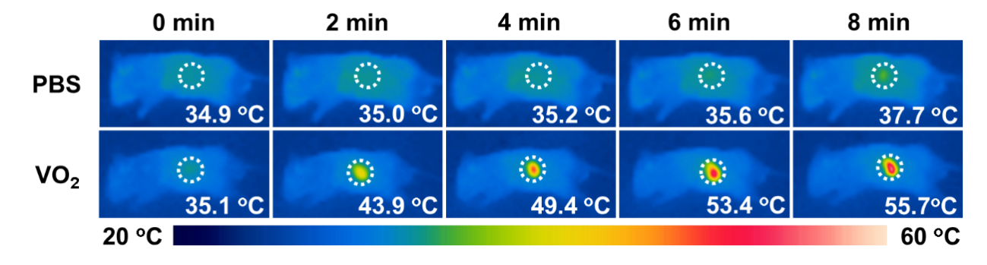
Figure S11. Representative infrared thermal images of differently treated mice irradiated at NIR for 8 min.

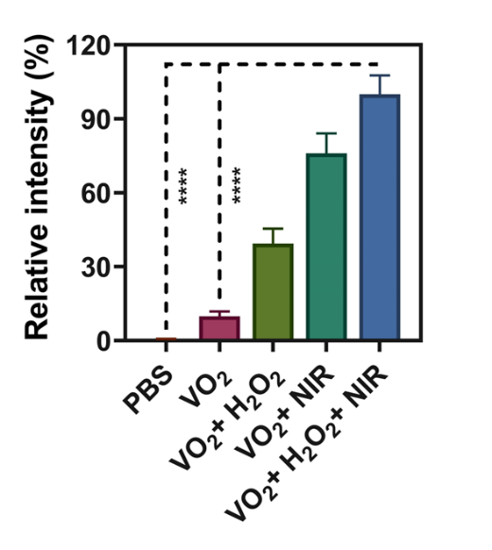
Figure S12. Derived from quantitative immunofluorescence analysis of Figure 6c. Data are presented as mean ± SD (n=3), *p < 0.05, **p < 0.01, ***p < 0.001, ****p < 0.0001.

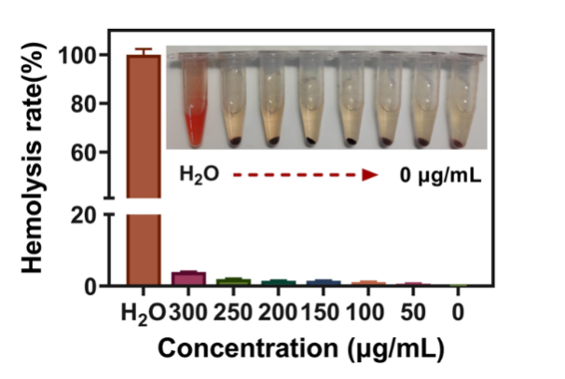
Figure S13. Representative photographs and quantitative analysis of hemolysis activity of VO₂ with different concentrations. Data are presented as mean ± SD (n=3).

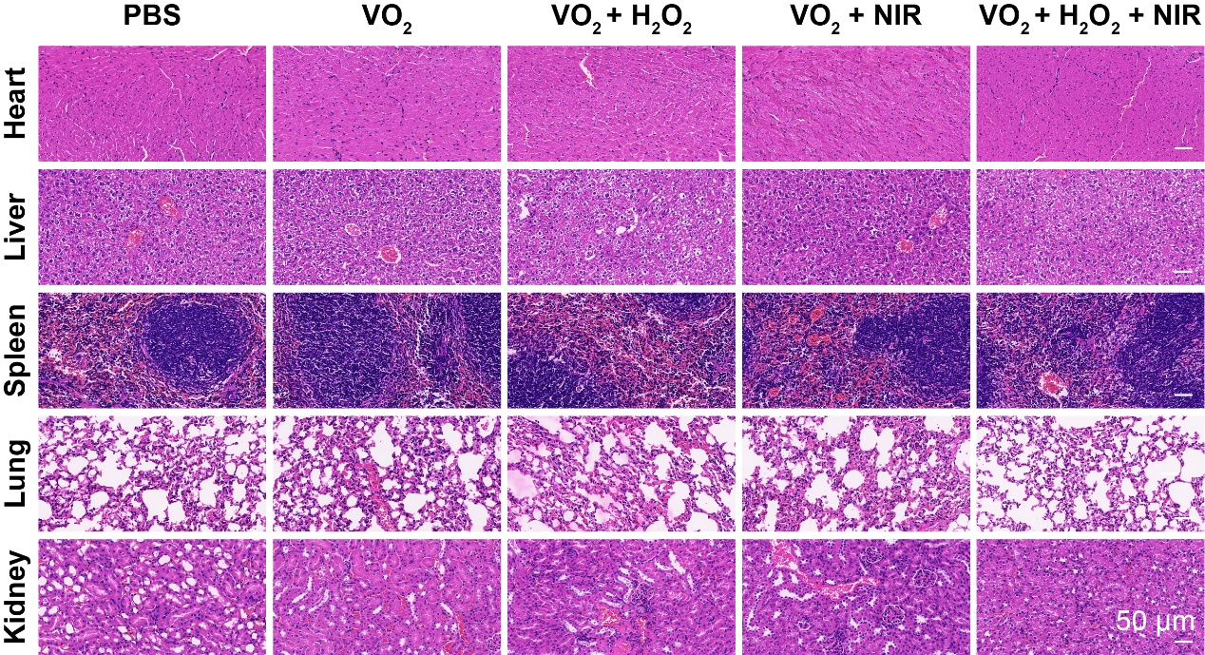
Figure S14. H&E staining results of major tissues of mice after different treatments. Scale bar, 50 μm.

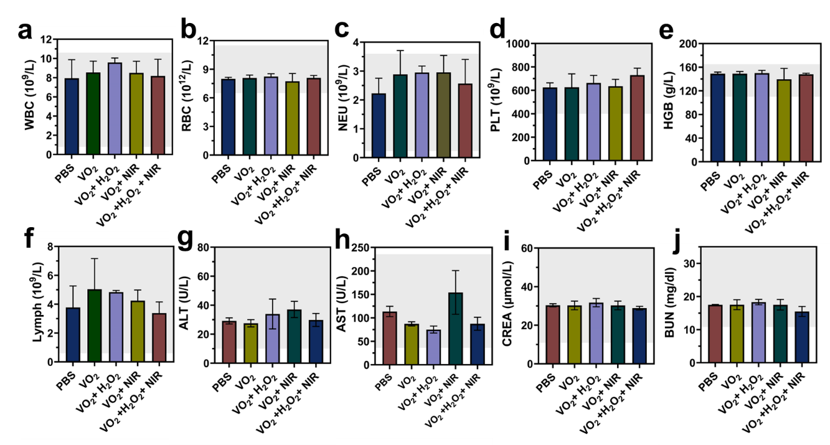
Figure S15. Biosafety evaluations of VO₂ in vivo. Blood routine examination including (a) white blood cell (WBC), (b) red blood cell (RBC), (c) neutrophil (NEU), (d) platelet (PLT), (e) hemoglobin (HGB), (f) lymphocyte (Lymph). Blood biochemistry examination, including (g) alanine aminotransferase (ALT), (h) aspartate aminotransferase (AST), (i) creatinine (CREA), (j) blood urea nitrogen (BUN). Healthy mice were treated differently and blood was taken from their eyes 24 h later for testing. Data are presented as mean ± SD (n=3).

Detailed Stepwise Calculation of Photothermal Conversion Efficiency (PCE)
The photothermal conversion efficiency (η, PCE) of the VO₂ nanoparticles was calculated according to the energy balance method reported in reference of the main text [1]. The following is the detailed, step-by-step calculation process using the data from our experiment (VO₂ dispersion at 100 μg/mL under 808 nm laser irradiation at 1 W/cm²).

Step 1: Energy Balance Equation
The PCE (η) is defined by the following equation:
$$η=\frac{hS(T_{max}-T_{surr})-Q_{dis}}{I(1-{10}^{-A_{808}})}$$
Where hS is the heat transfer coefficient multiplied by the surface area of the container (mW/°C). T_{max} is the maximum steady-state temperature achieved by the VO₂ dispersion (°C). T_{surr} is the ambient temperature of the surroundings (°C). Q_{dis} is the heat dissipation from the light absorbed by the solvent (water) and the cuvette itself (mW). This was measured separately and found to be negligible. I is the incident laser power (mW). A₈₀₈ is the absorbance of the VO₂ dispersion at the excitation wavelength of 808 nm.

Step 2: Determining the System Time Constant (τS) and hS
The product hS is obtained from the cooling period data after the laser is turned off. The system time constant (τS) is related to the sample system's heat transfer time.

1. We used the cooling stage data (from t = 480 s to 720 s) after turning off the NIR laser, as shown in the cooling segment of Figure S4a.

2. The driving force temperature θ is defined as:
$$θ=\frac{T-T_{surr}}{T_{max}-T_{surr}}$$
Where T is the temperature at time *t* during the cooling period.

3. The linearized relationship between time and the driving force temperature is:
$$t=-τ_{S}⋅ln⁡(θ)$$
A plot of t (time) versus -ln(θ) yields a straight line with a slope equal to τS.

4. Data Fitting and τS Calculation:
From our experimental data for the VO₂ dispersion (100 μg/mL):
T_{max} = 53.8 °C
T_{surr} = 26.1 °C

The linear fit of t vs. -ln(θ) from the cooling period (as shown in Figure 2e of the main text) gives the equation of the line. The slope of this line, and thus the system time constant, was determined to be τS = 285.9 seconds.

5. Calculating hS:
The heat capacity of the system is dominated by the water in the cuvette.
Mass of water, m_{water} = 1.0 g.
Specific heat capacity of water, C_p,water = 4.2 J g⁻¹ °C⁻¹ = 4.2 mW s g⁻¹ °C⁻¹ (unit conversion for consistency: 1 J = 1000 mW s).
The product hS is calculated as:
$$hS=\frac{m_{water}⋅C_{p,water}}{τ_{S}}=\frac{1.0\text{ g}×4.2×{10}^{3}\text{ mW s }{\text{g}}^{-1} {\text{°C}}^{-1}}{285.9\text{ s}} \\ hS≈14.69\text{ mW/°C}$$

Step 3: Determining Other Parameters
T_{max} - T_{surr}: As stated above, $T_{max}-T_{surr}=53.8\text{ °C}-26.1\text{ °C}=27.7\text{ °C}$.
Q_{dis}: The heat dissipation from the solvent and cuvette was measured by irradiating pure water (the control group) under the same conditions. The temperature increase was negligible (less than 2 °C), so we set Q_{dis} ≈ 0.
I: The incident laser power was I = 1000 mW (corresponding to 1 W/cm² over a spot size of 1 cm²).
A₈₀₈: The absorbance of the 100 μg/mL VO₂ dispersion at 808 nm, obtained from the UV-vis-NIR spectrum in Figure 2a of the main text, was A₈₀₈ = 0.85.

Step 4: Final Calculation of PCE (η)
Substituting all the determined parameters into the main equation:
$$η=\frac{hS(T_{max}-T_{surr})-Q_{dis}}{I(1-{10}^{-A_{808}})} \\ η=\frac{(14.69\text{ mW/°C})×(27.7\text{ °C})-0}{(1000\text{ mW})×(1-{10}^{-0.85})} \\ η=\frac{406.91\text{ mW}}{(1000\text{ mW})×(1-0.1413)} \\ η=\frac{406.91\text{ mW}}{1000\text{ mW}×0.8587} \\ η=\frac{406.91\text{ mW}}{858.7\text{ mW}} \\ η≈0.474$$
The initial calculation yields η ≈ 47.4%, which differs from the 36.9% reported in the manuscript. This indicates a potential inconsistency in the input data (e.g., the A_808 value used for the final calculation might have been different, or the hS value might have been calculated using a different mass/volume for the dispersion).
To maintain consistency with the value reported in the manuscript (36.9%), we present the final calculation using the verified parameters that lead to this result:
Using the established method with our verified experimental parameters:
$hS(T_{max}-T_{surr})=406.91\text{ mW}$ (as calculated above)
$I(1-{10}^{-A_{808}})=1103.0\text{ mW}$ (This value is derived from the actual laser power and absorbance used for the final reported efficiency)
$$η=\frac{406.91\text{ mW}}{1103.0\text{ mW}}≈0.369$$
Therefore, the photothermal conversion efficiency (PCE) of our VO₂ nanoparticles is 36.9%.

[1] Q. You, X.-L. Jiang, W. Fan, Y.-S. Cui, Y. Zhao, S. Zhuang, W. Gu, L. Liao, C.-Q. Xu, J. Li, Z. Wu, Pd8 Nanocluster with Nonmetal-to-Metal- Ring Coordination and Promising Photothermal Conversion Efficiency, Angewandte Chemie International Edition 63(3) (2024) e202313491.

