Supplementary material
Astaxanthin and Dihydroartemisinin loaded PLGA nanoparticles for atherosclerosis therapy via regulating lipid metabolism and immune microenvironment
Jiayao Huª, Hao Liu^{b#}, Yizhou Wu^{a#}, Xiaoyan Dong^{d}, Dongying Tangª, Wei Yan^{e}, Hongyan Zhou^{c}*, Bin Liuª*
ª College of Biology, Hunan University, Changsha, 410082, China
^{b} Department of Rehabilitation, The Second Xiangya Hospital, Central South University, Changsha, 410011, China
^{c} Department of Pharmacy, Tangdu Hospital, The Fourth Military Medical University, Xi'an 710038, China.
^{d} NHC Key Laboratory of Metabolic Cardiovascular Diseases Research, Ningxia Medical University, Yinchuan, 750004, China
^{e} Institute of Cardiovascular Research, Southwest Medical University, Luzhou, 646000, China.

Fig. S1. In vitro Siglec-1 level assay. (A&B) Fluorescence staining and quantified of macrophage after incubation with AST (1 µM), DHA (10 µM) and AST (1 µM) + DHA (10 µM). IFC detected and quantified with the Siglec-1.
Fig.S2. In vitro uptake of HPAD NPs to HUVECs. (A&B) CLSM images of HUVEC processed with different NPs. Cells were pre-incubated with HA (500 µg/mL) or HA@PLGA^{Ce6} NPs(as seen in the middle column). Cell nuclei were stained by DAPI (n = 3).

Fig. S3. Integrated analysis of quantitative transcriptomics and proteomics. (A) Volcano plot: Gene expression contrasts between Control and Model groups. (B) Volcano Plot: Gene Expression Changes in Model vs. HPAD Group. (C) The Venn diagram between the two comparisons (Control vs Model). (D) Gene ontology (GO) category of downregulated genes for biological processes, cellular component, and molecular function directly regulated in the Control group compared with those in the Model group. (E) KEGG pathway enrichment analysis of the identified DEGs bewteen Model group and the HPAD group. (F) KEGG pathway enrichment analysis of the identified DEGs bewteen Control group and the Model group.
Fig. S4. Macrophage colocalization analysis by flow cytometry quantification. (A-C) Representative flow cytometry plots showing quantitative analysis of P62, LC3 B, and LAMP1 colocalization in macrophages subjected to specific treatments.

Fig. S5. The effect of HPAD NPs on damaged HUVECS. (A&B) Images from CLSM and ROS (green) quantification results. (C&D) Optical images of HUVECS stained with ORO and Quantified data on ox-LDL-induced foam cell formation. (E) ELISA detected typical inflammatory cytokines MCP-1 secreted by LPS treated HUVECS.
Fig. S6. In vitro measurement of inflammatory and anti-inflammatory factor levels. (A&B) HPAD NPs inhibit phagocytosis of Dil-OxLDL by inflammatory macrophages. (C&D) Optical microscopy images of ORO staining and Quantified contents of oxLDL induced foam cells ormation.

Fig. S7. In vivo target behavior of HPAD NPs. (A&B) Fluorescence imaging depicted the dispersion and quantification of PLGA@^{Ce6} nanoparticles and HA@PLGA@^{Ce6} nanoparticles across multiple organs post-intravenous injection in ApoE^{-/-} mice.
Fig. S8. Ultrasound, Blood Flow Velocity, and Quantitative Analysis of Mouse Aorta. (A-C) Representative aortic ultrasound images. The yellow line indicates the thickness of the inner mesentery of the aortic root.
Fig. S9. Aortic flow cytometry and detection of inflammatory and anti-inflammatory factors. (A) Representative flow cytometry plots showing Th17 cell, IFN-γ cell, CD8⁺ T cell and Treg cell ratios in arotas extracted from mice receiving specified treatments. (B-E) Quantitative analysis of Th17 cell, IFN-γ cell, CD8⁺ T cell and Treg cell ratios in arotas. (F) ELISA assay of inflammatory cytokines of IL-6, TNF-α, MCP-1, IL-17A, TGF-β in serum.
Fig.S10 Assessment of in vitro biocompatibility of HPAD NPs. (A&B) Pictures and quantification of hemolysis test. (C) quantitative results of blood coagulation experiments. (D-F)The cell viability of HUVEC, VSMC and RAW264.7 with AST+DHA and treatment for 24 h. (G) Growth and development morphology of zebrafish in each group. (H)Zebrafish heart rate (n=3). (I)Body length of zebrafish in each group (n=3).
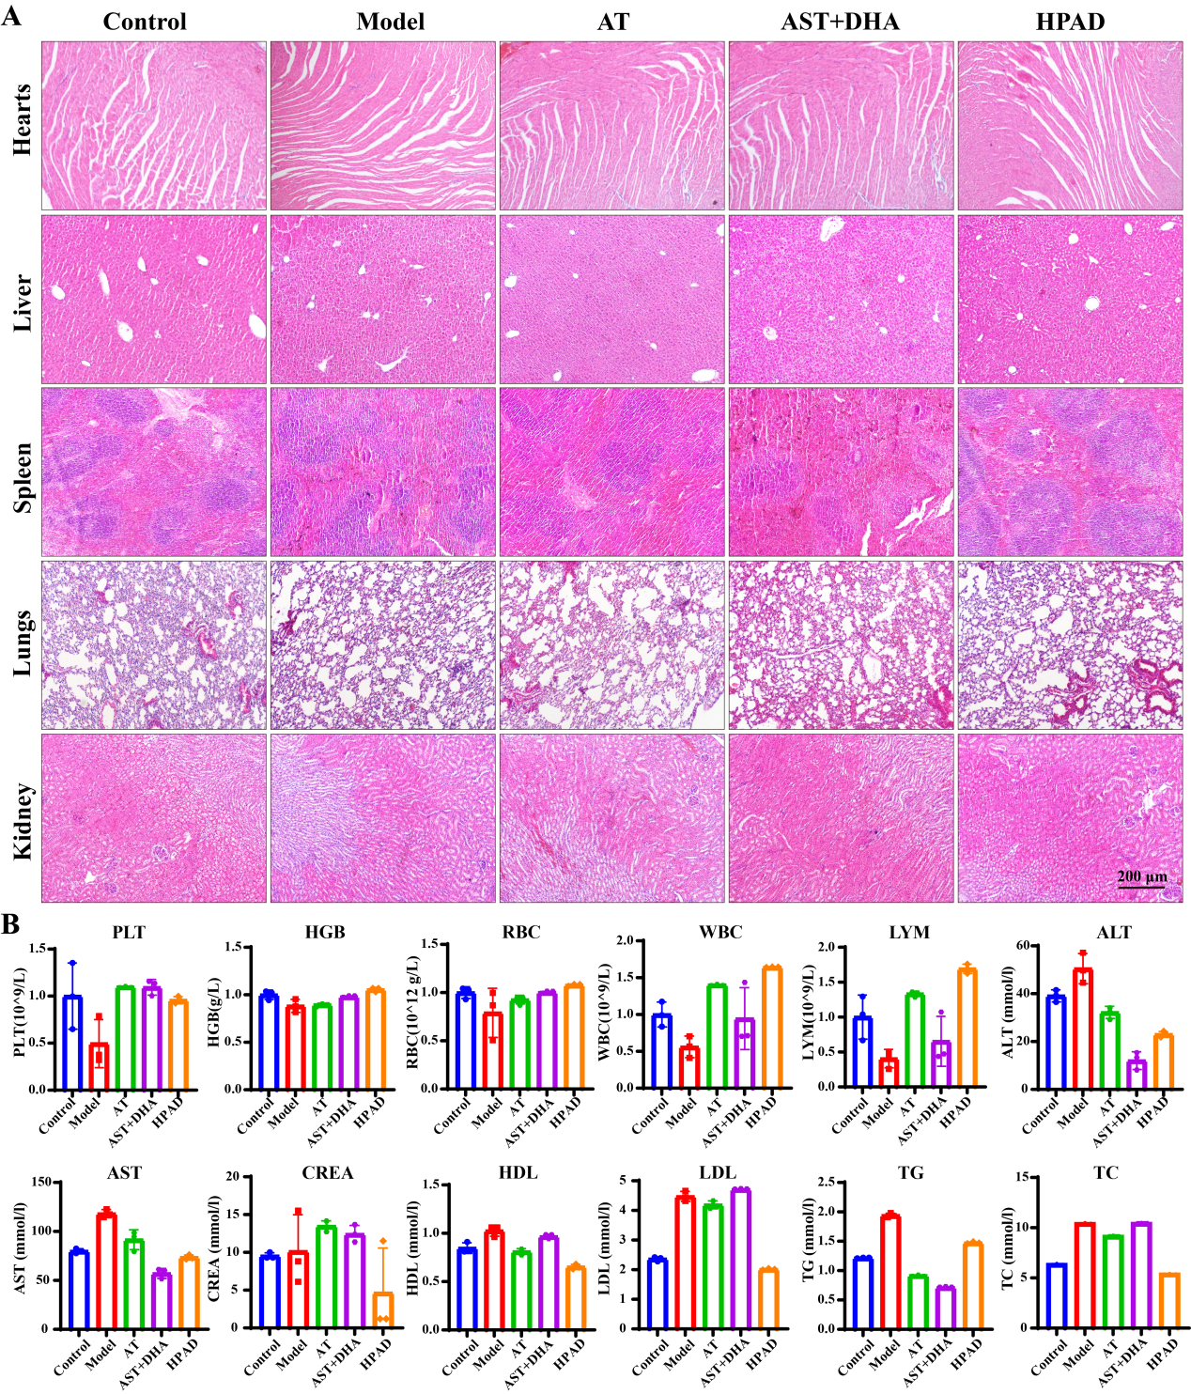
Fig. S11 Toxicological evaluations of HPAD NPs. (A) H&E-stained images of main organs from mice. (B) Detection of PLT, HGB, RBC, WBC, LYM, ALT, AST, CREA, HDL, LDL, TG and TC. Data are mean ± SD (n = 3).

