Dual-functional Nanovesicles Simultaneously Inhibit Stromal Fibrosis and Angiogenesis to Suppress Cholangiocarcinoma Progression

Lijing Zhang^{1†}, Xixi Duan^{1†}, Qiying Shi¹, Xiaohan Yao¹, Qiang Chen¹, Jiajia Wan¹, Fazhan Wang¹, Chen Ni¹, Yongjuan Li¹, Ming Wang¹, Yuqiao Sheng¹, Wenfu Zheng^{2,3}, Juan Liu^{4*}, Tianjiao Ji^{2,3*}, Zhihai Qin^{1*}

¹ Medical Research Center, the First Affiliated Hospital of Zhengzhou University, Zhengzhou University, Zhengzhou, 450052, China
² CAS Key Laboratory for Biomedical Effects of Nanomaterials & Nanosafety, CAS Center for Excellence in Nanoscience, National Center for Nanoscience and Technology, Beijing 100190, China
³ University of Chinese Academy of Sciences, Beijing, 100049, China
⁴ Hepato-Pancreato-Biliary Center, Beijing Tsinghua Changgung Hospital, Key Laboratory of Digital Intelligence Hepatology, Ministry of Education, School of Clinical Medicine, Tsinghua Medicine, Tsinghua University, Beijing, 102218, China

†These authors contributed equally to this work.
*Corresponding authors: Medical Research Center, The First Affiliated Hospital of Zhengzhou University, Zhengzhou University, Zhengzhou, 450052, Henan, China.
E-mail addresses: zhihai@ibp.ac.cn (Zhihai Qin), jitj@nanoctr.cn (Tianjiao Ji), lja02720@btch.edu.cn (Juan Liu).

Figure S1. Immunofluorescence (IF) evaluation of CD31 in HUCCT1 subcutaneous xenografts. Scale bar, 500 µm.
Figure S2. Treatment with anti-VEGFR2 increases α-SMA, expression in HUCCT1 subcutaneous xenografts. Scale bar, 500 µm.
Figure S3. Treatment with anti-VEGFR2 increases fibronectin expression in HUCCT1 subcutaneous xenografts. Scale bar, 500 µm.
Figure S4. Treatment with anti-VEGFR2 increases collagen I expression in HUCCT1 subcutaneous xenografts. Scale bar, 500 µm.
Figure S5. In vitro B7-33-SNPs reversed the activation of iMEF. (A) Western blot images and (B) corresponding quantitative analysis of phosphorylated Smad2 (p-Smad2), phosphorylated Smad3 (p-Smad3), total Smad2 (t-Smad2), and total Smad3 (t-Smad3) in iMEF cells under different treatment conditions (n = 3). Data are presented as mean ± standard deviation. Statistical significance was determined by Student’s t-test; *p < 0.05, **p < 0.01.
Figure S6. Differential expression of activated fibroblast marker proteins and pro-angiogenic factors from CAFs after treatment detected by qRT-PCR. Analysis of mRNA levels of pro-angiogenic factors in iMEF cells or TGF-β-activated iMEF after 48 hours of treatment with B7-33-SNPs. Data are shown as mean ± SD (n = 3); t-test indicated *p < 0.05, ‌**p < 0.01 and ***‌p < 0.001.

Figure S7. Post-treatment body weight in mice for each treatment group. The data are presented as the mean ± standard deviation (n = 6).

Figure S8. Tumor penetration analysis of SNPs-Cy5.5 following cRGD-B7-33 pretreatment. (A) Scheme of anti-fibrosis therapy. The cholangiocarcinoma-bearing mice received cRGD-B7-33 intravenously every 2 days for eight injections and subsequently the SNPs-cy5.5 was given afterward. (B) In vivo fluorescence imaging 1 h post-SNPs-Cy5.5 injection. (C) Quantified tumor fluorescence intensity. (D) Confocal microscopy images of tumor sections (DAPI: blue; SNPs-Cy5.5: red) showing spatial distribution (dotted lines demarcate tumor edge/core; scale bar=100μm). (E) Quantification of the depth of SNPs-cy5.5 penetration in tumors treated by the cRGD-B7-33. Results shown as mean ± SD (n = 6); t-test indicated ***‌p < 0.001.

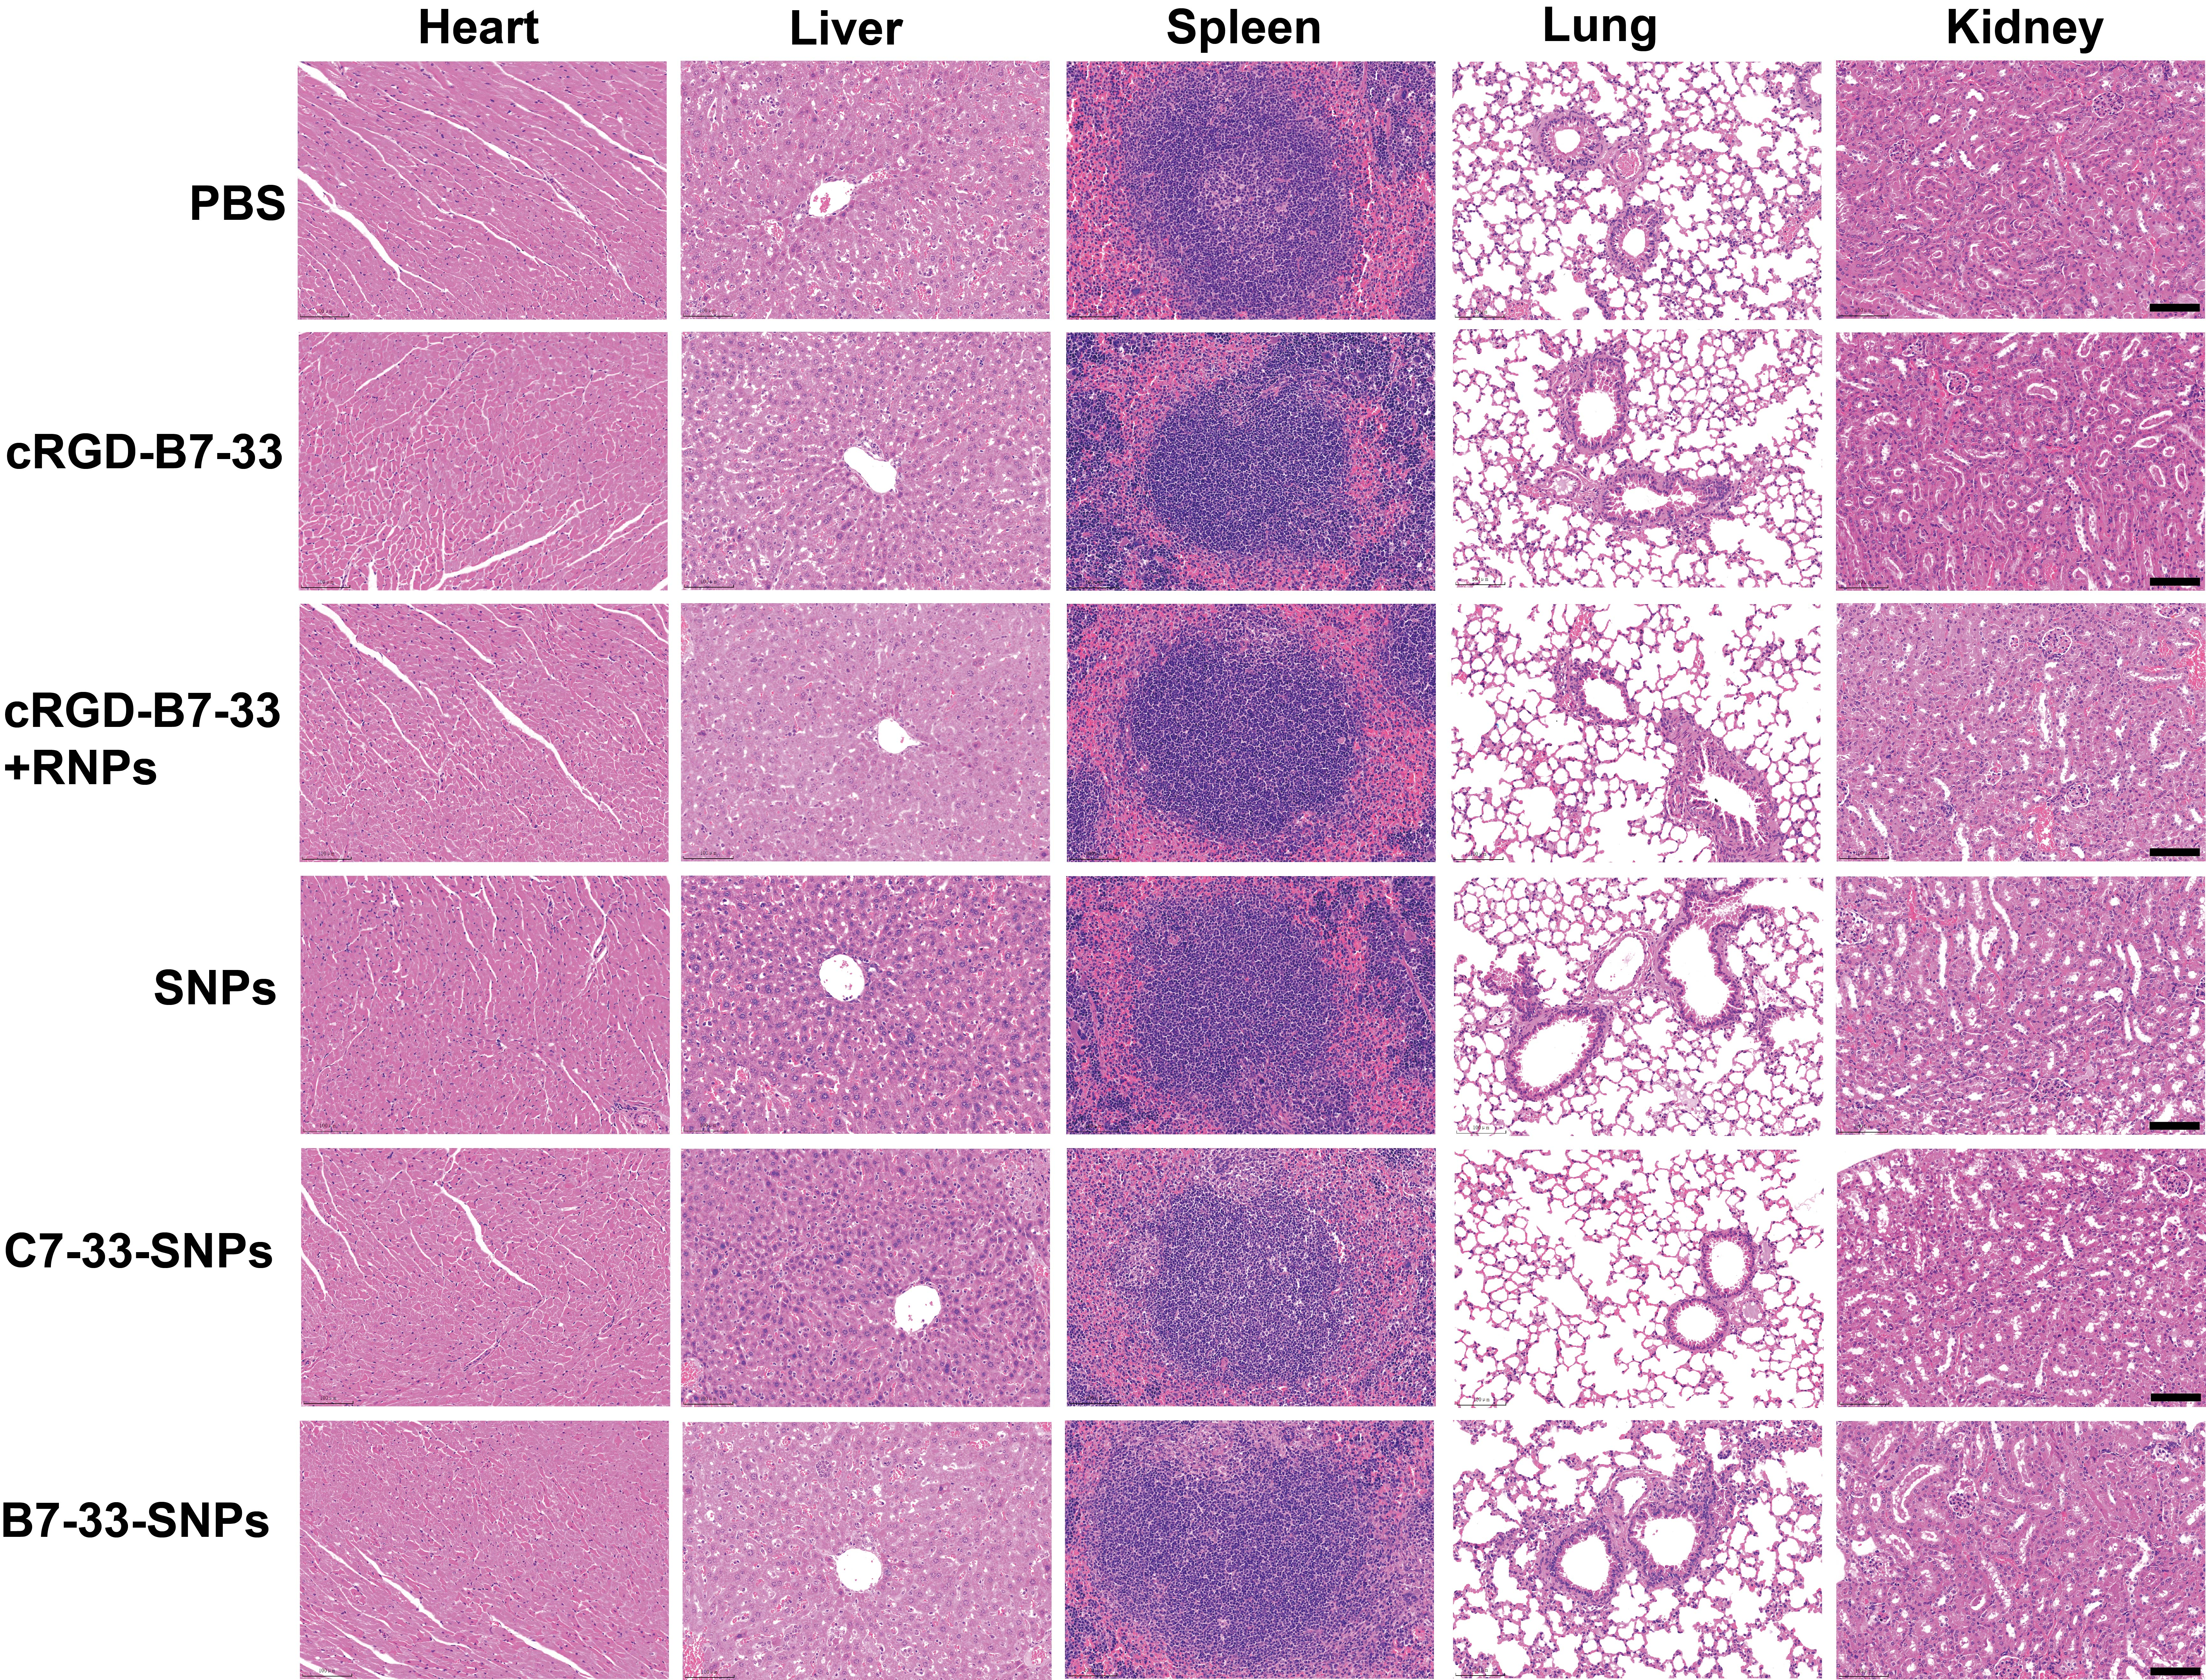
Figure S9. Histopathological evaluation of major organs. H&E-stained sections from mice with different treatments.

