Supporting Information
A Novel Biomimetic Nanoplatform Amplifies Ferroptosis for Specific cGAS-STING Pathway Activation to Enhance Hepatocellular Carcinoma Chemo-Immunotherapy

Hulinyue Peng ª, AQian Chang ª, Huizhong Zhang ª, Xiaohan Xu ª, Wenqi Wang ª, Ke Zhang ª, Jingwen Yang ª, Sha Xie ª, Xiaoyu Peng ª, Xingbin Yin ª, Changhai Qu ª, Jing Fu ^{b, *}, Jian Ni ^{a, *}, Xiaoxv Dong ^{a, *}

ª School of Chinese Material Medica, Beijing University of Chinese Medicine, Beijing 102488, China
^{b} Beijing Institute of Traditional Chinese Medicine, Beijing Hospital of Traditional Chinese Medicine, Capital Medical University, Beijing 100010, China

*Correspondence: fujing922@163.com(Jing Fu), njtcm@263.net (Jian Ni), dxiaoxv@163.com (Xiaoxv Dong)

Characterizations of TA-ZIF-8: The X-ray diffraction (XRD, D8 advance, Bruker, Germany) was used to record the XRD spectra of ZIF-8 and TA-ZIF-8. The Fourier Transform Infrared Spectroscopy (FT-IR, Nicolet iS50, Thermo Fisher, USA) was used to record the FTIR spectra of ZIF-8, TA and TA-ZIF-8. The physical adsorption curve was recorded used the BET surface area analyzer (ASAP2460, Micromeritics, USA).
Determination of the incubation concentration of N₃: MSC cells were seeded in 96-well plates at a density of 1 × 10⁴ cells//well overnight, and then 5, 10, 20, 30, 40, 50 and 60 μg/mL of N₃ were cocultured with MSC cells for 24 h. Subsequently, 10 μL of CCK-8 was added to each well, and incubated for 1 h. Finally, the cell viability was determined using a microplate reader at 450 nm.
Verification of the labeling of the cell membrane by N₃: Proliferating MSCs were seeded at a density of 2 × 10⁵ cells/well in a 6-well plate. After cell attachment, 2 mL of complete culture medium (containing 30 μg/mL of N₃) was added and the cells were cultured for 72 h. After washing with PBS, the cells were incubated with 70 μM DBCO-FITC for 1 h, followed by fixation with 4% paraformaldehyde at room temperature for 10 min. The cells were stained with DAPI staining solution for 8 min, washed twice with PBS, and observed under an inverted fluorescence microscopy.
HPLC Analysis Conditions: The mobile phase was acetonitrile and water in a ratio of 50:50. The flow rate was 1 mL/min. The column temperature was 30℃. The detection wavelength was 203 nm.
Evaluation of the in vitro safety of TA-ZIF-8 by the CCK8 assay: HepG2 cells were seeded in 96-well plates at a density of 8 × 10³ cells/well overnight, and then 1, 10, 20, 30, 40 and 50 μg/mL of TA-ZIF-8 were cocultured with HepG2 cells for 24 h. Subsequently, 10 μL of CCK-8 was added to each well, and incubated for 2 h. Finally, the cell viability was determined using a microplate reader at 450 nm.
Detection of cytochrome c: HepG2 cells were seeded in 6-well plates overnight and pretreated with Z-VAD-FMK (20 μM) and Ferrostatin-1 (1 μM) for 4 h, followed by treatment with PZ@M-T for 24 h. Subsequently, the content of cytochrome c in the cell lysate was detected in accordance with the introduction of Cyt-C ELISA Kit.
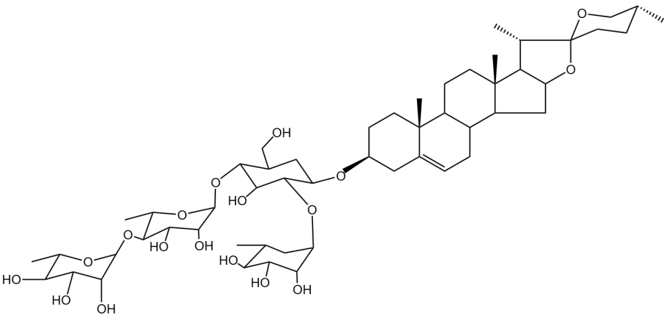
Fig. S1. The chemical structure of PPⅡ.
Fig. S2. Particle size of ZIF-8, TA-ZIF-8 and PZ@M-T.

Fig. S3. The cell viability of MSC cells after being treated with different concentrations of N₃ for 72 h (n = 6; compared with the control group, *P < 0.05, **P < 0.01, ***P< 0.001).
Fig. S4. Evaluation of the labeling situation of N₃ on the MSCm by the fluorescence images of DBCO-FITC.
.
Fig. S5. Western blot analysis of cell membrane markers (CD44, CD90 and CD105) in MSC lysate, MSC membrane (MSCm), PZ@M, and PZ@M-T.
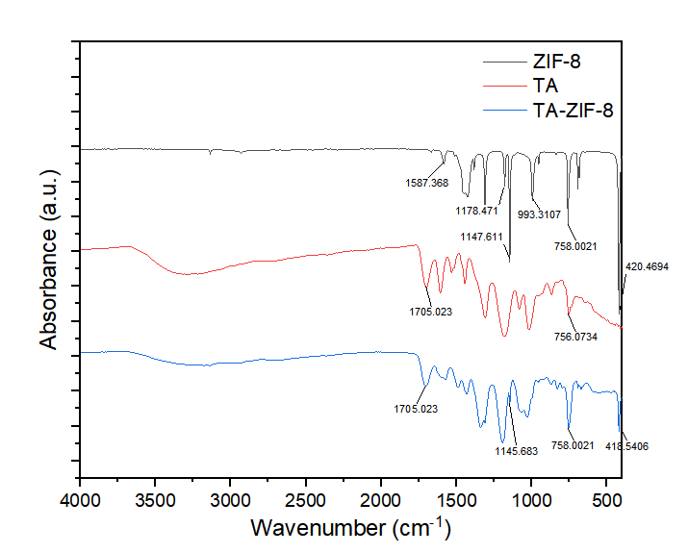
Fig. S6. FT-IR spectra of ZIF-8, TA and TA-ZIF-8.
Fig. S7. FT-IR spectra of TA-ZIF-8, PPⅡ and PZ.
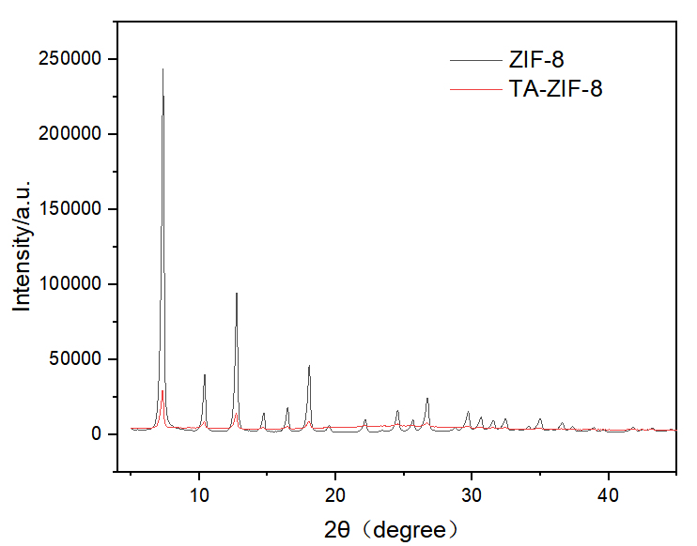
Fig. S8. The XRD spectra of ZIF-8 and TA-ZIF-8.
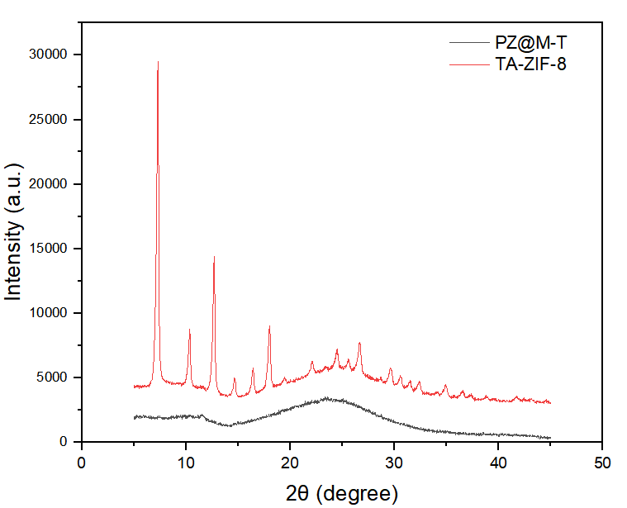
Fig. S9. XRD spectra of PZ@M-T.
Fig. S10. Adsorption and desorption curves of TA-ZIF-8.
Fig. S11. Pore diameter distribution of TA-ZIF-8.
Fig. S12. TGA curves of TA-ZIF-8 and PZ@M-T.

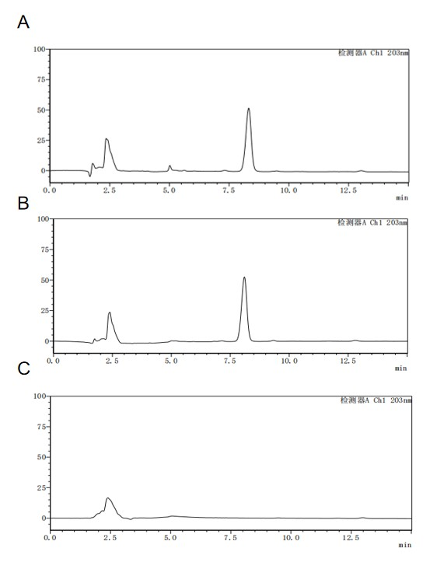
Fig. S13. HPLC chromatograms of PPⅡ (A), PZ@M-T(B) and TA-ZIF-8 (C).
Fig. S14. The uptake of nanoparticles by HepG2 cells. (A) The uptake of different nanoparticles was observed by CLSM. (B-C) Flow cytometry quantitatively analyzed the uptake of different nanoparticles (n = 3).

Fig. S15. The uptake of nanoparticles in THLE-2 cells was observed by CLSM.
Fig. S16. Investigation of the cellular internalization pathway of PZ@M-T. (A) Flow cytometry quantitatively analysis. (B) The relative uptake efficiency of different inhibitors. (n = 3)

Fig. S17. Lysosome escape of PZ@M-T visualized by CLSM.

Fig. S18. The cell viability of HepG2 cells after being treated with different concentrations of TA-ZIF-8 for 24 h (n = 6).
Fig. S19. Cell viability of HepG2 cells treated with various concentrations of PPⅡ, PZ, PZ@M, and PZ@M-T (n = 6). (Compared with the PZ@M-T, *p < 0.05, **p < 0.01, ***p < 0.001).

Fig. S20. Fluorescence images of intracellular Fe²⁺ in HepG2 cells.

Fig. S21. Fluorescence images of intracellular GSH in HepG2 cells.

Fig. S22. Analysis of intracellular GSH in HepG2 cells (n = 3). **p < 0.01, ***p < 0.001.

Fig. S23. Analysis of intracellular MDA levels in HepG2 cells (n = 3). **p < 0.01, ***p < 0.001.
Fig. S24. Western blot statistical quantification of cGAS, IFN-β, p-IRF3/IRF3, p-STING/STING, and p-TBK1/TBK1. (n = 3). (Compared with the PZ@M-T, *p < 0.05, **p < 0.01, ***p < 0.001).
Fig. S25. Western blot statistical quantification of cGAS, IFN-β, p-IRF3, p-STING, and p-TBK1. (n = 3).
Fig. S26. Western blot statistical quantification of GPX4, cGAS, IFN-β, p-IRF3, p-STING, and p-TBK1. (n = 3).
Fig. S27. Tumor volume of each group on the last day of treatment (n = 6). (ns represents p > 0.05, compared with the PZ@M-T, *p < 0.05, **p < 0.01, ***p < 0.001).

Fig. S28. Tumor growth curves of each group.

Fig. S29. Body weight of each group on the last day of treatment (n = 6).
Fig. S30. Hematological analysis of the mice. (A-D) WBC, RBC, HGB and PLT (n = 3).

Fig. S31. Blood biochemical analysis of the mice. (A-F) ALP, ALT, AST, CREA, UREA, and UA (n=3). *p < 0.05, **p < 0.01, ***p < 0.001 vs control group.
Fig. S32. H&E staining of main organs (heart, liver, spleen, lung and kidney).

Fig. S33. Zn²⁺ concentrations in tumors, heart, liver, spleen, lungs and kidneys (n = 3). (ns represents p > 0.05, compared with the PZ@M-T, *p < 0.05, **p < 0.01, ***p < 0.001).
Fig. S34. Gating strategy plot of dendritic cells (A), macrophages (B), T cells (C), and Tregs (D).

Fig. S35. Representative flow cytometric plots of M2-TAMs (CD86⁻CD206⁺) cells and M1-TAMs (CD86⁺CD206⁻) in tumors.
Fig. S36. Representative flow cytometric plots of Tregs (Foxp3⁺CD25⁺) in tumors.

Fig. S37. Immunofluorescence staining of CD8 and TIM-3 in tumors.
Fig. S38. Immunofluorescence staining of CD8 and CD103 in tumors.

