Supporting Information
Wenshuai Li^{a†}, Lulu Wang^{b†}, Hui Zhao^{c†}, Rui Zhang^{f}, Yinyin Zhangª, Sen Linª, Haoyang Qinª, Xianlong Zongª, Kang Ganª, Junjie Wang^{b}, Heng Yin^{d*}, Yazhou Chen^{e*}, Rui Li^{a*}

ª Department of Stomatology, The First Affiliated Hospital of Zhengzhou University, Zhengzhou 45000, China.
^{b} Department of Plastic Surgery, The Third People’s Hospital of Henan Province, Zhengzhou, 450007, Henan, China.
^{c} Zhengzhou Revogene Technology Co., LTD, Airport District, Zhengzhou 451162, Henan, China.
^{d} Jiangsu CM Clinical Innovation Center of Degenerative Bone & Joint Disease, Wuxi Affiliated Hospital of Nanjing University of Chinese Medicine, Wuxi, China.
^{e} Henan Institute of Advanced Technology, Zhengzhou University, Zhengzhou 45000, China.
^{f} Department of Oral and Maxillofacial, Zhengzhou Stomatology Hospital, Zhengzhou 450000, China

*Corresponding author:
Rui Li^{a*}(Email: fcclir@zzu.edu.cn; ORCID number: fcclir@zzu.edu.cn); Yazhou Chen^{e*}(yzchenbio@zzu.edu.cn); Heng Yin^{d*}(wxzy011@njucm.edu.cn).

Fig. S1. (a) SEM images of multilayered MXene. (b) SEM images of MXene and MXene-TA /Fe NSs at low magnification. (c) Quantitative analysis of NSs diameter from (b). (d) TEM images of MXene and MXene-TA/Fe NSs at low magnification. e) AFM images of MXene and MXene-TA/Fe NSs at low magnification. (f) XRD spectra of MAX and MXene. (g) AFM analysis of thickness of MXene NSs. (h) AFM analysis of thickness of MXene-TA/Fe NSs. (i) Zeta potential of MXene-TA/Fe NSs in different buffers during 7 days. Data are presented as mean ± SD (n = 3). N.S. indicates no significant difference. XPS spectra of (j) C 1s, (k) Ti 2p, (l) Fe 2p signals of MXene-TA/Fe NSs. (m) Schematic diagram of MXene-TA/Fe NSs synthesis.
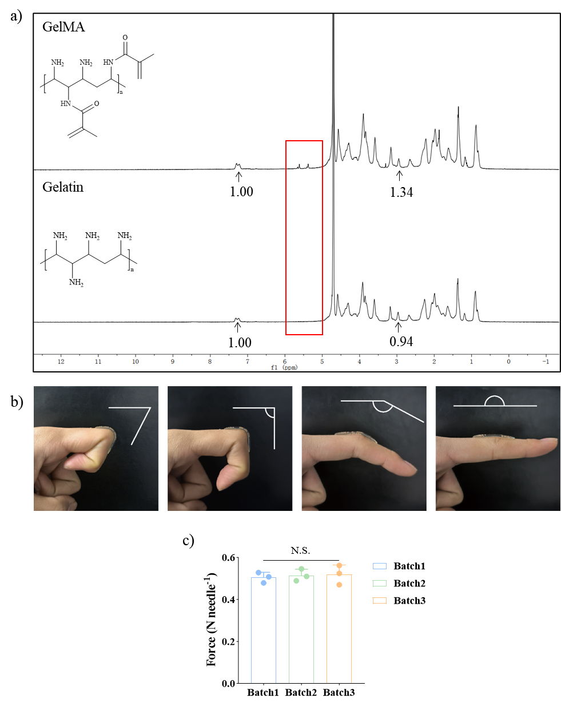
Fig. S2. (a) ¹HNMR spectra of GelMA and Gelatin. (b) Representative images showing the adhesive performance of 15% GelMA/5% PEGDA hydrogels under different bending angles. (c) Quantitative analysis of lowest tip fracture force of different batches of G15P5 microneedles.
Fig. S3. (a) Photothermal profiles of MoS₂ NSs solutions. (b) Photothermal profiles of 15%GelMA-5%PEGDA hydrogels loaded with different masses of MoS₂ NSs. (c) Heating and cooling profile of MoS₂@MNs (1 mg MoS₂ NSs) under NIR (808 nm, 1 W/cm²). (d) Efficiency of photothermal conversion in MoS₂@MNs. (e) Temperature changes of MoS₂@MNs (100 μg MoS₂ NSs) under different laser intensity. (f) Cyclic irradiation stability test of MoS₂@MNs (100 μg MoS₂ NSs) across five on/off cycles under NIR (808 nm, 1 W/cm²).
Fig. S4. Quantitative analysis of (a) S. aureus growth curve under different treatments. Determination of the half-maximal inhibitory concentration (IC₅₀) of MTF@MNs+NIR treatment against S. aureus (b) and E. coli (c). Antibacterial rate by bacteria agar plate counting assay of (d) E. coli and (e) S. aureus. Quantitative analysis of inhibition zone diameter of different treatments against (f) E. coli and (g) S. aureus. (h) Live/dead staining of S. aureus under different treatments. Data are presented as mean ± SD (n = 3). *P <0.05, **P <0.01, ***P < 0.001, ****P < 0.0001; N.S. denotes non-significant difference.
Fig. S5. Quantitative analysis of residual (a) E. coli biofilms and (b) S. aureus biofilms. Data are presented as mean ± SD (n = 3). *P <0.05, **P <0.01, ***P < 0.001, ****P < 0.0001.
Fig. S6. ROS scavenging of (a) L929 cells and (b) RAW 264.7 under different treatments (1 μmol/mL H₂O₂).
Fig. S7. (a) Illustration of cells-microneedles co-cultured models. (b) CCK-8 assay of L929 cells cultured with various microneedles for 1, 3 and 7 days. (c) Live and dead staining images of L929 cells incubated with different microneedles for 1, 3 and 7 days. (d) Hemolysis assay of Triton, PBS, MNs, MX@MNs, MTF@MNs and MTF@MNs+NIR. (e) Quantitative analysis of OD₅₄₀ from hemolysis experiments of RBC under different treatments. Data are presented as mean ± SD (n = 3). *P < 0.05, **P < 0.01, ***P < 0.001, ****P < 0.0001; N.S. denotes non-significant difference.
Fig. S8. (a) Images of L929 cells migration assay. (b) Quantitative analysis of the wound healing ratio of L929 cells under different treatments. (c) Images of tube formation of HUVECs assay. (d) Quantitative analysis of the number of angiogenesis nodes. Data are presented as mean ± SD (n = 3). *P < 0.05, **P < 0.01, ***P < 0.001, ****P < 0.0001; N.S. denotes non-significant difference.

Fig. S9. (a) Semi-quantitative fluorescence intensity analysis of Arg-1 expression. (b) Semi-quantitative fluorescence intensity analysis of CD206 expression. (c) Immunofluorescent staining of TNF-α under different treatments (red: TNF-α, blue: Hoechst). (d) Quantitative analysis of TNF-α gene expression in different group. (e) ELISA analysis of secreted TNF-α concentration after different treatments. (f) Semi-quantitative fluorescence intensity analysis of TNF-α after different treatments. (g) Protein expression of TNF-α and GAPDH analyzed by western blot. (h) Protein expression of TNFRSF1B and GAPDH analyzed by western blot. Data are presented as mean ± SD (n = 3). *P < 0.05, **P < 0.01, ***P < 0.001, ****P < 0.0001; N.S. denotes non-significant difference.
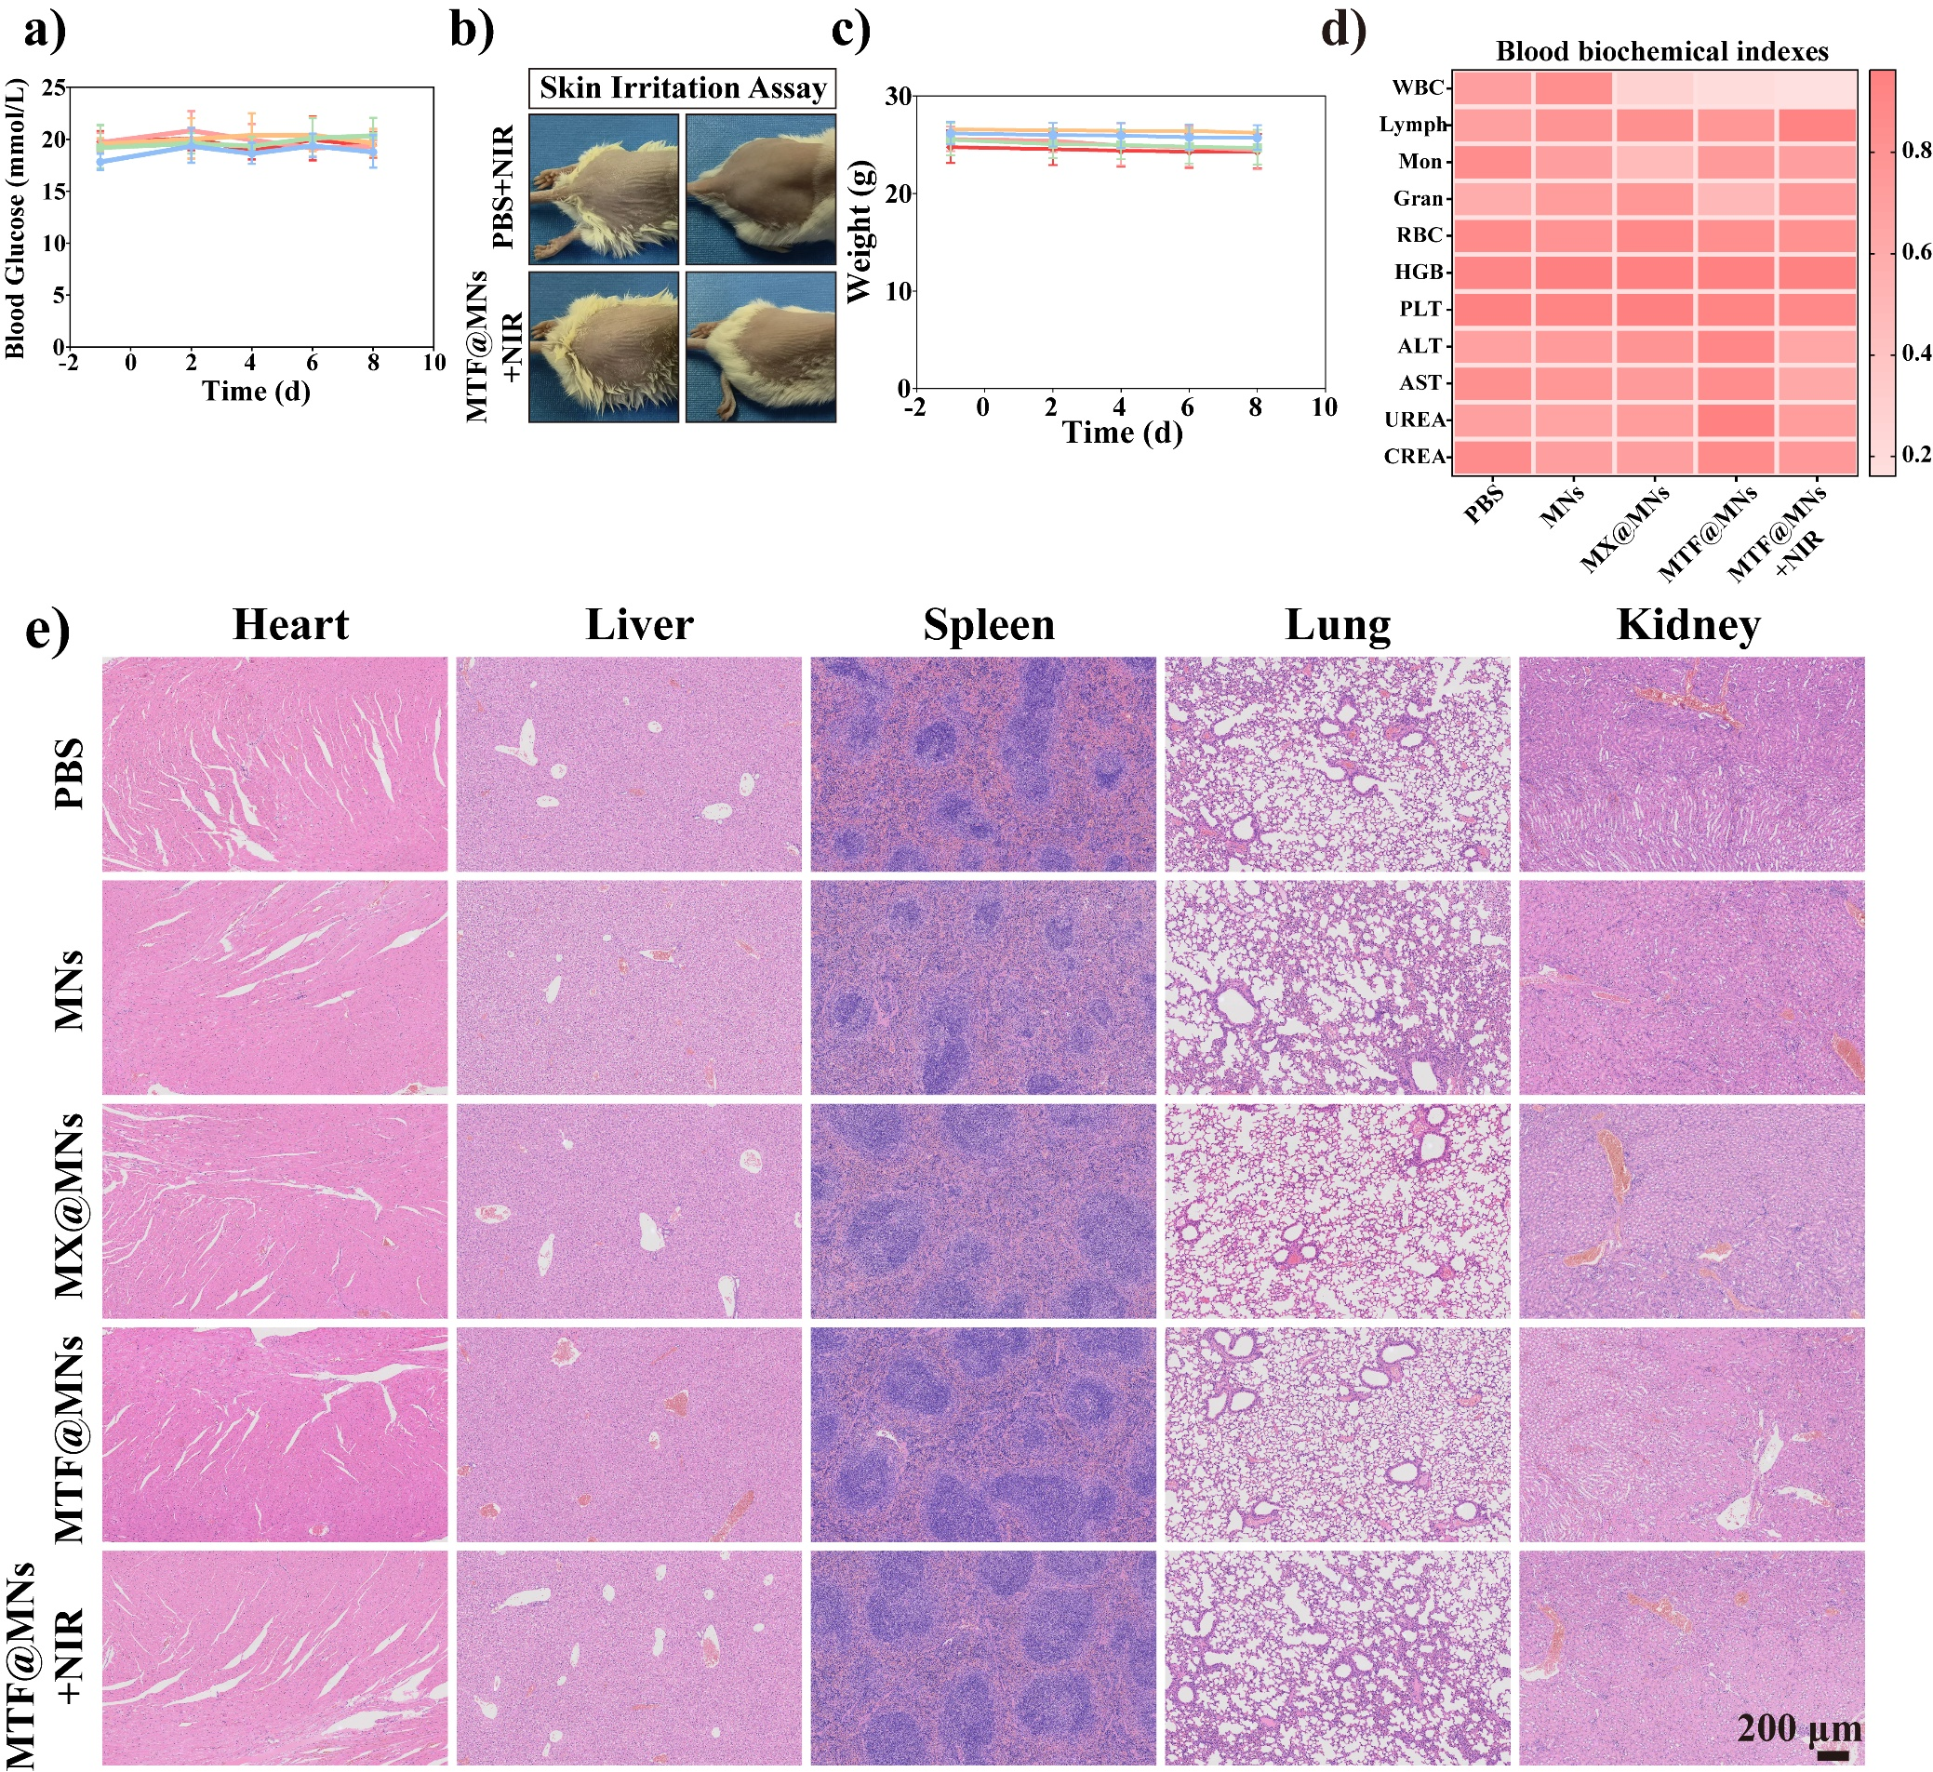
Fig. S10. (a) Changes in blood glucose of mice in each group during treatment. (b) In vivo skin irritation assay over the mice. (c) Weight changes among mice during treatment. (d) The heat map of mice routine blood test and liver and kidney blood biochemical indexes. (e) HE staining images of major organs (heart, liver, spleen, lung, kidney). Data are presented as mean ± SD (n = 5).
Fig. S11. (a) Quantitative analysis of fluorescence intensity of muscle fibers and collagen fibers deposition area in mice wound tissue. (b) Quantitative analysis of fluorescence intensity of CD86 in wound tissue. Representative immunohistochemical staining images of (c) TNF-α, (d) VEGF and (e) Ki-67 in wound after different treatments on day 8. Quantitative analysis of fluorescence intensity of (e) TNF-α, (f) VEGF and (h) Ki-67 in mice wound tissue. Data are presented as mean ± SD (n = 5). *P < 0.05, **P < 0.01, ***P < 0.001, ****P < 0.0001; N.S. denotes non-significant difference.
Fig. S12. ICP-MS analysis of (a) Ti and (b) Fe content in major organs (Heart, Liver, Spleen, Lung, Kidney) and the wound site from mice treated with PBS or MTF@MNs+NIR. (c) Quantitative analysis of iron ion concentration in blood biochemistry. Data are presented as mean ± SD (n = 5). ****P < 0.0001; N.S. indicates no significant difference.
Table S1. Primers used in this work.
Name | Catalog Number
Mouse IL-1β qPCR Primer Pair (Beyotime) | QM03422S
Mouse MAPK14 qPCR Primer Pair (Beyotime) | QM06170S
Mouse MAP2K3 qPCR Primer Pair (Beyotime) | QM06102S
Mouse RIPK2 qPCR Primer Pair (Beyotime) | QM08110S
Mouse MTOR qPCR Primer Pair (Beyotime) | QM06702S
Mouse AKT1 qPCR Primer Pair (Beyotime) | QM01138S
Mouse TNFRSF-1β qPCR Primer Pair (Beyotime) | QM05550S
Mouse TRAF1 qPCR Primer Pair (Beyotime) | QM05622S
Mouse TRAF2 qPCR Primer Pair (Beyotime) | QM05626S
Mouse CD206 qPCR Primer Pair (Beyotime) | QM17174S
Mouse ARG1 qPCR Primer Pair (Beyotime) | QM09790S
Mouse TNF-α qPCR Primer Pair (Beyotime) | QM05522S
Table S2. Antibody used in this study.
Antibody | Catalog Number
TNF-alpha Polyclonal Antibody (Rabbit) | 17590-1-AP
CD206 Polyclonal Antibody (Rabbit) | 18704-1-AP
Arginase-1 Polyclonal Antibody (Rabbit) | 16001-1-AP

