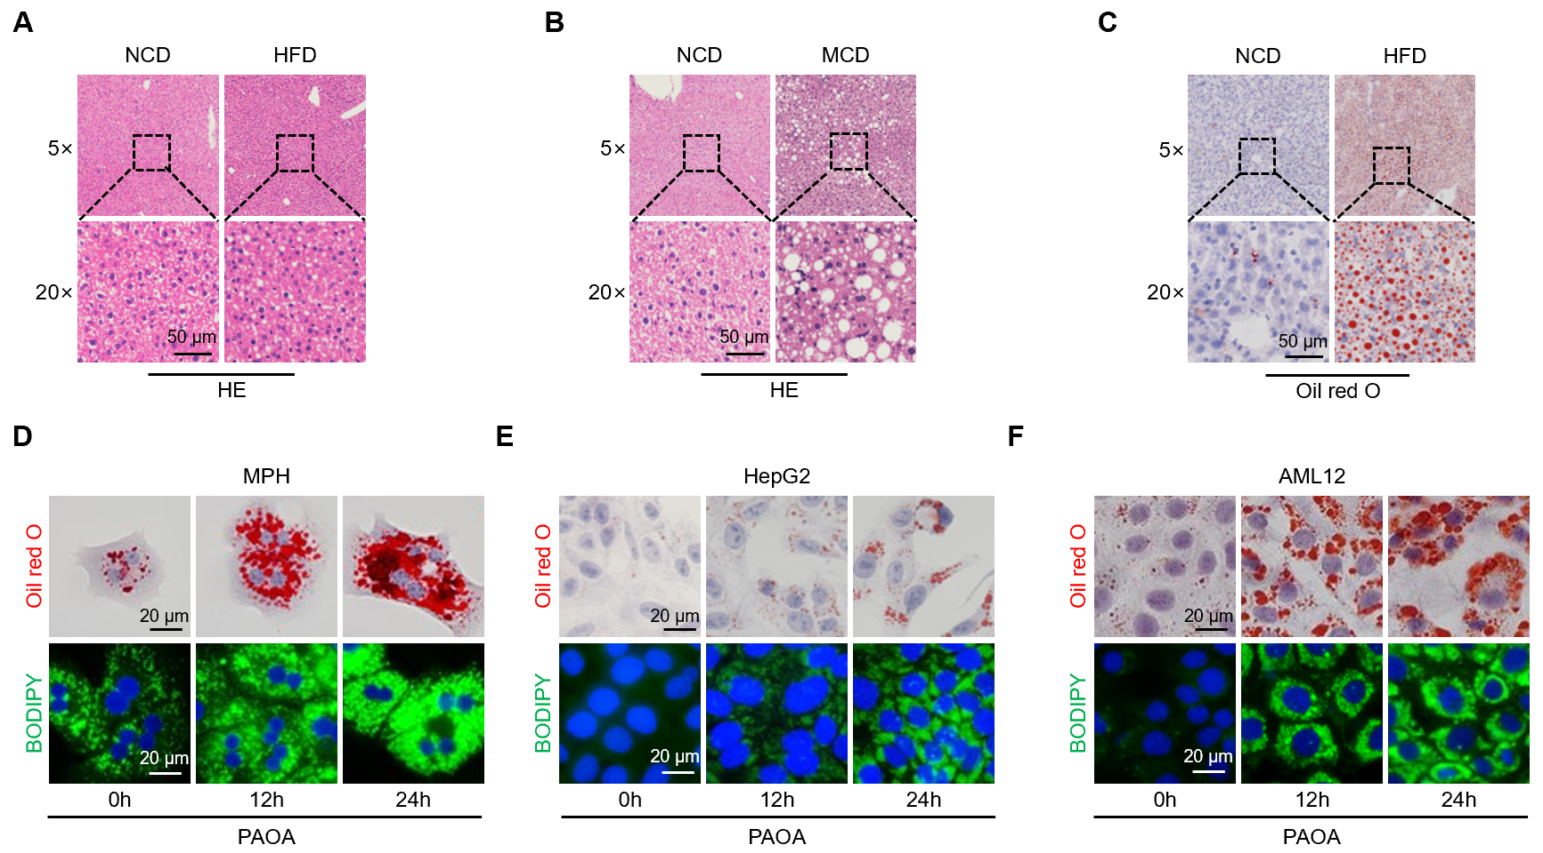
Figure S1. Immunohistochemistry and immunofluorescence staining of tissue sections.
A Hematoxylin and eosin (HE) staining images of liver tissue sections from mice fed a normal diet and a high-fat diet (HFD). Scale bar, 50 μm. B HE staining images of liver tissue sections from mice fed a normal diet and a methionine-choline-deficient (MCD) diet. Scale bar, 50 μm. C Oil Red O staining results of liver frozen sections from mice fed a normal diet and a high-fat diet. Scale bar, 50 μm. D-F Oil Red O and BODIPY staining were used to detect intracellular lipid droplets in MPH, HepG2 and AML12 after treatment with 1 mM PAOA for 0, 12, and 24 hours, respectively. Scale bar, 20 μm.

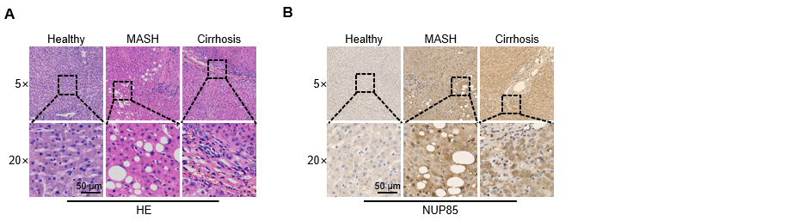
Figure S2. Immunohistochemical staining of human tissue samples.
A HE staining images of liver tissue sections from healthy individuals and patients with metabolic-associated steatotic hepatitis (MASH). Scale bar, 50 μm. B Representative immunohistochemical staining images of NUP85 expression in liver tissue from normal subjects, MASH patients, and cirrhosis patients. Scale bar, 50 μm.

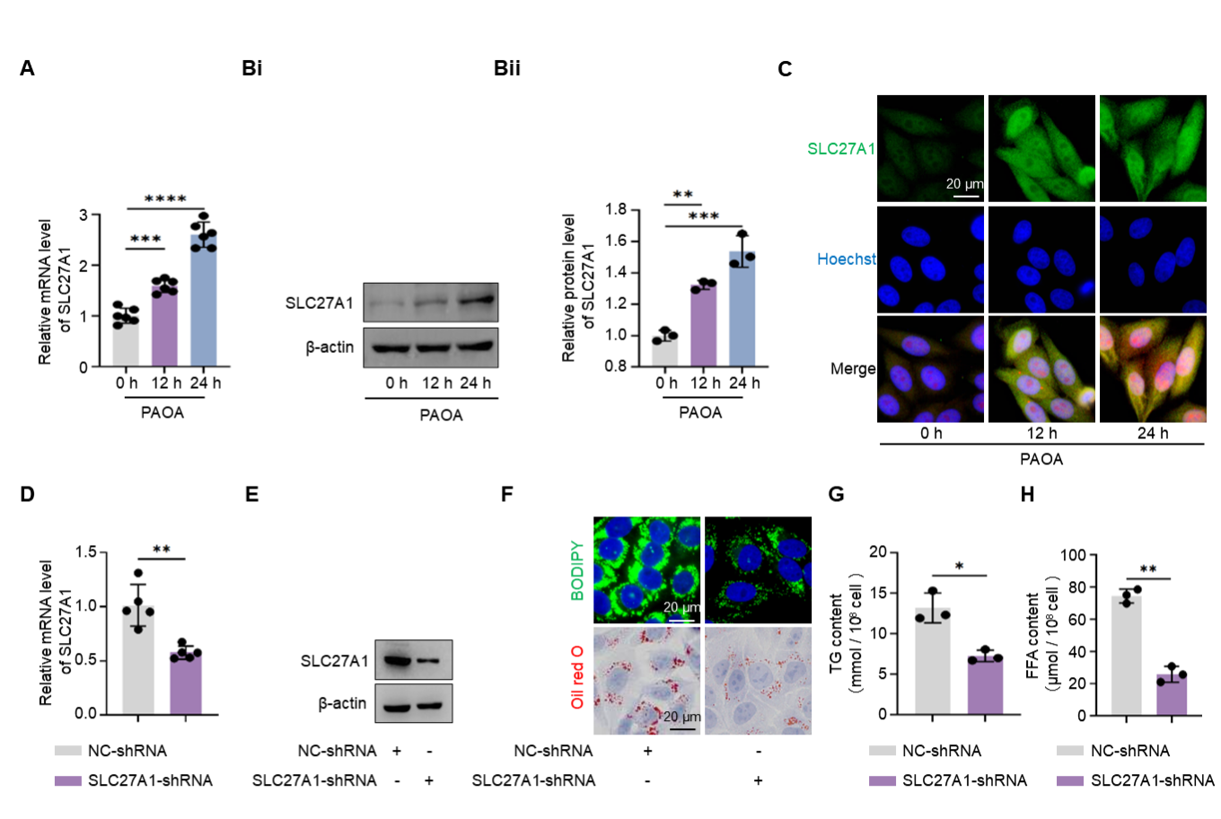
Figure S3. SLC27A1 promotes lipid deposition in hepatocytes.
A qRT-PCR was utilized to measure the relative levels of SLC27A1 mRNA in HepG2 cells treated with 1 mM PAOA for 0, 12, and 24 hours (n = 6). B Western blot was employed to assess the expression and statistical results of SLC27A1 protein in HepG2 cells treated with 1 mM PAOA for 0, 12, and 24 hours, respectively (n = 3). C Immunofluorescence results showed SLC27A1 (green) in HepG2 cells following treatment with 1 mM PAOA for 0, 12, and 24 hours, respectively. Scale bar, 20 μm. D qRT-PCR was conducted to evaluate the mRNA expression level of SLC27A1 after transfection with SLC27A1-shRNA (n = 5). E Western blot was performed to determine the protein expression level of SLC27A1 following transfection with SLC27A1-shRNA. F BODIPY and Oil Red O staining were utilized to visualize intracellular lipid droplets in cells transfected with SLC27A1-shRNA and induced by 1 mM PAOA. Scale bar, 20 μm. G-H A triglyceride detection kit and a free fatty acid kit were used to quantify the levels of TG (G) and FFA (H) in HepG2 cells transfected with SLC27A1-shRNA and induced by 1 mM PAOA (n = 3). All data are expressed as the mean ± SD. ns: no significance; * P < 0.05; ** P < 0.01; *** P < 0.001.

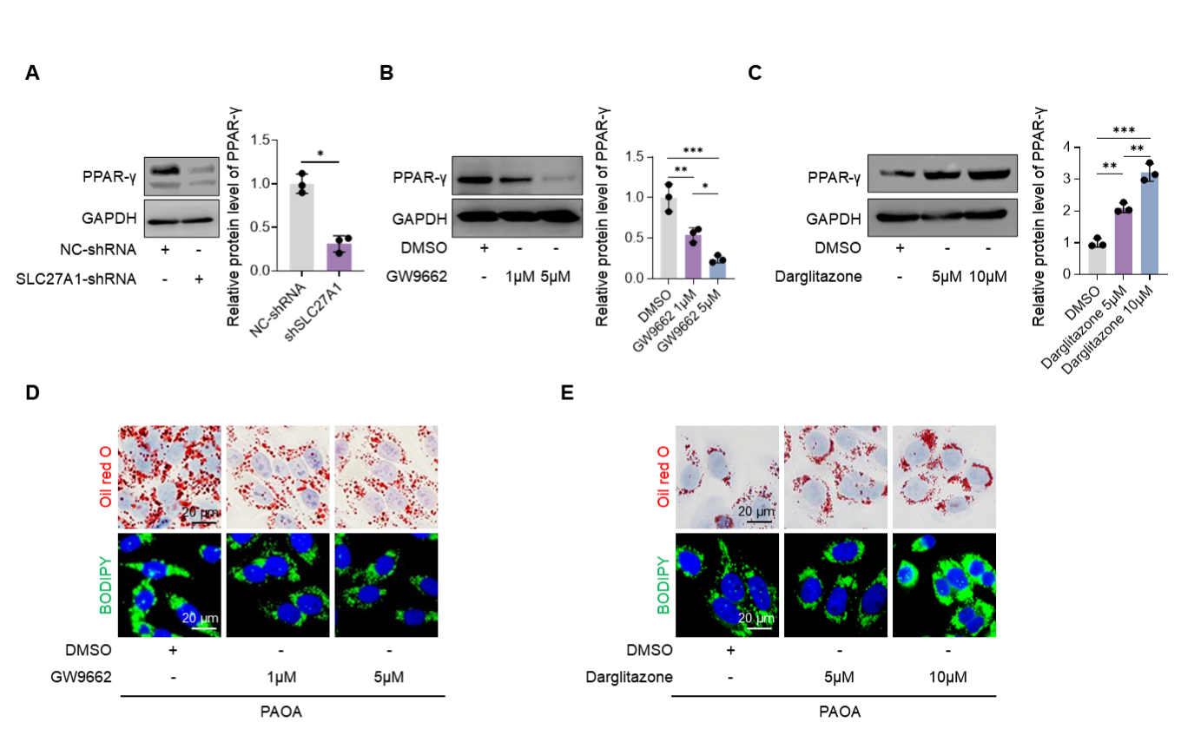
Figure S4. HepG2 cells were treated with PPAR-γ pathway inhibitors and agonists.
A Western blot detects the expression of PPAR-γ protein following transfection with SLC27A1-shRNA. B Western blot detects the expression level of PPAR-γ protein in HepG2 cells treated with DMSO or different concentrations (1 μM or 5 μM) of GW9662 respectively. C Western blot detects the expression level of PPAR-γ protein in HepG2 cells treated with DMSO or different concentrations (5 μM or 10 μM) of Darglitazone respectively. D Oil red O staining and BODIPY staining detected intracellular lipid droplets in HepG2 cells treated with DMSO or different concentrations (1 µM or 5 µM) of GW9662, respectively. Scale bar, 20µm. E Oil red O staining and BODIPY staining detected intracellular lipid droplets in HepG2 cells treated with DMSO or different concentrations (5 µM or 10 µM) of Darglitazone, respectively. Scale bar, 20µm.
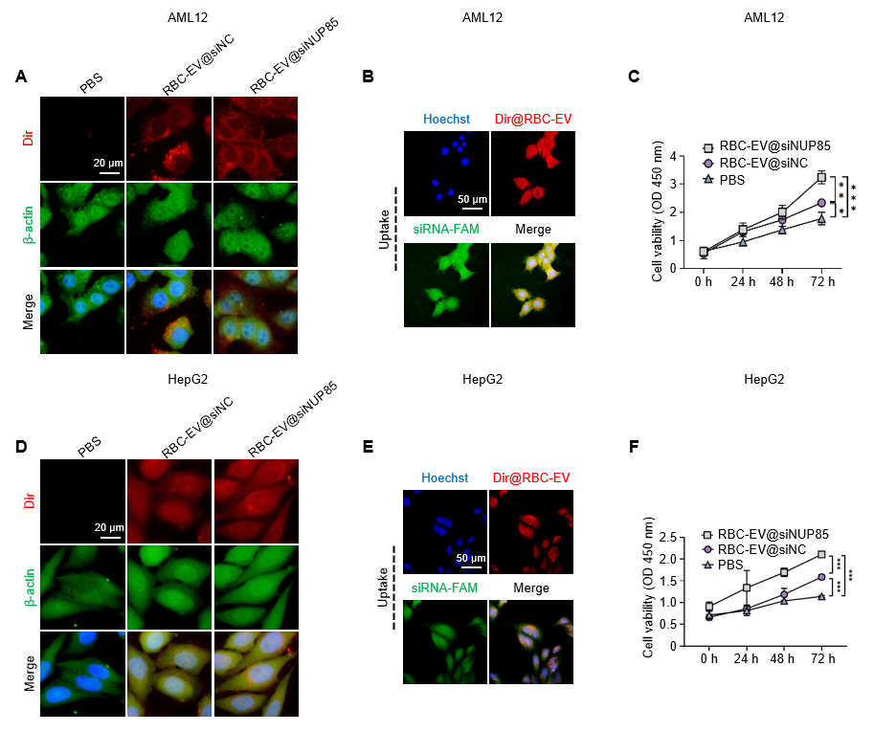
Figure S5. RBC-EVs internalization experiment and cell viability detection.
A Internalization of DIR-labeled RBC-EVs@NC and RBC-EVs@siNup85 into AML12. Scale bar, 20 μm. B Colocalization of DIR-labeled RBC-EVs and FAM-labeled siRNA in AML12 cells using fluorescence microscopy. Scale bar, 50 µm. C CCK-8 method was used to determine the effects of RBC-EVs@siNC and RBC-EVs@siNup85 on the proliferation of AML12 cells (n = 3). D Internalization of DIR-labeled RBC-EVs@siNC and RBC-EVs@siNUP85 into HepG2. Scale bar, 20 μm. E Colocalization of DIR-labeled RBC-EVs and FAM-labeled siRNA in HepG2 cells using fluorescence microscopy. Scale bar, 50 µm. F CCK-8 method was used to determine the effects of RBC-EVs@siNC and RBC-EVs@siNUP85 on the proliferation of HepG2 cells (n = 3).
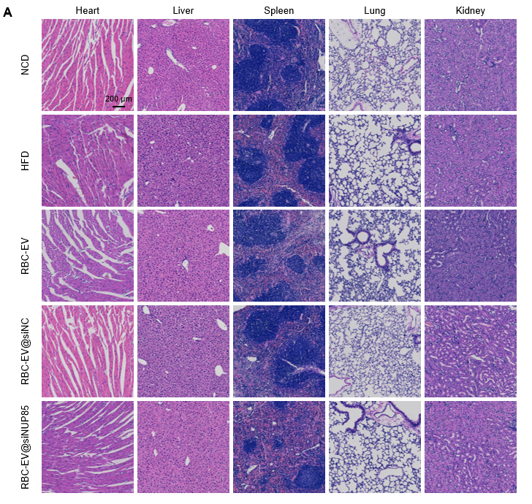 Figure S6. Biosafety of RBC-EV@siNup85.
A H&E staining of the liver, heart, spleen, lung, and kidney of the treated mice showed that injection of RBC-EV@siNup85 did not produce obvious pathological abnormality, indicating their good biosafety. Scale bars, 200 µm.

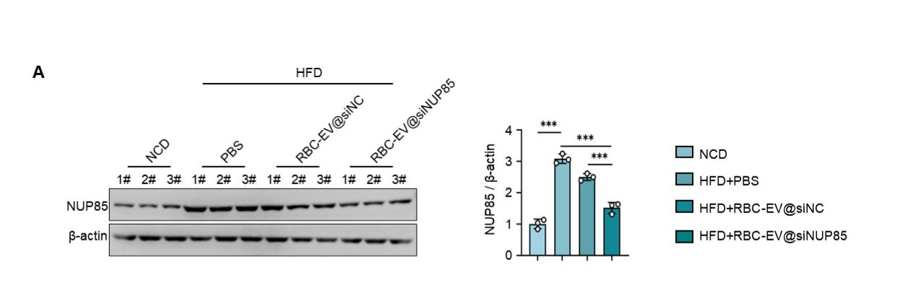
Figure S7. RBC-EV@siNup85 inhibits NUP85 expression in liver tissue of HFD mice.
A Western blot detects the NUP85 protein expression (n = 3) in the liver tissue of NCD-fed mice and HFD-fed mice injected with PBS, RBC-EV@siNC and RBC-EV@siNup85 through the tail vein. (n = 3).

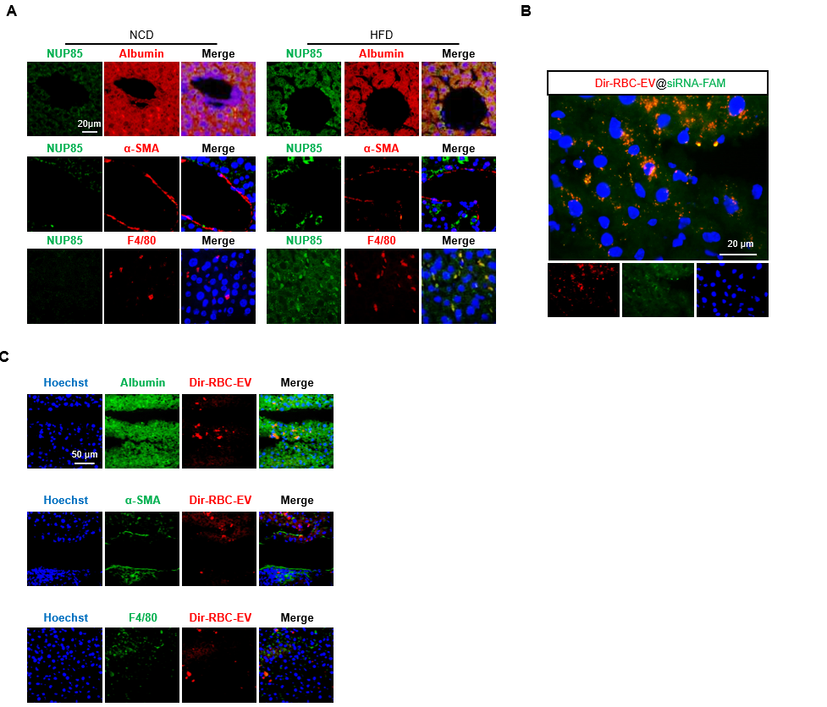
Figure S8. RBC-EV@siNup85 specifically targets NUP85 expression in hepatocytes.
A Co-localization of NUP85 (green), the hepatocyte marker albumin, the hepatic stellate cell marker α-SMA, and the hepatic macrophage marker F4/80 (red) in the livers of mice fed a normal diet and a high-fat diet. Scale bar, 20 μm. B Localization of Dir-labeled RBC-EV (red) and FAM-siRNA (green) in the liver of HFD-fed mice injected with RBC-EVs. Scale bar, 20µm. C Co-localization of Dir-RBC-EV (red) with the hepatocyte marker Albumin, the hepatic stellate cell marker α-SMA and the hepatic macrophage marker F4/80 (green) in mouse liver tissue. Scale bar, 50 µm.

