Reinvigorating CD8⁺ T Cells through ADRB1 Blockade Using Copper-Propranolol Nanoparticles for Enhanced Immune Checkpoint Blockade Therapy
Binshu Weng, Nan Zhu, Huirong Li, Lishan Ding, Yutong Wu, Ying Chen, Yijie Xi, Lifan Lin, Jiawen Chen, Le Xin, Jinjun Ye*, Yanfeng Hu*, Guoxin Li*, Weihong Guo*

Including affiliation:
B. Weng, N. Zhu, Y. Wu, Y. Chen, Y. Xi, L. Lin, J. Chen, Y. Hu, G. Li, W. Guo
Department of General Surgery
Nanfang Hospital, Southern Medical University
Guangzhou 510515, China

N. Zhu, L. Ding, G. Li
Cancer Center of Beijing Tsinghua Changgung Hospital
School of Clinical Medicine, Tsinghua Medicine, Tsinghua University
Beijing 102218, China

H. Li, J. Ye
Shenzhen Clinical Medical College, Guangzhou University of Chinese Medicine
Guangzhou 510006, China

L. Xin, J. Ye
Department of General Surgery
Longgang Central Hospital of Shenzhen
Shenzhen 518100, China

E-mail:
J. Ye: yejj610@163.com;
Y. Hu: banby@smu.edu.cn
G. Li: lgxa04510@btch.edu.cn;
W. Guo: gwh2823@smu.edu.cn.

Binshu Weng, Nan Zhu, Huirong Li and Lishan Ding contributed equally to this work.

Experimental Section
Materials
Cupric acetate anhydrous (Cu(OAc)₂), mPEG-SH (Mw 5000) were purchased from Macklin (Beijing, China). Propranolol hydrochloride, L-Epinephrine were purchased from MedChemExpress (MCE, USA). BeyoClick™ EdU Cell Proliferation Kit with AF488, Calcein/PI Cell Viability/Cytotoxicity Assay Kit were purchased from Beyotime (Shanghai, China). Annexin V-FITC/PI Apoptosis Detection Kit was purchased from DOJINDO LABORATORIES (Kumamoto, Japan). CRT, HMGB1, MEK, Phospho-MEK, ERK, Phospho-ERK antibodies were acquired from Cell Signaling Technology (USA). FDX1, DLAT, CREB, Phospho-CREB, ADRB1 and β-actin antibodies were acquired from Proteintech (Wuhan Sanying, China). LIAS antibody was acquired from Affinity Biosciences (USA).

Cell Lines and Animals
CT26 cell lines were purchased from the American Type Culture Collection (ATCC). Four-week-old male BALB/c mice were obtained from the Animal Experimental Center of Guangdong Provincial Center for Experimental Animals. All animal procedures were approved by the Medical Ethics Committee of the Southern Medical University (No.IACUC-LAC-20250529-003).

Synthesis of Cu-PN NPs
Cupric acetate (49.913 mg) and propranolol hydrochloride (129.674 mg) were weighed and dissolved in 20 mL deionized water (ddH₂O). The system pH was adjusted to 9 using NaOH solution. Subsequently, the reaction mixture was stirred for 6 hours under room temperature and dark conditions. After centrifugation and washing, the Cu-PN complex precipitate was obtained. mPEG (200 mg) was weighed and dissolved in 20 mL ddH₂O. The obtained Cu-PN complex precipitate was added dropwise to the mPEG-SH (MW 5000 Da) solution and stirred for another 2 hours under room temperature and dark conditions to yield the Cu-PN NPs solution. The mass ratio between the Cu-PN complex and mPEG-SH was optimized to 1:1, as this formulation consistently produced nanoparticles with the most favorable physicochemical characteristics. Based on the 1:1 molar ratio of the core coordination complex, the calculated mass ratio of copper to propranolol (m~Cu~ : m~PN~) in the nanoparticles is approximately 1:4.08. The solution was then washed three times with ddH₂O, centrifuged, and lyophilized to obtain Cu-PN NPs powder.

Drug Release Experiment
The release profile of Propranolol from Cu-PN NPs was determined using a dialysis method. Briefly, 1 mL of Cu-PN NPs dispersion was sealed in a dialysis bag (MWCO 3500) and immersed in 39 mL of PBS at different pH values (7.4, 6.5, 5.3). The system was incubated at 37°C with shaking at 100 rpm under light-protected conditions. At predetermined time intervals over 24 hours, 1 mL of the external PBS release medium was sampled and replaced with an equal volume of fresh PBS at the corresponding pH. The concentration of Propranolol in the sampled solutions was quantified by measuring the absorbance using UV-Vis spectroscopy at 290 nm against a standard calibration curve. The cumulative drug release was calculated using the following equation:
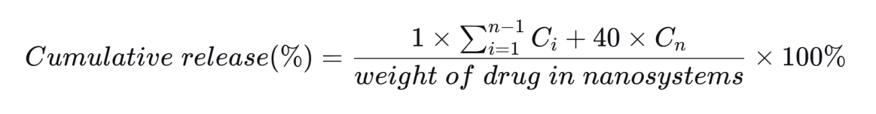
where Ci represents the concentration of Propranolol at the i-th sampling point, and Cn is the concentration at the n-th sampling point.

Characterization of Cu-PN NPs
The morphology and elemental composition of Cu-PN NPs were observed using transmission electron microscopy and elemental mapping. The hydrodynamic diameter and Zeta potential of Cu-PN NPs were measured by dynamic light scattering (DLS). The composition of Cu-PN NPs was analyzed using ultraviolet-visible spectroscopy (UV-Vis), Fourier transform infrared spectroscopy (FT-IR), and X-ray photoelectron spectroscopy (XPS).

Cytotoxicity of Cu-PN NPs at Various Concentrations
CT26 cells were seeded in 96-well plates at a density of 5×10³ cells per well and incubated at 37℃ for 24 hours. After cell attachment, fresh medium containing 0, 10, 20, 30, 40, 50, 60, 70 μg/mL Cu-PN NPs was added, and incubation continued for 24 hours. CCK-8 detection reagent was added, and the OD value was measured at 450 nm using a microplate reader.

Comparative Cytotoxicity of Different Drug Components
CT26 cells were seeded in 96-well plates at a density of 5×103 cells per well and incubated at 37℃ for 24 hours. After cell attachment, fresh medium containing PBS,Cu(OAc)2, Propranolol, or Cu-PN NPs was added, and incubation continued for 24 hours. CCK-8 detection reagent was added, and the OD value was measured at 450 nm using a microplate reader.

EDU Cell Proliferation Assay
CT26 cells were seeded in 24-well plates at a density of 2.5×10⁴ cells per well and incubated at 37℃ for 24 hours. After cell attachment, fresh medium containing PBS,Cu(OAc)₂, Propranolol, or Cu-PN NPs was added, and incubation continued for 24 hours. EDU labeling solution was added to each well and incubated for 2 hours. Cells were washed with PBS, fixed with 4% paraformaldehyde at room temperature for 30 min, washed again with PBS, permeabilized with 0.5% Triton X-100 at room temperature for 20 min, washed with PBS, incubated with EDU detection reaction solution in the dark at room temperature for 30 min, washed with PBS, stained with DAPI for 10 min, washed with PBS, and observed/photographed under a fluorescence microscope. Image J software was used to count EDU-positive cells and total cells.

Organoids culture:
The CRC PDO model was donated by Signet Therapeutics (Shenzheng,China). For passage, use TrypLE Express enzyme (Gibco) to dissociate organoids at 37 ℃ for 6 min. Mix cells (3 × 10⁵) with 200 μL Matrigel (Corning, 354234) on ice. Inoculate 6 portions of cell matrix gel suspension (25-30 μL each) into a 6-well plate. To polymerize the matrix gel, the plate was incubated upside down at 37 ℃ to prevent cells from adhering to the surface of the plate. After 5 min, restore the board to an upright position. Add 2.5 mL PDO medium (Advanced DMEM/F12 with 1X GlutaMax, 1X HEPES, 1X Penicillin Streptomycin Solution, 1X B-27, 50% L-WRN, 50ng/mL EGF, 200 ng/mL FGF10, 1mM N-acetylcysteine, 1nM Gastrin, 2 μM A83-01) to each well after 30min.

Western Blot Experiment
CT26 cells were seeded in 6-well plates and incubated at 37℃ until confluent. Fresh medium containing PBS, Cu(OAc)₂, Propranolol, or Cu-PN NPs was added, and incubation continued for 24 hours. Cells were scraped, centrifuged, and lysed on ice for 30 min in RIPA lysis buffer containing protease and phosphatase inhibitors (100:1). After high-speed centrifugation, the supernatant was collected, mixed with Loading Buffer, and heated at 100℃ for 10 min (DLAT was mixed with non-denaturing Loading Buffer and not heated), then stored at -80℃. Equal amounts of protein were electrophoresed and transferred to PVDF membranes. Membranes were blocked with 5% skim milk (or BSA for phosphoproteins) at room temperature for 1.5 hours, then incubated overnight at 4℃ with primary antibodies against MEK, p-MEK, ERK, p-ERK, CREB, DLAT, HSP70, LIAS, FDX1, and β-actin. After TBST washing, membranes were incubated with corresponding secondary antibodies at room temperature with shaking for 1.5 hours. Ultra-sensitive chemiluminescent solution was used for development.

Immunofluorescence Assay
CT26 cells were seeded in confocal dishes and incubated at 37℃ for 24 hours. Fresh medium containing PBS, Cu(OAc)₂, Propranolol, or Cu-PN NPs was added, and incubation continued for 24 hours. Cells were washed with PBS, fixed with 4% paraformaldehyde at room temperature for 30 min, washed with PBS, permeabilized with 0.5% Triton X-100 at room temperature for 20 min, washed with PBS, blocked with 5% BSA blocking solution at room temperature for 1 hour. Blocking solution was discarded, and primary antibodies against CRT or HMGB1 were added and incubated overnight at 4℃. After PBS washing, fluorescently labeled secondary antibodies of the corresponding species were added and incubated in the dark at room temperature for 1.5 hours. Cells were washed with PBS, stained with DAPI nuclear stain in the dark at room temperature for 10 min, and observed/photographed using a fluorescence microscope.

In vitro Induction of DC Maturation
Bone marrow cells were isolated from the femurs and tibias of 6-8 week-old BALB/c mice and seeded in 6-well plates at a density of 5×105 cells per well. Cells were cultured for 7 days at 37 ℃ in complete RPMI-1640 medium containing rmGM-CSF (20 ng/mL) and rmIL-4 (10 ng/mL) to generate BMDCs. CT26 cells were treated with medium containing PBS,Cu(OAc)₂, Propranolol, or Cu-PN NPs. After 24 hours, the supernatant was collected and co-cultured with the prepared BMDCs for 24 hours. BMDCs were collected, stained with anti-CD80 and anti-CD86 antibodies at 4℃ in the dark for 1 hour, washed with PBS, resuspended, and analyzed by flow cytometry.

In vitro Restoration of T Cell Function
CD8⁺ T cells were isolated from the spleens of 6-8 week-old BALB/c mice. Cells were seeded at a density of 5×10⁵ cells per well in 48-well plates pre-coated with anti-CD3 antibody (5 μg/mL), and soluble anti-CD28 antibody (2 μg/mL) was added. Cells were incubated at 37 ℃ for initial activation (3 days). On day 3, the medium was replaced with medium containing anti-CD3 antibody (5 μg/mL) and epinephrine (E, 10 μM) to induce exhaustion, along with fresh medium containing PBS,Cu(OAc)₂, Propranolol, or Cu-PN NPs. Within each group, cells were further divided into three subgroups: CD3-E- (no stimulation), CD3+E- (only anti-CD3 re-stimulation), CD3+E+ (anti-CD3 re-stimulation + epinephrine), and cultured for 7 days. On day 10, cells were harvested, washed with PBS, and stained with anti-PD-1, anti-Lag3, anti-TNF-α, and anti-IFN-γ antibodies at 4 ℃ in the dark for 45 min. After washing with PBS and resuspension, cells were analyzed by flow cytometry.

In vivo Antitumor Effect Assessment
CT26 cells in logarithmic growth phase (2×106 cells/mouse) were subcutaneously injected into the right flank of BALB/c mice to establish a tumor-bearing model. When tumor volume reached approximately 50 mm³, mice were randomly divided into four groups and administered PBS, Cu(OAc)₂, Propranolol, or Cu-PN NPs via tail vein injection. Tumor length (L) and width (W) were measured using calipers on days 0, 2, 4, 6, 8, 10, 12, and 14. Tumor volume was calculated using the formula V = 0.5×L×W². On day 14, mice were euthanized, tumors were completely excised, and tumor mass was weighed and recorded.

Near-Infrared Fluorescence Imaging for Biodistribution and Tumor Targeting
To evaluate the in vivo biodistribution and tumor-targeting capability of Cu-PN NPs, near-infrared fluorescence imaging was performed. CT26 tumor-bearing BALB/c mice (6-week-old male, tumor volume ≈ 100 mm³) were randomly divided into two groups (n = 3) and intravenously injected with free Cy5.5 or Cy5.5-labeled Cu-PN NPs (CuPN@Cy5.5 NPs), respectively. In vivo fluorescence imaging was conducted at 2, 8, 16, and 24 hours post-injection using an in vivo imaging system (IVIS) to monitor the real-time distribution of the agents. At 24 hours after administration, the mice were euthanized, and major organs (heart, liver, spleen, lung, kidney) together with tumors were harvested for ex vivo fluorescence imaging to quantitatively assess the accumulation of nanoparticles in various tissues.

IHC Analysis
Tumor tissues excised on day 14 of the in vivo antitumor experiment were fixed in 4% paraformaldehyde for 24 hours, paraffin-embedded, and sectioned at 4 μm thickness. Sections were deparaffinized in xylene, rehydrated through graded ethanol, and subjected to antigen retrieval in citrate buffer (pH 6.0) at 95 ℃ for 15 min. After cooling, endogenous peroxidase was blocked with 3% H₂O₂, and sections were blocked with 5 % BSA at room temperature for 1 hour. Sections were incubated overnight at 4 ℃ with primary antibodies against Ki67, FDX1, LIAS, p-ERK, or p-CREB. After PBS washing, HRP-labeled secondary antibodies were added and incubated at room temperature for 1 hour. DAB chromogen solution was used for color development, followed by hematoxylin counterstaining for 10 seconds. Sections were dehydrated through graded ethanol, cleared in xylene, and mounted with neutral resin. Observation was performed using an optical microscope.

In vivo Immune Effect Assessment
Tumor tissues excised on day 14 of the in vivo antitumor experiment were mechanically minced and digested with collagenase IV (1 mg/mL) and DNase I (0.5 mg/mL) at 37 ℃ for 30 min to prepare single-cell suspensions. After red blood cell lysis, cells were washed with PBS. Cells were aliquoted and stained with antibodies against CD80, CD86, CD8, PD-1, Lag3, TNF-α, IFN-γ, CD4, CD25, and Foxp3 (for intracellular staining of TNF-α, IFN-γ, and Foxp3, cells were first permeabilized for 40 min) at 4 ℃ in the dark for 45 min. After washing with PBS and resuspension, cells were analyzed by flow cytometry.
The gating strategy was shown as the following: representative flow cytometry plots show the sequential gating strategy used to identify CD3⁺CD8⁺ T cells from single-cell suspensions of tumor tissues. Cells were first gated on lymphocytes based on FSC-A and SSC-A, followed by selection of single cells using FSC-H vs FSC-A. CD45⁺leukocytes were then identified, from which CD3⁺CD8⁺T cell populations were analyzed. The percentage values indicate the proportion of parent population at each gating step (Figure S17).

Figure S1. Stability evaluation of Cu-PN NPs under physiological conditions. The hydrodynamic diameter of Cu-PN NPs was monitored over 7 days in 5% BSA solution at pH 7.4 and 37℃. Data are presented as mean ± standard deviation. (n=3).

Figure S2. Release profile of propranolol from Cu-PN NPs under different pH conditions (pH 5.3, pH 6.5, and pH 7.4).
Figure S3. Stability evaluation of CU-PN NPs over 7 days.The three-dimensional plot depicts the evolution of absorbance as a function of wavelength (200-800 nm) from Day 0 to Day 7.

Figure S4. Images of CRC PDOs from different groups at the beginning and the end of treatments. Scale bar: 100 μm. n=3.

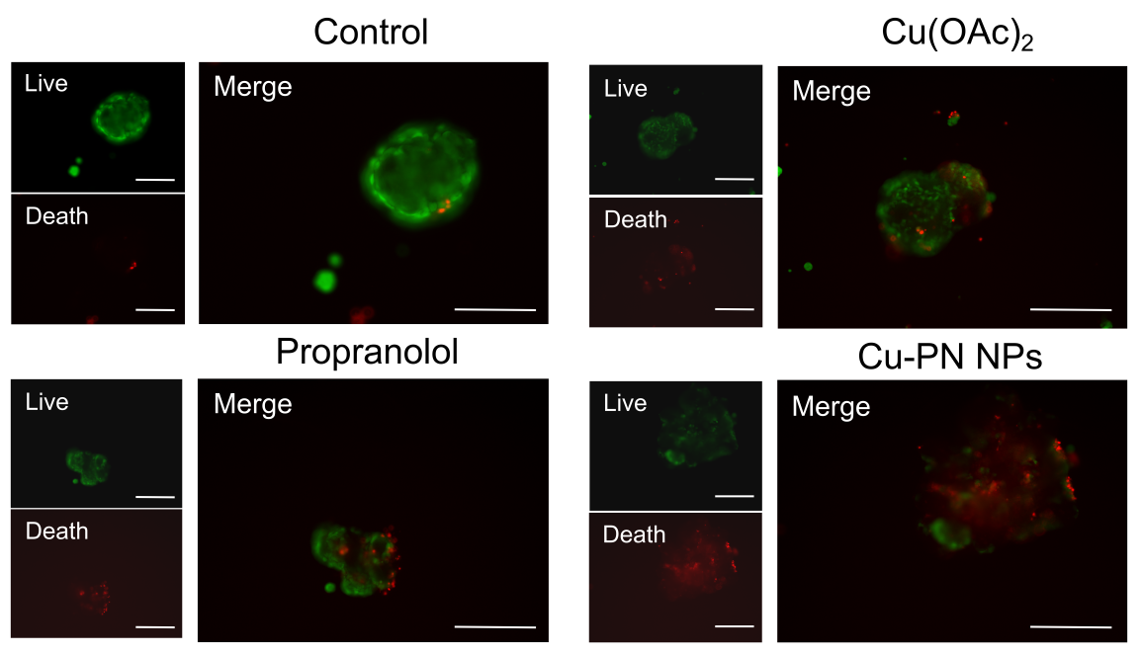
Figure S5. Fluorescence microscopy images of live/dead staining of CRC PDOs after various treatments. Scale bar: 75 μm. n=3.
.
Figure S6. The copper chelator TTM reverses the cytotoxicity of Cu-PN NPs. Cell viability of CT26 cells was assessed by CCK-8 assay after treatment with TTM alone, Cu-PN NPs + TTM, or PN (Propranolol) + TTM. Data are presented as mean ± standard deviation. ****P < 0.0001.

Figure S7. Quantitative analysis of apoptosis-related protein expression. Densitometric analysis of Western blot bands from Figure 3A. Data are presented as mean ± standard deviation. *P < 0.05, **P < 0.01, ***P < 0.001, ****P < 0.0001, ns, not significant.

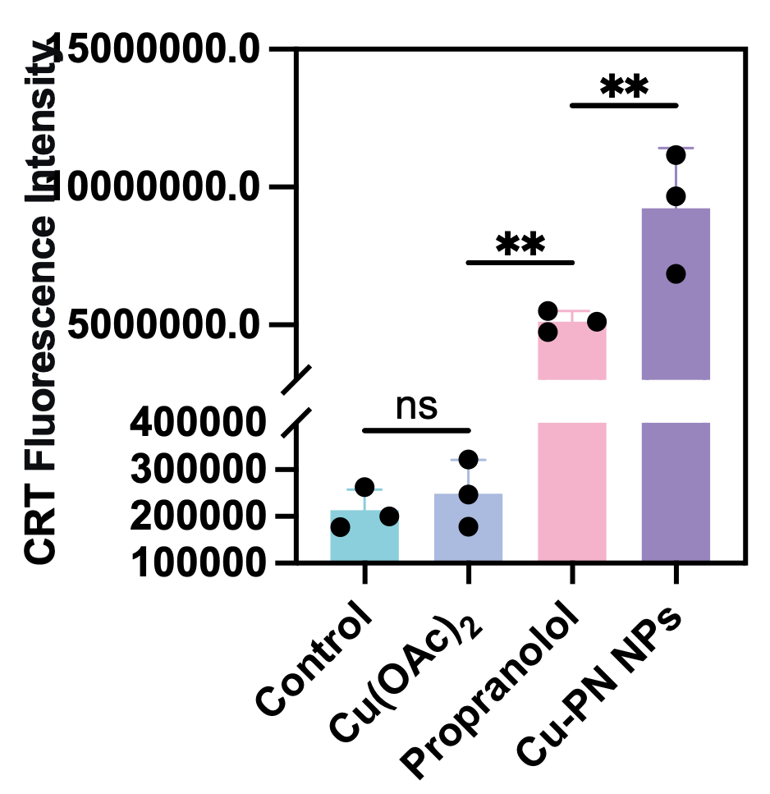
Figure S8. Quantification of the CRT means fluorescence intensity in CT26 cells after different treatments . Data are presented as means ± SD. **P < 0.01, ns, not significant.

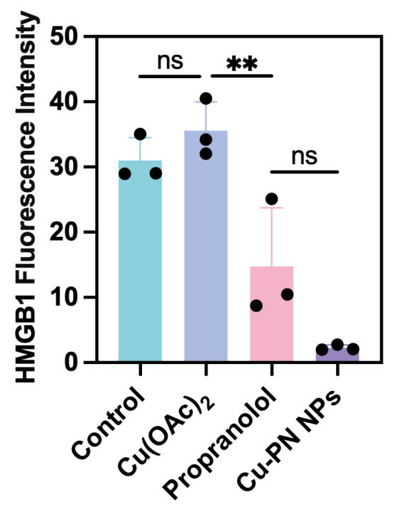
Figure S9. Quantification of the HMGB1 means fluorescence intensity in CT26 cells after different treatments . Data are presented as means ± SD. **P < 0.01, ns, not significant.

Figure S10. Protein expressions of ADRB1 and β-actin in CD8⁺T cells determined by Western blot.

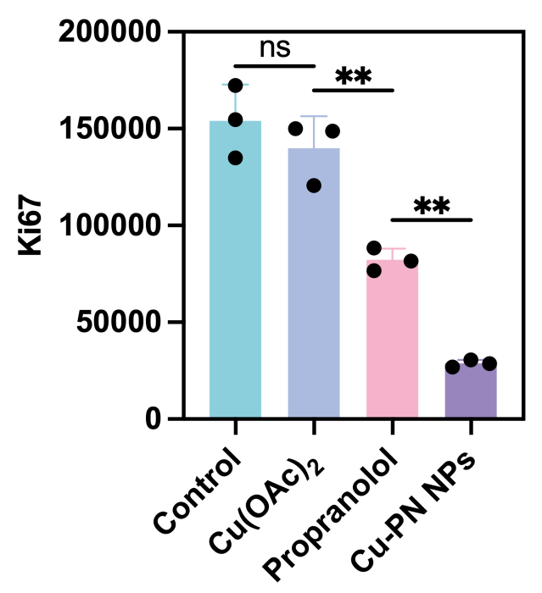
Figure S11. Quantification of the average IHC staining intensity of Ki67 in tumor tissue after receiving different treatments . Data are presented as mean ± standard deviation. **P < 0.01, ns, not significant.

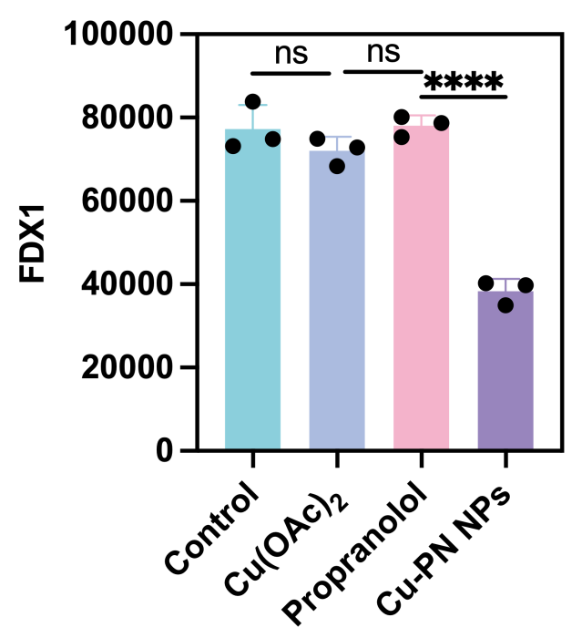
Figure S12. Quantification of the average IHC staining intensity of FDX1 in tumor tissue after receiving different treatments . Data are presented as mean ± standard deviation. ****P < 0.0001, ns, not significant.

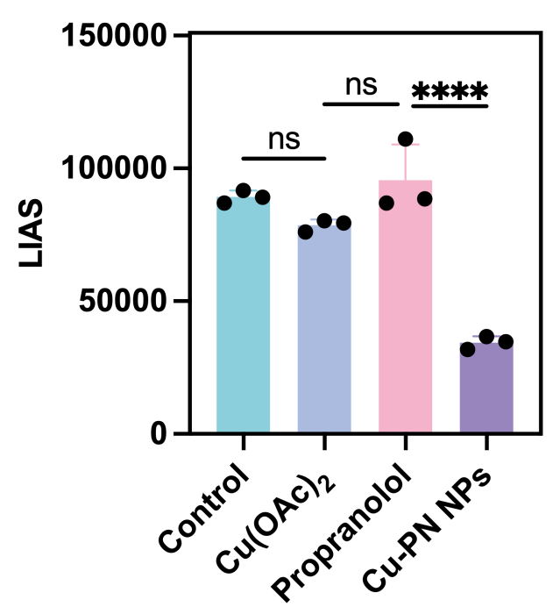
Figure S13. Quantification of the average IHC staining intensity of LIAS in tumor tissue after receiving different treatments . Data are presented as mean ± standard deviation. ****P < 0.0001, ns, not significant.

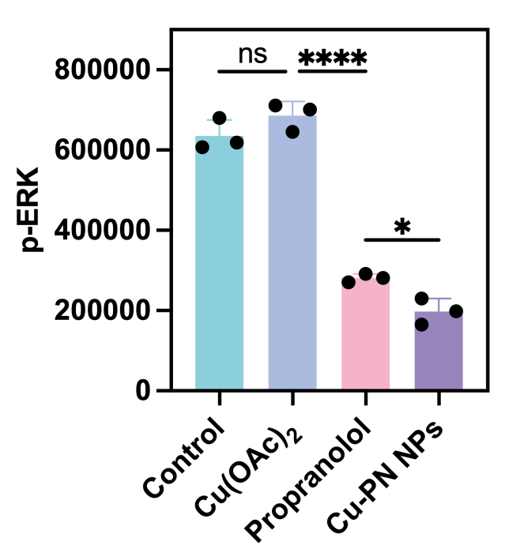
Figure S14. Quantification of the average IHC staining intensity of p-ERK in tumor tissue after receiving different treatments . Data are presented as mean ± standard deviation. *P < 0.05,****P < 0.0001, ns, not significant.

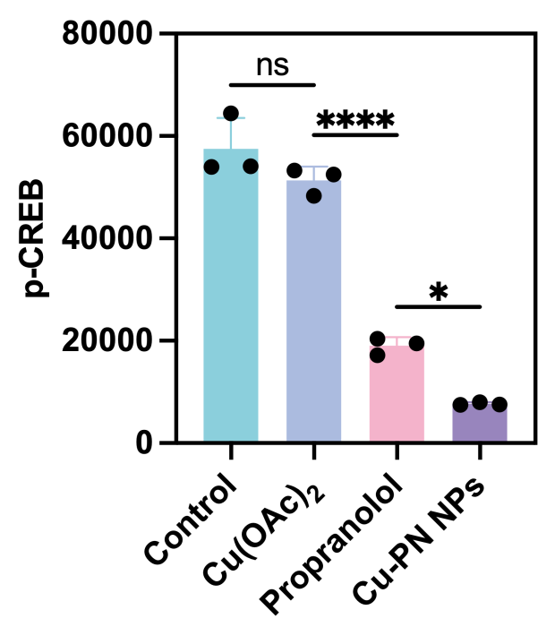
Figure S15. Quantification of the average IHC staining intensity of p-CREB in tumor tissue after receiving different treatments . Data are presented as mean ± standard deviation. *P < 0.05,****P < 0.0001, ns, not significant.

Figure S16. In vivo safety evaluation of Cu-PN NPs. Serum biochemical analysis of (A) alanine aminotransferase (ALT), (B) aspartate aminotransferase (AST), (C) creatinine (CREA), and (D) urea (UREA) levels in mice treated with PBS (Control) or Cu-PN NPs. (E) Representative H&E-stained images of major organs (heart, liver, spleen, lung, kidney). (F) Biodistribution and tumor accumulation of Cu-PN NPs in vivo. Scale bar: 100 μm. Data are presented as mean ± standard deviation. n=3. ns, not significant.

Figure S17. Gating strategy for flow cytometric analysis of tumor-infiltrating lymphocytes.

