Supplementary Material
Three-Dimensional Bioprinting of Patient-Derived Gastrointestinal Stromal Tumors: A Novel Platform for Precision Oncology and Drug Response Profiling
Liwei Du^{1#}, Zicheng Zheng^{2#}, Yanan Wang^{3#}, Kai Zhang¹, Yuce Lu¹, Minghao Sun¹, Mingchang Pang¹, Shangze Jiang¹, Yixuan He², Shunda Du¹, Haitao Zhao¹, Yilei Mao^{1*}, Huayu Yang^{1*}, Weiming Kang^{2*}
¹ Department of Liver Surgery, Peking Union Medical College (PUMC) Hospital, Peking Union Medical College (PUMC) & Chinese Academy of Medical Sciences (CAMS), Beijing, 100730, China
² Department of General Surgery, Peking Union Medical College Hospital, Chinese Academy of Medical Science and Peking Union Medical College, Beijing 100730, China.
³ State Key Laboratory of Common Mechanism Research for Major Diseases, Haihe Laboratory of Cell Ecosystem, Department of Physiology, Institute of Basic Medical Sciences and School of Basic Medicine, Chinese Academy of Medical Sciences and Peking Union Medical College, Beijing, China.

* Corresponding author
Yilei Mao
Department of Liver Surgery, Peking Union Medical College (PUMC) Hospital, PUMC & Chinese Academy of Medical Sciences, 1# Shuai-Fu-Yuan, Wang-Fu-Jing, Beijing 100730, China. E-mail: pumch-liver@hotmail.com
Huayu Yang
Department of Liver Surgery, Peking Union Medical College (PUMC) Hospital, PUMC & Chinese Academy of Medical Sciences, 1# Shuai-Fu-Yuan, Wang-Fu-Jing, Beijing, 100730, China. E-mail: dolphinyahy@hotmail.com
Weiming Kang
Department of General Surgery, Peking Union Medical College (PUMC) Hospital, PUMC & Chinese Academy of Medical Sciences, 1# Shuai-Fu-Yuan, Wang-Fu-Jing, Beijing, 100730, China. E-mail: Kangwm@pumch.cn
#These authors contributed equally to this work.
Supplementary Figures
Supplementary Figure S1
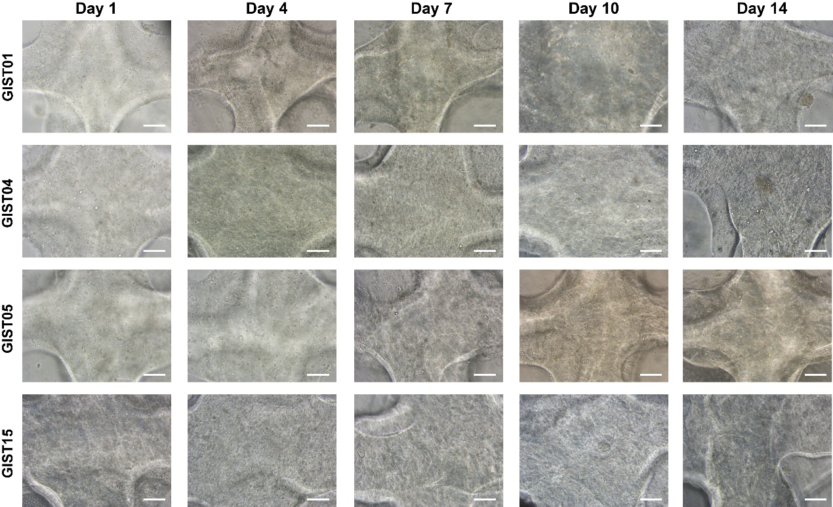
Fig. S1 Bright-field images of 3DP-GIST at days 1, 4, 7, 10, 14 after 3D bioprinting. Scale bar = 100 μm.

Supplementary Figure S2
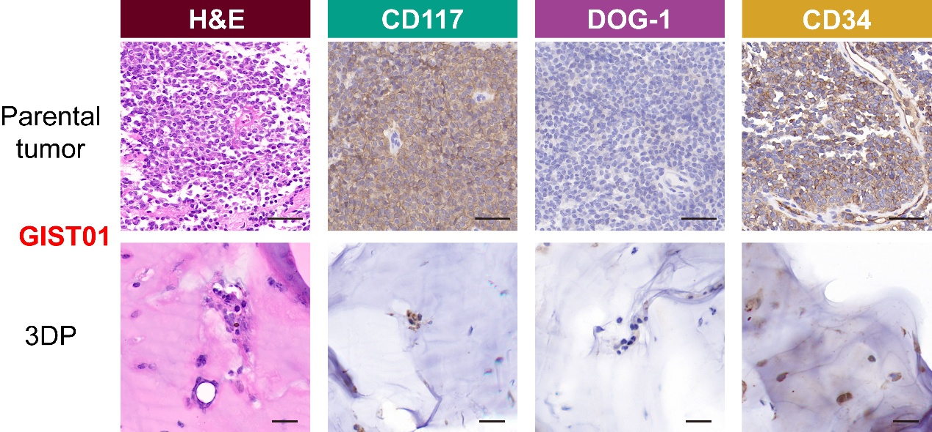
Fig. S2 H&E and IHC staining of the 3DP model of GIST01 (wild-type GIST) and the corresponding parental tumor. Scale bar of tumors = 50 μm. Scale bar of 3DP-GISTs = 20 μm.

Supplementary Figure S3
Fig. S3 Western blotting analysis of oncogenic KIT signaling pathway activation in 3DP-GIST models.
Western blot analysis of total and phosphorylated KIT, AKT, and ERK1/2 in matched parental tumor tissues (T) and corresponding 3DP-GIST models (P) from four representative patients (GIST09, GIST10, GIST11, GIST14).

Supplementary Figure S4
Fig. S4 Global distribution profile of base substitutions detected in tumor tissues and matched 3DP-GIST models.

Supplementary Figure S5
Fig. S5 Per-patient transcriptomic correlation between 3DP-GIST models and their corresponding parental tumors.
The transcriptomic similarity between individual 3DP-GIST models and their matched parental tumors was evaluated by Pearson correlation of gene expression levels. Each panel represents a distinct patient (GIST01, GIST02, GIST04, GIST05, GIST08, GIST15, GIST17). For each patient, the scatter plot displays the log10 transformed and offset-normalized gene expression values (log10 FPKM+1) for all detected genes in the parental tumor (X-axis) against the corresponding 3DP model (Y-axis). The red line indicates the line of best fit.

Supplementary Figure S6
Fig. S6 Cellular composition profiles for 3DP-GIST models and their corresponding parental tumors were inferred from RNA-seq data using the xCell algorithm.
(A) xCell analysis heatmap showing cell type enrichment profiles of 3DP-GIST models and paired parental tumors. Color intensity represents cell type enrichment score.
(B) Stacked bar plot illustrating the relative proportion of selected major cell types in 3DP-GIST models and paired parental tumors.
(C) Scatter plot demonstrating Pearson correlation of xCell enrichment scores between 3DP-GIST models and paired parental tumors. R-value and p-value indicate correlation strength and statistical significance.

Supplementary Figure S7
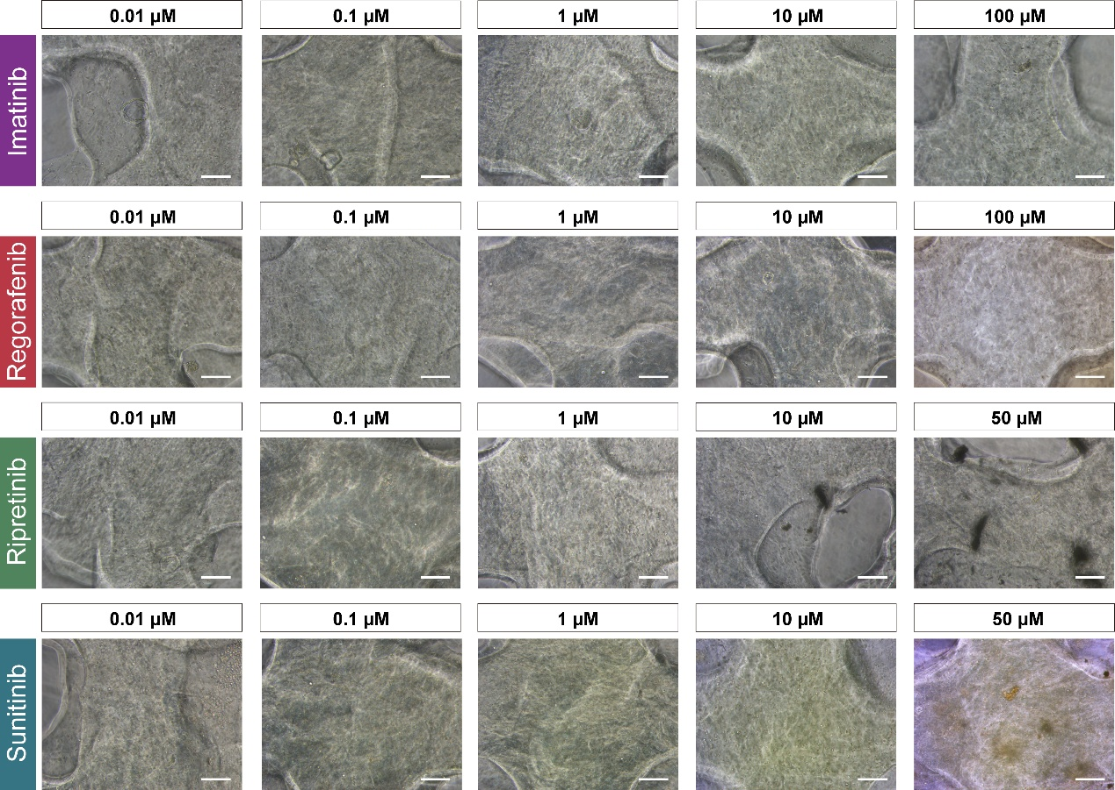
Fig. S7 Representative bright-field images of 3DP-GIST (GIST15) 7 days post-printing after 72 hours of treatment with different concentrations of chemotherapeutic drugs. Scale bar = 100 μm.

Supplementary Figure S8
Fig. S8 Drug sensitivity test results and clinical treatment effects of 3DP-GIST
Drug responsiveness of 12 3DP-GIST models to 4 targeted therapy drugs was quantitatively evaluated using normalized AUC values derived from corresponding dose-response curves.

Supplementary Figure S9
Fig. S9 Goodness-of-fit curves of normalized AUC values of 3DP-GISTs.
Goodness-of-fit curves were generated to determine the optimal number of intervals for Jenks classification, thereby preventing overfitting. The classification scheme achieving >90% goodness-of-fit (dashed line) with the minimal number of intervals was selected for subsequent analysis.

Supplementary Figure S10
Fig. S10 3DP-GIST models demonstrate exceptional predictive accuracy for personalized therapy in GIST patients.
- Treatment process and clinical response of patient GIST14. The blue arrow indicates when imaging was performed. SD: stable disease. PR: partial response.
- Imaging findings of target lesions in GIST14 patients after imatinib treatment.
- Drug-dose response curves for in vitro validation of the efficacy in patient GIST14.

Supplementary Table S1. Clinical baseline information for GIST patients included in the study.
ID | Gender | Age | Primary Site | Tumor Size (cm) | Nuclear fission | Recurrence risk grading | Therapeutic agents (before surgery) | Therapeutic agents (after surgery) | Clinical outcome | Success | Drug tests | WES | RNA-seq
GIST01 | male | 60 | Small intestinal | 4.8 × 4.3 | 15/50 HPF | high risk | imatinib | sunitinib | PD | √ | √ | √ | √
GIST02 | female | 49 | Gastric | 4.5 × 4 | 1-2/50 HPF | low risk | / | / | / | √ | √ | √ | √
GIST03 | male | 68 | Gastric | 9.7 × 7.8 | 4/50 HPF | intermediate risk | imatinib | imatinib | SD | √ | √ | √
GIST04 | male | 78 | Gastric | 5.2 × 5 | 4/50 HPF | intermediate risk | / | / | / | √ | √ | √ | √
GIST05 | male | 66 | Gastric | 4 × 3 | 8/50 HPF | intermediate risk | / | / | / | √ | √ | √ | √
GIST06 | male | 53 | Gastric | 1.9 × 1.8 | 5/50 HPF | low risk | / | / | /
GIST07 | male | 60 | Gastric | 3 × 2 | 5/50 HPF | low risk | / | / | /
GIST08 | female | 39 | Gastric | 6.5 × 4.5 | 4/50 HPF | intermediate risk | / | / | / | √ | √ | √ | √
GIST09 | female | 70 | Gastric | 2.1 × 1.7 | 5/50 HPF | low risk | / | / | /
GIST10 | male | 66 | Gastric | 4 × 3 | 4/50 HPF | low risk | / | / | /
GIST11 | male | 51 | Small intestinal | 15 × 12.5 | 10/50 HPF | high risk | / | imatinib | / | √ | √
GIST12 | male | 35 | Gastric | 2.7 × 2.5 | 10/50 HPF | high risk | / | / | / | √ | √ | √
GIST13 | male | 70 | Small intestinal | 4.6 × 4.5 | 10/50 HPF | high risk | sunitinib | sunitinib | SD | √ | √
GIST14 | male | 63 | Gastric | 6 × 5 | 1/50 HPF | intermediate risk | imatinib | / | / | √ | √
GIST15 | female | 54 | Gastric | 7.9 × 6.7 | 50/50 HPF | high risk | imatinib; ripretinib | ripretinib | imatinib (PD); ripretinib (PR) | √ | √ | √ | √
GIST16 | female | 48 | Gastric leiomyosarcoma | / | / | / | / | / | /
GIST17 | female | 61 | Small intestinal | 16 × 13.5 | 8/10 HPF | high risk | / | imatinib |  | √ | √ | √ | √

Supplementary Table S2. Drug screening of 3DP-GIST model to four targeted therapy drugs.
 | Imatinib |  |  |  | Regorafenib |  |  |  | Sunitinib |  |  |  | Ripretinib
 | LogIC50 | IC50 | AUC |  | LogIC50 | IC50 | AUC |  | LogIC50 | IC50 | AUC |  | LogIC50 | IC50 | AUC
GIST01 | 1.449 | 28.11 | 0.8054 |  | 0.663 | 4.602 | 0.6798 |  | -0.3484 | 0.4483 | 0.5399 |  | 0.08803 | 1.225 | 0.63758
GIST02 | 1.183 | 15.25 | 0.7532 |  | 0.267 | 1.849 | 0.6054 |  | -0.7209 | 0.1902 | 0.47883 |  | 0.4112 | 2.577 | 0.71781
GIST03 | -0.6563 | 0.2206 | 0.4614 |  | -0.3002 | 0.501 | 0.5194 |  | -0.3024 | 0.4984 | 0.55246 |  | 1.208 | 16.15 | 0.81081
GIST04 | 1.227 | 16.88 | 0.7672 |  | 0.6411 | 4.376 | 0.6734 |  | -0.0013 | 0.9971 | 0.61056 |  | 2.844 | 697.8 | 0.87167
GIST05 | -0.5047 | 0.3128 | 0.5034 |  | -1.373 | 0.04234 | 0.3832 |  | -1.345 | 0.04514 | 0.39562 |  | -1.137 | 0.0729 | 0.42052
GIST08 | -0.4152 | 0.3844 | 0.5086 |  | -0.3437 | 0.4532 | 0.5346 |  | -0.5804 | 0.2628 | 0.50564 |  | 0.4481 | 2.806 | 0.69419
GIST11 | 0.7801 | 6.027 | 0.694 |  | -0.7 | 0.1995 | 0.4692 |  | -0.1349 | 0.7329 | 0.59566 |  | 1.626 | 42.31 | 0.72292
GIST12 | -1.206 | 0.06216 | 0.3708 |  | -1.286 | 0.05182 | 0.3486 |  | -0.9362 | 0.1158 | 0.45073 |  | -0.9165 | 0.1212 | 0.46286
GIST13 | 0.2561 | 1.803 | 0.5892 |  | 0.9059 | 8.052 | 0.7364 |  | -0.3198 | 0.4788 | 0.53586 |  | 2.081 | 120.4 | 0.83337
GIST14 | -0.9752 | 0.1059 | 0.3848 |  | 0.863 | 7.294 | 0.73 |  | -0.1024 | 0.79 | 0.56267 |  | 1.218 | 16.51 | 0.82507
GIST15 | 2.428 | 267.8 | 0.7962 |  | 0.8661 | 7.347 | 0.721 |  | 0.4253 | 2.663 | 0.6861 |  | -0.3332 | 0.4643 | 0.5582
GIST17 | -0.3877 | 0.4095 | 0.5148 |  | 1.18 | 15.13 | 0.7246 |  | 0.123 | 1.327 | 0.61056 |  | 2.095 | 124.6 | 0.84805

