Supporting Information
A Smart Amphiphilic Nanoplatform Amplifies ROS-Mediated Immunogenic Cell Death to Suppress Bladder Cancer Growth and Metastasis

Chuntao Li ^{1, †}, Fanhu Meng ^{1, †}, Chunbo Lu ^{1, †}, Aimei Li ¹, Ziru Liu ¹, Jin Liu ¹, Hong Zhang ², Zhengqiang Yang ³, Jingkun Bai ^{1,} *

Materials and methods
Steps of the 3D Microsphere Experiment
We added 50 μL of agarose to a 96-well plate, which produced a concave surface. Afterward, 5 × 10³ suspended cells could be added separately. Cells were treated with the appropriate C6, C6/Pep0, or C6/Pep dose, incubated for 2 h, and then washed three times with PBS. Afterward, the cells were stained with DAPI for 15 min and observed with an inverted fluorescence microscope.
Small animal live imaging
Real-time NIRF imaging facilitated the analysis of drug distribution within living systems. The Ethics Committee of Shandong Second Medical University approved the animal experiments. A xenograft model was developed via subcutaneous injection. When the size of the tumor reached 100 mm³, 100 µL of DiR, DiR/Pep0, or DiR/Pep was injected into the tail vein. The fluorescence distribution was monitored at 2, 4, 8, 12, 24, 48, and 72 h using a small animal in vivo imaging system. After 72 h, mouse tumors and major organs were collected and imaged. The wavelengths for fluorescence were 745 nm for excitation and 835 nm for emission.
In vivo antitumor assay
C57BL/6 mice were allocated into the following five groups: Saline, MT, MC, MC/Pep0, and MC/Pep. A subcutaneous injection of 2 × 10⁶ cells was administered into the posterior axillary region of the mice. Treatment was administered via tail vein injection after the tumors in the mice reached 100 mm³. Each group of model mice was administered MT and CA via the tail vein (5 mg/kg each). Measurements of tumor volumes and body weights of the mice were performed with Vernier calipers and logged. The tumors and normal organs were removed after 7 treatments and used for subsequent experiments. Tumor analysis was conducted through H&E staining and TdT-mediated dUTP nick-end labeling (TUNEL) staining. CD4, CD8, CRT, CD45RO, CD56 and TNF-α expression was assessed via immunofluorescence. CD25 and TNF-α expression was assessed by immunohistochemistry.
Supporting figures
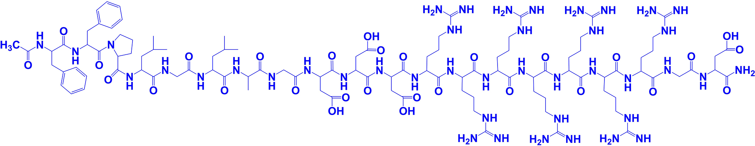
Supplementary Fig. 1 Structural formula of Pep.
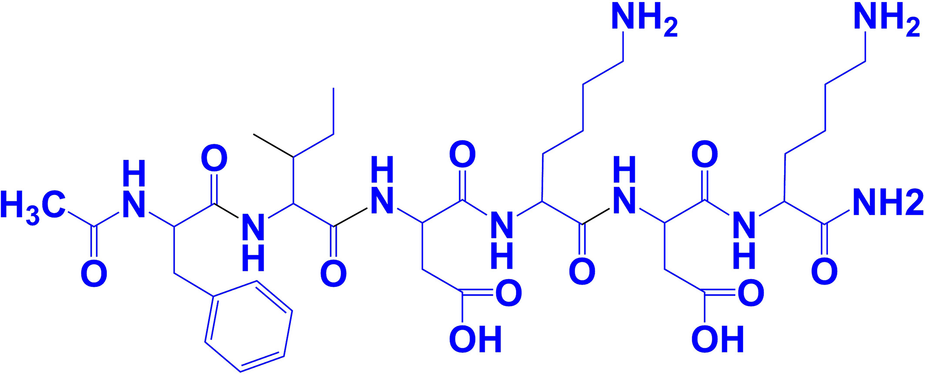
Supplementary Fig. 2 Structural formula of Pep0.

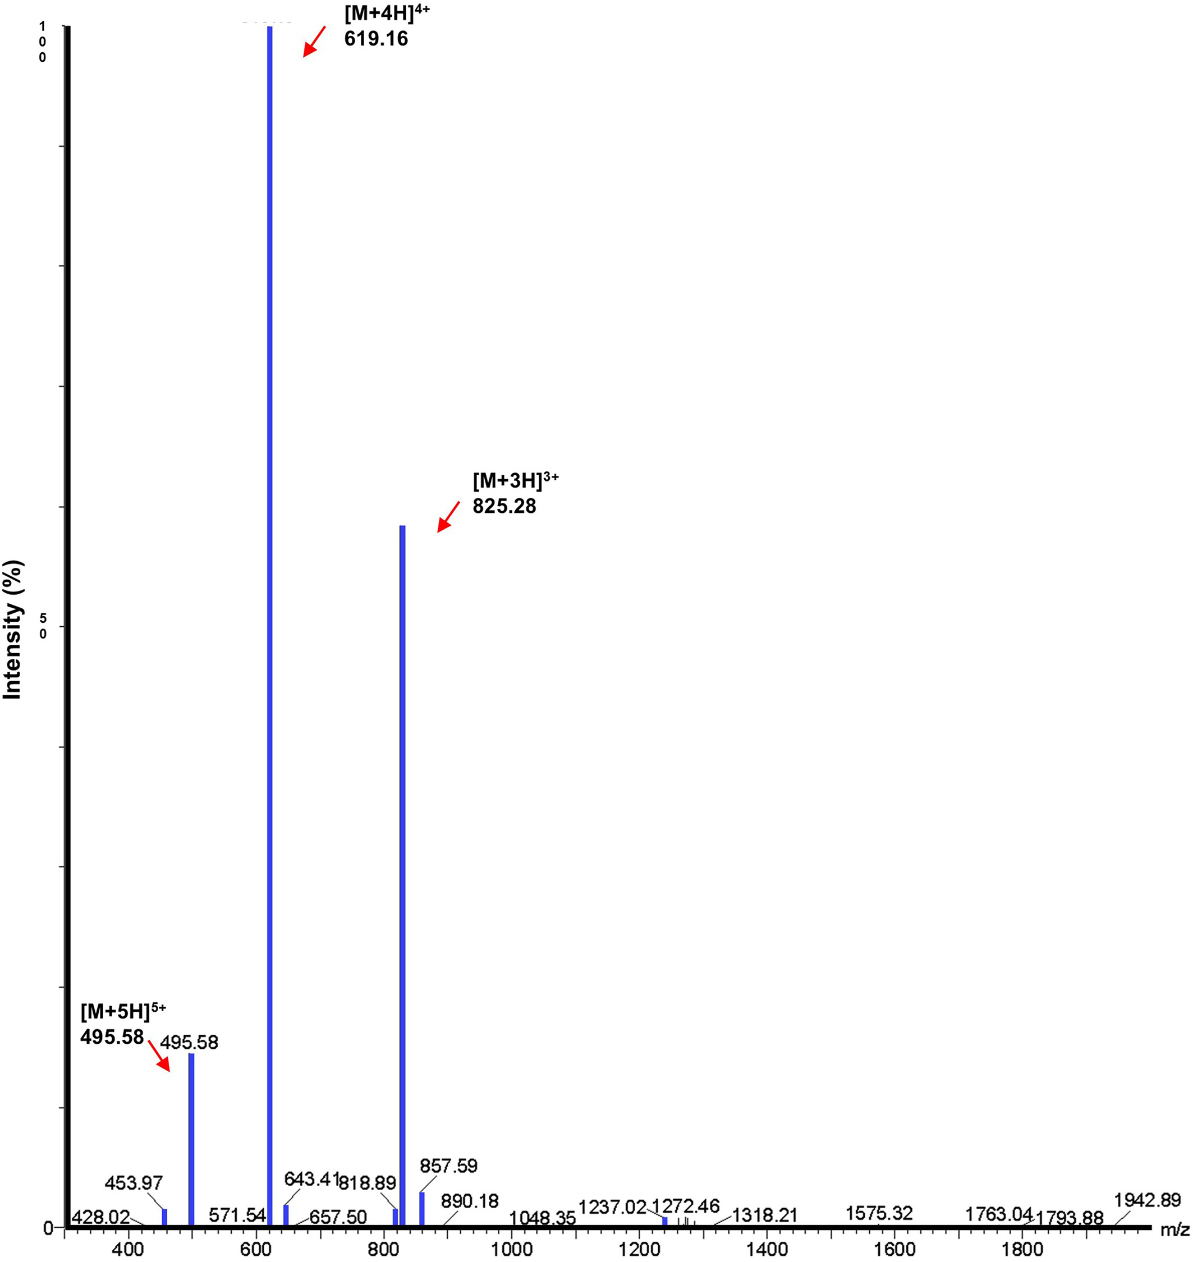
Supplementary Fig. 3 MS spectrum of Pep.
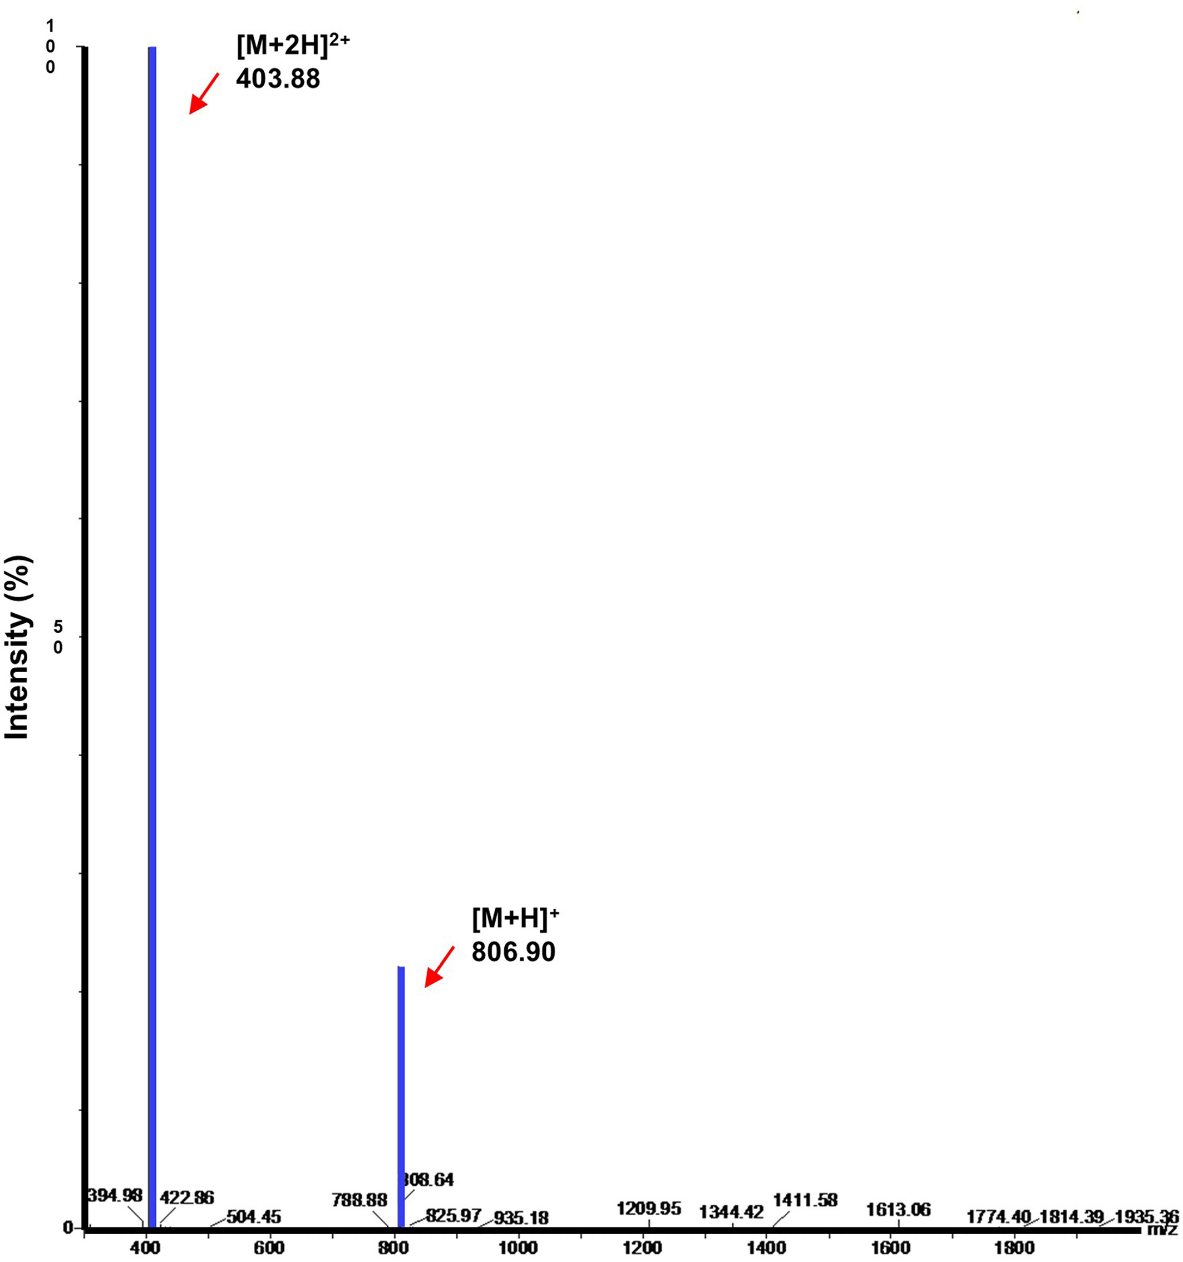
Supplementary Fig. 4 MS spectrum of Pep0.
Supplementary Fig. 5 Particle size distribution of Pep.
Supplementary Fig. 6 Particle size distribution of MC/Pep.
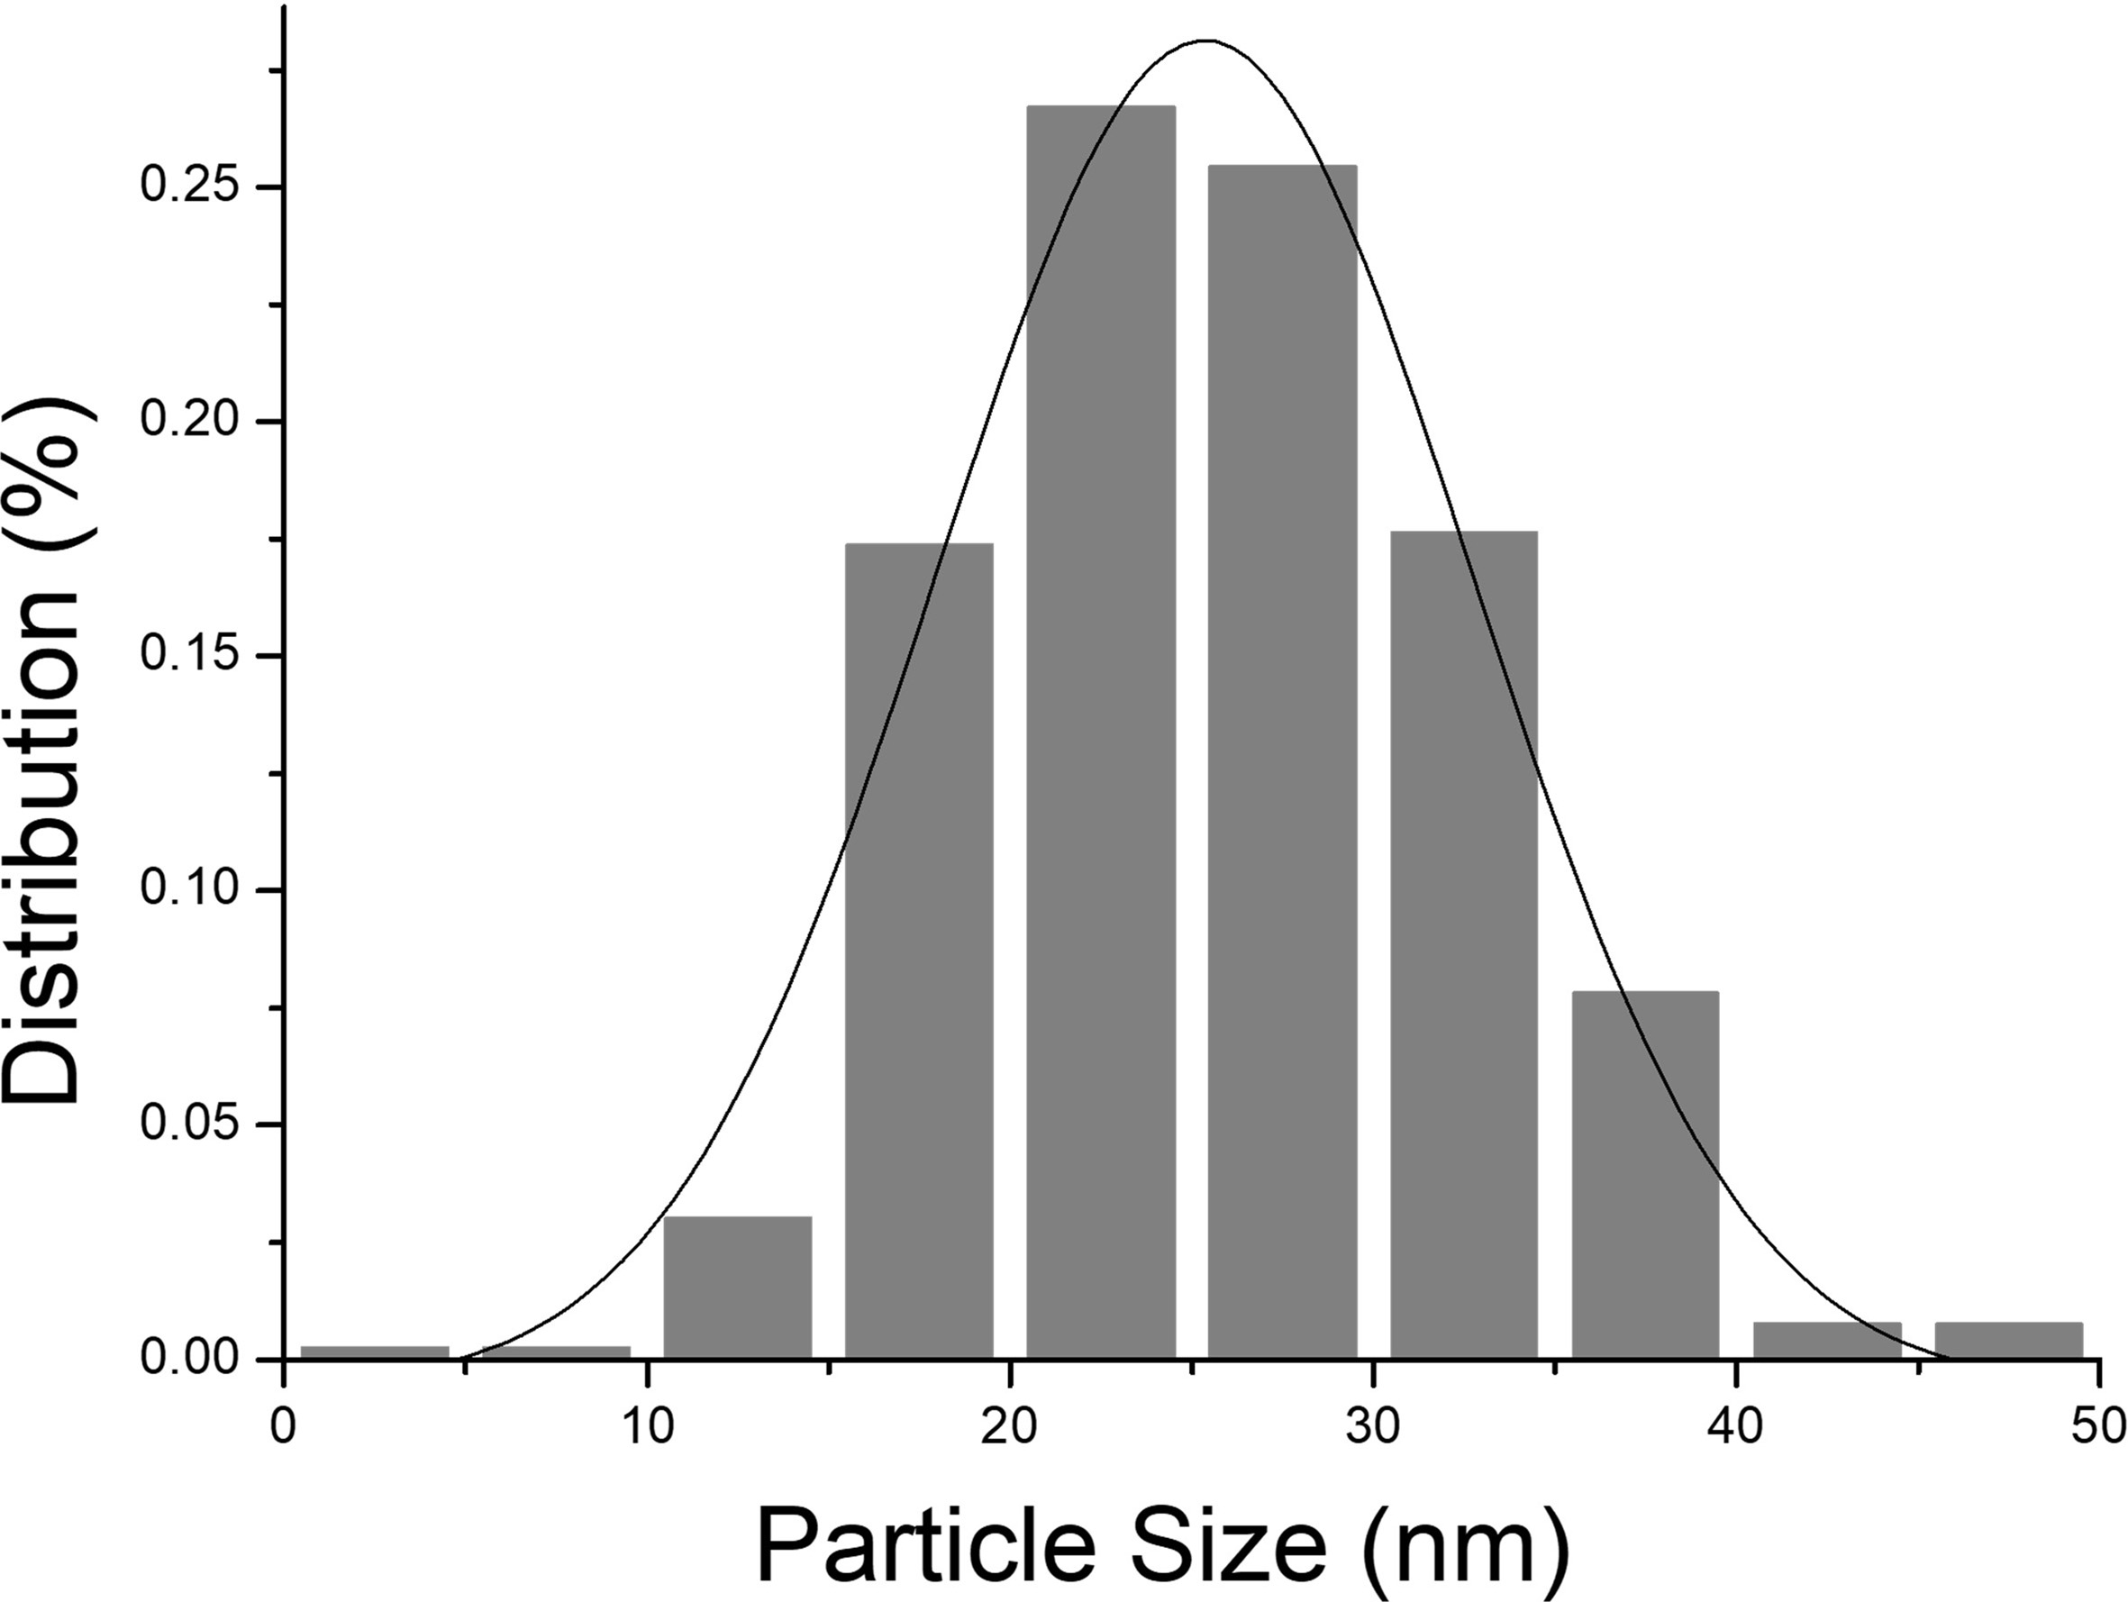
Supplementary Fig. 7 Particle size distribution of Pep0.
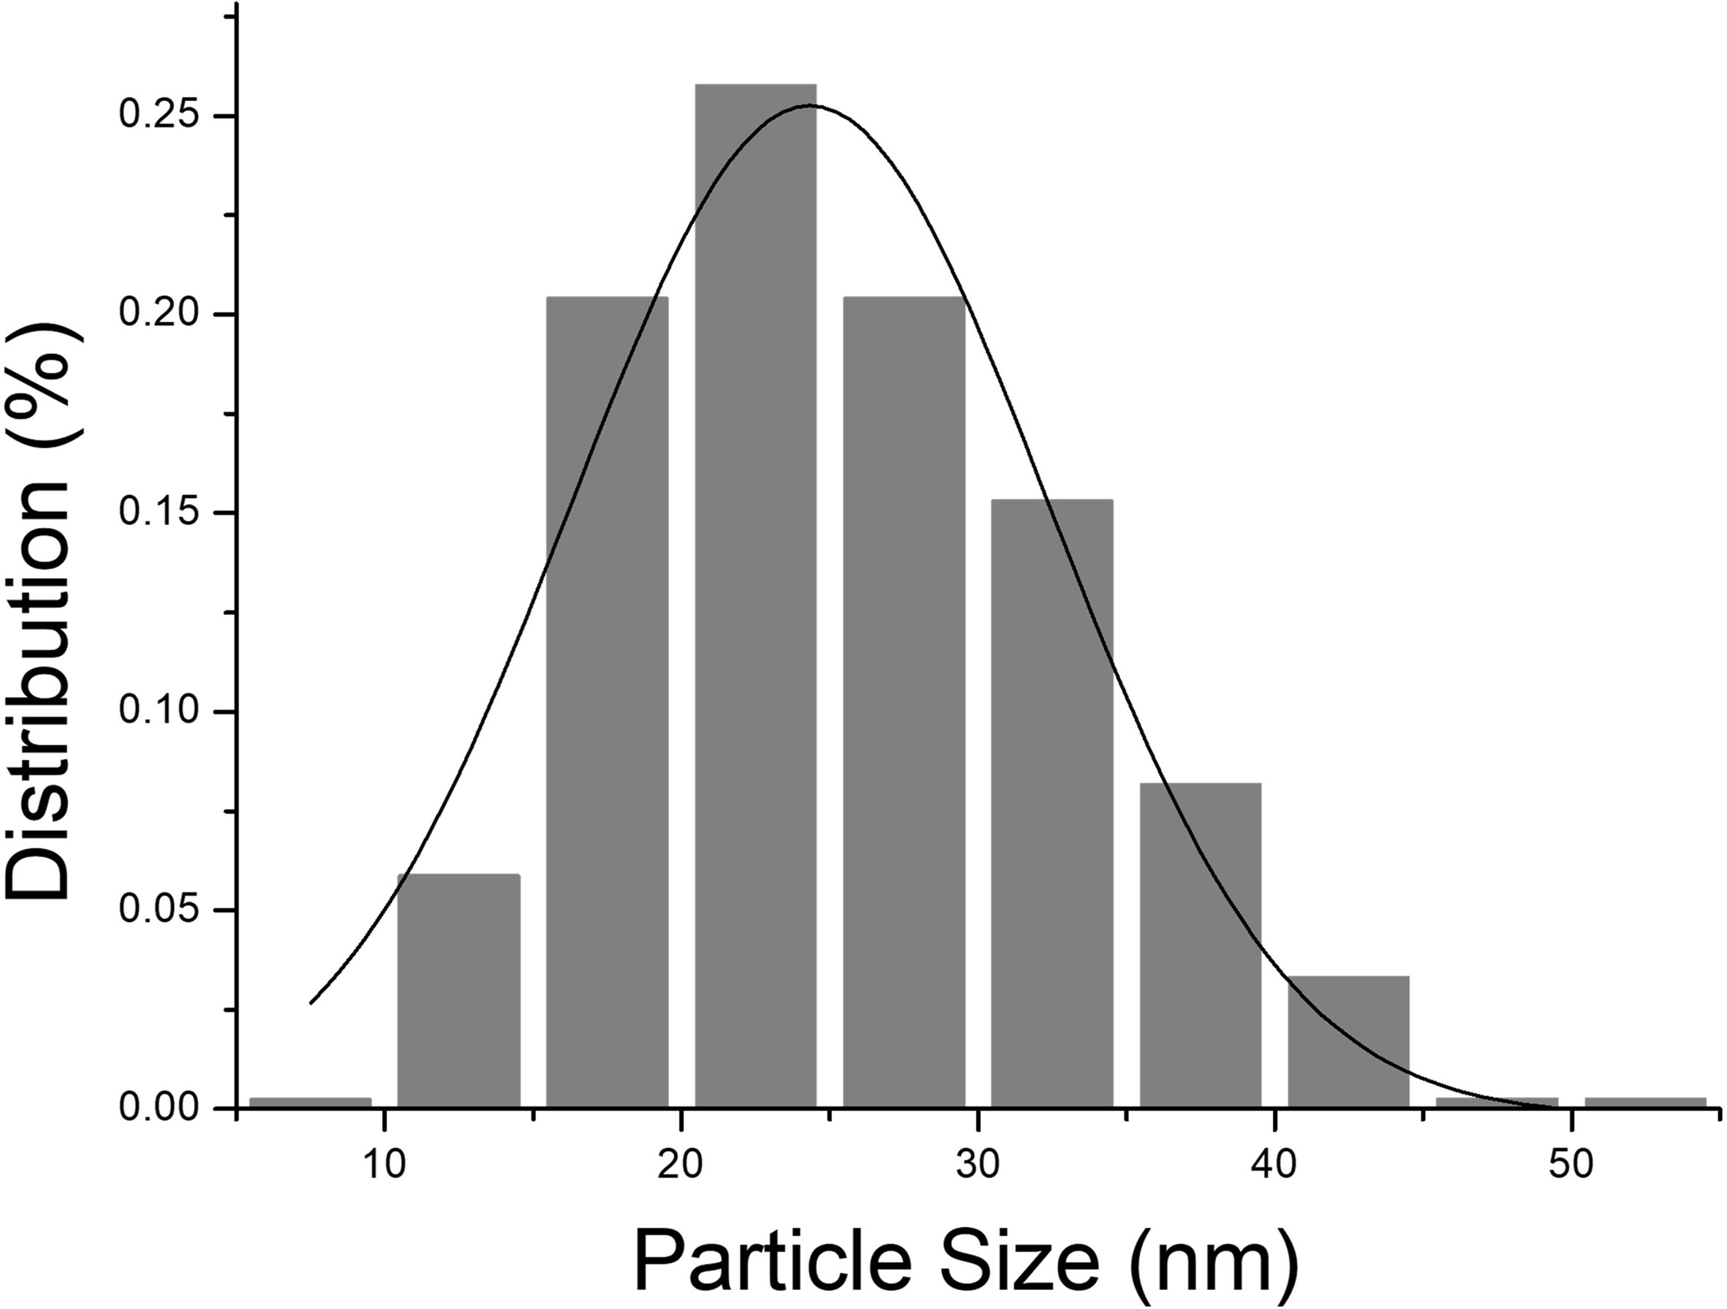
Supplementary Fig. 8 Particle size distribution of MC/Pep0.
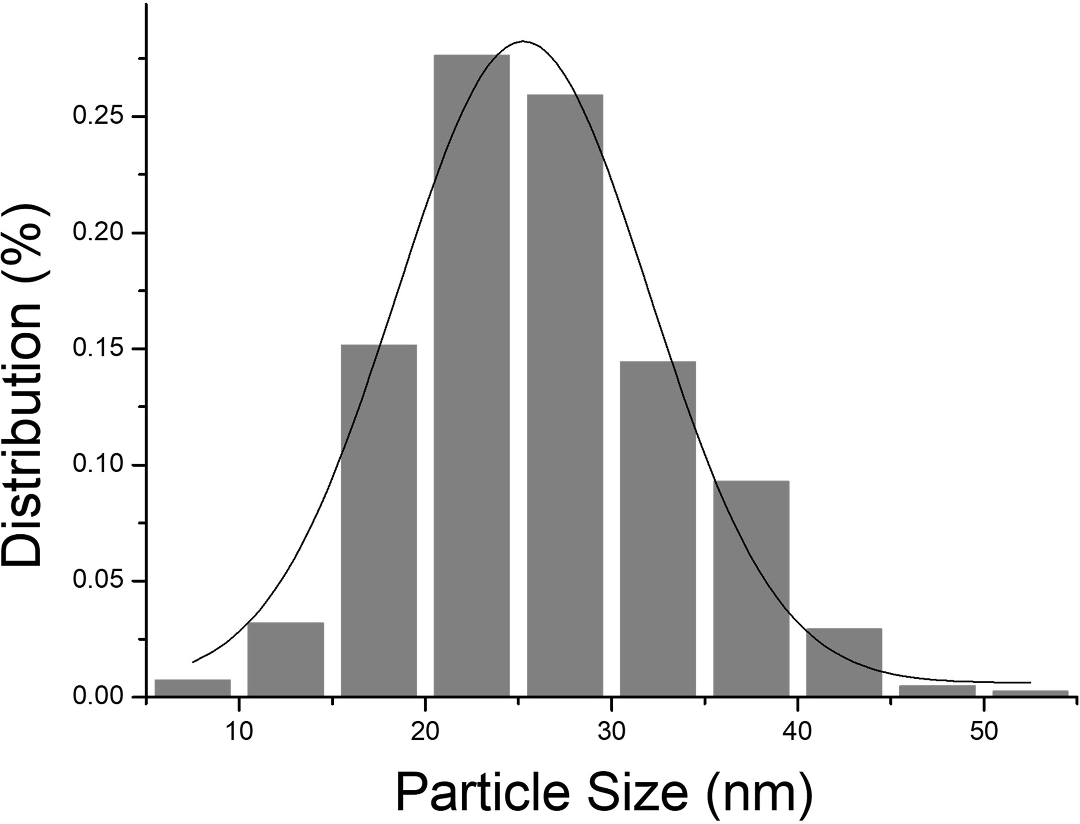
Supplementary Fig. 9 Particle size distribution of MC/Pep0 incubated with MMP2.

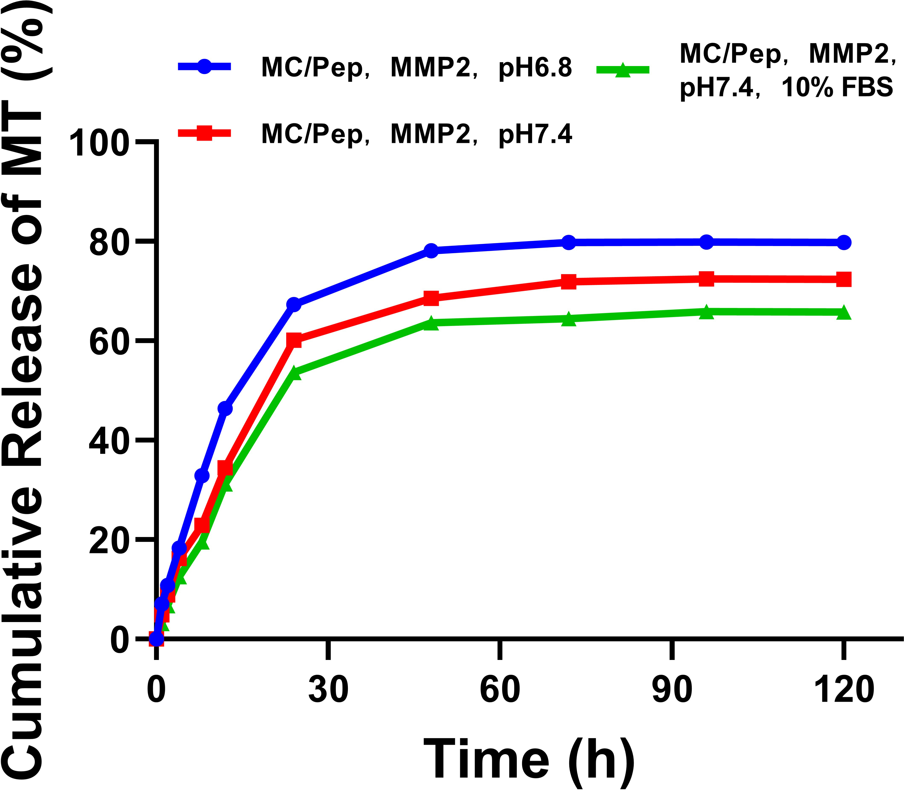
Supplementary Fig. 10 Cumulative release rates of MT in Pep in the presence and absence of 10% FBS at pH 6.8 and 7.
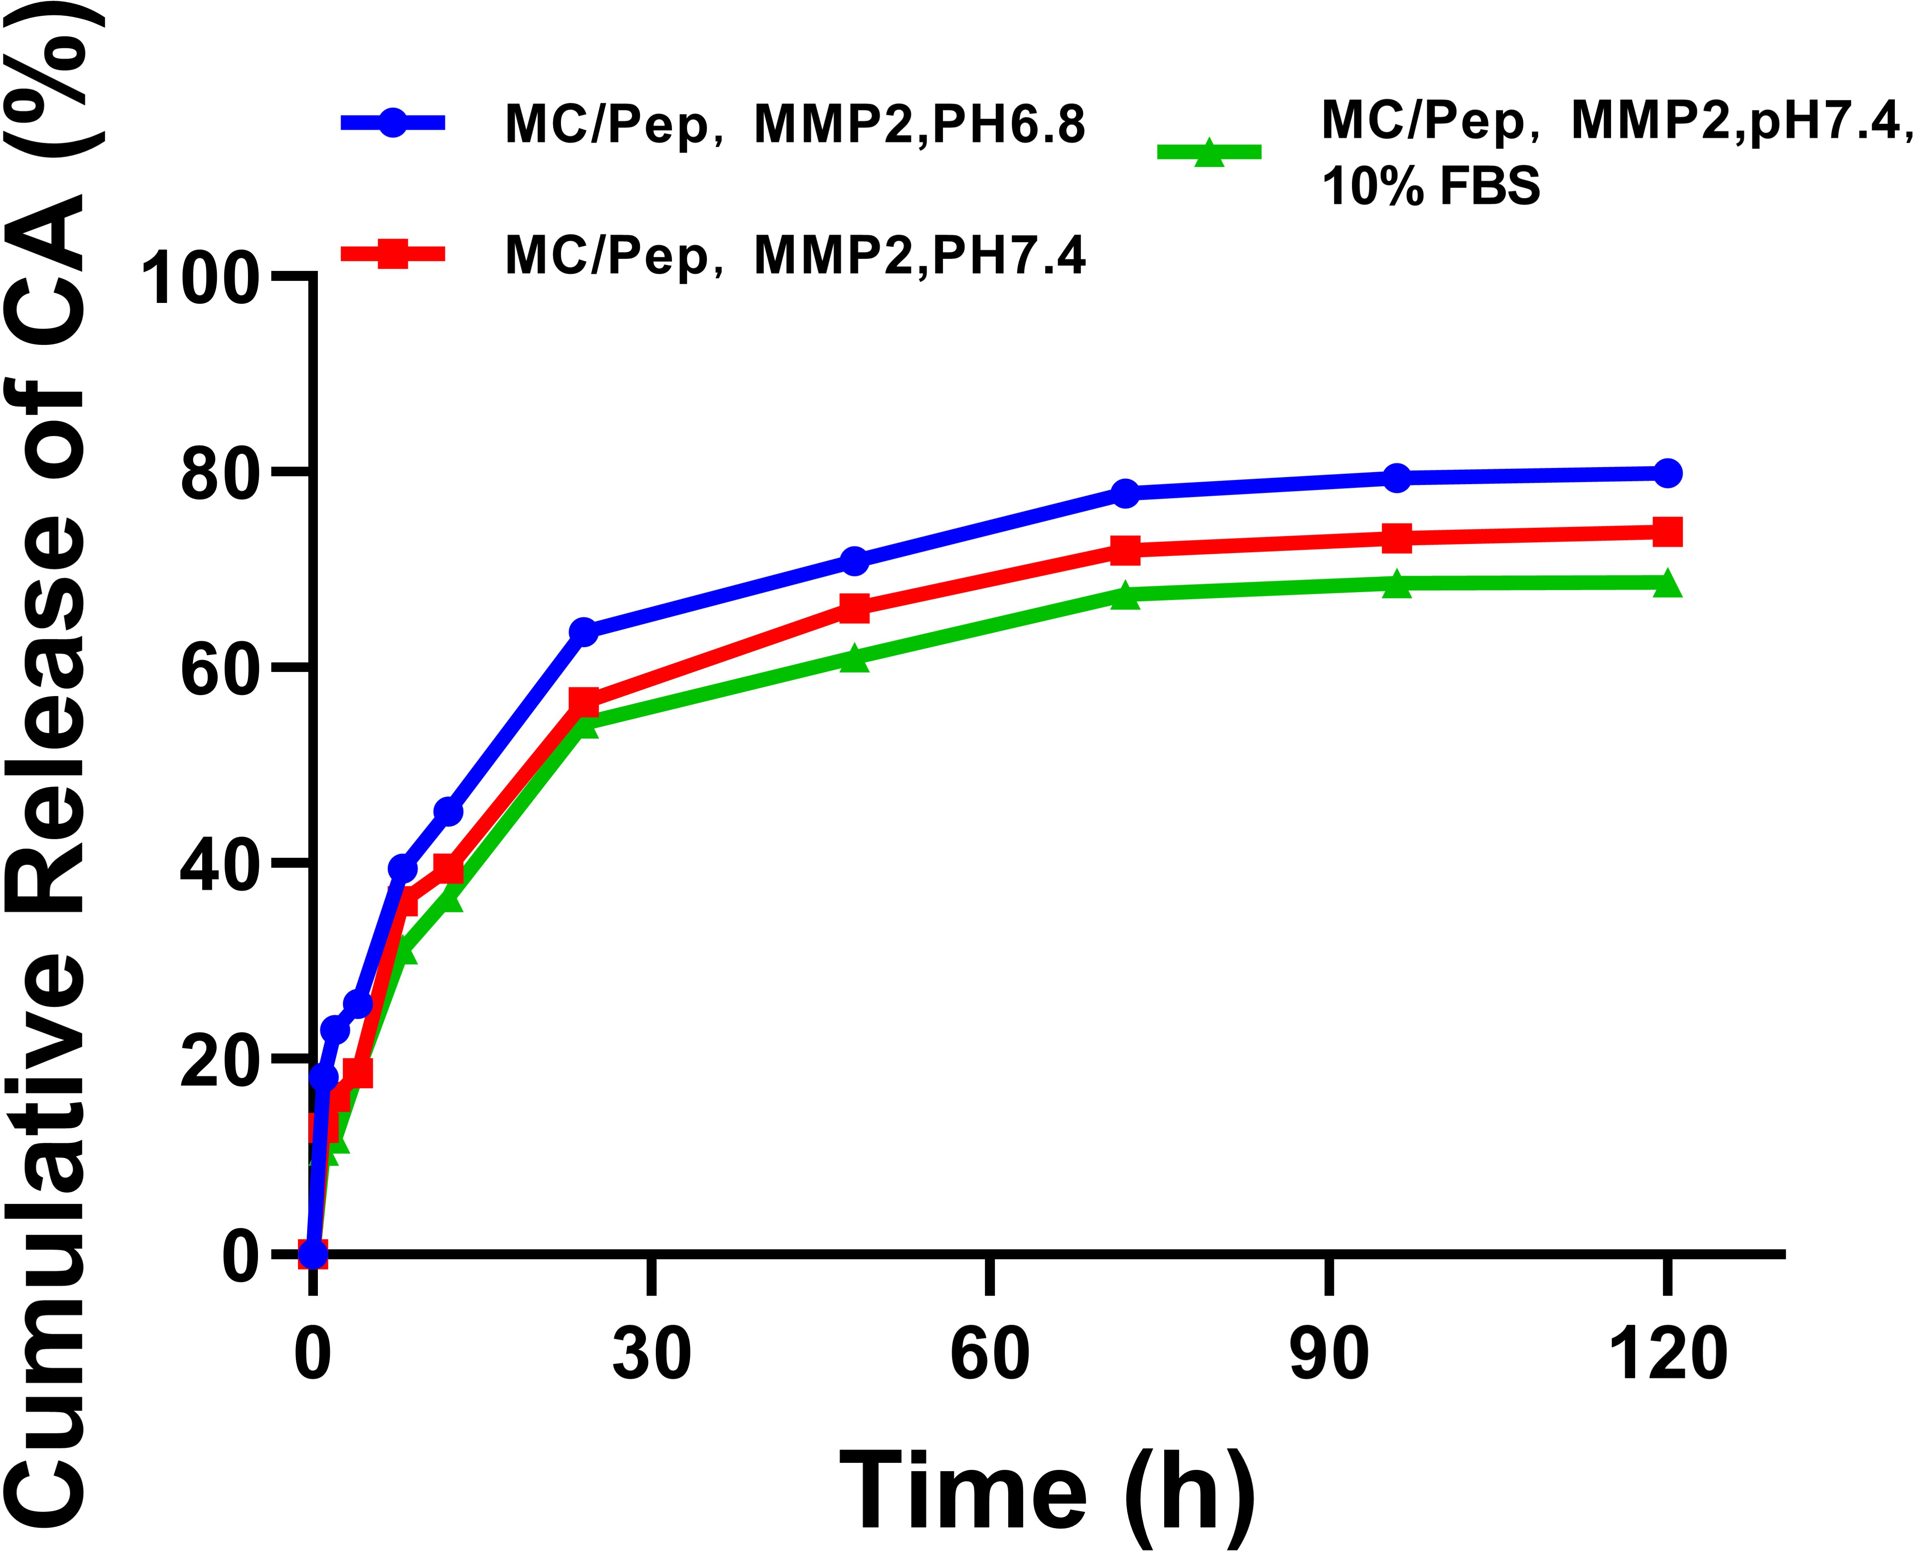
Supplementary Fig. 11 Cumulative release rates of CA in Pep in the presence and absence of 10% FBS at pH 6.8 and 7.
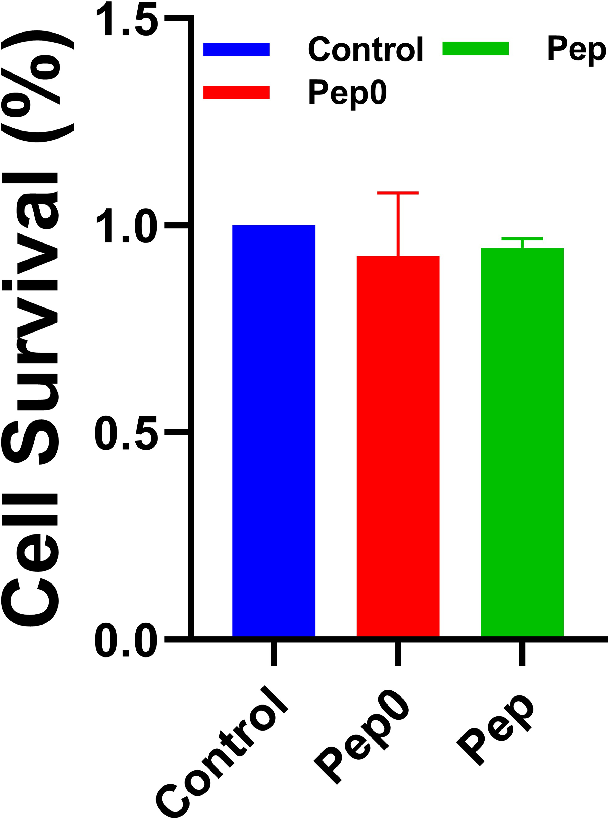
Supplementary Fig. 12 Survival rates of SV-HUC-1 after 12 h of incubation with Pep and Pep0.
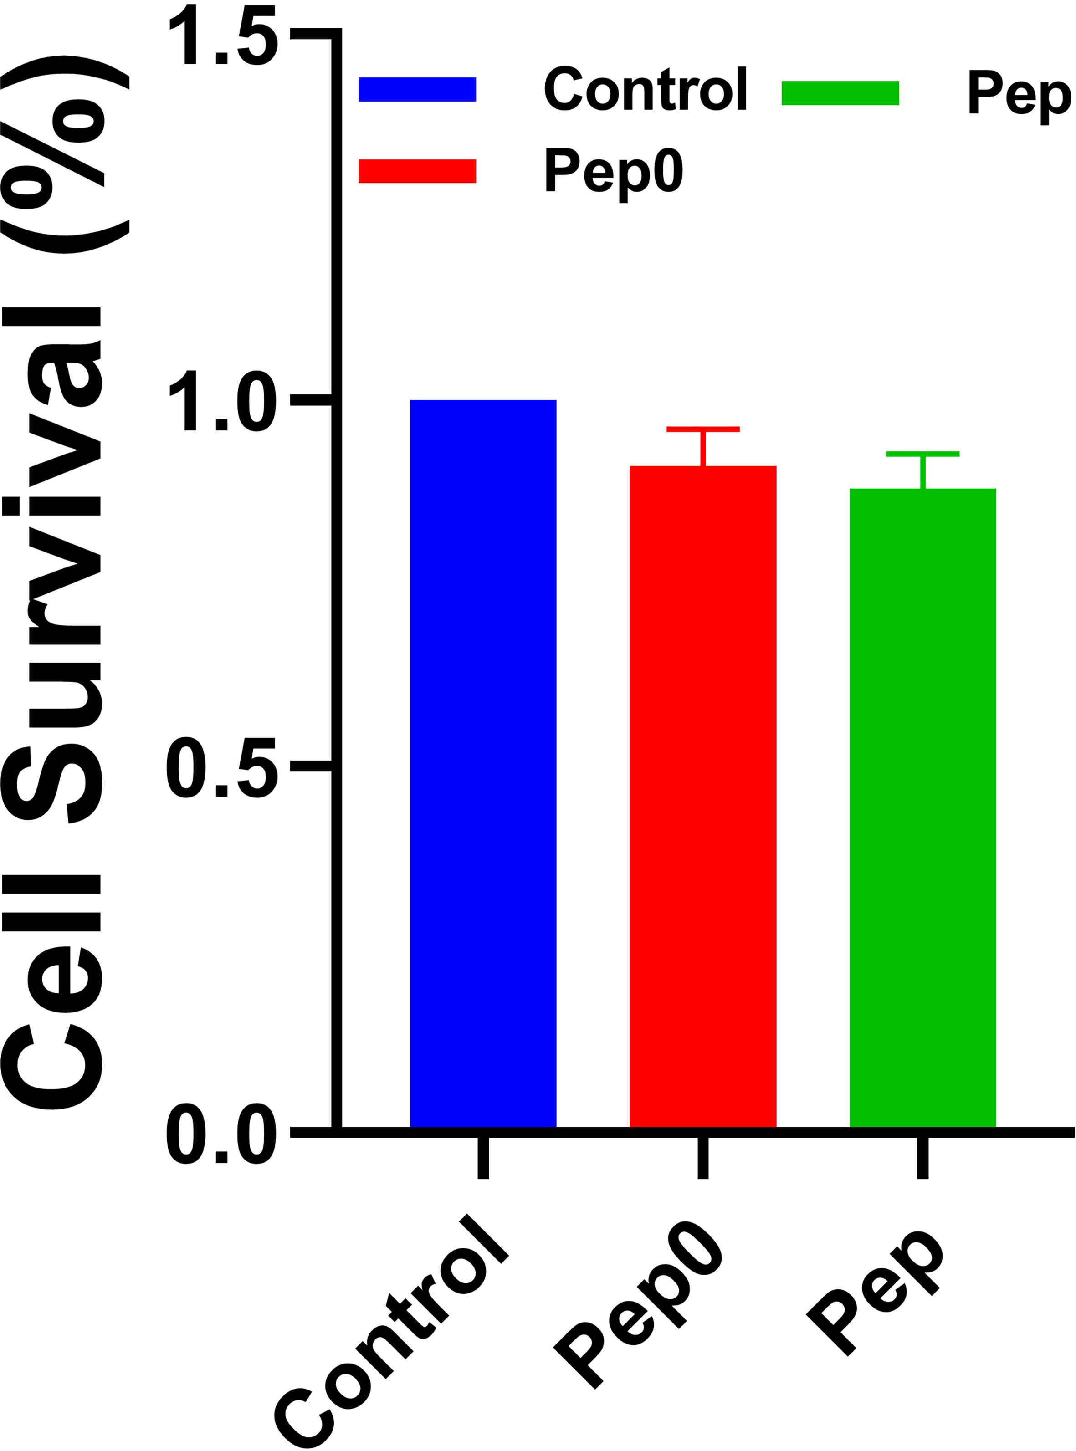
Supplementary Fig. 13 Survival rates of SV-HUC-1 after 24 h of incubation with Pep and Pep0.
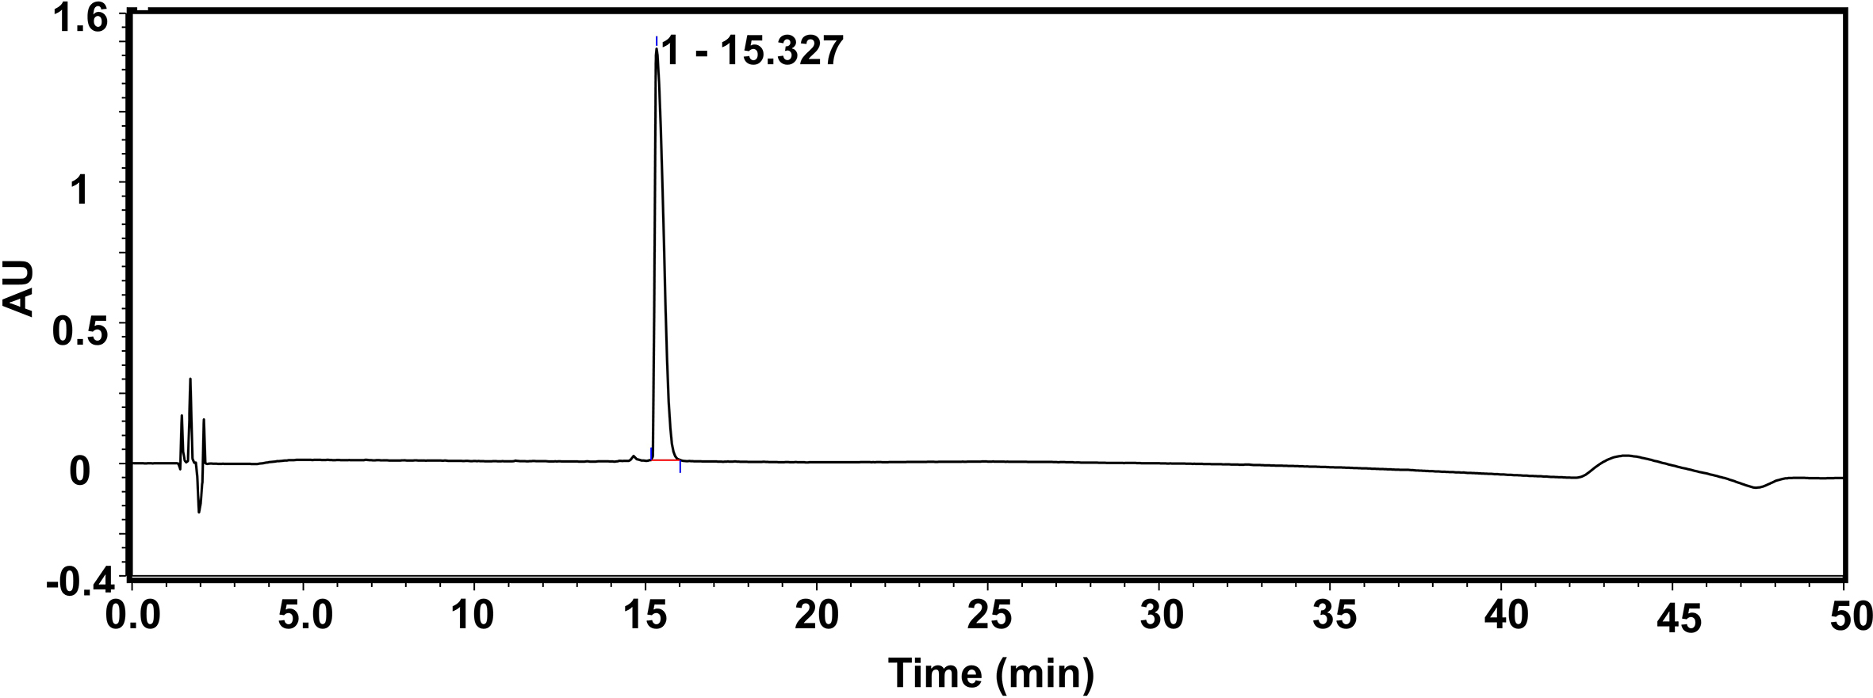
Supplementary Fig. 14 HPLC assay of Pep.
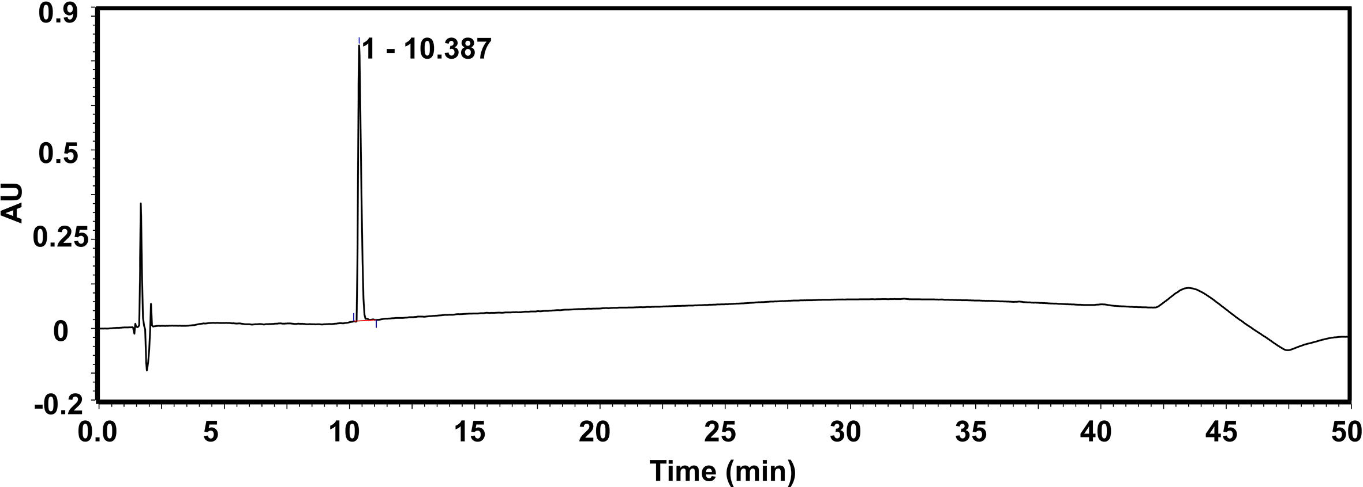
Supplementary Fig. 15 HPLC assay of Pep0.
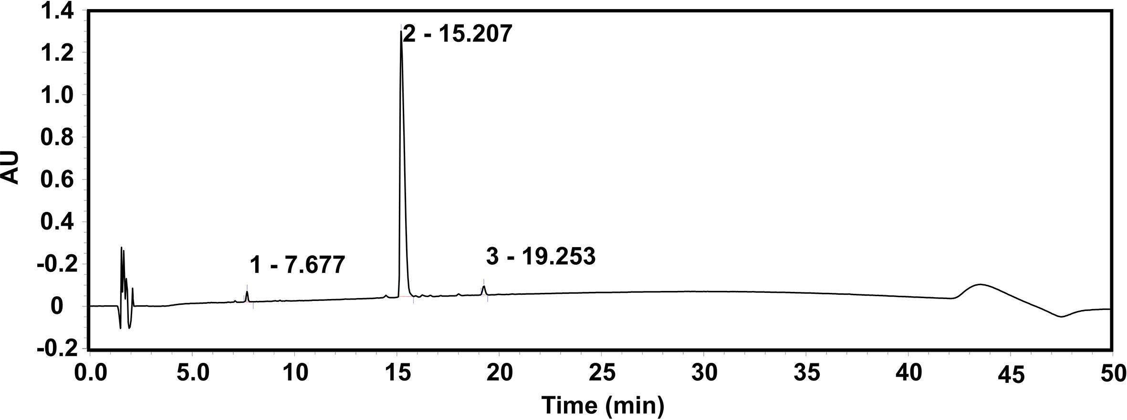
Supplementary Fig. 16 HPLC analysis of Pep incubated with MMP2.
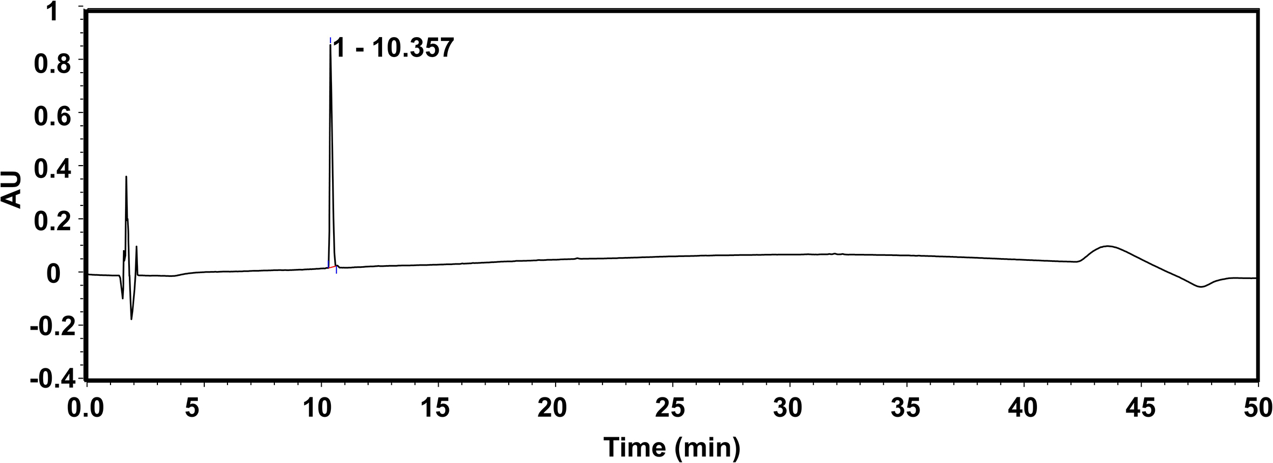
Supplementary Fig. 17 HPLC analysis of Pep0 incubated with MMP2.
Supplementary Fig. 18 ESI-MS spectrum of Pep after incubation with MMP2.
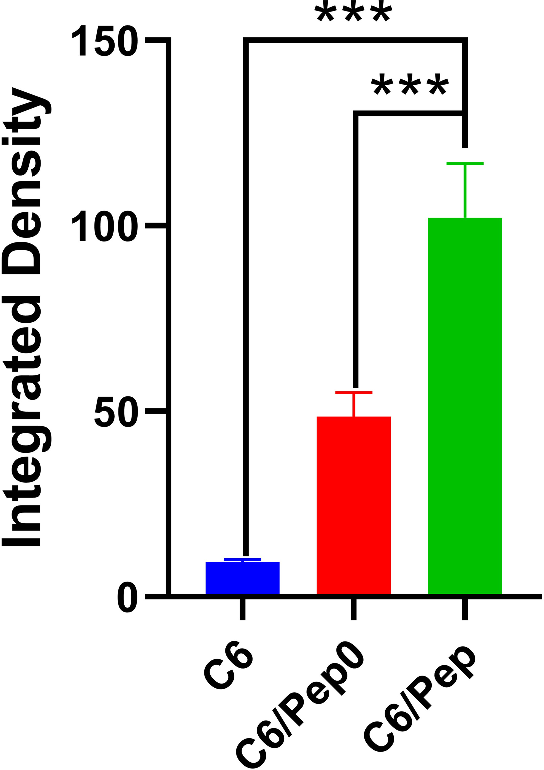
Supplementary Fig. 19 CLSM fluorescence intensity after 0.25 h of uptake of different formulations. *** P < 0.001.
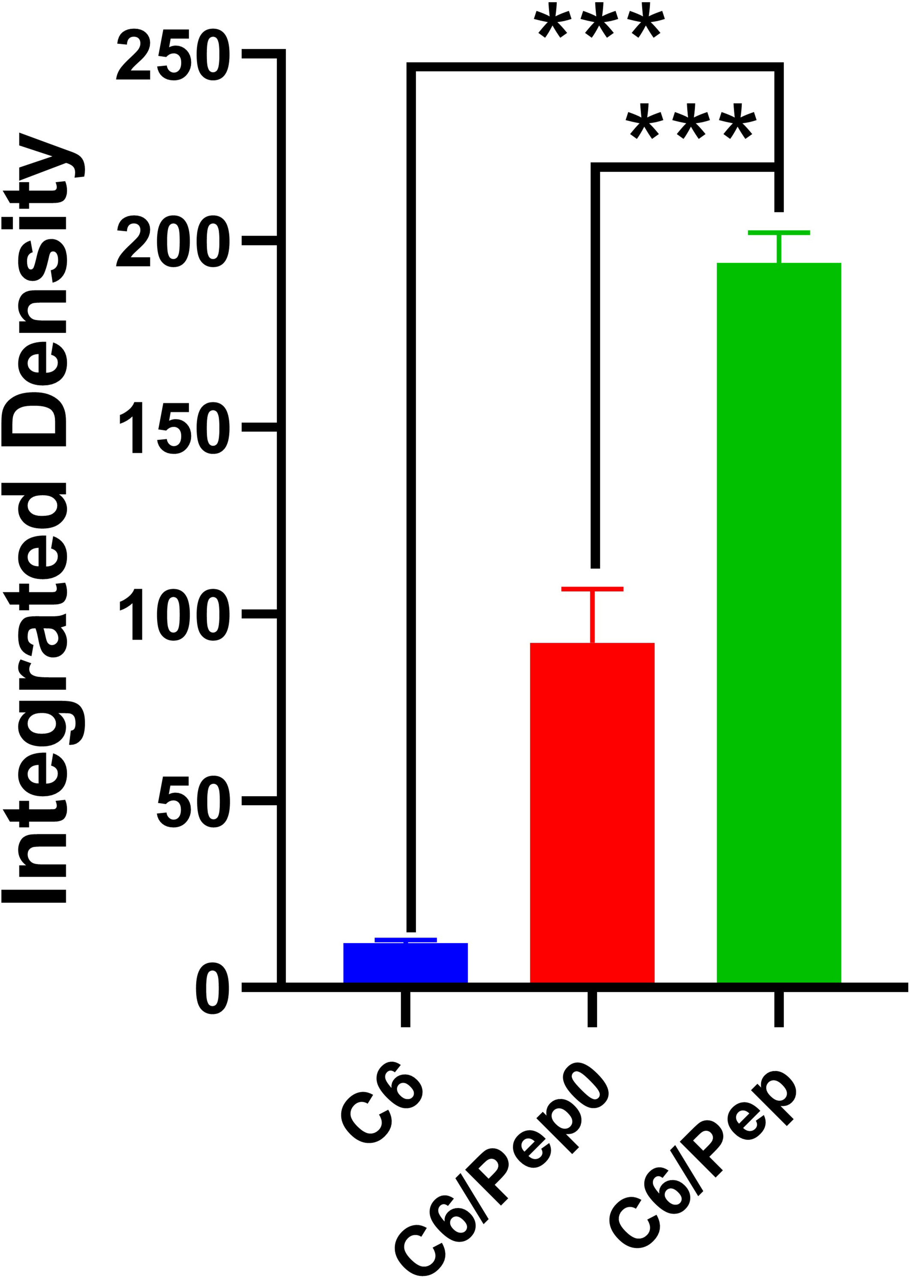
Supplementary Fig. 20 CLSM fluorescence intensity after 2 h of uptake of different formulations. *** P < 0.001.
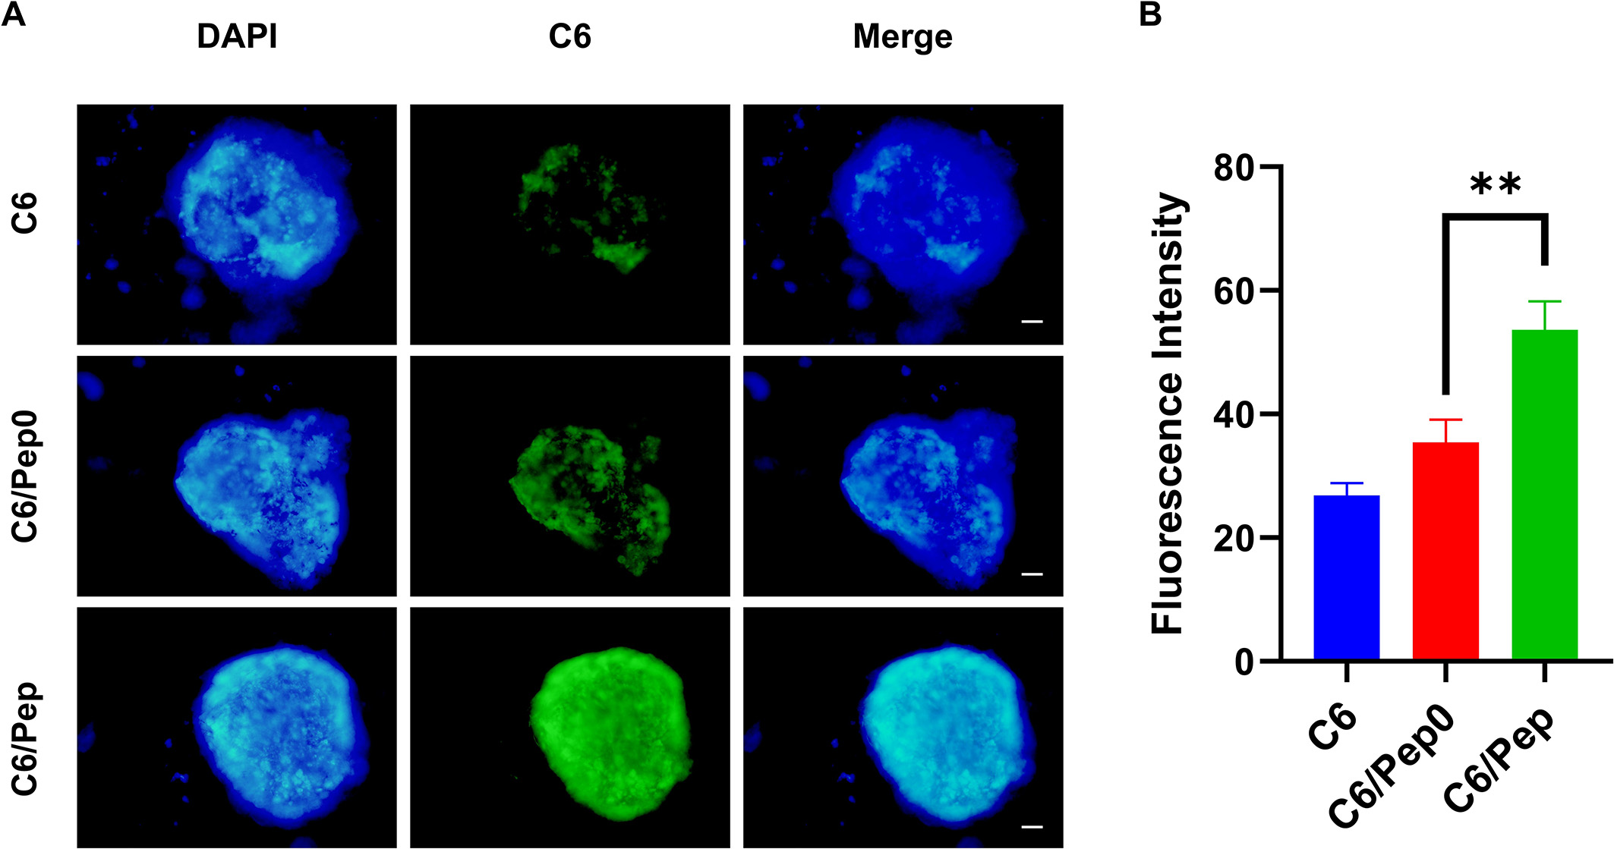
Supplementary Fig. 21 (A) Fluorescence microscopy images of 3D tumor microspheres incubated with C6, C6/Pep0, and C6/Pep for 2 h. Scale bar: 100 μm. (B) The mean fluorescence intensity after 2 h of uptake of different formulations. ** P < 0.01.
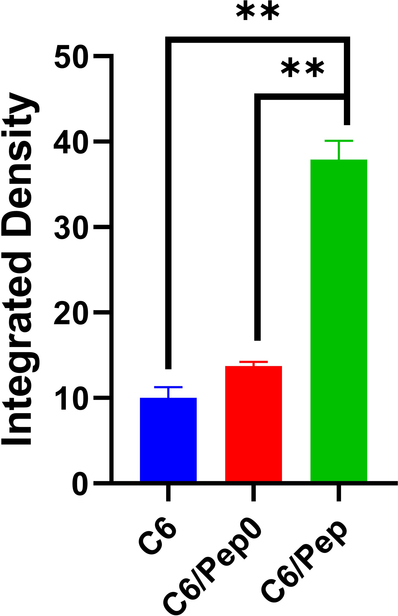
Supplementary Fig. 22 Quantification of intracellular C6 fluorescence after 96 h of incubation. ** P < 0.01.
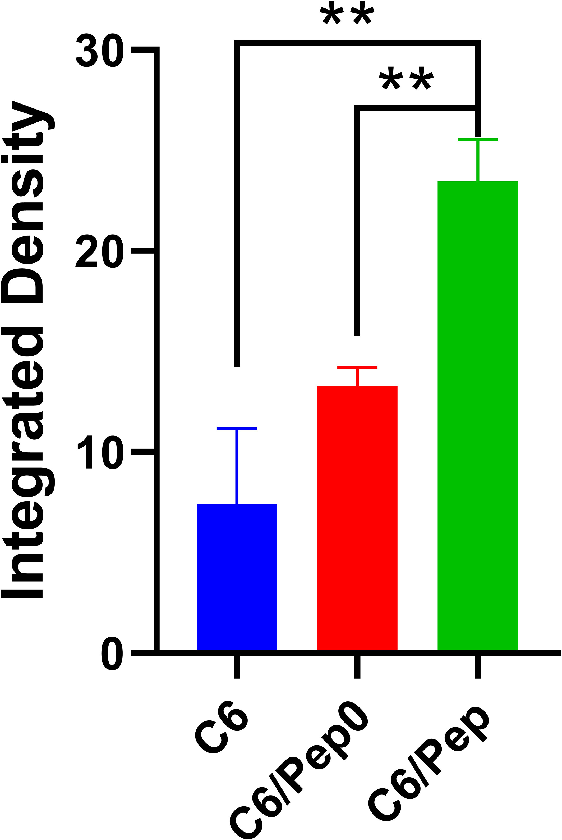
Supplementary Fig. 23 Quantification of intracellular C6 fluorescence after 120 h of incubation. ** P < 0.01.
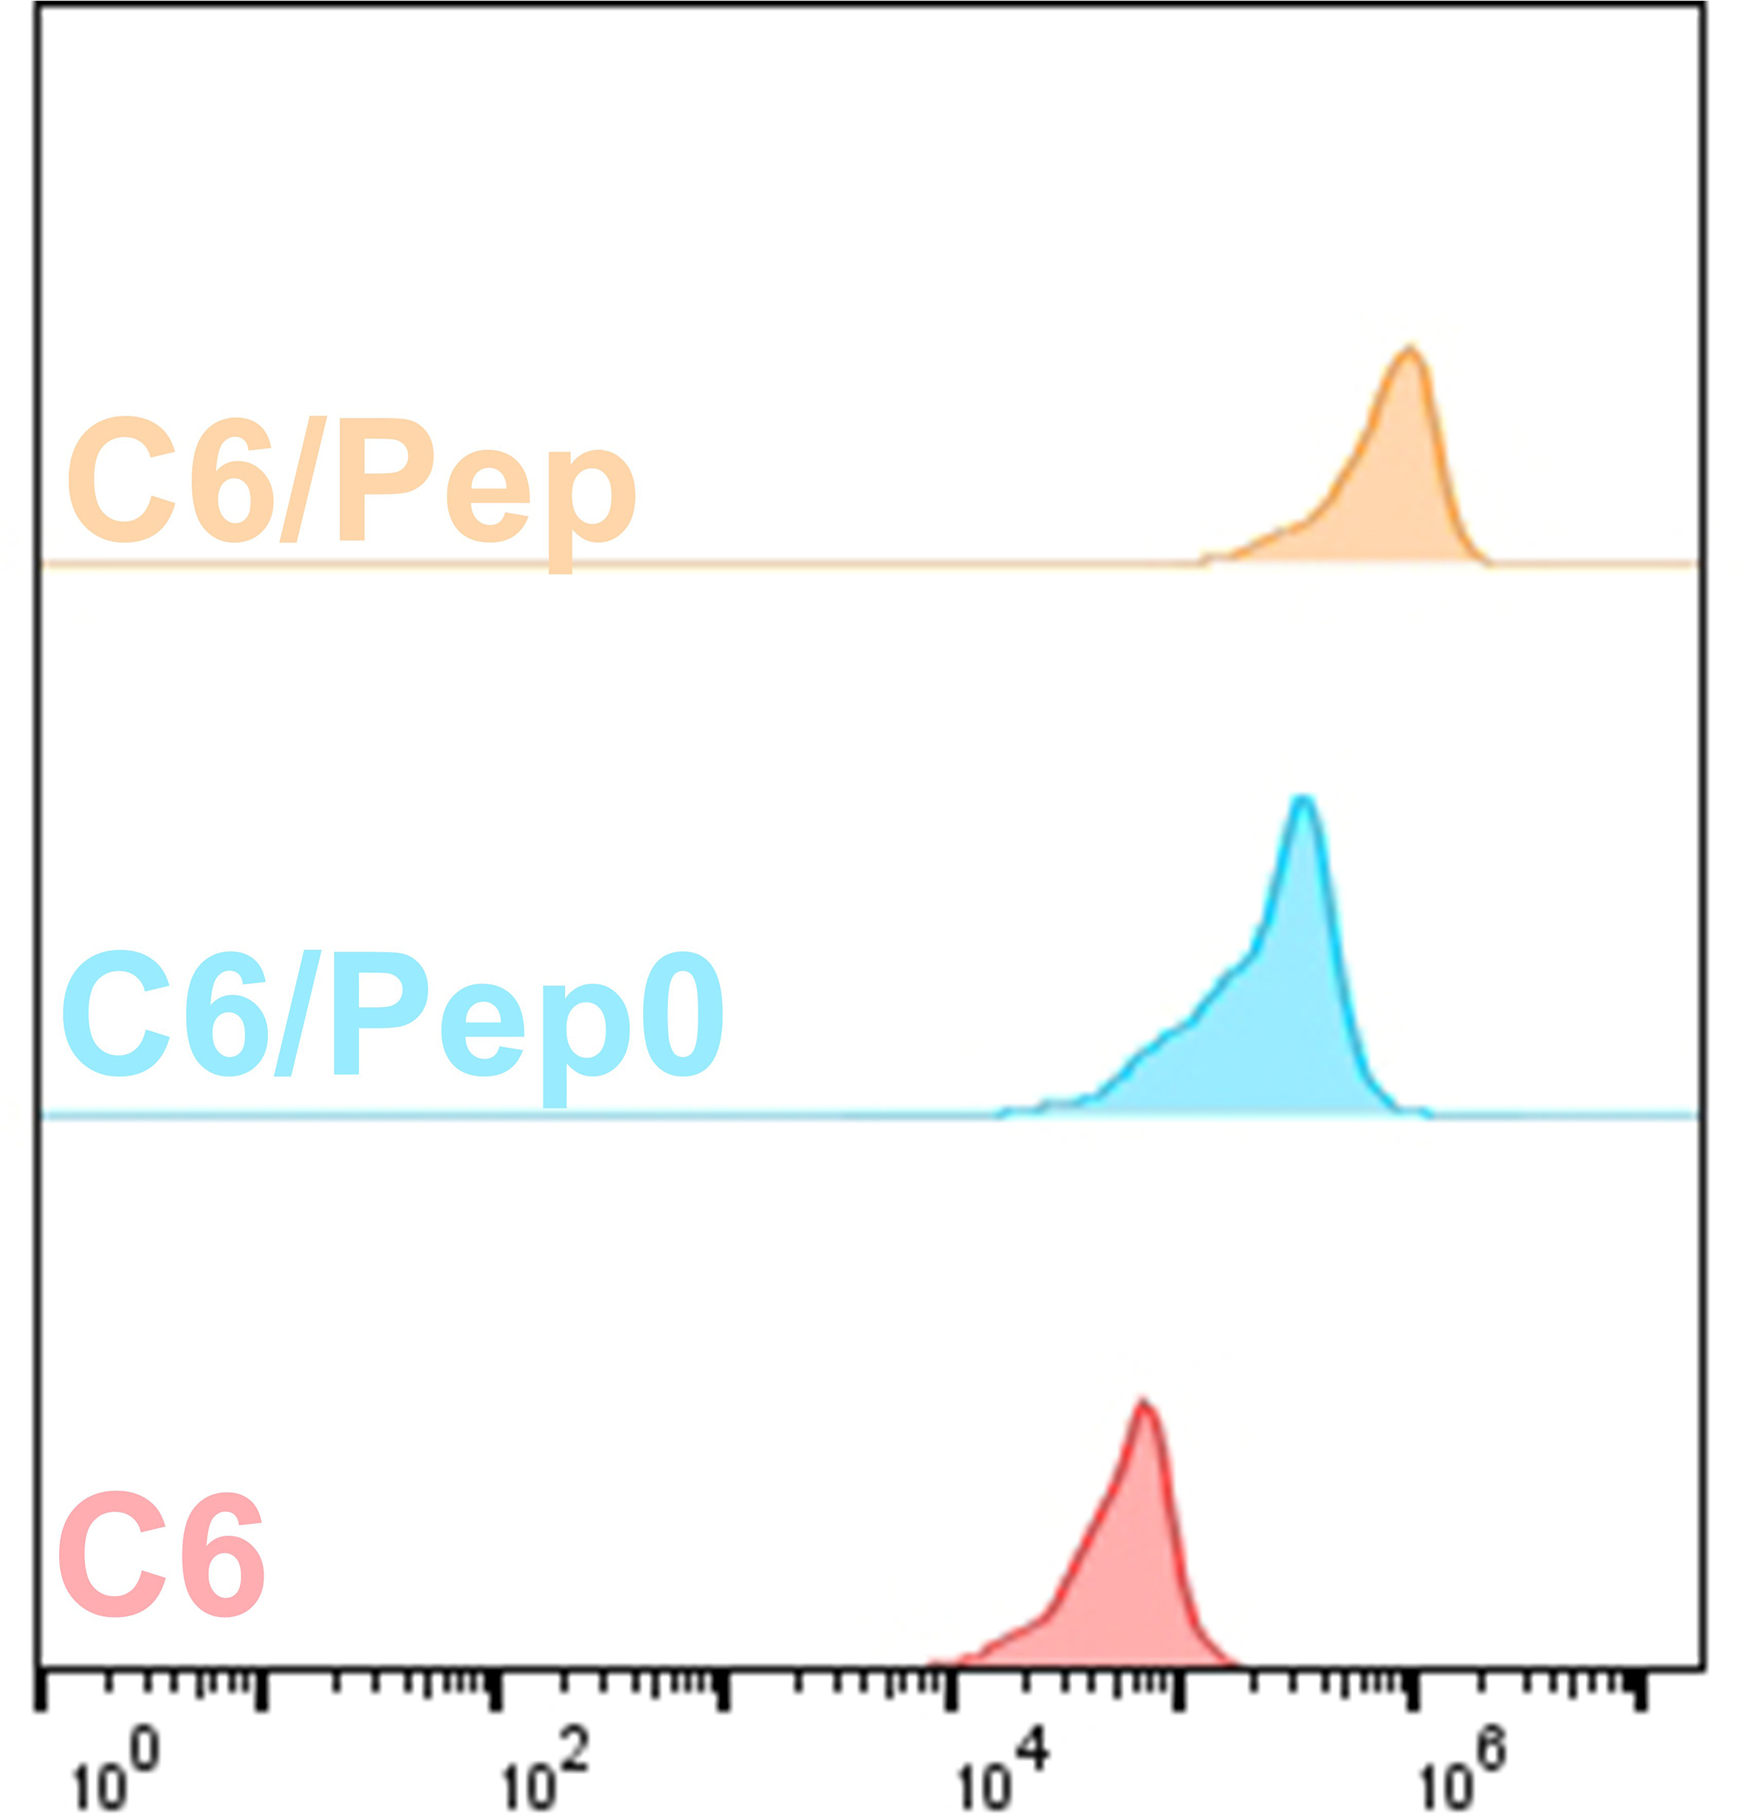
Supplementary Fig. 24 Flow cytometry analysis of MB49 cells incubated with C6, C6/Pep0 or C6/Pep for 96 h.
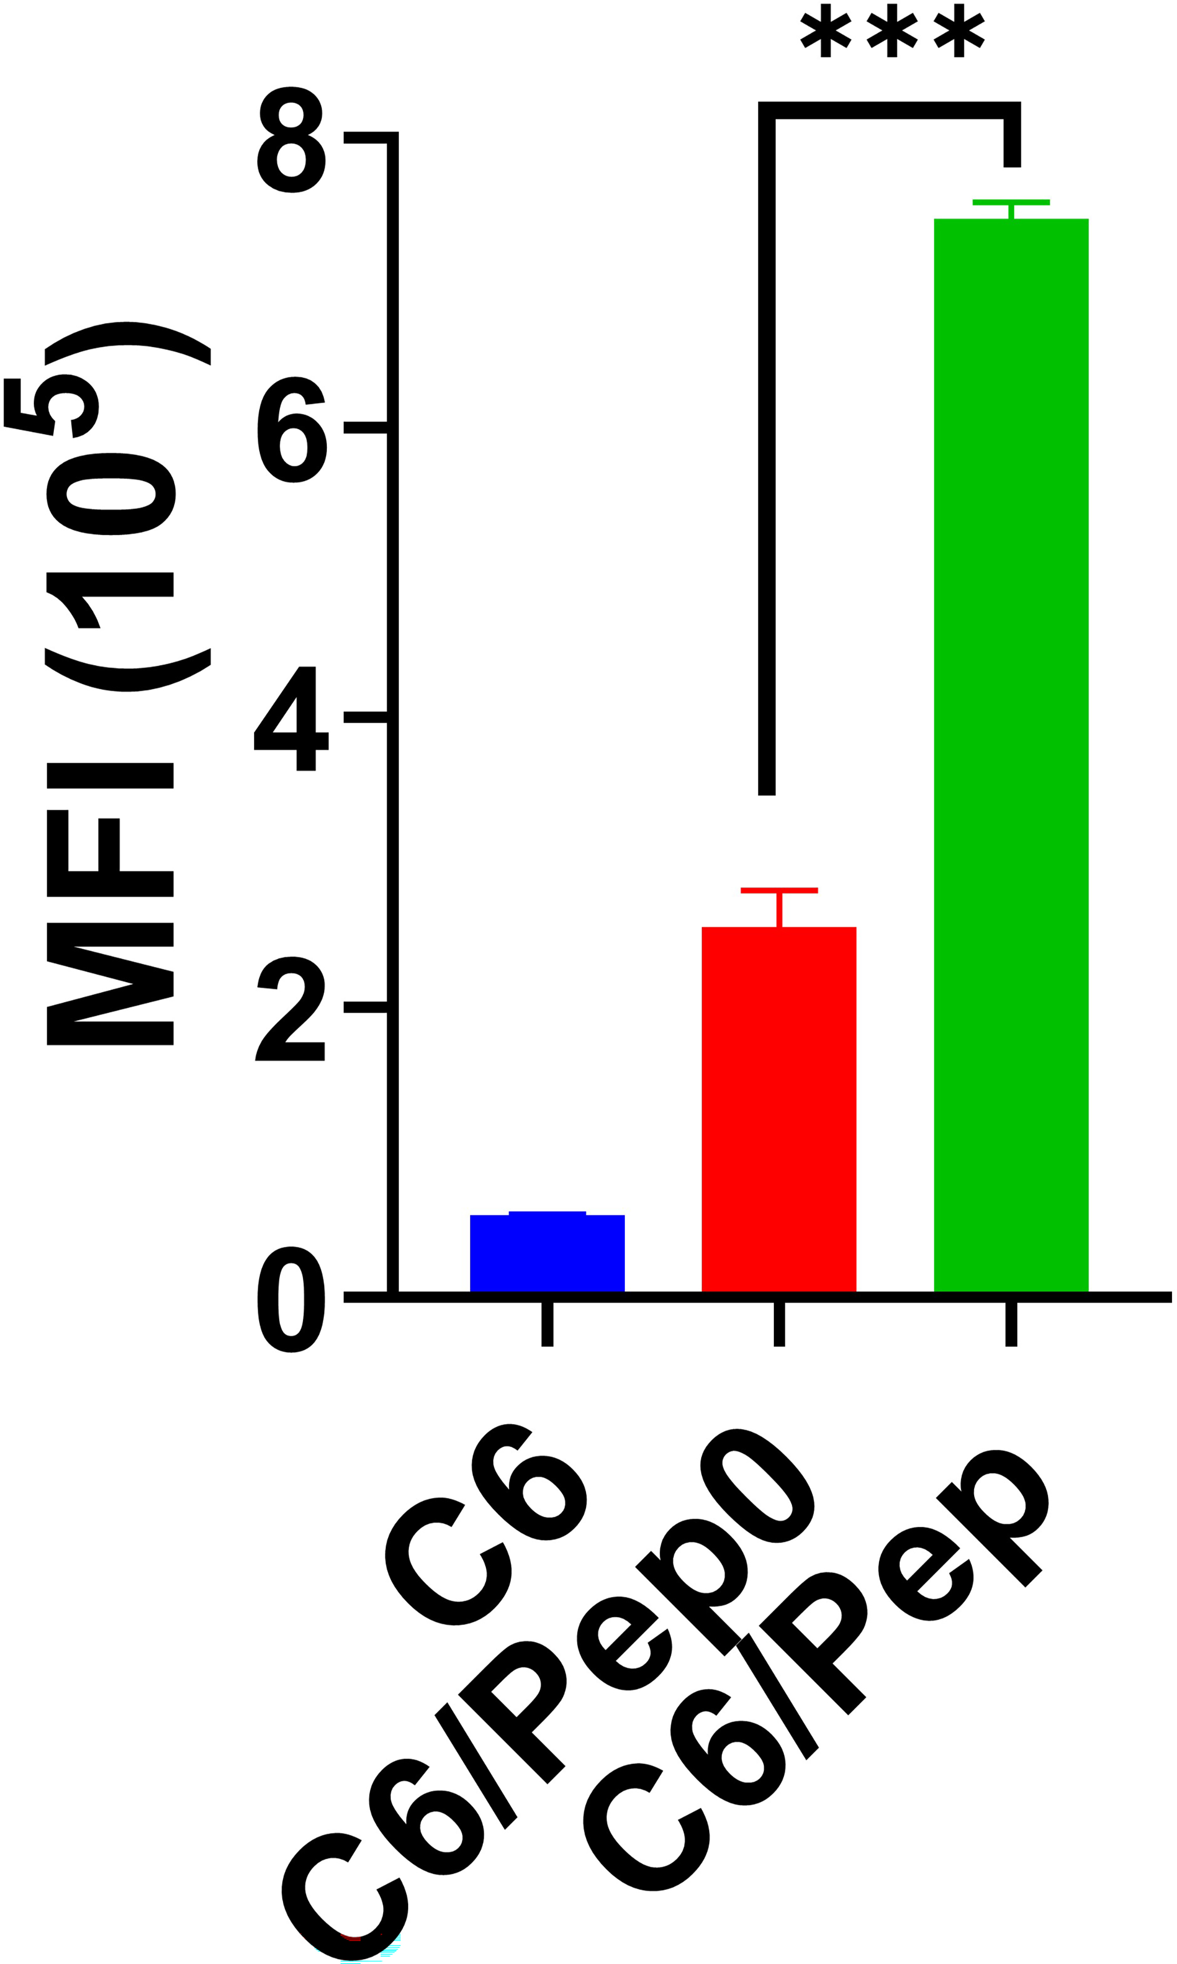
Supplementary Fig. 25 Mean fluorescence intensity analysis. *** P < 0.001.
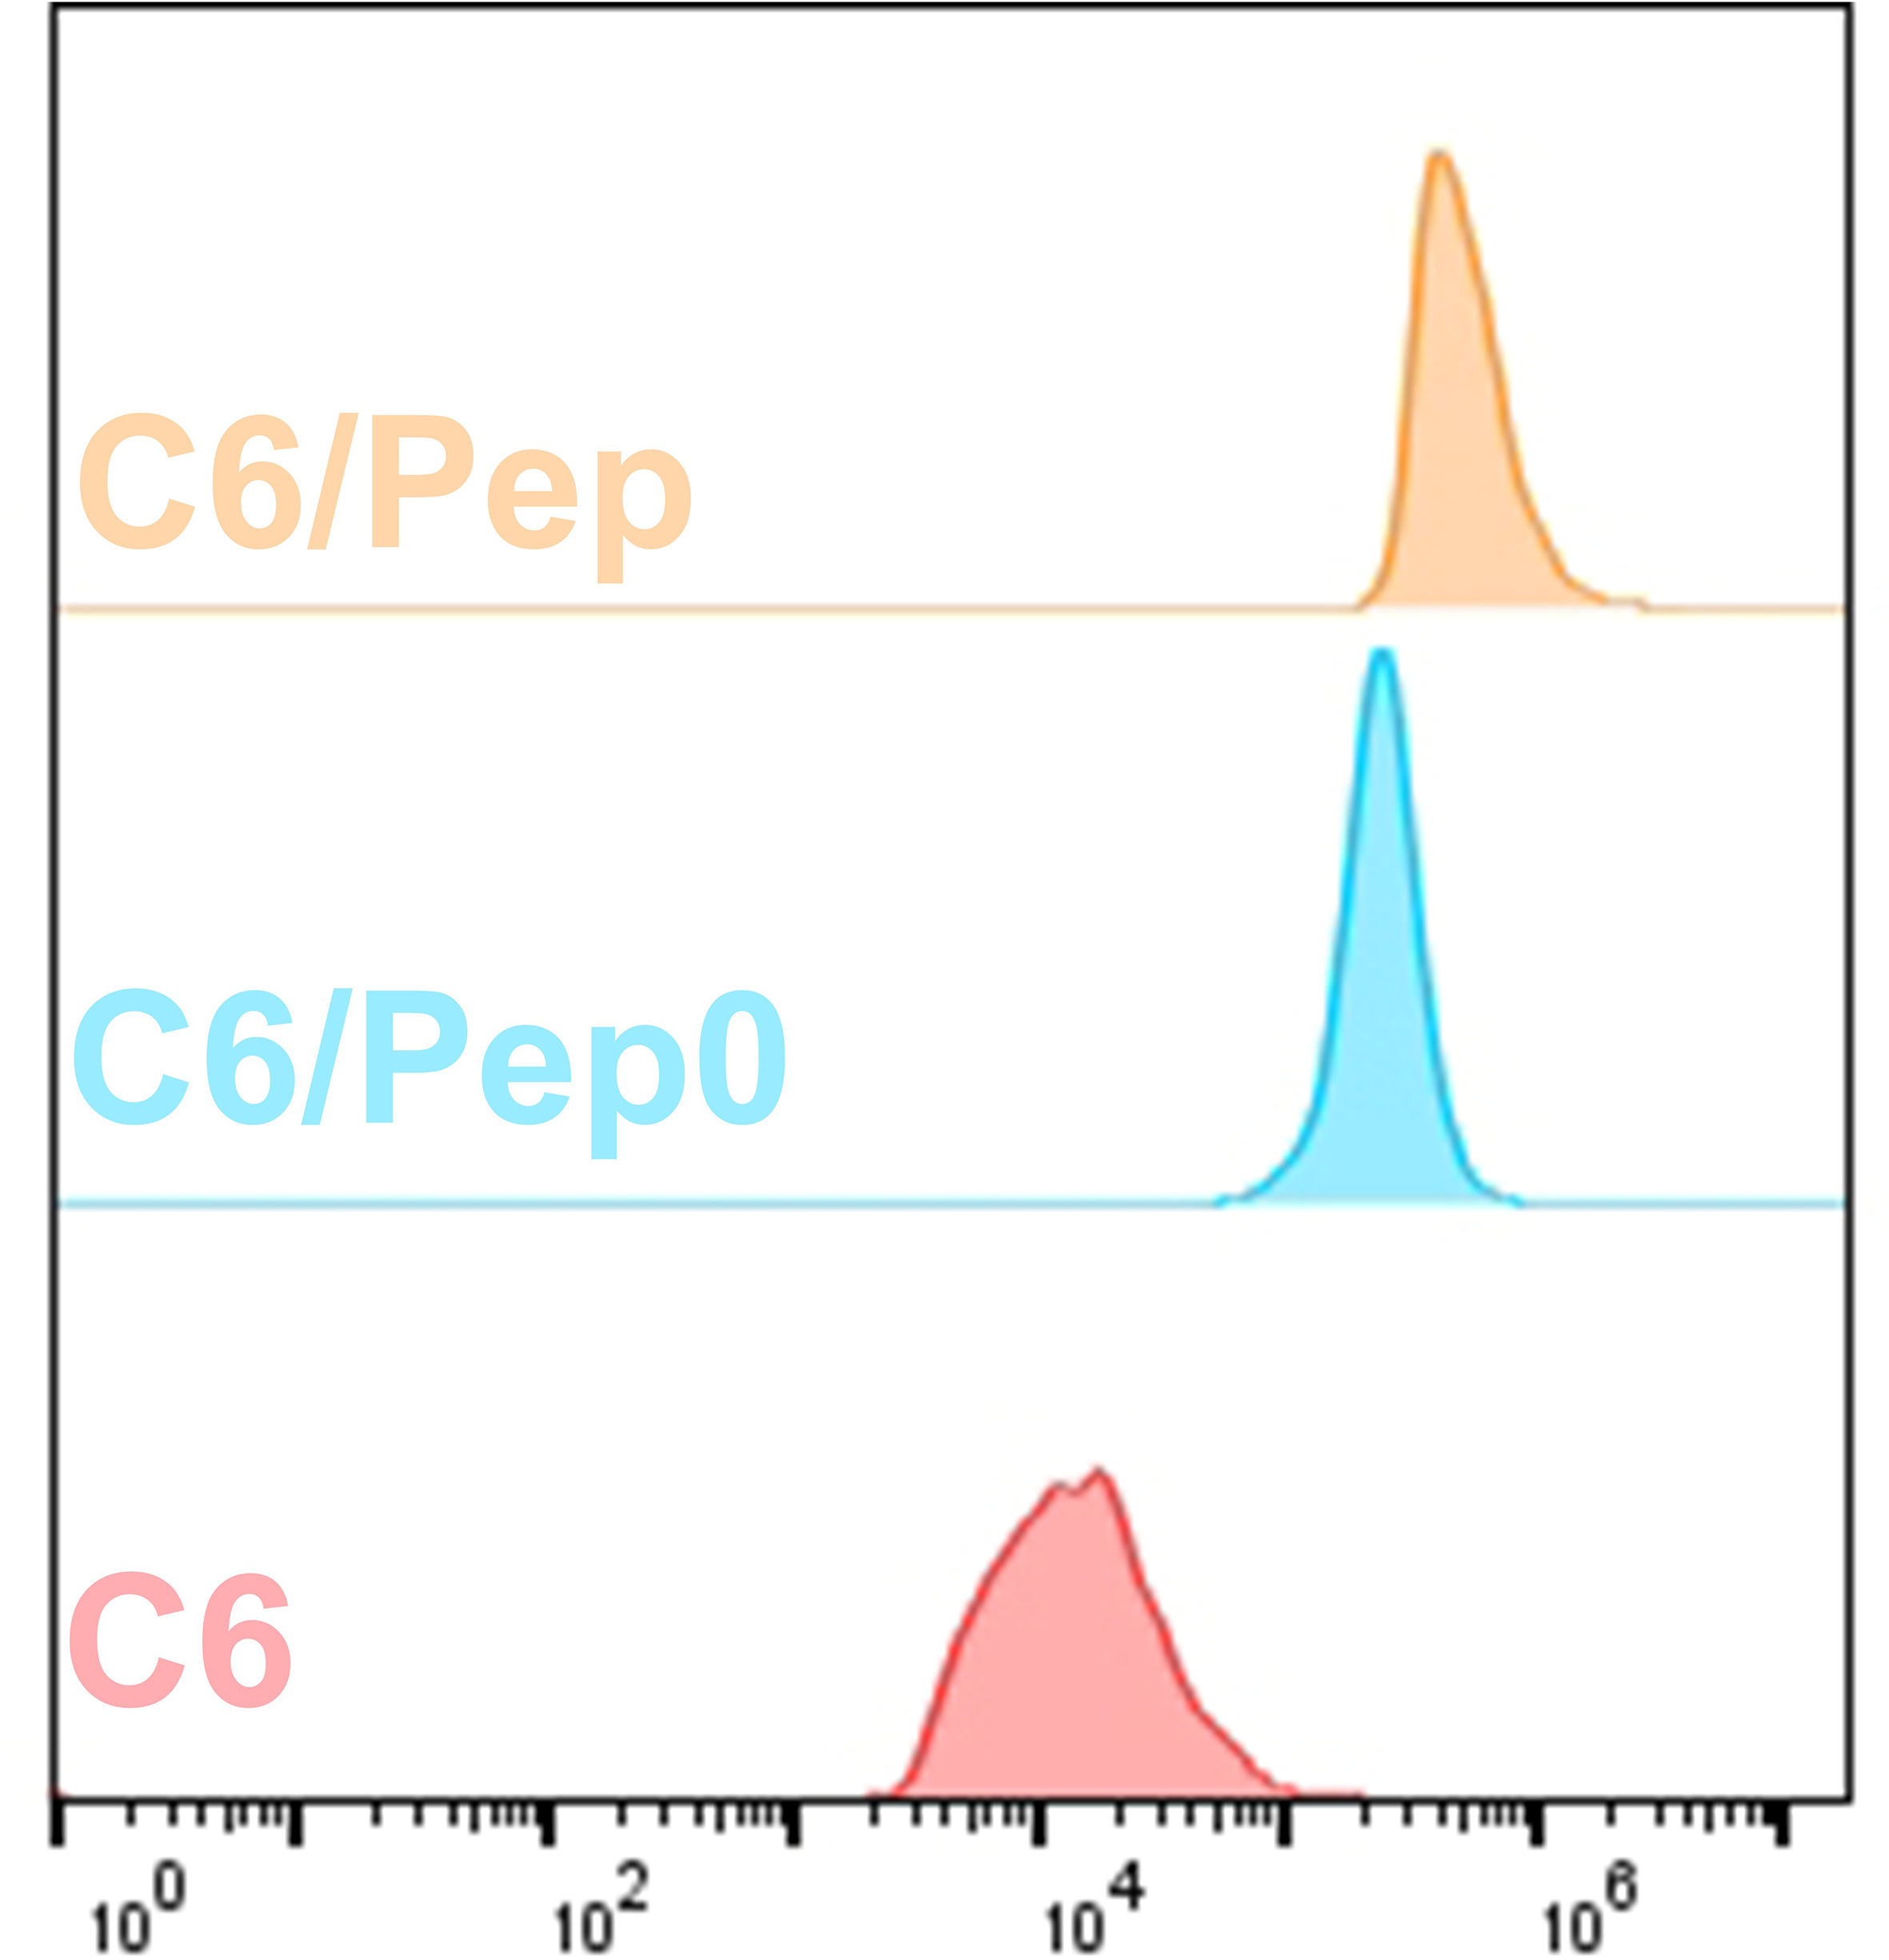
Supplementary Fig. 26 Flow cytometry analysis of MB49 cells incubated with C6, C6/Pep0 or C6/Pep for 120 h.
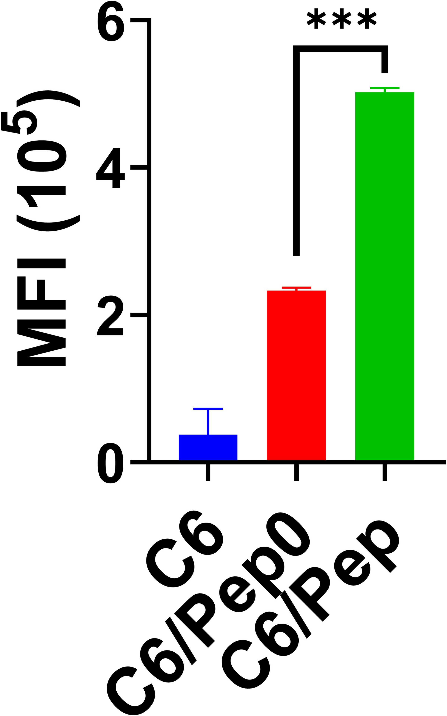
Supplementary Fig. 27 Mean fluorescence intensity. *** P < 0.001.
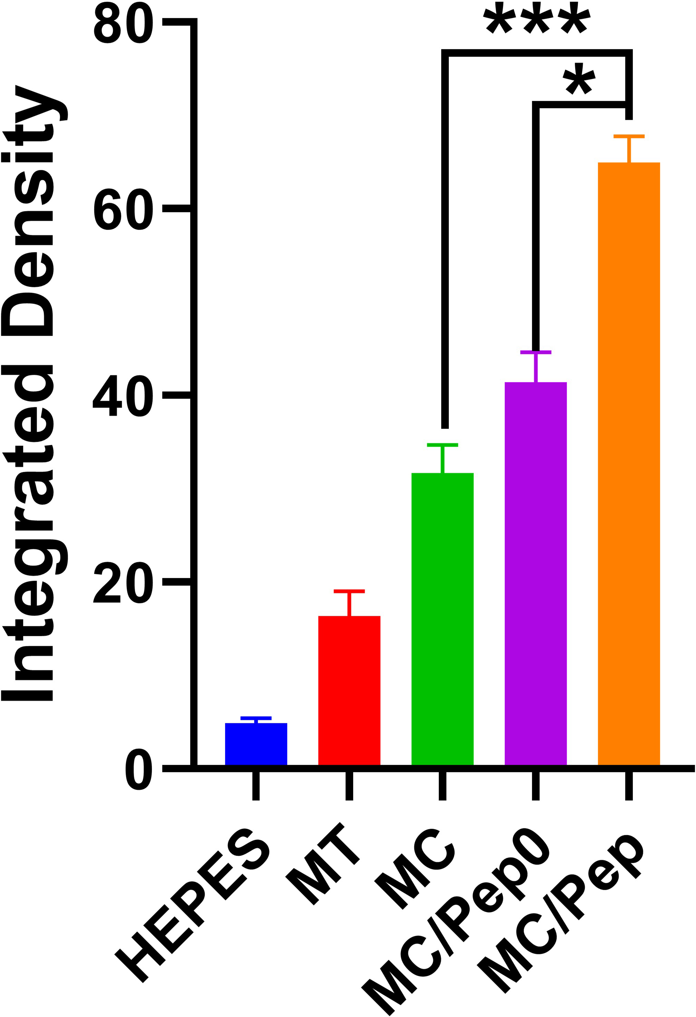
Supplementary Fig. 28 Average fluorescence intensity of ROS CLMS images. * P < 0.05. *** P < 0.001.

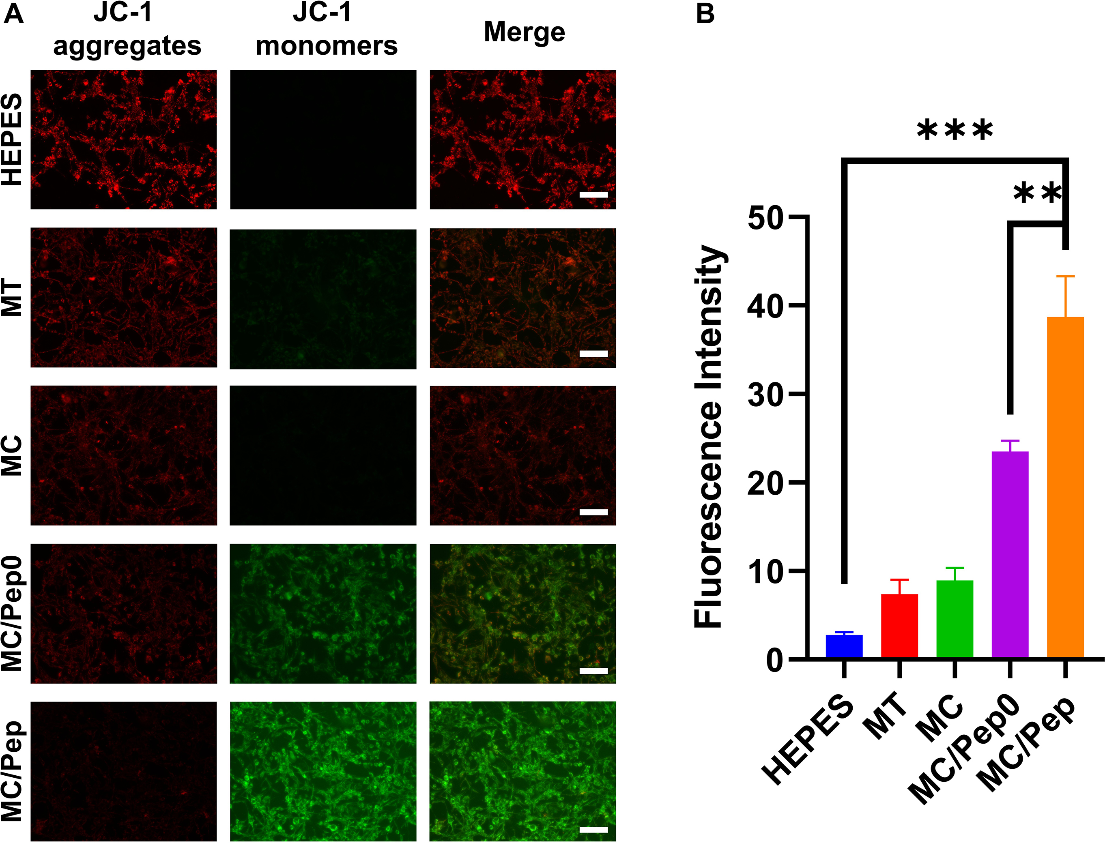
Supplementary Fig. 29 (A) JC-1 fluorescence images of MB49 cells cultured with HEPES, MT, MC, MC/Pep0, or MC/Pep for 24 h. Scale bar: 100 μm. (B) Quantification of JC-1 fluorescence after drug treatment. ** P < 0.01. *** P < 0.001.

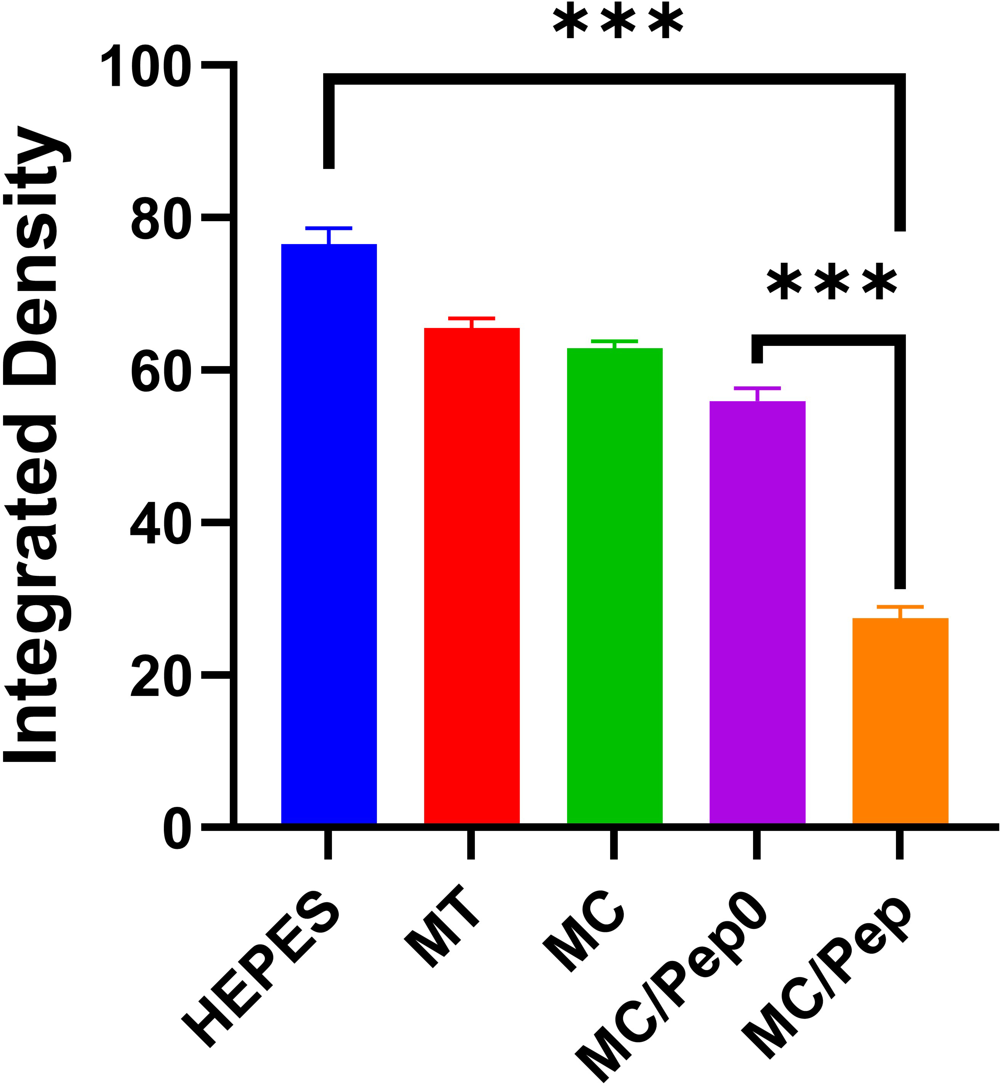
Supplementary Fig. 30 Average fluorescence intensity of HMGB1 CLMS images. *** P < 0.001.
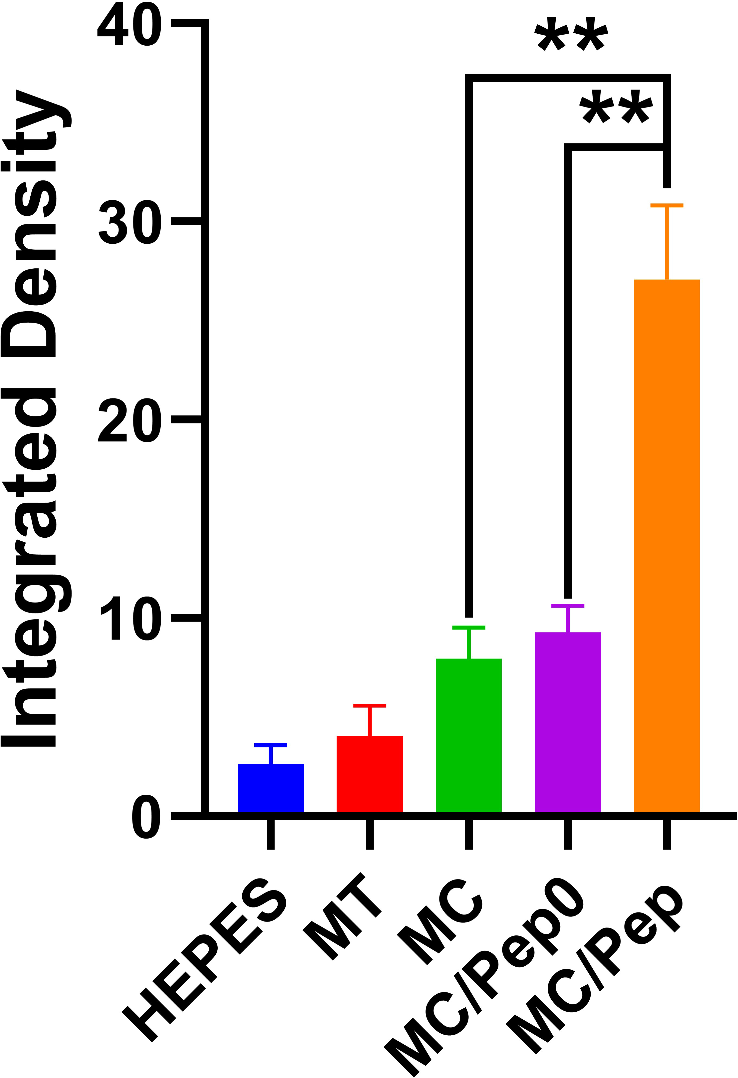
Supplementary Fig. 31 Average fluorescence intensity of CRT CLMS images. ** P < 0.01.
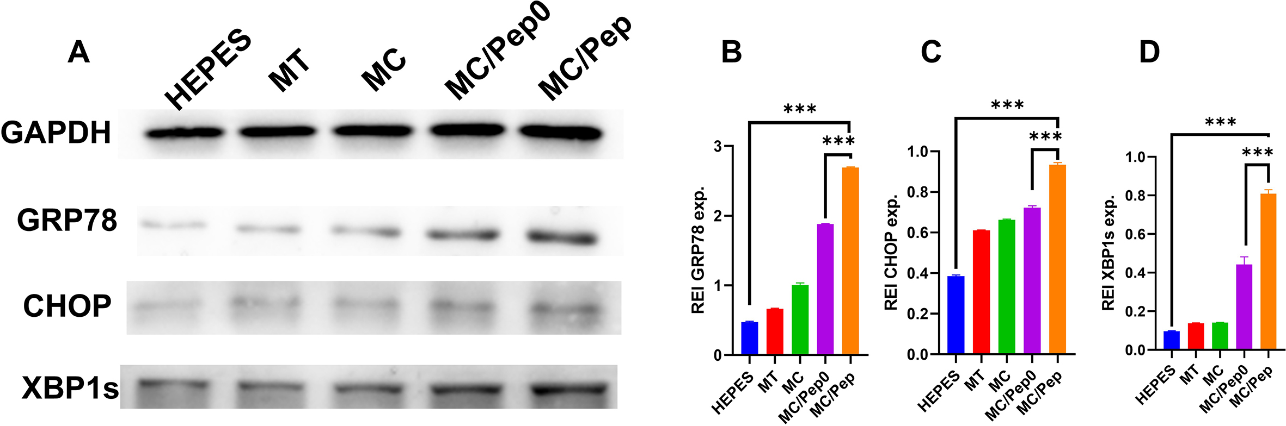
Supplementary Fig. 32 (A) Expression of XBP1, GRP78 and CHOP in MB49 cells from each group after drug treatment. Quantification of (B) GRP78, (C) CHOP, and (D) XBP1s expression. *** P < 0.001.
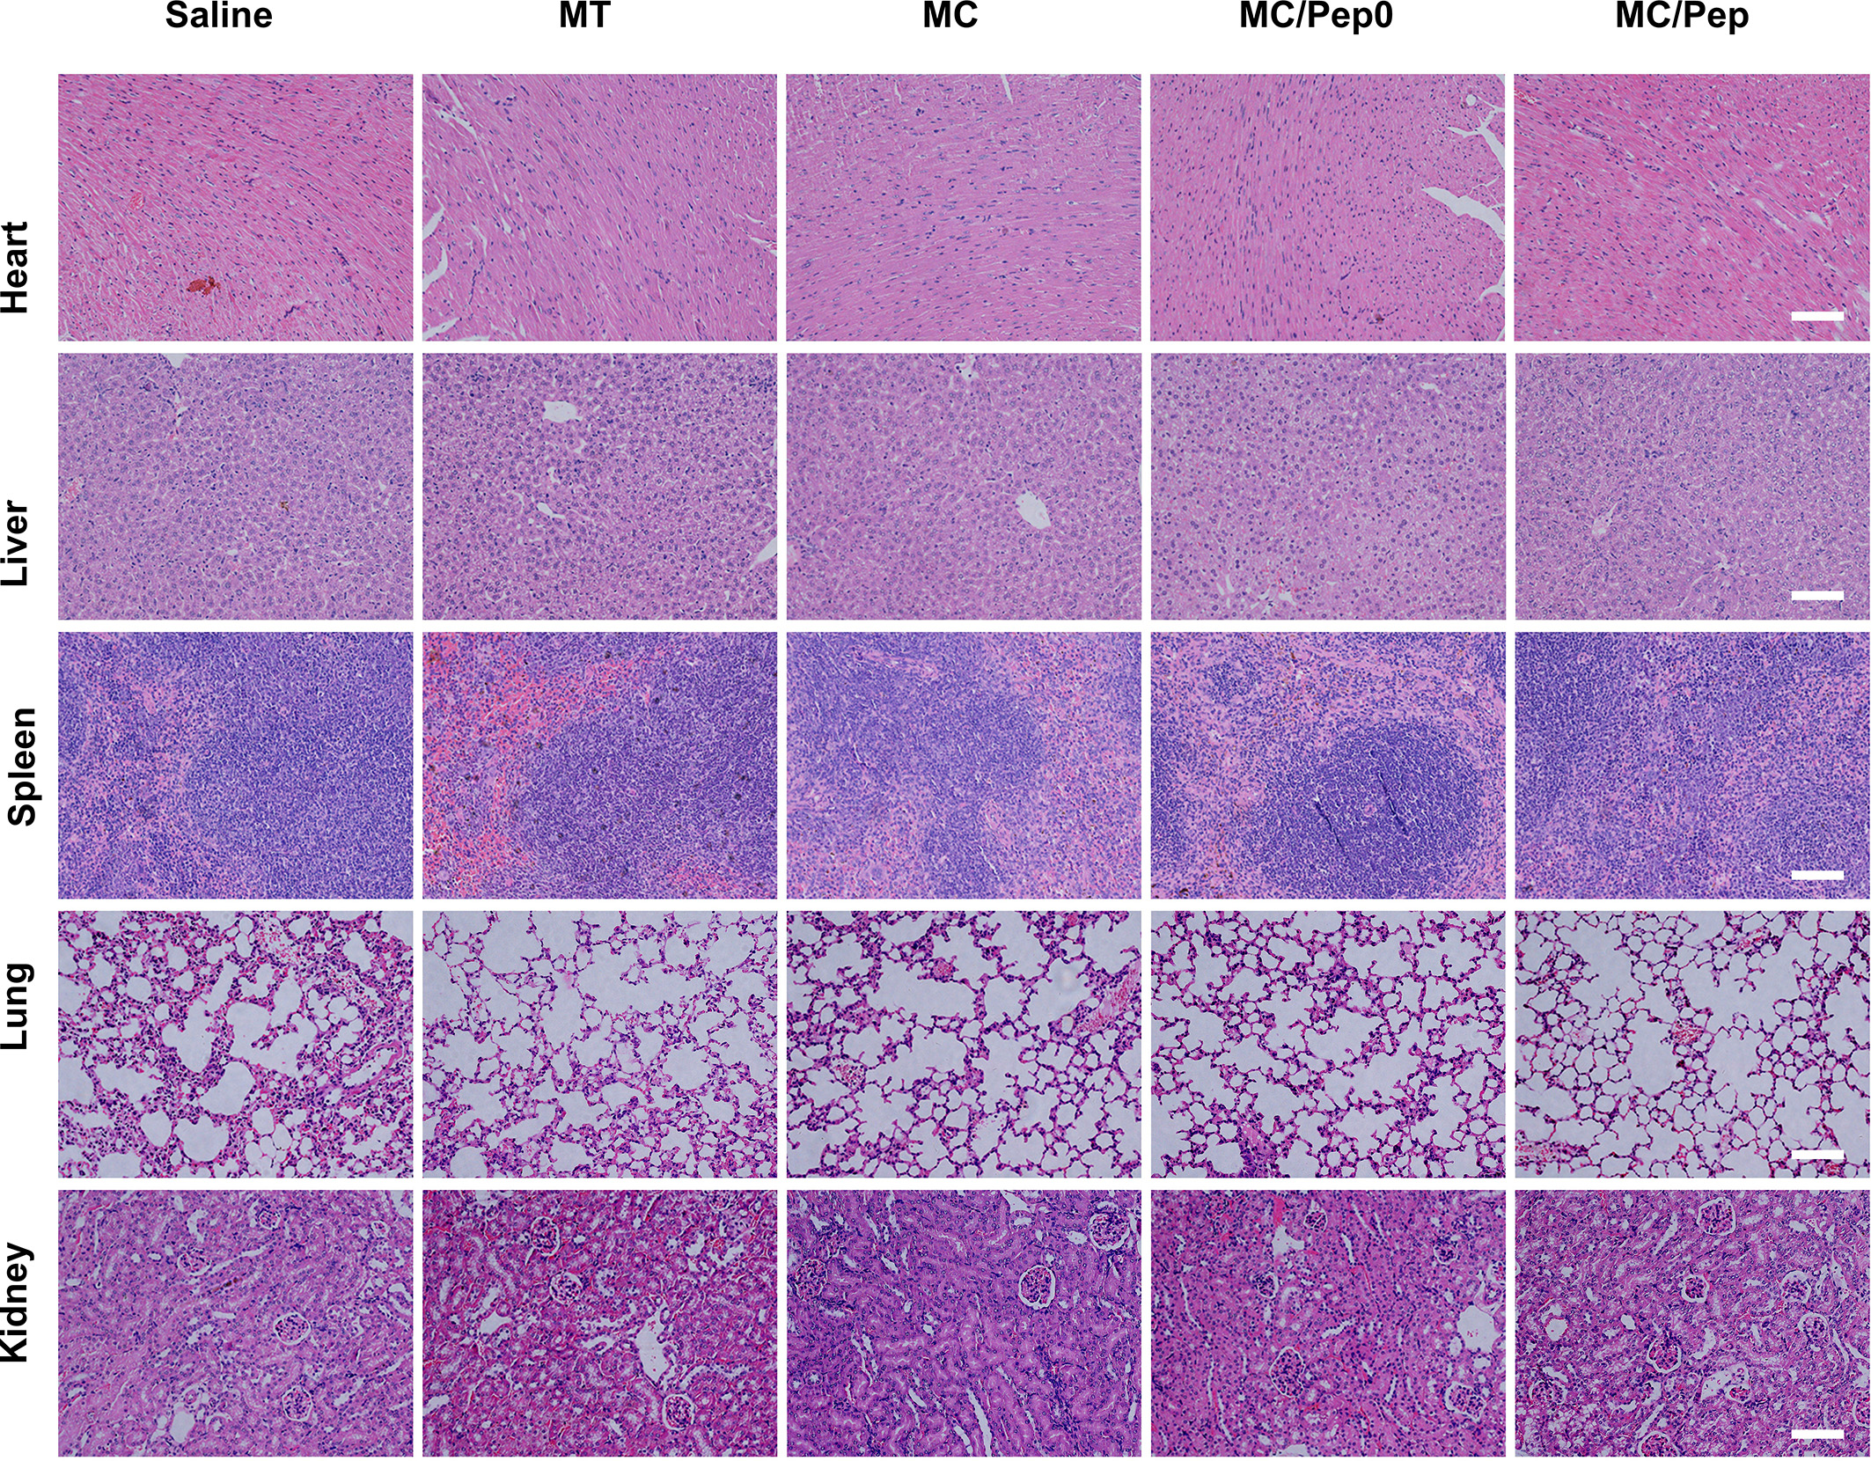
Supplementary Fig. 33 Sections of the heart, liver, spleen, lungs and kidneys from the antitumor experiments. Scale bar: 100 μm.
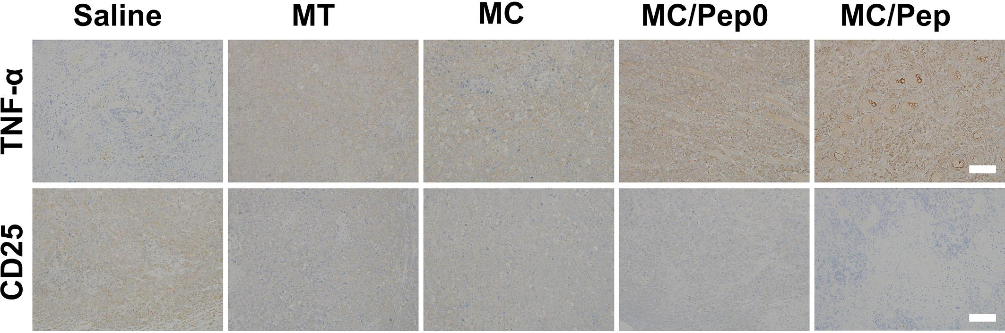
Supplementary Fig. 34 CD25 and TNF-α levels in tumors. Scale bar: 100 μm.
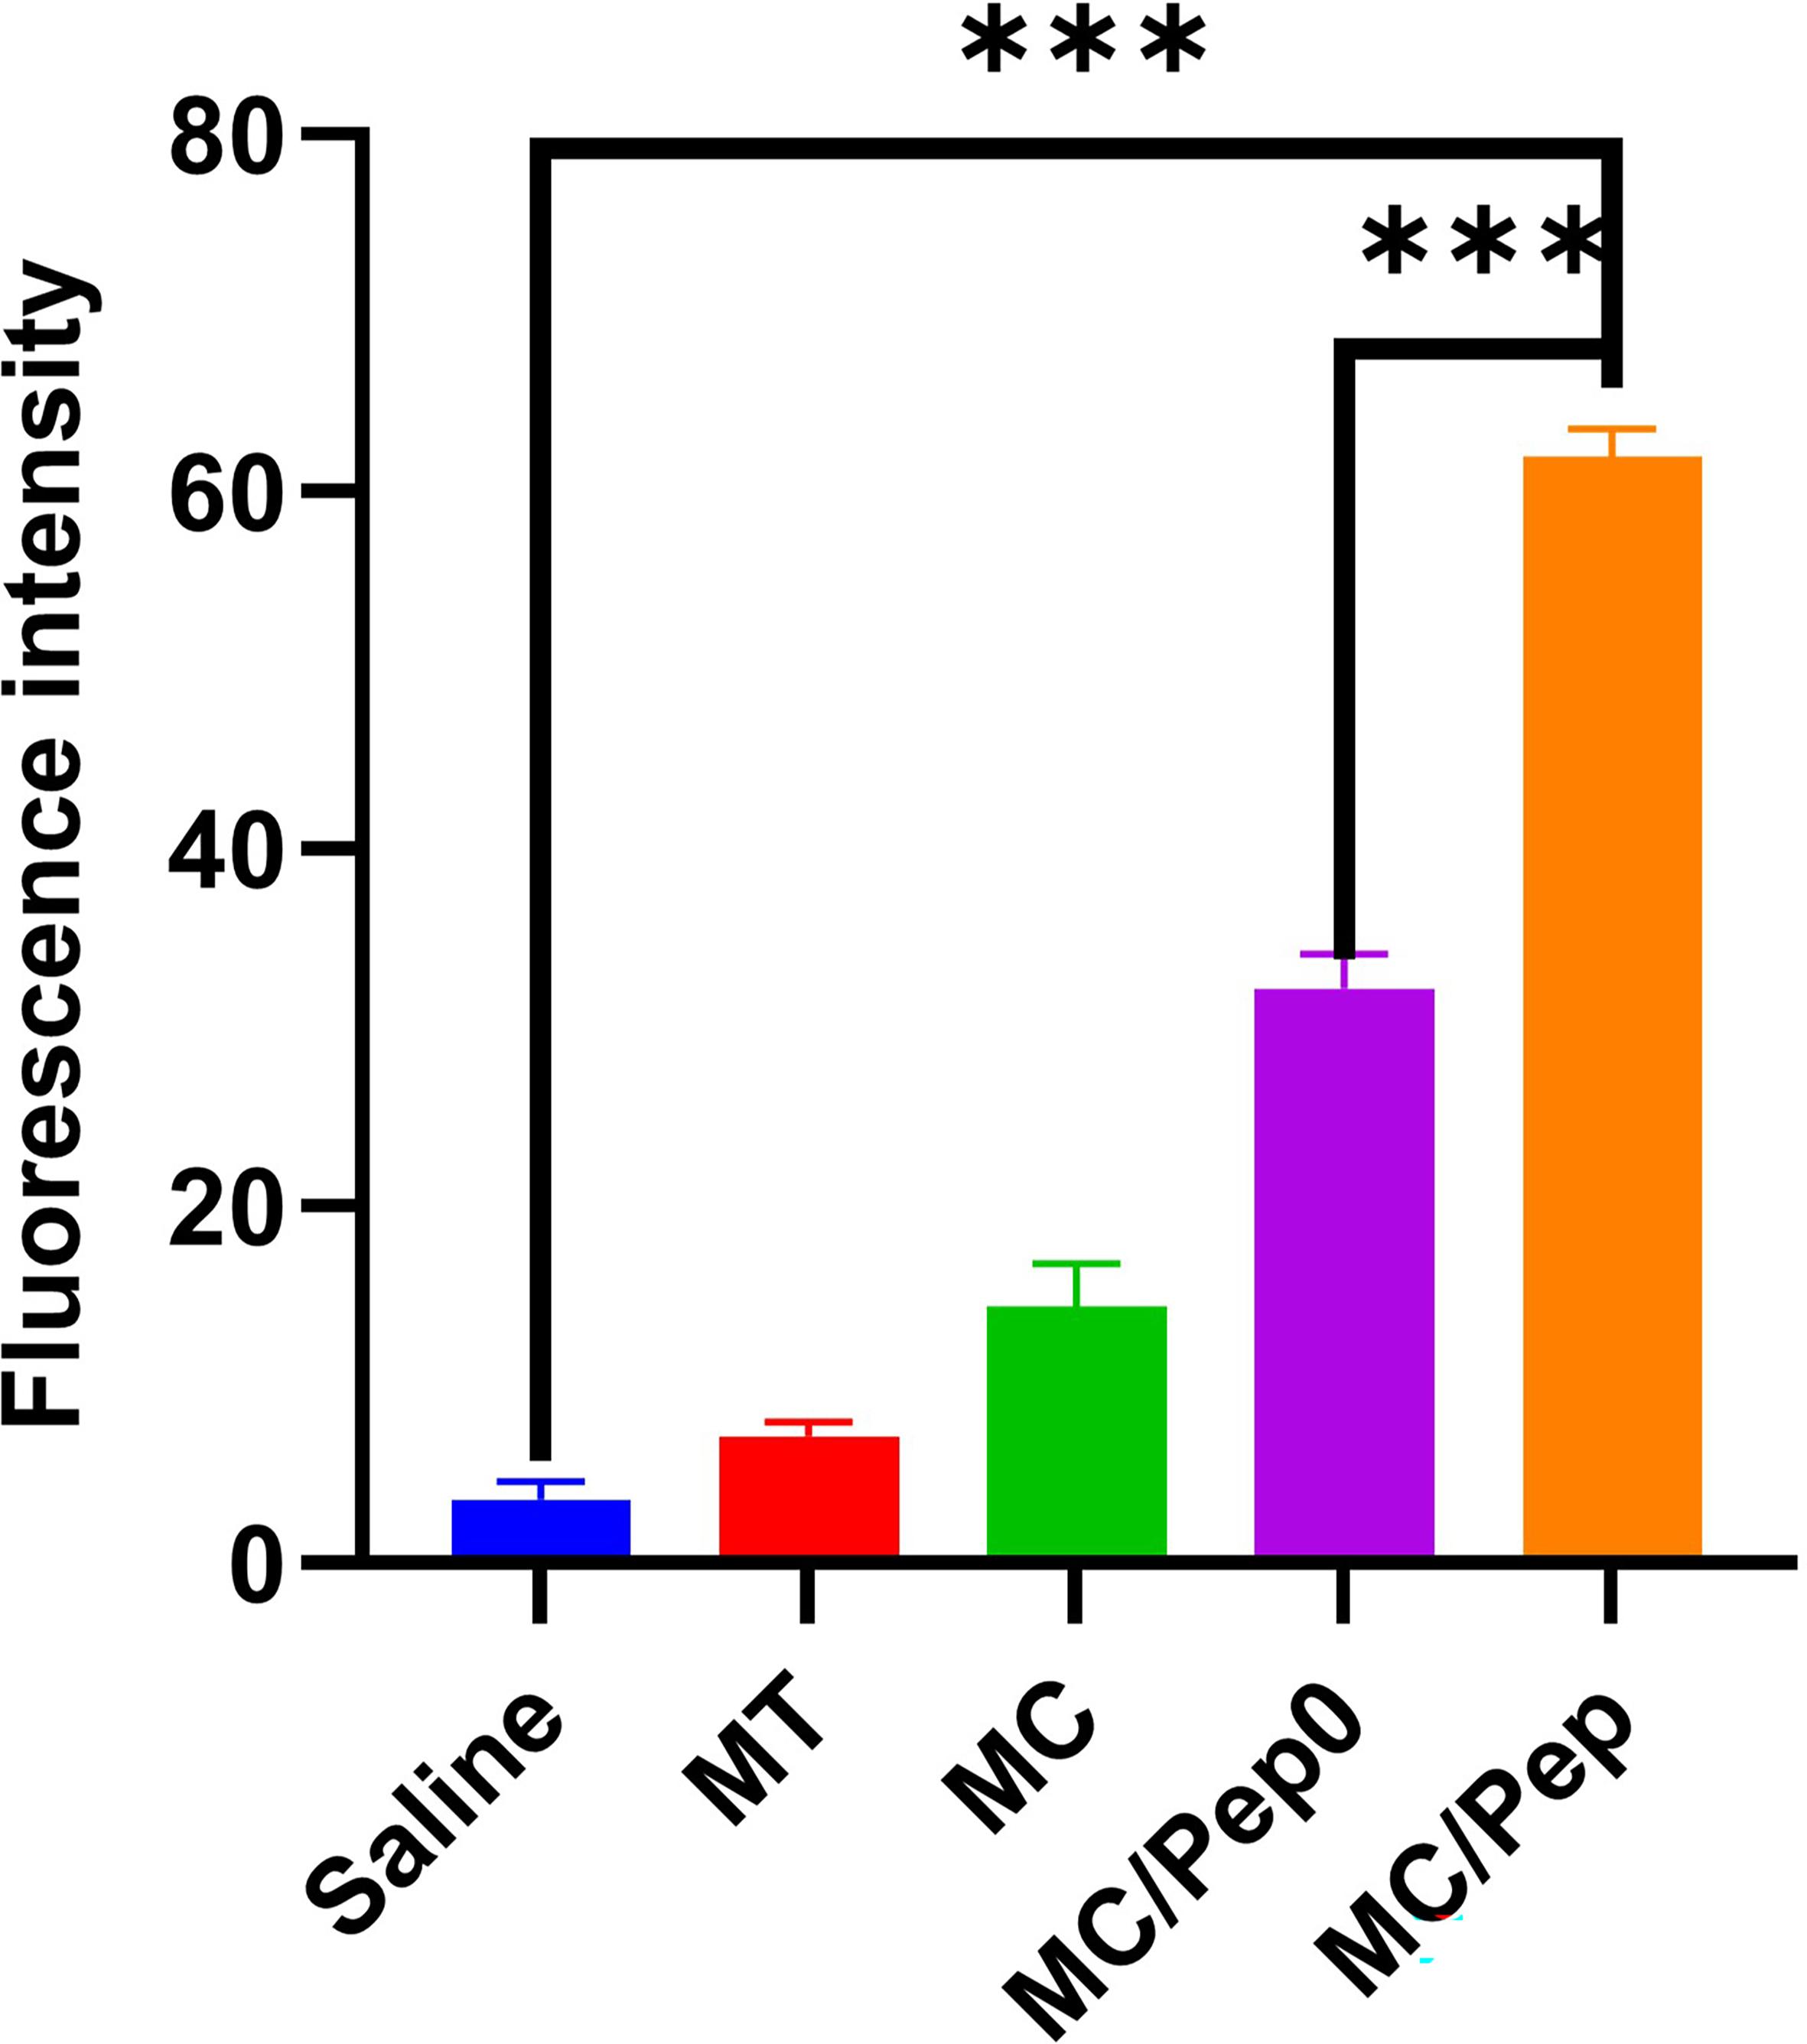
Supplementary Fig. 35 Quantification of the fluorescence intensity of CD4. *** P < 0.001.

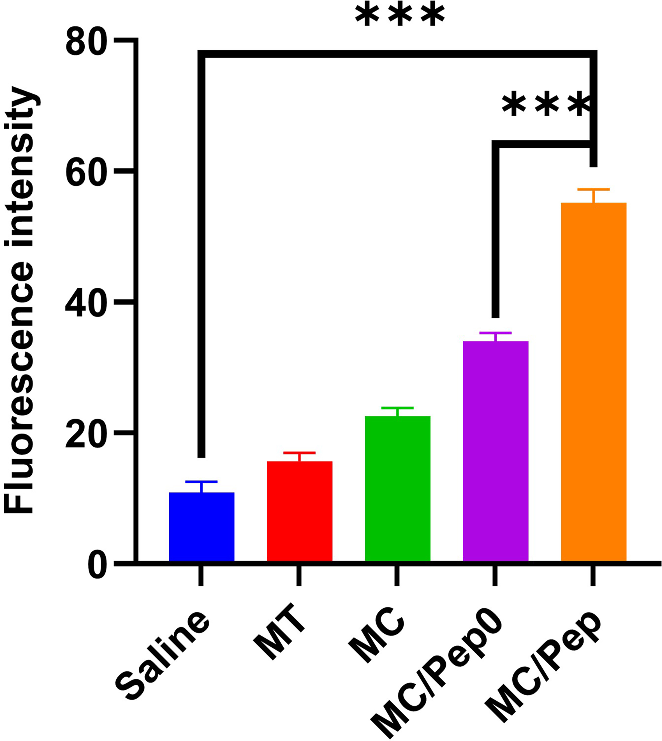
Supplementary Fig. 36 Quantification of the fluorescence intensity of CD8. *** P < 0.001.
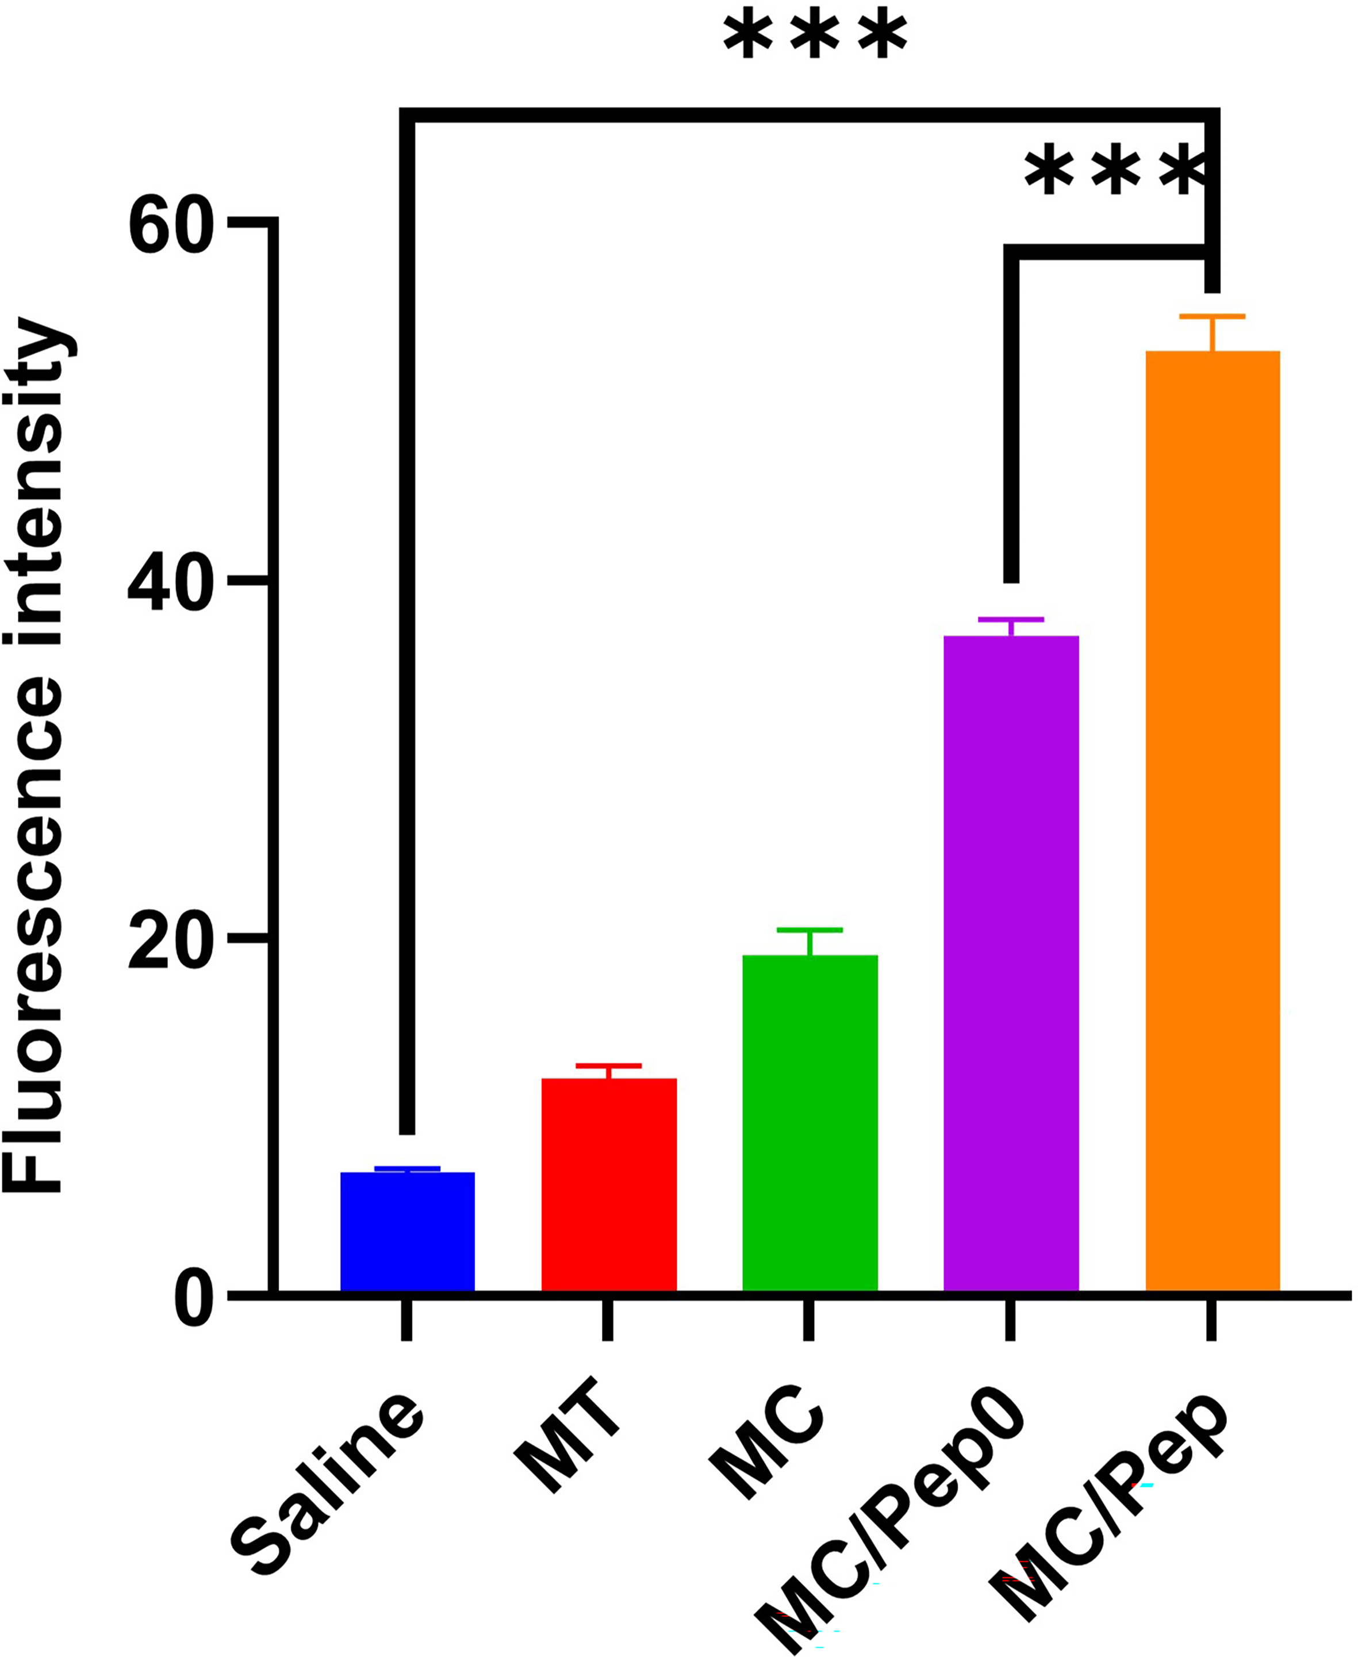
Supplementary Fig. 37 Quantification of the fluorescence intensity of CRT. *** P < 0.001.
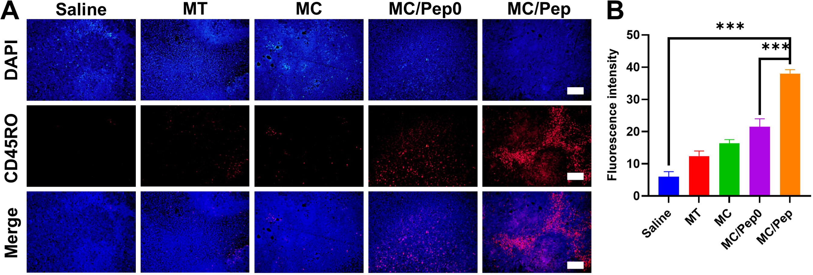
Supplementary Fig. 38 (A) CD45RO levels in the tumors. Scale bar: 100 μm. (B) Quantification of the fluorescence intensity of CD45RO. *** P < 0.001.
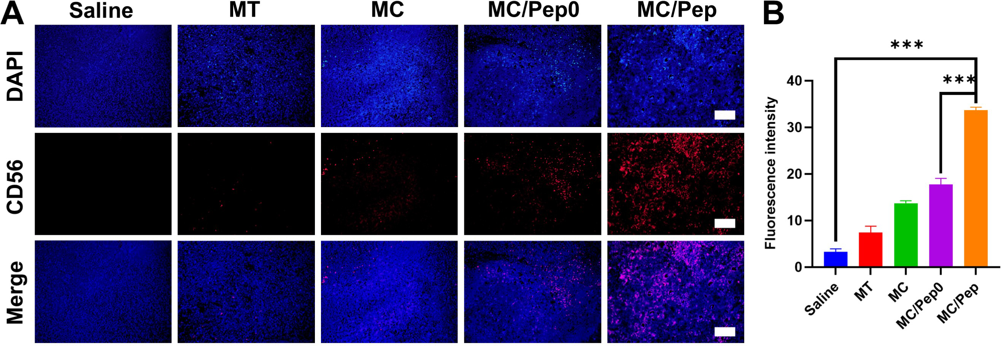
Supplementary Fig. 39 (A) CD56 levels in the tumors. Scale bar: 100 μm. (B) Quantification of the fluorescence intensity of CD56. *** P < 0.001.
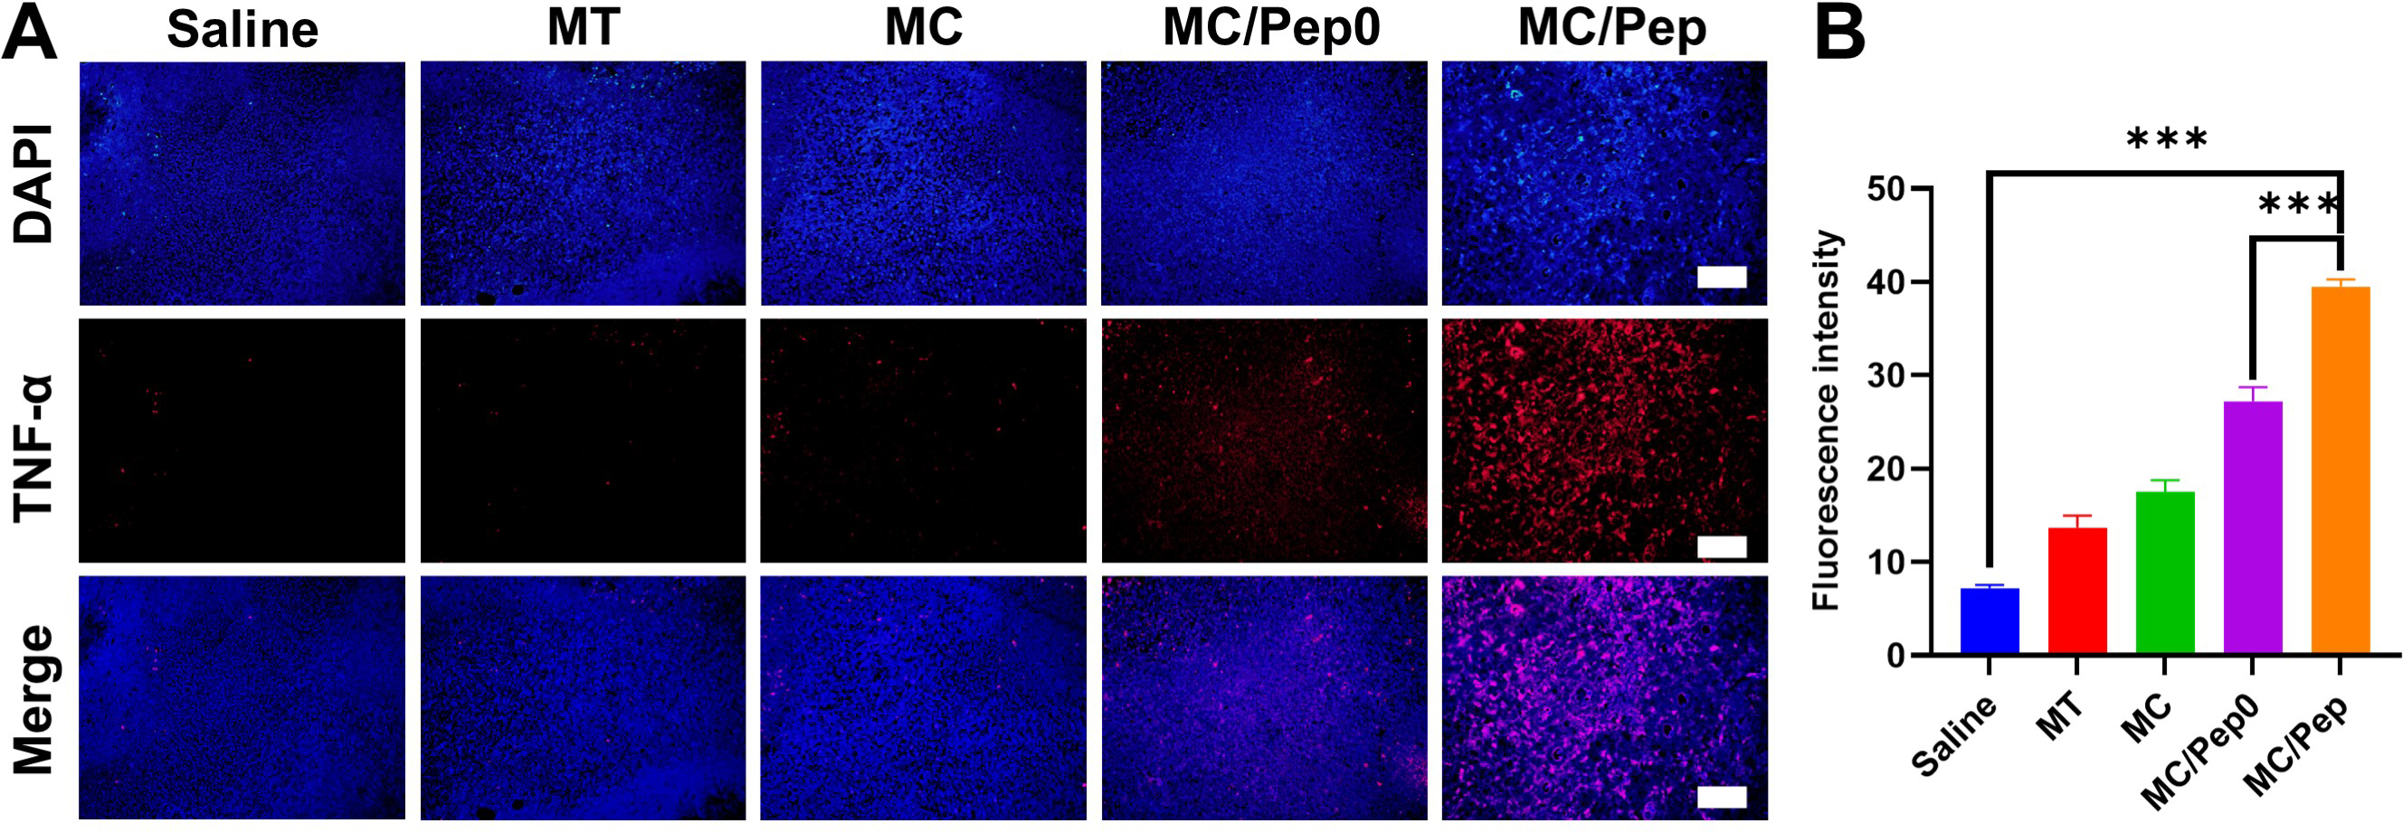
Supplementary Fig. 40 (A) TNF-α levels in the tumors. Scale bar: 100 μm. (B) Quantification of the fluorescence intensity of TNF-α. *** P < 0.001.

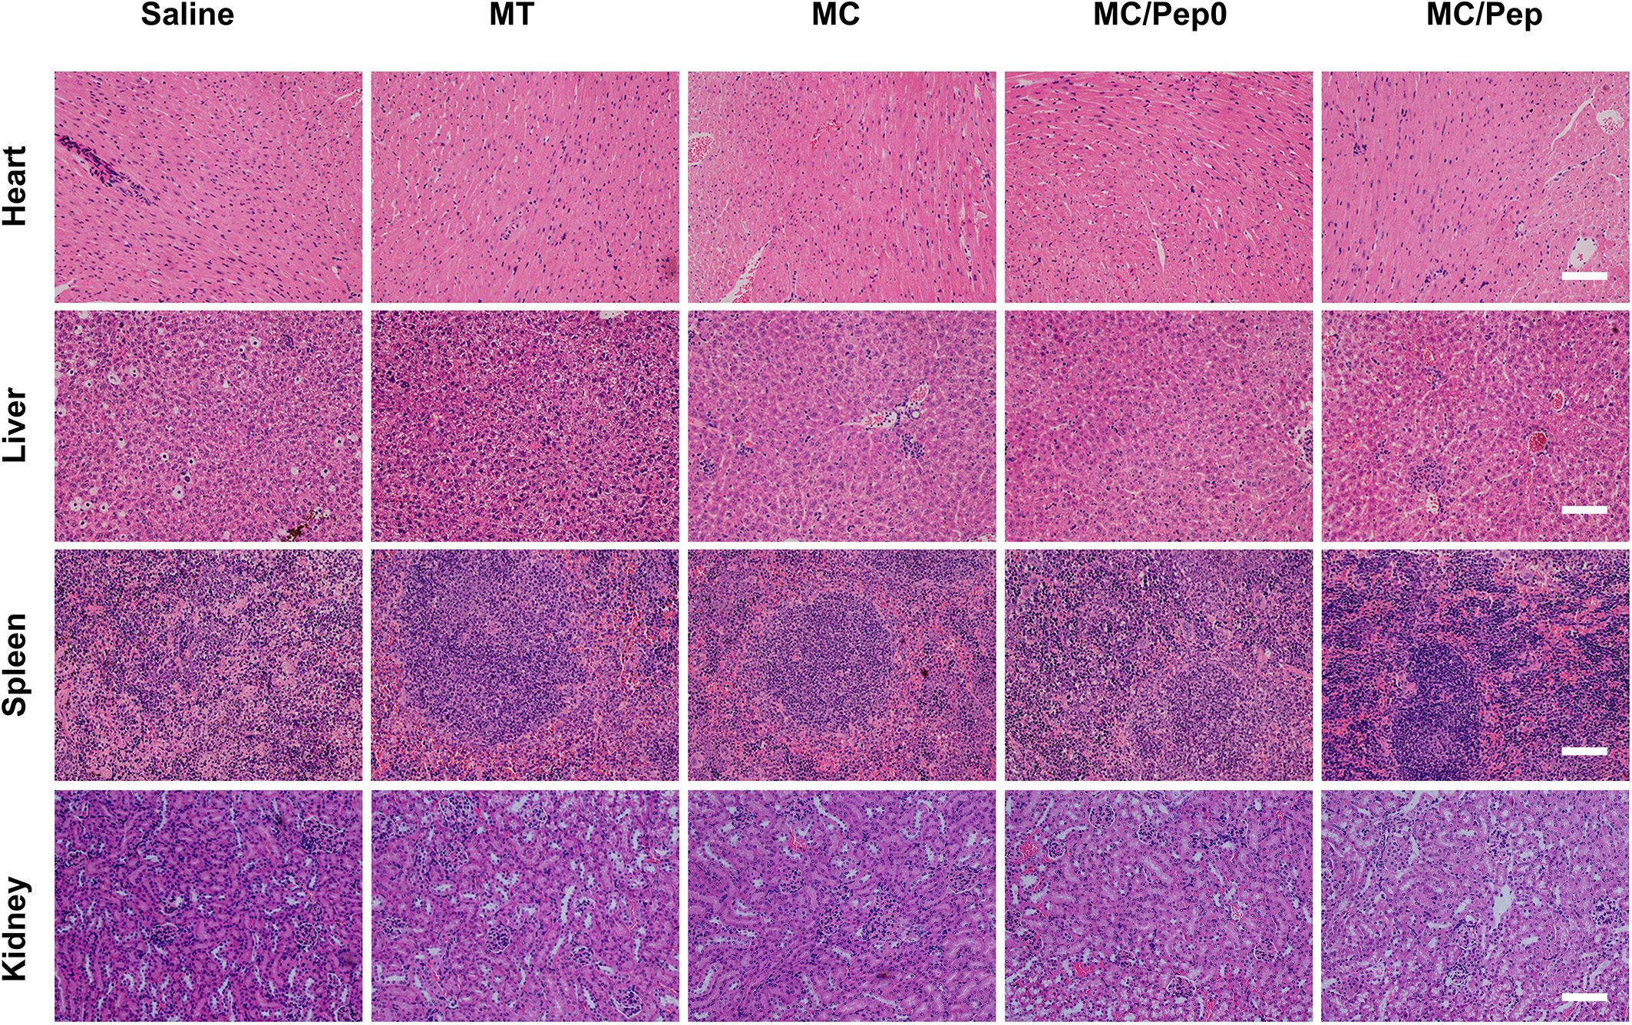
Supplementary Fig. 41 Sections of the heart, liver, spleen and kidneys from the antimetastasis experiments. Scale bar: 100 μm.
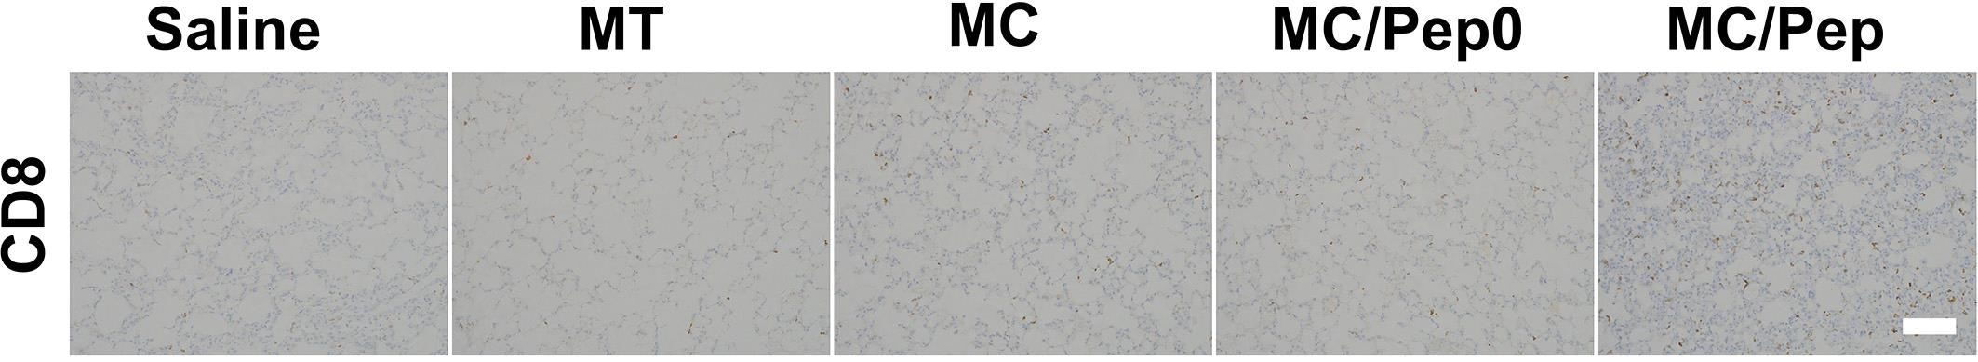
Supplementary Fig. 42 CD8 levels in the lung. Scale bar: 100 μm.
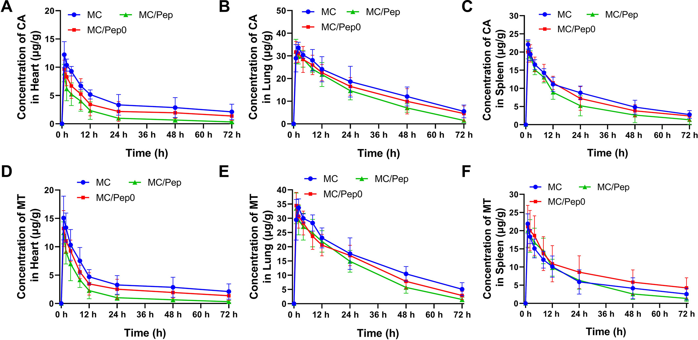
Supplementary Fig. 43 CA in the (A) heart, (B) lung, and (C) spleen. MT in the (D) heart, (E) lung, and (F) spleen.

