Supporting Information
Plain DNA and cationic aromatics: A platform to simplify carrier-free delivery systems
Shiji Fang^{1#}, Zhongwei Zhao^{1#}, Huaping Li^{2#}, Wenhui Li¹, Yiming Ding¹, Zhuojun Meng², Fazong Wu¹, Liyun Zheng¹, Gaofeng Shu¹, Minjiang Chen¹, Fangfu Ye², Qing Liu²*, Lifei Zheng^{1,2}* and Jiansong Ji¹*
¹Zhejiang Key Laboratory of Imaging and Interventional Medicine, Zhejiang Engineering Research Center of Interventional Medicine Engineering and Biotechnology, Key Laboratory of Precision Medicine of Lishui City, The Fifth Affiliated Hospital of Wenzhou Medical University, Lishui 323000, China.
²Wenzhou Institute, University of Chinese Academy of Sciences, Wenzhou 325001, China.
#Shiji Fang, Zhongwei Zhao, Huaping Li contributed equally to this work.
*Correspondence: liuqing@uacs.ac.cn; zhenglf@ucas.ac.cn; jijiansong@zju.edu.cn

Supplementary Methods
Materials
All chemicals were purchased from commercial suppliers and used without further purification. Doxorubicin (DOX), amsacrine hydrochloride (AH), Benzydamine hydrochloride (BH), α,β,γ,δ-Tetrakis(1-methylpyridinium-4-yl)porphyrin p-toluenesulfonate (TMPyP), rhodamine 6G (R6G), phenosafranine (Phe), pararosaniline (Par) and basic blue 7 (BB7) were purchased from Aladdin Scientific Corp (Shanghai, China). All the DNA sequences were ordered from Jie Li Biology (Shanghai, China).
UV-vis spectroscopy
To determine the DOX amount in nanoparticles, the solutions were centrifuged at 13,000 rpm for 5 minutes to fully precipitate the nanoparticles. Then, 10 μL of the supernatant was aspirated and diluted to 100 μL. The diluted solutions were placed in a 96-well plate and read on a BioTek Cytation 3-microplate reader at room temperature. The concentration in the supernatants was calculated based on the calibration curve at the absorption peak (480 nm, Figure S3a). The DOX amount loaded in the nanoparticles was calculated based on the following equation:
n = (c₀ – c_{supernatant}) * 100
in the equation, c₀ indicates the added concentration of DOX and c_{supernatant} indicates the DOX concentration in the supernatants.
For the measurement of the drugs, 30A-drug aggregates and 30A-drug nanospheres, the solutions were first prepared at corresponding concentrations (AH: 755.8 μM; BH: 2400 μM; TMPyP: 80 μM) in ddH₂O. Then, the solutions were diluted with ddH₂O and read on a BioTek Cytation 3-microplate reader at room temperature.
High-performance liquid chromatography (HPLC)
To determine the DNA amount, 50 μL of the aforementioned supernatant was analyzed by anionic exchange HPLC that was equipped with a HighTrap Q column (1 mL, GE Healthcare) through a custom gradients elution (buffer A: 10 mM phosphate buffer, pH 7.5; buffer B: 10 mM phosphate buffer, pH 7.5, 1 M NaCl). Pure DNA solutions (10 μM, 50 μL) were also analyzed. The DNA concentration in the supernatant was calculated based on the following equation:
c_{supernatant} = (A_{supernatant} / A₀) * 10
in the equation, A₀ indicates the integrated area of the fraction peak of pure DNA and A_{supernatant} indicates the integrated area of the fraction peak of the supernatant.
Synthesis of AIEgens
The synthesis of TVP-1 and TVP-2 followed the reported procedures [1,2]. The final products were characterized by nuclear magnetic resonance spectroscopy (NMR) using dimethyl sulfoxide-d₆ (Figure S16a,b).
DOX release in FBS-containing PBS
ASO4 nanospheres were prepared in ddH₂O as described above. Then, the nanospheres were washed with ddH₂O via centrifugation and resuspended in PBS. The nanospheres were then incubated in PBS containing various amounts of FBS (0, 10%, 20% and 50%). At desired time points (0, 1, 2, 6, 10, and 24 h), 100 μL solution was taken, diluted to 600 μL and read on fluorescence spectroscopy (Fluoro Max-4, Horiba, US) with the excitation wavelength of 480 nm. After the measurements, the samples were collected, washed with ddH₂O and visualized with SEM.
High-performance liquid chromatography-mass spectrometry (HPLC) for doxorubicin quantification
To determine the DOX concentration, the supernatants from the blood and tumor tissue samples collected at different time points were filtered (pore size: 0.22 μm). The solution was then analyzed with an HPLC equipped with an XBridge BEH C18 column (eluent A: 0.5% trifluoroacetic acid in H₂O; eluent B: acetonitrile). Standard DOX solutions at various concentrations were also analyzed. The peaks were integrated at 254 nm, and a calibration curve was constructed. The concentration of DOX in the plasma and tumor tissues at each time point was calculated based on this calibration curve.
Supplementary table and figures
Table S1. DNA sequences used in this work.
Type | Name | Sequence (5’→3’)
PolyA | 5A | AAA AA
PolyA | 10A | AAA AAA AAA A
PolyA | 20A | AAA AAA AAA AAA AAA AAA AA
PolyA | 30A | AAA AAA AAA AAA AAA AAA AAA AAA AAA AAA
PolyT | 5T | TTT TT
PolyT | 10T | TTT TTT TTT T
PolyT | 20T | TTT TTT TTT TTT TTT TTT TT
PolyT | 30T | TTT TTT TTT TTT TTT TTT TTT TTT TTT TTT
HomoC | 30C | CCC CCC CCC CCC CCC CCC CCC CCC CCC CCC
HomoG | 30G | GGG GGG GGG GGG GGG GGG GGG GGG GGG GGG
HeteroG | 5G25A | AAA AAG AAA AAG AAA AAG AAA AAG AAA AAG
HeteroG | 10G20A | AGA AGA AGA AGA AGA AGA AGA AGA AGA AGA
HeteroG | 20G10A | GAG GAG GAG GAG GAG GAG GAG GAG GAG GAG
Random sequences | 10R | CGC TAT GCA T
Random sequences | 20R | ATC TGC TAA GTC AAT GAT CT
Random sequences | 30R | TCG ACG CAA TAG ATG TGC TAA CCT AGC TGA
Antisense oligonucleotide | ASO | ATC CAT CCC GAC CTC TTT TT

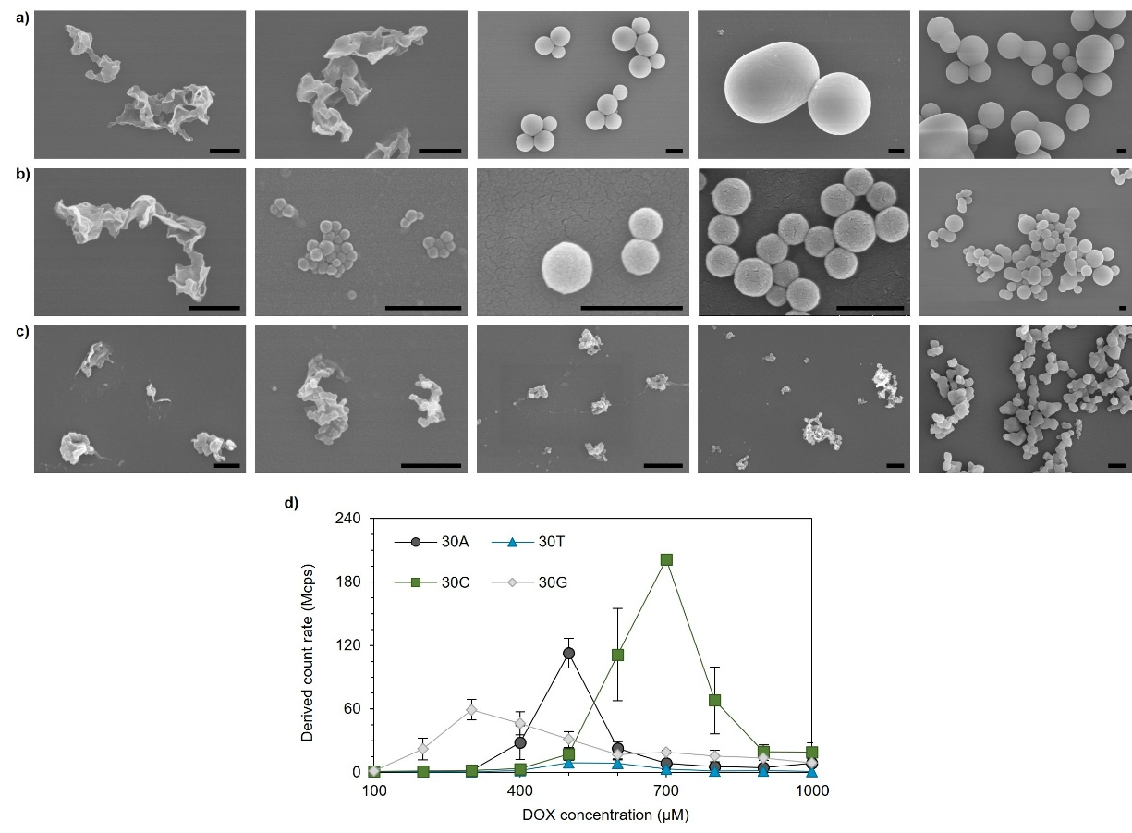
Figure S1. Characterization of DNA-DOX assemblies produced via thermal annealing. (a-c) Representative SEM images showing the morphology and size evolution of 30T (a), 30C (b) and 30G (c) containing different concentrations of DOX after thermal treatment. DOX concentration for all sequences (from left to right): 200, 300, 500, 700 and 1000 μM. DNA concentration for all samples: 10 μM. Scale bar: 500 nm. (d) DCR evolution as a function of DOX concentration derived from DLS. Measurements were performed using triplicate samples, and the averaged results with standard deviation were presented.

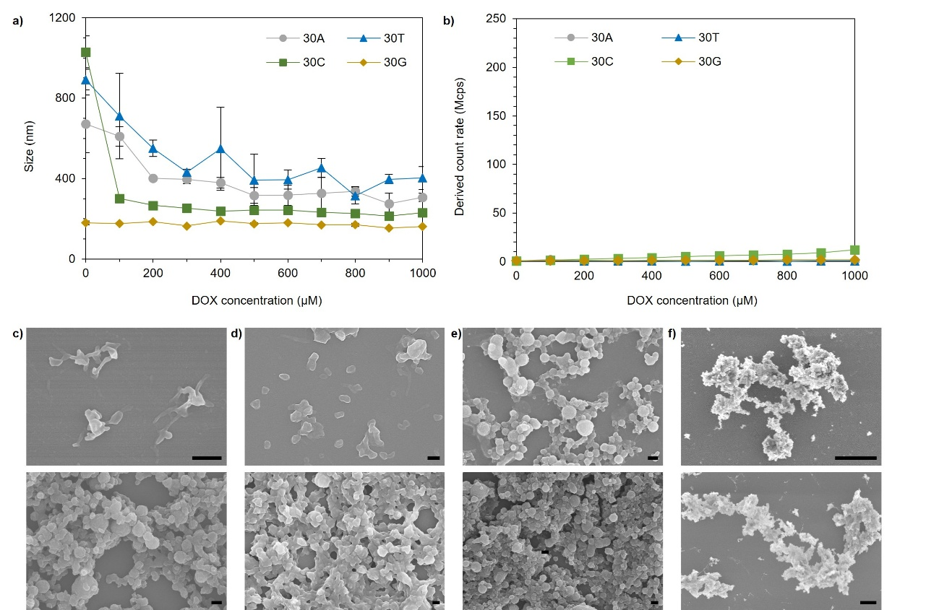
Figure S2. Characterization of DNA-DOX aggregates without heat treatment. (a,b) Size (a) and DCR (b) of the assemblies derived from DLS measurements. Measurements were performed using triplicate samples, and the averaged results with standard deviation were presented. (c-f) Representative SEM images showing the morphologies of 30A-DOX (c) 30T-DOX (d) 30C-DOX (e) and 30G-DOX (f). DOX concentration: 500 μM (top) and 1000 μM (bottom) for 30A-DOX; 500 μM (top) and 1000 μM (bottom) for 30T-DOX; 700 μM (top) and 1000 μM (bottom) for 30C-DOX; 300 μM (top) and 1000 μM (bottom) for 30G-DOX. DNA concentration for all samples: 10 μM. Scale bar: 500 nm in c, d and e; 5 μm in f.

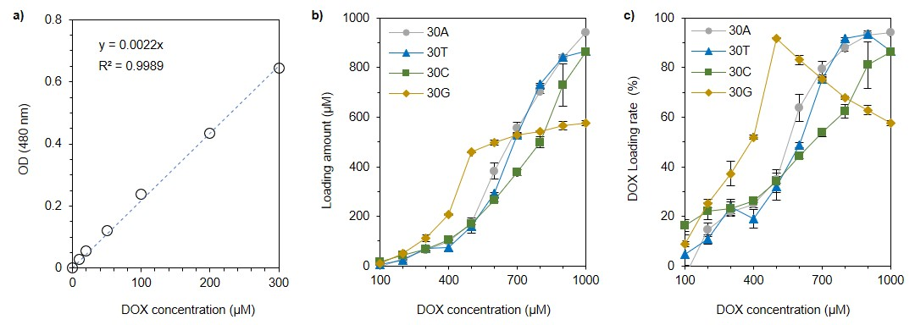
Figure S3. Quantification of the loading capacity of DOX in the heat-promoted DNA-DOX assemblies. (a) The calibration curve for DOX concentration at the absorption of 480 nm. (b) The calculated DOX concentrations loaded in the assemblies for 30A, 30T, 30C and 30G. (c) The calculated loading rates of DOX for 30A, 30T, 30C and 30G. Measurements were performed using triplicate samples, and the averaged results with standard deviation were presented.

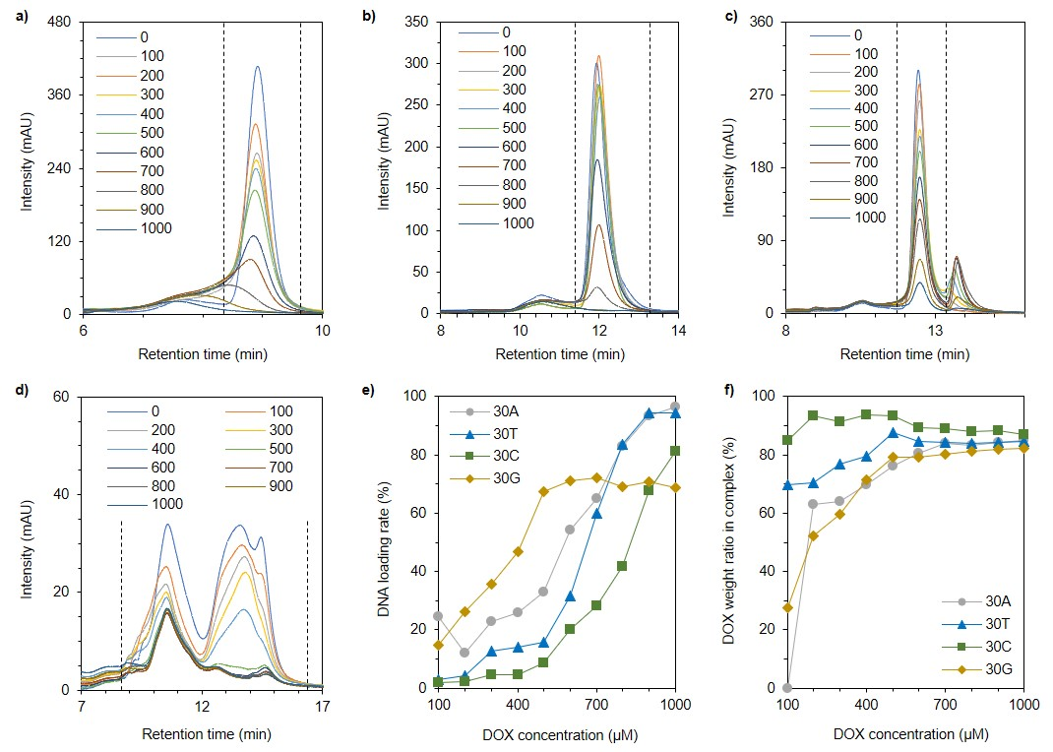
Figure S4. Determination of the loading ability of DNA in the heat-promoted DNA-DOX assemblies. (a) The absorption peaks (260 nm) of 30A (a) 30T (b) 30C (c) and 30G (d) in the supernatants obtained from HPLC. The peaks between the dashed lines were integrated and used to calculate the DNA that was loaded into the assemblies. (e) The calculated loading rates 30A, 30T, 30C and 30G. (f) The calculated weight ratio of DOX in the assemblies.

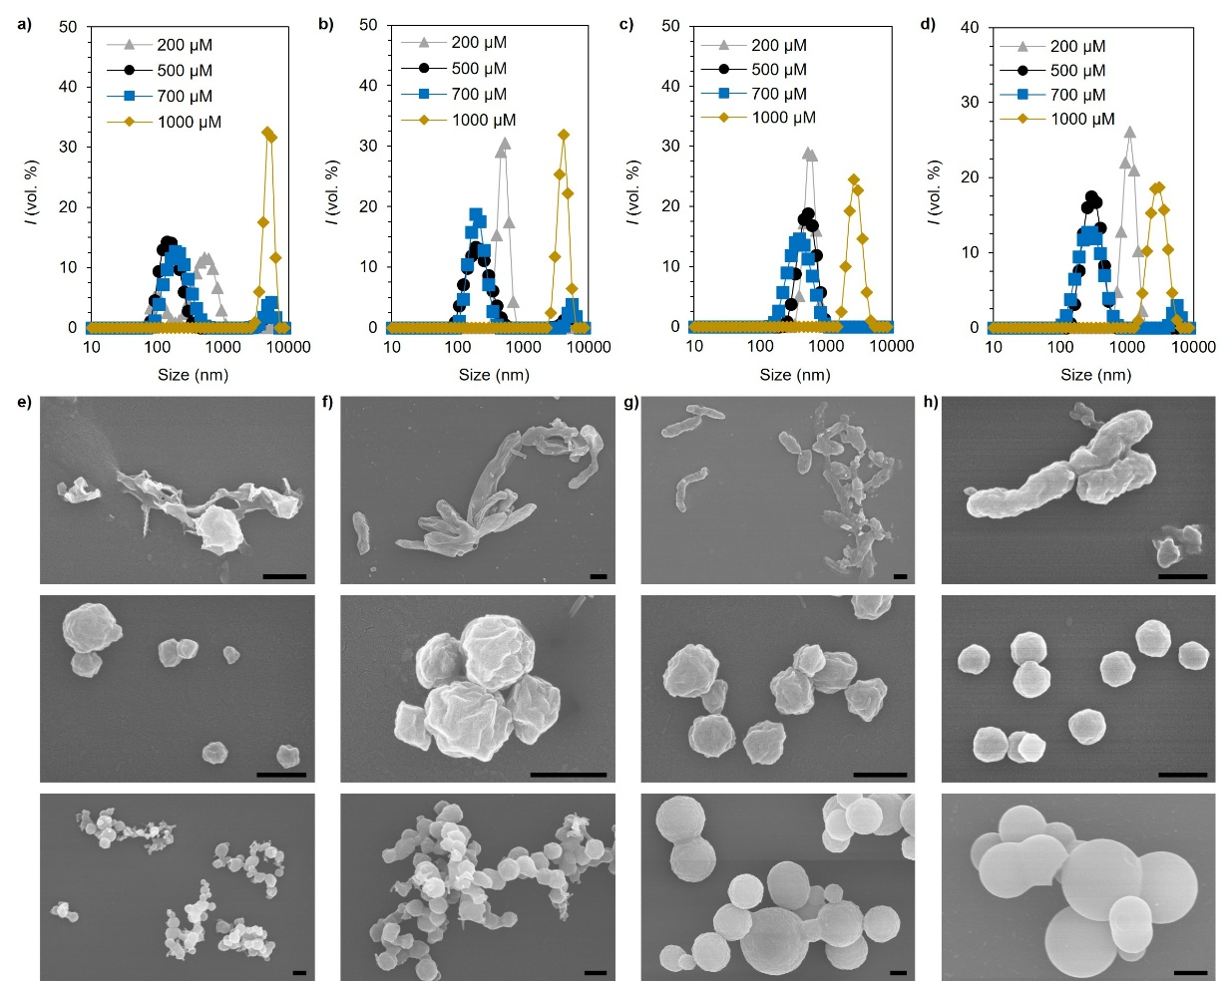
Figure S5. Characterization of 30A-DOX assembled at different heating temperatures. (a-d) The sizes of 30A-DOX assembled at 20 (a), 40 (b), 60 (c) and 80 °C (d) determined by DLS. (c-p) Representative SEM images showing the morphology evolution of 30A-DOX assemblies treated at 20 °C (e), 40 °C (f), 60 °C (g) and 80 °C (h). DOX concentrations for all temperatures (from top to bottom): 200, 700 and 1000 μM. 30A in all samples: 10 μM. Scale bar: 500 nm.

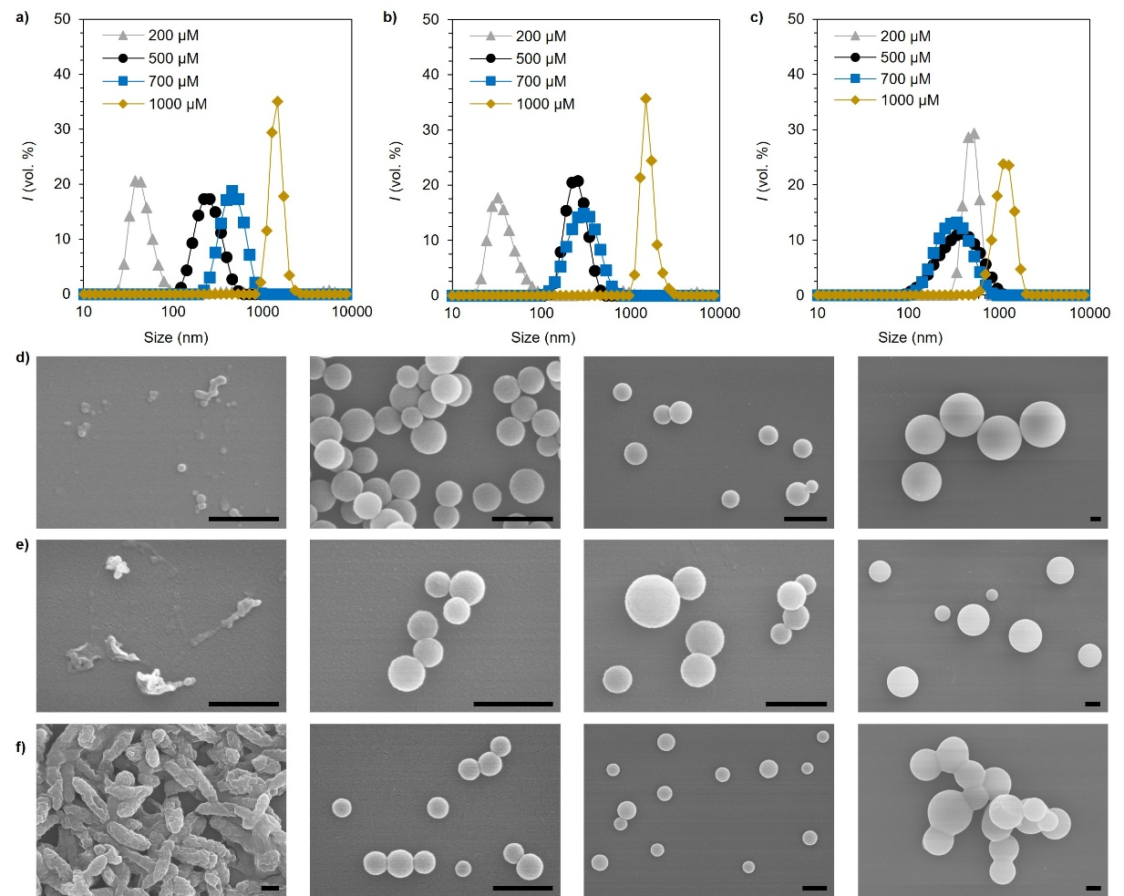
Figure S6. Characterization of 30A-DOX assemblies through different thermal treatments. (a-c) Representative hydrodynamic diameters of the assemblies obtained by (a) heating at 95 °C for 90 minutes and followed by a direct drop to 20 °C, (b) annealing at a step of 1 °C and (c) annealing at a step of 10 °C. (d-f) Representative SEM images of the assemblies obtained by (d) heating at 95 °C for 90 minutes and followed by a direct drop to 20 °C, (e) annealing at a step of 1 °C and (f) annealing at a step of 10 °C. DOX concentration at all conditions (from left to right): 200, 500, 700 and 1000 μM. DNA concentration for all samples: 10 μM. Scale bar: 500 nm.

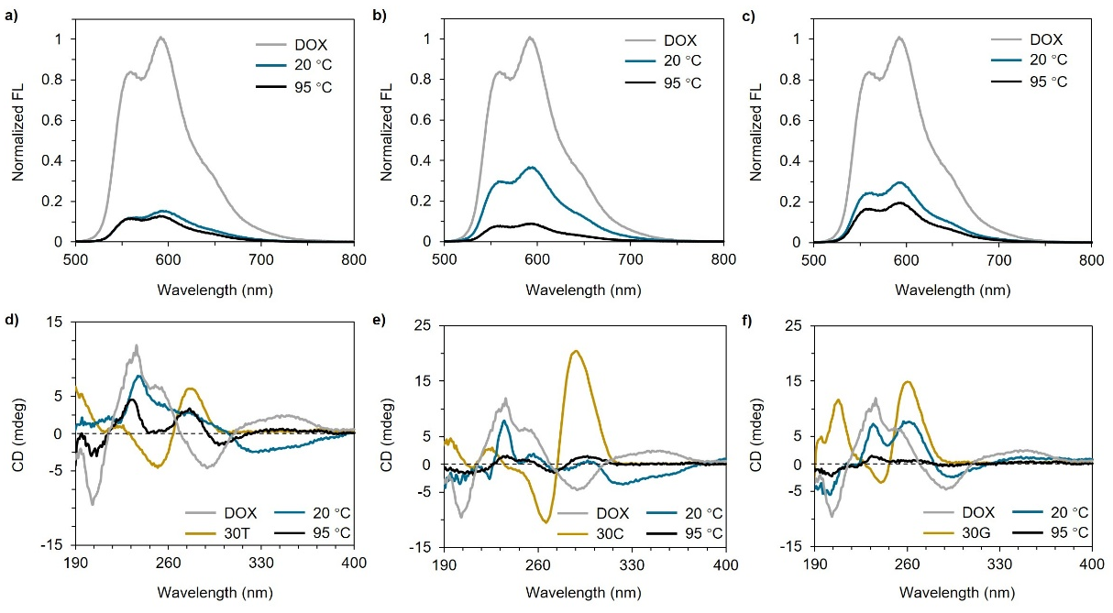
Figure S7. Characterization of DNA-DOX assemblies produced at different heating temperatures. (a-c) The normalized fluorescence intensity of DOX from 30T5 (a), 30C7 (b) and 30G3 (d) assembled at different temperatures. (d-f) The CD spectra of 30T5 (d), 30C7 (e) and 30G3 (f) assembled at different temperatures. The spectra of free DOX, 30T, 30C and 30G were also included for comparison.

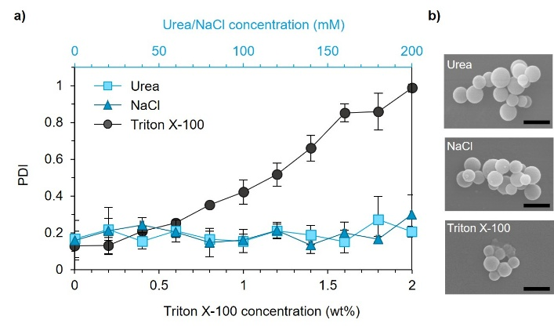
Figure S8. Stability of 30A7. (a) The evolution in PDI of 30A7 as a function of urea, NaCl or Triton X-100 concentrations measured by DLS. Measurements were performed using triplicate samples, and the averaged results with standard deviation were presented. (b) SEM images of the samples after the titrations. Scale bar: 500 nm.

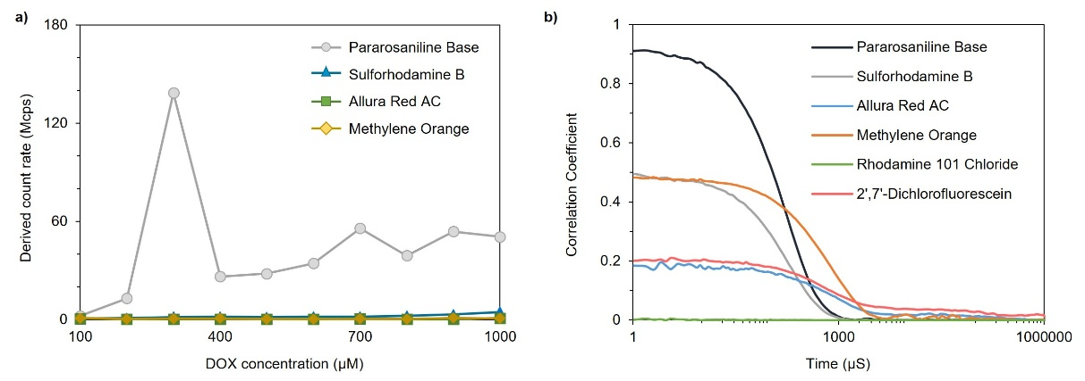
Figure S9. Characterization of 30A assembled with negatively charged (sulforhodamine B, allura red AC and methylene orange) and neutral (rhodamine 101 chloride and 2',7'-dichlorofluorescein) aromatics via thermal treatment. DCR (a) and correlation coefficient (b) of the assemblies derived from DLS measurements. Par was included for comparison.

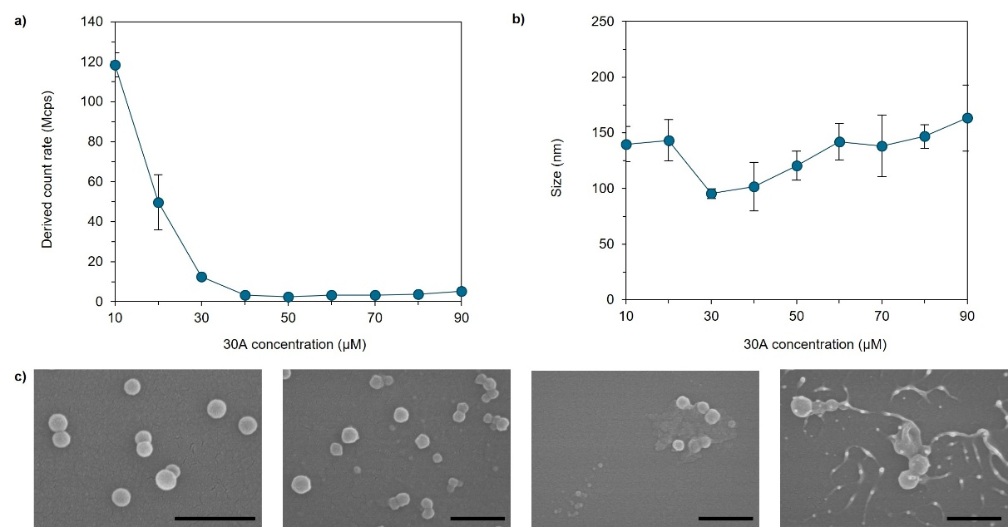
Figure S10. Characterization of the heat-promoted assemblies produced by DOX and 30A of varying concentrations. (a,b) DCR (a) and size (b) of the assemblies derived from DLS measurements. Measurements were performed using triplicate samples, and the averaged results with standard deviation were presented. (c) Representative SEM images showing the morphology evolution of the assemblies with different concentrations of 30A. 30A concentration (from left to right): 20, 40, 60 and 80 μM; DOX: 500 μM. Scale bar: 500 nm.
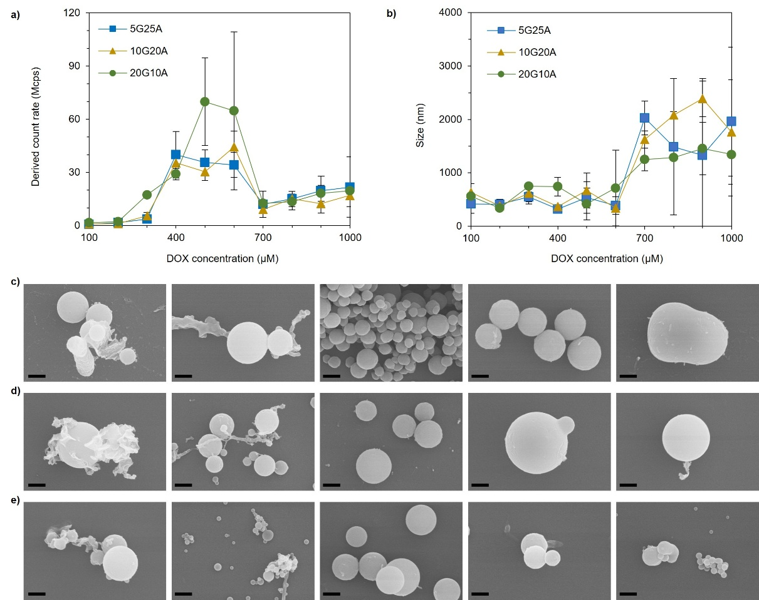
Figure S11. Characterization of the heat-promoted assemblies produced by DOX with heteroG sequences with varying guanine ratios (5G25A, 10G20A and 20G10A). (a,b) DCR (a) and size (b) of the assemblies derived from DLS measurements. Measurements were performed using triplicate samples, and the averaged results with standard deviation were presented. (c-e) Representative SEM images showing the morphology evolution of 5G25A (c), 10G20A (d) and 20G10A (e) with different concentrations of DOX. DOX concentration (from left to right for all sequences): 200, 300, 500, 700, and 1000 μM; DNA: 10 μM. Scale bar: 500 nm.

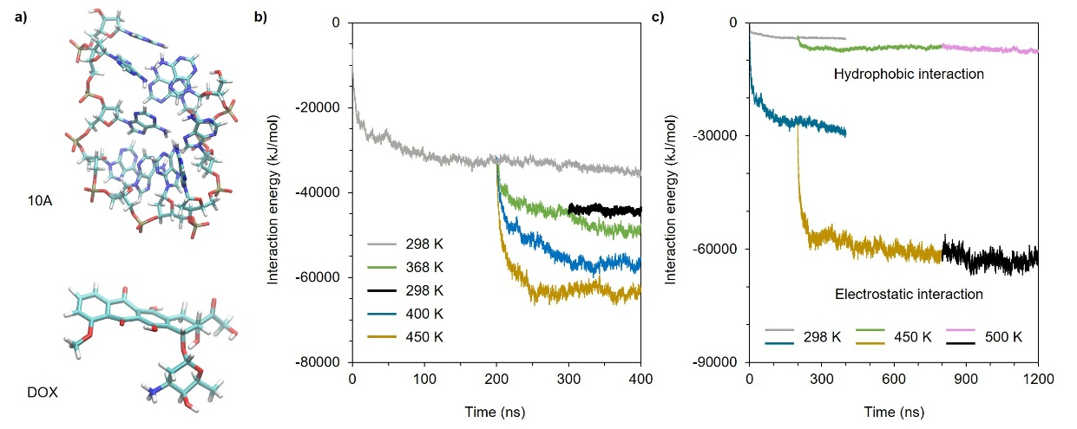
Figure S12. AAMD simulation results. (a) The molecular structures of single-stranded 10A (top) and DOX (bottom). (a) The evolution of the interaction energy of 10A-DOX assemblies retrieved from AAMD simulations. Different colors represent different systems: room-temperature simulation (298 K, gray); 368 K (green), 400 K (blue) and 450 K (yellow) simulations with initial conformation taken at 200 ns of the room-temperature trajectory. The black curve indicates the simulation at 298 K with the initial conformation taken at 100 ns of the trajectory at 368 K. (c) The evolution of the interaction energy within 10A-DOX assemblies indicating the contribution from hydrophobic interaction and electrostatic interaction. Different colors represent different systems: simulation at 298 K (gray and blue), at 450 K (green and yellow) with initial conformation taken at 200 ns of the trajectory at 298 K, at 500 K (magenta and black) with initial conformation taken at 600 ns of the trajectory at 450 K.

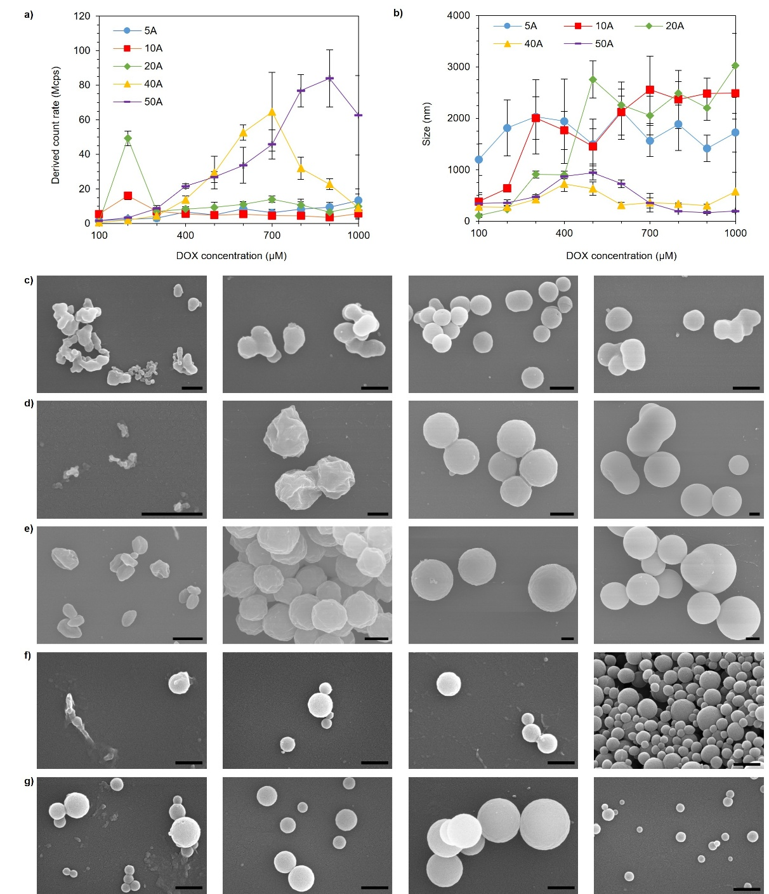
Figure S13. Characterization of the heat-promoted assemblies produced by DOX and polyA (5A, 10A, 20A, 40A and 50A). (a,b) DCR (a) and size (b) of the assemblies derived from DLS measurements. Measurements were performed using triplicate samples, and the averaged results with standard deviation were presented. (c-g) Representative SEM images showing the morphology evolution of 5A (c), 10A (d), 20A (e), 40A (f) and 50A (g) with different concentrations of DOX. DOX concentration (from left to right): 500, 700, 900 and 1000 μM for 5A; 200, 300, 500 and 1000 μM for 10A, 20A, 40A and 50A. PolyA: 10 μM. Scale bar: 500 nm.

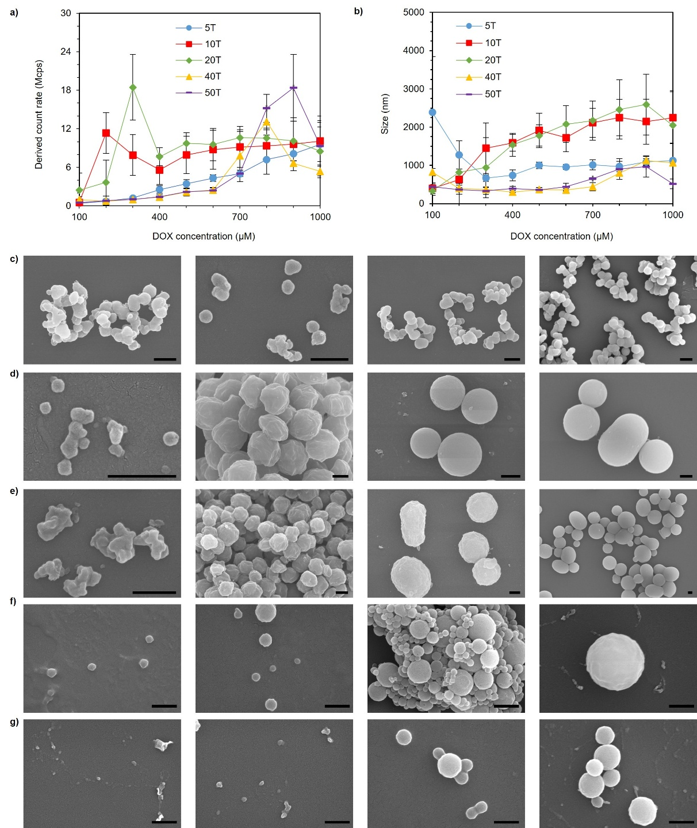
Figure S14. Characterization of the heat-promoted assemblies produced by DOX and polyT (5T, 10T, 20T, 40T and 50T). (a,b) DCR (a) and size (b) of the assemblies derived from DLS measurements. Measurements were performed using triplicate samples, and the averaged results with standard deviation were presented. (c-e) Representative SEM images showing the morphology evolution of 5T (c), 10T (d), 20T (e), 40T (f) and 50T (g) at different concentrations of DOX. DOX concentration (from left to right): 700, 800, 900 and 1000 μM for 5T; 200, 300, 700 and 1000 μM for 10T, 20T, 40T and 50T. PolyT: 10 μM. Scale bar: 500 nm.

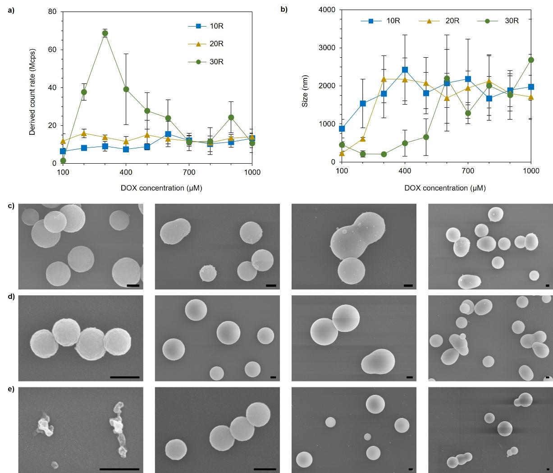
Figure S15. Characterization of the heat-promoted assemblies produced by DOX and random DNA sequences (10R, 20R and 30R). (a,b) DCR (a) and size (b) of the assemblies derived from DLS measurements. Measurements were performed using triplicate samples, and the averaged results with standard deviation were presented. (c-e) Representative SEM images showing the morphology evolution of 10R (c), 20R (d) and 30R (e) at different concentrations of DOX. DOX concentration for all 3 sequences (from left to right): 200, 500, 700 and 1000 μM. Random sequences: 10 μM. Scale bar: 500 nm.

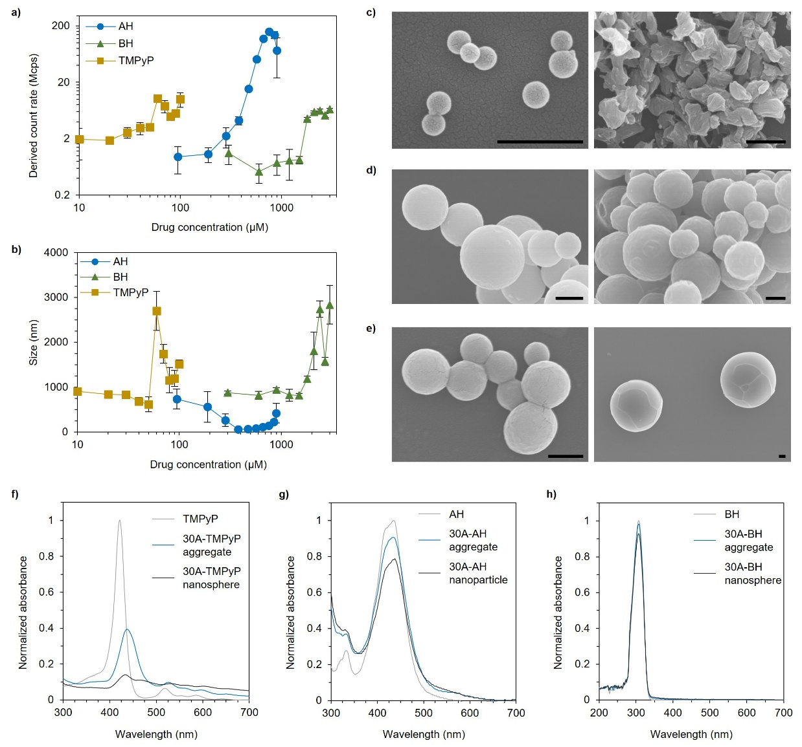
Figure S16. Characterization of the nanospheres assembled by 30A and different drugs (AH, BH and TMPyP) via thermal treatment. (a,b) DCR (a) and size (b) of the assemblies derived from DLS measurements. Measurements were performed using triplicate samples, and the averaged results with standard deviation were presented. (c) Representative SEM images showing the morphologies of nanoparticles assembled by 10 μM 30A with 755.8 μM (left) or 898 μM (right) AH. (d) Representative SEM images showing the morphologies of 30A-BH nanospheres assembled by 5 μM 30A with 1800 μM (left) or 3000 μM (right) BH. (e) Representative SEM images showing the morphologies of 30A-TMPyP nanospheres assembled by 5 μM 30A with 80 μM (left) or 100 μM (right) TMPyP. (f) The normalized UV-vis spectrum of TMPyP, 30A-TMPyP aggregate (without thermal treatment) and 30A-TMPyP nanosphere (with thermal treatment). For sample preparation: 30A: 5 μM; TMPyP: 80 μM. (g) The normalized UV-vis spectrum of AH, 30A-AH aggregate (without thermal treatment) and 30A-AH nanoparticle (with thermal treatment). For sample preparation: 30A: 10 μM; AH: 755.8 μM. (h) The normalized UV-vis spectrum of BH, 30A-BH aggregate (without thermal treatment) and 30A-BH nanosphere (with thermal treatment). For sample preparation: 30A: 5 μM; BH: 2400 μM. Scale bar: 500 nm.

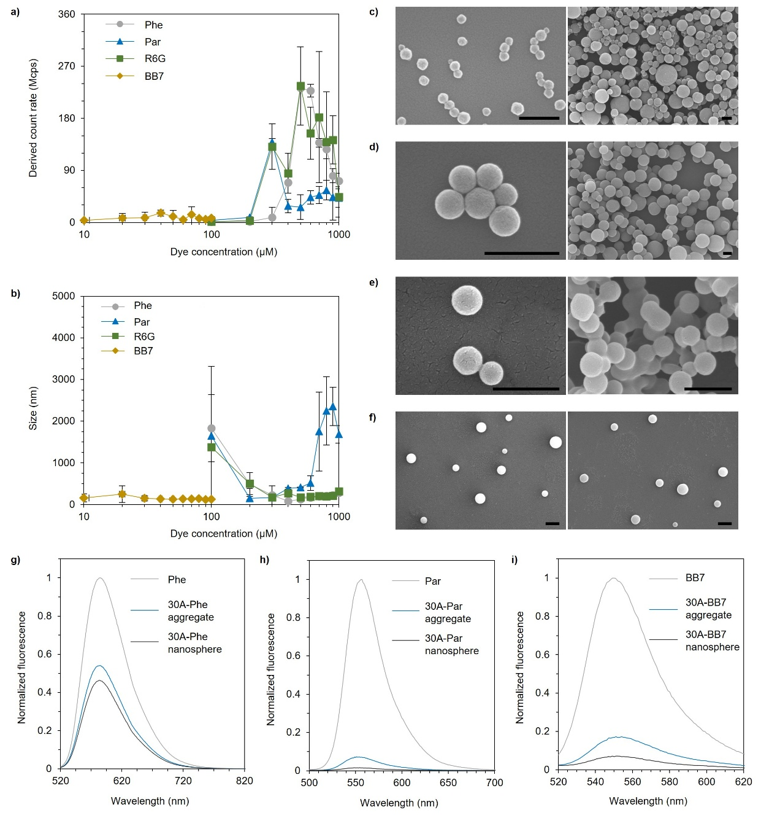
Figure S17. Characterization of the nanospheres assembled by 30A and fluorescent dyes (Phe, Par, R6G and BB7). (a,b) DCR (a) and size (b) of the assemblies derived from DLS measurements. Measurements were performed using triplicate samples, and the averaged results with standard deviation were presented. (c) Representative SEM images showing the morphologies of 30A-Phe assembled by 10 μM 30A with 500 μM (left) or 1000 μM (right) Phe. (d) Representative SEM images showing the morphologies of 30A-Par assembled by 10 μM 30A with 300 μM (left) or 1000 μM (right) Par. (e) Representative SEM images showing the morphologies of 30A-R6G assembled by 10 μM 30A with 500 μM (left) or 1000 μM (right) R6G. (f) Representative SEM images showing the morphologies of 30A-BB7 assembled by 10 μM 30A with 40 μM (left) or 100 μM (right) BB7. (g-i) The normalized fluorescent spectrum of the dye, 30A-dye aggregate (without thermal treatment) and 30A-dye nanosphere (with thermal treatment) of Phe (g), Par (h) and BB7 (i). Dye for sample preparation: 500 μM, 300 μM and 40 μM for Phe, Par and BB7, respectively. 30A: 10 μM. λ_{ex}: 500 nm, 368 nm and 500 nm for Phe, Par and BB7, respectively. Scale bar: 500 nm.

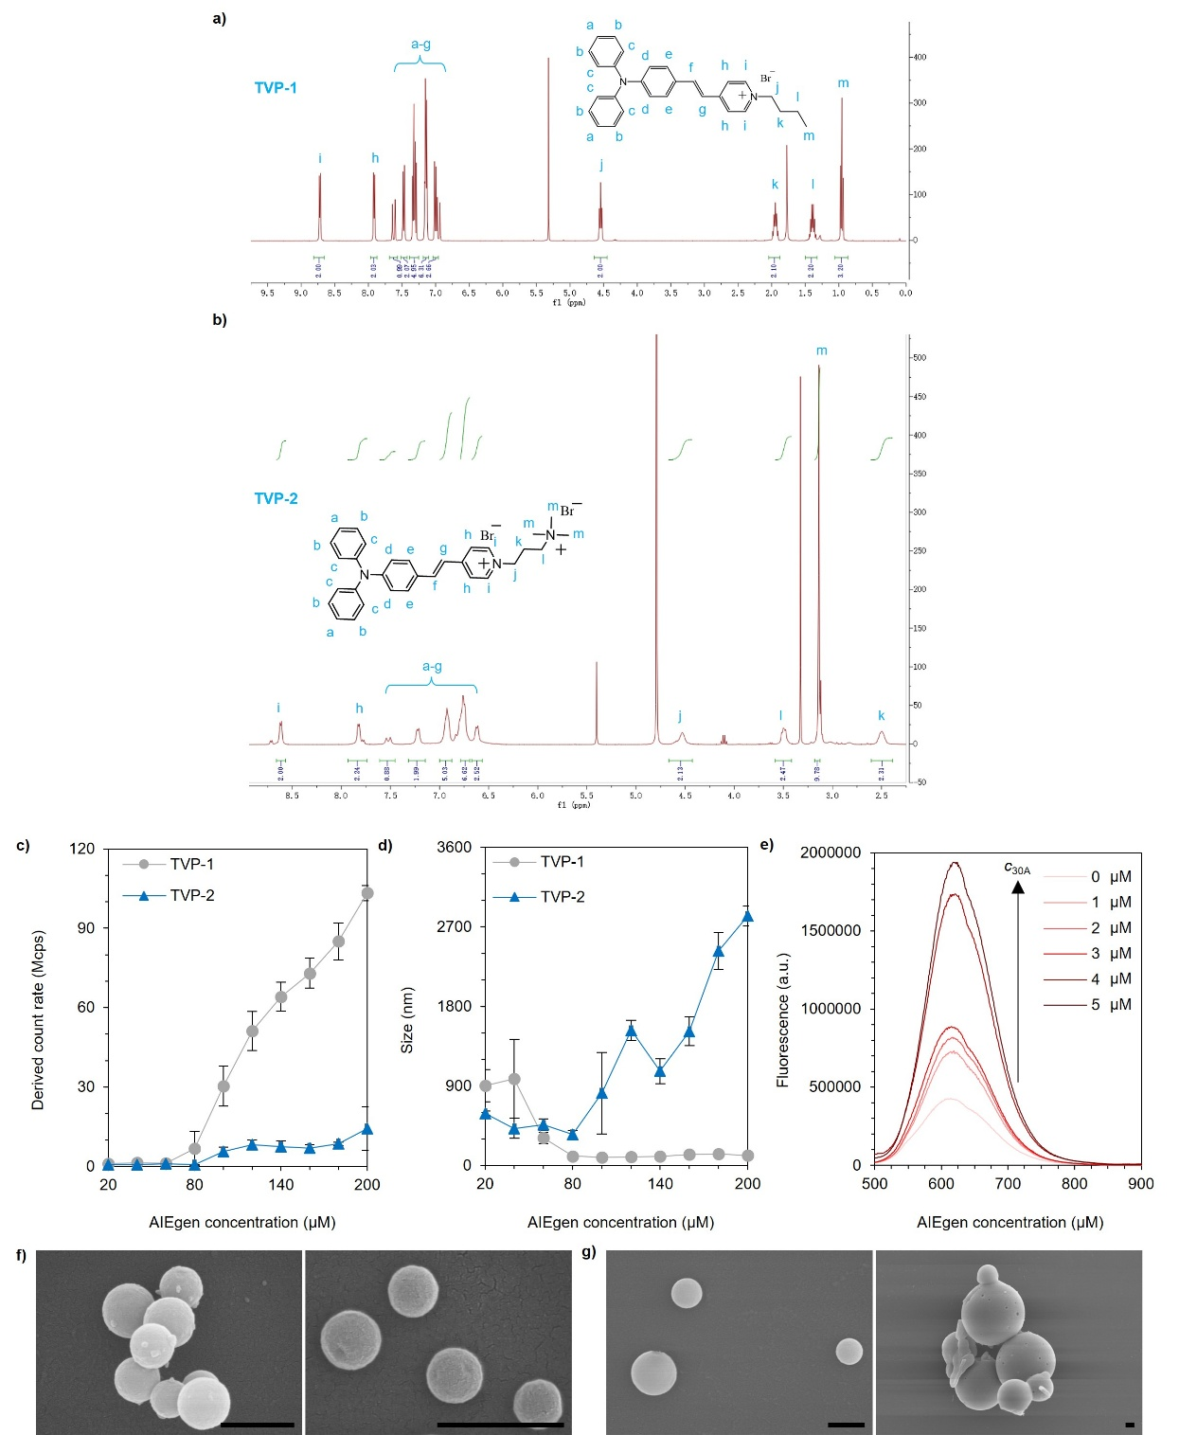
Figure S18. Characterization of the nanospheres assembled by 30A and AIEgens. (a,b) H¹-NMR spectra of TVP-1 (a) and TVP-2 (b). (c,d) DCR (c) and size (d) of the assemblies derived from DLS measurements. 30A: 5 μM. Measurements were performed using triplicate samples, and the averaged results with standard deviation were presented. (e) The normalized fluorescent spectrum (λ_{ex}: 480 nm) of nanospheres assembled by TVP-2 with varying concentrations of 30A. TVP-2 for sample preparation: 120 μM. (f) Representative SEM images showing the morphologies of 30A-TVP-1 containing 120 μM (left) and 200 μM (right) TVP-1. 30A: 5 μM. (g) Representative SEM images showing the morphologies of 30A-TVP-2 containing 120 μM (left) and 200 μM (right) TVP-2. 30A: 5 μM. Scale bar: 500 nm.

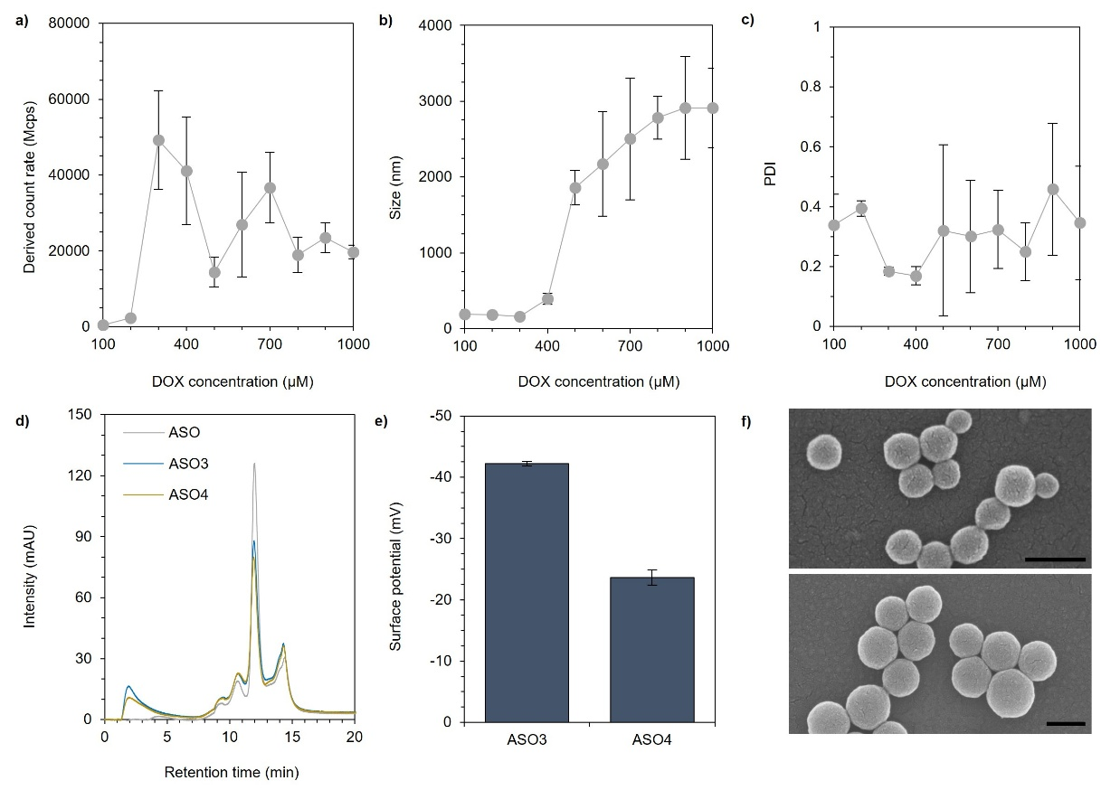
Figure S19. Characterization of the nanospheres assembled by ASO with DOX via thermal annealing. (a-c) DCR (a), size (b) and PDI (c) of the assemblies derived from DLS measurements. (d) HPLC curves (260 nm) showing the ASO amount remaining in the solutions. (e) Surface zeta potential of ASO3 and ASO4. (f) SEM images of ASO3 (top) and ASO4 (bottom). Measurements were performed using triplicate samples, and the averaged results with standard deviation were presented. Scale bar: 200 nm.

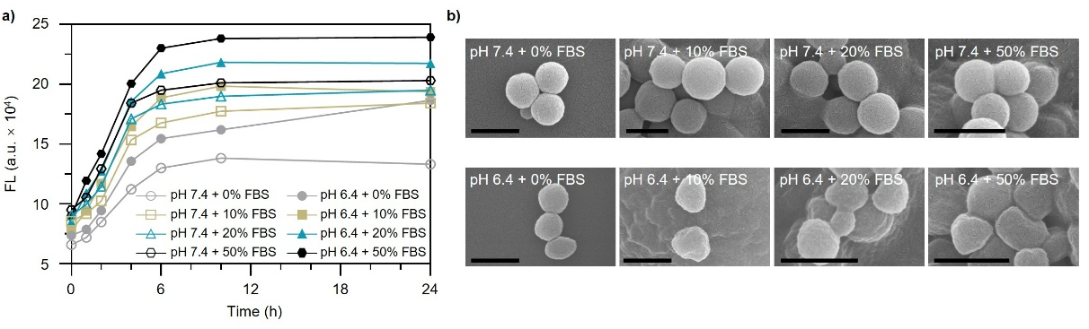
Figure S20. Characterization of the DOX-releasing behavior of ASO4 incubated in PBS (pH = 6.4 or 7.4) containing various amounts of FBS (0, 10, 20, 50%). (a) The time-dependent change of fluorescence intensity of ASO4 at selected time points (0, 1, 2, 4, 6, 10 and 24 h). (b) The SEM images of ASO4 after incubation under different conditions. Scale bar: 500 nm.

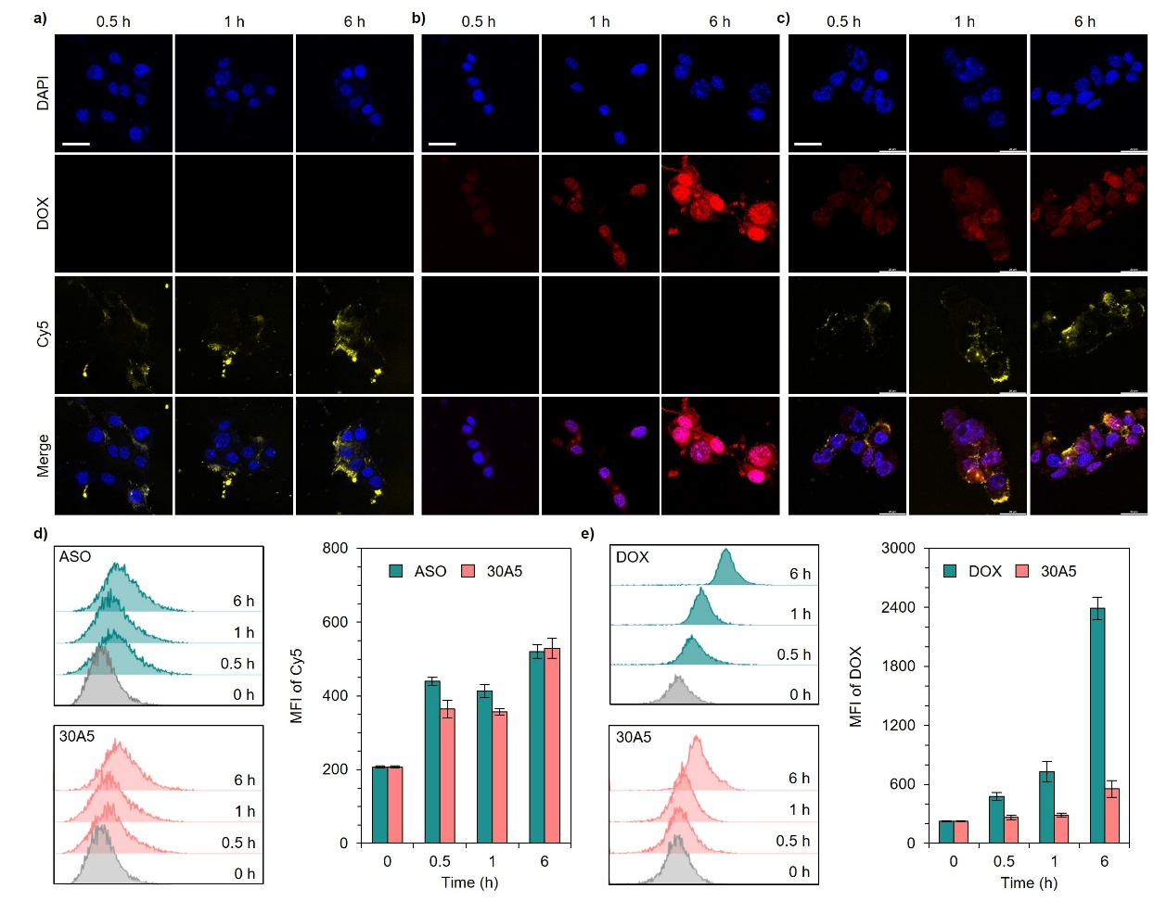
Figure S21. Evaluation of the in vitro cellular uptake performance. (a-c) The time-dependent cellular uptake of ASO (a), DOX (b) and 30A5 (c) determined by CLSM. 30A and ASO were labeled with Cy5. ASO concentration: 100 nM. DOX concentration in group DOX and 30A5: 5 μM. Scale bar: 20 μm. (d,e) Quantification of the time-dependent cellular uptake efficiency of ASO, DOX and 30A5 by flow cytometry under Cy5 (d) and DOX (e) channel. The right panels in the two figures show the mean fluorescence intensity of the corresponding results. Measurements were performed using triplicate samples, and the averaged results with standard deviation were presented.

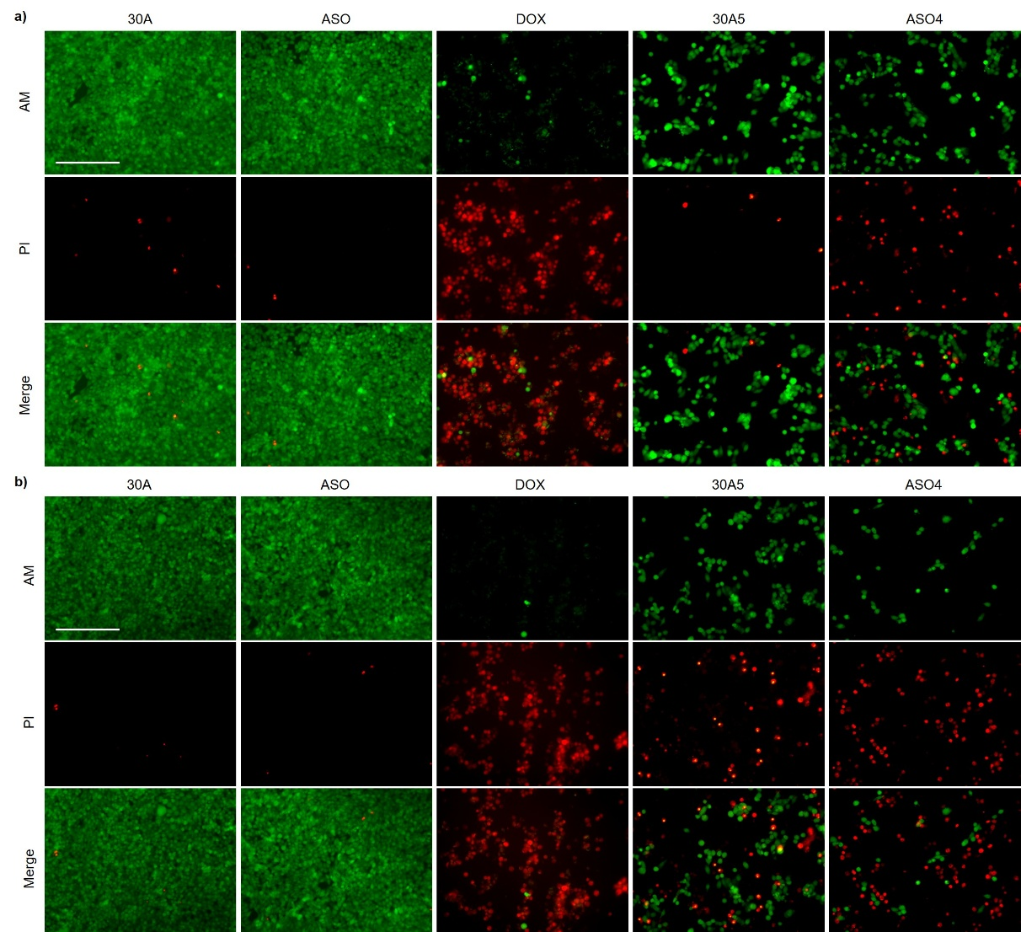
Figure S22. In vitro cytotoxicity determined by live/dead cell analysis. (a) DOX concentration in group DOX, 30A5 and ASO4: 10 μM. DNA concentration in group 30A and ASO: 250 nM for 30A and 200 nM for ASO. (b) DOX concentration in group DOX, 30A5 and ASO4: 20 μM. DNA concentration in group 30A and ASO: 500 nM for 30A and 400 nM for ASO. Scale bar: 200 μm.
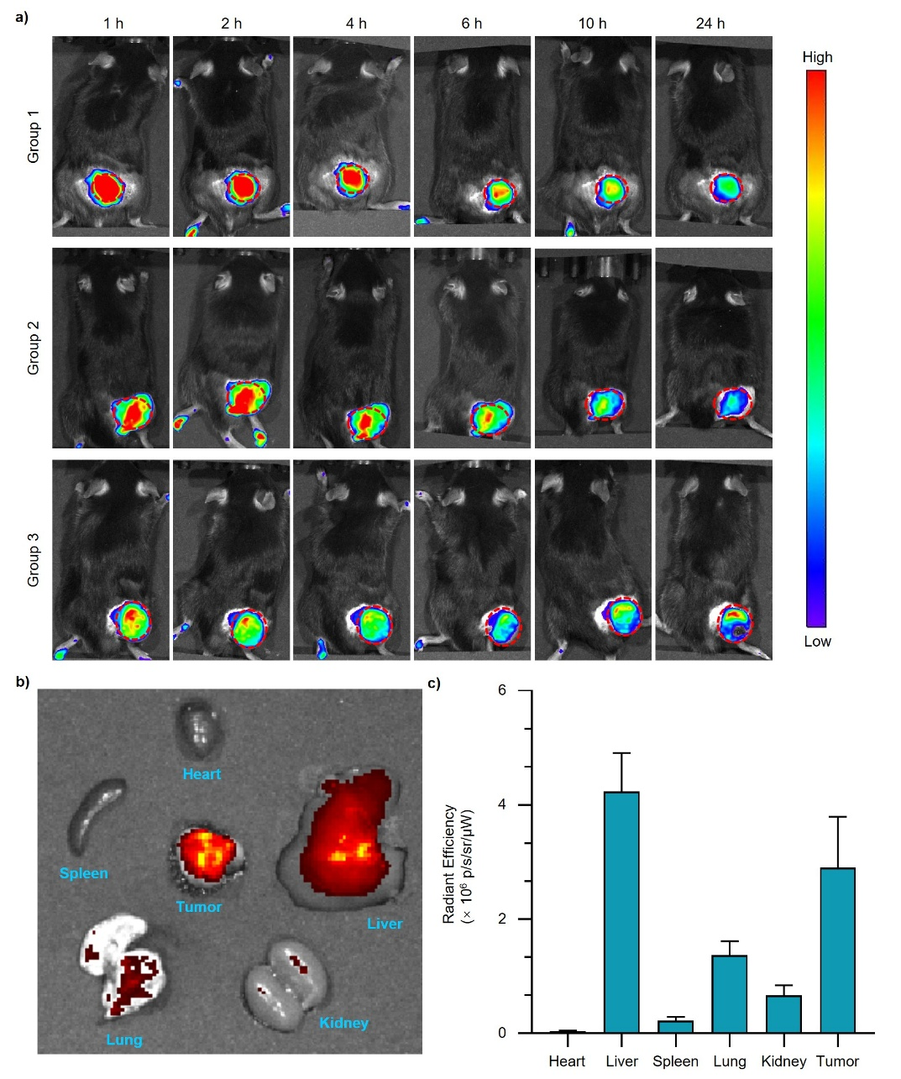
Figure S23. Evaluation of the distribution of ASO4 nanospheres (ASO was labeled with Cy5) in the tumor. (a) Additional fluorescence images of three parallel experiments showing the time-dependent evolution of ASO4 nanospheres in the tumor region. The red circles indicate the tumor. (b,c) The fluorescence image (b) and the corresponding quantitative analysis (c) showing the distribution of ASO4 in major organs (heart, liver, spleen, lung and kidney). Measurements were performed using triplicate samples, and the averaged results with standard deviation were presented.

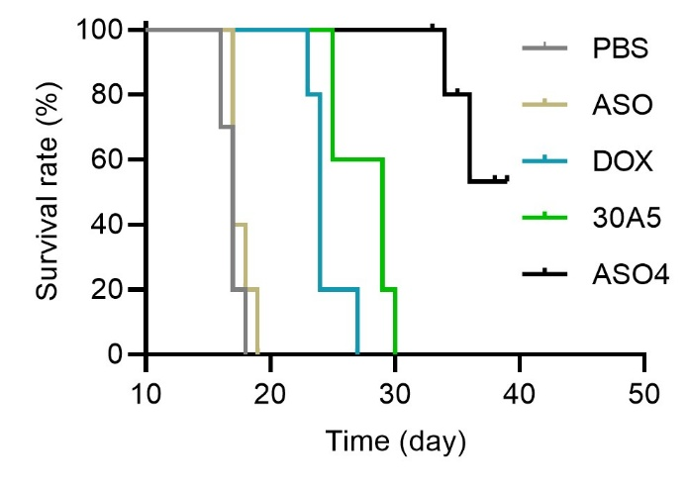
Figure S24. Evaluation of the survival rate of mice receiving different treatments (n = 5).

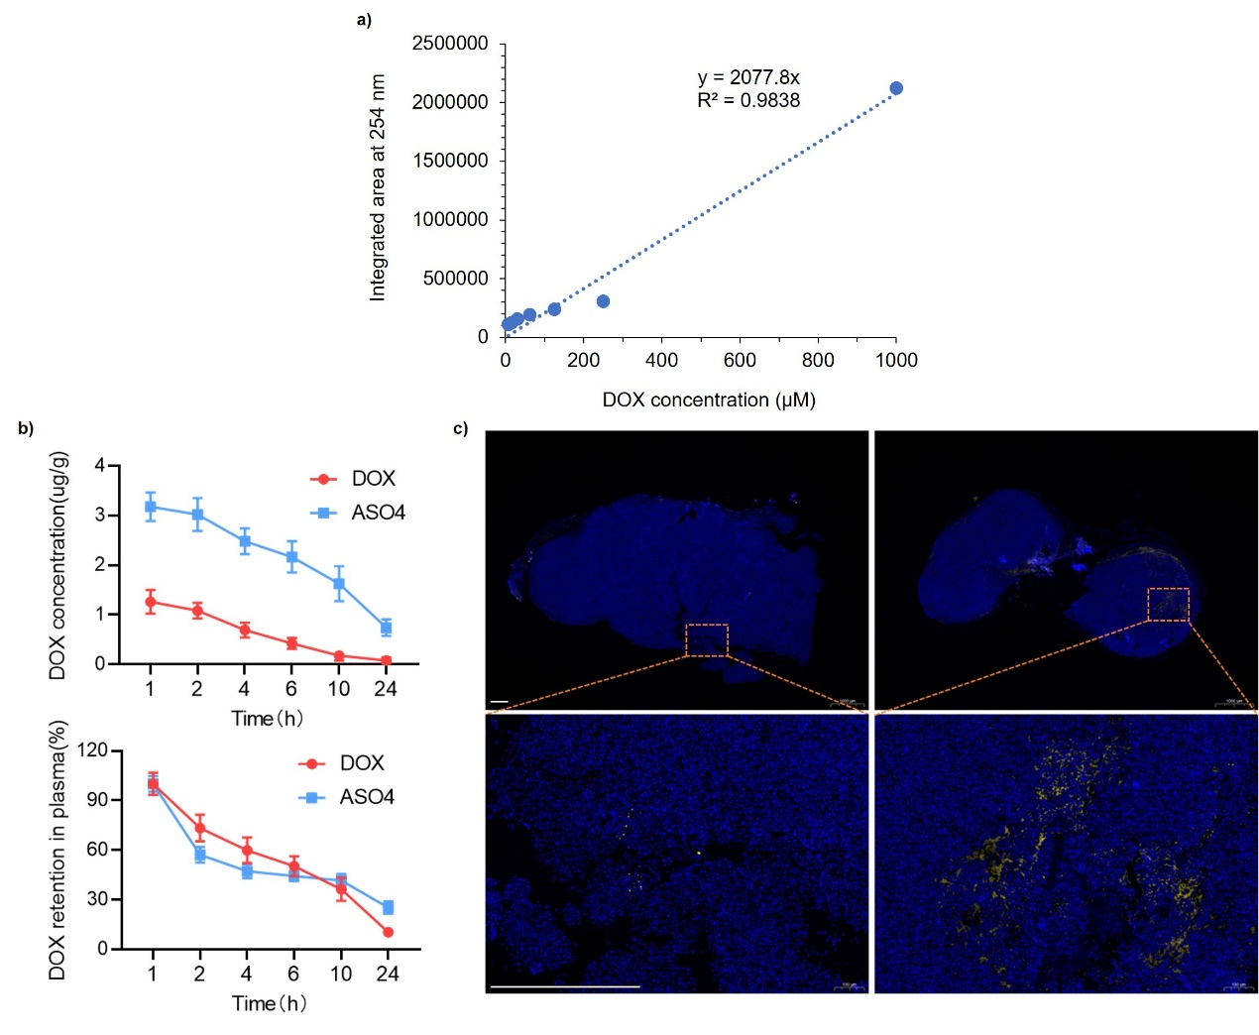
Figure S25. Evaluation of the biodistribution of ASO4. (a) Calibration curve for the determination of DOX concentration with HPLC-MS. (b) Comparison of the metabolic profiles of DOX (top) in the tumor or (bottom) in the plasma of mice administered with free DOX or ASO4. Measurements were performed using triplicate samples, and the averaged results with standard deviation were presented. (c) Comparison of the Cy5 signals in the tumor sections of mice treated with (left) ASO-Cy5 or (right) ASO4. Scale bar: 500 μm.
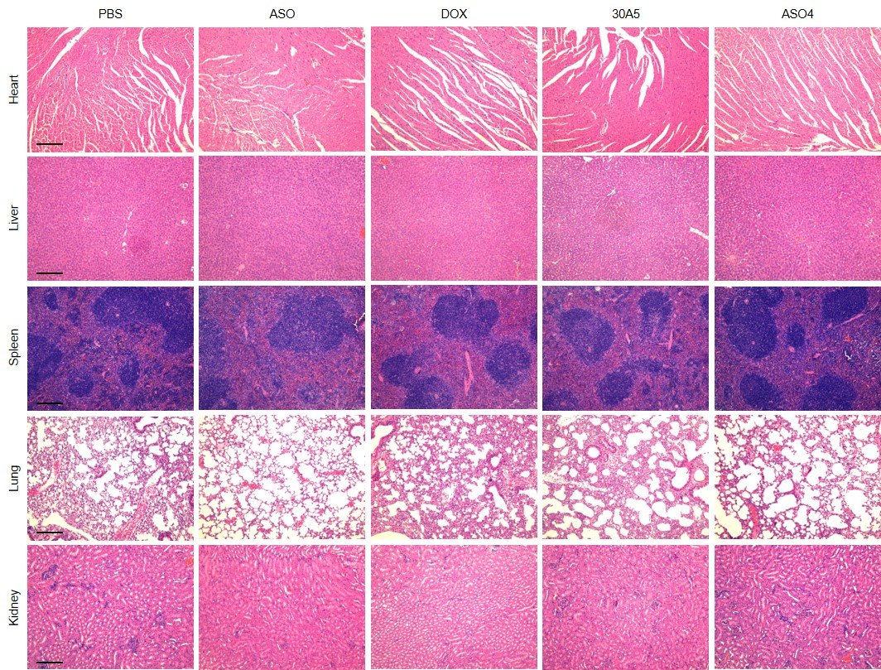
Figure S26. H&E histopathologic examination of the major organs (heart, liver, spleen, lungs, and kidneys) harvested from the mice after the treatment with PBS, ASO, DOX, 30A5 or ASO4. Scale bar: 200 μm.

References
1. Zhang J, He X, Tang BZ. Aggregation-induced emission-armored living bacteriophage-DNA nanobioconjugates for targeting, imaging, and efficient elimination of intracellular bacterial infection. ACS Nano 2024;18:3199-213.
2. Wang D, Su H, Kwok RTK, Hu X, Zou H, Luo Q, Lee MMS, Xu W, Lam JWY, Tang BZ. Rational design of a water-soluble NIR AIEgen, and its application in ultrafast wash-free cellular imaging and photodynamic cancer cell ablation. Chem Sci. 2018;9:3685-93.

