CXCR4-Engineered Fibroblast Membrane Nanovesicles for Photothermal-Enhanced Ferroptotic Therapy through Chemokine-Navigated Tumor Homing

Lu Bai^{1,2,3}, Ya-Nan Tan^{3,4}, Li-Fen Zhang³, Min Luo³, Jie Luo^{1,2}, Yu-Ma Yang^{1,2}, Yun-Zhi Liu³, Victor Ho-Fun Lee^{1,2,3}, Spring Feng-Ming Kong^{1,2,3}, Xin-Yuan Guan^{1,2,3,4}

1.Department of Clinical Oncology, Li Ka Shing Faculty of Medicine, The University of Hong Kong, Hong Kong.
2.State Key Laboratory of Liver Research, Li Ka Shing Faculty of Medicine, The University of Hong Kong, Hong Kong.
3.Department of Clinical Oncology, Shenzhen Key Laboratory for Cancer Metastasis and Personalized Therapy, The University of Hong Kong-Shenzhen Hospital, Shenzhen, China.
4.Advanced Energy Science and Technology Guangdong Laboratory, Huizhou, China.

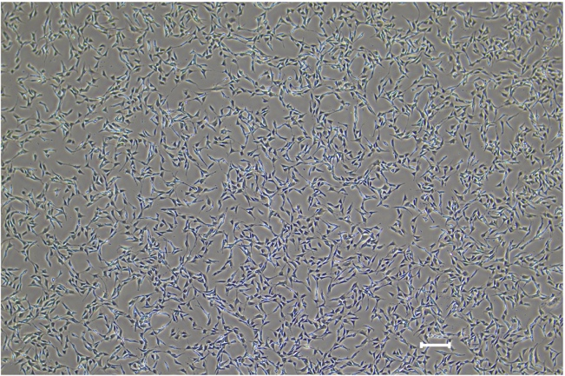
Figure S1. Representative microscopy image of murine dermal fibroblasts.

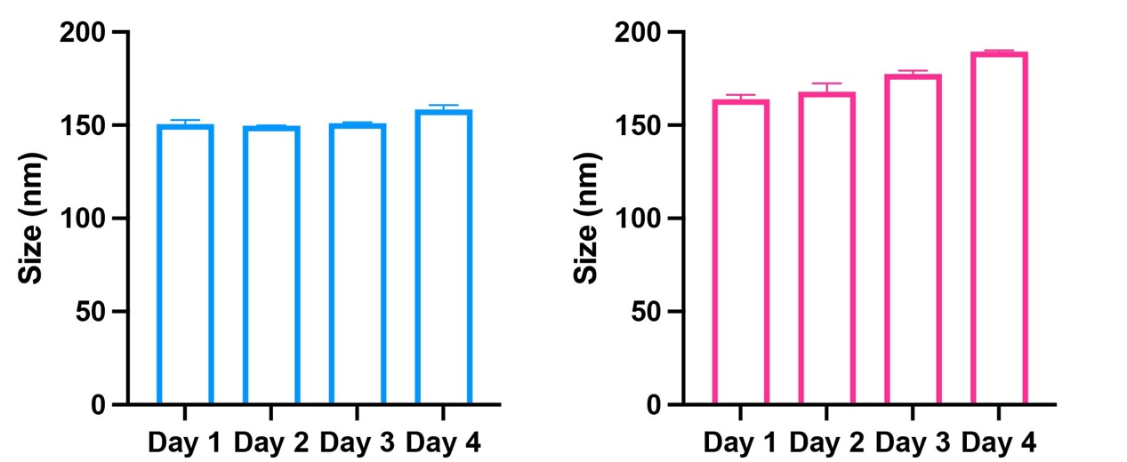
Figure S2. Average particle sizes of FbM@IR NPs (A) and FbM@IR/RSL3 NPs (B) in serum within 4 days. Data are presented as mean ± SEM.

Figure S3. CLSM images of the penetration of FITC labeled FbM@IR NPs by KYSE-30/MF spheroid (scale bar: 50 μm). KYSE-30 cells and MFs are stained with cell-tracker orange and deep red dyes, respectively. Z-stack images are acquired from the top to the equatorial plane of the spheroid.

Figure S4. Immunofluorescence staining of CXCL12 distribution on MDA-MB-468 (above) and KYSE-30 (below) tumors. Anti-CXCL12 are detected in PE channel (red). Tumor cells are stained with anti-EpCAM (yellow). Fibroblasts are detected by α-SMA staining (FITC, green). Nuclei are labeled with DAPI (blue). Scale bars = 100 μm.

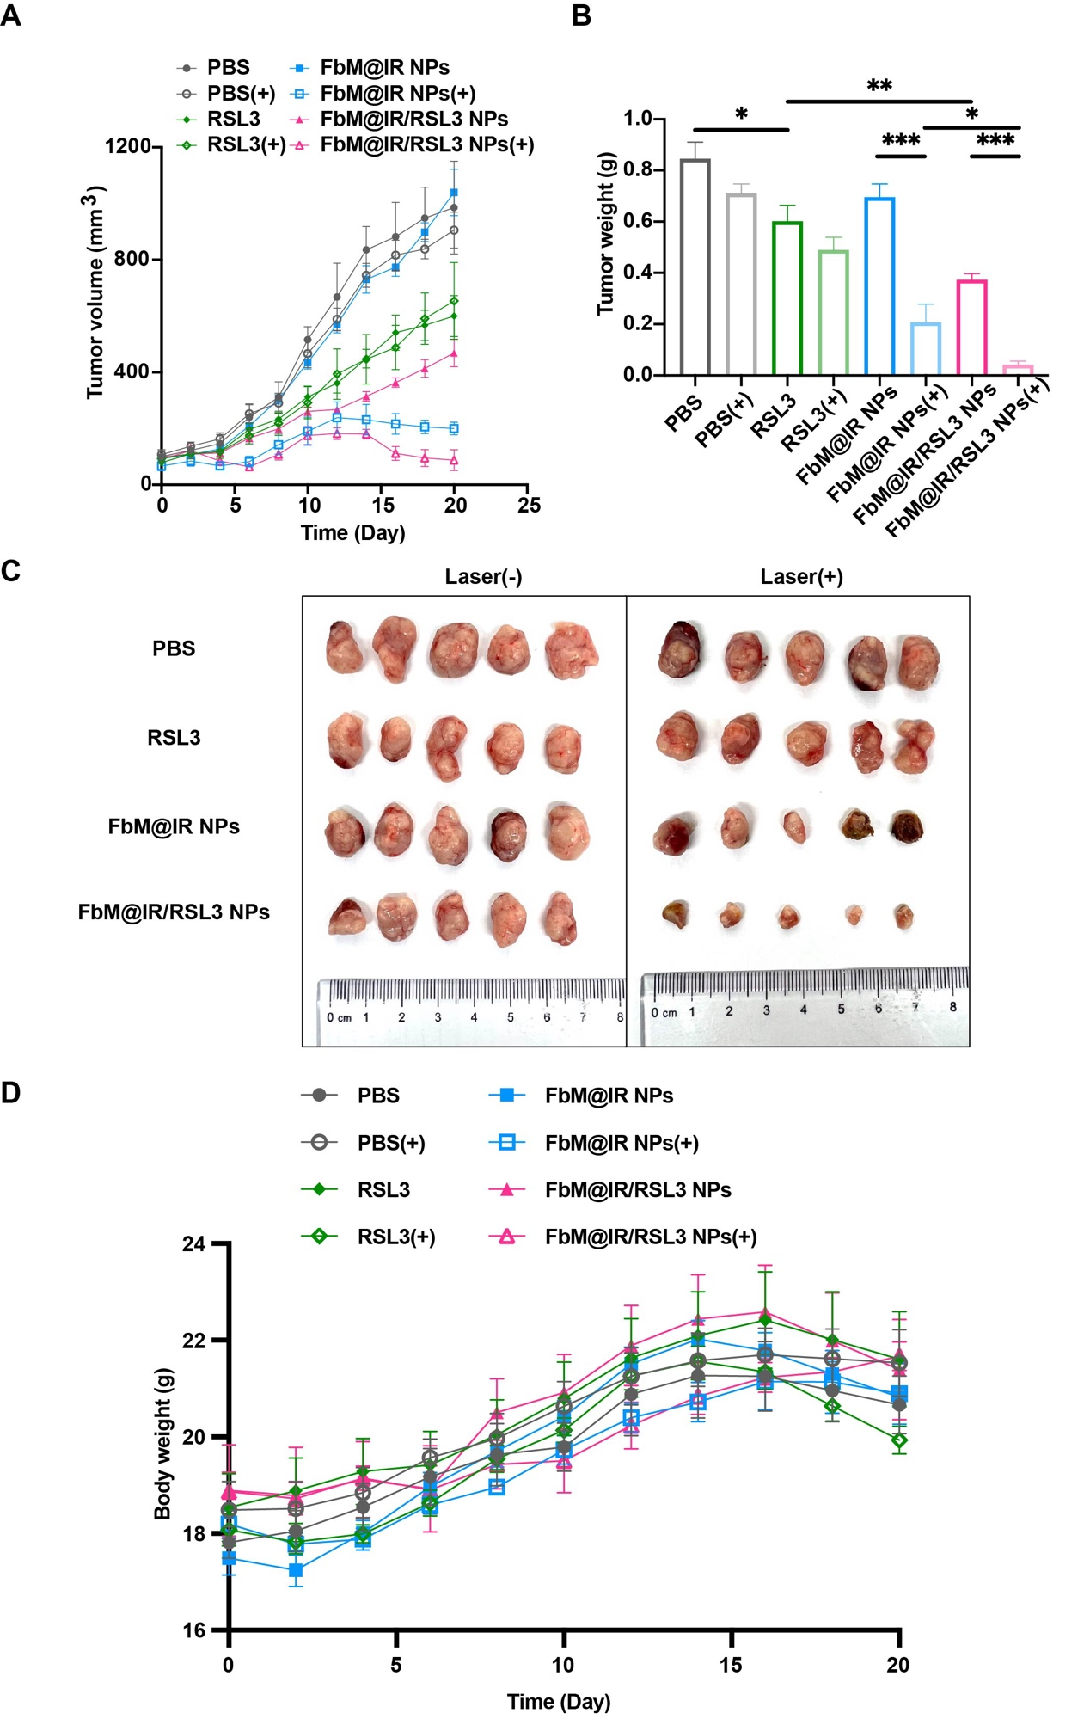
Figure S5. Antitumor efficacy and biosafety evaluation of FbM@IR/RSL3 NPs in KYSE-30 tumor-bearing mice. A. Tumor growth curves for KYSE-30 tumor-bearing mice treated with PBS, PBS(+), free RSL3, RSL3(+), FbM@IR NPs, FbM@IR NPs(+), FbM@IR/RSL3 NPs and FbM@IR/RSL3 NPs(+) during 21-day period (RSL3: 1.2 mg/kg; IR780-DSPE-PEG: 1.6 mg/kg). n=5. B and C. Tumor weights (B) and representative tumor images (C) collected from KYSE-30 tumor-bearing mice at day 21 (n = 5). D. Body weight trends of KYSE-30 tumor-bearing mice with various treatments. Data are presented as mean ± SEM from all replicates. Statistical significance is denoted as p < 0.05 (*), p < 0.01 (**) and p < 0.001 (***).

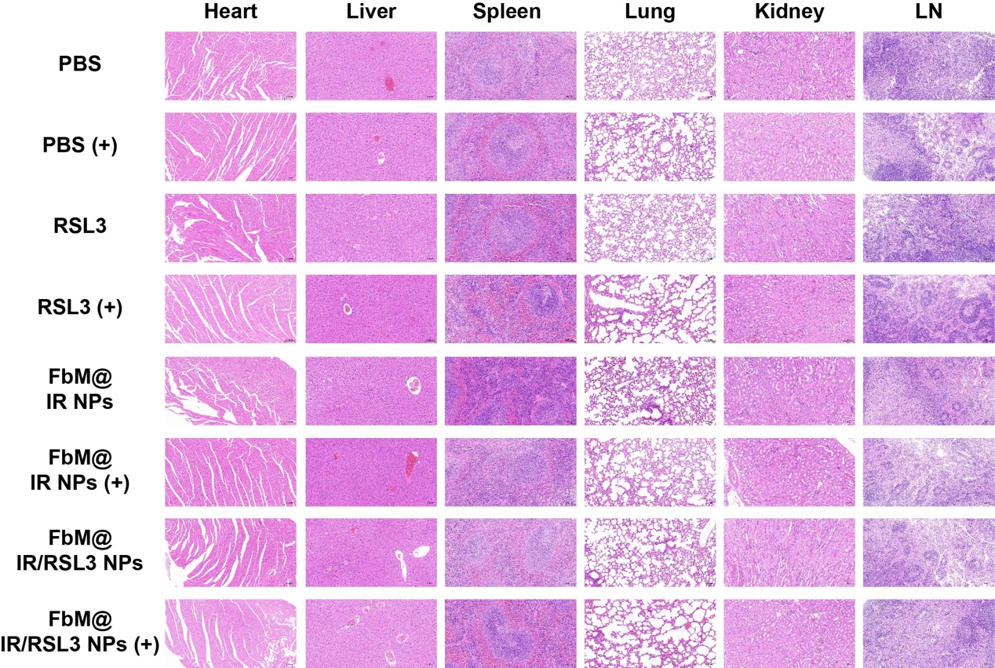
Figure S6. Histopathological analysis of major organs from MDA-MB-468 tumor-bearing mice after 21 days of different treatments.

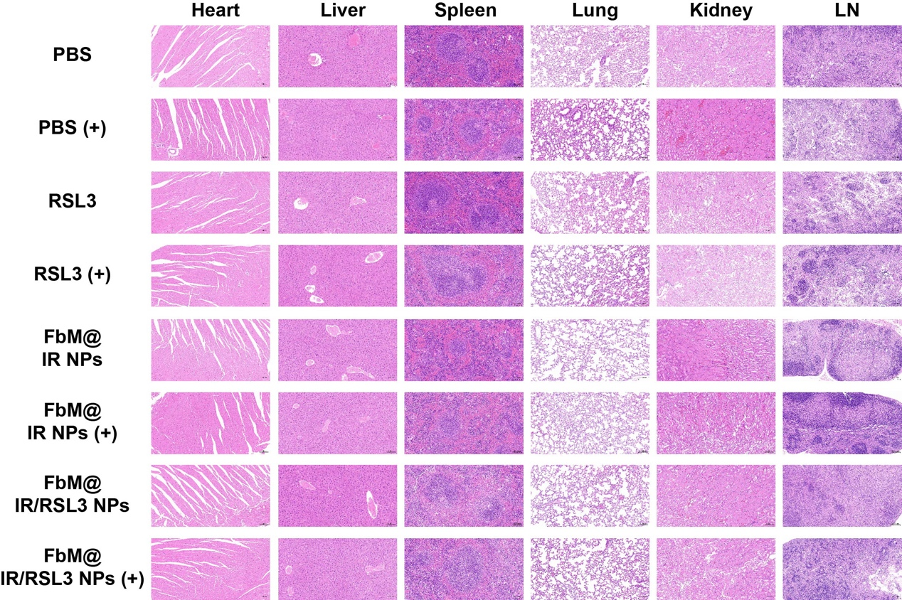
Figure S7. H&E-stained sections of organ slices from KYSE-30 tumor-bearing mice after 21 days of various treatments.

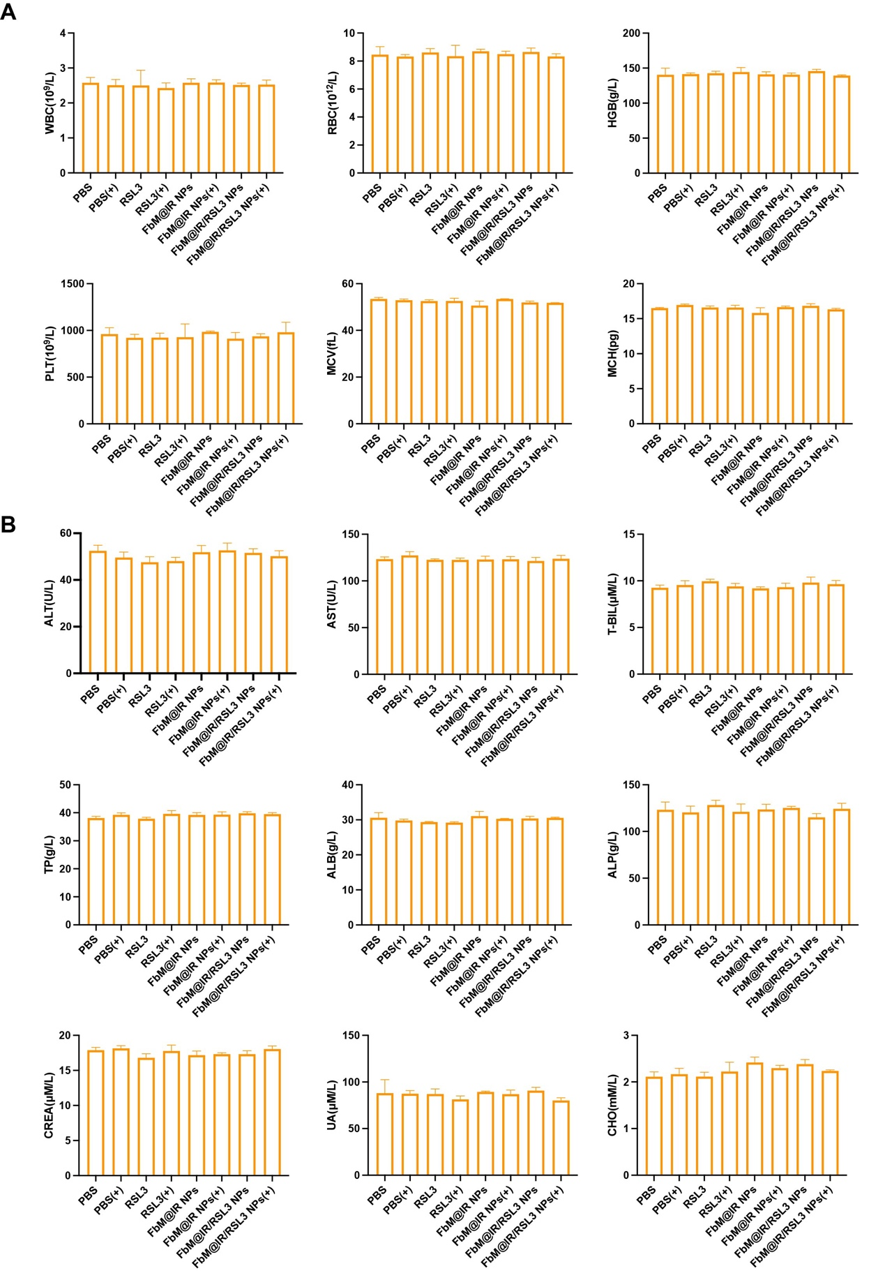
Figure S8. Routine blood tests (A) and blood biochemical analysis (B) of MDA-MB-468 tumor-bearing mice after being treated with various formulations at day 21 (n = 3). Data are displayed as mean ± SEM.
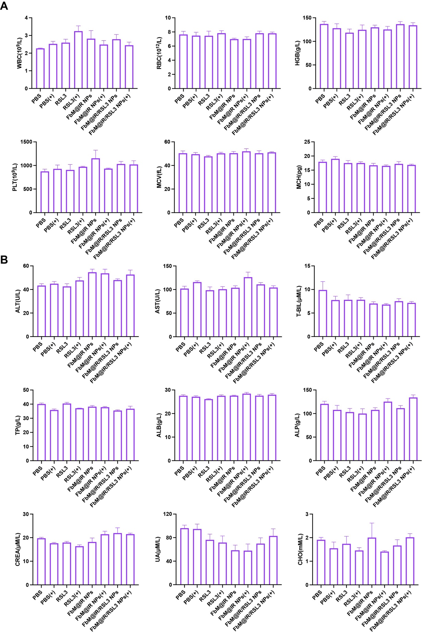
Figure S9. Hematological tests (A) and serum biochemical markers (B) in KYSE-30 tumor-bearing mice following 21 days of treatment with different formulations (n = 3). Data are represented as mean ± SEM.

