Supporting Information
Biomimetic "Tendon Band-Aid" Regulates Inflammatory Microenvironment and Tenogenic Differentiation for Tendinopathy Regeneration
Tongtong Zhang ¹ †, Chao Li ^{2,} †, Jiakuo Yu ² *, Dali Mu ¹ *
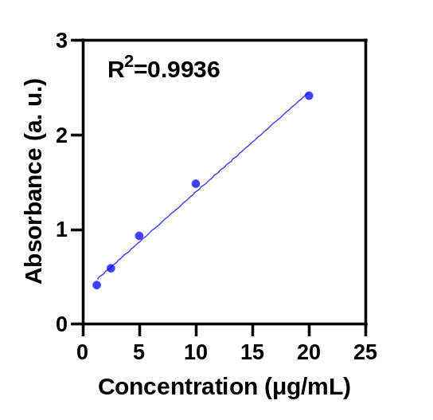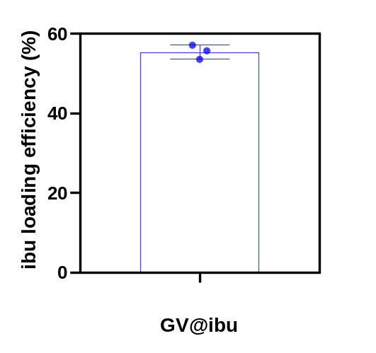
Fig. S1 Left: The standard curve of ibu was made from the data of the UV−vis absorption spectrum. Right: Loading efficiency of ibu in GV@ibu patch.
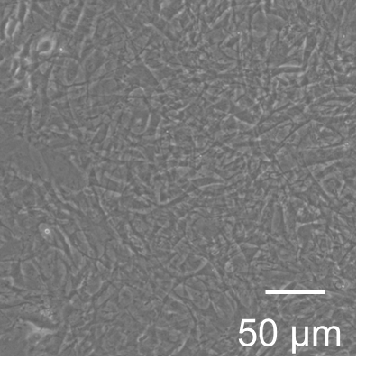
Fig. S2 The cellular morphology of TSCs is examined under brightfield microscopy.

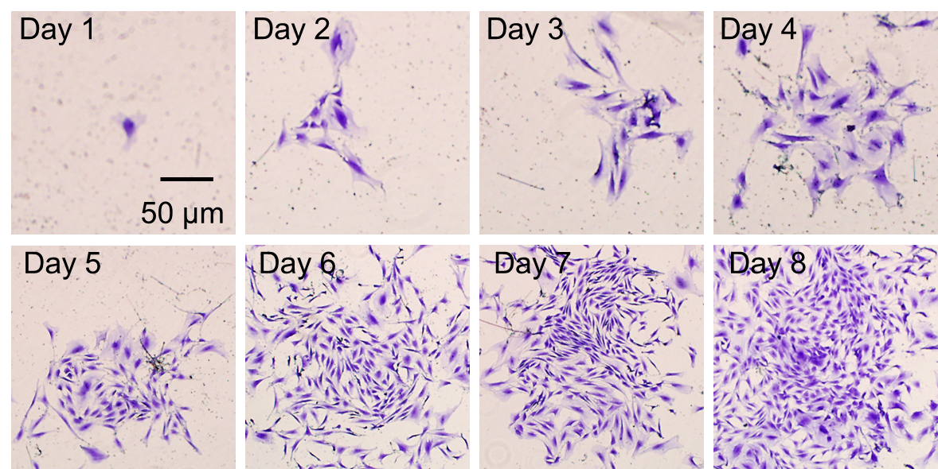
Fig. S3 Monoclonal crystal violet staining of TSCs on different days.

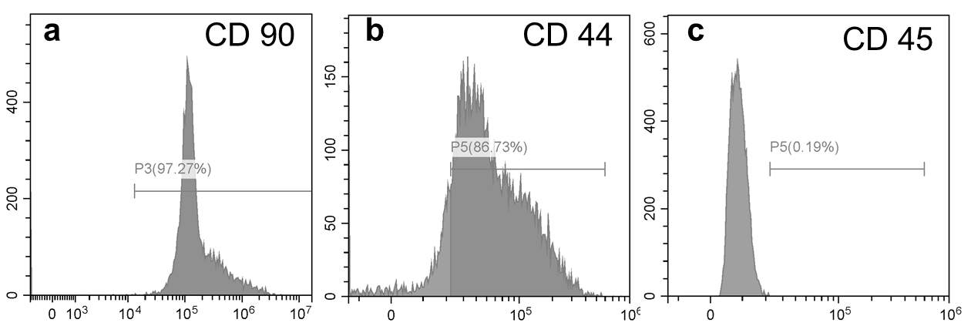
Fig. S4 Flow cytometry identification of surface markers on TSCs. a CD 90. b CD 44. c CD 45.

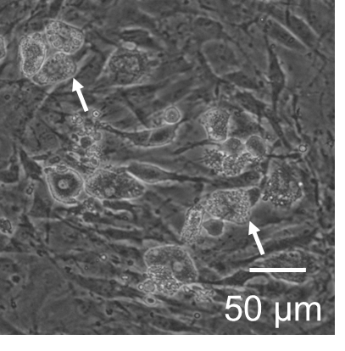
Fig. S5 Adipogenic differentiation and lipid droplet in TSCs under brightfield microscopy. White arrow: lipid droplet.

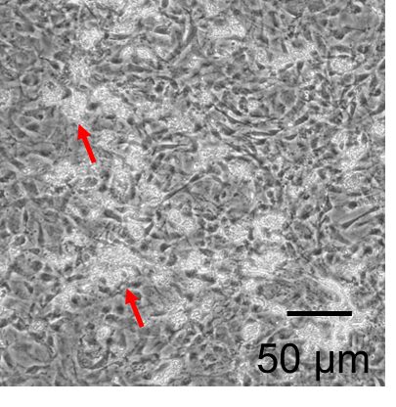
Fig. S6 Osteogenic differentiation and calcium nodules in TSCs under brightfield microscopy. Red arrow: calcium nodule.

Table S1 Sequences of primers for qPCR assay.
Primers | Species | Forward | Reverse
β-actin | Rat | ATCGTGGGCCGCCCT AGGCA | TGGCCTTAGGGTTCAGAGGGG
iNOS | Rat | AAGAGACGCACAGGCAGAG | CAGGCACACGCAATGATGG
TNF-α | Rat | GGCTTTCGGAACTCACTGGA | GGGAACAGTCTGGGAAGCTC
IL-1β | Rat | ATCTCGCAGCAGCACATCA | CCAGCAGGTTATCATCATCATCC
IL-6 | Rat | TCCTACCCCAACTTCCAATGC | GGTTTGCCGAGTAGACCTCAT

Table S2 List of primary and secondary antibodies used in the study.
 | Antibodies | Species | Source | Identifier
 | Anti-Collagen I antibody | Mouse | Abcam | ab6308
 | Anti-Collagen III antibody | Mouse | Abcam | ab6310
 | AGEs Polyclonal Antibody | Rabbit | Bioss | bs-1158R
Anti-α-SMA antibody |  | Mouse | Abcam | ab7817
 | Anti-IL-1β antibody | Mouse | Santa Cruz Biotechnology | sc-52012
 | Anti-TNF-α antibody | Mouse | Abcam | ab1793
 | Anti-COX-2 antibody | Rabbit | Abcam | ab15191
 | Anti-iNOS antibody | Rabbit | Abcam | ab15323
 | Anti-HO-1 antibody | Mouse | Abcam | ab13248
 | GAPDH Rabbit mAb | Rabbit | Cell Signaling Technology | 2118
 | Rabbit Anti-Mouse IgG (HRP) | Rabbit | Cell Signaling Technology | D3V2A
 | Goat Anti- Rabbit IgG (HRP) | Goat | Cell Signaling Technology | 7074
 | Goat Anti-Rabbit IgG H&L (FITC) | Goat | Abcam | ab6717
 | Goat Anti-Mouse IgG H&L (TRITC) | Goat | Abcam | ab6786

