Supplementary Information For
Charge-dependent mitochondrial targeting of cerium-doped polypyrrole nanoparticles to injured renal tubules for acute kidney injury therapy

Mengjie Huang et al.

Supplementary Figures
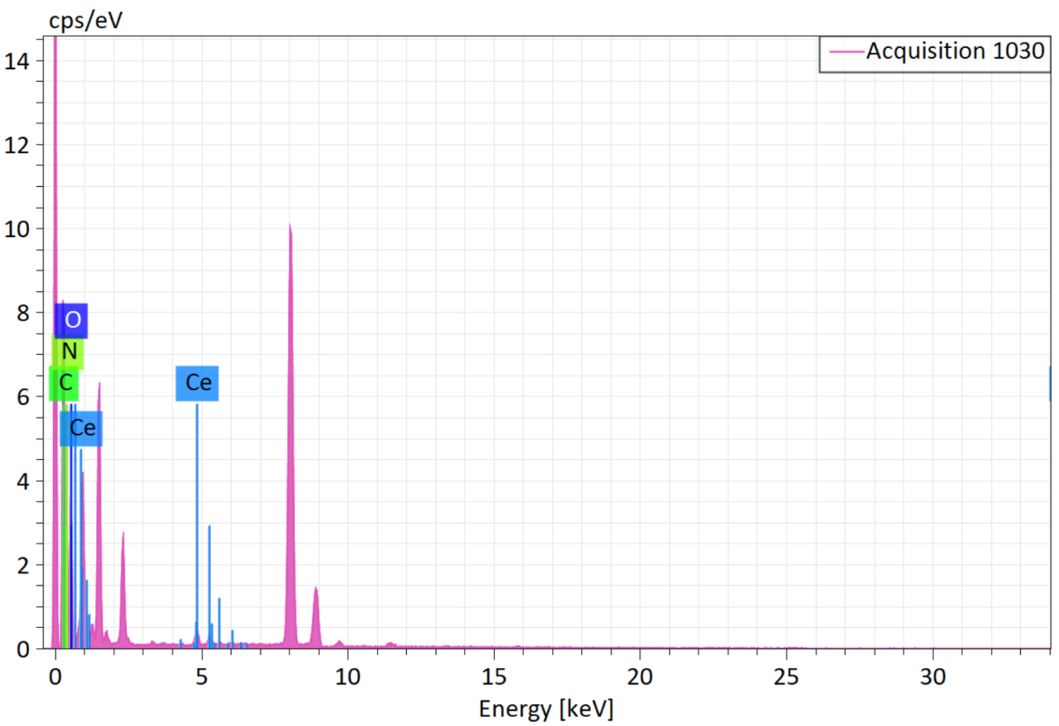
Fig. S1. Energy dispersive X-ray spectra of CePPy.

Fig. S2. Charge-dependent cellular uptake of (+)/(-)CePPy-Cy5 in AML12 hepatocytes.
To validate this charge-dependent uptake in vitro, we performed time-course kinetic studies in AML12 hepatocytes incubated with (+)/(-)CePPy-Cy5, monitored via high-content imaging. Compared with (-)CePPy, (+)CePPy exhibited significantly faster uptake and enhanced internalization.

Fig. S3. Charge-dependent hepatic uptake of (+)/(-)CePPy-Cy5.
To validate the authenticity of the in vivo hepatic fluorescent signals in Fig. 2A, liver tissues were collected from mice injected with equal doses of (+)CePPy-Cy5 or (–)CePPy-Cy5 at 1 hour post-injection for frozen section preparation and fluorescence microscopic examination. In the (+)CePPy group, extensive and intense red fluorescence was distributed uniformly throughout the hepatic parenchyma, particularly within the hepatic cord structures, consistent with the typical localization of hepatocytes. In contrast, liver sections from the (–)CePPy group exhibited only sparse and weak fluorescent spots, mainly localized around sinusoidal areas that correspond to the distribution of hepatic macrophages, with an overall signal intensity significantly lower than that of the (+)CePPy group.

Fig. S4. PTECs were incubated with pure Cy5 dye.
Cy5 fluorescence signal from pure Cy5 dye exhibited a diffuse cytoplasmic distribution in PTECs without specific targeting to any organelle.

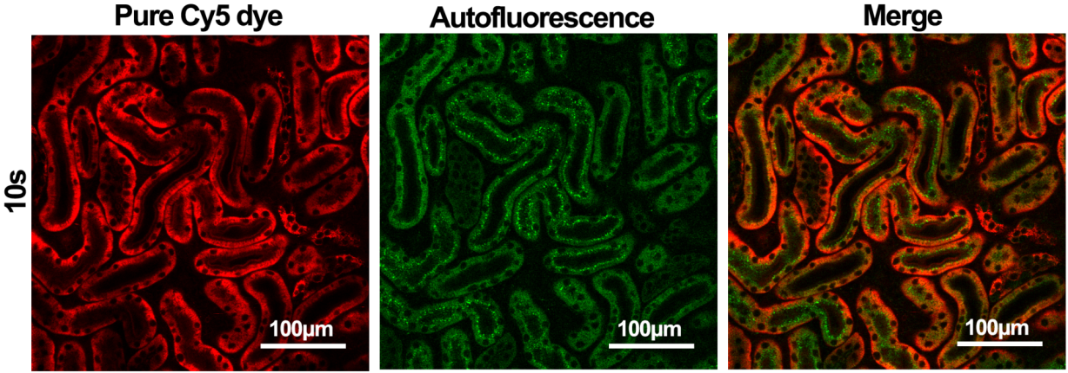
Fig. S5. Intravital microscopic imaging of uptake of Cy5 dye uptake in renal proximal tubules.
Representative intravital microscopy images of kidneys from mice injected intravenously with pure Cy5 dye. The Cy5 fluorescence signal rapidly and uniformly spread across the entire proximal tubules within 10 seconds post-injection.

Fig. S6. Renal accumulation dynamics of (+)CePPy-Cy5 and free Cy5.
Representative fluorescent images of mouse kidneys at 10 secomds and 1 hour after intravenous injection of (+)CePPy-Cy5 or free Cy5.
Red indicates Cy5 fluorescence, and green labels the renal microvasculature.

Fig. S7. Transcriptomic analysis of Eea1 expression in acute kidney, liver, and lung injury.
A Renal Eea1 expression at different time points in a mouse IRI-AKI model, as shown in a single-cell RNA-sequencing dataset (GSE190887). B Renal Eea1 expression across various renal cell types. PT, proximal tubule; PT-Inj, injured PT; PT-R, repairing PT; FR-PT, failed repair PT; ATL, thin ascending limb of LoH; DCT, distal convoluted tubule; CNT, connecting tubule; ICB, type B intercalated cell of collecting duct; Fib, ﬁbroblast; Myoﬁb, myoﬁbroblast; EC, endothelial cell; Ma, macrophage; Uro, urothelium. C Hepatic Eea1 expression in a mouse model of acute liver injury (GSE160880). D Pulmonary Eea1 expression in a mouse model of acute lung injury (GSE216943).

Fig. S8. Representative fluorescence microscopy images showing the ROS levels (DCFH-DA probe) after PPy (without Ce doping) treatment and H/R injury.

Fig. S9. Representative fluorescence microscopy images of the mitochondrial membrane potential after PPy (without Ce doping) treatment and H/R injury.

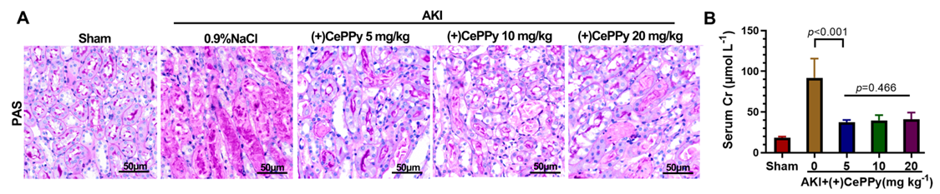
Fig. S10. Therapeutic efficacy of (+)CePPy at varying concentrations in AKI treatment.
A Representative micrographs of PAS staining in IRI mice treated with (+)CePPy at varying concentrations. B Scr levels in each group at 1 day after IRI.

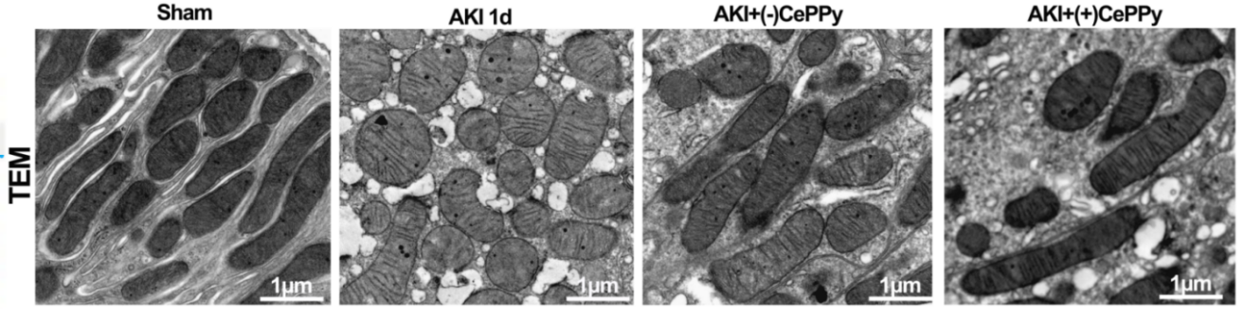
Fig. S11. (+)CePPy maintained mitochondrial morphology in AKI mice.
Representative electron microscopy images of mitochondria in sham mice, vehicle-treated AKI mice, and CePPy-treated AKI mice at 1 day post-AKI. The mitochondria in renal tubular epithelial cells of AKI mice exhibited significant swelling, derangement, and vacuolation, while mitochondrial damage was markedly alleviated after CePPy treatment, with the best therapeutic effect observed in the (+)CePPy group.

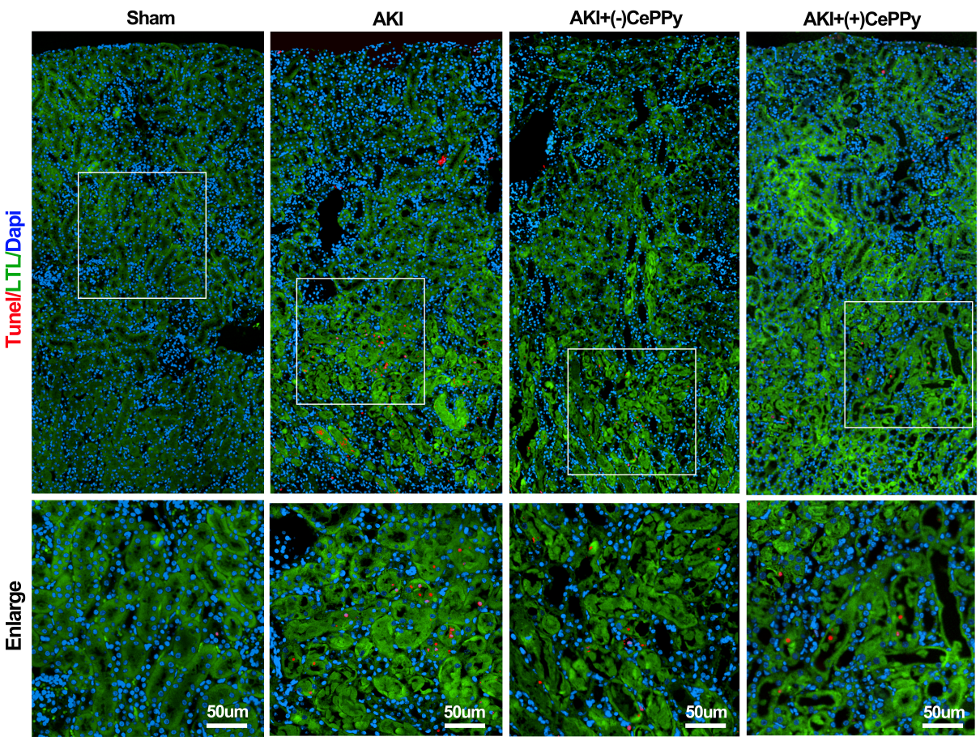
Fig. S12. (+)CePPy reduced AKI induced apoptosis.

Fig. S13. Mpv17l mediates renal protection against mitochondrial oxidative stress-induced injury
A Overexpression of Mpv17l in PTECs reduced mitochondrial ROS production.
B Overexpression of Mpv17l decreased the number of apoptotic cells.

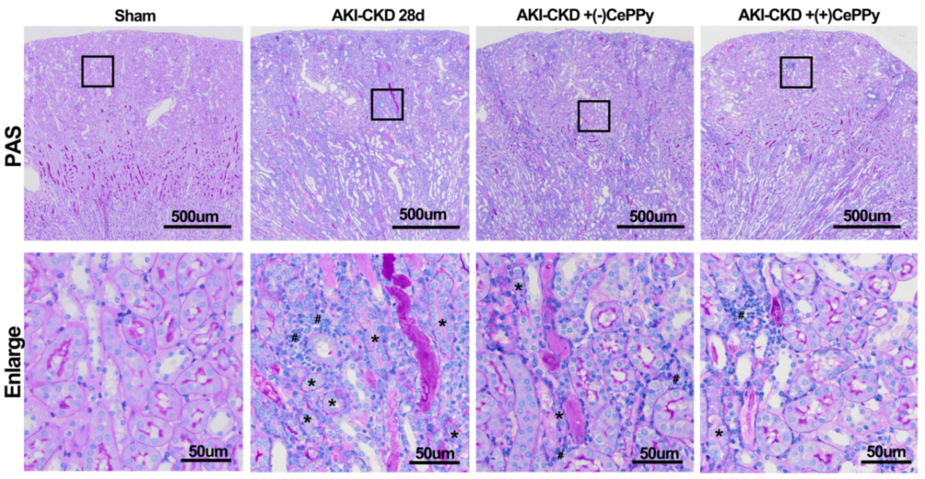
Fig. S14. (+)CePPy alleviated tubular atrophy and chronic inflammatory responses.
Representative micrographs showing PAS staining of tubular atrophy and inflammatory cells 28 days after uIRI in the various groups. PAS staining revealed that the vehicle-treated uIRI group exhibited focal tubular atrophy, interstitial fibrosis, and chronic inflammation, indicating progression to chronic kidney disease. In contrast, treatment with (+)CePPy significantly alleviated tubular atrophy and suppressed chronic inflammatory responses. *:Atrophic renal tubules. #: Infiltration of inflammatory cells.

Fig. S15. Attenuation of Renal Fibrosis by (+)CePPy (Sirius Red Staining).

Fig. S16. In vitro hemolysis assay of (+)CePPy at various concentrations.

Fig. S17. In vivo long-term toxicity assessment of (+)CePPy.
A Normal C57BL/6J mice received three intravenous injections of (+)CePPy at doses of 5, 10, or 20 mg/kg and were euthanized 14 days after the final injection for subsequent analysis. Major organs were collected for histological examination by H&E and PAS staining. B Serum samples from each group were analyzed for routine blood parameters, as well as liver and renal function markers. Data are presented as mean ± SDs, with n = 5 per group. For B, statistical comparisons were performed using one-way ANOVA.

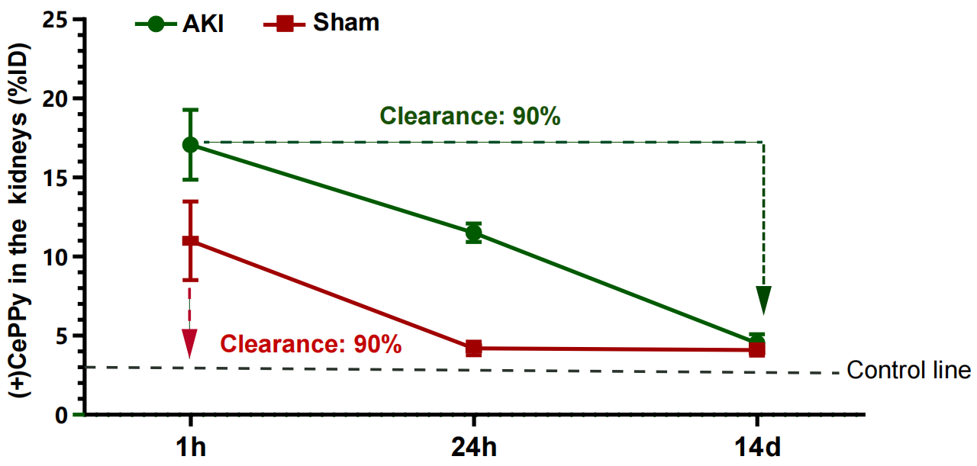
Fig. S18. Kidney clearance of (+)CePPy analyzed by ICP-MS.
The clearance of CePPy from the kidneys was investigated using ICP-MS to measure cerium levels at 1 hour, 24 hours, and 14 days following the injection of (+)CePPy in both AKI and sham mice. The control line represents baseline cerium levels detected by ICP-MS in kidneys of sham mice without CePPy administration. By 14 days, 89.68% of the accumulated (+)CePPy in sham mice and 89.61% in AKI mice had been eliminated from the kidneys.

Fig. S19. Effect of (+)CePPy on mitochondrial membrane potential in HK-2 cells at different concentrations.
Representative fluorescence microscopy images of mitochondrial membrane potential in the indicated treatment groups were assessed using JC-1 dye. The results demonstrated that (+)CePPy had no significant effect on mitochondrial membrane potential compared to the control group at various concentrations.
Fig. S20. (+)CePPy promotes energy homeostasis restoration after AKI.
A Significantly enriched GO Biological Process (GOBP) terms related to energy homeostasis regulation. B Expression patterns of key genes involved in the identified energy metabolism pathways.

Supplementary Tables

Table S1. Antibody list
Antibody | Company | Catalog No | Dilution/Application
Lotus Tetragonolobus Lectin (LTL) | Vector Laboratories | FLe1321 | 1:200 (IF)
Endomucin | Santa Cruz | sc-65495 | 1:200 (IF)
KIM-1 | R&D | AF1817 | 1:200 (IF)  1:1000 (WB)
BAX | Proteintech | 50599-2 | 1:1000 (WB)
Cleaved caspase 3 | CST | 9661 | 1:1000 (WB)
Mpv17l | Proteintech | 10310-1-AP | 1:1000 (WB)
α-SMA | Abcam | ab7817 | 1:1000 (WB)
F4/80 | Servicebio | GB113373 | 1:200 (IHC)
Vimentin | Abcam | ab92547 | 1:200 (IF)  1:1000 (WB)
EEA1 | Proteintech | 68065-1-1g | 1:1000 (IF)  1:5000(WB)

Table S2. Gene-specific siRNA oligo sequence used in our study.
Genes | Sense | Antisense
siNC | 5’-UUCUCCGAACGUGUCACGUTT-3’ | 5’-ACGUGACACGUUCGGAGAATT-3’
siMpv17l | 5’-CCACCAACGUGCUGCUUUATT-3’ | 5’-UAAAGCAGCACGUUGGUGGTT-3’
siEea1-328 | 5’-CUCUCAAGGUUCUGAUUUATT-3’ | 5’-UAAAUCAGAACCUUGAGAGTT -3’
siEea1-597 | 5’-GGUACUCAGAAGAAUUAAATT-3’ | 5’-UUUAAUUCUUCUGAGUACCTT-3’
siEea1-928 | 5’-GCUUCAGAGACCUGGUAUATT-3’ | 5’-UAUACCAGGUCUCUGAAGCTT-3’
siEea1-1126 | 5’-CCAAGAAGUUGCAGUAUAUTT-3’ | 5’-AUAUACUGCAACUUCUUGGTT-3’

Table S3. Gene-specific primers used in our study.
Genes | Forward Primer | Reverse Primer
18s | GTAACCCGTTGAACCCCATT | CCATCCAACGGTAGTAGCG
Dnm1 | AATATGCCGAGTTCCTGCACT | GTCTCAGCCTCGATCTCCAG
Dnm2 | AAGAGCCGAGTTTGAAGTGTG | ACGACTGCTCAATGTCAATCAG
Dnm3 | CTCAGGCATTGTAACCAGACG | CTCGGCATATTCTGCTTTAGAGG
Clta | CTCGGGTCGGTGCTCTTAC | CACTTCCTCTTTGCGCTTCTAAA
Cltb | GAAAGCGAGATTGCTGGCATC | CGTTAGCCTCCTGAAACACATC
Cltc | AGATTCTGCCCATTCGCTTTC | TCAGTGCAATCACTTTGCTGG
Cav1 | ATGTCTGGGGGCAAATACGTG | CGCGTCATACACTTGCTTCT
Cav2 | TCACCAGCTCAACTCTCATCT | GCCAGAAATACGGTCAGGAACT
Cavin1 | CAGCGTCAACGTGAAGACC | CCTCCGACTCTTTCAGCGAC
Hunk | GTGCTGACGGGAGAAAAGGTA | GGGTGTCGGATCATCTGCTG
Ctbp1 | GTGCCCTGATGTACCATACCA | TGATGTCGATATTGTCAAACCCG
Ankfy1 | GAGACCCCATTACACCTTGTAGC | CAACCGCTTTGCATTTCTCCA
Eea1 | AAACCAGCTAAGGAGTGAACTTG | GTGGGTGTAGTCTAGGTCTTTCT
Rab5a | GCTAATCGAGGAGCAACAAGAC | CCAGGCTTGATTTGCCAACAG
Rab5b | GGGAAGTCTAGCCTGGTGTTA | GCTTTCCTGGTATTCATGGAACT
Rab7 | AGGCTTGGTGCTACAGGAAAA | CTTGGCCCGGTCATTCTTGT
Rab11a | TGGGAAAACAATAAAGGCACAGA | ATGTGAGATGCTTAGCAATGTCA
Rab11b | ATTCAAAGTGGTGCTTATTGGGG | TCCGATGGTACTCTTGCTCTC
Rab27a | TCGGATGGAGATTACGATTACCT | TTTTCCCTGAAATCAATGCCCA

