Title: Multi-Enzymatic Platinum-Doped Emodin Carbon Dots Alleviate Sepsis-Induced Lung Injury by Modulating the Gut Microbiota-Palmitic Acid-Macrophage Pyroptosis Axis
Authors: Honghao Song^{1‡}, Yuqing Ma^{2‡}, Lei Peng^{1‡}, Fangyuan Gao^{3‡}, Xiaoyi Fan¹, Mei Yang¹, Tong Hua¹, Yutong Yang¹, Rongrong Fan¹, Zhenjie Li^{1*}, Hongbin Yuan^{1*}
Figure S1. The Single-Cell Landscape of Alveolar Macrophages in Sepsis. (A) UMAP projection of murine alveolar macrophages following unsupervised clustering across control, sepsis, and sepsis-48h groups, with color coding denoting distinct cell populations. (B) UMAP representation of murine alveolar macrophages segmented into eight transcriptionally distinct subclusters, each color-coded according to subcluster identity within the control, sepsis, and sepsis-48h groups. (C) Dot plot illustrating the expression of canonical marker genes for each identified cluster. Dot size corresponds to the proportion of cells expressing the marker, while color intensity reflects the average expression level.

Figure S2. Expression of (A) Nlrp3, (B) Gsdmd, (C) Caspase1, (D) Nod1, (E) Pycard, and (F) Il18 in macrophage subpopulations by t-SNE.

Figure S3. Expression of (A) Il1α, (B) Tnf, (C) Ccl17, (D) Ccl22, (E) Cxcl10, and (F) Nfe2I2 in macrophage subpopulations by t-SNE.

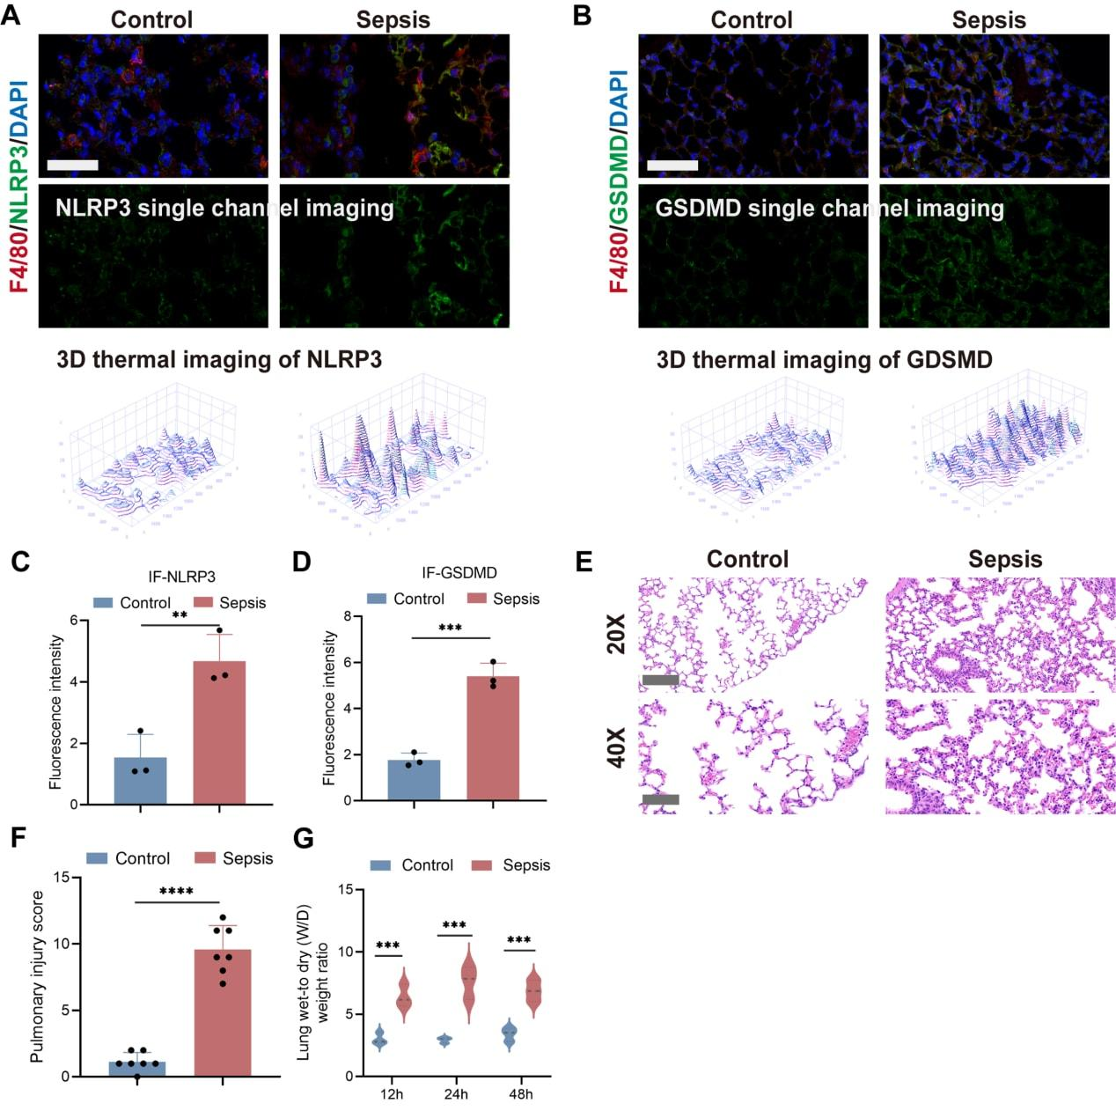
Figure S4. The occurrence of macrophage pyroptosis coincides with sepsis-induced lung injury in mice. (A-B) Representative IF co-staining image of (A) NLRP3 (green)/F4/80 (red) and (B) GSDMD (green)/F4/80 (red) in lung tissues (scale bars: 50 μm; n=3 biologically independent samples per group). (C-D) Quantitative fluorescence analysis of (C) NLRP3 and (D) GSDMD (n=3 biologically independent animals per group). (E) Representative histopathological changes in H&E-stained sections of lungs between sepsis and control groups. (F) Pulmonary injury score between sepsis and control groups (n=7 biologically independent animals per group). (G) Lung wet-to dry weight ratio at different time points between sepsis and control groups (n=7 biologically independent animals per group). Data were expressed as mean ± SD (Significance was calculated by t test, * P-value < 0.05; ** P-value < 0.01; *** P-value < 0.001; **** P-value < 0.0001)
Figure S5. (A) Representative WB results and (B) quantitative analysis for pyroptosis-related markers (NLRP3, N-GSDMD, CL-CASPASE1 and CL-IL1β) of human serum from different SOFA score patients.

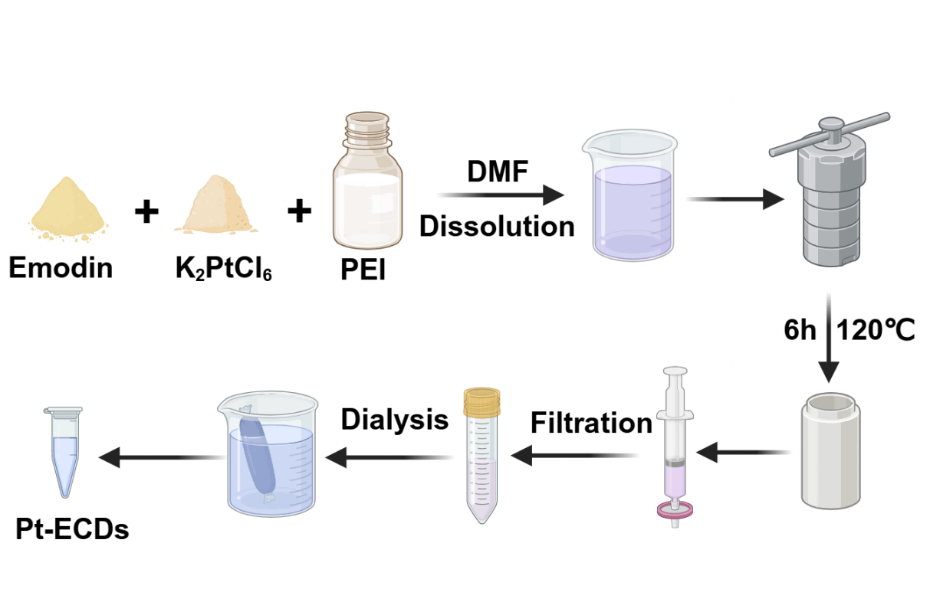
Figure S6. Synthesis procedures of Pt-ECDs.

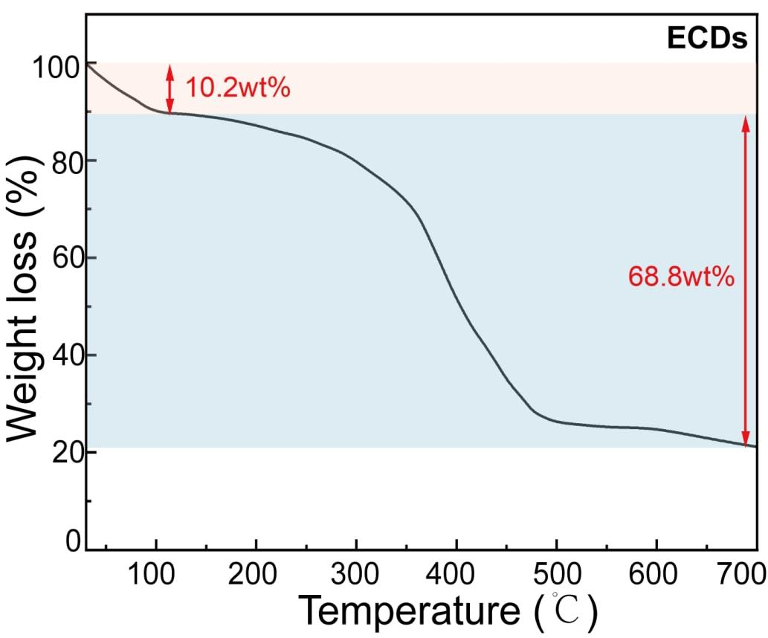
Figure S7. Thermogravimetric analysis (TGA) of ECDs.
Figure S8. Comparison of enzymatic activities of chrysophanol carbon dots doped with different metals. (A) Inhibition rate of SOD activity among Cu-ECDs, Fe-ECDs and ECDs. (B) Hydrogen peroxide scavenging rate among Cu-ECDs, Fe-ECDs and ECDs. (C) GPx enzymatic activity among Cu-ECDs, Fe-ECDs and ECDs.

Figure S9. The enzymatic activity of Pt-ECDs and ECDs. (A) Inhibition rate of SOD (n=3 biologically independent samples per group). (B) Lineweaver-Burk kinetic analysis for Pt-ECDs’ CAT enzyme activity (n=3 biologically independent samples per group). (C) Total Antioxidant Capacity (TAC) of ECDs (n=3 independent samples per group). (D) Lineweaver-Burk kinetic analysis for Pt-ECDs’ POD enzyme activity (n=3 independent samples per group). (E) Assessment of nitric oxide (NO) scavenging capacity between Pt-ECDs and ECDs using PTIO inhibition rate. Data were expressed as mean ± SD.

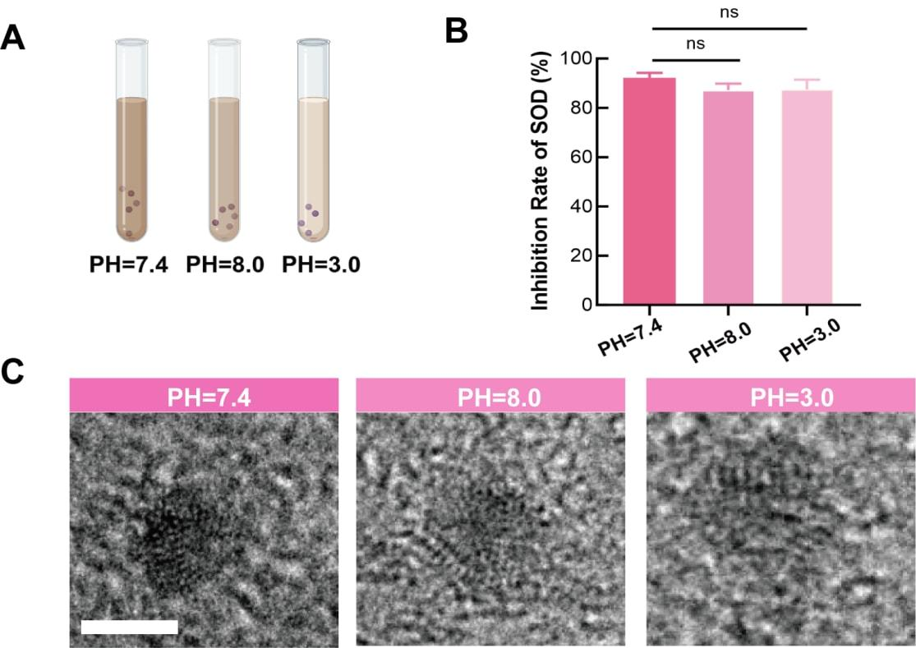
Figure S10. Characterization and characteristics evaluation of Pt-ECDs under different pH conditions. (A) Illustration of different pH condition settings. (B) Inhibition rate of SOD among three groups (n=3 independent samples per group). (C) TEM of Pt-ECDs in different PH conditions (scale bars: 2 nm). Data were expressed as mean ± SD (Significance was calculated by one-way ANOVA with Sidak’s multiple-comparisons test, * P-value < 0.05; ** P-value < 0.01; *** P-value < 0.001; **** P-value < 0.0001).

Figure S11. Reaction mechanisms of (A) SOD-, (B) CAT-, (C) GPx-like and (D) OH- remove activities in ECDs.

Figure S12. Time-dependent changes in serum TNF-α levels in mice after CLP (n=6 biologically independent animals per group). Data were expressed as mean ± SD (Significance was calculated by one-way ANOVA with Sidak’s multiple-comparisons test, * P-value < 0.05; ** P-value < 0.01; *** P-value < 0.001; **** P-value < 0.0001)

Figure S13. Evaluation of the therapeutic efficacy of different nanomaterials in septic mice. (A) Survival rates of septic mice treated by emodin (10 mg/kg), ECDs (5 μg/kg), Pt-ECDs (5 μg/kg) and K₂PtCl₄ (0.9 μg/kg) respectively (n=50 biologically independent animals per group). (B) Lung injury score of septic mice treated by emodin, ECDs, Pt-ECDs and K₂PtCl₄ respectively (n=5 biologically independent animals per group). (C-D) The serum levels of (C) TNF-α and (D) IL-1β in septic mice treated by emodin, ECDs, Pt-ECDs and K₂PtCl₄ respectively (n=5 biologically independent animals per group). Data were expressed as mean ± SD (Significance was calculated by one-way ANOVA with Sidak’s multiple-comparisons test, * P-value < 0.05; ** P-value < 0.01; *** P-value < 0.001; **** P-value < 0.0001)

Figure S14. Evaluation of Pt-ECDs concentration-dependent response. (A) Schematic overview of the assay for detecting serum inflammatory factors following administration of graded concentrations of Pt-ECDs to septic mice. (B-C) The resulting levels of (B) TNF-α and (C) IL-1β in the serum of treated septic mice (n=3 biologically independent animals per group). Data were expressed as mean ± SD (Significance was calculated by one-way ANOVA with Sidak’s multiple-comparisons test, * P-value < 0.05; ** P-value < 0.01; *** P-value < 0.001; **** P-value < 0.0001)

Figure S15. (A-E) Representative histopathological changes in H&E-stained sections of (A) lungs, (B) hearts, (C) livers, (D) kidneys, and (E) intestines in mice between control group and control+Pt-ECDs group (n=3 biologically independent animals per group). (F-H) Serum biochemical indices of (F) ALT, (G) AST and (H) BUN in mice between control group and control+Pt-ECDs group (n=5 biologically independent animals per group).

Figure S16. In vivo intestinal imaging in a murine sepsis model. (A) Representative ex vivo fluorescence images of intestinal tracts from septic mice following oral gavage of Cy5.5-conjugated PBS, captured at 4, 8, 12, 24, and 48 hours post-CLP (n=5 biologically independent mice per time point). (B) Quantitative analysis of intestinal Cy5.5 fluorescence intensity over time in mice treated with either cy5.5-labeled Pt-ECDs or cy5.5-labeled PBS. Data were expressed as mean ± SD (Significance was calculated by two-way ANOVA with Tukey’s multiple-comparisons tests, * P-value < 0.05; ** P-value < 0.01; *** P-value < 0.001; **** P-value < 0.0001).

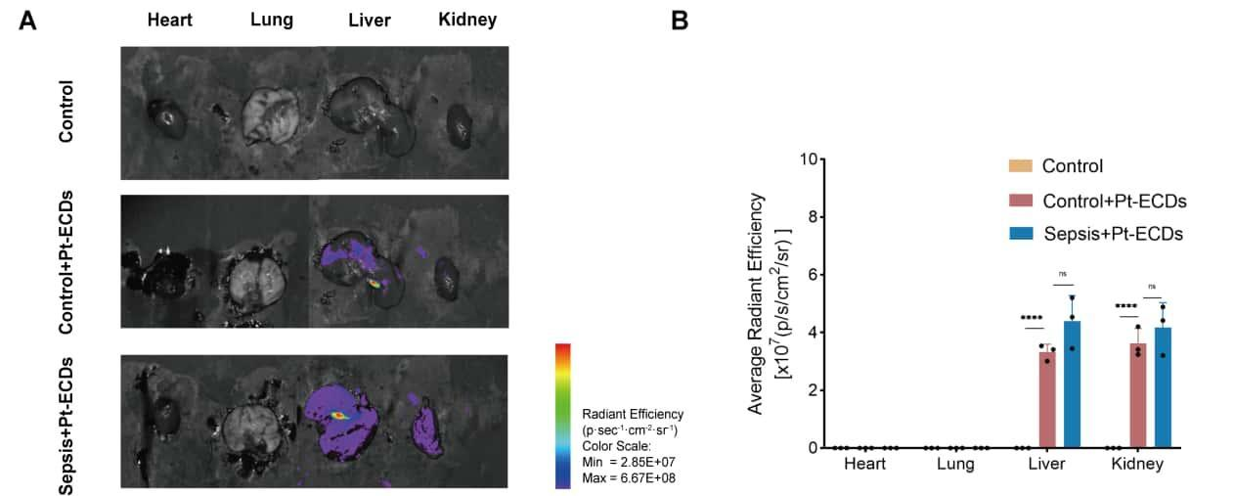
Figure S17. Distribution of Pt-ECDs in major organs. (A) Representative ex vivo fluorescence images showing the distribution of Pt-ECDs in the heart, lung, liver, and kidney of mice from the control group, control group administered with Pt-ECDs (5 μg/kg), and septic group (24 hours post-CLP) treated with Pt-ECDs (5 μg/kg) (n=3 biologically independent animals per group). (B) Quantitative comparison of fluorescence signal intensity (n=3 biologically independent animals per group). Data were expressed as mean ± SD (Significance was calculated by one-way ANOVA with Sidak’s multiple-comparisons test, * P-value < 0.05; ** P-value < 0.01; *** P-value < 0.001; **** P-value < 0.0001).

Figure S18. Quantitative analysis of serum biomarker and intestine tissue protein levels. (A) MDA serum levels among four groups (n=6 biologically independent animals per group). (B) Relative protein expression of ZO1 and (C) CLDN1 protein. (n=3 biologically independent animals per group). Data were expressed as mean ± SD (Significance was calculated by one-way ANOVA with Sidak’s multiple-comparisons test, * P-value < 0.05; ** P-value < 0.01; *** P-value < 0.001; **** P-value < 0.0001).

Figure S19. Quantitative fluorescence analysis of intestine tissue markers in mice. (A) Quantitative fluorescence analysis of CLDN1 and (B) ZO1 protein (n=3 biologically independent animals per group). Data were expressed as mean ± SD (Significance was calculated by one-way ANOVA with Sidak’s multiple-comparisons test, * P-value < 0.05; ** P-value < 0.01; *** P-value < 0.001; **** P-value < 0.0001).

Figure S20. Transcriptome results after CLP treatment in mice. (A) PCA visualization of two groups. (B) Heatmap of differentially regulated genes. Blue: downregulated, red: upregulated. (C) Bubble plots of significantly upregulated GO and KEGG pathways between sepsis and control groups. (D) GSEA of key pathways between sepsis group (24 hours post-CLP) and control group. (E) Chord diagram linking associated DEGs to functional pathways between sepsis group (24 hour post-CLP) and control group. (F) Top 20 KEGG term between sepsis group (24 hour post-CLP) and control group. Data were expressed as mean ± SD (Significance was calculated by ANOVA and t-test, * P-value < 0.05; ** P-value < 0.01; *** P-value < 0.001).

Figure S21. Transcriptome results after Pt-ECDs treatment in septic mice. (A) FKPM visualization of three groups. (B) PCA visualization of three groups. (C) Quantification of intersection gene number among control group, sepsis group and treatment group. (D) Chord diagram linking associated DEGs to functional pathways between treatment and sepsis groups. (E) KEGG enrichment top 20 pathways between treatment and sepsis groups.
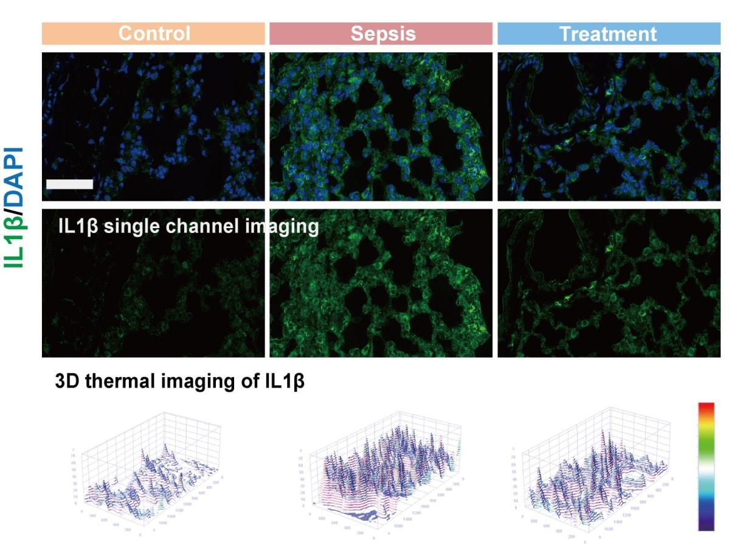
Figure S22. Representative fluorescence staining result image of IL-1β among h groups (scale bars: 100 μm; n=3 biologically independent animals per group).
Figure S23. Quantitative fluorescence analysis of lung tissue markers in mice. (A) Quantitative fluorescence analysis of NLRP3, (B) GSDMD, (C) iNOS, (D) CD86 and IL-1β protein (n=3 biologically independent animals per group). Data were expressed as mean ± SD (Significance was calculated by one-way ANOVA with Sidak's multiple-comparisons test, * P-value < 0.05; ** P-value < 0.01; *** P-value < 0.001; **** P-value < 0.0001).

Figure S24. Differences in fecal microbiota at the family level in sepsis patients.

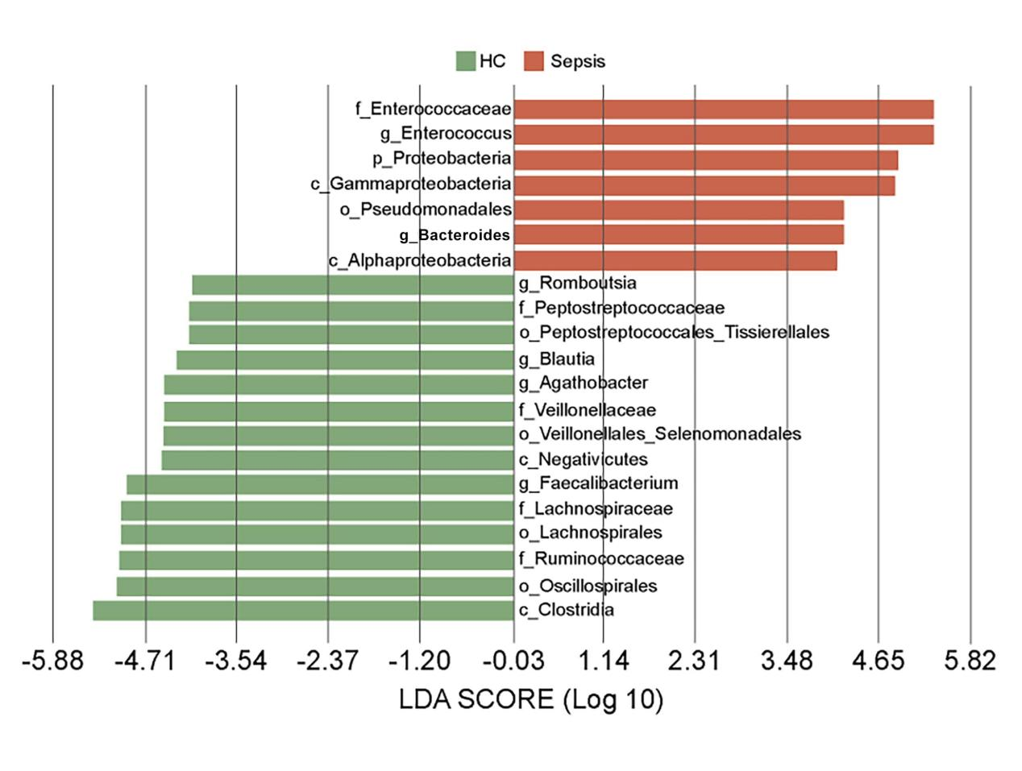
Figure S25. Characteristics of the fecal microbiome in patients with sepsis.

Figure S26. Mouse serum PA levels after treated with g_Bacteroides.

Figure S27. Cell viability assessment of BMDMs using CCK8 assay under different PA concentrations (0 μM, 3.125 μM, 6.25 μM, 12.5 μM, 25 μM, 50 μM, 100 μM, 200 μM) (n=6 biologically independent cells per group). Data were expressed as mean ± SD (Sgnificance was calculated by one-way ANOVA with Sidak’s multiple-comparisons test, * P-value < 0.05; ** P-value < 0.01; *** P-value < 0.001; **** P-value < 0.0001).

Figure S28. LDH release rate (n=3 biologically independent samples per group). Data were expressed as mean ± SD (Significance was calculated by one-way ANOVA with Sidak’s multiple-comparisons test, * P-value < 0.05; ** P-value < 0.01; *** P-value < 0.001; **** P-value < 0.0001).
Figure S29. ROS-overload further aggravated pyroptosis. (A-D) Expression of (A) Cybb, (B) Nlrp3, (C) Gsdmd and (D) Il-1β mRNA detected by qPCR (n=3 biologically independent cells per group). Data were expressed as mean ± SD (Significance was calculated by one-way ANOVA with Sidak’s multiple-comparisons test, * P-value < 0.05; ** P-value < 0.01; *** P-value < 0.001; **** P-value < 0.0001).

Figure S30. The NOX2 and NLRP3 inhibitor markedly attenuated macrophage pyroptosis and suppressed anti-inflammatory polarization. (A) Schematic diagram of the experiment where BMDMs were treated with NOX2 and NLRP3 inhibitors. (B) Representative western blot of NOX2 protein among five groups (n=3 biologically independent cells per group). (C) Expression of Cybb mRNA detected by qPCR (n=3 biologically independent cells per group). (D) Representative western blot of NLRP3, GSDMD, CASPASE1 and CL-IL1β protein among five groups (n=3 biologically independent cells per group). (E-G) Expression of (E) Nlrp3, (F) Gsdmd and (G) Il-1β mRNA detected by qPCR (n=3 biologically independent cells per group). (H) Representative western blot of iNOS protein among five groups (n=3 biologically independent cells per group). (I-J) Expression of (I) Cd80, (J) Cd86 mRNA detected by qPCR (n=3 biologically independent cells per group). Data were expressed as mean ± SD (Significance was calculated by one-way ANOVA with Sidak’s multiple-comparisons test, * P-value < 0.05; ** P-value < 0.01; *** P-value < 0.001; **** P-value < 0.0001).

Figure S31. Isoleucine residue (I411) serves as functional site for the binding of PA and NOX2. (A-B) Western blot and q-PCR analysis indicated the three kinds of mutant plasmid did not affect the expression of NOX2. Data were expressed as mean ± SD (Significance was calculated by multiple t-test, **** P-value < 0.0001). (C) The cell viability of NOX2-overexpressed BMDMs (n=6 biologically replicates per group). (D) IF of ROS among six groups (n=3 biologically replicates per group). (E) Representative western blot of pyroptosis-associated markers (n=3 biologically replicates per group). (F-H) Expression of mRNA including (F) Nlrp3, (G) Gsdmd and (H) Il-1β detected by qPCR among six groups (n=3 biologically replicates per group). Data were expressed as mean ± SD (Significance was calculated by one-way ANOVA with Sidak’s multiple-comparisons test, ** P-value < 0.01; *** P-value < 0.001; **** P-value < 0.0001).

Figure S32. Aspartic acid residue (D804) serves as functional site for the binding of PA and NLRP3. (A-B) Western blot and q-PCR analysis indicated the three kinds of mutant plasmid did not affect the expression of NLRP3. Data were expressed as mean ± SD (Significance was calculated by multiple t-test, **** P-value < 0.0001). (C) The cell viability of NLRP3-overexpressed BMDMs (n=6 biologically replicates per group). (D) Representative western blot of pyroptosis-associated markers (n=3 biologically replicates per group). (E-F) Expression of mRNA including (E) Gsdmd and (F) Il-1β detected by qPCR among six groups (n=3 biologically replicates per group). Data were expressed as mean ± SD (Significance was calculated by one-way ANOVA with Sidak’s multiple-comparisons test, **** P-value < 0.0001).

Figure S33. Quantitative fluorescence analysis of macrophage markers in BMDMs. (A) Quantitative fluorescence analysis of NLRP3, (B) GSDMD and (C) iNOS protein among three groups (n=3 biologically independent cells per group). Data were expressed as mean ± SD (Significance was calculated by one-way ANOVA with Sidak's multiple-comparisons test, * P-value < 0.05; ** P-value < 0.01; *** P-value < 0.001; **** P-value < 0.0001).

Figure S34. The protective effects of Pt-ECDs against septic lung injury in mice were significantly diminished following the depletion of gut microbiota. (A) Diagram of the microbiota clearance experiment. (B) Survival rates of mice across control group, sepsis group (24 hours post-CLP), treatment group (24 hours post-CLP), and treatment+ABx group (24 hours post-CLP) (n=20 biologically independent animals per group). (C) Lung injury score among four groups (n=7 biologically independent animals per group). (D) TNF-α and (E) IL-1β serum levels (n=4 biologically independent animals per group) among four groups. Data were expressed as mean ± SD (Significance was calculated by one-way ANOVA with Sidak’s multiple-comparisons test, **** P-value < 0.0001).

Figure S35. Differences in fecal microbiota at the Phylum level after FMT.

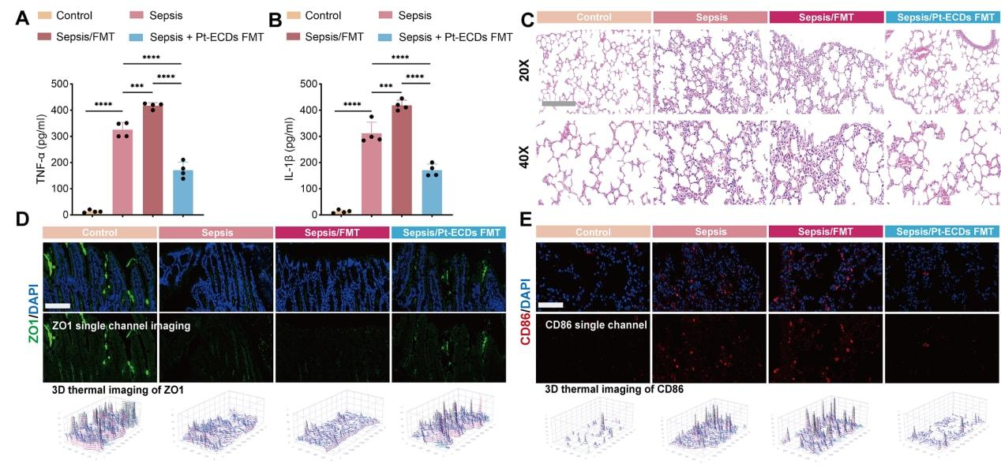
Figure S36. FMT effectively mitigated lung injury in septic mice. (A) TNF-α and (B) IL-1β serum levels among four groups (n=4 biologically independent animals per group). (C) Representative H&E staining of the four groups (n=3 biologically independent animals per group). (D-E) Representative IF of (D) ZO1 and (E) CD86 (scale bars: 100 μm; n=3 biologically independent animals per group). Data were expressed as mean ± SD (Significance was calculated by one-way ANOVA with Sidak’s multiple-comparisons test, *** P-value < 0.001;**** P-value < 0.0001).
Figure S37. Quantitative fluorescence analysis of intestine and lung tissue markers in mice. (A) Quantitative fluorescence analysis of intestine-ROS, (B) CLDN1, (C) ZO1, (D) lung-ROS, (E) NLRP3, (F) GSDMD, (G) iNOS and (H) CD86 among four groups (n=3 biologically independent animals per group). Data were expressed as mean ± SD (Significance was calculated by one-way ANOVA with Sidak’s multiple-comparisons test, * P-value < 0.05; ** P-value < 0.01; *** P-value < 0.001; **** P-value < 0.0001).

Supplementary Table 1 Antibodies, PCR primers, and Software Used in the Study
REAGENT | SOURCE | IDENTIFIER
Antibodies
Rabbit anti-NLRP3 antibody | Cell Signaling Technology | Cat# 15101, RRID:AB_2722591
Rabbit anti-GSDMD antibody | Abcam | Cat# ab219800, RRID:AB_2888940
Rabbit anti-caspase1 antibody | Cell Signaling Technology | Cat# 24232, RRID:AB_2890194
Rabbit anti-cleaved IL-1β antibody | Cell Signaling Technology | Cat# 63124, RRID:AB_2799639
Rabbit anti-NOX2 antibody | Abcam | Cat# ab310337, RRID:AB_3644331
Rabbit anti-F4/80 antibody | Cell Signaling Technology | Cat# 30325; RRID:AB_2798990
Rabbit anti-arginase-1 antibody | Cell Signaling Technology | Cat# 93668, RRID:AB_2800207
Mouse anti-β-Actin antibody | Abcam | Cat# ab6276, RRID:AB_2223210
Rabbit anti-iNOS antibody | Cell Signaling Technology | Cat# 13120, RRID:AB_2687529
Rabbit anti-p65 antibody | Abcam | Cat# ab16502, RRID:AB_443394
Rabbit anti-phspho p65 antibody | Abcam | Cat# ab76302, RRID:AB_1524028
Rabbit anti-ZO-1 antibody | Abcam | Cat# ab276131, RRID:AB_3083081
Rabbit anti-Claudin1 antibody | Abcam | Cat# ab211737, RRID:AB_3082989
Rabbit anti-CD86 antibody | Proteintech | Cat# 13395-1-AP, RRID:AB_2074882
FITC-AffiniPure Goat Anti-Mouse IgG (H+L) | Jackson ImmunoResearch Labs | Cat#115-095-003; RRID: AB_2338589
FITC-AffiniPure Goat Anti-Rabbit IgG (H+L) | Jackson ImmunoResearch Labs | Cat#111-095-003; RRID: AB_2337972
Cy3-AffiniPure Goat Anti-Mouse IgG (H+L) | Jackson ImmunoResearch Labs | Cat#115-165-003; RRID: AB_2338680
Cy3-AffiniPure Goat Anti-Rabbit IgG (H+L) | Jackson ImmunoResearch Labs | Cat#111-165-003; RRID: AB_2338000
Oligonucleotides
PCR primers: Nlrp3 forward:  AAGGCTTGTGTGGGACCAAA | This study | N/A
PCR primers: Nlrp3 reverse:  AGGGGCAGGAGTAAGAGGAG | This study | N/A
PCR primers: Gsdmd forward:  TGCGTGTGACTCAGAAGACC | This study | N/A
PCR primers: Gsdmd reverse:  CAAACAGGTCATCCCCACGA | This study | N/A
PCR primers: Caspase1 forward:  CGAGGGTTGGAGCTCAAGTT | This study | N/A
PCR primers: Caspase1 reverse:  AGAAGTCTTGTGCTCTGGGC | This study | N/A
PCR primers: Il-6 forward:  GCCTTCTTGGGACTGATGCT | This study | N/A
PCR primers: Il-6 reverse:  AGCCTCCGACTTGTGAAGTG | This study | N/A
PCR primers: Tnf-α forward:  GGACTAGCCAGGAGGGAGAA | This study | N/A
PCR primers: Tnf-α reverse:  CGCGGATCATGCTTTCTGTG | This study | N/A
PCR primers: Arg1 forward: GGGAAGACAGCAGAGGAGGT | This study | N/A
PCR primers: Arg1 reverse: GGAGAAGGCGTTTGCTTAGTT | This study | N/A
PCR primers: Cd80 forward:  CCCCAGAAGACCCTCCTGATAGC | This study | N/A
PCR primers: Cd80 reverse:  TGATGACAACGATGACGACGACTG | This study | N/A
PCR primers: Cd86 forward: ATGCCTGGAAAGGTCTGGA | This study | N/A
PCR primers: Cd86 reverse: AGCACCGAGGTGGCTGATA | This study | N/A
PCR primers: Cybb forward:  CGAAGACAACTGGACAGGAACCTC | This study | N/A
PCR primers: Cybb reverse:  AAATCCCGACTCTGGCATTCACAC | This study | N/A
PCR primers: Il-10 forward: AGTGGAGCAGGTGAAGAGTGAT | This study | N/A
PCR primers: Il-10 reverse: GGTCCTGGAGTCCAGCAGAC | This study | N/A
PCR primers: Il-1β forward: GGGCTGGACTGTTTCTAATGC | This study | N/A
PCR primers: Il-1β reverse: CTTGTGACCCTGAGCGACC | This study | N/A
Software and algorithms
Image J | https://imagej.nih.gov/ij/ | RRID: SCR_002285
Prism 10 | https://www.graphpad.com/ | N/A
Abobe Illustrator | https://www.adobe.com/products/ | N/A

Supplementary Table 2 Patient’s information
No. of patients | Sex | Age | Diagnosis | SOFA | APAHCE-Ⅱ
1 | M | 56 | Post-cholecystectomy | 7 | 23
2 | M | 67 | Post-hepatectomy for intrahepatic cholelithiasis | 5 | 18
3 | M | 59 | Post-hepatic abscess drainage / excision | 5 | 24
4 | F | 53 | Post-pancreaticoduodenectomy (Whipple procedure) for peri-hilar or distal bile duct tumor | 6 | 23
5 | F | 62 | Post-cholecystectomy | 4 | 22
6 | M | 64 | Post-hepatectomy for intrahepatic cholelithiasis | 4 | 19
7 | F | 65 | Post-hepatic abscess drainage / excision | 4 | 20
8 | M | 71 | Post-cholecystectomy | 3 | 16
9 | M | 69 | Post-hepatic abscess drainage / excision | 4 | 15
10 | M | 64 | Post-cholecystectomy | 3 | 17
11 | F | 56 | Post-hepatic cyst excision | 5 | 25
12 | F | 57 | Post-choledochal cyst excision with biliary-enteric anastomosis | 7 | 19
13 | F | 63 | Post-hepatic abscess drainage / excision | 5 | 16
14 | M | 51 | Post-choledochal cyst excision with biliary-enteric anastomosis | 2 | 19
15 | M | 68 | Post-pancreaticoduodenectomy (Whipple procedure) for peri-hilar or distal bile duct tumor | 3 | 16
16 | F | 63 | Post-hilar cholangiocarcinoma radical resection (Klatskin tumor resection) | 3 | 19
17 | M | 69 | Post-hilar cholangiocarcinoma radical resection (Klatskin tumor resection) | 2 | 16
18 | M | 59 | Post-hepatic cyst excision | 4 | 23
19 | F | 67 | Partial hepatectomy / Hepatic segmentectomy | 3 | 18
20 | F | 63 | Post-hepatic abscess drainage / excision | 1 | 8
21 | F | 54 | Partial hepatectomy / Hepatic segmentectomy | 0 | 6
22 | M | 57 | Post-hilar cholangiocarcinoma radical resection (Klatskin tumor resection) | 0 | 5
23 | M | 72 | Post-hepatectomy for intrahepatic cholelithiasis | 0 | 9
24 | F | 63 | Post-choledochal cyst excision with biliary-enteric anastomosis | 0 | 7
25 | M | 59 | Post-cholecystectomy | 1 | 9
26 | M | 67 | Post-choledochal cyst excision with biliary-enteric anastomosis | 0 | 8
27 | F | 63 | Post-hepatic abscess drainage / excision | 0 | 10
28 | M | 55 | Post-pancreaticoduodenectomy (Whipple procedure) for peri-hilar or distal bile duct tumor | 0 | 9
29 | M | 53 | Post-hepatic abscess drainage / excision | 0 | 8
30 | F | 58 | Post-cholecystectomy | 1 | 8
21 | F | 57 | Post-pancreaticoduodenectomy (Whipple procedure) for peri-hilar or distal bile duct tumor | 0 | 11
32 | M | 63 | Post-hepatectomy for intrahepatic cholelithiasis | 1 | 7
33 | F | 59 | Post-hepatic cyst excision | 1 | 9
34 | M | 60 | Post-cholecystectomy | 0 | 10
35 | M | 59 | Post-hilar cholangiocarcinoma radical resection (Klatskin tumor resection) | 1 | 9
36 | F | 63 | Post-hepatic abscess drainage / excision | 0 | 6
37 | M | 73 | Post-hepatic cyst excision | 0 | 7
38 | M | 67 | Post-cholecystectomy | 0 | 9

