Supporting Information
Targeted inhibition of P. gingivalis OMV-derived tsRNA by tetrahedral framework nucleic acids for periodontal regeneration
Yumeng Cao^{1,2,#}, Xuan Li^{1,2,#}, Lin Jing^{1,2,#}, Fang Li^{1,2}, Yuzhe Chen^{1,2}, Daokun Deng^{1,2}, Wenjie Zhang^{1,2}, Fen Liu³, Yunfeng Lin⁴, Beimin Tian^{1,2,*}, Mi Zhou^{4,*}, and Xiaotao He^{1,2,*}
¹State Key Laboratory of Oral & Maxillofacial Reconstruction and Regeneration, National Clinical Research Center for Oral Diseases, Shaanxi International Joint Research Center for Oral Diseases, Department of Periodontology, School of Stomatology, The Fourth Military Medical University, Xi’an, Shaanxi, China
²Military Medical Innovation Center, Fourth Military Medical University, Xi'an, Shaanxi, China
³Key Laboratory of Shaanxi Province for Craniofacial Precision Medicine Research, Laboratory Center of Stomatology, Department of Paediatric Dentistry, College of Stomatology, Xi’an Jiaotong University, Xi’an, China
⁴State Key Laboratory of Oral Diseases, National Center for Stomatology, National Clinical Research Center for Oral Diseases, West China Hospital of Stomatology, Sichuan University, Chengdu, Sichuan, China
#Yumeng Cao, Xuan Li, and Lin Jingcontributed equally to this work.
*Corresponding author:
Beimin Tian beimin24@163.com
Mi Zhou zhoumi731@scu.edu.cn
Xiaotao He xiaotaohe@fmmu.edu.cn
Table S1. Primer Pairs used for qRT-PCR
Gene | Forward primer sequence (5′-3′) | Reverse primer sequence (3′-5′)
GAPDH | GGTGAAGGTCGGAGTCAACGGA | GAGGGATCTCGCTCCTGGAAGA
ALP | AAGGAAGATGCCGACGGTAA | GGGGTCTTTCTCTTTCTCTGG
RunX2 | TGGTTACTGTCATGGCGGGTA | TCTCAGATCGTTGAACCTTGCTA
COL1A1 | CCCAGCCACAAAGAGTCTACAT | GATTGGTGGGATGTCTTCGTCTT
OCN | CCCAGGCGCTACCTGTATCAA | GGTCAGCCAACTCGTCACAGTC
EMB | ATGGGGAATCTTACTGGTGCC | CCCCTCATCTGAGTGCTTCTTT
PTEN | TGGATTCGACTTAGACTTGACCT | GGTGGGTTATGGTCTTCAAAAGG
FBXW7 | GGCCAAAATGATTCCCAGCAA | ACTGGAGTTCGTGACACTGTTA
PIK3CA | CCACGACCATCATCAGGTGAA | CCTCACGGAGGCATTCTAAAGT
COL1A1 | CCCAGCCACAAAGAGTCTACAT | GATTGGTGGGATGTCTTCGTCTT
RET | AAAGTGGCATTGGGCCTCTAC | GCAGGGCATGGACGTACAG
FGFR2 | AGCACCATACTGGACCAACAC | GGCAGCGAAACTTGACAGTG
SEMA6A | AATCAGTATTTCGCATGGCAACT | GCAATGTAGAGGGTTCCGTTCA
Table S2. Information on the Top 7 Candidate tsRNAs Identified in this Study
ID | Sequence | Subtype | Length
tiRNA-Asn-GTT-2 | GCTTTCTTAGCTCAGTCGGTTAGAGCATCTGACTG | tiRNA-5 | 35
tiRNA-Pro-CGG-1 | CGGGATGTAGCACAGTTGGTAGCGCGCCACGTTC | tiRNA-5 | 34
tRF-fMet-CAT-2 | CGCGGAGTGGAGCAGTGGTAGCTCGTTGGGC | tRF-5c | 31
tRF-Gly-GCC-1-M3 | GCGGAAGTAGCTCAG | tRF-5a | 15
tiRNA-Asn-GTT-1 | TCTTCCTTAGCTCAGTTGGTTAGAGCATCTGACTG | tiRNA-5 | 35
tRF-Pro-GGG-1 | CGGGGTGTAGCTCAGC | tRF-5a | 16
tRF-fMet-CAT-1 | CGCGGAGTGGAGCAGTGGTAGCTCGTTGGGCT | tRF-5c | 32
Table S3. Primers for U6 and tsRNAs used in Poly(A)-Tailing qRT-PCR
Primers | Sequence (5'-3')
U6 (Forwards) | TGCTTCGGCAGCACATATAC
U6 (Reverse) | TCACGAATTTGCGTGTCATC
tiRNA-Asn-GTT-2 | GGTGAAGGTCGGAGTCAACGGA
tiRNA-Pro-CGG-1 | GAGGGATCTCGCTCCTGGAAGA
tRF-fMet-CAT-2 | AAGGAAGATGCCGACGGTAA
tRF-Gly-GCC-1-M3 | GGGGTCTTTCTCTTTCTCTGG
tiRNA-Asn-GTT-1 | TGGTTACTGTCATGGCGGGTA
tRF-Pro-GGG-1 | TCTCAGATCGTTGAACCTTGCTA
tRF-fMet-CAT-1 | CCCAGCCACAAAGAGTCTACAT
Table S4. The Sequences of the RNA Inhibitors and Mimics
Name | Sequence (5'-3')
si-tiRNA-Asn-GTT-2 | CAGUCAGAUGCUCUAACCGACUGAGCUAAGAAAGC
si-tiRNA-Pro-CGG-1 | GAACGUGGCGCGCUACCAACUGUGCUACAUCCG
si-tRF-Gly-GCC-1-M3 | CUGAGCUACUUCCGC
si-tiRNA-Asn-GTT-1 | CAGUCAGAUGCUCUAACCAACUGAGCUAAGGAAGA
si-tRF-Pro-GGG-1 | GCUGAGCUACACCCCG
OE-tiRNA-Asn-GTT-1 | UCUUCCUUAGCUCAGUUGGUUAGAGCAUCUGACUG
OE-tRF-Pro-GGG-1 | CGGGGUGUAGCUCAGC
si-PurB-1 | GCGAAUUCUUGGUGCGUGA
si-PurB-2 | GCUCAUAGACGACUACGGA
si-PurB-3 | GCUGGGCGACUUCAUAGAA
Table S5. The Nucleic Acid Sequences used in this Study
DNA | Sequence (5’-3’)
S1 | ATTTATCACCCGCCATAGTAGACGTATCACCAGGCAGTTGAGACGAACATTCCTAAGTCTGAATTGACCTGTGAATT
S2 | ACATGCGAGGGTCCAATACCGACGATTACAGCTTGCTACACGATTCAGACTTAGGAATGTTCGTTGACCTGTGAATT
S3 | ACTACTATGGCGGGTGATAAAACGTGTAGCAAGCTGTAATCGACGGGAAGAGCATGCCCATCCTTGACCTGTGAATT
S4 | ACGGTATTGGACCCTCGCATGACTCAACTGCCTGGTGATACGAGGATGGGCATGCTCTTCCCG
si-tRF sense strand | GCUGAGCUACACCCCG
si-tRF antisense strand | CGGGGUGUAGCUCAGCUUCACAGGUCAA

Revised Fig S1. The differences in the detection of the particle size concentration before (brown) and after (yellow) Triton X-100 treatment reflected the P. gingivalis OMVs purity.
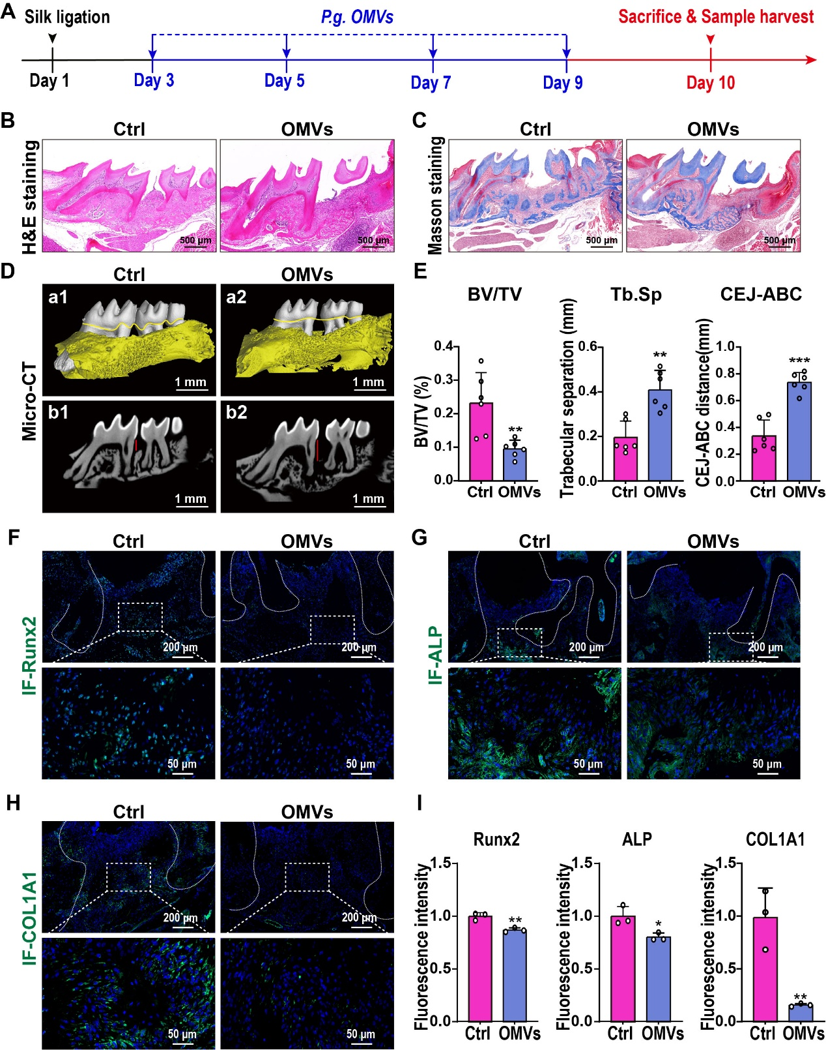
Fig. S2. P. gingivalis OMV injection suppresses osteogenesis in a murine periodontitis model. (A) Schematic diagram depicting the periodontal injection of P. gingivalis OMVs in mice. (B) Representative images of H&E staining showing the remaining alveolar bone of periodontal tissues from the control and OMVs groups. (C) Representative images of Masson’s trichrome staining showing the periodontal fibers in the periodontal ligamentous tissues from the control and OMVs groups. (D) Representative micro-CT images showing the remaining periodontal bone in the control and OMVs groups. (a1−a2) Representative images of 3D reconstructed views and (b1−b2) sagittal-section views. The yellow lines indicate the border of the CEJ. The red lines mark the distance from the CEJ to the ABC. (E) Quantitative analysis of the BV/TV, Tb.Sp, and CEJ-ABC based on micro-CT scanning (n = 6). (F-H) Representative images of immunofluorescence staining showing the expression of (F) Runx2, (G) ALP, and (H) COL1A1 in periodontal tissues from the control and OMVs groups. (I) Corresponding quantitative analysis of Runx2, ALP, and COL1A1 expression (n = 3). The data are presented as the means ± SDs. *p < 0.05, **p < 0.01, and ***p < 0.001 indicate significant differences between the two groups.

Fig. S3. Successful isolation and characterization of PDLSCs. (A) representative optical microscopic images showing the cellular shapes of PDLSCs. (B) The growth curves of PDLSCs analyzed by CCK8 assays. (C) Flow cytometry showing the positive expression of CD90, CD105, and CD 146 and negative expression of CD31, CD34 and CD45 in PDLSCs. (D) Representative images of ARS staining showing the osteogenic differentiation potentials of PDSLCs following 21 days’ osteogenic induction. (E) Representative images of oil red staining showing the adipogenic differentiation potentials of PDSLCs following 21 days of adipogenic culture.

Fig. S4. The influence of different concentrations (1, 3, and 10 μg/mL) of P. gingivalis OMVs on the proliferation of PDLSCs analyzed by CCK8 analysis (n = 3).

Revised Fig. S5. Relative expression levels of tRF-Pro-GGG-1 and PurB in PDLSCs following treatments with tRF-Pro-GGG-1 inhibitor, mimic or si-PurB in transfection experiments (n = 3).

Revised Fig. S6. In vivo safety assessment of si-tRF-tFNA. (A) Quantitative analysis of the liver function indicators (ALT and AST) and the kidney function indicators (BUN and CREA) (n = 4). (B) Quantitative analysis of the complete blood count (n = 4). (C) Representative images of H&E staining of major organs (heart, liver, spleen, lung, and kidney).

