Supplementary Materials
Biomimetic Scaffolds with Synergistic BMSC Targeting and ROS Scavenging for Mitochondrial Protection and Effective Bone-Defect Repair

Sheng Yao^{a,1}, Lian Zeng^{b,1}, Huan Wang^{c}, Jia Liu ^{d}, Xiaojian Cao ª, Zhenguo Xu ^{e}, Youran Zhang ^{e}, Sitao He ^{e}, Bing Ye^{b, *}, Tingfang Sun^{b,} *, Xiaodong Guo ^{b,} *

ª Department of Rehabilitation Medicine, Tongji Hospital, Tongji Medical College, Huazhong University of Science and Technology, Wuhan 430030, China
^{b} Department of Orthopaedics, Union Hospital, Tongji Medical College, Huazhong University of Science and Technology, Wuhan 430022, China
^{c} Department of Orthopaedics, Tongji Hospital, Tongji Medical College, Huazhong University of Science and Technology, Wuhan 430030, China
^{d} Radiology department, Union Hospital, Tongji Medical College, Huazhong University of Science and Technology, Wuhan 430022, China
^{e} Union Hospital, Tongji Medical College, Huazhong University of Science and Technology, Wuhan 430022, China

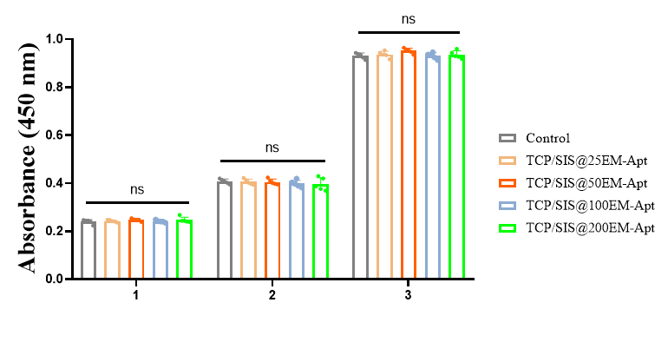
Day 1
Day 2
Day 3

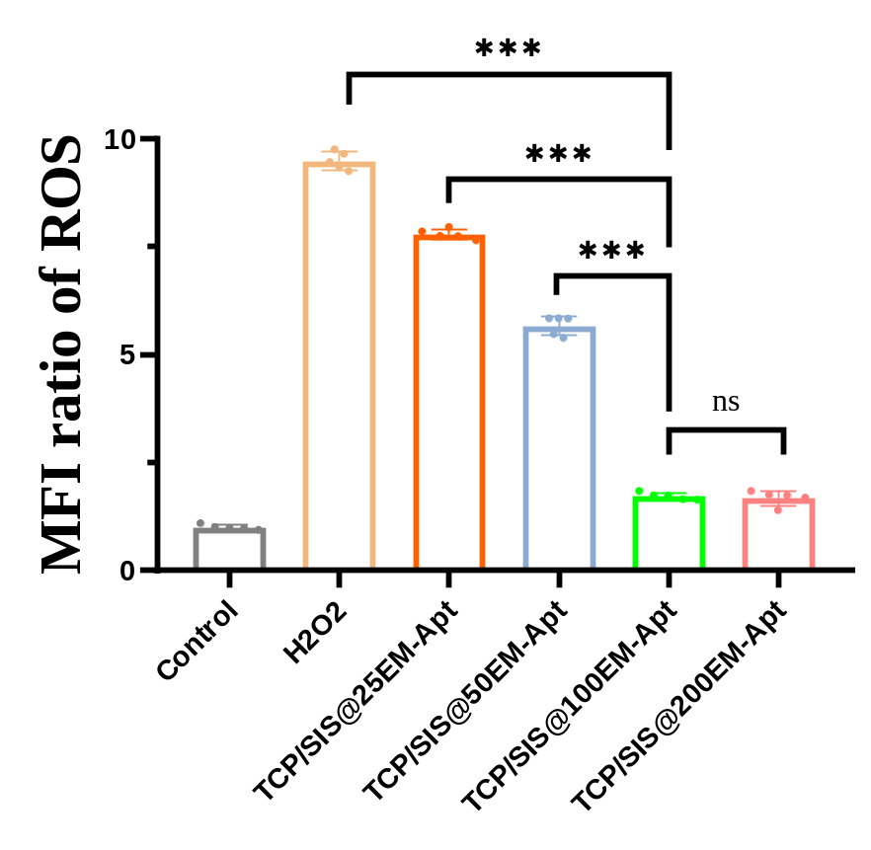
Figure S1. CCK-8 assay to assess BMSCs viability following treatment with various hydrogels

Figure S2. Fluorescence microplate reader assessment of the antioxidant stress capacity of hydrogels in different groups

Table S1. Determination of encapsulation efficiency of mitoQ in EXOs
EXO  (μg/mL) | mitoQ (μg/mL) (W_{a}) | Concentration  (μg/mL) (W_{b}) | Encapsulation Efficiency (%) | Mean ± SD  (%)
500 | 500 | 268.23 | 53.65 | 52.24 ± 3.40
500 | 500 | 240.56 | 48.11 | 52.24 ± 3.40
500 | 500 | 280.20 | 56.04 | 52.24 ± 3.40
500 | 500 | 255.85 | 51.17 | 52.24 ± 3.40
EXO, exosome; SD, standard deviation. Encapsulation efficiency (%) = W_{b}/W_{a} ×100%. W_{a} represents the total mass of the drug initially added to the system, and W_{b} denotes the mass of the drug encapsulated within the exosomes.

Table S2. Determination of mitoQ loading capacity of EXOs
EXO-mitoQ  (μg/mL) (W₀) | Concentration  (μg/mL) (W₁) | Loading rate  (%) | Mean ± SD  (%)
768.23 | 268.23 | 35.92 | 34.29 ± 1.47
740.56 | 240.56 | 32.48 | 34.29 ± 1.47
780.20 | 280.20 | 35.91 | 34.29 ± 1.47
755.85 | 255.85 | 33.85 | 34.29 ± 1.47
Exo, exosome; SD, standard deviation. Loading efficiency (%) = W₁/W₀ ×100%. W₁ refers to the mass of the loaded drug, and W₀ represents the total mass of the drug-loaded exosomes.

