Supplementary Material
Design and Mechanistic Insights into ZMF59/CpG: A Complementary Adjuvant System Boosting Immunity and Safety in Herpes Zoster Vaccines
Lijun Bian¹, Dongdong Li¹, Jingying Zhou¹, Gaotian Li¹, Xiaoyan Zhao¹, Liao Xing¹, Jixuan Xu¹, Mingze Shi¹, Bo Sun^{1,2}, Yingnan Guo³, Chunlai Jiang^{1,2,3,4}, Yan Chen^{1,2,4}, Wei Kong^{1,2,3,4}, Yong Zhang^{1,2,4}*
¹National Engineering Laboratory for AIDS Vaccine, School of Life Sciences, Jilin University, Changchun 130012, China;
²Key Laboratory for Molecular Enzymology and Engineering, The Ministry of Education, School of Life Sciences, Jilin University, Changchun 130012, China;
³R&D Center, Changchun BCHT Biotechnology Co., Changchun 130012, China;
⁴NMPA Key Laboratory of Humanized Animal Models for Evaluation of Vaccines and Cell Therapy Products, Changchun 130012, China.
*Corresponding author: Yong Zhang
School of Life Sciences, Jilin University, Qianjin Street No. 2699, Changchun 130012, China
E-mails: zhypharm@jlu.edu.cn, zhangyongking1@gmail.com.
Tel: +86 431 85167751; Fax: +86 431 85167674
This supplementary material includes:
Methods
Fig. S1 to Fig. S7
Table S1 to Table S6

Methods

Characterization of gE/ZMF59/CpG formulations
To characterize the physicochemical properties of gE in the presence and absence of adjuvants, the following approaches were employed. First, the size, polydispersity index (PDI) and zeta potential of ZMF59, ZMF59/CpG and gE/ZMF59/CpG were measured by dynamic light scattering (DLS) (Table S3). Measurements were performed using a Malvern Zetasizer Nano ZS, with each sample analyzed independently at least three times. Second, the spectral properties of gE were examined by fluorescence spectroscopy (Fig. S7A). Excitation and emission spectra of gE were recorded in the presence of ZMF59/CpG at different dilution factors (1/20, 1/40 and 1/80) using a PerkinElmer LS‑55 fluorescence spectrophotometer. Excitation spectra were acquired at an emission wavelength of 350 nm with a scan range of 200-330 nm, and emission spectra were acquired at an excitation wavelength of 280 nm with a scan range of 300-500 nm. In both cases, the slit widths were set to 6 nm. Finally, polyacrylamide gel electrophoresis (PAGE), including reducing SDS‑PAGE (Fig. S7B) and native PAGE (Fig. S7C), was used to analyze the samples. After electrophoresis, gels were stained with Coomassie Brilliant Blue to visualize protein bands, and band positions and molecular weights were determined by comparison with the protein marker.

Histopathology
To evaluate potential local inflammatory response at injection sites, primed C57BL/6 mice (n=3) were intramuscularly injected with 5 μg gE antigen formulated with or without adjuvants. Muscle tissues from injection sites were collected on days 1, 3, and 7 post-inoculation. Specimens were fixed in 4% paraformaldehyde (Servicebio), embedded into paraffin, sectioned, and stained with hematoxylin & eosin (H&E). The processed slides were examined and imaged using an Olympus IX73 microscope.

Hemolysis Assay
For ZMF59/QS-21 and ZMF59/CpG group, 15 μg QS-21 or 20 μg CpG were mixed with 50 μL ZMF59, respectively, and adjusted to 100 μL with PBS, matching the formulation used in the animal study. ZMF59 and PBS served as negative controls, with 2% Triton X-100 being the positive control. Experimental groups (QS-21, ZMF59/QS-21 and ZMF59/CpG) and the negative control ZMF59 were prepared in twofold serial dilutions (final volume: 100 μL) in 96-well plates. Each dilution was then mixed with 100 μL of 4% rabbit erythrocyte suspension (Sbjbio) and incubated at 37 °C for 1 h. After centrifugation at 3,000 rpm for 10 min, erythrocyte pellets were photographed through the plate bottom to avoid emulsion-induced supernatant opacity issues. Supernatants were then transferred to flat-bottom 96-well plates for optical density (OD) measurement at 550 nm using a microplate reader (Biotek, EL×800). The hemolysis rate was calculated based on the following formula:
Hemolysis rate (%) = (OD_{sample} − OD_{negative}) / (OD_{Triton X-100} – OD_{PBS}) ×100%
where ODsample represented absorbance values of experimental groups; ODnegative was the absorbance of PBS for the QS-21 group, or ZMF59 for the ZMF59/QS-21 and ZMF59/CpG groups.

Correlation Analysis
Pearson correlation analysis was performed to assess the relationships between immune cell populations and key immune response indicators. The numbers for each immune cell population were obtained from flow cytometry data at 24 hours post immunization. The key immune indicator data were obtained from measurements on day 28 after the first immunization, including IgG antibody levels, the number of IFN-γ⁺ splenocytes, and the proportion of polyfunctional CD4⁺ T cells. The strength and direction of the correlation are represented by the correlation coefficient (r). For visualization, r values are color-coded as follows: red indicates a positive correlation (r ≥ 0.2), blue indicates a negative correlation (r ≤ -0.2), and white indicates a weak or no linear correlation (-0.2 < r < 0.2). The statistical significance of each correlation, assessed by its corresponding P-value, is represented by the size of the bubbles. To facilitate intuitive visual comparison of significance levels, we applied an inverse scaling transformation to the P-values and normalized them to the [0, 1] range using the following equation:
$\text{The processed P-value=clip}\left(\frac{\text{-}{\text{log}}_{\text{10}}\left(\text{max}{（\text{P-value,1×}{\text{10}}^{\text{-8}}）}\right)}{\text{-}{\text{log}}_{\text{10}}\left(\text{1×}{\text{10}}^{\text{-8}}\right)}\text{，}\text{0}\text{，}\text{1}\right)$.
The processed P-values were then directly used as the radius of the bubbles. Consequently, smaller P-values correspond to larger bubbles, denoting stronger statistical significance.

Synergy analysis
To determine whether the ZMF59/CpG combination acts beyond simple additivity, we analyzed the data within a standard 2×2 factorial design using ordinary two-way ANOVA on GraphPad software. In this framework, the presence or absence of ZMF59 and CpG are treated as two fixed factors, and the interaction term formally tests whether the joint effect of the combination deviates from the sum of the individual effects. This approach is widely used in pharmacology and immunology to detect synergistic or antagonistic interactions between treatments.
For each immunological indicator, we fitted the linear model
$$Y_{ijk}=μ+αA_{i}+βB_{j}+γ\left(A_{i}B_{j}\right)+ε_{ijk},$$
where $A_{i}$ and $B_{j}$ encode the presence/absence of ZMF59 and CpG, respectively; α and β denote their main effects; γ represents the non-additive “extra” part beyond simple additivity (i.e., the interaction); and ε represents the random error for that individual. Under the usual cell coding for a 2×2 design, the group means satisfy
$$μ_{C}=μ, μ_{A}=μ+α, μ_{B}=μ+β, μ_{AB}=μ+α+β+γ,$$
where $μ_{C}$, $μ_{A}$, $μ_{B}$, and $μ_{AB}$ denote the means for baseline, CpG_only, ZMF59_only, and combination groups, respectively. Solving for the interaction term yields
$$γ=μ_{AB}-μ_{A}-μ_{B}+μ_{C}=\left(μ_{AB}+μ_{C}\right)-\left(μ_{A}+μ_{B}\right).$$
Thus, the interaction in the two-way ANOVA is estimated by the contrast
$$Δ=\left(combo+baseline\right)-\left(CpG_{only}+ZMF{59}_{only}\right),$$
Which directly quantifies how much the observed combination response exceeds (or falls below) the response expected under an additive model.
Accordingly, we performed a two-way ANOVA with CpG and ZMF59 (present vs. absent) as fixed factors and included their interaction term for each immunological indicator in Table S4. The analysis was applied to total IgG titers at D14, D28, D42, D70, and D126; IgG1 and IgG2c titers at D28; IFN-γ and IL-2 cytokine levels at D28; IFN-γ ELISPOT spot counts at D28 and D70; and polyfunctional CD4⁺ T-cell frequencies at D28 and D70. For each indicator, data from the Y-gE, Y-gE/CpG, Y-gE/ZMF59, and Y-gE/ZMF59/CpG groups were coded as baseline, CpG_only, ZMF59_only, and combo, respectively. The ANOVA provided P values for the main effects of CpG and ZMF59, as well as for the CpG×ZMF59 interaction term. Based on the interaction contrast Δ alongside the interaction P value, each indicator was classified as follows: synergistic (Δ>0 and P value<0.05), antagonistic (Δ<0 and P value<0.05), or additive (P value≥0.05 regardless of the sign of Δ). However, because interaction terms were tested across multiple indicators, P values were further adjusted using the Benjamini-Hochberg procedure to control the false discovery rate (FDR) across these 13 tests to avoid accidental significance. The resulting FDR-adjusted P values are reported as q values. Interactions with q≤0.10 were considered statistically significant at a 10% FDR level, and the final column “Class (FDR≤0.10)” is based on this FDR-corrected classification. And interactions with p<0.05 but q>0.10 are interpreted as showing a synergistic trend rather than FDR-significant synergy.
In addition to the adaptive immune responses described above, we also performed synergy analyses for cytokine/chemokine production and immune cell recruitment at the injection site and in draining lymph nodes (dLNs) following CpG and ZMF59 administration. The results were summarized in Table S5 and Table S6.

Figures
Fig. S1 The frequencies of central memory T cells and effector or effector memory T cells by flow cytometric analysis. The primed mice were immunized intramuscularly twice on day 0/14 with the different vaccine formulations. On day 28 after the first immunization, splenocytes from immunized mice were treated with gE protein, and analyzed for memory T cells. (A) Gating strategy. The central memory T cells (Tcm) were detected by CD44⁺CD62L⁺ gating, and effector or effector memory T cells (Teff or Tem) were identified based on CD44+CD62L- gating. (B) Proportion of Tcm and Tem/Teff among CD4⁺ T cells. (C) Proportion of Tcm and Tem/Teff among CD8⁺ T cells. N=5, points represented individual mice. Data were shown as mean± SEM. *P< 0.05 (one-way or two-way ANOVA with Tukey’s multiple comparisons test).
Fig. S2 Safety evaluation. (A) The images of spleen from immunized mice. (B) Hemolysis rate of erythrocytes treated by ZMF59/CpG. (C) Representative bottom-view images of erythrocyte pellets in 96-well plates after hemolysis assay. ZMF59 concentrations were kept consistent in the corresponding wells of the same column in ZMF59, ZMF59/QS-21 and ZMF59/CpG groups.
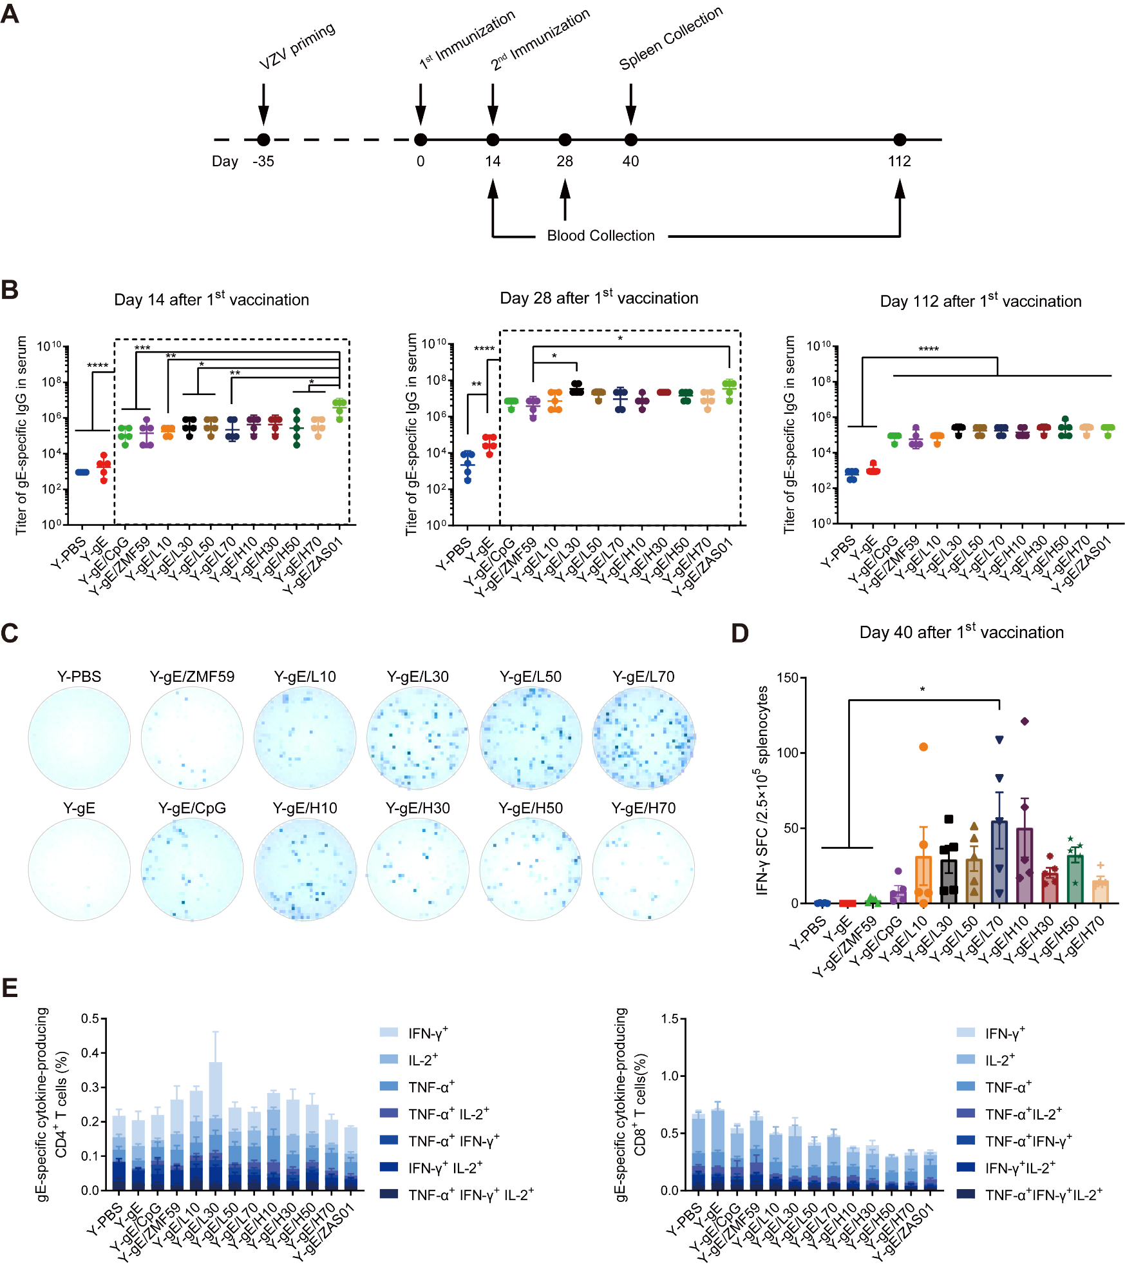
Fig. S3 Dose optimization of ZMF59/CpG combination adjuvant. (A) The schedule of vaccination, bleeding and spleen collection. Primed C57BL/6 mice were injected with different vaccine formulations on day 0/14. The blood was collected 14, 28, and 112 days after the first immunization for antibody detection, and the spleens were collected on day 40 for ELISpot and flow cytometry. (B) Antigen-specific antibody levels in serum. (C) Representative images of spot-forming cells (SFC) in ELISpot (D) The gE-specific IFN-γ- secreting cells (per 2.5×10⁵ splenocytes). (E) The frequencies of gE-specific CD4⁺ or CD8⁺ T cells expressing IFN-γ, TNF-α, and/or IL-2 cytokines. Group nomenclature in panels B-E: “L” and “H” denote 25 μL and 50 μL ZMF59, respectively; numbers denote CpG doses in micrograms (full group names are Y-gE/L30, Y-gE/H30, etc., as detailed in Table S1). Antibody titers are shown as geometric mean titers (GMTs) with 95% confidence intervals (CIs), and statistical significances were performed on log10-transformed values. Results of panel D and E were shown as mean ± SEM. All experiments included 5 mice per group per timepoint. Statistical significance was analyzed by one-way ANOVA with Tukey’s multiple comparisons test (*p < 0.05, **p < 0.01, ***p < 0.001, ****P<0.0001).
Fig. S4 Concentrations of other cytokines detected in muscle tissues at the injection sites at 4 hours post-inoculation by Luminex multiplex assay. Data was shown as mean ±SEM. Statistical significances (one-way ANOVA with Tukey's multiple comparisons test) are denoted by asterisks (*, P < 0.05; **, P < 0.01; ***, P < 0.001; ****, P < 0.0001).
Fig. S5 Gating strategy for polyfunctional T cells. After single cell selections (FSC-A × FSC-H, SSC-A × SSC-H and FSC-A × FSC-W), loose gate of lymphocytes was identified, followed by CD3⁺ gating to determine T cells subset. CD4⁺ and CD8⁺ T cells subsets were separated in the CD3⁺ population, and then analyzed for positive populations of three independent cytokines IFN-γ, IL-2, and TNF-α, respectively. Boolean gating was performed to determine the frequencies of every possible combination of cytokine-producing CD4⁺ and CD8⁺ cells using CytExpert software.
Fig. S6 Gating strategy for identifying antigen/adjuvant-positive immune cell populations. Single-cell suspensions were prepared from injection site muscle tissues and draining lymph nodes and analyzed by flow cytometry. Initial gating was performed on forward scatter (FSC) and side scatter (SSC) parameters (FSC-A × FSC-H, SSC-A × SSC-H, and FSC-A × FSC-W) to select singlet populations. A broad immune cell gate was applied using a loose strategy. Leukocytes were defined as CD45⁺ cells. Neutrophils were identified as CD11b⁺Ly6G⁺ within the CD45⁺ population. After excluding neutrophils, dendritic cells (DCs) were defined as CD45⁺Ly6G⁻CD11b⁺CD11c⁺ cells. DC subsets were further classified based on CD64 expression: classical dendritic cells (cDCs) as CD64⁻ and monocyte-derived dendritic cells (moDCs) as CD64⁺. Following exclusion of total DCs, monocytes were gated as CD45⁺Ly6G⁻CD11c⁻CD11b⁺Ly6C⁺ cells. Macrophages were subsequently identified from the monocyte-depleted fraction as CD45⁺Ly6G⁻CD11c⁻Ly6C⁻CD11b⁺F4/80⁺ cells. For lymphocyte analysis, CD45⁺ cells were further separated into T lymphocytes (CD3⁺CD19⁻) and B lymphocytes (CD3⁻CD19⁺). Within each defined immune cell population, antigen/adjuvant-positive cells were stratified into three groups: gE⁺ cells, double-positive cells (gE⁺CpG⁺ or gE⁺ZMF59⁺), and triple-positive cells (gE⁺ZMF59⁺CpG⁺).
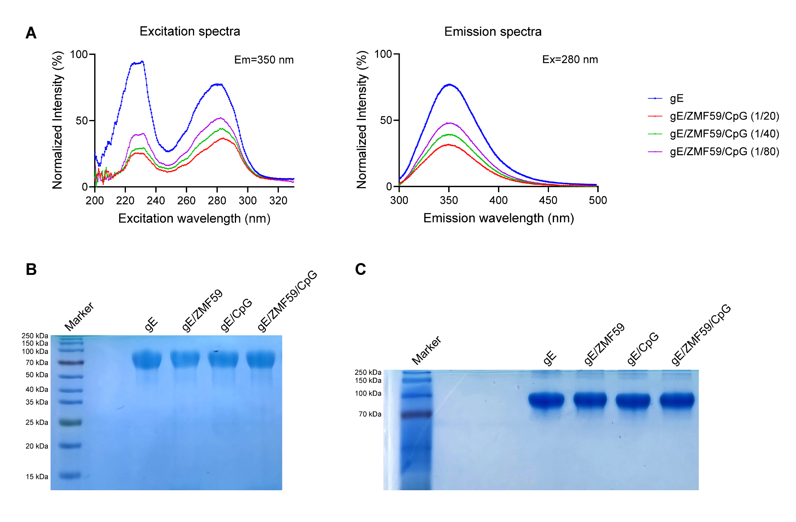
Fig. S7 Characterization of gE in the presence or absence of ZMF59/CpG. (A) Fluorescence excitation and emission spectra. (B) SDS-PAGE (C) Native-PAGE.

Tables
Table S1 Grouping Scheme for dose optimization experiment.
Vaccine group | VZV-priming | Treatments (2 doses; Day 0/14; 50 or 100 μL/dose*)
Y-PBS | Yes | PBS
Y-gE | Yes | gE (5 μg)
Y-gE/CpG | Yes | gE (5 μg)/CpG (70 μg)
Y-gE/ZMF59 | Yes | gE (5 μg)/ZMF59 (50 μL)
Y-gE/L10 | Yes | gE (5 μg)/ZMF59 (25 μL)/CpG (10 μg) †
Y-gE/L30 | Yes | gE (5 μg)/ZMF59 (25 μL)/CpG (30 μg) †
Y-gE/L50 | Yes | gE (5 μg)/ZMF59 (25 μL)/CpG (50 μg) †
Y-gE/L70 | Yes | gE (5 μg)/ZMF59 (25 μL)/CpG (70 μg) †
Y-gE/H10 | Yes | gE (5 μg)/ZMF59 (50 μL)/CpG (10 μg)
Y-gE/H30 | Yes | gE (5 μg)/ZMF59 (50 μL)/CpG (30 μg)
Y-gE/H50 | Yes | gE (5 μg)/ZMF59 (50 μL)/CpG (50 μg)
Y-gE/H70 | Yes | gE (5 μg)/ZMF59 (50 μL)/CpG (70 μg)
Y-gE/ZAS01 | Yes | gE (5 μg)/ZAS01 (50 μL)
† Mice were immunized with the different vaccine formulations in a total volume of 50 μL in the groups Y-gE/L10, Y-gE/L30, Y-gE/L50, and Y-gE/L70, or 100 μL in other groups.
Table S2 Grouping Scheme for mechanistic studies.
Vaccine group | Treatments in cytokine/chemokine detection | Treatments in fluorescence imaging | Treatments in flow cytometry
Y-PBS | PBS | PBS | PBS
Y-gE | gE (5 μg) | AF647-gE (5 μg) | AF647-gE (15 μg)
Y-gE/CpG | gE (5 μg)/CpG (30 μg) | AF647-gE (5 μg)/CpG (30 μg) | AF647-gE (15 μg)/FAM-CpG (30 μg)
Y-gE/ZMF59 | gE (5 μg)/ZMF59 (25 μL) | AF647-gE (5 μg)/ZMF59 (25 μL) | AF647-gE (15 μg)/DiI-ZMF59 (25 μL)
Y-gE/ZMF59/CpG | gE (5 μg)/ZMF59 (25 μL)/CpG (30 μg) | AF647-gE (5 μg)/ZMF59 (25 μL)/CpG (30 μg) | AF647-gE (15 μg)/DiI-ZMF59 (25 μL)/FAM-CpG (30 μg)
Table S3 Physicochemical characterization of ZMF59, ZMF59/CpG and gE/ZMF59/CpG formulations.
Sample | Size | Polydispersity index (PDI) | Zeta potential
ZMF59 | 149.4±1.153 nm | 0.118±0.011 | -37.8±0.72 mV
ZMF59/CpG | 148.9±1.050 nm | 0.101±0.009 | -33.2±1.07 mV
gE/ZMF59/CpG | 147.5±0.681 nm | 0.102±0.008 | -34.5±0.75 mV

Table S4 Synergistic analysis of CpG and ZMF59 on various immunological indicators.
Indicators/  sampling time | CpG main effect | ZMF59 main effect | Interaction (Δ) | Interaction  (P value) | q value | Class (FDR≤0.1)
IgG/D14 | ns, p=0.1275 | ns, p=0.0748 | Δ=3.9e+05 | 0.3384 | 0.5499 | Additive
IgG/D28 | ↑, p=0.0113 | ↑, p=0.0169 | Δ=2.5e+06 | 0.0407 | 0.1323 | Synergistic trend
IgG/D42 | ns, p=0.1169 | ns, p=0.1169 | Δ=5.5e+06 | 0.1893 | 0.4922 | Additive
IgG/D70 | ↑, p=0.0001 | ↑, p=0.0001 | Δ=1.1e+05 | 0.0195 | 0.0858 | Synergistic
IgG/D126 | ↑, p=0.0001 | ↑, p=0.0001 | Δ=1.3e+05 | 0.0094 | 0.0858 | Synergistic
IgG1/D28 | ns, p=0.2845 | ↑, p=0.0472 | Δ=-2.3e+05 | 0.2845 | 0.5284 | Additive
IgG2c/D28 | ↑, p=0.0048 | ns, p=0.4455 | Δ=-1.1e+05 | 0.6264 | 0.7403 | Additive
IFN-γ/D28 | ↑, p=0.0056 | ↑, p=0.0211 | Δ=1.2e+03 | 0.5561 | 0.7403 | Additive
IL-2/D28 | ns, p=0.2405 | ↑, p=0.0009 | Δ=-70 | 0.5989 | 0.7403 | Additive
ELISPOT/D28 | ↑, p=0.0324 | ↑, p=0.0307 | Δ=15 | 0.9119 | 0.9119 | Additive
ELISPOT/D70 | ns, p=0.8848 | ↑, p=0.0245 | Δ=-10 | 0.8094 | 0.8769 | Additive
Polyfunctional CD4 T cells/D28 | ns, p=0.0492 | ns, p=0.0467 | Δ=0.62 | 0.2305 | 0.4994 | Additive
Polyfunctional CD4 T cells/D70 | ns, p=0.9109 | ns, p=0.9942 | Δ=0.21 | 0.0198 | 0.0858 | Synergistic
“↑” or “ns” in CpG or ZMF59 main effect means when this factor is present, the result is significantly elevated or the effect is not significant, and the corresponding P value is attached after the sign.
Table S5 Synergistic analysis of CpG and ZMF59 on cytokines and chemokines.
Cytokines/  chemokines | CpG main effect | ZMF59 main effect | Interaction (Δ) | Interaction  (P value) | q value | Class (FDR≤0.10)
CCL2 | ↑, p=0.0001 | ↑, p=0.0001 | Δ=6.3e+03 | 0.0002 | 0.0024 | Synergistic
CCL3 | ↑, p=0.0003 | ↑, p=0.0002 | Δ=5e+02 | 0.0172 | 0.0295 | Synergistic
CCL4 | ↑, p=0.0001 | ↑, p=0.0001 | Δ=1.4e+03 | 0.0020 | 0.0120 | Synergistic
CXCL1 | ↑, p=0.0080 | ↑, p=0.0005 | Δ=4.1e+02 | 0.0131 | 0.0262 | Synergistic
G-CSF | ↑, p=0.0076 | ↑, p=0.0033 | Δ=1e+03 | 0.0093 | 0.0223 | Synergistic
GM-CSF | ↑, p=0.0005 | ↑, p=0.0001 | Δ=10 | 0.0093 | 0.0223 | Synergistic
IFN-γ | ns, p=0.4878 | ns, p=0.0698 | Δ=5.7 | 0.0299 | 0.0449 | Synergistic
IL-6 | ↑, p=0.0069 | ↑, p=0.0002 | Δ=3.1e+02 | 0.0085 | 0.0223 | Synergistic
IL-12p70 | ↑, p=0.0037 | ↑, p=0.0179 | Δ=25 | 0.0754 | 0.1005 | Additive
IL-2 | ns, p=0.0526 | ns, p=0.9718 | Δ=7.7 | 0.4558 | 0.4558 | Additive
IL-5 | ns, p=0.5608 | ↑, p=0.0005 | Δ=5.5 | 0.4465 | 0.4558 | Additive
TNF-α | ↑, p=0.0020 | ↑, p=0.0335 | Δ=5.2 | 0.1534 | 0.1841 | Additive
Table S6 Synergistic analysis of CpG and ZMF59 on immune cells at the injection site or in dLNs.
Cells | CpG main effect | ZMF59 main effect | Interaction (Δ) | Interaction  (P value) | q value | Class (FDR≤0.10)
At the injection site
4 hpi  Innate immune cells | ↑, p=0.0104 | ns, p=0.1881 | Δ=1.3e+02 | 0.8991 | 0.9382 | Additive
24 hpi  Innate immune cells | ns, p=0.2432 | ↑, p=0.002 | Δ=6.6e+02 | 0.7652 | 0.9176 | Additive
48 hpi  Innate immune cells | ↑, p=0.0005 | ↑, p=0.0002 | Δ=2.8e+03 | 0.0106 | 0.1272 | Synergistic trend
72 hpi  Innate immune cells | ns, p=0.1715 | ↑, p=0.0024 | Δ=-1.8e+03 | 0.0780 | 0.2674 | Additive
4 hpi  Lymphocytes | ↑, p=0.0042 | ns, p=0.824 | Δ=-2e+03 | 0.3675 | 0.6171 | Additive
24 hpi  Lymphocytes | ↑, p=0.0037 | ↓, p=0.0181 | Δ=-8.9e+03 | 0.4045 | 0.6171 | Additive
48 hpi  Lymphocytes | ↑, p=0.0001 | ns, p=0.0973 | Δ=-4.1e+03 | 0.3316 | 0.6171 | Additive
72 hpi  Lymphocytes | ns, p=0.0529 | ns, p=0.4272 | Δ=-1.1e+03 | 0.8744 | 0.9382 | Additive
4 hpi gE+ cells | ↑, p=0.0057 | ns, p=0.7656 | Δ=1.3e+02 | 0.8029 | 0.9176 | Additive
24 hpi gE+ cells | ns, p=0.5536 | ↑, p=0.001 | Δ=1.1e+03 | 0.4160 | 0.6171 | Additive
48 hpi gE+ cells | ↑, p=0.0003 | ↑, p=0.0001 | Δ=1.6e+03 | 0.0018 | 0.0432 | Synergistic
72 hpi gE+ cells | ↓, p=0.0042 | ↑, p=0.0035 | Δ=-2.3e+02 | 0.0583 | 0.2674 | Additive
In dLNs
4 hpi  Innate immune cells | ↓, p=0.0062 | ↑, p=0.0248 | Δ=4.9e+02 | 0.0242 | 0.1936 | Synergistic trend
24 hpi  Innate immune cells | ↑, p=0.0233 | ns, p=0.505 | Δ=3.6e+02 | 0.2836 | 0.6171 | Additive
48 hpi  Innate immune cells | ↑, p=0.0001 | ns, p=0.1793 | Δ=3.8e+02 | 0.0341 | 0.2046 | Synergistic trend
72 hpi  Innate immune cells | ↑, p=0.0022 | ns, p=0.9274 | Δ=-1.7e+02 | 0.6756 | 0.8534 | Additive
4 hpi  Lymphocytes | ns, p=0.0763 | ns, p=0.3576 | Δ=3.6e+02 | 0.9838 | 0.9838 | Additive
24 hpi  Lymphocytes | ns, p=0.0502 | ns, p=0.9875 | Δ=1.8e+04 | 0.4371 | 0.6171 | Additive
48 hpi  Lymphocytes | ns, p=0.1513 | ↓, p=0.0003 | Δ=2.3e+04 | 0.0729 | 0.2674 | Additive
72 hpi  Lymphocytes | ↑, p=0.0001 | ns, p=0.8444 | Δ=-3.2e+04 | 0.1961 | 0.5883 | Additive
4 hpi gE+ cells | ↓, p=0.002 | ns, p=0.8098 | Δ=78 | 0.3411 | 0.6171 | Additive
24 hpi gE+ cells | ↑, p=0.0107 | ns, p=0.226 | Δ=1e+02 | 0.2950 | 0.6171 | Additive
48 hpi gE+ cells | ↑, p=0.0288 | ns, p=0.173 | Δ=13 | 0.5304 | 0.7072 | Additive
72 hpi gE+ cells | ↑, p=0.0029 | ns, p=0.8053 | Δ=-27 | 0.4136 | 0.6171 | Additive

