SUPPORTING INFORMATION
Low-Dose X-ray Activated Radiodynamic Therapy via a Lutetium-Coordinated Nanoplatform Synergizing PARP Inhibition and Ferroptosis
Wanli Song^{,1,2†}, Chuanyi Zhao^{1,2†,} Youqing Mai^{1,2†}, Guangrong Zhang^{1,2}, Wenyue Kang^{1,2}, Xuanjun Zheng^{1,2}, Qingpeng Yuan^{1,2}, Zeyang Chen^{1,2}, Chengxun Zhong^{1,2}, Junbao Tang^{1,2}, Duoyi Fu^{1,2}, Tiantian Zhai¹, Kai Ling^{1,2,3*} and Hongyan Jiang ^{1,2,3*}
¹Department of Radiation Oncology, Cancer Hospital of Shantou University Medical College, Shantou 515041, China
²Department of Pharmacology, Shantou University Medical College, Shantou 515041, China.
³Department of Radiology, The First Affiliated Hospital of Shantou University Medical College, Shantou 515041, China.
†These authors contributed equally to this work
*Corresponding author:
Kai Ling
kailing@stu.edu.cn
Hongyan Jiang
hyjiang@stu.edu.cn

Supporting results section

Table S1. Comparison of representative high-Z element-based RDT platforms.
High-Z Element | Representative RDT Platform (DOI) | Z | Reported ROS Amplification (vs. Control) | Clinical Status of Element
Hf | Hf-porphyrin-Au nanoclusters (10.1021/acsnano.3c08068) | 72 | ~2.1-fold ↑ | FDA-approved HfO₂ nanoparticles (NBTXR3) in clinical trials.
Bi | Bi₂S₃ nanosheets (10.1016/j.biomaterials.2017.10.048) | 83 | ~2.5-fold ↑ | Bismuth compounds are widely used in medicine (e.g., Pepto-Bismol).
Lu | Lu³⁺-coordinated BPNS (This work) | 71 | ~3.2-fold ↑ (Fig. 2h) | FDA-approved non-radioactive Lu³⁺ (Lutex)

Figure S1. Optimization of encapsulation efficiency (EE) and loading capacity (LC). (a, b) Effects of varying BPNS concentrations (20–45 μg mL⁻¹) on EE and LC. (c, d) Effects of different Lu³⁺ concentrations on EE and LC. (e, f) Effects of different Lap feeding concentrations on EE and LC. Data are presented as mean ± standard deviation (n = 3). *P < 0.05; **P < 0.01; ***P < 0.001; ****P < 0.0001.

Figure S2. Systematic optimization of Lu³⁺ coordination within BPNS@Lu³⁺/Lap-CMV under different pH conditions (4.8, 7.2, and 8.5). Data are presented as mean ± standard deviation (n = 3).

Figure S3. Hydrodynamic size characterization of nanoplatforms. (a–c) Dynamic light scattering-measured size distributions of BPNS, BPNS@Lu³⁺, and BPNS@Lu³⁺/Lap. (d) Average hydrodynamic diameters of all formulations. Data are presented as mean ± standard deviation (n = 3).
Figure S4. CLSM images show the co-localization of the Cy5-labeled BPNS@Lu³⁺/Lap core (red) and the DiO-labeled CMV shell (green) in the final BPNS@Lu³⁺/Lap-CMV nanoplatform. Scale bar = 10 μm.
Figure S5. Atomic force microscopy (AFM) analysis. (a–d) Topography and height profiles of BPNS, BPNS@Lu³⁺, BPNS@Lu³⁺/Lap, and BPNS@Lu³⁺/Lap-CMV. Scale bar = 120 nm
Figure S6. Time-dependent UV-vis absorption spectra of (a) BPNS@Lu³⁺/Lap-CMV in ultrapure water, (b) BPNS@Lu³⁺, and (c) bare BPNS in 10% fetal bovine serum (FBS), monitored over a period of 9 days at room temperature.

Figure S7. Mean fluorescence intensity in 4T1 cells after incubation with Cy5-labeled BPNS@Lu³⁺/Lap-CMV for different durations. Data are presented as mean ± standard deviation (n = 3). *P < 0.05; **P < 0.01; ***P < 0.001; ****P <0.0001.

Figure S8. Quantitative validation of Lu³⁺-mediated radiosensitization via intracellular ROS generation. (a) Representative fluorescence micrographs of intracellular ROS in cells treated with BPNS, free Lu³⁺, or BPNS@Lu³⁺ under no irradiation (-RT) or X-ray irradiation (+RT), detected using the DCFH-DA probe. Scale bar = 50 μm. (b) Quantification of mean fluorescence intensity (mean ± SD, n = 3). ns, not significant; *P < 0.05; **P < 0.01; ***P < 0.001; ****P < 0.0001.

Figure S9. Evaluation of the radiosensitizing capacity of BPNS@Lu³⁺/Lap-CMV under hypoxic conditions. Representative fluorescence microscopy images of intracellular ROS generation in tumor cells cultured under normoxic (21% O₂) and hypoxic (1% O₂) conditions. Cells were either untreated or treated with BPNS@Lu³⁺/Lap-CMV followed by X-ray irradiation (+RT).
Figure S10. Immunofluorescence staining for γ-H2AX foci (green) in 4T1 cells after treatment (a) with or (b) without RT (6 Gy). Scale bar = 50 μm.

Figure S11. Corresponding γ-H2AX staining fluorescence intensities in 4T1 cells following the indicated treatments (n = 3, fluorescence intensity per nucleus). *P < 0.05; **P < 0.01; ***P < 0.001; ****P <0.0001.
Figure S12. Western blot analysis of cellular PARylation levels following different treatments. Lanes (left to right): (1) Untreated, (2) RT, (3) BPNS@Lu³⁺/Lap-CMV, (4) BPNS@Lu³⁺/Lap-CMV+RT, (5) Ola, (6) Ola + RT, (7) Ola + BPNS@Lu³⁺/Lap-CMV, (8) Ola + BPNS@Lu³⁺/Lap-CMV + RT.
Figure S13. Western blot analysis of RAD51 and BRCA1 expression levels in tumor cells. Lanes (left to right): (1) Untreated, (2) RT, (3) BPNS@Lu³⁺/Lap-CMV, (4) BPNS@Lu³⁺/Lap-CMV+RT, (5) Ola, (6) Ola + RT, (7) Ola + BPNS@Lu³⁺/Lap-CMV, (8) Ola + BPNS@Lu³⁺/Lap-CMV + RT).
Figure S14. Western blot analysis of 4-hydroxynonenal (4-HNE)-modified proteins in tumor cells following the indicated treatments. Lanes (left to right): (1) Untreated, (2) RT, (3) BPNS@Lu³⁺/Lap-CMV, (4) BPNS@Lu³⁺/Lap-CMV+RT, (5) Ola, (6) Ola + RT, (7) Ola + BPNS@Lu³⁺/Lap-CMV, (8) Ola + BPNS@Lu³⁺/Lap-CMV + RT).
Figure S15. Pharmacokinetics and biodistribution profiles of BPNS@Lu³⁺/Lap and BPNS@Lu³⁺/Lap-CMV. (a–b) Blood circulation curves depicting the time-dependent concentration of Lu³⁺ in the bloodstream following intravenous administration of BPNS@Lu³⁺/Lap and BPNS@Lu³⁺/Lap-CMV. (c–d) Time-dependent Lu³⁺ accumulation in liver after injection of BPNS@Lu³⁺/Lap and BPNS@Lu³⁺/Lap-CMV. (e–f) Time-dependent Lu³⁺ accumulation in spleen following administration of BPNS@Lu³⁺/Lap and BPNS@Lu³⁺/Lap-CMV. Data are expressed as mean ± standard deviation (n = 3).
Figure S16. Therapeutic efficacy evaluation of the heterologous cell membrane-camouflaged nanoplatform. (a) Digital photographs of excised tumors from BALB/c mice bearing 4T1 breast tumors at the experimental endpoint. (b) Quantitative analysis of corresponding tumor weights. Data are expressed as mean ± standard deviation (n = 3). *P < 0.05; **P < 0.01; ***P < 0.001; ****P < 0.0001.
Figure S17. Individual tumor growth curves for each mouse within the eight treatment groups. G1: Saline, G2: RT, G3: Lap, G4: BPNS@Lu³⁺/Lap, G5: BPNS@Lu³⁺/Lap + RT, G6: BPNS@Lu³⁺/Lap-CMV, G7: BPNS@Lu³⁺/Lap-CMV + RT, G8: Ola + BPNS@Lu³⁺/Lap-CMV + RT.
Figure S18. Hemolysis rate of red blood cells (RBCs) in the presence of different concentrations of BPNS@Lu³⁺/Lap-CMV (0–320 μg mL⁻¹) at room temperature for 3 h. Data are presented as mean ± standard deviation (n = 3).
Figure S19. Body weight changes of mice in each treatment group over the 18-day study period. G1 (Saline), G2 (RT), G3 (Lap), G4 (BPNS@Lu³⁺/Lap), G5 (BPNS@Lu³⁺/Lap + RT), G6 (BPNS@Lu³⁺/Lap-CMV), G7 (BPNS@Lu³⁺/Lap-CMV + RT), G8 (Ola + BPNS@Lu³⁺/Lap-CMV + RT). Data are presented as mean ± standard deviation (n = 5).
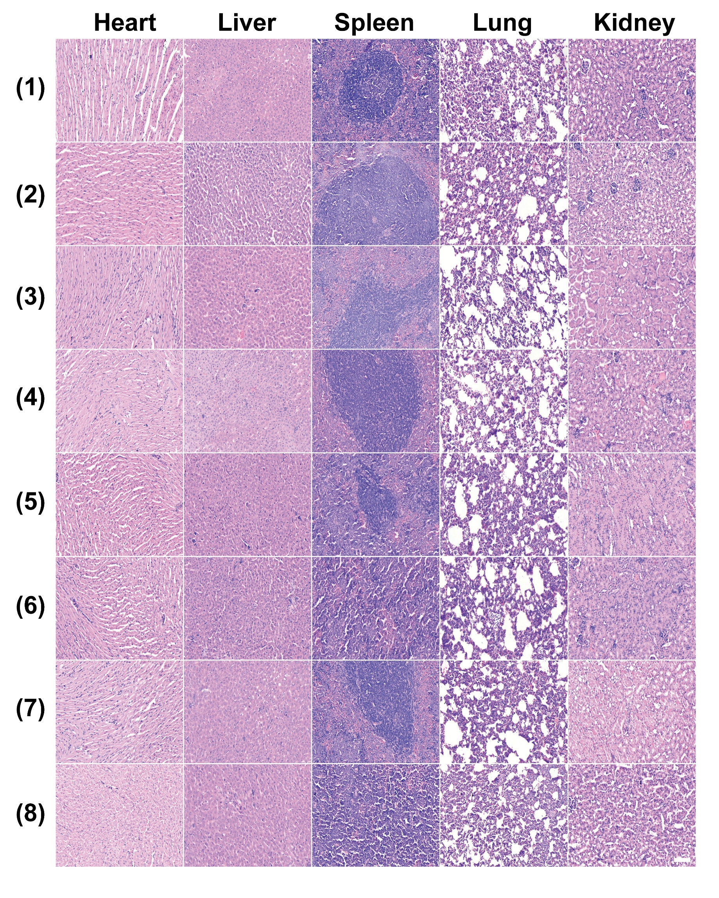
Figure S20. H&E-stained sections of heart, liver, spleen, lung, and kidney from all treatment groups (n = 5). (1) Saline, (2) RT, (3) Lap, (4) BPNS@Lu³⁺/Lap, (5) BPNS@Lu³⁺/Lap + RT, (6) BPNS@Lu³⁺/Lap-CMV, (7) BPNS@Lu³⁺/Lap-CMV + RT, (8) Ola + BPNS@Lu³⁺/Lap-CMV + RT.

Figure S21. Serum biochemistry analysis for hepatorenal function. Serum levels of (a) Alanine Aminotransferase (ALT), (b) Aspartate Aminotransferase (AST), (c) Creatinine (CRE), and (d) Blood Urea Nitrogen (BUN) in 4T1 tumor-bearing mice post-treatment. Data are presented as mean ± standard deviation (n = 3). (G1) Saline, (G2) RT, (G3) Lap, (G4) BPNS@Lu³⁺/Lap, (G5) BPNS@Lu³⁺/Lap + RT, (G6) BPNS@Lu³⁺/Lap-CMV, (G7) BPNS@Lu³⁺/Lap-CMV + RT, (G8) Ola + BPNS@Lu³⁺/Lap-CMV + RT.
Figure S22. Lu³⁺ biodistribution in healthy mice after long-term treatment. Lu³⁺ content normalized to tissue mass (µg g⁻¹) in (a) liver and (b) spleen for the BPNS@Lu³⁺/Lap-CMV group versus the control. Data are mean ± standard deviation (n = 3). ns, not significant; *P < 0.05; **P < 0.01; ***P < 0.001; ****P < 0.0001.

Figure S23. Serum biochemistry for chronic toxicity assessment in healthy mice after long-term treatment. Markers measured: (a) ALT, (b) AST, (c) CRE, and (d) BUN. Data are presented as mean ± standard deviation (n = 3).

