Supporting Information
All-natural Medicine Food Homology Herb-based Self-gelling Hemostatic Powder for Rapid Hemostasis and Diabetic Wound Management
Mijia Zhang^{1,#}, Jianhua Peng^{2,#}, Xin Peng¹, Tao Ye¹, Qiwen Qin¹, Li Deng¹, Yongzhou Wang¹, Yong Jiang^{2,*}, Pan Liang^{1,2,*}
¹Drug Research Center of Integrated Traditional Chinese and Western Medicine & Department of Gynecology, The Affiliated Traditional Chinese Medicine Hospital, Southwest Medical University, Luzhou 646000, China.
²Department of Neurosurgery, The Affiliated Hospital, Southwest Medical University, Luzhou 646000, China.
#These authors contributed equally and could be considered as co-first author.
* Correspondence:
Prof. Pan Liang,
Drug Research Center of Integrated Traditional Chinese and Western Medicine, The Affiliated Traditional Chinese Medicine Hospital, Southwest Medical University, Luzhou 646000, China.
E-mail address: xnydzyylp@swmu.edu.cn (P. Liang)
Prof. Yong Jiang,
Department of Neurosurgery, The Affiliated Hospital, Southwest Medical University, Luzhou 646000, China.
E-mail address: jiangyong@swmu.edu.cn (Y. Jiang).
Coauthor e-mail addresses: migacheung@swmu.edu.cn (M. Zhang), pengjianhua@swmu.edu.cn. (J. Peng), 20220314330714@stu.swmu.edu.cn (X. Peng), delilah@swmu.edu.cn (T. Ye), 20230314331016@stu.swmu.edu.cn (Q. Qin), d1181920@swmu.edu.cn (L. Deng), fkwyz@swmu.edu.cn (Y. Wang), jiangyong@swmu.edu.cn (Y. Jiang), xnydzyylp@swmu.edu.cn (P. Liang).
Experiments section
Chemicals and Materials
Charred Nelumbinis Rhizomatis Nodus (NR) was provided by Baicaotang Herbal Pieces Co., Ltd. (Sichuan, China, #201229-1). Puerarin (Pue), riboflavin, nitrotetrazolium blue chloride (NBT) and L-methionine were purchased from Aladdin (Shanghai, China). 2,2-Biphenyl-1-picrohydrazyl (DPPH) was purchased from ACMEC Biochemical (Shanghai, China). 2,2’-azino-bis (3-ethylbenzthiazoline-6-sulfonic acid (ABTS) assay kit, Reactive Oxygen Species Assay (DCFH-DA probe) Kit, Cell Counting Kit-8 kit, and Calcein AM/PI dye solution were provided by Beyotime Company (Shanghai, China). Acetic acid-sodium acetate (HAc-NaAc) buffer solution (0.1 M, pH = 4.5) and hydrogen peroxide (H₂O₂) were obtained from Yuanye Company (Shanghai, China). 3,3’,5,5’-tetramethylbenzidine (TMB) was provided by Macklin Company (Shanghai, China). Ferrous sulfate (FeSO₄) was purchased from Harveybio (Beijing, China). 2,2-Dimethyl-3,4-dihydro-2H-pyrrole 1-oxide (DMPO) was obtained from GLPBIO Company (Montclair, USA). Lipopolysaccharide (LPS) was purchased from sigma company.
Cell lines and animals
Mouse leukemia monocyte macrophages (RAW 264.7) cells and mouse fibroblasts (L929) cells were purchased from Procell company. Among them, RAW264.7 cells were cultured in DMEM medium containing 10% fetal bovine serum, 100 IU/mL penicillin and 100 μg/mL streptomycin. L929 cells were cultured in MEM medium containing 10% fetal bovine serum, 100 IU/mL penicillin and 100 μg/mL streptomycin. These cell lines were cultured under conditions of 37°C and 5% CO₂.
C57BL/6J male mice (6-8 weeks) and Sprague‒Dawley (SD) male rats (6-8 weeks) were sourced from GemPharmatech Company (Chengdu, China). All animal experiments were conducted in strict accordance with Chinese national standards, and all followed the experimental protocols approved by the Animal Ethics Committee of Southwest Medical University.
Synthesis of NR-CDs
NR-CDs was synthesized according to our previous work [1, 2]. Specifically, 10 g of NR was soaked in 1 L of deionized water for 0.5 h, and then heated for 2 h. After that, the resulting product was successively coarse filtrated and fine filtrated, followed by dialyzed (molecular weight cutoff: 1000 Da) for 72 h. Finally, the solution was lyophilized to yield the NR-CDs powder.
Characterization of NR-CDs
The microstructure of the NR-CDs was observed using a high-resolution transmission electron microscope (HR-TEM, JEM 2100F, JEOL). Fourier transform infrared (FT-IR) spectra of the NR and NR-CDs were collected using a spectrometer (IRTracer 100, Shimadzu). X-ray diffractometer (XRD, Ultima IV, Rigaku) and Raman micro spectrometer (LabRAM HR, Horiba Scientific) were applied to determine the surface structure of the NR-CDs. The absorbance and fluorescence spectra of the NR-CDs were detected using a UV–vis spectrophotometer (TU-1900, Purkinje General Instrument) and fluorescence spectrofluorometer (FS5, Edinburgh), respectively. X-ray photoelectron spectroscopy (XPS, AXIS SUPRA+, Kratos, Shimadzu) was used to analyze the element composition of the NR-CDs.
·O₂⁻ and ·OH scavenging rate of NR-CDs
For ·O₂⁻ scavenging test, a 50 μM NBT, 20 μM riboflavin, 13 mM L-methionine, and different concentrations of NR-CDs solution were mixed in equal proportions. After the LED irradiation for 5 min, the absorbance of resulting solution was determined using a UV–vis spectrophotometer and a microplate reader (SP-Max3500, Flash) at 560 nm. For ·OH scavenging test, a Fenton reaction system consisted of 1 mM FeSO₄, 0.25 mM TMB and 2 mM H₂O₂ was constructed to generate ·OH. Different concentrations of the NR-CDs were reacted with the Fenton system for 5 min. Then, the absorbance of the resulting solution was measured a UV–vis spectrophotometer and a microplate reader at 652 nm, respectively. Finally, the ·O₂⁻ and ·OH scavenging rate was calculated. Further, electron spin resonance (ESR) spectra were recorded on a Elexsys E500 (Bruker) using 20 mM DMPO as ·O₂⁻ or ·OH trapping agent.
ABTS⁺ and DPPH· scavenging rate of NR-CDs
For ABTS⁺ scavenging test, different concentrations of the NR-CDs were reacted with ABTS⁺ solution for 30 min, and the absorbance of the resulting solution was measured a UV–vis spectrophotometer and a microplate reader at 734 nm, respectively. Similarly, for DPPH· scavenging test, the NR-CDs were mixed with 125 μM DPPH· solution for 30 min of reaction, and the absorbance of the resulting solution was measured a UV–vis spectrophotometer and a microplate reader at 515 nm, respectively. Finally, ABTS⁺ and DPPH· scavenging rate were analyzed.
Fabrication of NR@Pue hydrogel and NR@Pue powder
The classical heating-cooling method was used to prepare NR@Pue hydrogel [3]. First, Pue and NR-CDs with mass ratio of 4:1 were weighted and dissolved in deionized water, and heated at 80 ℃ for 30 min. Then, the resulting solution cooled to room temperature to form hydrogel. Finally, the NR@Pue hydrogel was lyophilized to yield the NR@Pue powder.
Characterization of NR@Pue
The microstructures of Pue powder and NR@Pue powder were visualized using a SEM (SPA 300HV, SEIKO). ζ-potential of Pue, NR-CDs and NR@Pue was measured using a potential analyzer (90plus PALS, Bruker). The absorbance and fluorescence spectra of Pue and NR@Pue were detected using a UV–vis spectrophotometer. The FT-IR spectra of Pue and NR@Pue were evaluated by a spectrometer (IRTracer 100, Shimadzu). X-ray patterns of Pue and NR@Pue were performed on an X-ray diffractometer (Ultima IV, Rigaku). The chiral characteristics of Pue and NR@Pue were observed using circular dichroism spectroscopy (J-1500, JASCO). The rheological properties of Pue and NR@Pue hydrogels were performed on a rheometer (Kinexus Lab+, NETZSCH).
Self-healing, injectability and adhesion ability of NR@Pue
To evaluate the injectability, a mixture solution of Pue and NR-CDs was injected into a 1-mL syringe, and the NR@Pue hydrogel was formed through a heating-cooling process. Subsequently, to assess the self-healing property, the water gel was cut in half using a surgical knife and the healing process was observed. Meanwhile, the NR@Pue hydrogel was placed at the finger joints, bent at different angles, and then restored to observe the recovery. Finally, the NR@Pue hydrogel was adhered to the major organs of mice to assess adhesion ability.
Self-gelling and wetting properties of NR@Pue
The self-gelling property was investigated by dropping deionized water onto the NR@Pue powder, and observed the gel state.
In vitro Pue release from NR@Pue hydrogel
The Pue release rate from NR@Pue hydrogel was investigated using dialysis bag method. In detail, 5 mL of NR@Pue hydrogel was placed in 100 mL of releasing medium, followed by incubated at 37 ℃. Subsequently, at specific points (1, 2, 4, 8, 12, 24, 48 and 72 h), the 1 mL of releasing medium was taken and supplemented with equal volume of fresh medium. Finally, after centrifugated at 12000 rpm for 30 min, the Pue contents were quantified using Ultra Performance Liquid Chromatography Combined with High-resolution Mass Spectrometry, and the cumulative release of Pue was calculated.
Hemolysis test
Blood samples were collected from rats, and then centrifuged at 3500 rpm for 5 min at 4 ℃ to obtain red blood cells. Next, 800 μL of red blood cells were incubated with 200 μL of Pue, NR-CDs and NR@Pue for 3 h, respectively. To assess the degree of hemolysis, positive (Triton X-100) and negative (PBS) control groups were also included. After centrifugation at 3500 rpm for 5 min, the absorbance at 540 nm was measured using a multimode reader. The hemolysis rate was calculated.
In vitro biosafety assessment
In vitro biosafety assessment of NR@Pue was analyzed by CCK-8 test and live/dead staining test. For CCK-8 assay, HUVEC, RAW 264.7 cells and L929 cells were respectively inoculated into 96-well plates. Subsequently, the culture medium was replaced with Pue, NR-CDs or NR@Pue, and incubated for 24 h. Afterwards, 10% CCK-8 solution was added and incubated for 2 h. Finally, the absorbance value at 45 nm of each well was determined using a multimode reader, and the cell viability was analyzed. Meanwhile, for the live/dead cell staining assay, L929 cells and RAW 264.7 cells were cultured and treated with Pue, NR-CDs or NR@Pue. Then, cells were stained with Calcein-AM/PI dye and analyzed using a fluorescence microscope (Eclipse Ts2R, Nikon).
In vivo biosafety assessment
After 14 days of Pue, NR-CDs, NR@Pue administration, the blood samples of mice were collected. Part of the whole blood is used for testing blood routine, while the other part is collected by centrifugation to measure liver and kidney function. Meanwhile, the major organs of all treated mice, including heart, liver, spleen, lung, and kidney, were isolated, embedded in paraffin, and sectioned. Finally, HE staining was performed to observe the histocompatibility of the hydrogel.
Intracellular ROS scavenging study
Briefly, L929 cells and RAW 264.7 cells were seeded into 12-well plates. Next, 1 μg/mL LPS was added and cultured for 24 h [4, 5]. Next, cells were co-cultured with Pue, NR-CDs or NR@Pue for 24 h. Next, cells were cultured with 10 μmol/L DCFH-DA for 30 min at 37 ℃ in the dark, then imaged by a fluorescence microscope.
Cell scratching assay
L929 cells were respectively inoculated into 12-well plates and allowed to culture for 24 h. Then, cells were cultured with 1 μg/mL LPS for 24 h. Subsequently, a 20-μL pipette tip was used to make a scratch in each well. Then, the cells were co-cultured with 500 μL of Pue, NR-CDs or NR@Pue, respectively. At 0 hours and 24 hours after the treatment, the migrating cells were captured using a microscope, and the cell scratch healing rate were calculated.
In vivo hemostasis assay
For the rat tail amputation model, the pre-weighed filter paper was placed under the tail. The rat tail was cut 8-cm away from the tail base using surgical scissor. After free bleeding for 3 s, 20 mg Pue powder, 20 mg NR-CDs powder or 20 mg NR@Pue powder was immediately placed at the bleeding wound, respectively. For the rat liver hemorrhage model, the pre-weighted filter paper was placed under the liver after cutting open the abdomen. Next, a 10-mm long and 5-mm deep wound was established on the liver using a knife. Then, 20 mg Pue powder, 20 mg NR-CDs powder or 20 mg NR@Pue powder was used to stop bleeding, respectively. Meanwhile, rats without any treatment served as control group. Finally, the blood loss (g) and hemostatic time (s) of each rat were analyzed.
In vivo diabetic wound repair of NR@Pue hydrogel
According to previous study, a streptozotocin (STZ)-induced type I diabetes C57BL/6J mouse model was established by injected intraperitoneally with 60 mg/kg for 4 days. The blood glucose level maintained over 16.7 mmol/L for 7 days indicated the successful establishment of diabetes mouse model. Subsequently, mice were anesthetized and shaved, and a full-thickness circular skin wound with a diameter of 10 mm was constructed. Subsequently, above wounds were randomly divided to the following treatment (n = 10/group): (1) Mod group, 100 μL PBS; (2) Pue group, 10 mg Pue powder and 100 μL PBS per three days; (3) NR-CDs groups, 10 mg NR-CDs powder and 100 μL PBS per three days; (4) NR@Pue group, 10 mg NR@Pue powder and 100 μL PBS per three days. NR@Pue powder and PBS were simultaneously sprayed onto the wound area, causing the powder to absorb liquid to form a gel. Meanwhile, wounds established in healthy mice were served as normal control (NC) group. During the whole treatment period, the wound area was recorded at day 0, 3, 6, 9 and 12. Besides, the body weight and blood glucose of all mice were determined during the whole treatment.
On day 12, the mice were sacrificed, and the wounds were and fixed with 4% paraformaldehyde solution. After being embedding and sectioned, HE and Masson staining of wound tissues were performed to observe hair follicle, epithelial thickness and collagen deposition. Further, immunofluorescence staining for CD86 (Bioss, BS-1035R), CD206 (Abcam, #ab64693), TNF-α (Qinke Biology, #af7014), IL-6 (Servicebio, #GB11117), IL-10 (Bioss, #BS-0698R), CD31(Abcam, #ab182981), α-SMA (Abcam, AB5694), collagen I (Servicebio, GB11022-3), collagen III (Servicebio, GB111629) was performed to assess the polarization of macrophages, inflammatory response, vascularization, collagen deposition and matrix remodeling at the wound site. Finally, fluorescence images were captured using a fluorescence microscope (Eclipse Ts2R, Nikon).
Statistical analysis
The experimental data were shown as the mean ± standard deviation (SD). Images and graphs were prepared using Origin 2021, Adobe Illustrator 2024, and Adobe Photoshop 2024 software. Statistical comparisons were made using one-way analysis of variance and a t-test, and the significance between two groups was indicated as “*” p < 0.05, “**” p < 0.01 and “***” p < 0.001.
Supplementary Figure section
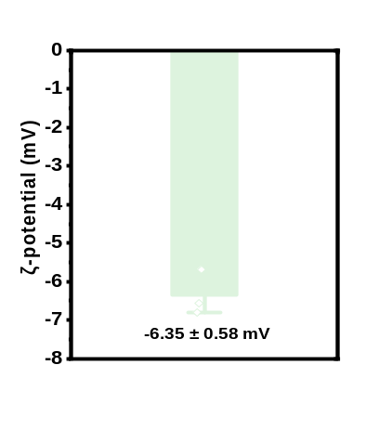
Figure S1. ζ-potential of NR-CDs.
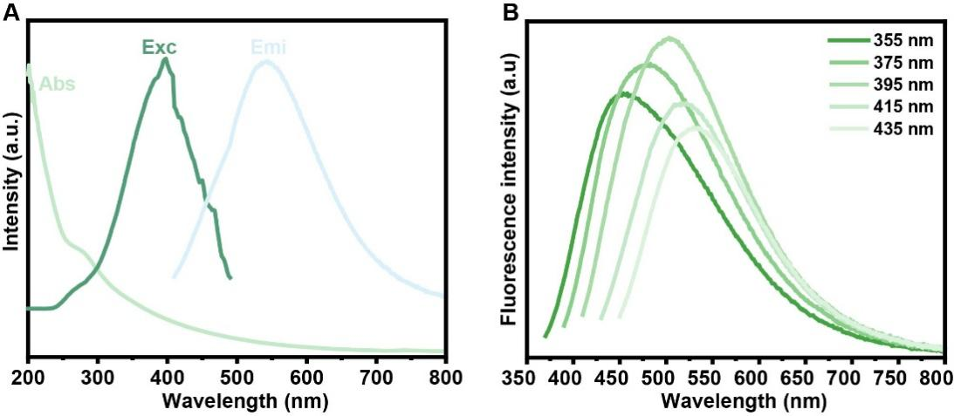
Figure S2. (A) UV–vis absorption spectra (Abs), emission (Emi) and excitation (Exc) spectra of NR-CDs. (B) Emission spectra of NR-CDs under different excitation wavelengths.
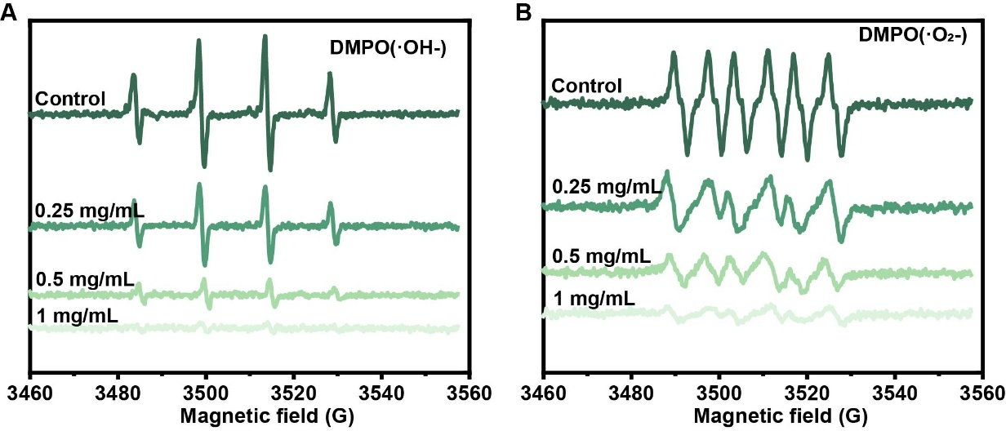
Figure S3. Electron spin resonance (ESR) spectra of (A) ·OH and (B)·O₂⁻ treated with different concentrations of NR-CDs.
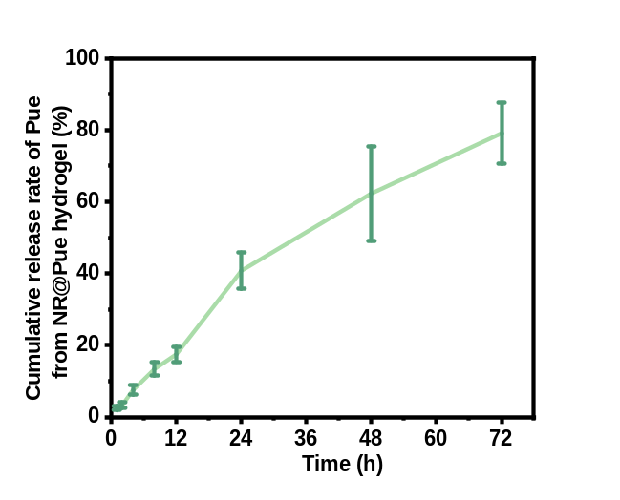
Figure S4. The cumulative release rate of Pue from NR@Pue hydrogel (n = 3).
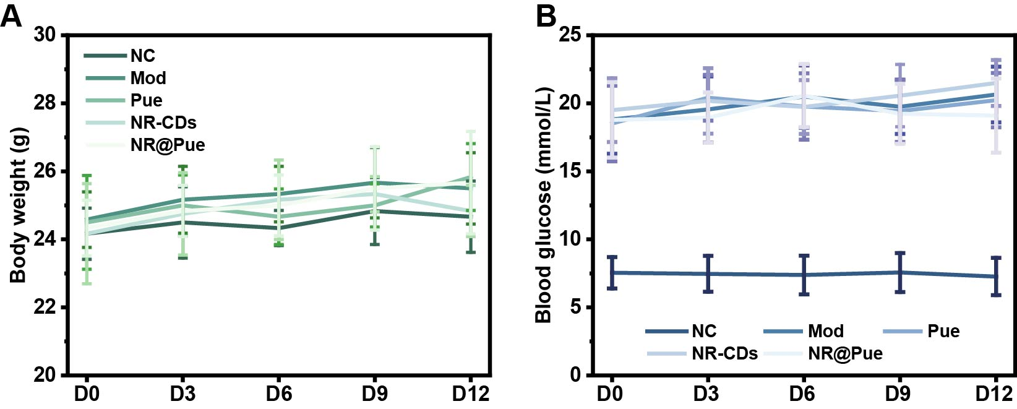
Figure S5. The body weight (g) and blood glucose (mmol/L) of mice during 12-days’ treatment (n = 6).
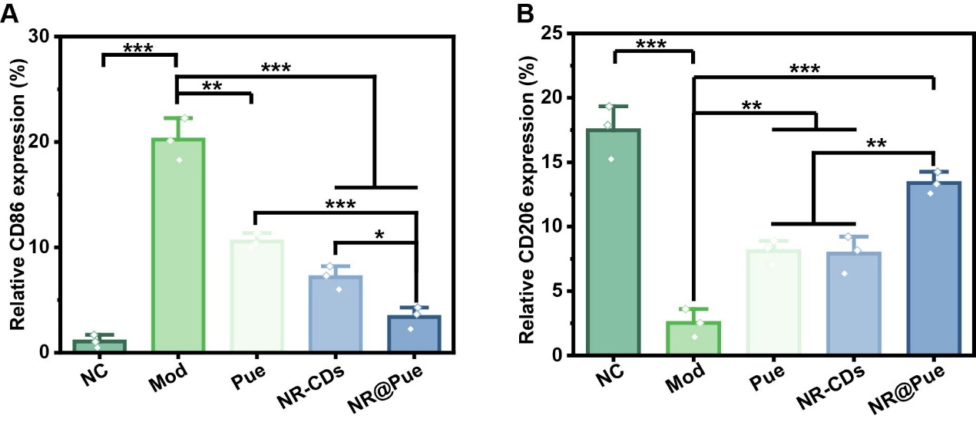
Figure S6. Quantification analysis of (A) CD86 and (B) CD206 of wound tissues on day 12. All data were shown as mean ± SD (n = 3). P value: “*” p < 0.05, “**” p < 0.01 and “***” p < 0.001.
Reference
1. Liang P, Bi T, Zhou Y, Wang C, Ma Y, Xu H, Shen H, Ren W, Yang S: Carbonized Platycladus orientalis Derived Carbon Dots Accelerate Hemostasis through Activation of Platelets and Coagulation Pathways. Small 2023, 19:e2303498.
2. Liang P, Ma Y, Song M, Wang H, Peng X, Sun Q, Shen H, Liu Z, Luo P, Ren W: Design of nano mume Fructus charcoal by reshaping inflammatory microenvironment as biofunctional wound nanomedicine. Materials Today Bio 2025, 33:101971.
3. Luo L, Li Y, Bao Z, Zhu D, Chen G, Li W, Xiao Y, Wang Z, Zhang Y, Liu H, et al: Pericardial Delivery of SDF-1 alpha Puerarin Hydrogel Promotes Heart Repair and Electrical Coupling. Adv Mater 2023:e2302686.
4. Peng Y, Mei S, Qi X, Tang R, Yang W, Feng J, Zhou Y, Huang X, Qian G, Xing S, et al: PGC-1α mediates migrasome secretion accelerating macrophage–myofibroblast transition and contributing to sepsis-associated pulmonary fibrosis. Experimental & Molecular Medicine 2025, 57:759-774.
5. Wang S, Liu Y, Wang X, Chen L, Huang W, Xiong T, Wang N, Guo J, Gao Z, Jin M: Modulating macrophage phenotype for accelerated wound healing with chlorogenic acid-loaded nanocomposite hydrogel. J Control Release 2024, 369:420-443.

